actuator: default exposure:
- /actuator
- /health/{*path}
- /health

to exposure all:
management.endpoints.web.exposure.include=*

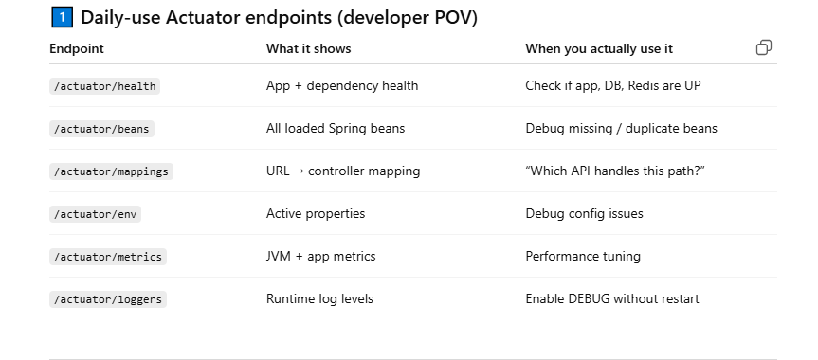

🔥 Common Spring Boot Actuator Endpoints – One-Liners
/actuator/health
One-liner: Tells whether the application and its dependencies are alive.
Example use:
Load balancer checks if DB is down before routing traffic.

/actuator/info
One-liner: Shows application metadata like version and build info.
Example use:
Verify which version is deployed in production.

/actuator/beans
One-liner: Lists all Spring-managed beans with scope and source.
Example use:
Debug why a @Service is not getting injected.

/actuator/mappings
One-liner: Shows all HTTP endpoints and their controller mappings.
Example use:
Find which controller handles /api/orders.

/actuator/env
One-liner: Displays active configuration properties and profiles.
Example use:
Confirm whether spring.datasource.url is correct.

/actuator/metrics
One-liner: Exposes JVM, system, and application performance metrics.
Example use:
Monitor API response time and memory usage.

/actuator/loggers
One-liner: View and change logging levels at runtime.
Example use:
Turn DEBUG on in prod without restarting the app.

/actuator/threaddump
One-liner: Shows current JVM thread states.
Example use:
Diagnose deadlocks or stuck threads.

/actuator/heapdump
One-liner: Dumps JVM heap for memory analysis.
Example use:
Investigate memory leaks using tools like VisualVM.

/actuator/scheduledtasks
One-liner: Lists all scheduled jobs in the application.
Example use:
Verify cron jobs are registered correctly.

/actuator/caches
One-liner: Shows cache usage and cache names.
Example use:
Debug why cached data is not refreshing.

⭐ Singleton Scope – One-Line Examples
- Singleton: One bean instance shared across the whole application
Example: @Service OrderService
- Prototype: New instance every time requested
Example: Temporary object builder
- Request: One instance per HTTP request
Example: Request-scoped context data
- Session: One instance per user session
Example: Login/session data

Docker
Shared environment, version conflicts, envioronmental inconsistency
Docker container: pack application, configuration, dependencies into individual containers

- It is an open-source platform that allows you to automate the deployment, scaling and management of applications using containerization.
- Can be ported and deployed in any systems that supports dockerr

Abstract class vs Interface
New method added in base interface should have implementation in sub interface

Docker CLI:
CLI is client that allows uses to interact with docker
Docker CLI interact with Docker daemon to execute the commands
Docker Daemon runs on host os and is responsible for building docker images and managing containers
Docker Api
Docker Images are templates (blueprint) to create containers, one image can be used to create multiple containers.
Docker registry is the place that stores docker images (public / private)
Docker Image -> pull from -> Docker registry -> run image to get containers and pull also vice-versa
Images are the templates that define the container and its dependencies.
Containers are the runtime environments created from docker image
Engine is the runtime that runs and manages containers
Dockerfile: A file that contains the instructions to build a docker image
Docker Hub: A cloud based registry that hosts a vast collection of docker images.

Docker Registry is similar to git: pull, push, version
Hub.docker.com
Aws ecr
Gcp artifact registry
Microsoft acr

