**HTML**

**Introduction**

* HTML stands for **Hyper Text Markup Language**.
* HTML is the standard **markup** language used for creating web pages.
* **Hyper Text** refers to linking web pages together.
* A **markup** **language** is a set of rules that define how the layout and presentation of text, and images should appear in a digital document.
* HTML describes the structure of a web page.
* HTML is not Case Sensitive i.e. <p> = <P>.

**History**

* The first version of HTML was invented in 1991 by Tim Berners-Lee.
* The present version of HTML is HTML5.
* HTML Version chart:

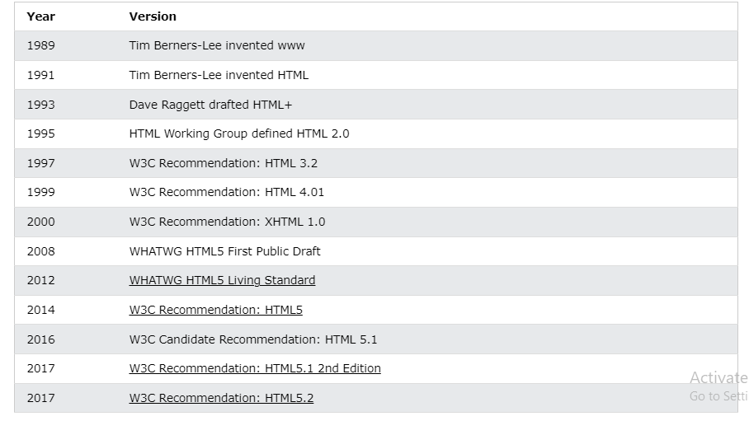

* HTML5 has included lot of features that help in creating dynamic web pages.
* For all the features refer to below URL:https://www.browserstack.com/guide/top-html5-features
* Some basic features of HTML5:

1. Audio and Video Support
2. Geolocation API
3. Local Storage
4. Responsive Images
5. Drag and Drop API

**Editors**

* VS Code
* Notepad: File -> Save As -> FileName.htm or FileName.html -> run in browser

**Standard HTML Template Structure**

<!DOCTYPE html>  
<html>  
<head>  
<title>Page Title</title>  
</head>  
<body>  
  
<h1>My First Heading</h1>  
<p>My first paragraph.</p>  
  
</body>  
</html>

**Explanation**

**HTML Elements**

* An html element is defined by a start tag and an end tag.
* All html elements have a start tag followed by some content and an end tag.
* There are some special elements like <br>, <hr> which don’t have content and closed tags.
* Some HTML Elements:

1. <h1>Hi</h1>
2. <br>
3. <p> welcome</p>

**HTML Attributes**

* All HTML elements can have attributes.
* Attributes provide additional information about elements.
* Attributes are always specified in the start tag.
* Attributes always appear in “name:value” pairs.
* Some examples:
  1. <a href = “https://www.kluniversity.in/”>Visit KL </a>
  2. <img src = “location” alt = “image”>
* Here:
* href is attribute for <a> element.
* src, alt are attributes of img tag.

**HTML** **Headings**

* HTML Headings are the titles or subtitles that you want to display on a webpage.
* HTML Headings are defined with the <h1> to <h6> tags.
* <h1> defines the most important heading and <h6> defines the least important one.

**HTML Paragraphs**

* The HTML <p> elements define a paragraph.
* A paragraph within <p> elements always start in a new line and in browser output there is always some space between paragraphs.

**HTML Quotations**

**Examples:**

<p>Here is a quote from WWF's website:</p>

<blockquote>For 60 years, WWF has worked to help people and nature thrive.

</blockquote>

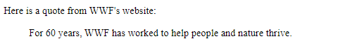

<p>My goal is to: <q>Build a future.</q></p>



<p>The <abbr title="World Health Organization">WHO</abbr> was founded in 1948.</p>



<bdo dir="rtl">This text will be written from right to left</bdo>



**HTML Links**

* Html links are hyperlinks which can be used to jump to another document by clicking.
* When we move our mouse arrow over a link, the mouse arrow will turn into a little hand.
* HTML links can be texts, images, etc.
* The html <a> tag defines a link.
  + <a href = “https://r-venkat-kalyan.github.io/”>Portfolio</a>
* By default, the links will be opened on the same page, but to configure the link to open in other tabs we can use the **target** attribute of <a> tag.
* The **target** attribute can have one of the following values:

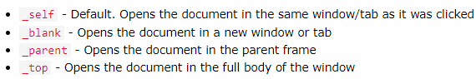

* We can even create links in html that opens email program:
* <a href = “mailto:2100030959cseh@gmail.com”>Mail</a>
* This link named as “Mail” will open user’s mail program like Gmail to send a mail to specified mail.
* By default, whenever we hover over a link it displays an underline, we can remove that underline by adding style as follows:
* <a href = [“mailto:2100030959cseh@gmail.com](mailto:2100030959cseh@gmail.com)”

style = “text-decoration: none;”>Mail</a>

**HTML Favicon**

* A favicon is a small image displayed next to the page title in the browser tab.
* To add a favicon icon, ­­­­we need to use **<link>** tag.
* <link rel = “icon” href="C:\Users\DELL\Downloads\li.png">

**HTML Tables**

* Tables are used to organize data in the form of rows and columns.
* The useful html tags while dealing with tables are **<table>, <tr>, <th>, <td>, <caption>.**
* **<table>:** This is the root tag that is used to create a table. **</table>**
* **<tr>:** It stands for **table row** which is used to define a row. **</tr>**
* **<th>:** It stands for **table header** which is used to define a cell as header. **</th>**
* **<td>:** It stands for **table data** which is used to define the content of a table. **</td>**
* **<caption>:** It is used to define a caption to our table. **</caption>**

**Example:**

<body>

    <h1> Welcome To HTML Tables</h1>

    <table border="1px">

        <caption>My Details</caption>

        <tr>

            <th>Name</th>

            <th>Age</th>

            <th>Email</th>

        </tr>

        <tr>

            <td>Kalyan</td>

            <td>20</td>

            <td>kalyan@gmail.com</td>

        </tr>

        <tr>

            <td>Venkat</td>

            <td>20</td>

            <td>venky@gmail.com</td>

        </tr>

    </table>

</body>

**Output:**

* In the above code I have given table border as 1px to format the table with proper look.

**HTML Lists**

* Lists allow us to group a set of related items.
* Lists can be nested also, and list items can contain other html elements.
* The list item should be defined using <li> tag.
* In HTML we have 3 types of lists:
  + Unordered Lists (<ul></ul>)
  + Ordered Lists (<ol></ol>)
  + Description Lists (<dl></dl>)

**Unordered Lists**

* An Unordered list can be defined using <ul> tag.
* By default, the <ul> list item will be marked with bullet points.
* We can change the type of <ul> list markers by using **list-style-type** property.
* The **list-style-type** property of <ul> tag defines the type of the list item marker.
* Types of markers for <ul> list item:

**Example:**

<ul style="list-style-type:square;">

        <li>RR</li>

        <li>CSK</li>

        <li>PBKS</li>

        <li>KKR</li>

</ul>

**Output:**

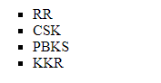

* Here I have used **list-style-type: square** to get the li items with squares.

**Ordered Lists**

* An ordered list can be defined using <ol></ol> tag.
* By default, the <ol> list items will be marked with numbers.
* We can change the type of <ol> list markers by using **type** attribute.
* The **type** attribute of <ol> tag defines the type of the list item marker.
* Types of markers for <ol> list items:

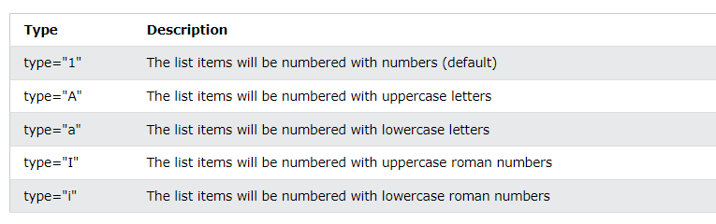

**Example:**

<body>

    <h3>Ordered List with default type marker</h3>

    <ol>

        <li>RR</li>

        <li>CSK</li>

        <li>PBKS</li>

        <li>KKR</li>

    </ol>

    <h3>Ordered List with customized type marker</h3>

    <ol type="A">

        <li>RR</li>

        <li>CSK</li>

        <li>PBKS</li>

        <li>KKR</li>

    </ol>

</body>

**Output:**

* We can even control the starting of type markers by using **start** attribute of <ol> tag**.**
* **<ol type="A" start="5">.**
* This above list will start with the type marker from ‘E’ as it is the 5th alphabet.

**Description Lists**

* A description list is a list of terms with description to each term.
* The main tags that are used under description list are **<dl> <dt> <dd>.**
* The **<dl>** tag is used to define a description list.
* The **<dt>** tag is used to define the description term.
* The **<dd>** tag is used to describe the term.

**Example**

    <h3>My Projects Description</h3>

    <dl>

        <dt>TaskPrompter</dt>

        <dd>Next Level Task Management System. </dd>

        <dd>Sends Timely Email Notifications. </dd>

        <dt>PDFsquare</dt>

        <dd>Online Document Management Application. </dd>

        <dd>Allows conversion of pdf files to images, words, & vice-versa. </dd>

    </dl>

**Output**

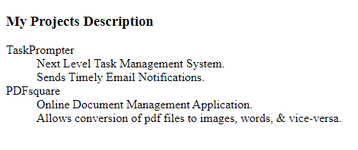

**HTML Element Types**

* In general HTML elements are classified into two categories:
  + Block-level Elements.
  + Inline Elements

**HTML Block-level Elements**

* A Block-level Element always starts on a new line, and the browser automatically adds a line space between these elements.
* A Block-level Element always takes up the full width available.
* Block-level Elements in HTML are:

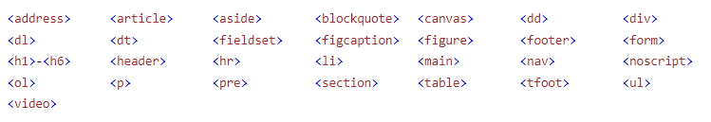

**HTML Inline Elements**

* An inline element doesn’t start on a new line.
* An inline element takes the required space only.
* Inline Elements in HTML are:

**HTML Forms**

* Forms are used to collect data or user input.
* In HTML forms can be defined using the **<form>** tag.

**Attributes of Form Element**

* **action**: It defines the action to be performed when a form is submitted.
* **method**: It specifies an http method to be used when submitting the form.
* **target**: It is used to specify the page where action is going to be performed.
* **autocomplete**: It is an attribute having two values as ‘on’ or ‘off’, when it is ‘on’ browser automatically suggests the values for inputs based on our previous entries and by default the form tag takes it as ‘on’.

**Input Tag**

* The most used tag inside form is **<input>** tag.
* The **<input>** tag is used to take input from user.
* An **<input>** tag can be displayed in many ways, depending on the **type** attribute using which we can specify the value type which we want to collect from user.
* The default type of **<input>** is text only.
* The <input> tag in html also has so many attributes.
* Some of them are:
  + 1. **required:** *validates the field as mandatory field.*
    2. **readonly:** *makes the field readable only.*
    3. **disabled:** *marks the field as disabled i.e. no data can be provided here.*
    4. **max:** *defines a maximum value as boundary constraint.*
    5. **min:** *defines a minimum value as boundary constraint.*
    6. **maxlength:** *restricts the length of the input text.*
    7. **multiple:** *used when working with files to drag multiple files at a time.*

**Example**

<body>

    <h3>HTML Forms</h3>

    <form action="https://r-venkat-kalyan.github.io/" method="get" target="_blank" autocomplete="on">

        <label for="name">Enter Your Name: </label><br>

        <input type="text" id="name" placeholder="Name"/><br>

        <label for="email">Email Address:</label><br>

        <input type="email" id="mail" placeholder="Email"/><br>

        <label for = "age">Your Age: </label><br>

        <input type="number" id="age" placeholder="Age" min="1" max="100"/><br>

        <label for = "ID">Your 10-digit ID: </label><br>

        <input type="number" id="id" placeholder="ID" /><br>

        <label for = "gender">Your Gender: </label><br>

        <input type="radio" id="genderM" value="Male"/>

        <label for = "male">Male </label>

        <input type="radio" id="genderF" value="FeMale"/>

        <label for = "female">FeMale </label><br>

        <label for="graduation">Graduation date</label>

        <input type="date" id="date” required/><br>

        <label for="Time for graduation” >Select Time:</label>

        <input type="time" id="time" /> <br>

        <label for="Rate">Rating:</label><br>

        <input type="range" id="range" /><br>

        <input type="checkbox" id="check1" required/>

        <label for = "terms">Accept Terms and Conditions</label><br>

        <input type="submit" value="Submit"/>

        <input type="reset" value="Reset"/>

    </form>

</body>

* Here after we click the **submit** button some **validations** will happen for **graduation date: required, age: 1-100, must select Accept Terms**.
* If all validations are successful, then we will be redirected to **Portfolio page** in a new tab as we have specified **form action as Portfolio-URL and target as _blank.**
* While filling in the form the browser will auto suggest values for some fields as we have provided **autocomplete= “on”.**
* Here I have used the form method as **‘get’** which is not that preferable when dealing with sensitive data as it displays all the data entered in the form in the URL in the format of **name: value pairs**.
* Whenever we deal with sensitive data it is always preferable to go with the **‘post’** method which appends the data inside the body of the HTTP request.

**Output**

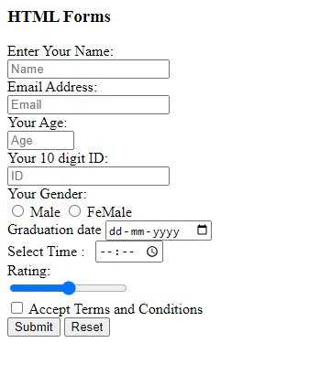

**HTML Drop-Down**

* To create a drop-down list, we need to use **<select>** tag.
* To define an option element, we need to use **<option>** tag.
* In drop-down lists the first option is selected by default.
* To define a pre-selected option, add the **selected** attribute to the option.

**Example:**

    <h4>HTML Drop-Downs</h4>

    <select name="movies">

        <option value="chroncile">The Chronicles of Narnia</option>

        <option value="12th Fail">Salaar</option>

        <option value="Hi Nanna" selected>Hi Nanna</option>

    </select>

**Output:**

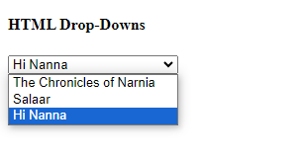

**HTML <textarea>**

* The **textarea** element defines a multi-line input field.
* It mainly consists of two attributes **rows** and **cols**.
* The **rows** attribute specifies the visible number of lines.
* The **cols** attribute specifies the visible width.
* The difference between **<input type=”text”>** and <**textarea>** is that in in <**textarea**> we can have multiple lines.

**Example**

    <textarea rows="10" cols="30">

    I am R. Venkat Kalyan

    </textarea>

**Output**

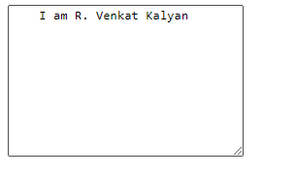

**HTML Canvas**

* The HTML **Canvas** is used to draw graphics in our web pages using **javascript**.
* The **<canvas>** element is only a container; we need to use **javascript** to draw the graphics.
* A **canvas** is a rectangular box on a html page with no borders.

**HTML SVG**

* **SVG** stands for Scalable Vector Graphics.
* **SVG** defines vector-based graphics in XML which can be embedded directly into HTML pages.
* **SVG** graphics are scalable and do not lose any quality if they are zoomed in or resized.

**HTML Media**

* **Media** on the web is **sound, music, video, movies, etc**.
* **HTML5** includes some elements to support **audio** and **video** content to the web pages.
* The HTML **<video>** element is used to show a video on our web page.
* The HTML **<audio>** element is used to play audio on our page.
* Both **video** and **audio** tags need to include another tag within them which is called as <**source**> tag which is used to provide the path of the video.
* Some attributes for this <**video**> and <**audio**> tags are as follows:
  + **controls**: It adds controls like **play**, **pause** and **volume**.
  + **autoplay**: To start a video **automatically** we use the **autoplay** attribute.
  + **autoplay muted**: It starts a video **automatically** but **mutes** the volume.
  + source **type:** It is used to specify the **type** like **mp4**, **ogg**, **webm.**

**Video Example**

    <h1>HTML Videos</h1>

    <video width="500" height="400" controls>

        <source src="shiva.mp4" type="video/mp4">

    </video>

**Output**

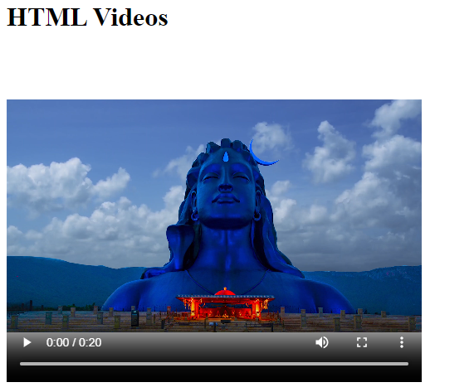

* A controllable video is displayed, we can also include attributes like **autoplay**, **autoplay** **muted** in the above code.

**Audio Example**

<h4>HTML Audios</h4>

    <br>

    <audio width="500" height="400" controls>

        <source src="Jay Shri ram.mp3" type="audio/mp3">

    </audio>

**Output**

**IMPORTANT URLS**

**ALL HTML ELEMENTS LIST:** <https://www.w3schools.com/tags/default.asp>

**ALL HTML ATTRIBUTES LIST:**

<https://www.w3schools.com/tags/ref_attributes.asp>

**COMPLETE HTML TUTORIAL**

<https://www.w3schools.com/html/default.asp>