**JavaScript**

**Introduction**

* JavaScript (JS) is a lightweight interpreted programming language.
* It is most well-known as scripting language for web pages and many non-browser environments such as node.js also use it.
* JS is multi-paradigm, single-threaded, dynamic language supporting object-oriented styles.
* JS can change HTML Content, HTML Attribute values, HTML styles, hide and display HTML Elements.
* JS is **case sensitive.**
* JS and Java are completely different languages, both in concept and design.

**History**

* JS was invented by Brendan Eich in 1995.
* It was developed for NetScape 2 and became the ECMA-262 standard in 1997.
* JavaScript is standardized at ECMA (European Computer Manufacturers Association) to deliver a standardized, international programming language based on JavaScript.
* This standardized version of JavaScript, called ECMAScript, behaves the same way in all applications that support the standard.

**JS Where To**

* In HTML JS code is inserted between **<script> </script>** tag.
* We can place the **<script> </script>** tag under **<head> </head>** tag or **<body> </body>** tag.
* We can include an external JS file like this: **<script src = myscript.js/>**

**JS Output**

JS output data can be displayed in following different ways:

* Writing into an HTML element using **innerHTML**
* Writing into the HTML output using **document.write**
* Writing into an alert box, using **window.alert()**
* Writing into the browser console, using **console.log()**

**Example1:**

**Output:**

**Example2:**

**

**Note:**

Using **document.write()** after an html file is loaded will clear all the existing html.

**Example2.1:**

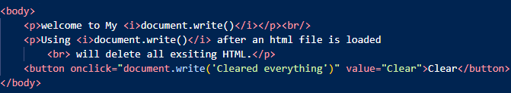

**Output**

**Before ‘Clear’ After ‘Clear’**

**Example3:**

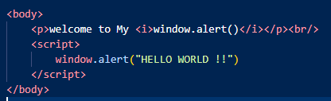

**Note:**

* Whenever a page is loaded the content under **window.alert()** or **alert()** will be displayed first within a alert box, followed by this the rest content will appear.
* **window.alert()** and **alert()** workssame**.**

**Output:**

**Example4:**

**Output:**

**Note:**

* **console.log ()** is mostly used for debugging purposes.
* To view the output of cosole.log:
* -> browser -> right click -> inspect -> console

**JS Variables:**

* Variables are used to store data.
* JS Variables can be declared in 4 ways:

1. Automatically
2. Using var
3. Using let
4. Using const

**Automatically:**

* These variables are undeclared variables.
* They are automatically declared when first used.
* **Example:** id = 30959;

**Using var:**

* The **var** keyword was used in JS from 1995 to 2015.
* In 2015 the keywords **let** and **const** were added.
* The **var** is mostly preferred to use in code written for old browsers.
* Variables declared using **var** keyword has **Global** **Scope.**
* Variables declared using **var** keyword have no **block scope.**
* Variables declared using **var** keyword can be **redeclared**.
* **Example:** var id = 30959, age = 21;

**Using let:**

* The **let** keyword is used when we cannot use const.
* Variables declared with **let** keyword have **block scope** and cannot be **redeclared & reassigned** in the **same scope.**
* These variables must be declared before use.
* **Example:** let name = “kalyan”;

**Using const:**

* The **const** keyword in JS is used if we want the values not to be changed.
* The **const** keyword in JS is used if we want the type of variables to be fixed.
* Variables declared with **const** keyword have **block scope** and cannot be **redeclared & reassigned** in the **same scope.**
* These variables must be declared before use.
* **Example:** const id = 30959;

**JS Operators:**

* There are different types of operators in JS:
* **Arithmetic: +, -, *, **, /, %, ++, --**
* **Assignment: =, +=, -=, *=, **=, /=, %=**
* **Comparison: ==, ===, !=, !==, >, <, >=, <=**
* **String: + (concatenation), +=**
* **Logical: &&, ||, !**
* **Bitwise: &, |, ~, ^, <<, >>, >>> (unsigned right shift)**
* **Ternary: ?**
* **Type: typeof, instanceof**

**Note:**

* The **===** comparison operator checks the equal value and equal type.
* The **instanceof** operator returns true if an object is an instance of an object type and the **\*\*** is the **exponential** operator.

**JS Datatypes:**

* Datatypes define the type of data that can be stored in a variable.
* JS has 8 Datatypes:

1. **String**
2. **Number**
3. **Boolean**
4. **BigInt**
5. **Undefined**
6. **Null**
7. **Symbol**
8. **Object ->** can contain an **object, array, date.**

**String:**

* In JS to represent a string variable we can use both single quotes **(‘ ‘)** as well as double quotes **(“ “).**
* When we are working with strings and we want to enclose some text with special symbols like **(‘ ‘, “ “, /)** we need to use escape character **(\).**

**Example:**

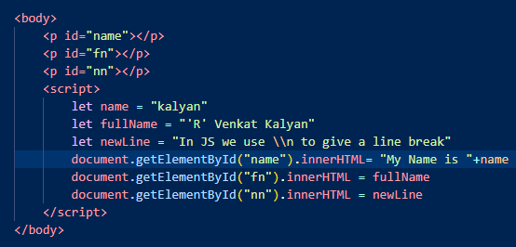

**Output:**

**JS String Methods:**

|  |  |
| --- | --- |
| [String length](https://www.w3schools.com/js/js_string_methods.asp#mark_length) [String charAt()](https://www.w3schools.com/js/js_string_methods.asp#mark_charat) [String charCodeAt()](https://www.w3schools.com/js/js_string_methods.asp#mark_charcodeat) [String at()](https://www.w3schools.com/js/js_string_methods.asp#mark_at) [String [ ]](https://www.w3schools.com/js/js_string_methods.asp#mark_propertyaccess) [String slice()](https://www.w3schools.com/js/js_string_methods.asp#mark_slice) [String substring()](https://www.w3schools.com/js/js_string_methods.asp#mark_substring) [String substr()](https://www.w3schools.com/js/js_string_methods.asp#mark_substr) **See Also:** [String Search Methods](https://www.w3schools.com/js/js_string_search.asp) [String Templates](https://www.w3schools.com/js/js_string_templates.asp) | [String toUpperCase()](https://www.w3schools.com/js/js_string_methods.asp#mark_touppercase)  [String toLowerCase()](https://www.w3schools.com/js/js_string_methods.asp#mark_tolowercase)  [String concat()](https://www.w3schools.com/js/js_string_methods.asp#mark_concat) [String trim()](https://www.w3schools.com/js/js_string_methods.asp#mark_trim) [String trimStart()](https://www.w3schools.com/js/js_string_methods.asp#mark_trimstart) [String trimEnd()](https://www.w3schools.com/js/js_string_methods.asp#mark_trimend) [String padStart()](https://www.w3schools.com/js/js_string_methods.asp#mark_padstart) [String padEnd()](https://www.w3schools.com/js/js_string_methods.asp#mark_padend) [String repeat()](https://www.w3schools.com/js/js_string_methods.asp#mark_repeat) [String replace()](https://www.w3schools.com/js/js_string_methods.asp#mark_replace) [String replaceAll()](https://www.w3schools.com/js/js_string_methods.asp#mark_replaceall) [String split()](https://www.w3schools.com/js/js_string_methods.asp#mark_split)  [String indexOf()](https://www.w3schools.com/js/js_string_search.asp#mark_indexof) [String lastIndexOf()](https://www.w3schools.com/js/js_string_search.asp#mark_lastindexof) [String search()](https://www.w3schools.com/js/js_string_search.asp#mark_search) |

**Number:**

* JS has only one type of number.
* Numbers can be written with or without decimal points.
* In JS Integers are accurate up to 15 digits. (2100030959309599)
* In JS floating arithmetic is not accurate. (2.1 + 3.1)