**JavaScript**

**Introduction**

* JavaScript (JS) is a lightweight interpreted programming language used to develop web pages.
* It is most well-known as scripting language for web pages and many non-browser environments such as node.js also use it.
* Scripting language is a programming language that is used to manipulate, customize, and automate the facilities of an existing system.
* JS can change HTML Content, HTML Attribute values, HTML styles, hide and display HTML Elements.
* JS is **case sensitive.**
* JS and Java are completely different languages, both in concept and design.

**History**

* JS was invented by Brendan Eich in 1995.
* It was developed for NetScape 2 and became the ECMA-262 standard in 1997.
* JavaScript is standardized at ECMA (European Computer Manufacturers Association) to deliver a standardized, international programming language based on JavaScript.
* This standardized version of JavaScript, called ECMAScript, behaves the same way in all applications that support the standard.

**JS Where To**

* In HTML JS code is inserted between **<script> </script>** tag.
* We can place the **<script> </script>** tag under **<head> </head>** tag or **<body> </body>** tag.
* We can include an external JS file like this: **<script src = myscript.js/>**

**JS Output**

JS output data can be displayed in following different ways:

* Writing into an HTML element using **innerHTML**
* Writing into the HTML output using **document.write**
* Writing into an alert box, using **window.alert()**
* Writing into the browser console, using **console.log()**

**Example1:**

**Output:**

**Example2:**

**

**Note:**

Using **document.write()** after an html file is loaded will clear all the existing html.

**Example2.1:**

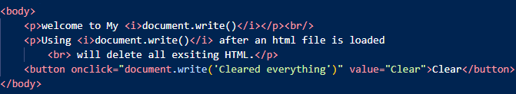

**Output**

**Before ‘Clear’ After ‘Clear’**

**Example3:**

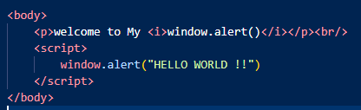

**Note:**

* Whenever a page is loaded the content under **window.alert()** or **alert()** will be displayed first within a alert box, followed by this the rest content will appear.
* **window.alert()** and **alert()** workssame**.**

**Output:**

**Example4:**

**Output:**

**Note:**

* **console.log ()** is mostly used for debugging purposes.
* To view the output of cosole.log:
* -> browser -> right click -> inspect -> console

**JS Variables:**

* Variables are used to store data.
* JS Variables can be declared in 4 ways:

1. Automatically
2. Using var
3. Using let
4. Using const

**Automatically:**

* These variables are undeclared variables.
* They are automatically declared when first used.
* **Example:** id = 30959;

**Using var:**

* The **var** keyword was used in JS from 1995 to 2015.
* In 2015 the keywords **let** and **const** were added.
* The **var** is mostly preferred to use in code written for old browsers.
* Variables declared using **var** keyword has **Global** **Scope.**
* Variables declared using **var** keyword have no **block scope.**
* Variables declared using **var** keyword can be **redeclared**.
* **Example:** var id = 30959, age = 21;

**Using let:**

* The **let** keyword is used when we cannot use const.
* Variables declared with **let** keyword have **block scope** and cannot be **redeclared & reassigned** in the **same scope.**
* These variables must be declared before use.
* **Example:** let name = “kalyan”;

**Using const:**

* The **const** keyword in JS is used if we want the values not to be changed.
* The **const** keyword in JS is used if we want the type of variables to be fixed.
* Variables declared with **const** keyword have **block scope** and cannot be **redeclared & reassigned** in the **same scope.**
* These variables must be declared before use.
* **Example:** const id = 30959;

**JS Operators:**

* There are different types of operators in JS:
* **Arithmetic: +, -, *, **, /, %, ++, --**
* **Assignment: =, +=, -=, *=, **=, /=, %=**
* **Comparison: ==, ===, !=, !==, >, <, >=, <=**
* **String: + (concatenation), +=**
* **Logical: &&, ||, !**
* **Bitwise: &, |, ~, ^, <<, >>, >>> (unsigned right shift)**
* **Ternary: ?**
* **Type: typeof, instanceof**

**Note:**

* The **===** comparison operator checks the equal value and equal type.
* The **instanceof** operator returns true if an object is an instance of an object type and the **\*\*** is the **exponential** operator.

**JS Datatypes:**

* Datatypes define the type of data that can be stored in a variable.
* JS has 8 Datatypes:

1. **String**
2. **Number**
3. **Boolean**
4. **BigInt**
5. **Undefined**
6. **Null**
7. **Symbol**
8. **Object ->** can contain an **object, array, date.**

**String:**

* In JS to represent a string variable we can use both single quotes **(‘ ‘)** as well as double quotes **(“ “).**
* When we are working with strings and we want to enclose some text with special symbols like **(‘ ‘, “ “, /)** we need to use escape character **(\).**

**Example:**

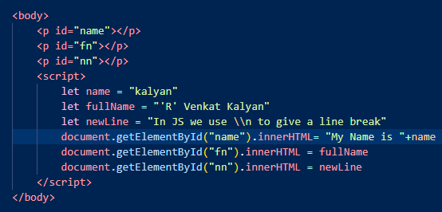

**Output:**

**JS String Methods:**

|  |  |
| --- | --- |
| [String length](https://www.w3schools.com/js/js_string_methods.asp#mark_length) [String charAt()](https://www.w3schools.com/js/js_string_methods.asp#mark_charat) [String charCodeAt()](https://www.w3schools.com/js/js_string_methods.asp#mark_charcodeat) [String at()](https://www.w3schools.com/js/js_string_methods.asp#mark_at) [String [ ]](https://www.w3schools.com/js/js_string_methods.asp#mark_propertyaccess) [String slice()](https://www.w3schools.com/js/js_string_methods.asp#mark_slice) [String substring()](https://www.w3schools.com/js/js_string_methods.asp#mark_substring) [String substr()](https://www.w3schools.com/js/js_string_methods.asp#mark_substr) **See Also:** [String Search Methods](https://www.w3schools.com/js/js_string_search.asp) [String Templates](https://www.w3schools.com/js/js_string_templates.asp) | [String toUpperCase()](https://www.w3schools.com/js/js_string_methods.asp#mark_touppercase)  [String toLowerCase()](https://www.w3schools.com/js/js_string_methods.asp#mark_tolowercase)  [String concat()](https://www.w3schools.com/js/js_string_methods.asp#mark_concat) [String trim()](https://www.w3schools.com/js/js_string_methods.asp#mark_trim) [String trimStart()](https://www.w3schools.com/js/js_string_methods.asp#mark_trimstart) [String trimEnd()](https://www.w3schools.com/js/js_string_methods.asp#mark_trimend) [String padStart()](https://www.w3schools.com/js/js_string_methods.asp#mark_padstart) [String padEnd()](https://www.w3schools.com/js/js_string_methods.asp#mark_padend) [String repeat()](https://www.w3schools.com/js/js_string_methods.asp#mark_repeat) [String replace()](https://www.w3schools.com/js/js_string_methods.asp#mark_replace) [String replaceAll()](https://www.w3schools.com/js/js_string_methods.asp#mark_replaceall) [String split()](https://www.w3schools.com/js/js_string_methods.asp#mark_split)  [String indexOf()](https://www.w3schools.com/js/js_string_search.asp#mark_indexof) [String lastIndexOf()](https://www.w3schools.com/js/js_string_search.asp#mark_lastindexof) [String search()](https://www.w3schools.com/js/js_string_search.asp#mark_search) |

**Number:**

* JS has only one type of number.
* Numbers can be written with or without decimal points.
* In JS Integers are accurate up to 15 digits.
* **Max Range: +-9007199254740991 or +-2^53-1.**
* In JS floating arithmetic is not accurate. (2.1 + 3.1)

**JS Number Methods:**

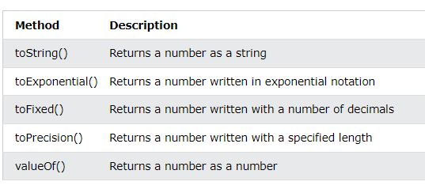

**BigInt:**

* In JS **bigint** variables are used to store big int values that are too large to represent in number datatype.
* In JS to create a **bigint** append a n at end of value or call **BigInt().**
* In JS we cannot perform any **arithmetic operations** by using a **combination** of **bigint variable** and a **number varible**.
* **Example:**
* *let x = 99999999999999999****n****;*
* *let y =* ***BigInt****(9999999999999999);*

**Objects:**

* Objects are variables too, but objects can contain many values.
* The values are written as **name:value** pairs.
* In JS objects use named indexes.
* We can access object properties in two ways:
* **objectName.propertyName**
* **objectName[propertyName]**

**Example:**

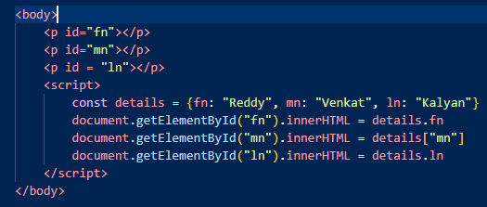

**Output:**

**Arrays:**

* Arrays are used to store a list of items.
* In JS Arrays use numbered indexes.
* In JS arrays can be created in two ways:
* const myArr = [1,2,3,4]
* const myArr = new Array(1,2,3,4)

**Array Methods:**

[Array length](https://www.w3schools.com/js/js_array_methods.asp#mark_length)   
[Array toString](https://www.w3schools.com/js/js_array_methods.asp#mark_tostring)()  
[Array at()](https://www.w3schools.com/js/js_array_methods.asp#mark_at)  
[Array join()](https://www.w3schools.com/js/js_array_methods.asp#mark_join)   
[Array pop()](https://www.w3schools.com/js/js_array_methods.asp#mark_pop)  
[Array push()](https://www.w3schools.com/js/js_array_methods.asp#mark_push)

**Loops in JS:**

JS supports the following loops:

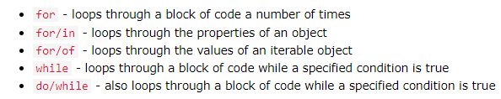

**JS Hoisting:**

* Hoisting is JS’s default behavior of moving declarations to top.
* In JS a variable can be declared after it is used using **var** keyword.
* Variables declared with **let** and **const** keyword cannot be used before declaration.

**Example:**

x= 10; **// hoisting**

var x;

**JS Use Strict:**

* The **“use strict”** directive doesn’t allow a variable to be used before declaration.
* Strict mode is declared by adding **“use strict”;** to the beginning of a script.

**Example:**

“use strict”;

x = 10 ; **// error due to strict mode**

var x = 10; **// executes without error**

**JS JSON:**

* JSON is a format for storing and transporting data.
* JSON is often used when data is sent from a server to a web page.
* JSON stands for **JavaScript Object Notation.**
* JSON is a lightweight data interchange format.
* JSON is **language independent**.
* JSON Rules:
* Data is always in name/value pairs, separated by commas.
* Curly braces hold objects and square braces hold arrays.

**Example:**

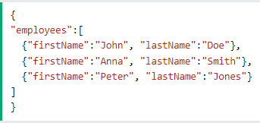

**JS Class:**

* In JS a class is a template for objects.
* In JS we can create a class by using the **class** keyword.
* To create a constructor in class we need to use the **constructor** keyword.
* The **constructor** method is executed when a new object is created.
* It is used to initialize object properties.
* If you do not define a constructor method, JS declares an empty constructor method.

**Example:**

**Getters & Setters**

* In JS we can create getters and setters using **get** & **set** keywords.

**Example:**

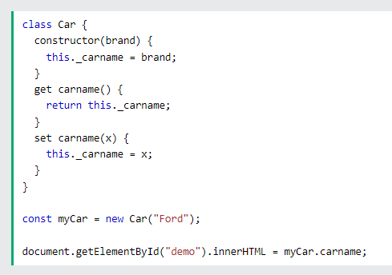

* **Hoisting is not supported by classes.**

**JS HTML DOM:**

* With HTML DOM, JS can access and change all the elements of an HTML document.
* When a web page is loaded in a browser, the browser creates a **Document Object Model (DOM).**
* The DOM is a **W3C (World Wide Web Consortium)** standard and DOM defines a standard for accessing documents.
* The HTML DOM is a standard for how to get, change, add, or delete HTML elements.

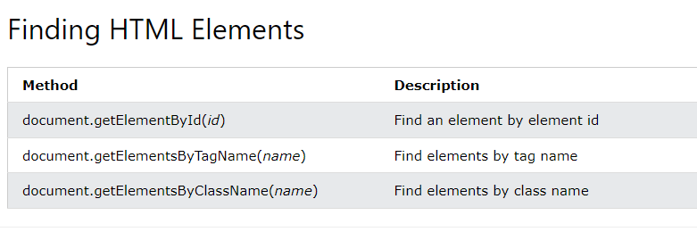

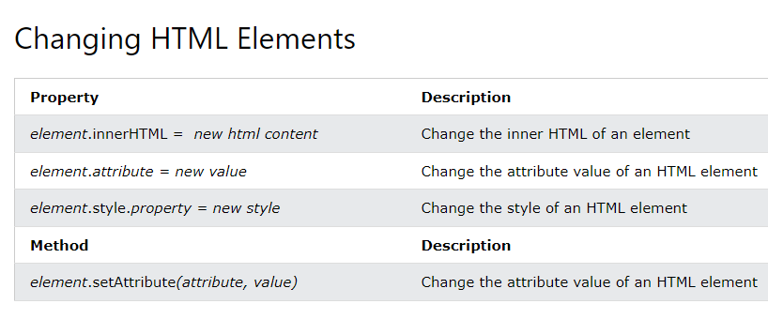

JS DOM EventListener:

* The **addEventListener()** in JS attaches an event handler to the specified element.
* The **addEventListener()** attaches an event handler without overriding existing events.

**Example:**

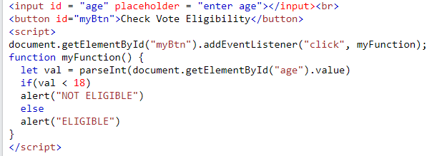

* In this example an event is created for button to validate age and this event triggers **myFunction()** to check eligibility and displays a **alert().**

**JS BOM:**

* The **Browser Object Model (BOM)** allows JS to **talk to** the browser.
* The object used by **BOM** is the **window.**
* The **window** object is supported by all the browsers, and it represents a browser window.

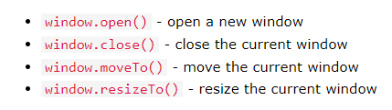

**JS Popup Boxes:**

JS has three kind of popup boxes:

**alert (“Displayable Message”) -> only we will get ok button.**

**confirm (“Displayable Message”) -> we will get ok & cancel button.**

**Prompt(“Displayable Message”, ”Default Message”) -> ok & cancel button.**

**JS Cookies:**

* Cookies help us to store information user information in web browsers.
* Cookies are data stored in small text files on our devices.
* When a web server has sent a web page to the browser, the server shuts down and it forgets all information. To solve this problem cookies are used to store data and are saved in name-value pairs.
* Using JS we can create, read, and delete cookies with the **document.cookie** property.

**Example:**

document.cookie = “username=Kalyan”;