Context

1. Project Overview………………………………………………………………………………………2
2. Project Resources……………………………………………………………………………………….3
3. Project Diagram………………………………………………………………………………………….5
4. Diagram explanation…………………………………………………………………………………8
5. Configuration of Devices……………………………………………………………………………9
6. Execution of the Project
7. Final remarks
8. Project Overview:

The Network Security Project is a simulation of an Enterprise Network which consist of different devices used in everyday execution of an Enterprise. The simulation is to be carried out on Cisco Packet tracer.

The Devices included in the Project are Router, Switches, AP, Computer, Laptop, Printer, IP phone, Smartphones and Server of different kinds.

The Project consist of different departments which will eventually cause different set of configuration as listed below:

1. Network Topology: Design a network topology with multiple departments (e.g., HR, IT, Sales) using switches and routers.
2. VLAN Configuration: Segment the network into different VLANs for each department.
3. Inter-VLAN Routing: Configure inter-VLAN routing to allow communication between VLANs while applying security controls.
4. ACL Implementation: Apply ACLs on routers to control traffic flow between VLANs, allowing only authorized traffic.
5. Port Security: Implement port security on switches to prevent unauthorized devices from connecting to the network.
6. VPN Setup: Configure a site-to-site VPN to securely connect a remote branch office to the corporate network.
7. Testing: Simulate attacks like unauthorized access attempts and test the network's response to these threats.
8. Project Resources:

Multiple devices will be used in different departments throughout the project. The list of the devices and amount is as follows:

1. Routers (ISR4331) x 2
2. Switch (2950 T) x 6
3. Computers (PC) x 6
4. Printers x 3
5. Laptops x 3
6. Access points (PT-AC) x 6
7. IP phone (7960) x 2
8. Wired end device x 1
9. Sniffer x 1
10. Server x 2
11. Meraki Server x 1
12. Network Controller x 1

Departments:

1. Office 1 Router
2. Management office 1
3. HR office 1
4. IT department 1
5. Router office 2
6. IT department office 2
7. HR department office 2
8. Management office 2

The connection of switches in office 1 and office 2 form a Mesh topology while the routers are standalone devices. A cloud is used to form a connection between Server 1 in Office 1 IT department to connect to Backup Server in IT department of Office 2.

1. Project Diagram:

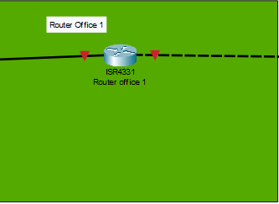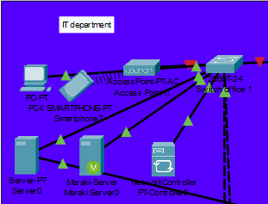 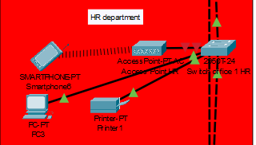 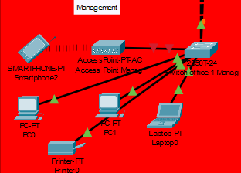 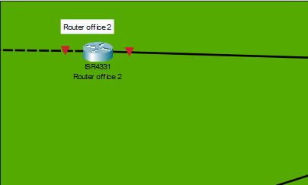 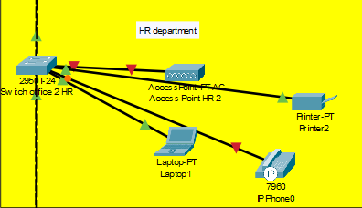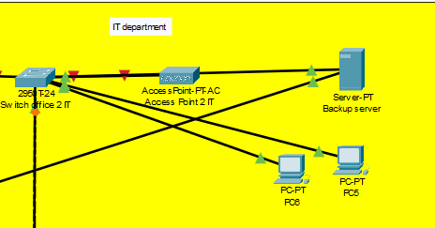

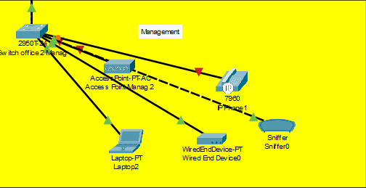 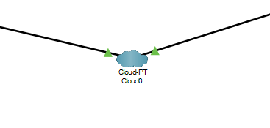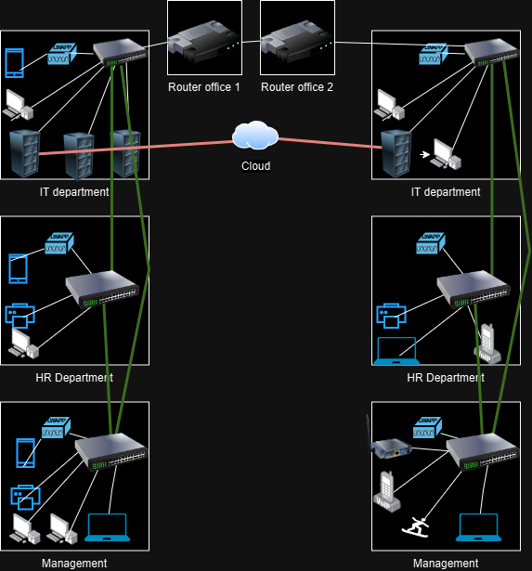

1. Diagram Explanation:

In Project 1 there are 2 offices connected to one another using routers and at the end of the router is the IT department which consist of layer 3 switches connected to different end devices like PC, laptop, printer and IP phones. The connections are tested with one another using continuous pings to test the stability.

1. Configuration Of Devices:

**Router Office 1 configuration:**

Router1> enable

Router1# configure terminal

Router1(config)# hostname Router1

! Assign IP address to the interface connected to Router2

Router1(config)# interface GigabitEthernet0/0/0

Router1(config-if)# ip address 192.168.1.1 255.255.255.252

Router1(config-if)# no shutdown

! Save the configuration

Router1(config-if)# exit

Router1(config)# end

Router1# write memory

On Router1, execute ping 192.168.1.2 to ensure connectivity.

**Router Office 2 configuration:**

Router2> enable

Router2# configure terminal

Router2(config)# hostname Router2

! Assign IP address to the interface connected to Router1

Router2(config)# interface GigabitEthernet0/0/0

Router2(config-if)# ip address 192.168.1.2 255.255.255.252

Router2(config-if)# no shutdown

! Save the configuration

Router2(config-if)# exit

Router2(config)# end

Router2# write memory

On Router2, execute ping 192.168.1.1.

This setup assigns the IP addresses 192.168.1.1/30 and 192.168.1.2/30 to the connected interfaces on the two routers. The /30 subnet mask allows for exactly two usable IP addresses, making it ideal for point-to-point links.