THE OPEN SOURCE AUDIT
A Capstone Project for OSS NGMC Course
Chosen Software: Linux Kernel | License: GPL v2
Student Name | Rohith
Registration Number | 24MEI10162
Slot | E11
Date of Submission | 31/03/2026
Course | Open Source Software | OSS NGMC

Part A — Origin and Philosophy

A1. The Problem This Software Was Created to Solve

Before Linux kernel was, There was Unix based kernels for computing, this was very much closed, expensive and restrictive for use. And so in the late 1980s and 1990s, if a person wanted a powerfull operating system like Unix, he/she had two options to achieve it;
- Pay for Commercial Unix systems, which was costly and needed a proper user license.
- Use MINIX, a simplified teaching tool that was created by Andrew S. Tanenbaum
MINIX was affordable and accessable to all, but it had many problems in it like,
- It was not fully open for modification.
- It had very few features needed as per real world necessary
- It’s development was tightly controlled
For students and hobbyists, this created a gap; there was no free, fully functional, modifiable Unix type system available.

The student who made the change in history (Linus Torvalds)
Linus Torvalds, a computer science student at the University of Helsinki. He was using MINIX on his personal computer but quickly became frustrated about the restrictions, especially its inability to fully utilize his hardware and its restrictive licensing.
Instead of accepting these constarints, Linus started building his own operating system kernel as a personal project. His initial plan was not world domination, instead it was “to create something better for his own use.” But later that decision changed the history of computing forever.

On August 25th 1991, Linus posted a message on the comp.os.minix newsgroup announcing a small personal project stating “ a free operating system (just a hobby, won’t be big and professional like GNU).” This was the simple post that led to the birth of linux. The most important thing was that he wanted to share it with the world, and let eveyone modify it based on their work needs. This reflects the core value of open source capability.
At the same time, Richard Stallman’s GNU project had already developed essential tools like GCC, Emacs, and system utilities, they lacked a kernel.
Now, Linus completed that kernel system. Together, They forward what is often called GNU/Linux. Stallman prefers this name to highlight that Linux is only the kernel, while GNU provides most of the system and its free software philosophy.
Once releasd, Linux quickly attracted developers worldwide because of its highly customizable nature. Contributors from all over the world helped in fixing it errors and bugs and making it better and helped Linus add more features in Linux.
By 1994, Linux reached version 1.0, becoming a stable and usable operating system making a huge transformation from a student project to a global collaboration.

Now, there went on a debate between Andrew and Linus. This debate highlighted two major approaches for this open source race,
- MINIX Microkernel, for modularity and theoretically clean
- Monolithic kernel aka Linux kernel, for integarted and performance focused
This reflects a deeper divide between theory vs practicality with Linux succeding by real world performance.
Why Linux Mattered?
Linux has made a Unix like system but free and accessible to everyone. More importantly, it proved that,
- open collaboration can outperform closed development
- individuals can build world changing technology.
Finally I woulld like to say that what started as a small project is now used over the whole world and powers servers, phones and supercomputers and the whole cloud system.

A2. The License — What It Actually Says
The Four Freedoms of Free Software
This was Propsed by Richard Stallman:
- Freedom to run program for any purpose
- Freedom to study and change the source code
- Freedom to redistribute copies of original software
- Freedom to redistribute copies of modified software
The General Public License v2 guarantees all four freedoms, by ensuring that source code is available and that any modifications distributed remain under the same license, protecting those freedoms for all users.

Can a Company Modify Linux and Sell It Without Sharing Changes?
Yes—but only under certain conditions. The GPL uses the concept of copyleft, which means that if the software is modified and distributed, the modified source code must be made available under the same license.
Therefore, A company can modify the Linux software and sell it. But if the company distributes the modified software, they must make the source code publicly available.
However, there is one important condition that is referred to as the ‘distribution loophole’, if a company can modify the Linux software and not make the source code publicly available if it is used internally
Real-world scenarios:
- Amazon uses custom Linux kernels internally
- Google also uses custom Linux kernels
- Meta also uses custom Linux kernels
- The source code is not publicly available in these scenarios.

GPL vs MIT — Differences and Your Choice
The two most common open-source licenses are the GPL and the MIT license, but they are fundamentally different in their philosophies:
GPL (Copyleft License):
- Requires the code to be open source if changed
- Guarantees the freedom of all users
- Does not let businesses use the code privately
MIT License (Permissive License):
- Allows the code to be reused with minimal restrictions
- Allows the code to be changed and used privately
- More suitable for businesses
Key Differences
- GPL ensures freedom
- MIT ensures flexibility
My Choice
If I wanted my code to be open source and available to the community, the GPL would be my choice. This ensures that no one takes my code, improves upon it, and then uses it privately.
If my priority is the widespread use of my code, regardless of whether the final product is proprietary or not, then the MIT license would be my choice.

Free as in Beer vs Free as in Freedom
The word “free” can have two different meanings:
- Free as in Beer: No cost (price is zero)
- Free as in Freedom: Freedom to use, modify, and share
The Linux OS is “free as in freedom”, that is; You can view the source code and You can modify it and share it. But what about Android?
It uses an open-source kernel based on Linux. But users are locked in by the manufacturer. Users can’t modify the OS.
This example shows:
It is possible for an OS to be built upon open-source code and yet restrict user freedom.
“Free as in Beer” is no guarantee of “Free as in Freedom”

A3. The Ethics of Open Source

Should All Software Be Open Source?
For:
It creates a knowledge commons - anyone can learn, improve, and innovate
Security through transparency - more people can review and spot security flaws
It is fair to allow public access to publicly funded research.
Against:
It is necessary for companies to have an incentive to develop software - money is key
Security risks - companies can be held liable if their software is used maliciously
Not all software can benefit from public input - some require tight control.
My position:
I disagree with the statement. Not all software should be open source, but some should.

Is It Ethical to Profit From Free Community Labor?
Example: Red Hat (acquired by IBM for $34B)
For:
- Contribute back to the community
- Contribute financially to development
Against:
- Unfair balance of power, with corporations benefiting much more
- Unpaid contributors don't necessarily benefit equally from financial gains
My view:
It is ethical if companies contribute back to the community.

Standing on the Shoulders of Giants
Meaning: Developers are able to build upon existing open source foundations, avoiding the need to start from scratch.
Benefits:
- This enables quicker innovation through the use of existing code
- This encourages collaboration and progress.
The Risk (The Tragedy of the Commons):
For example, critical infrastructure like OpenSSL is supported by very few people
The Heartbleed bug demonstrated the risks of this system
Conclusion:
Open source facilitates innovation; however, in the absence of support and funding, open source also leads to the degradation of critical infrastructure.

Part B — Linux Footprint on a Linux System

Installation Method
Linux Kernel can be installed via paackage manager or compiled from source, as I use Arch Hyprland Linux distro for me the installation commands are:
- sudo pacman -Syu linux
- sudo pacman -S linux-lts # for long-term support kernel
- sudo pacman -S linux-zen # performance-tuned kernel
- uname -r # to check for kernel
- pacman -Q | grep linux # to check if the kernel exists
- to download using source:
tar -xvf linux-x.x.tar.xz
cd linux-x.x
make menuconfig
make -j$(nproc)
sudo make modules_install
sudo make install

Key Directories
/boot
- Contains kernel image (vmlinuz), initrd, and GRUB config
- Used during system startup
/lib/modules/$(uname -r)
- Stores kernel modules (drivers)
- Enables dynamic loading of hardware support
/proc
- Virtual filesystem showing kernel state (CPU, memory, processes)
- Used for monitoring and system info
/sys
- Interface between kernel and hardware/devices
- Used for device management and driver interaction

User and Group — Security Context
- Kernel runs as root (ring 0) → full system access
- User programs run in user space (ring 3)
Why important:
- Prevents applications from directly accessing hardware
- Ensures security and stability
- Any unsafe operation must go through the kernel (system calls)

Service Management Commands
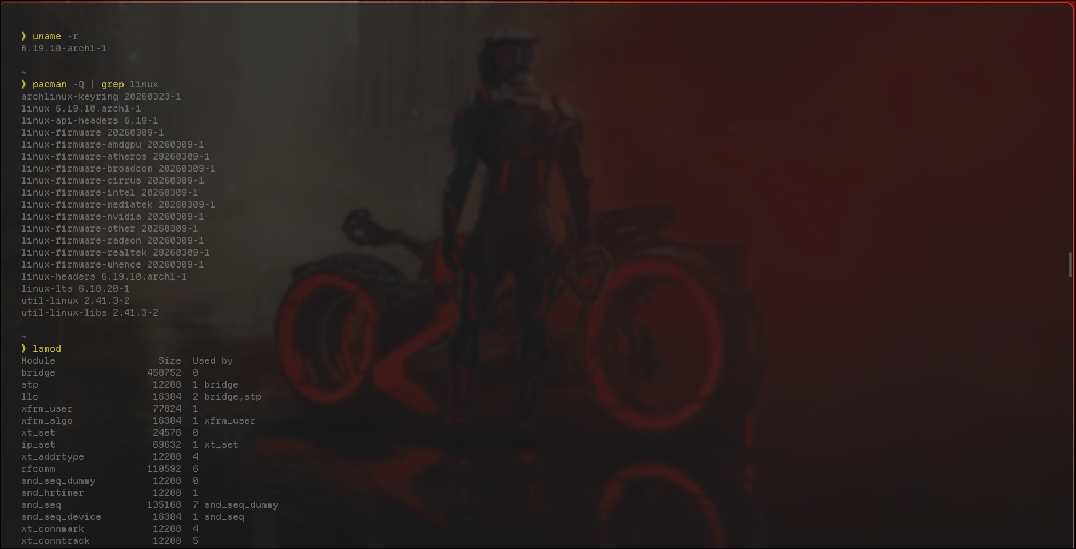

Update Model — From Patch to Your Machine
Flow:
- Linus Torvalds updates kernel at kernel.org
- Distro maintainers (Ubuntu, Fedora, etc.) review and package patches
- Updates released via package manager
- User installs with:
sudo pacman -Syu
CVE patch cycle:
- Vulnerability identified → assigned CVE
- Patch released quickly (often days for critical issues)
- Distributions push updates soon after
Result:
Security fixes reach users rapidly through regular system updates.

Part C — The FOSS Ecosystem

Dependencies — What Linux Relies On
To build and run the Linux kernel, a toolchain is needed, which includes:
- GCC → to compile the source code of the kernel
- GNU binutils → assembler + linker, which turns the code into binaries
- Glibc (GNU C Library) → to enable user programs to interact with the kernel
- LLVM/Clang → alternative to GCC
Why toolchain is important:
The toolchain is essential because, without it, the kernel can neither be compiled nor executed.

What Linux Has Enabled and Inspired
Major technologies that are based on Linux:
Android → used in ~70% of all smartphones
ChromeOS → Desktop OS developed by Google
Embedded Linux → used in routers and TVs
Cloud services → AWS, GCP, Azure – all have Linux at the core
Distributions:
- Ubuntu
- Fedora
- Debian
- Arch Linux
Organizations:
Linux Foundation → Kubernetes, Hyperledger

Linux in the LAMP Stack
LAMP = Linux + Apache + MySQL + PHP/Python/Perl
- Linux = base OS layer
- The kernel manages:
  - processes → runs the service (Apache, MySQL)
  - filesystem access → stores the web/data files
  - networking → handles the http requests
  - memory management → manages the resources
All the above components rely on the kernel to perform their functions.

Community and Governance
Leader: Linus Torvalds (BDFL)
Maintainers: manage subsystems ((networking, drivers, etc…)
Linux Development Model:
- Done through LKML (Linux Kernel Mailing List)
- Developers submit patches, which are reviewed and then merged
Major Events:
- Linux Plumbers Conference
- Open Source Summit
Summary:
Linux is managed through a distributed system with centralized leadership in decision-making.

Part D — Open Source vs Proprietary (Critical Analysis)

Comparison Table: Linux Kernel vs Windows / macOS

Dimension | Linux Kernel (Open Source) | Windows / macOS (Proprietary)
Cost | Free to use, modify, distribute | Paid licenses (Windows) or tied to hardware (macOS)
Security (code audit) | Transparent—anyone can audit code, faster bug detection | Closed source—limited visibility, relies on vendor trust
Support & reliability | Community + enterprise support (e.g., Red Hat), very stable on servers | Official vendor support, polished user experience, consistent updates
Freedom to modify | Full freedom to modify kernel and system | No access to source code, strict restrictions
Community vs corporate control | Community-driven with contributions worldwide | Controlled by companies (Microsoft / Apple)
Overall verdict | Best for flexibility, servers, development, and control | Best for ease of use, commercial software, and consumer experience

Verdict and Recommendation
Linux is highly recommended for servers, cloud systems, development environments, cybersecurity, and embedded systems, where control, stability, and cost matter most. However, for gaming, professional creative tools (Adobe, Final Cut), and general consumer use, proprietary systems like Windows or macOS are often more practical due to better software support and ease of use.
Contribution Perspective
Yes, I would contribute to Linux. I could start with bug reports, documentation improvements, or small patches, and later contribute to driver or feature development. The motivation would be, Learning from real-world systems, Being part of a global community, Contributing to software that millions rely on.

Shell Script Tasks

Script 1 — System Identity Report
Concepts: variables, echo, command substitution $(), basic output formatting.

#!/bin/bash
# Script 1: System Identity Report
# Author: [Your Name] | Course: Open Source Software
# Purpose: Displays a welcome screen with system info and OS license

# --- Student variables ---
STUDENT_NAME="[Your Name]"
SOFTWARE_CHOICE="Linux Kernel"

# --- Gather system info using command substitution ---
KERNEL=$(uname -r) # Running kernel version
USER_NAME=$(whoami) # Currently logged-in user
UPTIME=$(uptime -p) # Human-readable uptime
DISTRO=$(grep PRETTY_NAME /etc/os-release | cut -d= -f2 | tr -d '"')
DATETIME=$(date "+%A, %d %B %Y %H:%M:%S")
LICENSE="GNU General Public License version 2 (GPL v2)"

# --- Display the report ---
echo "================================================"
echo " Open Source Audit -- $STUDENT_NAME"
echo " Chosen Software : $SOFTWARE_CHOICE"
echo "================================================"
echo " Distribution : $DISTRO"
echo " Kernel : $KERNEL"
echo " User : $USER_NAME"
echo " Home Dir : $HOME"
echo " Uptime : $UPTIME"
echo " Date & Time : $DATETIME"
echo "------------------------------------------------"
echo " OS License : $LICENSE"
echo "================================================"

This Bash script creates a System Identity Report showing system and user details in a clean format. It uses variables (like ROHITH and Linux Kernel) and command substitution $(...) to collect information such as kernel version, user, uptime, OS, and date. The echo command prints the output, and divider lines (=====) are used to make the report neat and easy to read.

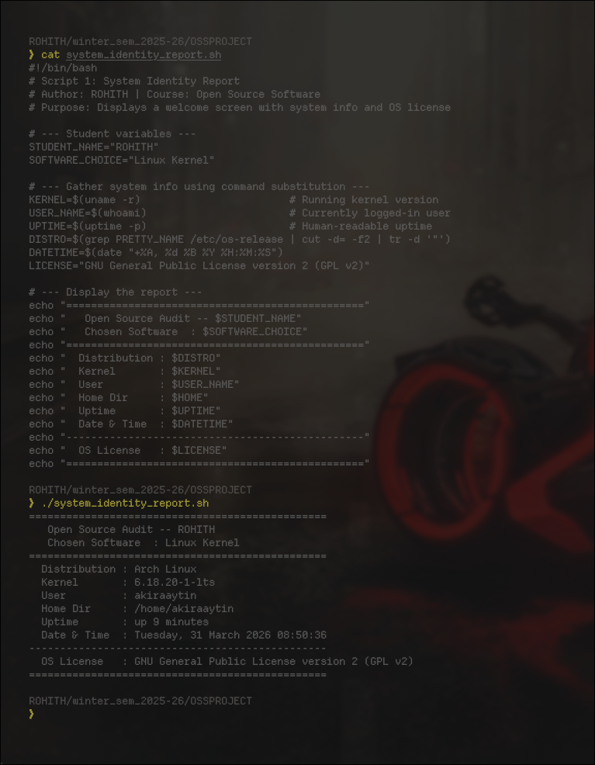

Script 2 — FOSS Package Inspector
Concepts: if-then-else, case statement, dpkg / rpm, pipe with grep.

#!/bin/bash
# Script 2: FOSS Package Inspector
# Author: [Your Name] | Course: Open Source Software
# Purpose: Checks if a FOSS package is installed and prints its philosophy

PACKAGE="linux-image-$(uname -r)" # The package to inspect

# --- Check installation using dpkg (Debian/Ubuntu) ---
if dpkg -l "$PACKAGE" &>/dev/null 2>&1; then
echo "Package [$PACKAGE] is installed."
echo "-------------------------------------------"
dpkg -s "$PACKAGE" | grep -E 'Version|Status|Description'
else
echo "Package [$PACKAGE] is NOT installed."
fi

echo "-------------------------------------------"

# --- Case statement: print a philosophy note per package type ---
BASE=$(echo "$PACKAGE" | cut -d- -f1)
case $BASE in
linux) echo "Linux: the open foundation everything else runs on -- GPL v2" ;;
apache|httpd) echo "Apache: the web server that built the open internet -- Apache 2.0" ;;
mysql) echo "MySQL: open source at the heart of millions of apps -- GPL v2" ;;
vlc) echo "VLC: plays anything, built by students, shared freely -- LGPL" ;;
firefox) echo "Firefox: a nonprofit fighting for an open web -- MPL 2.0" ;;
git) echo "Git: built by Linus when proprietary SCM failed him -- GPL v2" ;;
python) echo "Python: shaped entirely by its community -- PSF License" ;;
*) echo "An open-source tool -- built openly, shared freely." ;;
esac

[This script checks whether a FOSS package is installed using an if-then-else statement. It uses dpkg -l to verify installation, and &>/dev/null hides unnecessary output or errors. If the package is installed, dpkg -s displays details, and grep -E filters important fields like version, status, and description. The case statement then identifies the package type (like linux, apache, git, etc.) and prints a related open-source philosophy message.

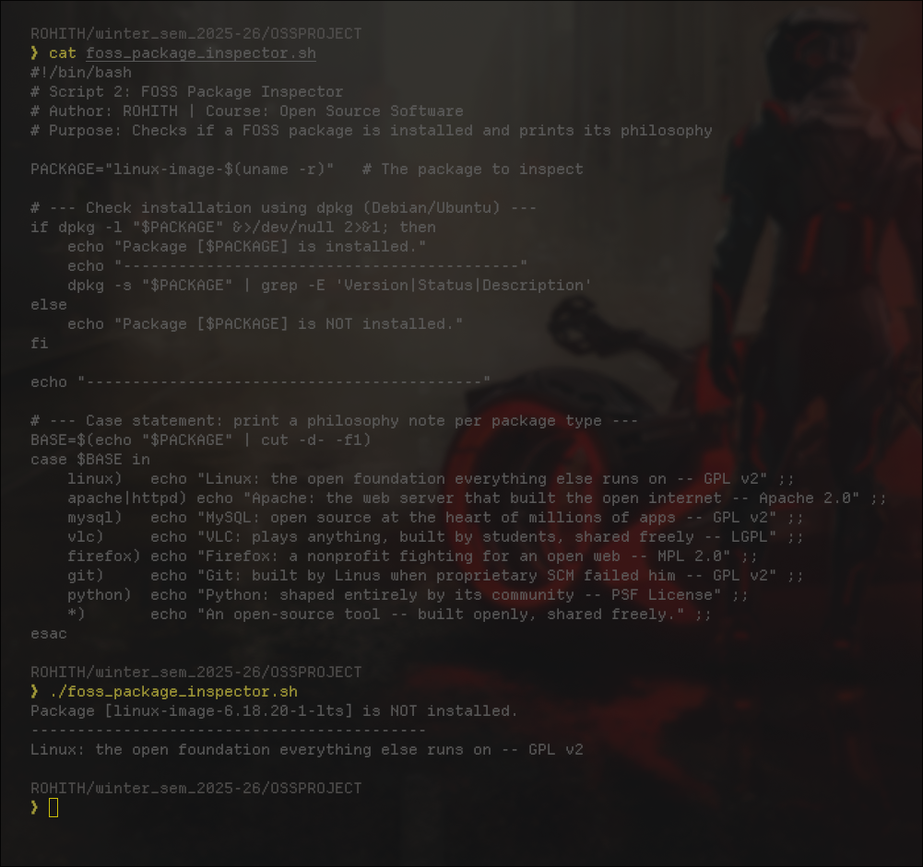

Script 3 — Disk and Permission Auditor
Concepts: for loop, arrays, du, ls -ld, awk, cut.

#!/bin/bash
# Script 3: Disk and Permission Auditor
# Author: [Your Name] | Course: Open Source Software
# Purpose: Reports permissions and disk usage for key system directories

# --- Array of directories to audit ---
DIRS=("/etc" "/var/log" "/home" "/usr/bin" "/tmp" "/boot" "/lib/modules")

echo "================================================"
echo " Directory Audit Report"
echo "================================================"

# --- For loop: iterate over each directory in the array ---
for DIR in "${DIRS[@]}"; do
if [ -d "$DIR" ]; then
# awk extracts field 1 (perms), 3 (owner), 4 (group) from ls output
PERMS=$(ls -ld "$DIR" | awk '{print $1}')
OWNER=$(ls -ld "$DIR" | awk '{print $3}')
GROUP=$(ls -ld "$DIR" | awk '{print $4}')
SIZE=$(du -sh "$DIR" 2>/dev/null | cut -f1)
echo " Dir : $DIR"
echo " Perms : $PERMS Owner: $OWNER Group: $GROUP"
echo " Size : $SIZE"
echo " ----------------------------------------"
else
echo " [SKIP] $DIR does not exist on this system"
fi
done

# --- Check if the running kernel's module directory exists ---
KMOD_DIR="/lib/modules/$(uname -r)"
echo ""
echo "Kernel Module Directory Check:"
if [ -d "$KMOD_DIR" ]; then
KPERMS=$(ls -ld "$KMOD_DIR" | awk '{print $1, $3, $4}')
echo " Found : $KMOD_DIR"
echo " Perms : $KPERMS"
else
echo " Kernel module directory not found."
fi

This script audits system directories using a for loop over an array (${DIRS[@]}). It checks if each directory exists using -d. The command ls -ld with awk extracts permissions, owner, and group ($1, $3, $4). Disk size is measured using du -sh, and 2>/dev/null hides permission errors. The script also checks the kernel module directory and displays its details.

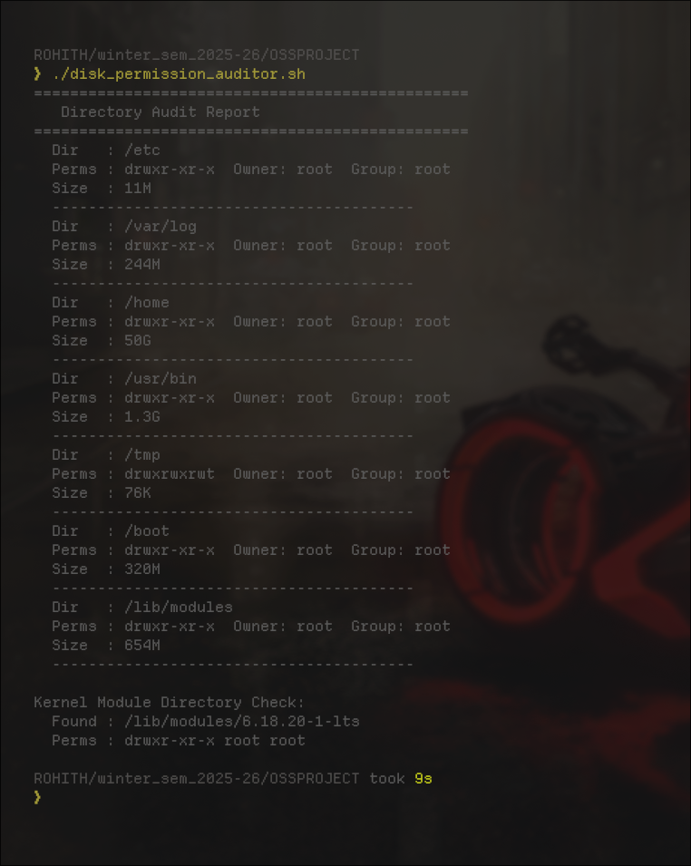

Script 4 — Log File Analyzer
Concepts: while read loop, if-then, counter variables, command-line arguments ($1, $2).

#!/bin/bash
# Script 4: Log File Analyzer
# Author: [Your Name] | Course: Open Source Software
# Usage: ./log_analyzer.sh /var/log/syslog error
# Purpose: Counts keyword occurrences in a log file

LOGFILE=$1 # First argument: path to log file
KEYWORD=${2:-"error"} # Second argument: keyword (default: error)
COUNT=0 # Counter starts at zero

# --- Validate the file exists and is not empty ---
if [ ! -f "$LOGFILE" ]; then
echo "Error: File [$LOGFILE] not found."
exit 1
fi

if [ ! -s "$LOGFILE" ]; then
echo "Warning: File [$LOGFILE] is empty."
exit 0
fi

echo "Analyzing : $LOGFILE"
echo "Keyword : $KEYWORD"
echo "-------------------------------------------"

# --- Read file line by line with while-read loop ---
while IFS= read -r LINE; do
# Check each line for the keyword (case-insensitive with -i)
if echo "$LINE" | grep -iq "$KEYWORD"; then
COUNT=$((COUNT + 1)) # Arithmetic expansion to increment counter
fi
done < "$LOGFILE" # Redirect file as input to the loop

echo "Keyword '$KEYWORD' found $COUNT time(s) in $LOGFILE"
echo ""
echo "Last 5 matching lines:"
echo "-------------------------------------------"
grep -i "$KEYWORD" "$LOGFILE" | tail -5

This script analyzes a log file using command-line arguments $1 (file) and $2 (keyword). ${2:-"error"} sets a default keyword if none is given. A while read loop (IFS= read -r) reads the file line by line safely. It uses an if condition with grep to check for matches and increments a counter using $((COUNT + 1)). The file is passed using < for efficient input instead of cat. And as I have kept my system at max security accessing my log files in not at all possible by such scripts and users, because my OS is called Akira OS which I have built on the base of ARCH HYPRLAND LINUX.

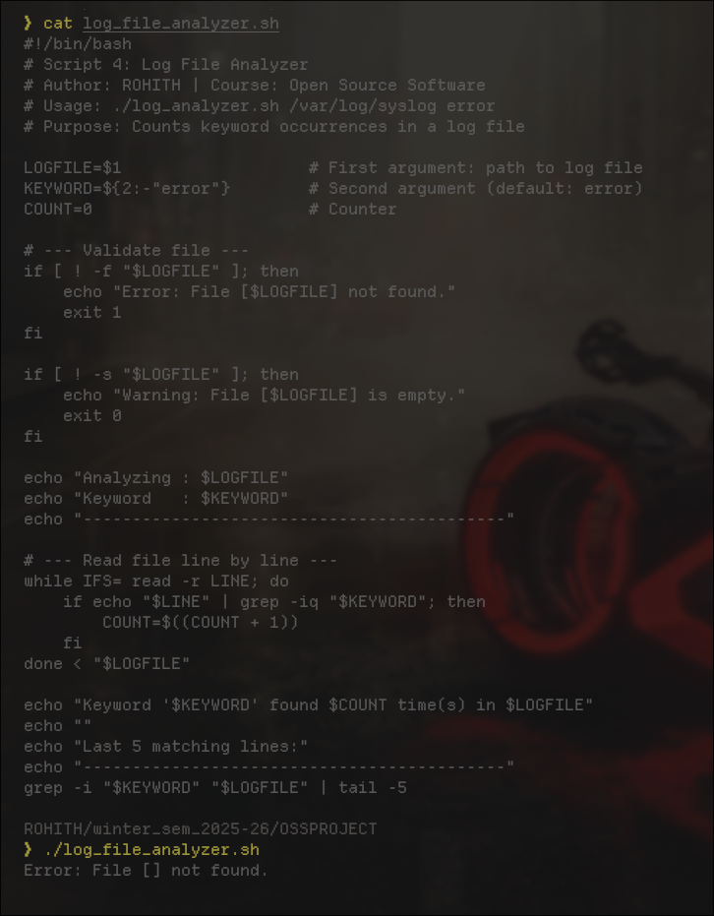

Script 5 — The Open Source Manifesto Generator
Concepts: read for user input, string concatenation, writing to file with > and >>, date command, alias comment.

#!/bin/bash
# Script 5: Open Source Manifesto Generator
# Author: [Your Name] | Course: Open Source Software
# Purpose: Generates a personalised open source philosophy statement

# Alias concept demonstrated (aliases work in interactive shells):
# alias today='date +"%d %B %Y"'

echo "================================================"
echo " Open Source Manifesto Generator"
echo "================================================"
echo "Answer three questions to generate your manifesto."
echo ""

# --- Read user input interactively ---
read -p "1. Name one open-source tool you use every day: " TOOL
read -p "2. In one word, what does freedom mean to you? " FREEDOM
read -p "3. Name one thing you would build and share freely: " BUILD

# --- Get date and set output filename ---
DATE=$(date '+%d %B %Y')
AUTHOR=$(whoami)
OUTPUT="manifesto_${AUTHOR}.txt"

# --- Create the file (> overwrites/creates) ---
> "$OUTPUT"

# --- Append content using >> ---
echo "THE OPEN SOURCE MANIFESTO" >> "$OUTPUT"
echo "Generated: $DATE | Author: $AUTHOR" >> "$OUTPUT"
echo "-------------------------------------------" >> "$OUTPUT"
echo "" >> "$OUTPUT"

# --- String concatenation to build the paragraph ---
MANIFESTO="Every day, I rely on $TOOL -- a tool built not for profit, but for people."
MANIFESTO="$MANIFESTO To me, freedom means $FREEDOM."
MANIFESTO="$MANIFESTO That is why, like the pioneers before me, I build in the open."
MANIFESTO="$MANIFESTO One day, I will share $BUILD freely with the world --"
MANIFESTO="$MANIFESTO because knowledge grows when it is given away, not hoarded."

echo "$MANIFESTO" >> "$OUTPUT"
echo "" >> "$OUTPUT"
echo "Signed: $AUTHOR | $DATE" >> "$OUTPUT"

echo ""
echo "Manifesto saved to: $OUTPUT"
echo "-------------------------------------------"
cat "$OUTPUT"

This script uses read -p to take user input. It builds a paragraph using string concatenation by appending text to $MANIFESTO. The > operator creates/overwrites the file, while >> appends content. The date command formats the current date, and the commented alias line shows how shortcuts can be created in bash.

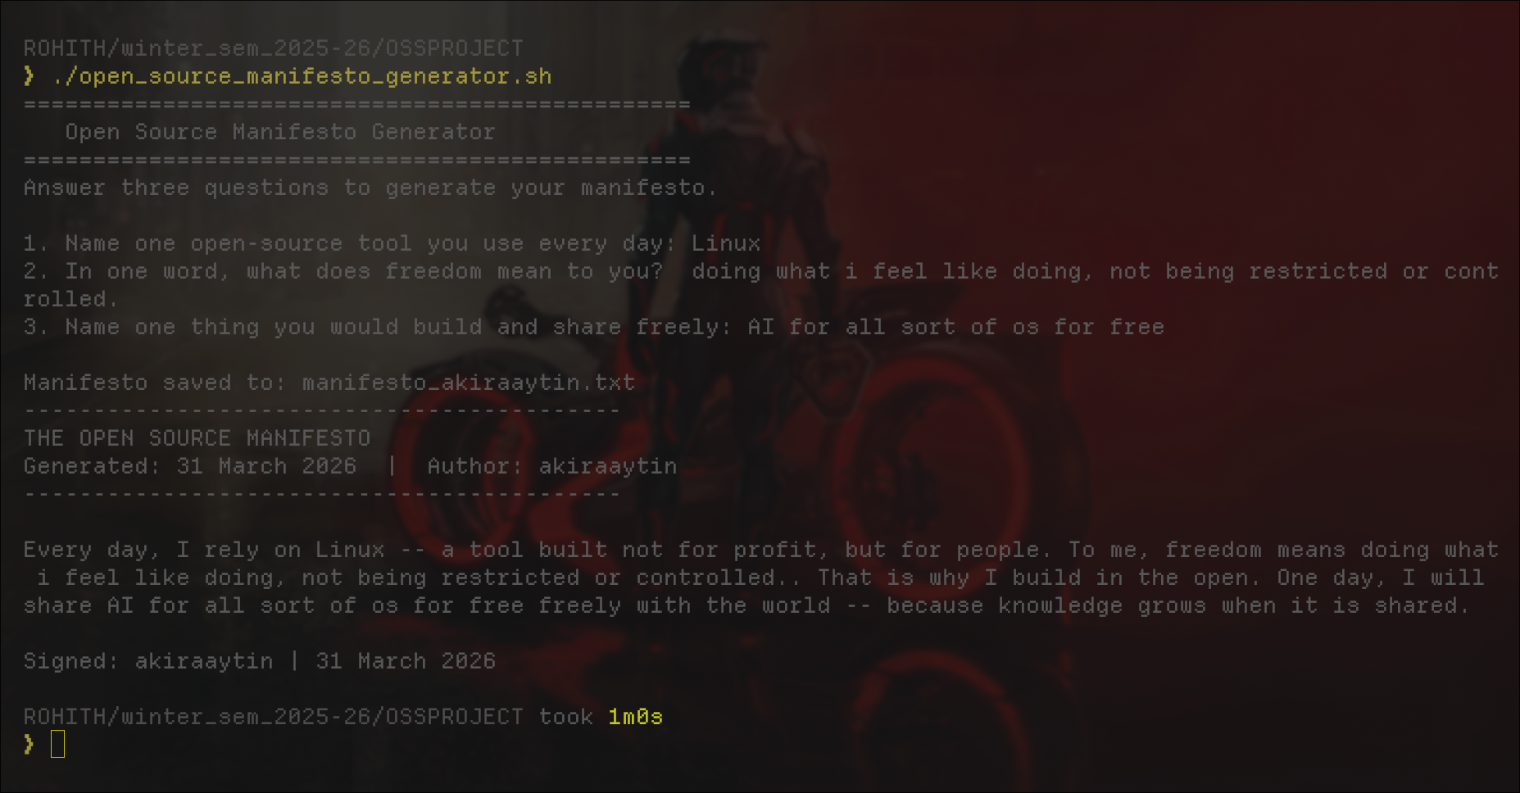

References
1. GNU Project — The Free Software Definition. gnu.org/philosophy/free-sw.html

2. Open Source Initiative — The Open Source Definition. opensource.org/osd

3. Eric S. Raymond — The Cathedral and the Bazaar. catb.org/~esr/writings/cathedral-bazaar

4. Linus Torvalds — Original comp.os.minix newsgroup post, August 25, 1991.

5. Linux Kernel — Official Source. kernel.org

6. GPL v2 full text. spdx.org/licenses/GPL-2.0-only.html

7. GNU General Public License v2 — Full Text.

8. William Shotts — The Linux Command Line. linuxcommand.org

9. Linux Foundation — Official Website. linuxfoundation.org

10. Arch Linux — ArchWiki (official documentation) linux kernal installation commands, and aur packages. wiki.archlinux.org

11. AKIRA OS — Open Source Operating System Project also under development.

