Week 7: Writing Your Own (Vector) Functions

Writing Functions in R
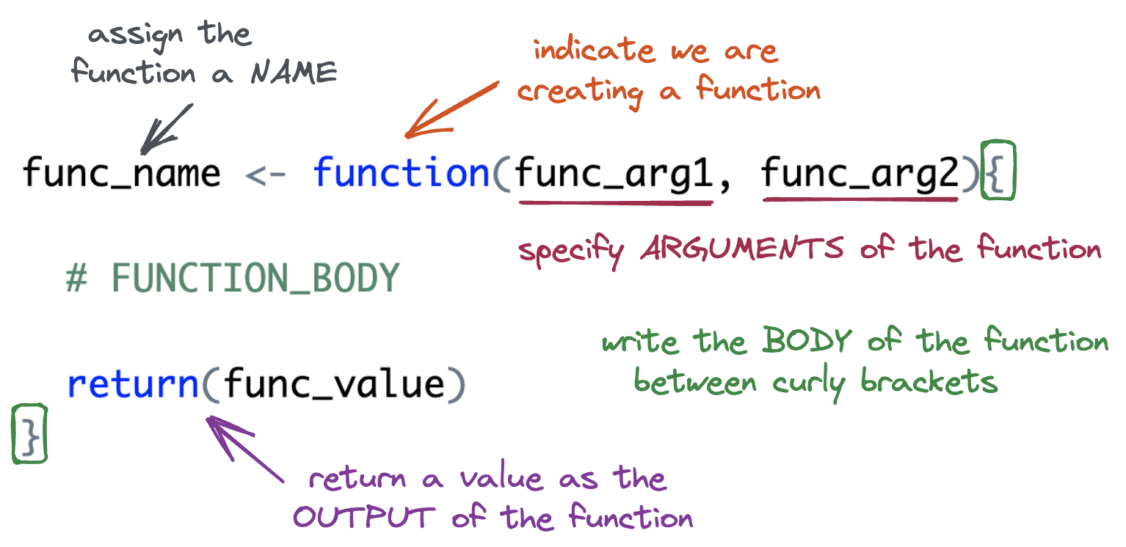
- Write a function named add_two() that will add 2 to whatever number is input.
- In your function what is the:
- Function Name:
- Function Argument(s):
- Function Body:
- Function Return:
- What if we wanted to write a more general function, named add_something(). The function would take two inputs:
- x the vector to add to
- something the value to add to x
How would your function change?
- Are your arguments optional or required?
- What is the difference?
- What are the two ways you can return a value in a function?
- Which method for returning a value makes more sense to you?

Function Practice
- Fill in the code below to create a function named above_average(). The function should keep only the elements of x greater than the mean.
above_average <- function(x) {
}
- Write down the steps you would need to create a function named every_third() that takes in a vector and returns every third element from that vector (i.e., indices 1, 4, 7, 10, etc.).
Think about:
- What inputs the function should take.
- How to identify which positions in the vector are “every third.”
- How to select those elements from the vector.

