In Module 3, we will illustrate a clustered dataset and review non-multilevel-modelling options for handling that clustering.

The data for Module 3 were taken from chapter 3 of Heck, R. H., Thomas, S. L., & Tabata, L. N. (2011). *Multilevel and Longitudinal Modeling with IBM SPSS*: Taylor & Francis. These are the variables in the dataset:

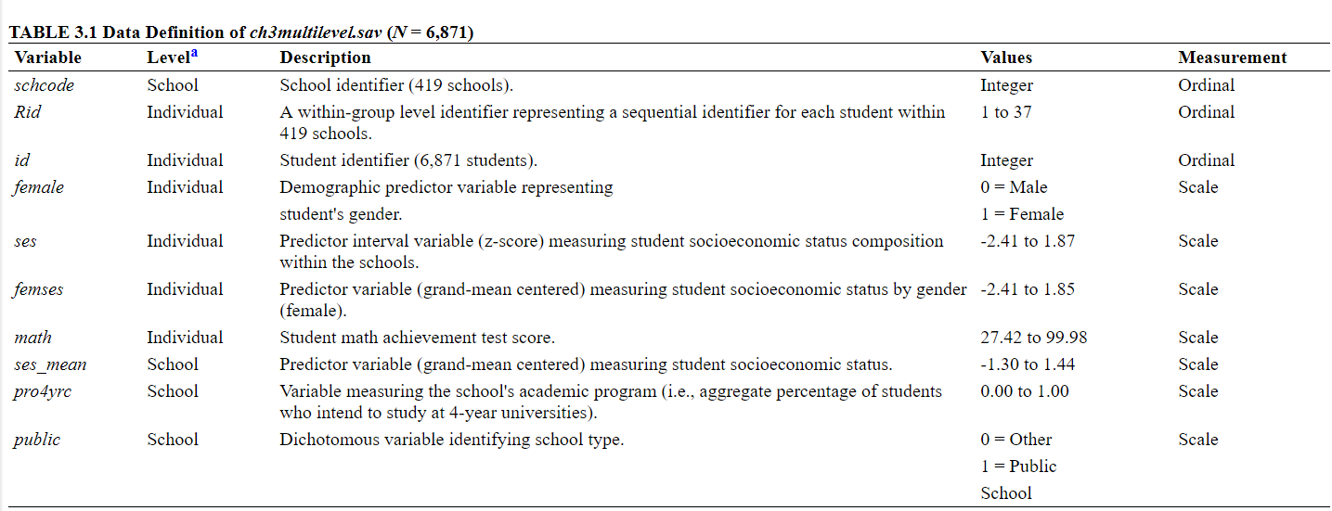

1. Load the data stored in the heck2011.csv file and the packages we’ll be using for this data demo: dplyr, lmtest, and sandwich.
2. In Module 2, we conducted a linear regression predicting math achievement from socioeconomic status and sex. Run the same model.
3. The model in question 5 only asks a question at one level: the students. Perhaps we don’t need to use a multilevel model. Estimate cluster-robust standard errors.
4. Run a model using the cluster-robust standard errors. Compare the coefficients and their significance between the regular and cluster-robust models.