In Module 5, we will introduce fixed predictors at both level-1 and level-2.



The data for Module 5 were taken from chapter 3 of Heck, R. H., Thomas, S. L., & Tabata, L. N. (2011). *Multilevel and Longitudinal Modeling with IBM SPSS*: Taylor & Francis. These are the variables in the dataset:

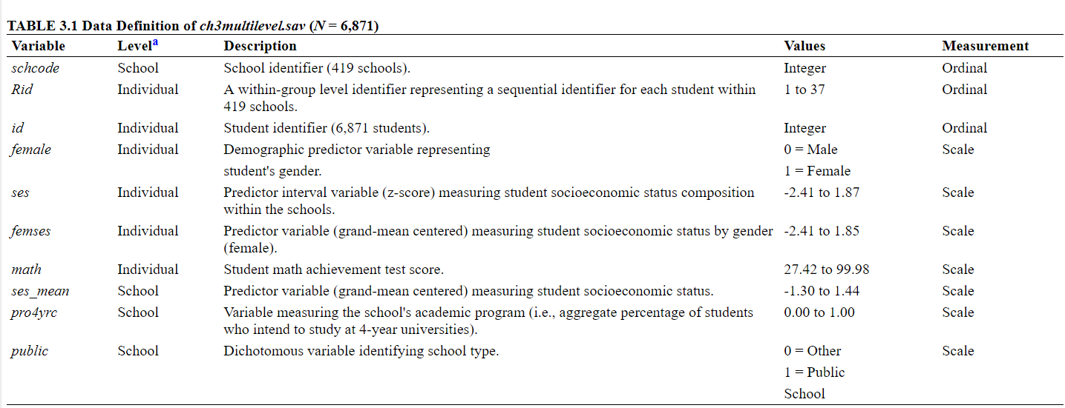

1. Load in the data and the libraries we will use for this module: lme4, ggplot2, and lmtest.
2. As a recap of Module 4, run the null model with math achievement as the DV.
3. Build a multilevel model that includes SES as a predictor at level 1 (within school predictor, predictor at the individual level)
   1. Write out the equation for the model L1 and L2 and combined
4. List each parameter that is estimated and interpret the estimate in the output
5. Run a simple regression with math as the DV and SES as the IV (as we did in Module 3). Compare the standard errors and regression coefficients from the MLM to this regular regression.
6. Calculate the conditional ICC and interpret it
7. Calculate how much the level-1 (within school) error variance was reduced by adding this predictor.
8. What is the difference between **τ02** and **σ2** going from the intercept only model to the model with SES as a predictor at level 1?
9. How much was the variance at level 1 and level 2 reduced when adding SES as a predictor?
   1. Proportion variance reduction at level 1
   2. Proportion variance reduction at level 2
10. What is the conditional ICC and how do you interpret it?
11. What is unexplained variance in the intercepts? Calculate the 95% plausible values range for the residual intercept variance, does it seem substantial?
12. Let’s now consider a level-2 variable, school type, calculate mean math achievement for private (=0 in the data) vs. public (=1 in the data) and conduct a t-test, which school type has higher math achievement? What is the difference in means?
13. Is the t-test significant? How do you expect these results to be biased, given we ignored the clustering?
14. Let’s run a multilevel model with school type as a predictor of intercepts; write out a new model with the outcome as math achievement. A random intercept for mean math achievement across schools, and school type as a level-2 predictor of those random intercepts
15. How many fixed and random effects will we estimate?
16. What does the random effect of the intercept represent in this case? What if we didn’t estimate it, what would that mean?
17. List the estimates and interpret them
18. How much is the variance reduced at level 1 and level 2, by adding the school type predictor?
19. Overall, do you think school type is related to math achievement?
20. Now let’s combine what we have done so far by running a model with SES as a level 1-predictor and school type as a level-two predictor of the intercept. We will estimate the random effect for the intercept, but not the slope.
21. How many fixed and random effects will we be estimated?
22. List the estimates for each parameter and interpret each one.