In Module 6, we will review crosslevel interactions and random effects.

The data for Module 6 were taken from chapter 3 of Heck, R. H., Thomas, S. L., & Tabata, L. N. (2011). *Multilevel and Longitudinal Modeling with IBM SPSS*: Taylor & Francis. These are the variables in the dataset:

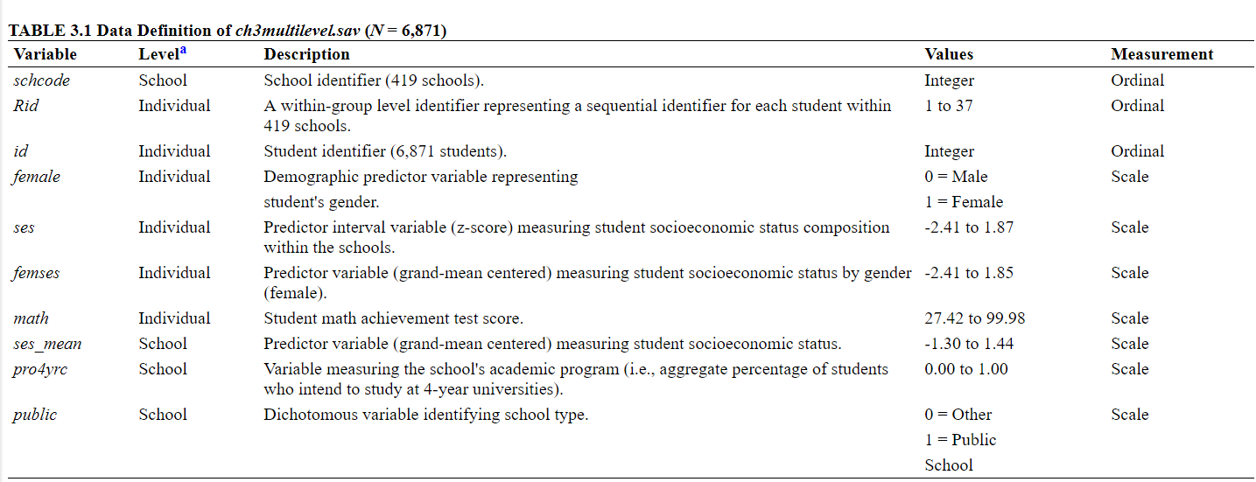

1. Load in the data and the libraries we will use for this module: dplyr, ggplot2, lme4 and lmerTest.
2. Recall the scatterplot we created in an earlier module:

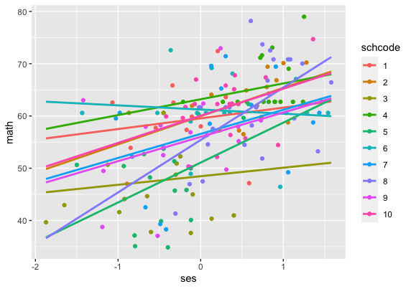

1. We know that, across schools, mean math achievement adjusted for SES (the expected values of math achievement at mean SES, i.e., the intercepts) varies quite a bit. This is shown from the variance components and also in the scatterplot. But what about the slopes? Right now our model assumes that the relationship between SES and math achievement is the SAME across schools, does that seem to be the case based on this graph?
2. Let’s run a model with SES as a predictor at level 1 with random intercepts and random slopes. We will exclude school type this time.
3. How many fixed and random effects will we estimate based on this equation?
   1. Note that we will now have a tiny matrix of between school random effects, sometimes referred to as a τ (tau) matrix
4. Interpret τ01, what would it mean if it were positive? If it were negative?
5. Interpret all estimates from the model.
6. Calculate the EB estimates of the intercepts and slopes
7. Create a scatterplot of the intercepts and slopes, how are they related?
8. Go back to the output and calculate the correlation, from the covariance



1. What is the correlation in the output for the Taus, where is it located in the R output?
2. Write out the equation for a model with SES as a predictor at level 1 with random intercepts and random slopes.
   1. L1, L2, and combined
3. Key output to note/interpret is
   1. Number of parameters
   2. Estimates of fixed effects
   3. Estimates of covariance parameters
      1. Residual
      2. Intercept
4. Run the model and interpret all coefficients. (Note that there is a warning about the not positive matrix at the top: boundary (singular) fit: see ?isSingular – we’ll address this in Module 7.)
5. Write out the equation for a model with SES as a predictor at level 1 with random intercepts and random slopes, and public as a predictor of both the intercept and slope for SES.
   1. L1, L2, and combined
6. Run the model and interpret all output, including the slope covariance/correlation term.