In Module 7 we will review common estimation options, problems that can arise, and how to troubleshoot those problems.

The data for Module 7 were taken from chapter 3 of Heck, R. H., Thomas, S. L., & Tabata, L. N. (2011). *Multilevel and Longitudinal Modeling with IBM SPSS*: Taylor & Francis. These are the variables in the dataset:

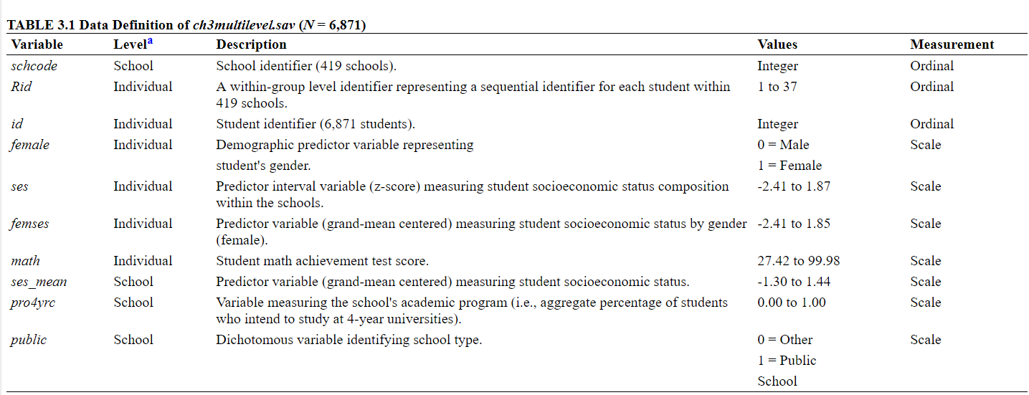

1. Load in the data and the libraries we will use for this module: dplyr, ggplot2, lme4, and lmerTest.
2. Re-run the model from module 6 with math achievement predicted by SES, with both a random intercept and random slope.
3. Note that there is a warning about the not positive matrix at the top: boundary (singular) fit: see ?isSingular.
4. Request profile confidence intervals for tests of the fixed and random effects and interpret them. Are the fixed effects significantly different from zero? For variances, what units are the intervals in? Are the variances significantly different from zero?
5. Rerun the model restricting the covariance to be zero, does this remove the error?
6. Recompute the confidence intervals on the model with the covariance restricted to zero
7. Recompute the confidence interval for a 90% interval, changing the default.
8. Run a model with SES as a level-1 predictor without a random slope, and use a deviance test to compare it to the model with the random slope.
9. Is there a significant difference in fit? Should we keep our random slope in or remove it?