In Module 8 we will review options for and interpretations of centering variables in multilevel models.

The data for Module 8 were taken from chapter 3 of Heck, R. H., Thomas, S. L., & Tabata, L. N. (2011). *Multilevel and Longitudinal Modeling with IBM SPSS*: Taylor & Francis. These are the variables in the dataset:

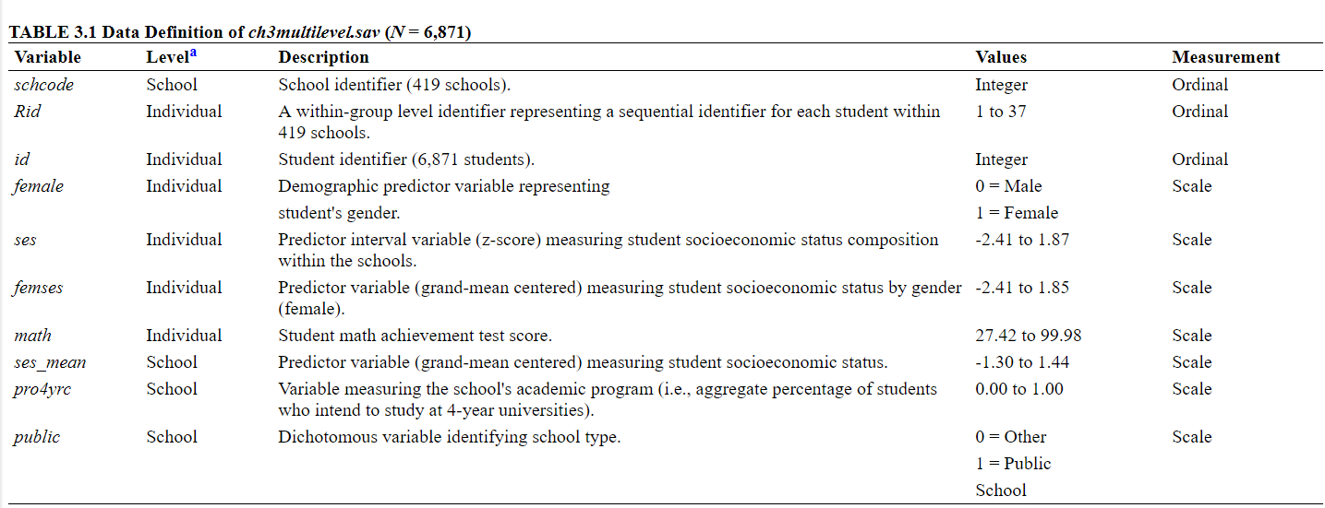

1. Load in the data and the libraries we will use for this module: dplyr, lme4, and lmerTest.
2. First we need to do some data management. Create an ses_mean variable that is the school level SES for each school.
3. Using the mutate function again, create a new variable for SES which is centered within cluster.
4. Write out the null model with math achievement as the DV; what three parameters will you estimate? Run the model.
5. Interpret the parameter estimates from the model.
6. Calculate the ICC and interpret it.
7. Run a random intercepts model with student level SES as a predictor at level-1 (no random slopes). Write out the model; how many parameters will we estimate with this model?
8. How is SES centered in this model? Interpret the parameter estimates
9. Calculate the variance reduced at level-1 and level-2 by adding in SES as an individual level predictor
10. Let’s add the school level aggregate of SES to level 2, to tease apart the within, between, and contextual effect of SES, write out the model (no random slope, just a random intercept).
11. How many parameters will be estimated with this model?
12. Run the model and interpret the parameter estimates, which coefficients correspond to the within, between, and contextual effects of SES?
13. Now let’s try with the centered within cluster version of SES at level 1 and the aggregate at level 2 to compare the results, in this new model what is the within, between, and contextual effect?
14. If time, add a random slope for the effect of ses_cwc. What does this random effect represent?
15. Is there significant variance in the effect of ses_cwc across clusters? Conduct a deviance test and interpret the confidence interval.
16. Compare these results to using the ANOVA option, how are they different?
17. What if we were only interested in using an LRT to test the effect of the covariance, how would we do this?