**DETAILED PROJECT REPORT**

**CROP PRODUCTION IN INDIA ANALYSIS**

**Project Detail:**

|  |  |
| --- | --- |
| Project title | Crop Production in India Analysis |
| Technology | Business Intelligence |
| Domain | Agriculture |
| Project difficulty level | Advanced |
| Programming language | Python |
| Tools used | Jupyter notebook, Excel ,Tableau |

**Problem Statement & objective:**

The Agriculture business domain, as a vital part of the overall supply chain, is expected to highly evolve in the upcoming years via the developments, which are taking place on the side of the Future Internet. This paper presents a novel Business-to-Business collaboration platform from the agri-food sector perspective, which aims to facilitate the collaboration of numerous stakeholders belonging to associated business domains, in an effective and flexible manner.

**Dataset:**

Datasets is available in the given link. You can download as per your convenient. <https://data.world/thatzprem/agriculture-india>

This dataset provides a huge amount of information on crop production in India ranging from several years. Based on the Information the ultimate goal would be to predict crop production and find important insights highlighting key indicators and metrics that influence the crop production.

**Dataset Information:**

* State name- Name of States in India
* District name- Name of Districts in India
* Crop Year- Crop Year from 1997 to 2015
* Season- Seasons(kharif, whole year, Rabi)
* Crop- Name of crop
* Area- area
* Region- Name of Regions in India (north, south, etc.)
* Production- Crop production
* Date- date column
* Category- crop category
* Productivity- calculated productivity
* Total Production- total production (for kpi’s)

**Insights (Story):**

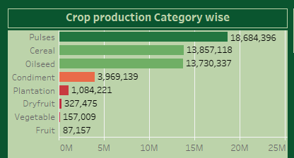

* Pulses, cereal, oilseeds are 3 highest crop production categories.
* Kharif season has more production followed by Rabi and Whole year.
* North India has highest production.

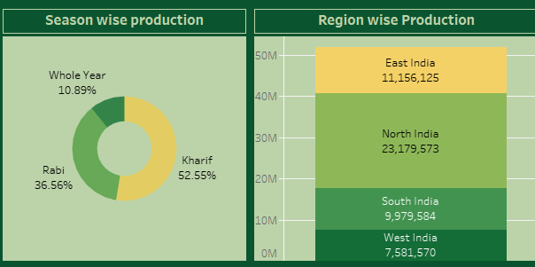

* Rapeseed & Musturd, Blackgram, Tur are 3 crops with highest production.
* Uttar Pradesh is highest production with 14.39% followed by Madhya Pradesh with 8.23%.

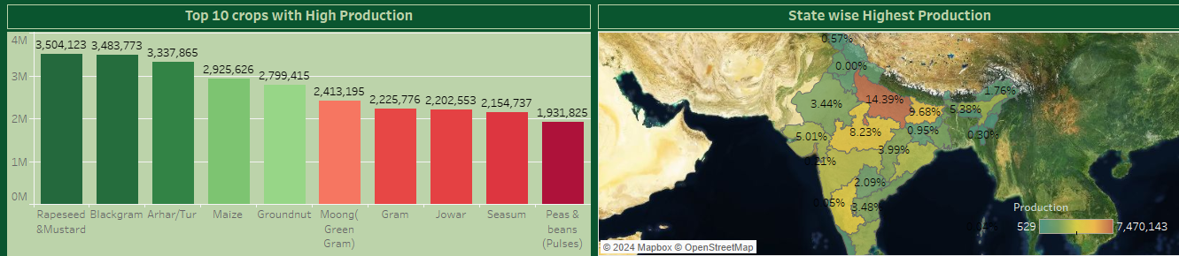

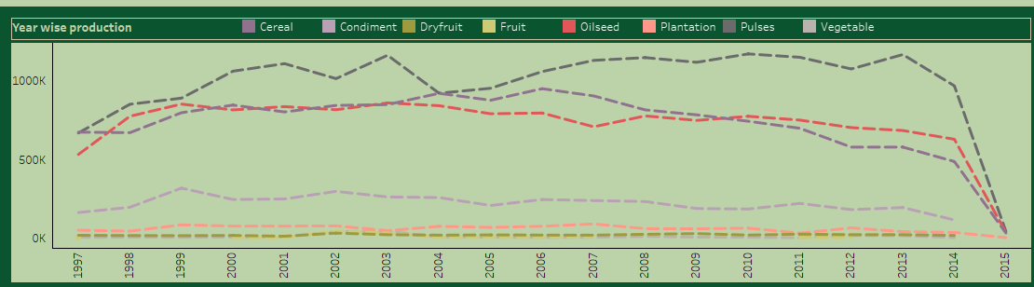

* Pulses, oilseed & vegetables have highest production from 1997 to 2015.
* In 2003, 2010 & 2013 pulses have more production (above 1000k ).

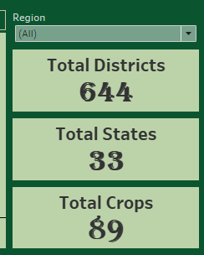

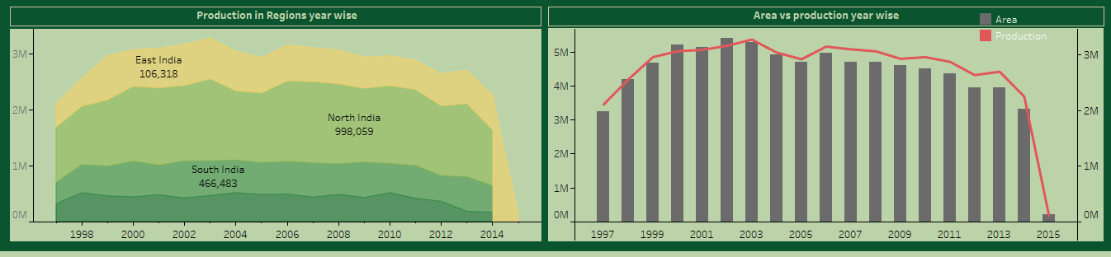

* There are total 33 states & 644 districts and 89 crops data in this dataset. You can see the KPI’s.
* North India has highest contribution in crop production over the years from 1998 to 2015.
* We can see there was rise in production from 2000 to 2003 that was peak years, then onwards we can see slightly decrease in production after 2005.
* Only years 2000, 2001 & 2002 we can see production is higher than the Area.

We have added Filter here of Region, data will change according to regions like North India, South India etc.

* Pulses, oilseed, Cereals have more area of production compare to other crops categories.

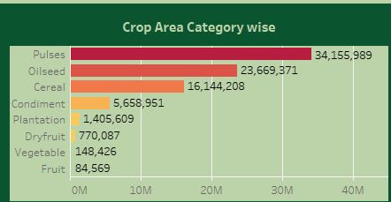

* Also North India & South India have high area of production leads to highest production regions in India.
* Here we have added State filter so we can get info and make analysis on particular state.

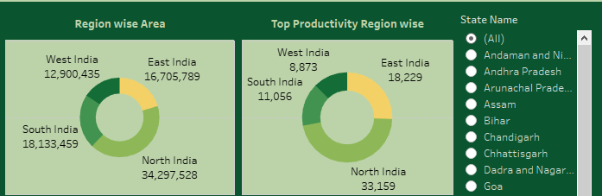

* Blackgram, Seasum, Green gram (Moong), Rapeseed & mustard, Tur are top 5 crops with Larger area.

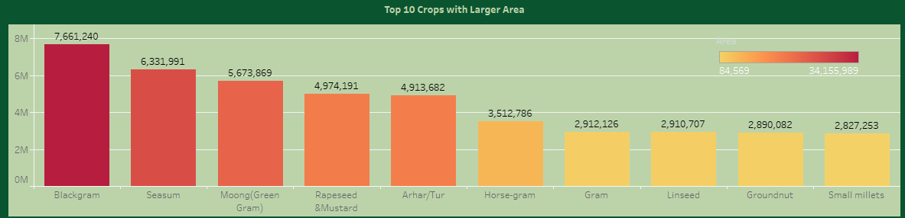

**Q & A:**

1. **What is the source of data?**

This dataset is provided by Ineuron provided Project document. Datasets is available in the given link. You can download as per your convenient. <https://data.world/thatzprem/agriculture-india>

1. **What was type of data?**

Data was both numerical & categorical.

1. **What Libraries used in python?**

I used pandas, numpy, seaborn, matplotlib libraries of python.

**THANK YOU**