# **HIGH LEVEL DESIGN**

**CROP PRODUCTION IN INDIA ANALYSIS**

|  |  |
| --- | --- |
| Written by | Rohan Deore |
| Document version | 1.3 |
| First Revised Date | 30/12/2023 |
| Last Revised Date | 1/1/2024 |
| Last Revised Date | 3/1/2024 |

**Contents**

Document Version

Control.........................................................................................................2

Abstract......................................................................................................................................3

1 Introduction .................................................................................................................5

1.1 Why this High-Level Design Document?...................................................................5

1.2 Scope ...............................................................................................................................5

2 General Description .......................................................................................................6

2.1 Product Perspective & Problem Statement ...........................................................6

2.2 Tools used........................................................................................................................6

3 Design Details.....................................................................................................................7

3.1 Functional Architecture...................................................................................................7

3.2 Optimization .....................................................................................................................8

4 KPIs.........................................................................................................................................9

4.1 KPIs (Key Performance Indicators) ......................................................................9

5 Deployment..............................................................................................................9

Abstract:

The Crop Production in India High-Level Design (HLD) document serves as comprehensive blueprint for the architecture and functionality of a sophisticated system designed to analyze and optimize crop production practices in India. With a focus on enhancing agricultural productivity and sustainability, the system encompasses various components that facilitate data-driven decision-making for farmers, policymakers, and agricultural stakeholders.

**1 Introduction**

**1.1 Why this High-Level Design Document?**

The purpose of this High-Level Design (HLD) Document is to add the necessary detail to the current project description to represent a suitable model for coding. This document is also intended to help detect contradictions prior to coding, and can be used as a reference manual for how the modules interact at a high level.

**The HLD will:**

1. Present all of the design aspects and define them in detail
2. Describe the user interface being implemented
3. Describe the hardware and software interfaces
4. Describe the performance requirements
5. Include design features and the architecture of the project

• List and describe the non-functional attributes like:

* Security
* Reliability
* Maintainability
* Portability
* Reusability
* Application compatibility
* Resource utilization
* Serviceability

**1.2 Scope**

The HLD documentation presents the structure of the system, such as the database architecture, application architecture (layers), application flow (Navigation), and technology architecture. The HLD uses non-technical to mildly-technical terms which should be understandable to the administrators of the system.

**2 General Description**

**2.1 Product Perspective & Problem Statement**

The Agriculture business domain, as a vital part of the overall supply chain, is expected to highly evolve in the upcoming years via the developments, which are taking place on the side of the Future Internet. This paper presents a novel Business-to-Business collaboration platform from the agri-food sector perspective, which aims to facilitate the collaboration of numerous stakeholders belonging to associated business domains, in an effective and flexible manner.

This dataset provides a huge amount of information on crop production in India ranging from several years. Based on the Information the ultimate goal would be to predict crop production and find important insights highlighting key indicators and metrics that influence the crop production.

The objective of the project is to perform data visualization techniques to understand the insight of the data, we will make Dashboards and combine them to create Meaningful Story.

2.2 Tools used

Business Intelligence tools and libraries works such as Numpy, Pandas, Excel, R,

Tableau, Power BI are used to build the whole framework.

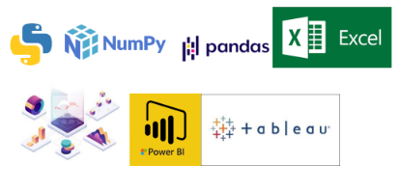

**3 Design Details**

**3.1 Functional Architecture**

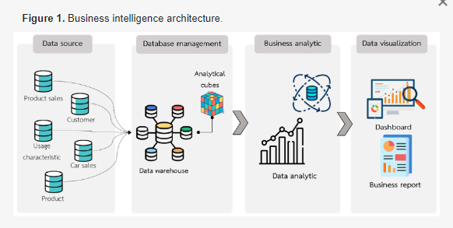

**Tableau Architecture :**

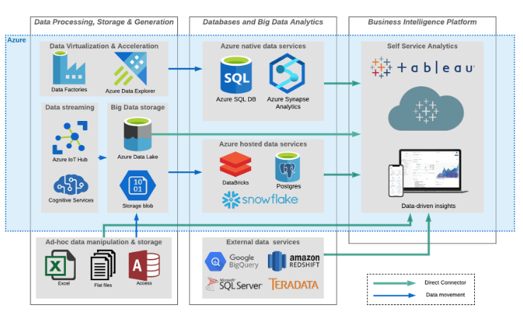

**3.2 Optimization**

It outlines a sophisticated system geared towards enhancing agricultural productivity, sustainability, and resource utilization. Rooted in data-driven insights and advanced analytics, the system aims to empower farmers, policymakers, and stakeholders with actionable information for optimized decision-making in crop production.

**Data Ingestion and Integration:**

Leverages ETL processes to ingest diverse datasets, including state data, crop information, date, area data, production data and historical yields.

Utilizes Tableau connectors for seamless integration with the system's database.

**Analytical Engine:**

Integrates with Tableau for real-time data visualization of analytical insights.

**Decision Support System:**

Integrates Tableau dashboards for presenting actionable insights to farmers, policymakers, and stakeholders.

Utilizes Tableau's interactivity to facilitate drill-downs and detailed exploration of data.

**Key Features and Modules:**

Tableau integration enhances key modules for an interactive user experience:

**Dynamic Crop Dashboards:**

Utilizes Tableau dashboards to present real-time and historical data on crop yields,and market trends.

Enables farmers to make informed decisions on crop selection, and market entry.

**Data Flow and Visualization:**

**Efficient data flow and visualization for actionable insights:**

**Real-time Data Processing:**

Implements real-time data processing in the analytical engine and seamlessly integrates with Tableau for immediate visualization.

**User-Friendly Interfaces:**

Utilizes Tableau's intuitive interface for creating user-friendly dashboards. Ensures easy navigation and interactive data exploration for users.

**Security and Scalability:**

**Ensures security and scalability considerations with Tableau integration:**

**Secure Data Visualization:**

Implements secure Tableau Server configurations for data visualization, ensuring controlled access to sensitive agricultural information.

**Scalable Tableau Server Architecture:**

Utilizes scalable Tableau Server architecture to accommodate growing data volumes and increasing user demands.

**4 KPIs**

Dashboards will be implemented to display and indicate certain KPIs and relevant indicators

1. Total Production
2. Year wise production
3. Production in region year wise
4. Area vs production year wise
5. Total states, total crops , total districts, total crops category
6. Top crops Area wise



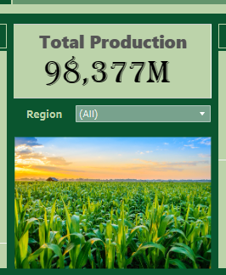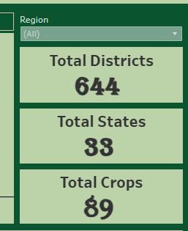

**5 Deployment**

Prioritizing data and analytics couldn’t come at a better time. Your company, no matter what size, is already collecting data and most likely analyzing just a portion of it to solve business problems, gain competitive advantages, and drive enterprise transformation. With the explosive growth of enterprise data, database technologies, and the high demand for analytical skills, today’s most effective IT organizations have shifted their focus to enabling self-service by deploying and operating Tableau at scale, as well as organizing, orchestrating, and unifying disparate sources of data for business users and experts alike to author and consume content.

**Tableau Public Deployment**

**1. Visualization Design:**

Tableau Desktop Development:

Data Preparation: Describes the data preparation process within Tableau Desktop.

Dashboard Creation: Outlines the steps for designing the interactive dashboard.

**2. Tableau Public Account:**

Account Creation:

Guides users on creating a Tableau Public account.

Emphasizes the importance of public sharing and accessibility.

**3. Save to Tableau Public:**

Publishing to Tableau Public:

Explains the process of saving the Tableau Workbook to Tableau Public.

Highlights considerations for data privacy and public sharing.

**4. Data Source Connectivity:**

Data Source Sharing:

Addresses how data sources are shared and connected in Tableau Public.

Discusses considerations for publicly available data sources.

**5. Visualization Settings:**

Public Access Settings:

Describes the settings for making the visualization public.

Highlights privacy and accessibility options.

**6. Embedding and Sharing:**

Embedding in Websites and Blogs:

Guides users on embedding Tableau Public visualizations in websites and blogs.

Discusses embedding options and customization.

Sharing Public Link:

Outlines the process of sharing the public link to the Tableau Public visualization.

Emphasizes the importance of promoting the visualization for wider reach.

**7. User Engagement:**

Interactivity and Exploration:

Highlights the interactive features available to users.

Encourages users to explore and interact with the visualization.

**8. Monitoring and Analytics:**

View Count and Analytics:

Discusses how Tableau Public provides analytics on the number of views.

Encourages users to monitor engagement and use analytics for improvement.

**9. Best Practices and Tips:**

Optimizing for Tableau Public:

Provides best practices for optimizing visualizations for Tableau Public.

Covers considerations for performance and responsiveness.

**10. Conclusion:**

Impact and Accessibility:

Concludes by summarizing the impact of deploying on Tableau Public.

Emphasizes the accessibility and reach achieved through public sharing.