# **LOW LEVEL DESIGN**

**CROP PRODUCTION IN INDIA**

**ANALYSIS**

|  |  |
| --- | --- |
| Written by | Rohan Deore |
| Doc version | 1.3 |
| First Revised | 2/1/2023 |
| Last Revised | 7/1/2023 |
| Last Revised | 14/1/2023 |

**Contents**

1. Introduction................................................................................................................. 04

1.1 What is Low-Level Design Document? ........................................................... 04

1.2 Scope ..................................................................................................................... 04

2. Architecture .............................................................................................................. 05

3. Architecture Description ..................................................................................... 08

3.1 Data Description ................................................................................................... 08

3.2 Data Transformation .......................................................................................... 08

3.3 Export Data from database ................................................................................. 12

3.4 Deployment ......................................................................................................... 12

**1. Introduction**

**1.1 What is Low-Level design document?**

The goal of the LDD or Low-level design document (LLDD) is to give the internal logic design of the actual program code for the House Price Prediction dashboard. LDD describes the class diagrams with the methods and relations between classes and programs specs. It describes the modules so that the programmer can directly code the program from the document.

**1.2 Scope**

Low-level design (LLD) is a component-level design process that follows a step-by-step refinement process. The process can be used for designing data structures, required software architecture, source code and ultimately, performance algorithms. Overall, the data organization may be defined during requirement analysis and then refined during data design work.

2. Architecture

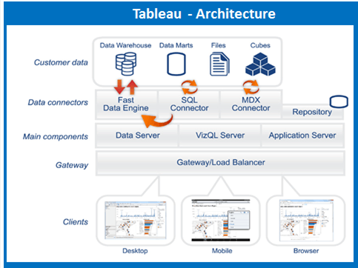

Tableau Public is a free version of Tableau that allows users to create, share, and explore interactive data visualizations on the web. Unlike Tableau Server or Tableau Online, Tableau Public has some limitations in terms of data privacy and sharing options. Here's a high-level overview of the architecture of Tableau Public:

**Tableau Desktop:**

Users create interactive data visualizations using Tableau Desktop, a powerful tool for designing and building dashboards.

Data Sources:

Tableau Public supports a variety of data sources, including Excel, CSV, Google Sheets, and other commonly used formats.

Users can connect to and import data directly into Tableau Desktop for analysis and visualization.

**Tableau Public Cloud:**

Once a visualization is created in Tableau Desktop, users publish it to Tableau Public Cloud.

Tableau Public Cloud is a cloud-based service provided by Tableau where public visualizations are hosted.

Tableau Public Repository:

The Tableau Public repository is a storage space that holds the published Tableau Public visualizations.

It includes metadata, thumbnails, and other information related to the visualizations.

Tableau Public Website:

Tableau Public visualizations are accessible through the Tableau Public website (public.tableau.com).

Users can explore, share, and embed visualizations directly from the Tableau Public website.

Public Profiles:

Tableau Public allows users to create public profiles showcasing their published visualizations.

Public profiles display a user's work and contributions to the Tableau Public community.

Sharing and Embedding:

Visualizations on Tableau Public can be shared via direct links, social media, or embedded in websites and blogs.

Users can choose to make their visualizations public or unlisted, controlling the level of visibility.

Community and Interactivity:

Tableau Public encourages a community-driven approach where users can explore and comment on each other's visualizations.

The platform supports interactive features such as tooltips, filters, and dynamic dashboards.

Data Privacy Considerations:

Tableau Public has limitations on data privacy. All data published to Tableau Public is publicly accessible.

Users should avoid publishing sensitive or confidential information on Tableau Public.

**3. Architecture Description**

**3.1. Data Description**

Datasets is available in the given link. You can download as per your

convenient. <https://data.world/thatzprem/agriculture-india>

Dataset contains:

State Name- Name of states in India

District Name- District names

Crop Year- 1997 to 2015

Season- kharif , rabi, whole year

Crop Name- name of particular crop

Area & production of crop

New columns created:

Date column

Crop Category – pulses, dry-fruits, cereal etc

Region- divided into 4 regions east, west, north, south india

Productivity & Total Production

**3.2 Data Transformation**

Data transformation in Tableau refers to the process of preparing and shaping your data so that it can be effectively analyzed and visualized in Tableau. Tableau provides various tools and features to help users transform and clean their data. Here are some common techniques for data transformation in Tableau:

**Connecting to Data Sources:**

Tableau connects to a wide range of data sources, including databases, spreadsheets, cloud-based data, and more.

Use the "Connect" pane to establish a connection to your data source.

**Data Preparation Pane:**

After connecting to a data source, Tableau displays the Data Source tab, where you can see and modify the structure of your data.

In the Data Source tab, you can rename fields, create calculated fields, and perform basic data cleaning tasks.

**Data Cleaning:**

Clean and standardize data using features like Find and Replace, Split, and Merge.

Remove unnecessary columns or rows that do not contribute to your analysis.

**Data Joins and Blends:**

Combine data from multiple tables using joins or blends.

Joins merge data from different tables based on common fields, while blends combine data from different data sources in the same visualization.

**Calculated Fields:**

Create calculated fields to perform calculations on existing data or derive new fields.

Use calculated fields for aggregations, mathematical operations, string manipulations, and more.

**Pivoting and Unpivoting:**

Pivot your data to transform columns into rows or unpivot to transform rows into columns.

This is useful when your data is in a wide format, and you need to reshape it for analysis.

**Data Aggregation:**

Aggregate your data to summarize information at a higher level.

Use functions like SUM, AVG, COUNT, etc., to aggregate numerical data.

**Dynamic Parameters:**

Create dynamic parameters to allow users to interactively adjust certain aspects of the data, such as date ranges or filter criteria.

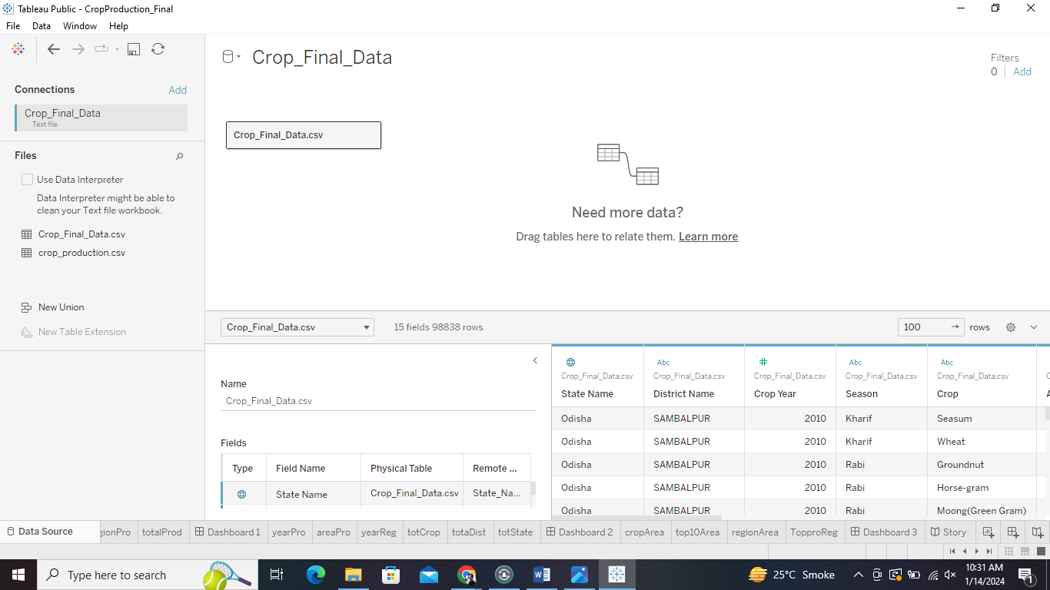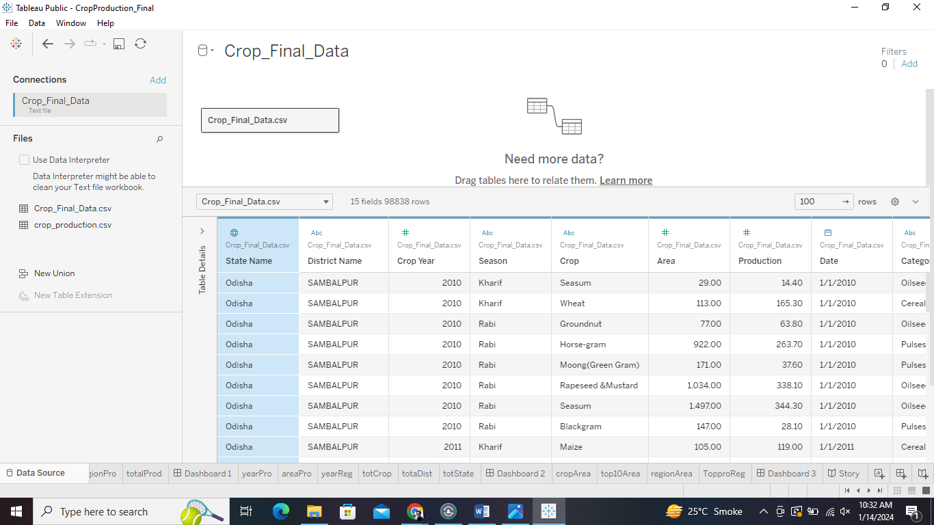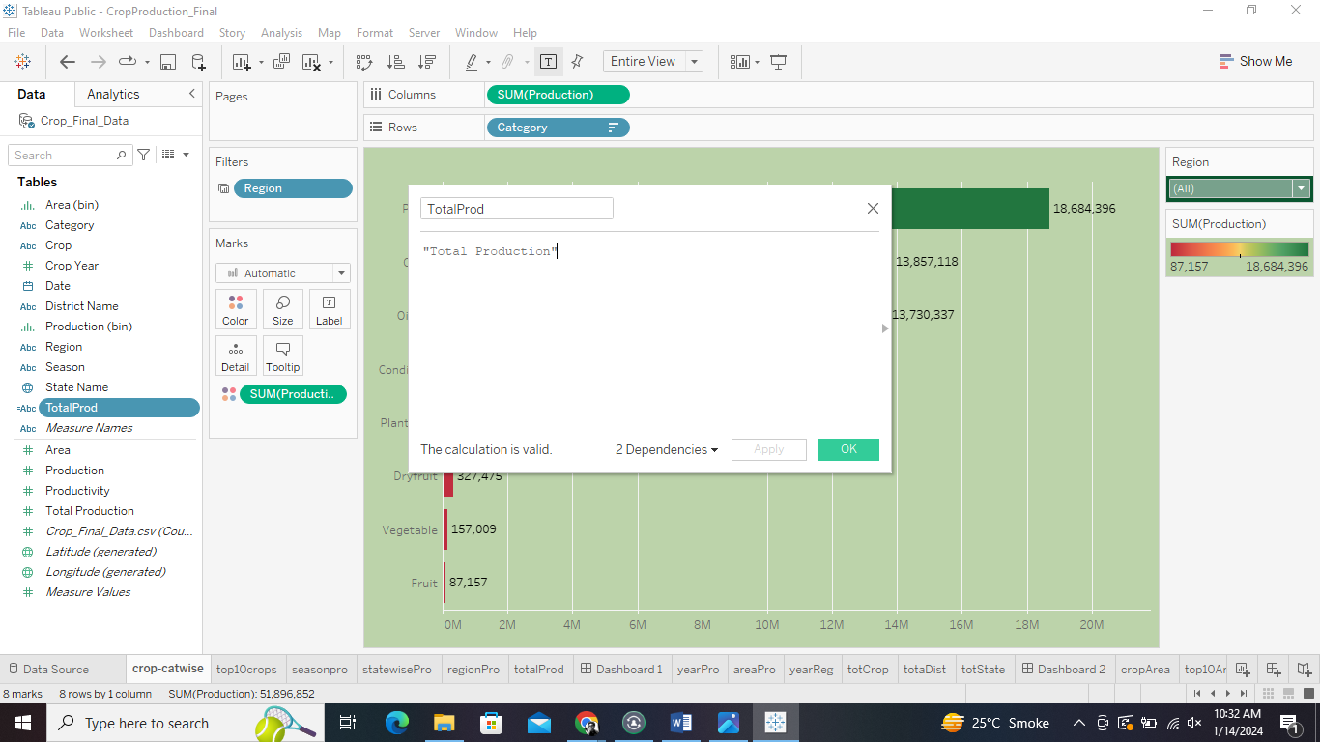

**3.5. Export Data from Database**

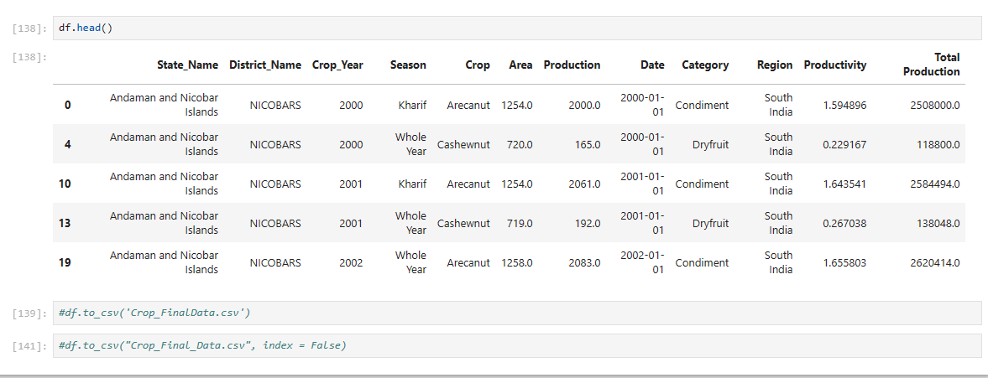

**3.6 Deployment.**

Once you’ve completed your dashboard, follow these steps:- Server, Tableau Public, Save to Tableau Public As You may be prompted to log into your Tableau Public profile first if this is your first time publishing.

