NC State University
Department of Electrical and Computer Engineering
ECE 463/521: Fall 2013 (Rotenberg)
Project #1: Cache Design, Memory Hierarchy Design

by

<< Neal G O'Hara >>

NCSU Honor Pledge: "I have neither given nor received unauthorized aid on this test or assignment."

Student’s electronic signature: ____Neal O'Hara_____
(sign by typing your name)

Course number: _____ECE 521______
(463 or 521 ?)

Section 9.1. L1 Cache exploration: SIZE and ASSOC

Graph #1
L1 cache: SIZE is varied, ASSOC is varied, BLOCKSIZE = 32.
L2 cache: None
Prefetching: None

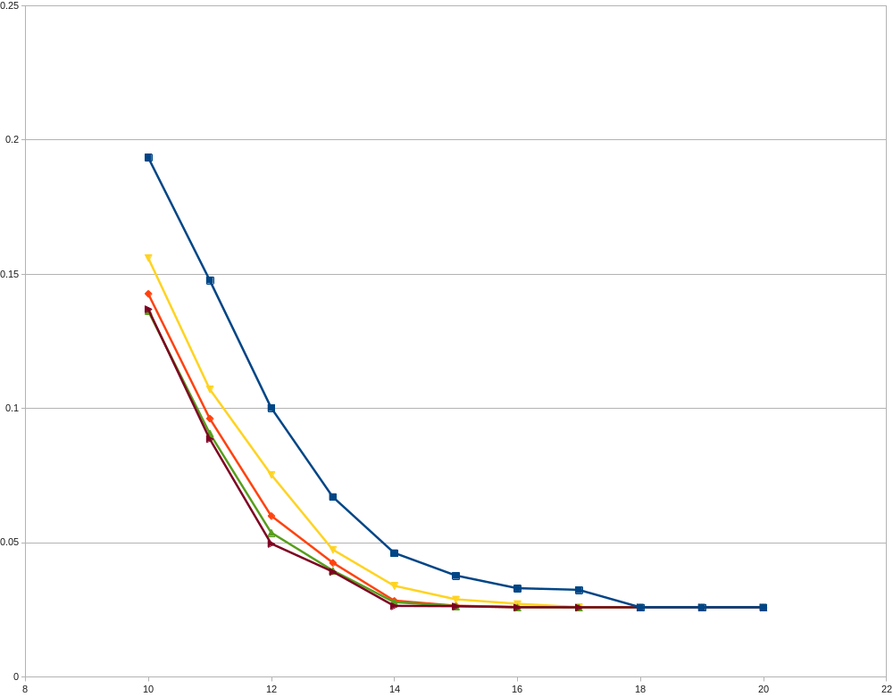
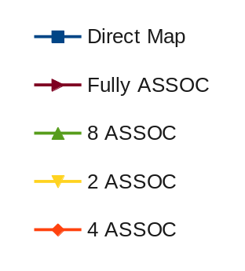
log_2(Size)
Miss
Rate

Discussion
- For each associativity, increasing the cache size decreases the miss rate exponentially.
For each cache size, increasing the associtivity decreases the miss rate with diminishing returns, ie. 2 ASSOC is much better than Direct Map, but Fully ASSOC is not much better than 8 ASSOC.

- From the graph and data, the compulsory miss rate appears to be around 0.02582, ie. where the graphs bottom out.

- Conflict miss rate can be approximated by Direct Map Miss Rate – Fully ASSOC Miss Rate.
This calculates out to:
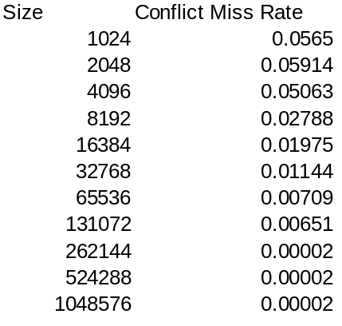

GRAPH #2
Same as GRAPH #1, but the y-axis should be AAT instead of L1 miss rate.

Formula Used:

Miss_Penalty (in ns) = 20 ns + 0.1*(BLOCKSIZE / 16 B/ns)
= 20 + 0.1*(32/16) = 20.2 ns

Average access time (AAT) = HT_L1 + MR_L1* Miss_Penalty

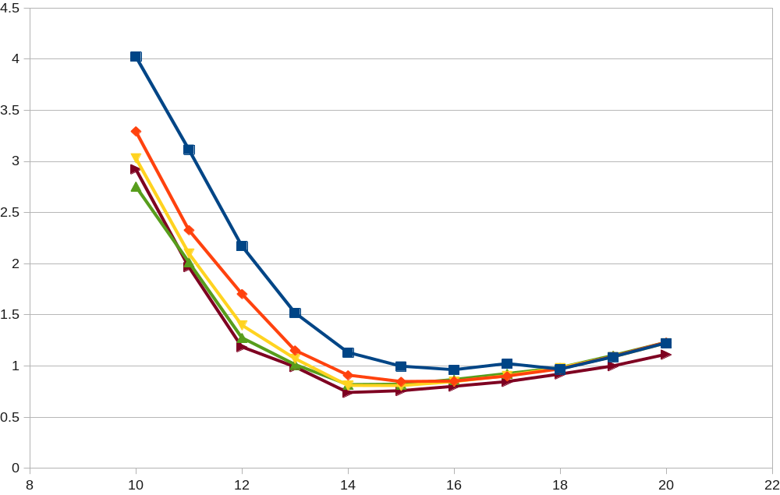
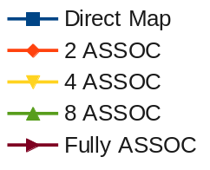
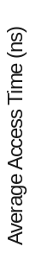
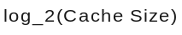
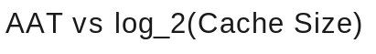
Discussion
- By graph and data, one can see that a fully associative, 16 kb cache has the best AAT,
at 0.737676 ns .

GRAPH #3
Add the following L2 cache to the memory hierarchy: 512KB, 8-way set-associative, same block size as L1 cache.
Vary the L1 cache size only between 1KB and 256KB (since L2 cache is 512KB).

Formula Used:

Miss_Penalty (in ns) = 20 ns + 0.1*(BLOCKSIZE / 16 B/ns)
= 20 + 0.1*(32/16) = 20.2 ns

Average access time (AAT) = HT_L1 + MR_L1* (HT_L2 + MR_L2*Miss_Penalty)

HT_L2 for 512KB, 8 ASSOC cache = 0.578177 ns

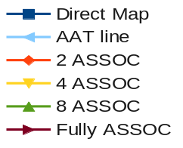
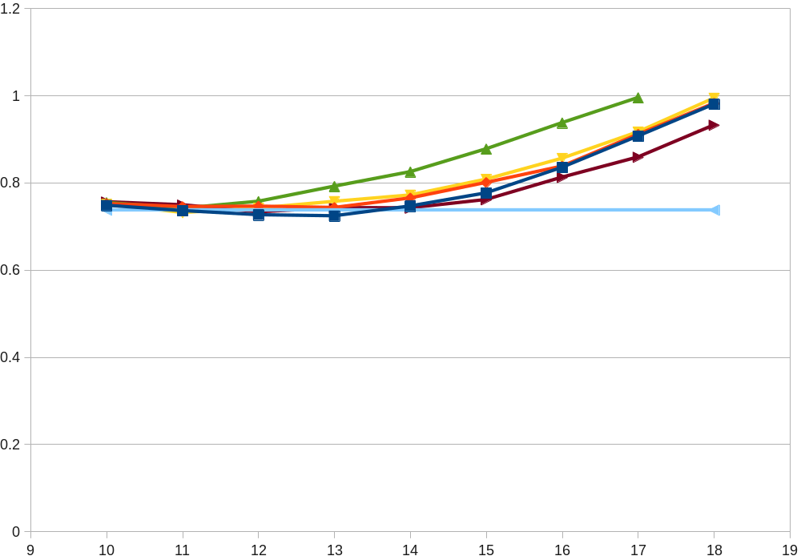

Discussion
- The following Caches (table below), with their respective L1 Size, L1 ASSOCC, and AAT, fell within 5% of the best AAT time for the previous section. The arrows indicate the AATs less than the best from the earlier section.
- The best configuration is the 8192 B Direct Map L1 cache, at 0.724131 ns AAT. This is 0.013544 ns faster.

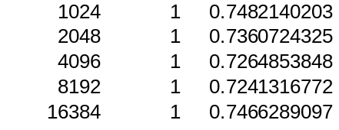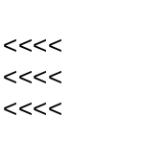

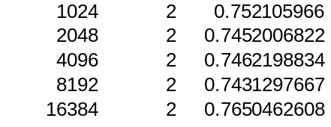

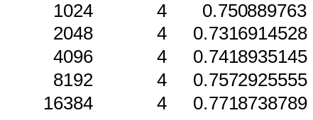
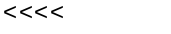

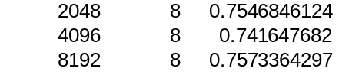

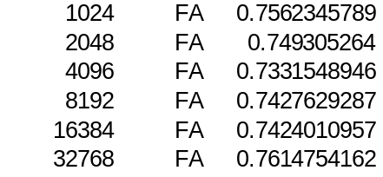

Section 9.2. L1 cache exploration: SIZE and BLOCKSIZE

GRAPH #4
L1 cache: SIZE is varied, BLOCKSIZE is varied, ASSOC = 4.
L2 cache: None.
Prefetching: None.

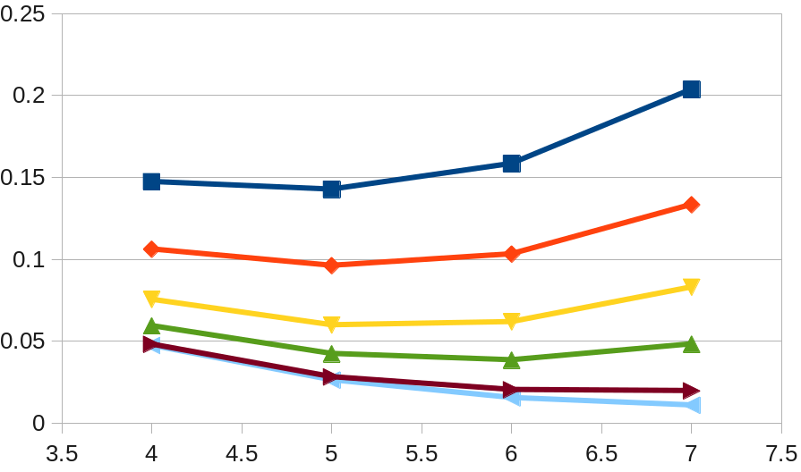

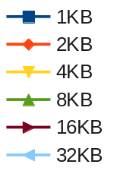

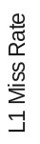

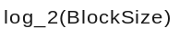

Discussion
- The 32KB cache has the lowest miss rate at the high end of the Block Sizes, while the 1KB cache has the lowest miss rate at the low end of Block Sizes. This indicates the smaller caches prefer smaller blocks, while larger caches prefer larger blocks. In these scales, 1, 2, and 4 KB count as small, and 16 and 32 KB count as large. 8KB is right in the middle, about the same miss rate on either end of the spectrum.

Section 9.3. L1 + L2 co-exploration

GRAPH #5
L1 cache: SIZE is varied, BLOCKSIZE = 32, ASSOC = 4.
L2 cache: SIZE is varied, BLOCKSIZE = 32, ASSOC = 8.
Prefetching: None.

Formula Used:

Miss_Penalty (in ns) = 20 ns + 0.1*(BLOCKSIZE / 16 B/ns)
= 20 + 0.1*(32/16) = 20.2 ns

Average access time (AAT) = HT_L1 + MR_L1* (HT_L2 + MR_L2*Miss_Penalty)
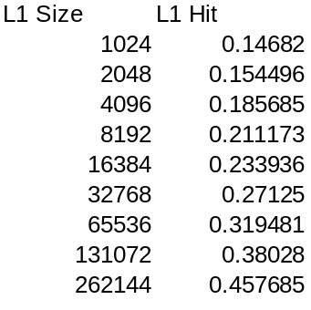
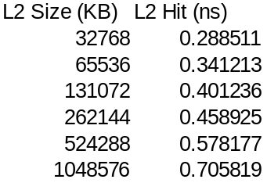

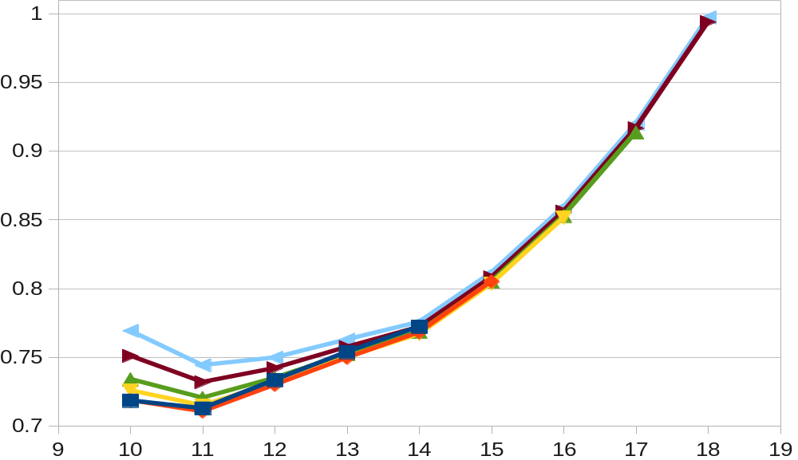
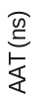
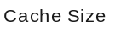
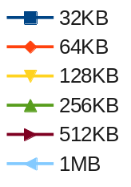

Formula:

Area = A1 + A2

A1(2KB L1 with Blocksize = 32, ASSOC = 4) = 0.018662359 mm^2

A2(64KB with Blocksize = 32, ASSOC =8) = 0.360317611 mm^2

Discussion

- The 64KB L2 cache with L1 cache of 2KB has the lowest AAT of 0.710306 ns.
- Best_AAT_Total_Area = 0.397897997 mm^2
The only memory with 5% of the above's AAT, with a smaller area, is the 64KB L2 cache with L1 cache of 1KB. The smallest five L1 caches of the 32KB L2 configuration all have smaller areas, but are not within 5% of the area. The first three are within 5% of the AAT however.

Section 9.4 Stream Buffer Study

Unfortunately, I still have not successfully implemented Stream Buffers.

