SOFTWARE ENGINEERING

CAL2

Mario Cobos Maestre
and
Adrián de Juan Lora

1-The function.

We have decided to use the sigmoid function which is a function related to the learning curves of many different systems as well as lot of actions of our daily life.

2-JUnit testing.

a)Basic funcionality

First, we tested the function multiple times, trying different inputs that will have predictable results. This was done in order to double check the basic funcionality of the function, as it seemed to be right we continued our work.

b)Exceptions

A exception called InvalidInputException was created, this exception, if executed would stop the execution of the function, returning the following message: "The inserted input is not valid"
The exception would be used only in the case of the user inserting an invalid input, that is a number below 0. It should be noted that negative numbers are actually valid inputs in a sigmoid function, and that the only purpose of marking them as invalid was testing this very exception using Junit.

3-Coverage measurement

A JaCoCoverage test was done using EclEmma the results of the test were the following:

A test of the whole program:
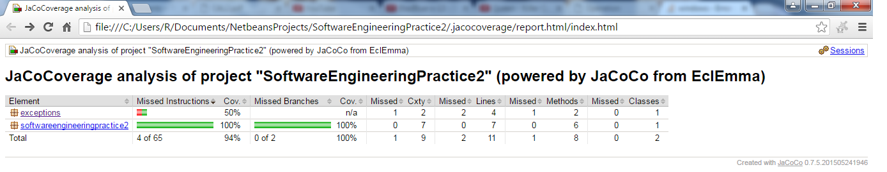
A test for the exceptions:
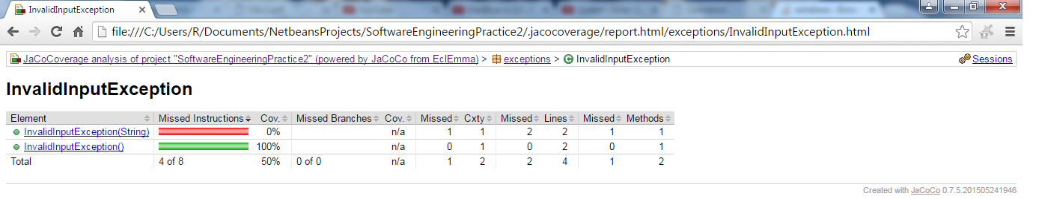

A test for the calculator:
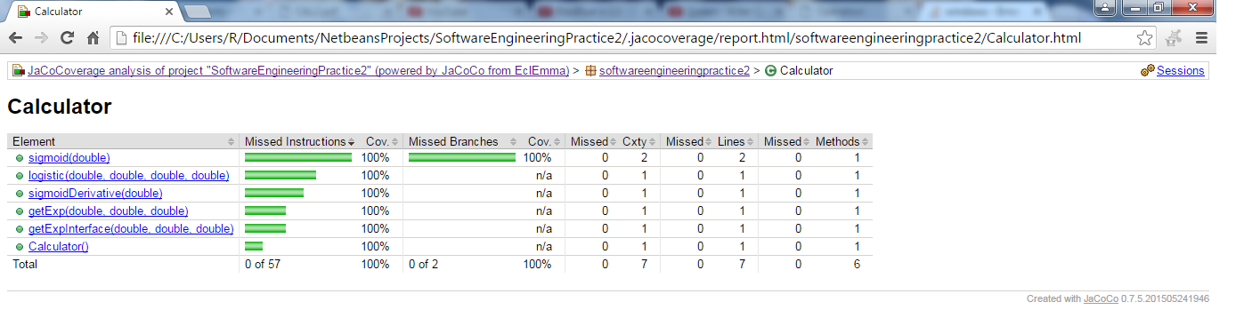

4-Metrics

We performed a measurement of the metrics of the program, the results of this were the following.
Calculator:
*WMC: 6
*DIT: 1
*NOC: 0
*CBO: 1
*RFC: 10
*LCOM: 15
*Ca: 0
*Ce: 1
*NPM: 5
*LCOM3: 2.0000
*LOC: 63
*DAM: 0.0000
*MOA: 0
*MFA: 0.0000
*CAM: 0.9167
*IC: 0
*CBM: 0
*AMC: 0.5000

InvalidInputException:
*WMC: 2
*DIT: 3
*NOC: 0
*CBO: 1
*RFC: 3
*LCOM: 1
*Ca: 1
*Ce: 0
*NPM: 2
*LCOM3: 2.0000
*LOC: 10
*DAM: 0.0000
*MOA: 0
*MFA: 1.0000
*CAM: 0.7500
*IC: 0
*CBM: 0
*AMC: 4.0000
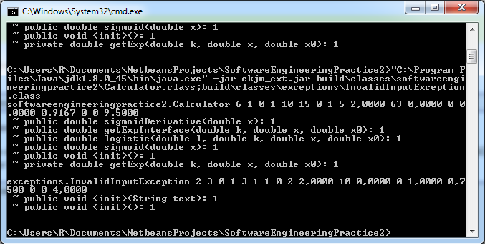
Metrics obtained using ckjm

5-Profiler
We used the Netbeans profiler to measure the program, the profiler returned different measures of the program such as the used heap or the number of threads, this were the exact results.

