Computer Vision HW1

R04921040 李中原

Part1.

Language: Python3

Description: I use OpenCV to do image I/O, and load raw pixel data (height , length , channels) from lena.bmp.

Upside_down[x , y] correspond to lena[height-x , y]

Right_side_left[x , y] correspond to lena[x , length-y]

diagonally_mirrored[x , y] correspond to lena[height-x , length-y]

Run: python hw1.py

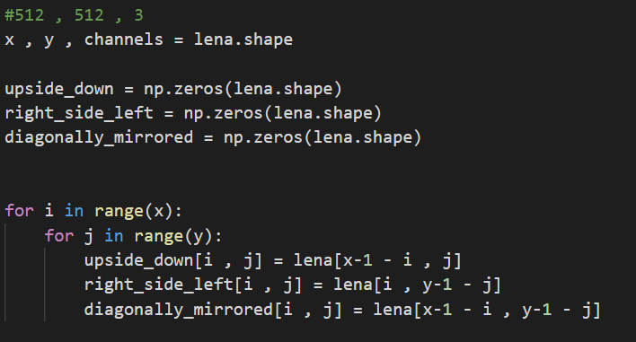

1. Upside-down

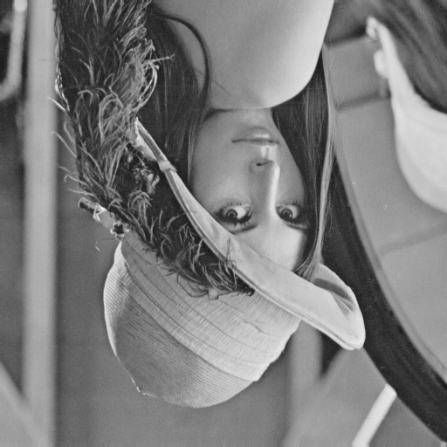

1. Right-side-left

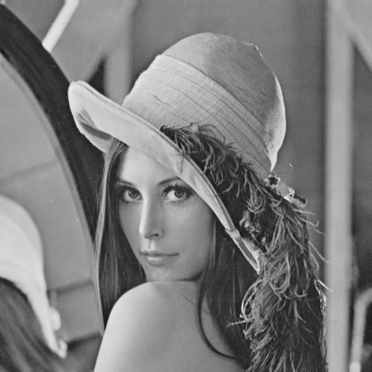

1. Diagonally mirrored

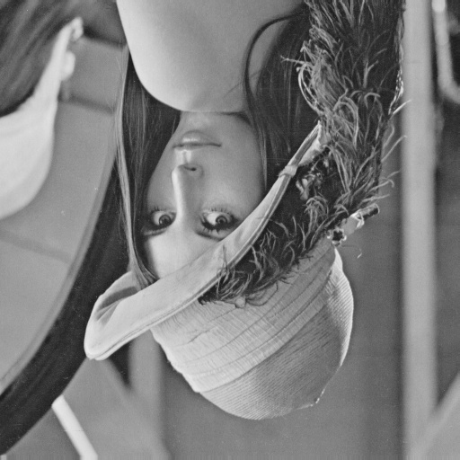

Part2.

1. rotate lena.im 45 degrees clockwise 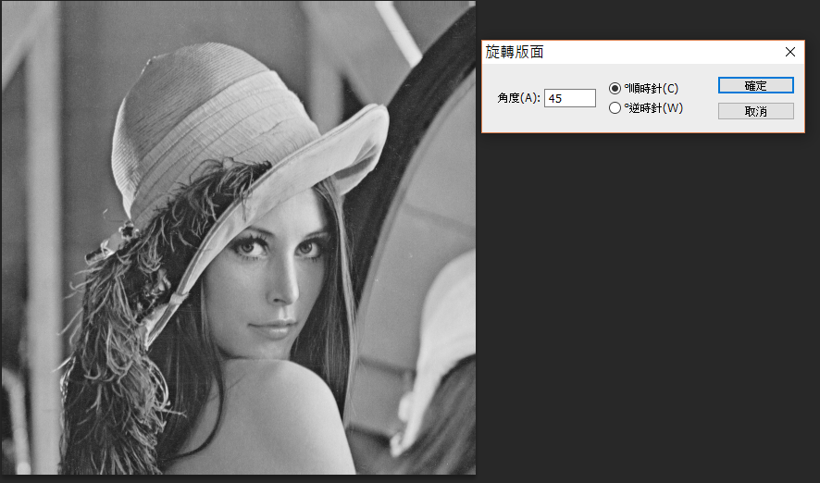

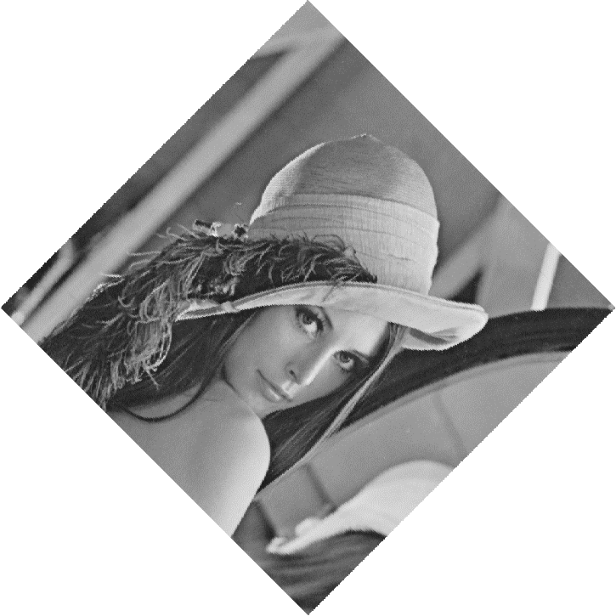

1. shrink lena.im in half

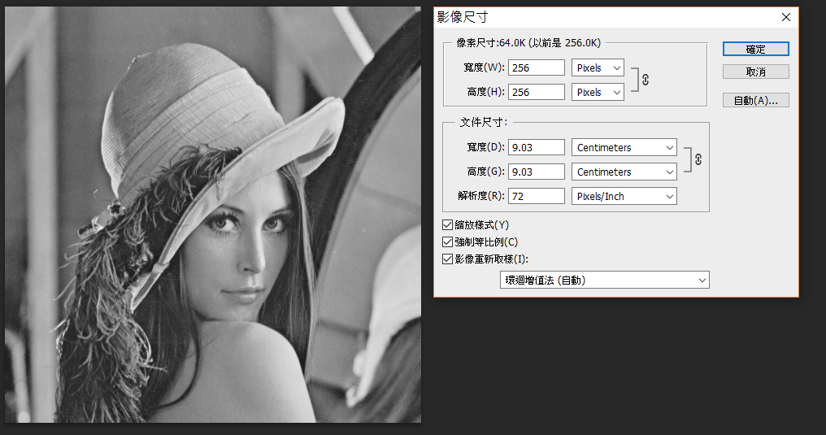

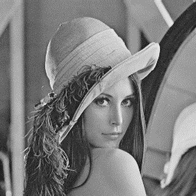

1. binarize lena.im at 128 to get a binary image

