Computer Vision HW7

R04921040 李中原

Language: Python3

Description: I use OpenCV to do image I/O, and load raw pixel data (height , length , channels) from lena.bmp.

Run: python hw7.py

Code fragment:

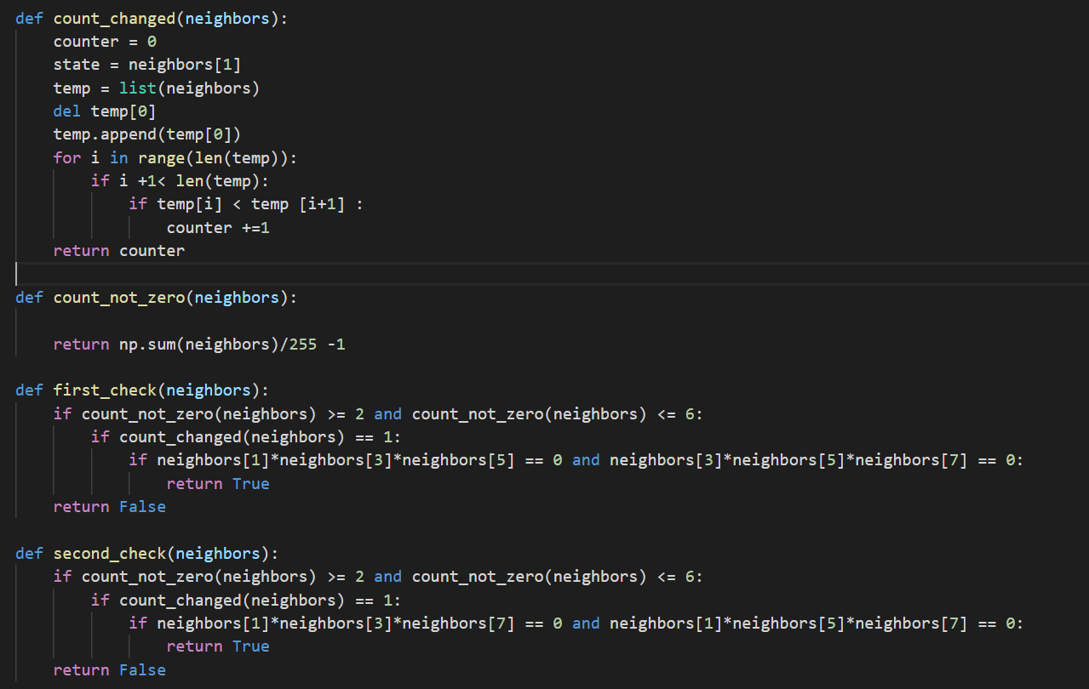

Description:

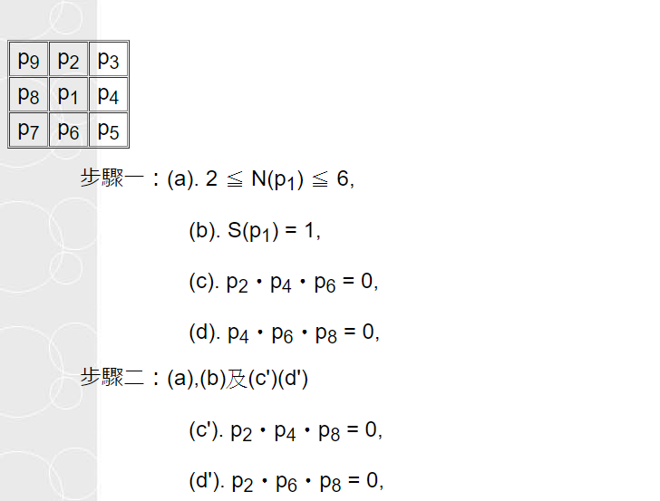

參考thining作法，不斷重複步驟一、二直到不會再變動為止

Reference: http://140.112.94.11/~ttlin/course01/lecture_notes/c1lecture_note13.htm

Results: