AOL HCI LAB-JetFlix

NIM: 2602076405

Nama: Regina Oktavia Joely

Description of the Website

Features
JetFlix wesite has five main features:
- Homepage: jumbotron, sign up button (to regis page), kids movie
- New and Popular Page: top 5 movies and its info with a download and play button
- Movies page: top movie, movies by categories
- Details page: more information of best movie
- Registration page

Contents
HTML Files
Home.html - home page
Movies.html – movie page
detail.html – details page
New.html – New and Popular page
Regis.html - Registration page

CSS Files
footer.css - stylesheet for footer
general.css - stylesheet for Home.html, Movies.html, detail.html, New.html, Regis.html
header.css - stylesheet for header
JS Files
script.js – validation for regis.html

Others
Assets - folder for images used in the source code

References
- https://fonts.google.com/icons
- https://fonts.google.com/
- https://www.netflix.com/browse
- https://www.imdb.com/

process documentation
Low Fidelity:
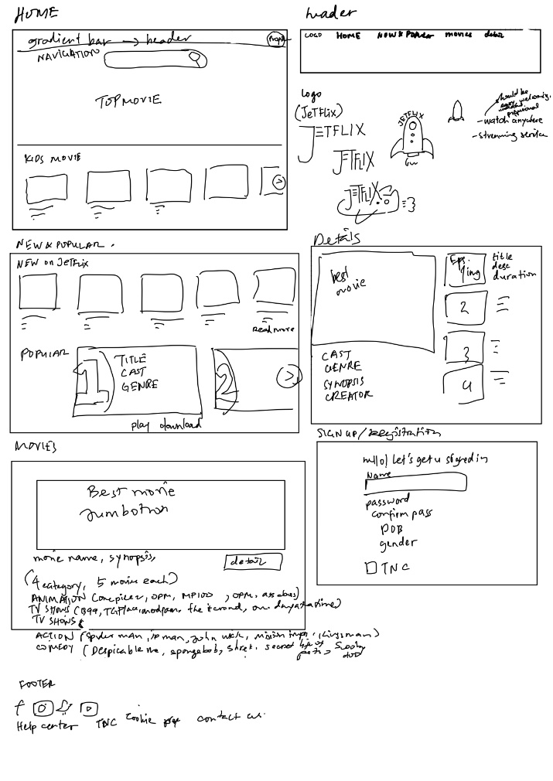

Figma Link: https://www.figma.com/file/EOnKdQ7OSL69Xr7pn2cmHR/JETFLIX?type=design&node-id=0%3A1&t=p7IVO7QenxzX51FU-1

