**Block wise Explanation:-**



* flask framework for the UI
* csv for handling comma separated values of a file
* Object creation for the Flask application (templates is the name of the folder that consists of all html files

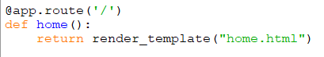

* When the url(localhost:5555 in this case) is opened, home function gets invoked
* It renders home.html file

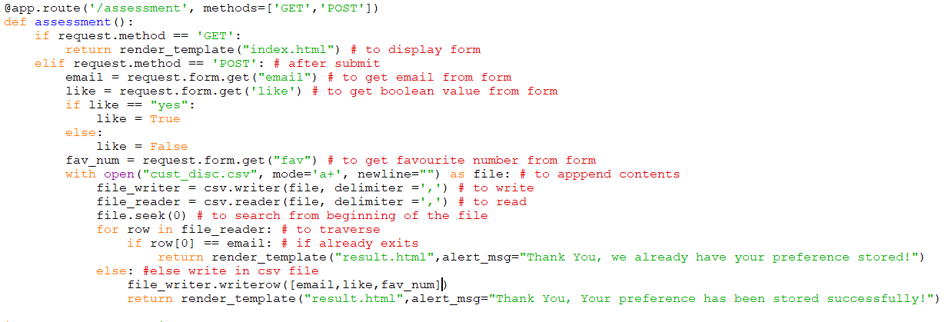

* When the url(localhost:5555/assessment in this case) is opened, assessment function gets invoked
* It renders index.html file , which consists of the form, upon whose submission the same url is invoked with post method
* In post method, all the form values are requested and stored in appropriate variables
* CSV file is opened in append and read mode
* Objects for writer and reader of the files are created with delimiter as comma
* File Pointer is moved to the beginning of the file
* The file is traversed row by row, in each row the 1st value is matched with the email we got as input from form, if it matches, we pass an appropriate message for the proper rendering of the result.html page
* If the email doesn’t already exist, the input values are written in the csv file and, we pass an appropriate message and render the result.html page



* The if condition makes sure that the implementation works only when it is run through the application
* Host and port can be changed according to requirement
* debug must be False while deploying, it can be kept True for developing purposes

**basic.html**

This file consists of the basic syntax or template of any html file that is used in the application, including the style, so that it need not be retyped.

**home.html**

This file just has a welcome message and a hyper link to the actual assessment page.

**index.html**

This file consist the form that takes email, a Boolean value and favourite number as input.

Upon submission, email validations and required validations are performed, then using url_for() the assessment function is again called with the post method, and further processing is done.

**result.html**

This file contains a message that is passed from the python program, which is simply displayed.