s=[1,2,3,4,5,6,7,8,9,10]
even_odd=lambda x:"even" if x%2==0 else "odd"
for i in s:
print(i,"is",even_odd(i))

print(list(map(lambda x:"even" if x%2==0 else "odd",s )))

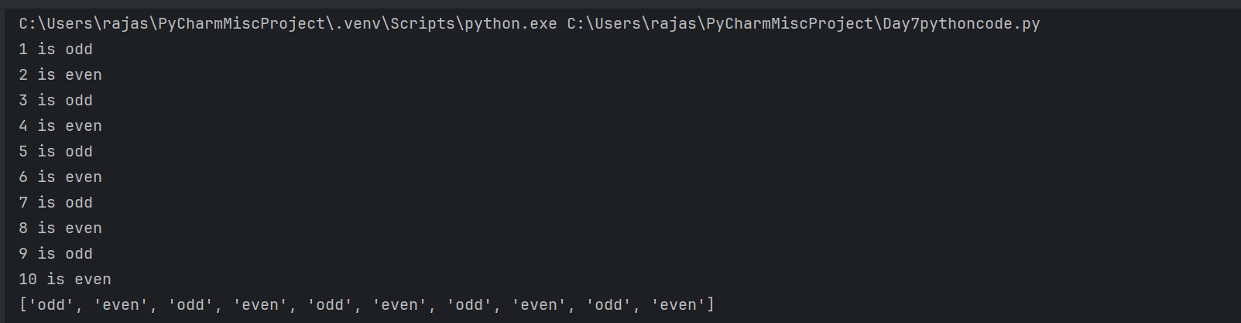

s=input()
palindrome=lambda x:"string is palindrome" if x==x[::-1] else "not palindrome"
print(palindrome(s))
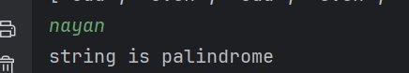

s=input()
palindrome=lambda x:"string is palindrome" if x==x[::-1] else "not palindrome"
print(palindrome(s))
