# Q.1) Write a Python function to check whether a string is a pangram or not.
# Note : Pangrams are words or sentences containing every letter of the alphabet at least once.
# For example : "The quick brown fox jumps over the lazy dog"
def is_paragram(s):
s=s.lower()
letters=set()
for ch in s:
if "a"<=ch<="z":
letters.add(ch)
return len(letters)==26
text=input("enter text:")
if is_paragram(text):
print("the string is paragram")
else:
print("not paragram")

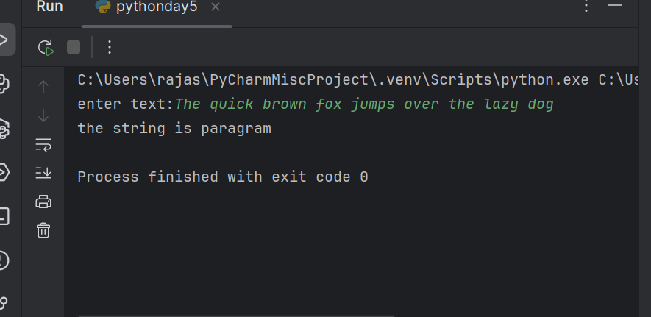

#Q.2) Write a Python program to calculate the sum of the digits in an integer.
num = int(input("Enter an integer: "))
sum_digits = 0
while num > 0:
sum_digits += num % 10
num //= 10
print("Sum of digits:", sum_digits)

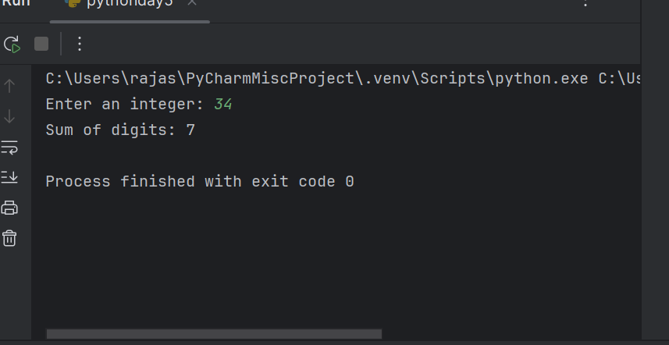

#9.Write a Python program to sort three integers without using conditional statements and loops. [ u can use built in functions for this ]
a = int(input("Enter first number: "))
b = int(input("Enter second number: "))
c = int(input("Enter third number: "))
sorted_nums = sorted([a, b, c])
print("Sorted numbers:", sorted_nums)
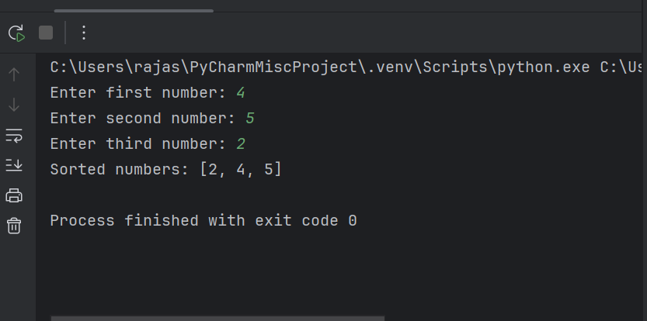

# 23. Write a Python function to check whether a number is perfect or not.
def is_perfect_num(num):
if num<=1:
return False
divisors_sum=1
for i in range(2,num//2+1):
if num%i==0:
divisors_sum+=i
return divisors_sum==num
n=int(input("enter num:"))
if is_perfect_num(n):
print(n,"is_perfect_num")
else:
print(n,"is not perfect_num")
