“””
Que 1::int arr[]={1,2,2,3,3,4,4,4,4,5,5,5,5,5}
alter array in such way that the element which occur most times will print first.
sample output-arr[]={5,5,5,5,5,4,4,4,4,2,2,3,3,1};
“””

mylist=[1,2,2,3,3,4,4,4,4,5,5,5,5,5]
cnt = {}
for i in set(mylist) :
if i not in cnt.keys():
cnt[i]=mylist.count(i)
sorted_dict = sorted(cnt.items(), key=lambda item : item[1], reverse=True)
print(sorted_dict)
res = []
for value, counts in sorted_dict:
res.extend([value]*counts)
print(res)
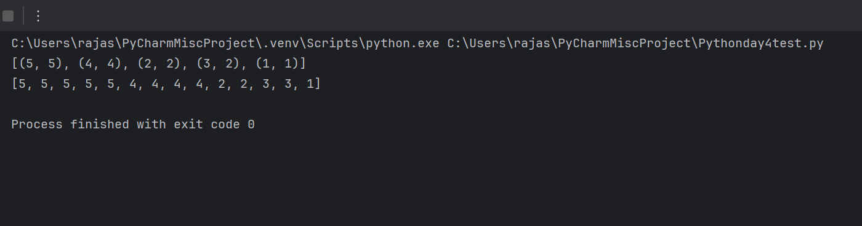
“””
#Q.3) Write a Python program to filter a given list whether the values in the list are having length of 6 using Lambda
“””

words = ["python", "coding", "lambda", "filter", "java", "script"]
result = list(filter(lambda x: len(x) == 6, words))
print(result)

