1. KPI’s

1.Total Sales:

SELECT CAST(SUM(Sales)/1000000 AS DECIMAL(10,2)) AS Sales_Millions

FROM Blinkit_data

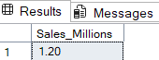

2.Average Sales:

SELECT CAST(AVG(Sales) AS DECIMAL(10,1)) AS Avg_Sales FROM Blinkit_data



3.No. of Items:

SELECT COUNT(*) AS No_of_Items FROM Blinkit_data



4. Average Ratings:

SELECT CAST(AVG(Rating) AS DECIMAL(10,2)) AS Avg_Rating FROM Blinkit_data

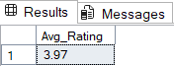

1. Granular Requirements
2. Total Sales by Fat Content

SELECT Item_Fat_Content,

CAST(SUM(Sales)/1000 AS DECIMAL(10,2)) AS Sales_Thousands,

CAST(AVG(Sales) AS DECIMAL(10,1)) AS Avg_Sales,

COUNT(*) AS No_of_Items,

CAST(AVG(Rating) AS DECIMAL(10,2)) AS Avg_Rating

FROM Blinkit_data

GROUP BY Item_Fat_Content

ORDER BY Sales_Thousands DESC

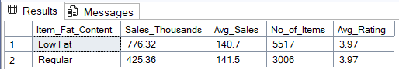

1. Total Sales by Item Type

SELECT TOP 5 Item_Type,

CAST(SUM(Sales)/1000 AS DECIMAL(10,2)) AS Sales_Thousands,

CAST(AVG(Sales) AS DECIMAL(10,1)) AS Avg_Sales,

COUNT(*) AS No_of_Items,

CAST(AVG(Rating) AS DECIMAL(10,2)) AS Avg_Rating

FROM Blinkit_data

GROUP BY Item_Type

ORDER BY Sales_Thousands DESC

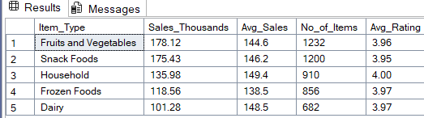

1. Fat content by outlet for total sales

SELECT Outlet_Location_Type,

ISNULL([Low Fat], 0)AS Low_Fat,

ISNULL([Regular], 0)AS Regular

FROM

(

SELECT Outlet_Location_Type, Item_Fat_Content,

CAST(SUM(Sales) AS DECIMAL(10,2))AS Sales

FROM blinkit_data

GROUP BY Outlet_Location_Type, Item_Fat_Content

)AS SourceTable

PIVOT

(

SUM(Sales)

FOR Item_Fat_Content IN ([Low Fat],[Regular])

) AS PivotTable

ORDER BY Outlet_Location_Type;

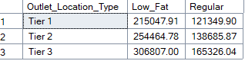

1. Total Sales by Outlet Establishement

SELECT Outlet_Establishment_Year,

CAST(SUM(Sales) AS DECIMAL(10,2)) AS Sales

FROM Blinkit_data

GROUP BY Outlet_Establishment_Year

ORDER BY Outlet_Establishment_Year ASC

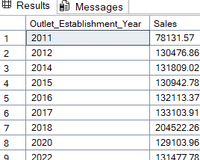

5.Percentage of Sales by Outlet size

SELECT

Outlet_Size,

CAST(SUM(Sales) AS DECIMAL(10,2)) AS Sales,

CAST((SUM(Sales) * 100.0 / SUM(SUM(Sales)) OVER()) AS DECIMAL(10,2)) AS Sales_Percentage

FROM blinkit_data

GROUP BY Outlet_Size

ORDER BY Sales DESC;

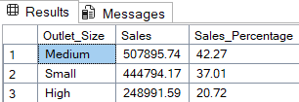

1. Sales by Outlet Location

SELECT Outlet_Location_Type,

CAST(SUM(Sales) AS DECIMAL(10,2)) AS Sales

FROM Blinkit_data

GROUP BY Outlet_Location_Type

ORDER BY Sales DESC

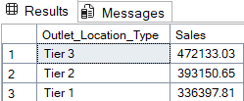

7.All metrics by Outlet Type

SELECT Outlet_Type,

CAST(SUM(Sales) AS DECIMAL(10,2)) AS Sales,

CAST((SUM(Sales) * 100.0 / SUM(SUM(Sales)) OVER()) AS DECIMAL(10,2)) AS Sales_Percentage,

CAST(AVG(Sales) AS DECIMAL(10,1)) AS Avg_Sales,

COUNT(*) AS No_of_Items,

CAST(AVG(Rating) AS DECIMAL(10,2)) AS Avg_Rating

FROM blinkit_data

GROUP BY Outlet_Type

ORDER BY Sales DESC;

