Reminder of names

I believe this is for the truth table checking algorithm

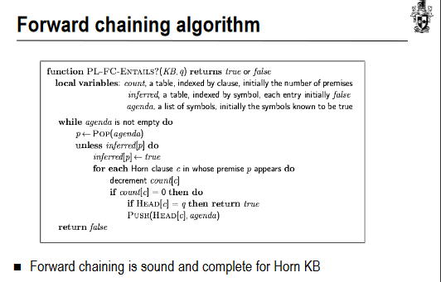

This will need to be repurposed for backwards chaining which should be simple enough

