­­­ Web Technologies Coursework 1 Report

1. The website will include a description of what a cipher is and it will allow the user to enter their own message that they would like to be deciphered. There are many different types of ciphers but the two that will be included on this website will be the Caesar cipher and the Atbash Cipher.

2. The way that I am going to structure this website will include the creation of a home page and another two pages that can be accessed from any page. Buttons will be used to navigate through the website. There will be a text box and button on each cipher page for the user to enter their code to decipher. I will include the JavaScript for the ciphers in the html files and use an external CSS file for the appearance of the website. The website will be simple and easy to use as there will only be a small description of the cipher and an input and output text box for the deciphering of the code.

3. I started the website by making a home page called ciphers. Two more pages were then created for the Caesar cipher and Atbash cipher. The three pages were then linked to together with buttons for navigation. A small description of what a Cipher is was then added to the home page followed by a description of the chosen ciphers on their pages. I then made an external css file that each page uses so that they all look the same.

Here are some screenshots of the website :

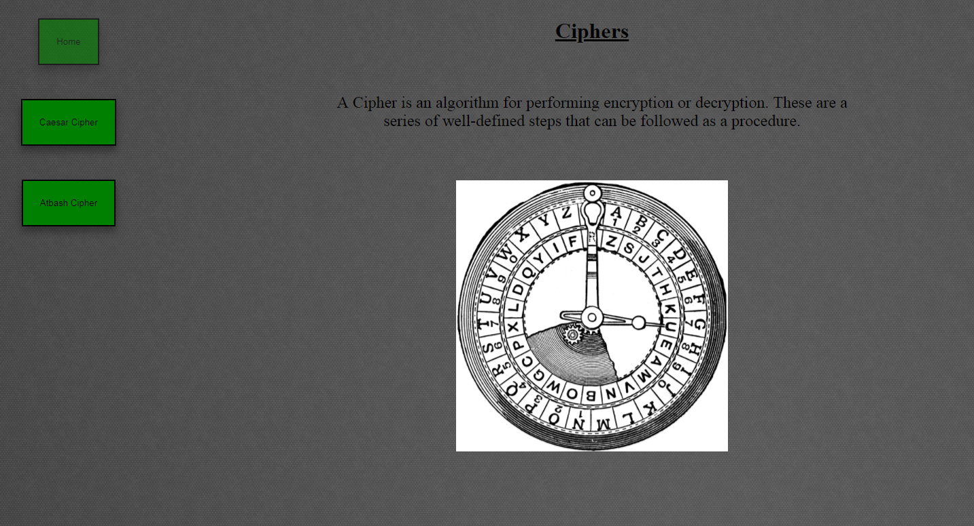 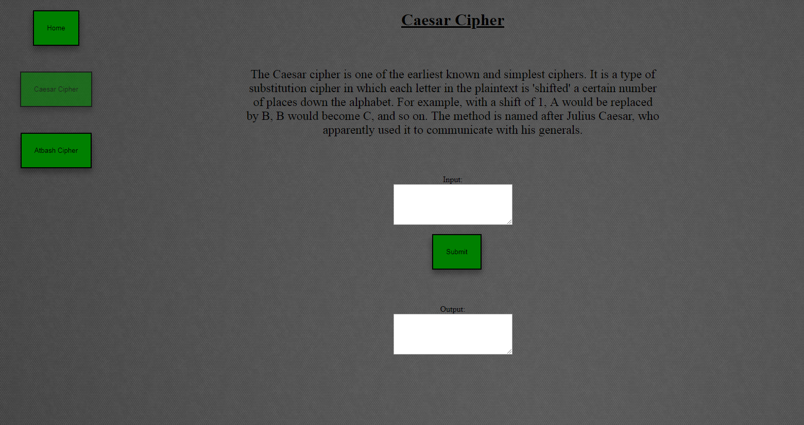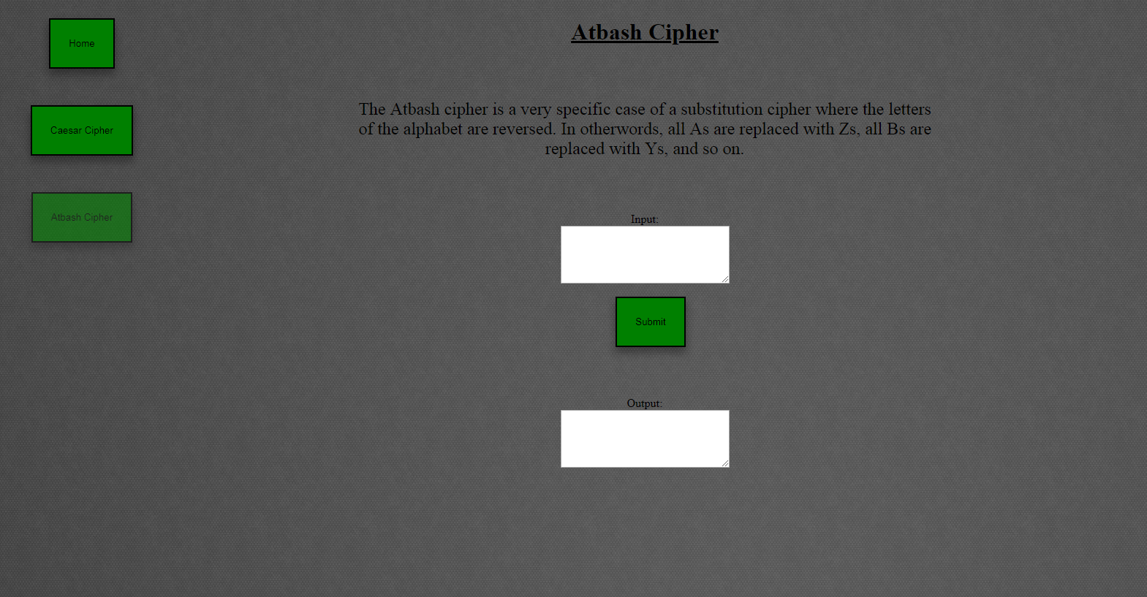

4. I would say that my website follows the guidelines and does what it is supposed to do. More ciphers could have been added to the website and I could have chosen more difficult ciphers to do instead of the Caesar cipher and Atbash cipher which are quite simple. I could have added more information about the ciphers and made the website look better as well. Input and output boxes could have been made to look better.

5. I had the navigation and the look of the website done way before I managed to get the ciphers working. I struggled with the loop in the Caesar cipher and it took me a long time to figure out what was wrong with it. However, I didn’t have many problems with the Atbash cipher as I got it working quite fast. Originally I was trying to run the JavaScript for the ciphers from external files but I couldn’t get it to work so I ended up putting the scripts in the same html files for the pages. I have learned from the mistakes that I made and will hopefully not make those same mistakes again.