**SYNOPSIS**

1. **Title of the Project**:

AgriBizz – Online Agriculture Management System

1. **Introduction and Objective of the project:**

The name ‘AgriBizz - Agriculture Management System' indicates Intelligent Agriculture. ‘AgriBizz’ is a model farmer management website application. This site helps the farmers to sell their agricultural produce online and suggests best -in-practice farming processes. Hence, providing a wider market and helping them to not restrict themselves to the local market. It helps the wholesalers and retailers in buying produce from larger number of farmers. Thereby, enables the wholesalers and retailers in expanding their business. It features online shopping for fertilizers, pesticides, machinery & tools, etc. It helps the farmers to keep track of their agricultural production with features such as virtual calendar, weather forecasting, etc. and enables them to hire labourers, which in turn, will help the farm labourers to find small jobs by having a work profile in the website. As a whole, ‘AgriBizz’ provides a concept of virtual agricultural trade to its users.

1. **Project Category:**

RDBMS (Relational Database Management System).

1. **Tools and Environment used:**

**Programming Languages Used:**

* Design and Interface: HTML, CSS
* Programming language: PHP
* Scripting language: AJAX, Javascript
* Database: MySQL Server
* Front End: HTML, CSS, Javascript, Bootstrap
* Back End: PHP & MySQL

**Hardware Requirements:**

* Operating System: Windows XP, 7 OR 8
* Processor: Intel Core Duo 2.0 GHz or more
* RAM: 1 GB or more
* Hard Disc: 80 GB or more
* Monitor: 15 inches CRT or LCD Monitor
* Keyboard: Normal or multimedia keyboard
* Mouse: Compatible Mouse

**Software Requirements:**

* XAMPP Software
* Apache Server
* MySQL Server 5.4
* Notepad++
* Browser: Google Chrome, Mozilla Firefox, Microsoft Edge

1. **Problem Definition, Requirement Specifications (Detailed functional Requirements and Technical Specifications), Project Planning and Scheduling (Gantt chart and PERT chart).**
2. **Problem Definition:**

In this project the farmers can sell their products online and the buyer can purchase the seeds and products through online. Buyer can send purchase request to check the quality of the product. The Payments will be received from the seller once the product delivered to the seller. The customers can buy products and equipment’s in this project. The article and blogs section helps farmers to improve their productivity and profitability. Administrator can view and print all kinds of reports.

Following issues found in the existing system:

* Existing system was not user friendly.
* The system not providing solution for new Farm Acts 2020.
* Existing system doesn’t have online sales option.
* In the existing system famer has to sell nearest agents.
* Existing system doesn’t provide any information to the farmers.

1. **Detailed Functional and Technical Requirement Specification:**

**“AgriBizz”** is a website for online agricultural trade. This website helps farmers by providing them a large market online to sell their produce. They can also hire farm labourers and be updated with the recent agricultural developments. The wholesalers and the retailers are also benefited as they can buy from a larger market. They can shop for farming equipments easily. The consumers can also buy fresh produce directly from the farmers.

To provide technology and services to the farmers, merchants and farm labourers, thus, helping them to expand their business and provide them with a wider market. Hence, improve the present farming processes and to provide knowledge about recent agricultural issues.

To provide a helping hand to the farmers and farm labourers in improving their lives through the medium of technology, thereby, improving the Agricultural Sector in the Indian Economy.

**User Types:**

* **Administrators:** Administrators are the ones who can add or administer the categories for the products, and administers the all-website information’s. Administrator has full privilege of the website.
* **Sellers:** Sellers are the farmers and they can sell their productions through online after the registration. After the registration the farmers can login to the system by entering login id and password.
* **Customer:** Customers can buy products through online. The customer can send purchase request to check the quality of the products.
* **Worker:** Workers can receive various work requests from multiple farmers and they can also reject or approve a request depending upon their interest.

1. **Project Planning and Scheduling:**

* **User Interfaces:**

Each part of the user interface intends to be as user friendly as possible. The fonts and buttons used will be intended to be very fast and easy to load on web pages. The pages will be kept light in space so that it won’t take a long time for the page to load.

* **Performance Requirements:**
  + Performance requirements define acceptable response times for system functionality.
  + The system is supposed to be having good memory space and RAM should be Above 256 MB preferably.
  + The sound card and graphics card will have to be of good quality and capacity.
  + The load time for user interface screens shall take no longer than three seconds.
  + The log in information shall be verified within three seconds.
  + Queries shall return results within three seconds.
* **Assumptions and Dependencies:**
* The users should have basic knowledge of the computers. They must be trained well to handle the features provided by this system.
* Some of the details are required to be entered by the user and may not be generated automatically.
* Administrator is created in the system already.
* Roles and tasks are predefined.
* **Safety Requirements:**
* In case the customer forget their password, they can recover the password in the Forgot Password panel
* The password stores in the database in the format of encrypted password.
* **Security Requirements:**
* Only authenticated users can access this system.

1. **Scope of the solution:**

This product has following features:

* The farmers can sell their productions online and the buyer can purchase various agricultural products online. Buyer can send purchase request to check the quality of the product.
* After collecting all the farm produce from the farmers, it should be sold to the wholesaler/retailer. This module covers these entries and the charge details also should be entered. The Payments will be received from the wholesaler/retailer once the product delivered to them.
* There are 4 types of users: Customer, Farmers, Workers, and Administrator. The login id and password must be required to login the system.
* The article and blog section helps farmers to improve their productivity and profitability.
* Administrator can view and print all kinds of reports.

1. **Analysis**

* **Level 0: Context Flow Diagram (CFD)**



* **Level 1: Top Level DFD**



* **DFD Level 2.1**

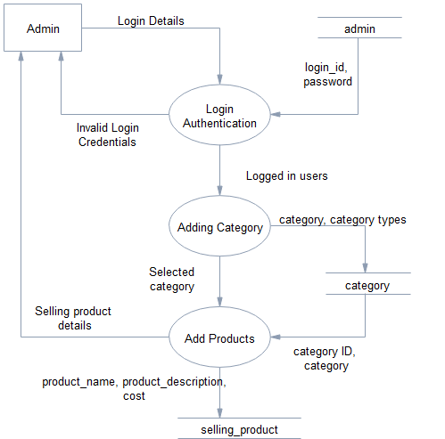

* **DFD Level 2.2**

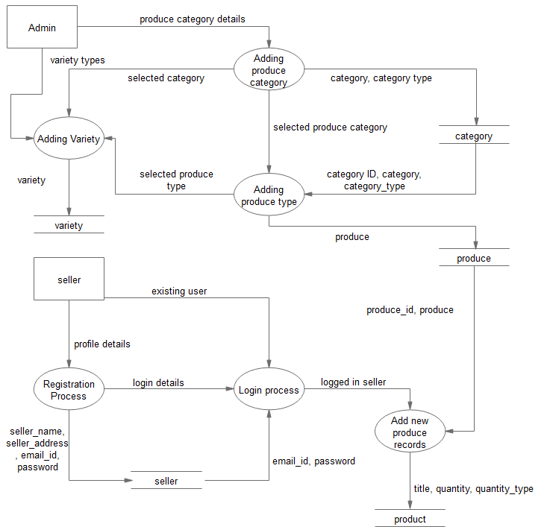

* **DFD Level 2.3**

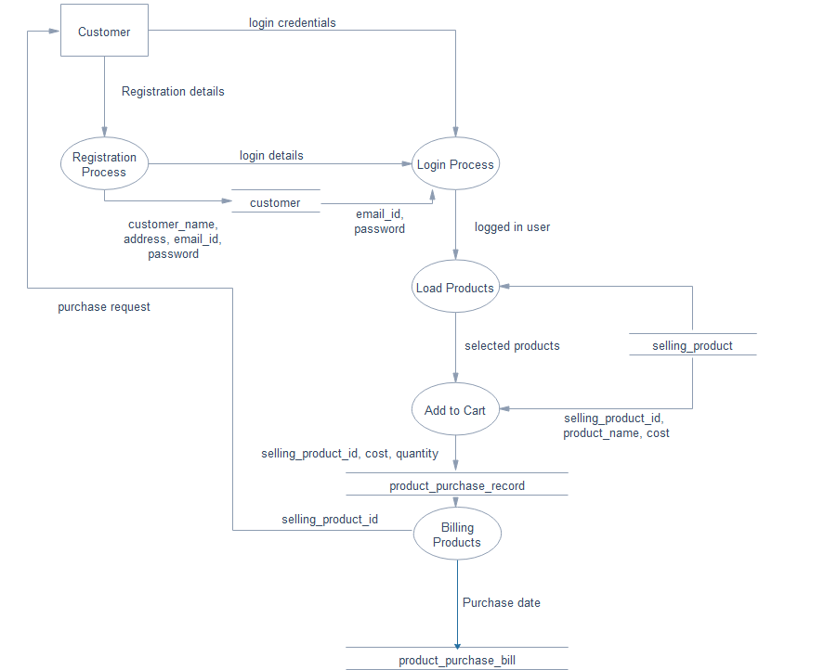

* **DFD Level 2.4**

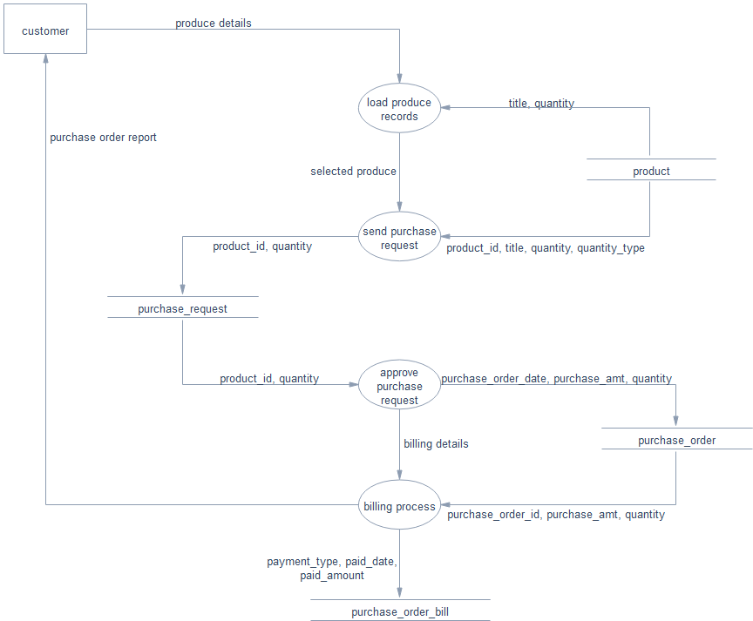

* **DFD Level 2.5**

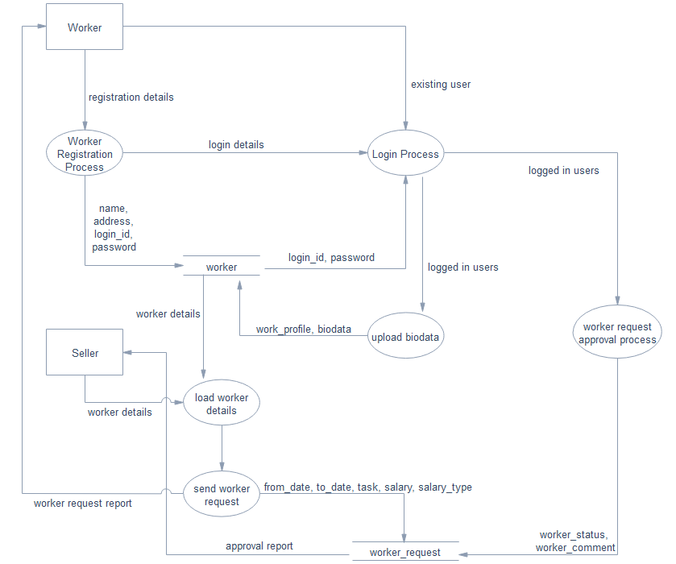

* **DFD Level 2.6**

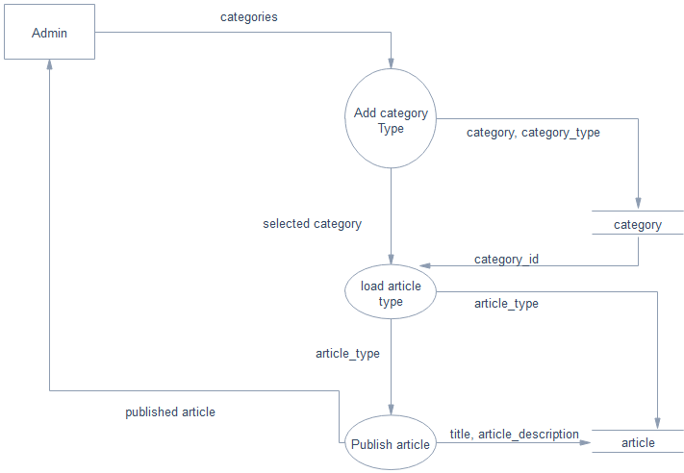

* **ER DIAGRAM**

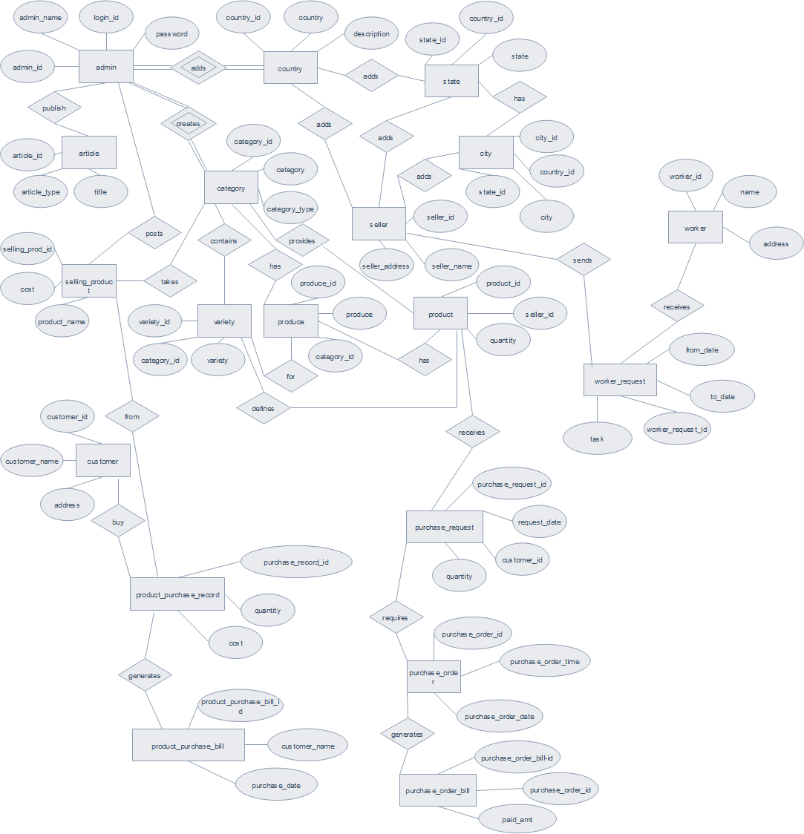

1. **Database Design**

**Database**: A Database is collection of related data, which can be of any size and complexity. By using the concept of Database, we can easily store and retrieve the data. The major purpose of a database is to provide the information, which utilizes it with the information’s that the system needs according to its own requirements.

**Database Design**: Database design is done before building it to meet needs of end-users within a given information-system that the database is intended to support. The database design defines the needed data and data structures that such a database comprises. The database is physically implemented using MySQL.

**Table Design:**

**Structure of Table “admin”:**

|  |  |  |  |
| --- | --- | --- | --- |
| **Field Name** | **Field Type** | **Size** | **Description** |
| admin_id | int | 10 | Admin ID |
| admin_name | varchar | 25 | Admin Name |
| login_id | varchar | 20 | Login ID |
| password | varchar | 50 | Password |
| status | varchar | 10 | Status |

**Structure of Table “article”:**

|  |  |  |  |
| --- | --- | --- | --- |
| **Field Name** | **Field Type** | **Size** | **Description** |
| article_id | Int | 10 | Article ID |
| article_type | varchar | 25 | Article type |
| publish_date | date |  | Publishing date of the article |
| title | varchar | 100 | Title of the article |
| article_description | text |  | Description of the article |
| article_img1 | varchar | 100 | Image of the article |
| article_img2 | varchar | 100 | Image of the article |
| article_img3 | varchar | 100 | Image of the article |
| article_img4 | varchar | 100 | Image of the article |
| article_img5 | varchar | 100 | Image of the article |
| status | varchar | 10 | Status |

**Structure of Table “category”:**

|  |  |  |  |
| --- | --- | --- | --- |
| **Field Name** | **Field Type** | **Size** | **Description** |
| category_id | int | 10 | Category ID |
| category | varchar | 25 | Category |
| category_type | varchar | 25 | Category type |
| description | text |  | Description |
| img | varchar | 100 | Image |
| satus | varchar | 10 | Status |

**Structure of Table “city”:**

|  |  |  |  |
| --- | --- | --- | --- |
| **Field Name** | **Field Type** | **Size** | **Description** |
| city_id | Int | 10 | City ID |
| country_id | Int | 10 | Country ID |
| state_id | Int | 10 | State ID |
| City | varchar | 25 | City |
| description | text |  | Description |
| status | varchar | 10 | Status |

**Structure of Table “country”:**

|  |  |  |  |
| --- | --- | --- | --- |
| **Field Name** | **Field Type** | **Size** | **Description** |
| country_id | int | 10 | Country ID |
| country | varchar | 25 | Country |
| description | text |  | Description |
| status | varchar | 10 | Status |

**Structure of Table “customer”:**

|  |  |  |  |
| --- | --- | --- | --- |
| **Field Name** | **Field Type** | **Size** | **Description** |
| customer_id | int | 10 | Customer ID |
| customer_name | int | 25 | Customer Name |
| address | int |  | Address |
| country_id | varchar | 10 | Country ID |
| state_id | varchar | 10 | State ID |
| city_id | varchar | 10 | City ID |
| pincode | varchar | 10 | Pincode |
| contact_no | varchar | 15 | Contact number |
| mobile_no | varchar | 15 | Mobile number |
| email_id | varchar | 50 | Email ID |
| password | varchar | 25 | Password |
| customer_type | varchar | 25 | Customer Type |
| status | varchar | 10 | Status |

**Structure of Table “produce”:**

|  |  |  |  |
| --- | --- | --- | --- |
| **Field Name** | **Field Type** | **Size** | **Description** |
| produce_id | int | 10 | Produce ID |
| category_id | Int | 10 | Category ID |
| produce | varchar | 25 | Produce |
| description | text |  | Description |
| img | varchar | 100 | Image |
| status | varchar | 10 | Status |

**Structure of Table “product”:**

|  |  |  |  |
| --- | --- | --- | --- |
| **Field Name** | **Field Type** | **Size** | **Description** |
| product_id | int | 10 | Product ID |
| seller_id | int | 10 | Seller ID |
| category_id | int | 10 | Category ID |
| produce_id | int | 10 | Produce ID |
| variety_id | int | 10 | Variety ID |
| Title | varchar | 100 | Title |
| img_1 | varchar | 100 | Image of the product |
| img_2 | varchar | 100 | Image of the product |
| img_3 | varchar | 100 | Image of the product |
| img_4 | varchar | 100 | Image of the product |
| img_5 | varchar | 100 | Image of the product |
| Quantity | float | 10,2 | Quantity |
| quantity_type | varchar | 25 | Quantity type |
| description | text |  | Description |
| uploaded_date | date |  | Uploaded date |
| status | varchar | 10 | Status |

**Structure of Table “product purchase bill”:**

|  |  |  |  |
| --- | --- | --- | --- |
| **Field Name** | **Field Type** | **Size** | **Description** |
| product_purchase_bill_id | int | 10 | Product purchase bill ID |
| country_id | int | 10 | Country ID |
| state_id | int | 10 | State ID |
| city_id | int | 10 | City ID |
| customer_name | varchar | 25 | Customer Name |
| customer_address | text |  | Customer Address |
| pincode | varchar | 10 | Pincode |
| customer_contact_number | varchar | 15 | Customer Contact Number |
| purchase_date | date |  | Purchase Record |
| Status | varchar | 10 | Status |
| payment_type | varchar | 25 | Payment Type |
| payment_description | text |  | Payment Description |
| seller_id | int | 10 | Seller ID |

**Structure of Table “product_purchase record”:**

|  |  |  |  |
| --- | --- | --- | --- |
| **Field Name** | **Field Type** | **Size** | **Description** |
| purchase_record_id | int | 10 | Purchase record ID |
| product_purchase_bill_id | int | 10 | Product purchase bill ID |
| selling_product_id | int | 10 | Selling Product ID |
| quantity | int | 10 | Quantity of the product |
| cost | float | 10,2 | Cost of the product |
| Status | varchar | 10 | status |

**Structure of Table “purchase_order”:**

|  |  |  |  |
| --- | --- | --- | --- |
| **Field Name** | **Field Type** | **Size** | **Description** |
| purchase_order_id | int | 10 | Purchase Order ID |
| product_id | int | 10 | Product ID |
| purchase_request_id | int | 10 | Purchase Request ID |
| customer_id | int | 10 | Customer ID |
| seller_id | int | 10 | Seller ID |
| purchase_order_date | date |  | Date of purchase order |
| purchase_order_time | time |  | Time of purchase order |
| purchase_amt | float | 10,2 | Amount of purchase order |
| quantity | float | 10,2 | Quantity of purchase order |
| status | varchar | 10 | Status of purchase order |

**Structure of Table “purchase_order_bill”:**

|  |  |  |  |
| --- | --- | --- | --- |
| **Field Name** | **Field Type** | **Size** | **Description** |
| purchase_order_bill_id | int | 10 | Purchase order bill ID |
| purchase_order_id | int | 10 | Purchase order ID |
| payment_type | varchar | 20 | Mode of payment |
| payment_description | text |  | Description of the payment |
| paid_date | date |  | Date of payment made |
| paid_amt | float | 10,2 | Amount paid |
| status | varchar | 10 | Status of purchase order bill |

**Structure of Table “purchase_request”:**

|  |  |  |  |
| --- | --- | --- | --- |
| **Field Name** | **Field Type** | **Size** | **Description** |
| purchase_request_id | int | 10 | Purchase Request ID |
| customer_id | int | 10 | Customer ID |
| product_id | int | 10 | Product ID |
| quantity | float | 10,2 | Quantity of purchase request |
| request_date | date |  | Date of purchase request |
| request_date_expire | date |  | Expiry date of purchase request |
| note | text |  | Note on Purchase Request |
| status | varchar | 20 | Status of purchase request |

**Structure of Table “seller”:**

|  |  |  |  |
| --- | --- | --- | --- |
| **Field Name** | **Field Type** | **Size** | **Description** |
| seller_id | int | 10 | Seller ID |
| seller_name | varchar | 25 | Name of the seller |
| seller_address | text |  | Address of the seller |
| state_id | int | 10 | State ID |
| country_id | int | 10 | Country ID |
| city_id | int | 10 | City ID |
| pincode | varchar | 10 | Pincode of the seller’s location |
| contact_number | varchar | 15 | Contact Number of the seller |
| mobile_no | varchar | 10 | Mobile Number of the seller |
| email_id | varchar | 50 | E-Mail of the seller |
| password | varchar | 25 | Password to login |
| bank_name | varchar | 50 | Name of the bank |
| bank_branch | varchar | 50 | Branch Name of the bank |
| bank_IFSC | varchar | 25 | IFSC Code of seller’s bank account |
| bank_acno | varchar | 25 | Seller’s bank account number |
| status | varchar | 10 | Status of the seller |

**Structure of Table “selling_product”:**

|  |  |  |  |
| --- | --- | --- | --- |
| **Field Name** | **Field Type** | **Size** | **Description** |
| selling_prod_id | int | 10 | Selling product ID |
| category_id | int | 10 | Category ID |
| product_name | varchar | 25 | Name of the product |
| product_ description | text |  | Description of the product |
| product_img1 | varchar | 100 | Image of the product |
| product_img2 | varchar | 100 | Image of the product |
| product_img3 | varchar | 100 | Image of the product |
| product_img4 | varchar | 100 | Image of the product |
| product_img5 | varchar | 100 | Image of the product |
| quantity_type | varchar | 50 | Quantity Type |
| cost | float | 10,2 | Cost of the product on sale |
| status | varchar | 10 | Status of the product on sale |

**Structure of Table “state”:**

|  |  |  |  |
| --- | --- | --- | --- |
| **Field Name** | **Field Type** | **Size** | **Description** |
| state_id | int | 10 | Primary key |
| country_id | int | 10 | Foreign key |
| state | varchar | 25 | Name of the state |
| description | text |  | Description of the state |
| status | varchar | 10 | Status of the state |

**Structure of Table “variety”:**

|  |  |  |  |
| --- | --- | --- | --- |
| **Field Name** | **Field Type** | **Size** | **Description** |
| variety_id | int | 10 | Variety ID |
| category_id | int | 10 | Category ID |
| produce_id | int | 10 | Produce ID |
| variety | varchar | 25 | Name of the produce variety |
| description | text |  | Description about the variety |
| img | varchar | 100 | Image of the produce variety |
| status | varchar | 10 | Status of the produce variety |

**Structure of Table “worker”:**

|  |  |  |  |
| --- | --- | --- | --- |
| **Field Name** | **Field Type** | **Size** | **Description** |
| worker_id | int | 10 | Worker ID |
| name | varchar | 50 | Name of the worker |
| address | text |  | Address of the worker |
| state_id | int | 10 | State ID |
| city_id | int | 10 | City ID |
| country_id | int | 10 | Country ID |
| pincode | varchar | 10 | Pincode of the worker’s location |
| work_profile | text |  | Services provided by the worker |
| biodata | varchar | 100 | Biodata of the worker |
| contactno | varchar | 15 | Contact Number |
| date_of_birth | date |  | Date of birth of the worker |
| login_id | varchar | 100 | Worker’s login ID |
| password | varchar | 100 | Worker’s password to login |
| expected_salary | float | 10,2 | Salary range the worker expects |
| status | varchar | 10 | Status of the worker |

**Structure of Table “worker_request”:**

|  |  |  |  |
| --- | --- | --- | --- |
| **Field Name** | **Field Type** | **Size** | **Description** |
| worker_request_id | int | 10 | Worker Request ID |
| worker_id | int | 10 | Worker ID |
| seller_id | int | 10 | Seller ID |
| from_date | date |  | Date of commencement of work |
| to_date | date |  | Date of completion of work |
| task | text |  | Task to be done by the worker |
| country_id | int | 10 | Country ID |
| state_id | int | 10 | State ID |
| city_id | int | 10 | City ID |
| salary | float | 10,2 | Salary provided |
| salary_type | varchar | 20 | Type of salary |
| seller_status | varchar | 20 | Status of the seller |
| worker_status | varchar | 20 | Status of the worker |
| seller_comment | text |  | Comment by the seller |
| worker_comment | text |  | Comment by the worker |

1. **Project Structure**

The project contains following modules:

* + - **Login module:** In this module, the customer, seller, worker and the admin can login to the system by entering login id and password. The system opens main account page after the login.
    - **Customer module:** The customer can register to the website by entering profile details. The customer can purchase products which are uploaded by administrator. They can also send purchase request for purchasing farm produce which is uploaded by farmers. After quality test and price quotation, the customer can approve or reject the purchase request.
    - **Seller module:** The farmers are the sellers where they can sell their productions online. The system will display farm produces in the main page of the website.
    - **Worker module:** This module is for labours where they can register by entering their profile and experience details. The farmers can hire farm labourers in this module.
    - **Dashboard module:** Dashboard module is for administrator and employees. In the dashboard module, admin has complete settings of the website. Employees can manage all kinds of records.
    - **Article module:** In the article module, employees or admin can post news and blogs. This article module is helpful for farmers. The farmers can view the article by browsing article menu.
    - **Category module:** In this module, the administrator can create different types of categories. The system has three types of categories: i.e. Farm Produce, Agricultural Machinery & Tools, and Article types.
    - **Location module:** This is the master page where admin can add country, state, city.
    - **Products module:** This website sells two kinds of products. Admin or employees can sell products directly and it has another option where farmers can sell their productions online.
    - **Billing Report:** The system generates billing after purchasing the product. The system calculates total cost automatically. In the billing report, it displays customer contact details, billing details, and purchased product information.

1. **Implementation of security mechanisms at various levels**

- SSL and secured hosting is assured

- Password encrypted in the database

1. **Future scope and further enhancement of the project.**

* We can create Android or iOS application for this project.
* We can make use of sensor technology to measure the quality of the product.

1. **Bibliography**

* PHP Tutorial -

<http://www.w3schools.com/php/default.asp>

<http://www.tutorialspoint.com/php/>

* MySQL Tutorial -

<http://www.w3schools.com/php/php_mysql_intro.asp>

<http://www.tutorialspoint.com/mysql/index.htm>

* JavaScript -

<http://www.w3schools.com/js/default.asp>

<http://www.tutorialspoint.com/javascript/index.htm>

* CSS -

<http://www.w3schools.com/css/default.asp>

<http://www.tutorialspoint.com/css/index.htm>

* HTML -

<http://www.w3schools.com/html/default.asp>

<http://www.tutorialspoint.com/html/index.htm>

HTML 5 - <http://www.tutorialspoint.com/html5/index.htm>

* AJAX -

<http://www.w3schools.com/ajax/default.asp>

<http://www.tutorialspoint.com/ajax/index.htm>

* **Question and answer site:**[www.stackoverflow.com](http://www.stackoverflow.com)
* Sams Teach Yourself PHP, MySQL and Apache All in One (5th Edition)  
  Author: Julie Meloni
* Learning PHP, MySQL, JavaScript, and CSS: A Step-by-Step Guide to Creating Dynamic Websites  
  Author: Robin Nixon