**DWDM Model Lab**

**Name : Rohindh R**

**Roll No. : 18BCS078**

**Github :** [**https://github.com/rohindh-hub/DWDM-Model-Lab-18BCS078**](https://github.com/rohindh-hub/DWDM-Model-Lab-18BCS078)

1.Download a suitable dataset for clustering from any Repository. List the attributes and its type in a word Doc.

Dataset - [link](https://archive.ics.uci.edu/ml/machine-learning-databases/00292/Wholesale%20customers%20data.csv)

|  |  |
| --- | --- |
| **Attributes** | **Attributes Type** |
| 1. Channel | Ordinal |
| 1. Region | Ordinal |
| 1. Fresh | Nominal |
| 1. Milk | Nominal |
| 1. Grocery | Nominal |
| 1. Frozen | Nominal |
| 1. Detergents_Paper | Nominal |
| 1. Delicatessen | Nominal |

2. Tried with the same dataset but faced lots error so i change the dataset for 2 Question

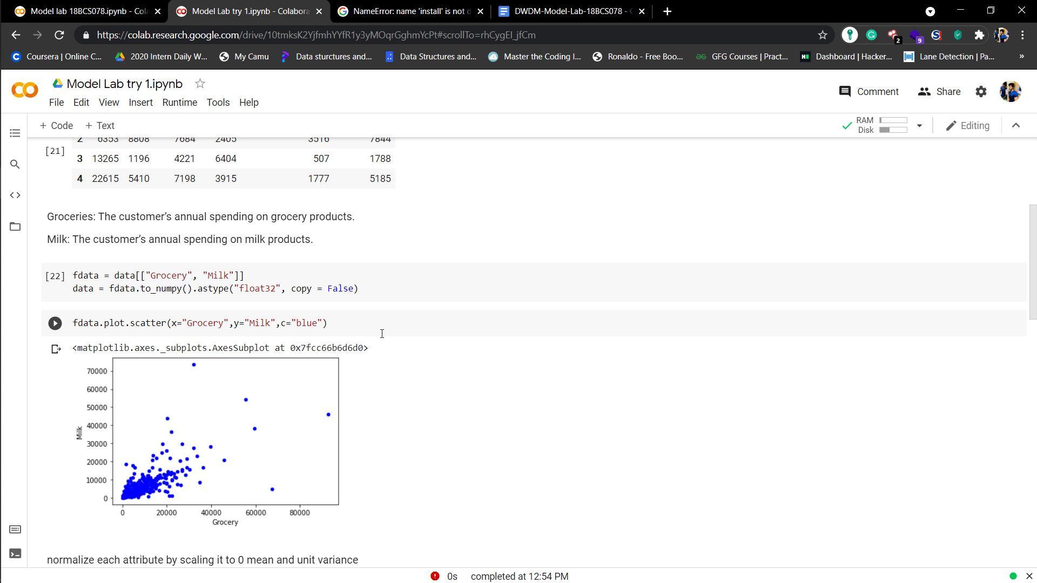

Dataset 2 : [link](https://raw.githubusercontent.com/rohindh-hub/DWDM-Model-Lab-18BCS078/main/Credit_Card.csv)

|  |  |
| --- | --- |
| **Attributes** | **Attributes type** |
| 1. CUST_ID | Nominal |
| 1. BALANCE | Nominal |
| 1. BALANCE_FREQUENCY | Nominal |
| 1. PURCHASES | Nominal |
| 1. ONEOFF_PURCHASES | Nominal |
| 1. INSTALLMENTS_PURCHASES | Nominal |
| 1. CASH_ADVANCE | Nominal |
| 1. PURCHASES_FREQUENCY | Nominal |
| 1. ONEOFF_PURCHASES_FREQUENCY | Nominal |
| 1. PURCHASES_INSTALLMENTS_FREQUENCY | Nominal |
| 1. CASH_ADVANCE_FREQUENCY | Nominal |
| 1. CASH_ADVANCE_TRX | Nominal |
| 1. PURCHASES_TRX | Nominal |
| 1. CREDIT_LIMIT | Nominal |
| 1. PAYMENTS | Nominal |
| 1. MINIMUM_PAYMENTS | Nominal |
| 1. PRC_FULL_PAYMENT | Nominal |
| 1. TENURE | Nominal |

