Experiment No. 5

Student Name: Roshan Kumar Singh UID: 25MCA20067
Branch: MCA(GEN) Section/Group: 25MCA-1_A
Semester: 2nd Date of Performance: 24/02/26
Subject Name: Technical Training-1 Subject Code: 25CAP-652

Aim:

To gain hands-on experience in creating and using cursors in PostgreSQL for row-by-row data processing, enabling sequential access and manipulation of query results.

Objective:
- To understand the concept and need of cursors in PostgreSQL
- To learn sequential data access using cursors
- To perform row-level manipulation using cursor logic
- To understand cursor lifecycle management
- To handle cursor termination and exceptions.

Tools Used:

PostgreSQL
Procedure:

Step 1: Implementing a Simple Forward-Only Cursor

- Creating a cursor to loop through an employee table and print individual records.

Step 2: Complex Row-by-Row Manipulation

- Using a cursor to update salaries based on a dynamic "Experience-to-Performance" ratio logic.

Step 3: Exception and Status Handling

- Ensuring the cursor handles empty result sets or termination signals gracefully.

Code:

CREATE TABLE employee (
emp_id INT PRIMARY KEY,
emp_name VARCHAR(50),
salary NUMERIC,
experience INT,
performance VARCHAR(1)
);

INSERT INTO employee VALUES
(1, 'Roshan', 25000, 5, 'B'),
(2, 'Swayam', 40000, 3, 'A'),
(3, 'Sanchit', 25000, 2, 'C'),
(4, 'Ankush', 30000, 4, 'A'),
(5, 'Riya', 30000, 3, 'B');

--1
DO $$
DECLARE
emp_cursor CURSOR FOR
SELECT emp_id, emp_name, salary FROM employee;
rec RECORD;
BEGIN
OPEN emp_cursor;

LOOP
FETCH emp_cursor INTO rec;
EXIT WHEN NOT FOUND;
RAISE NOTICE 'ID: %, Name: %, Salary: %',
rec.emp_id, rec.emp_name, rec.salary;
END LOOP;

CLOSE emp_cursor;
END $$;

--2
DO $$
DECLARE
emp_cursor CURSOR FOR
SELECT emp_id, salary, experience, performance FROM employee;
rec RECORD;
new_salary NUMERIC;
BEGIN
OPEN emp_cursor;

LOOP
FETCH emp_cursor INTO rec;
EXIT WHEN NOT FOUND;

IF rec.experience >= 5 AND rec.performance = 'A' THEN
new_salary := rec.salary * 1.20;
ELSIF rec.experience >= 3 AND rec.performance = 'B' THEN
new_salary := rec.salary * 1.10;
ELSE
new_salary := rec.salary * 1.05;
END IF;

UPDATE employee
SET salary = new_salary
WHERE emp_id = rec.emp_id;
END LOOP;

CLOSE emp_cursor;
END $$;
--3
DO $$
DECLARE
emp_cursor CURSOR FOR SELECT * FROM employee;
rec RECORD;
BEGIN
OPEN emp_cursor;

LOOP
FETCH emp_cursor INTO rec;
EXIT WHEN NOT FOUND;
RAISE NOTICE 'Processing Employee: %', rec.emp_name;
END LOOP;

CLOSE emp_cursor;

EXCEPTION
WHEN OTHERS THEN
RAISE NOTICE 'Error occurred: %', SQLERRM;
END $$;

Output:

Table create and data insert

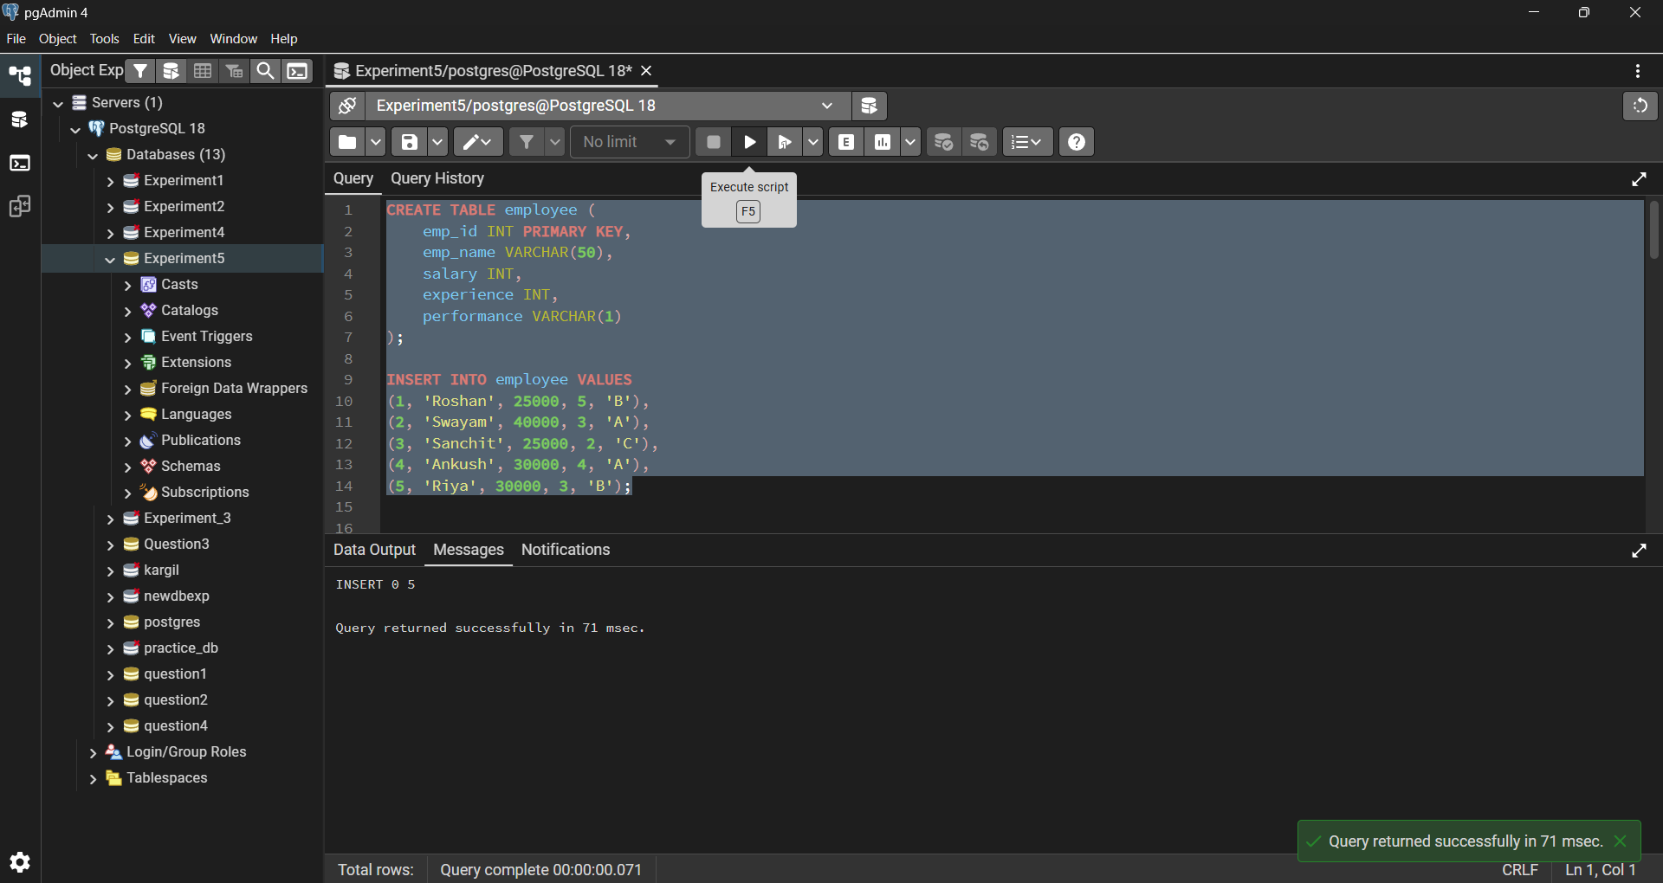

Step1: Implementing a Simple Forward-Only Cursor

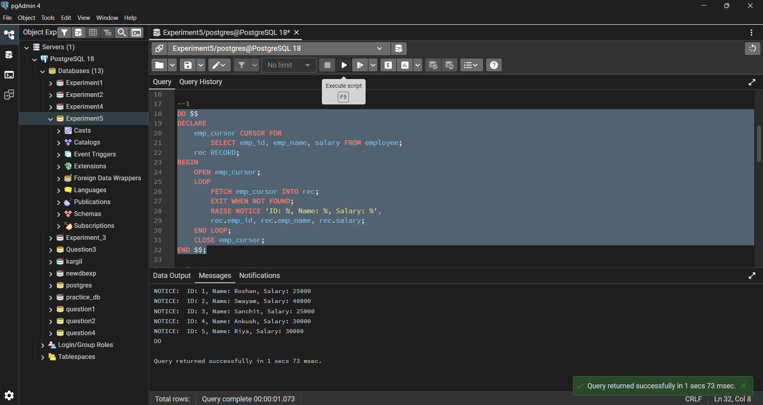

Step2: Complex Row-by-Row Manipulation

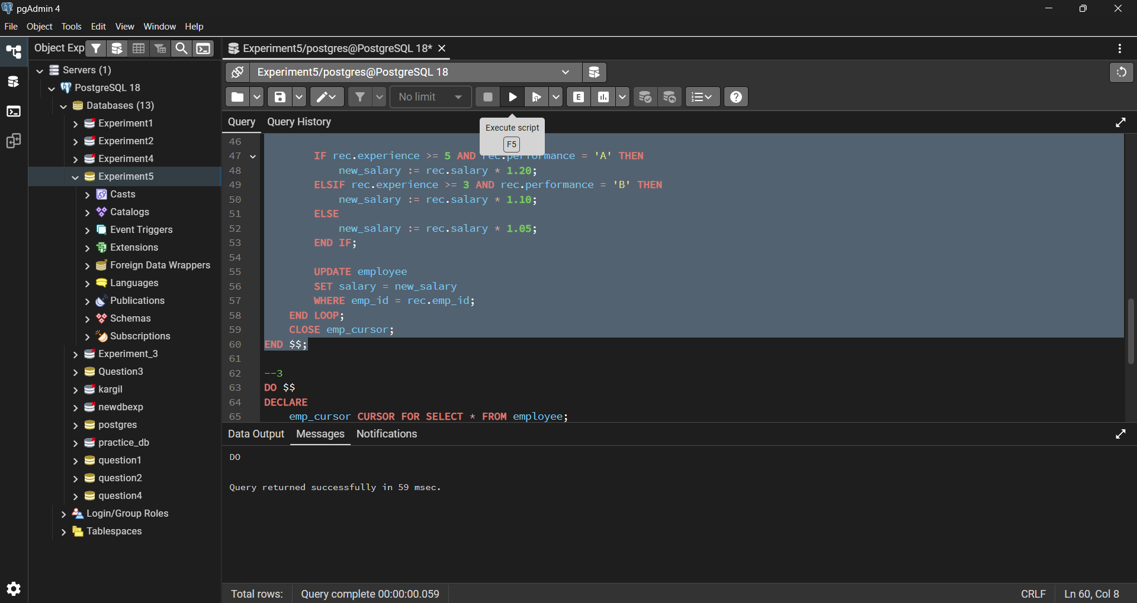

Step3: Exception and Status Handling

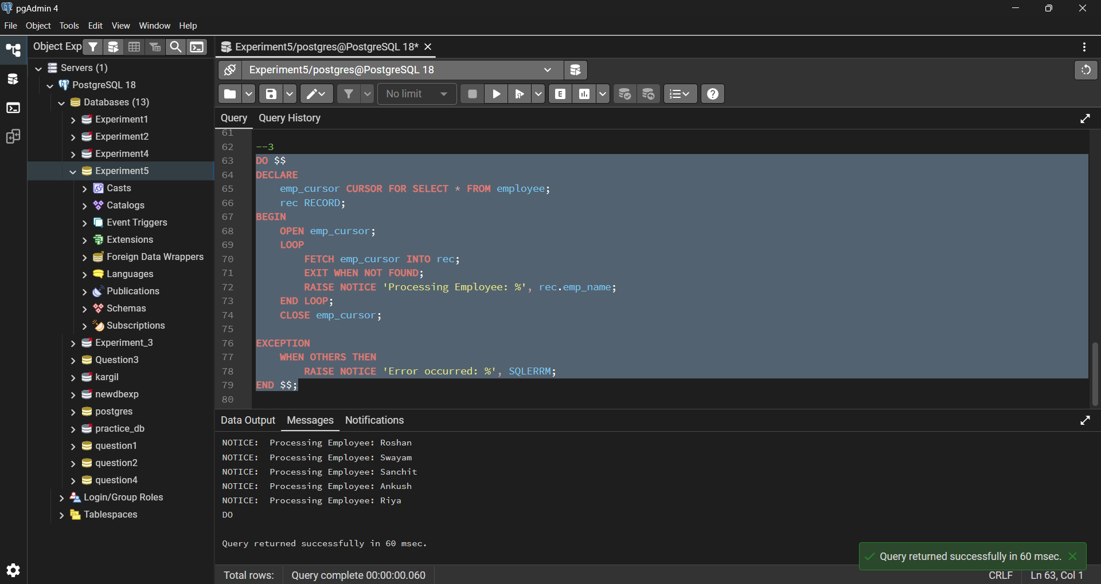

Learning Outcomes:

- Understood cursor-based row-by-row processing
- Learnt cursor lifecycle in PostgreSQL
- Applied complex conditional logic using cursors
- Handled cursor termination and exceptions
- Gained confidence in writing procedural SQL programs.

