Experiment No. 6

Student Name: Roshan Kumar Singh UID: 25MCA20067
Branch: MCA(GEN) Section/Group: 25MCA-1_A
Semester: 2nd Date of Performance: 24/02/26
Subject Name: Technical Training-1 Subject Code: 25CAP-652

Aim:

To learn how to create, query, and manage views in PostgreSQL in order to simplify database queries and provide a layer of abstraction and security for end-users.

Objective:
- To understand data abstraction using views
- To learn how views enhance database security
- To simplify complex queries using views
- To understand creation, modification, and deletion of views
- To apply views in real-world scenarios like payroll and reporting.

Tools Used:

PostgreSQL
Procedure:

Step 1: Creating a Simple View for Data Filtering

- Create a view to show only active employees
- Hide unnecessary columns

Step 2: Creating a View for Joining Multiple Tables

- Combine employee and department data
- Simplify multi-table queries

Step 3: Advanced Summarization View

- Generate department-level statistics automatically

Code:

CREATE TABLE department (
dept_id INT PRIMARY KEY,
dept_name VARCHAR(50)
);

CREATE TABLE employee (
emp_id INT PRIMARY KEY,
emp_name VARCHAR(50),
salary NUMERIC,
status VARCHAR(10),
dept_id INT,
FOREIGN KEY (dept_id) REFERENCES department(dept_id)
);

INSERT INTO department VALUES
(1, 'HR'),
(2, 'IT'),
(3, 'Finance');

INSERT INTO employee VALUES
(1, 'Roshan', 30000, 'Active', 2),
(2, 'Swayam', 40000, 'Active', 2),
(3, 'Riya', 25000, 'Inactive', 1),
(4, 'Ankush', 35000, 'Active', 3),
(5, 'Sanchit', 28000, 'Active', 1);

--1
CREATE VIEW active_employees AS
SELECT emp_id, emp_name, dept_id
FROM employee
WHERE status = 'Active';

SELECT * FROM active_employees;

--2

CREATE VIEW employee_department_view AS
SELECT e.emp_id, e.emp_name, d.dept_name
FROM employee e
JOIN department d ON e.dept_id = d.dept_id;

SELECT * FROM employee_department_view;

--3

CREATE VIEW department_summary AS
SELECT d.dept_name,
COUNT(e.emp_id) AS total_employees,
AVG(e.salary) AS average_salary
FROM department d
JOIN employee e ON d.dept_id = e.dept_id
GROUP BY d.dept_name;

SELECT * FROM department_summary;

DROP VIEW department_summary;

Output:

Table create and data insert

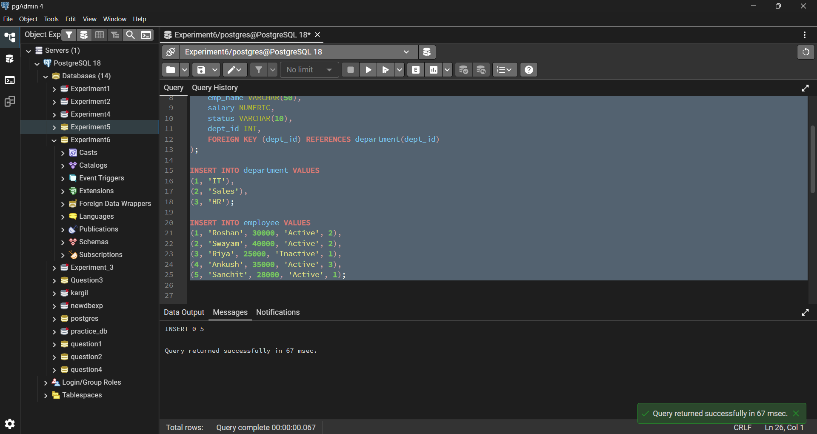

Step1: Creating a Simple View for Data Filtering

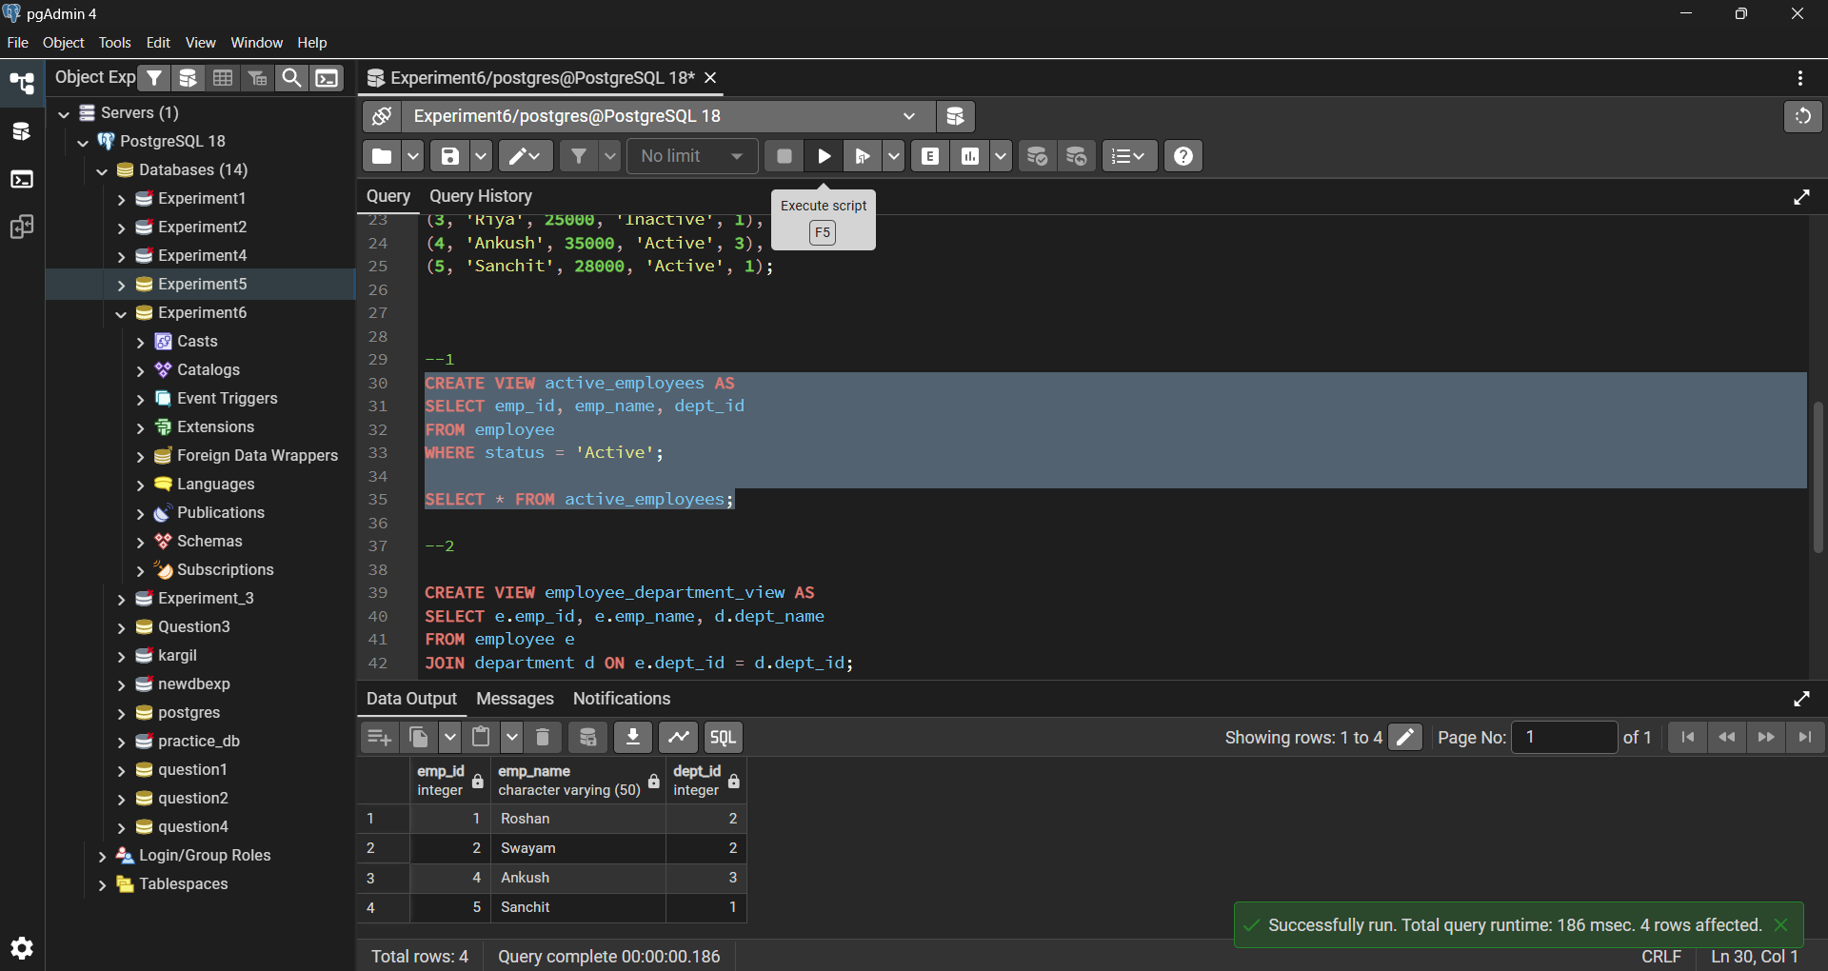

Step2: Creating a View for Joining Multiple Tables

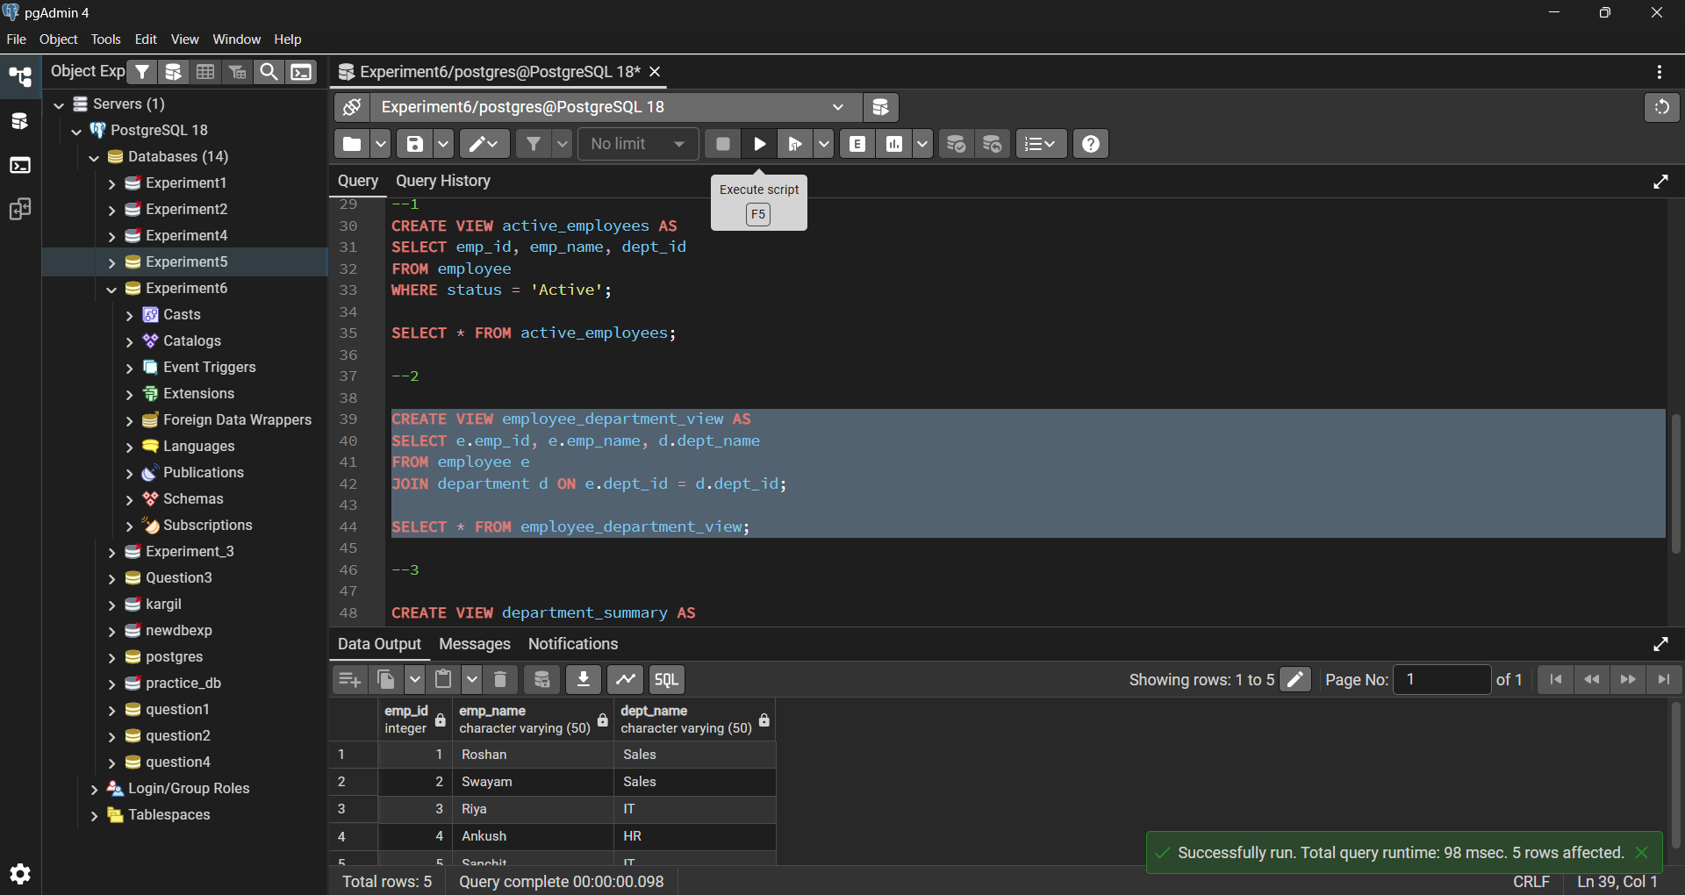

Step3: Advanced Summarization View

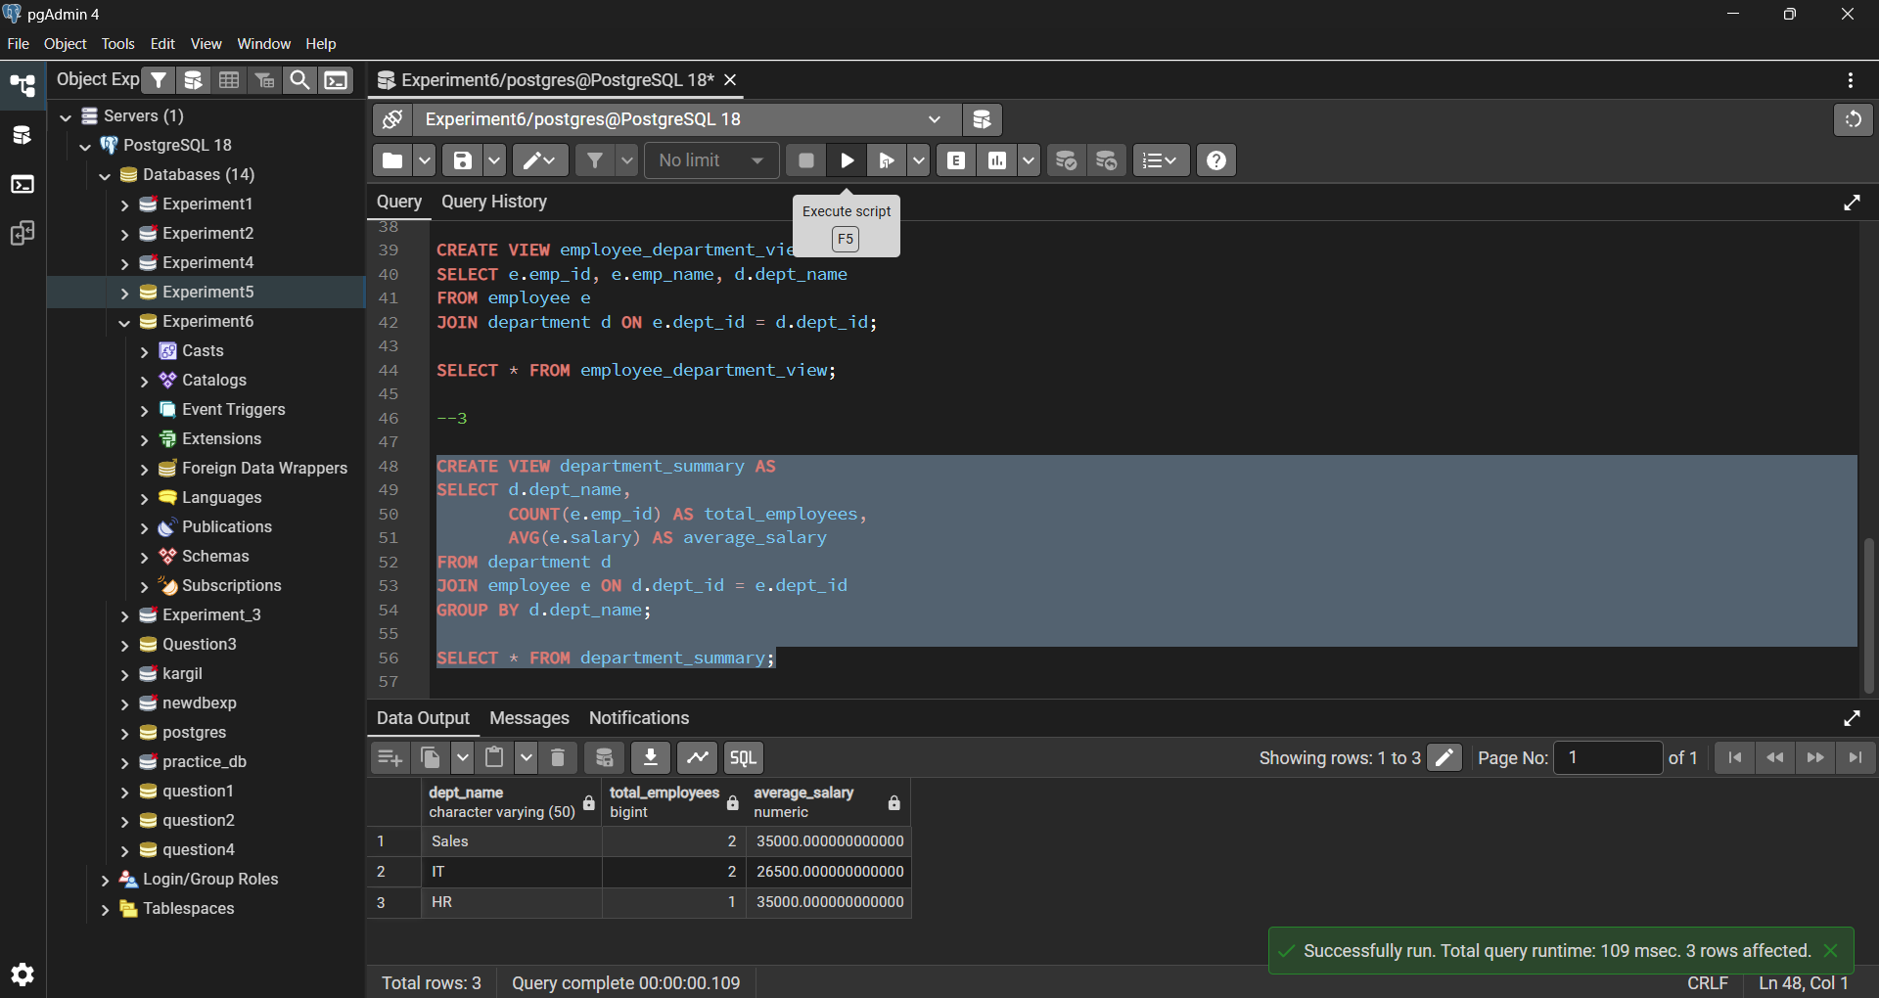

Learning Outcomes:

- Understood the concept of views in PostgreSQL
- Learnt how views provide data abstraction and security
- Created simple and complex views
- Used views for reporting and summarization
- Gained practical knowledge of real-world database design.

