Experiment No. 2

Student Name: Roshan Kumar Singh UID: 25MCA20067
Branch: MCA(GEN) Section/Group: 25MCA-1_A
Semester: 2nd Date of Performance: 13/01/26
Subject Name: Technical Training-1 Subject Code: 25CAP-652

Aim:

To implement and analyze SQL SELECT queries using filtering, sorting, grouping, and aggregation concepts in PostgreSQL for efficient data retrieval and analytical reporting.

Objective:
- To retrieve specific data using filtering conditions
- To sort query results using single and multiple attributes
- To perform aggregation using grouping techniques
- To apply conditions on aggregated data
- To understand real-world analytical queries commonly asked in placement interviews

S/W Requirement:

PostgreSQL
Procedure:
Step 1: Database and Table Preparation

- Start the PostgreSQL server.
- Open the PostgreSQL client tool.
- Create a database for the experiment.
- Prepare a sample table representing customer orders containing details such as customer name, product, quantity, price, and order date.
- Insert sufficient sample records to allow meaningful analysis.

Step 2: Filtering Data Using Conditions

- Execute data retrieval operations to display only those records that satisfy specific conditions, such as higher-priced orders.
- Observe how filtering limits the number of rows returned.

Step 3: Sorting Query Results

- Retrieve selected columns from the table and arrange the output based on numerical values such as price.
- Perform sorting using both ascending and descending order.
- Apply sorting on more than one attribute to understand priority-based ordering.

Step 4: Grouping Data for Aggregation

- Group records based on a common attribute such as product.
- Calculate aggregate values like total sales for each group.
- Analyze how multiple rows are combined into summarized results.

Step 5: Applying Conditions on Aggregated Data

- Apply conditions on grouped results to retrieve only those groups that satisfy specific aggregate criteria.
- Compare the difference between row-level filtering and group-level filtering.

Step 6: Conceptual Understanding of Filtering vs Aggregation Conditions
- Analyze scenarios where conditions are incorrectly applied before grouping.
- Correctly apply conditions after grouping to avoid logical errors.

Code:

CREATE TABLE customer_orders(
order_id INT PRIMARY KEY ,
customer_name VARCHAR(50),
product VARCHAR(50),
quantity INT,
price INT,
order_date DATE
);

INSERT INTO customer_orders (order_id,customer_name,product,quantity,price,order_date)VALUES
(1,'Roshan','Laptop',1,55000,'2025-01-10'),
(2,'Sanchit','Mouse',2,1200,'2025-01-11'),
(3,'Riya','Laptop',1,58000,'2025-01-12'),
(4,'Rohan','Keyboard',1,2500,'2025-01-12'),
(5,'Swayam','Mouse',3,1800,'2025-01-13'),
(6,'Rittika','Laptop',2,110000,'2025-01-14');

--step 2
SELECT * FROM customer_orders WHERE price>50000;

--step3
--asc
SELECT customer_name,product,price FROM customer_orders ORDER BY price ASC;
--desc
SELECT customer_name,product,price FROM customer_orders ORDER BY price DESC;
--mul col
SELECT customer_name,product,price FROM customer_orders ORDER BY product ASC, price DESC;

--step4
SELECT product, SUM(price) AS total_sales FROM customer_orders GROUP BY product;

--step5
SELECT product, SUM(price) AS total_sales FROM customer_orders GROUP BY product HAVING SUM(price)>60000;

--step6
SELECT product, SUM(price * quantity) AS total_sales FROM customer_orders WHERE SUM(price * quantity) > 60000 GROUP BY product;

SELECT product, SUM(price) FROM customer_orders GROUP BY product HAVING SUM(price)>60000;

Output:

Step2 output:

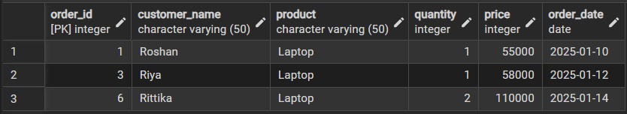

Step3 outputs
Asc order:

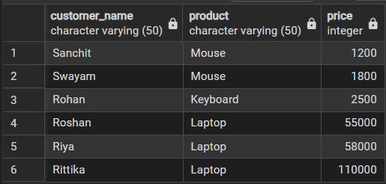

Desc order:

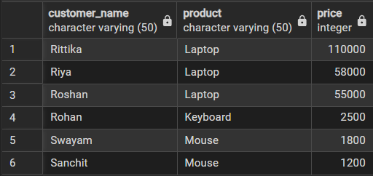

Multiple column:

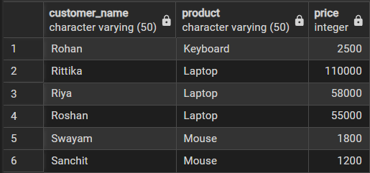

Step4 output:

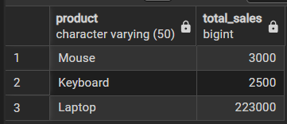

Step5 output:

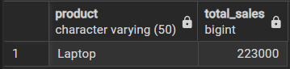

Step6 error while where conditions are incorrectly applied before grouping.

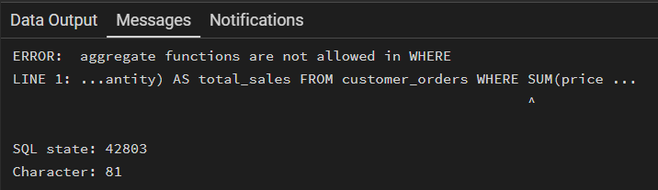

Step6 output:

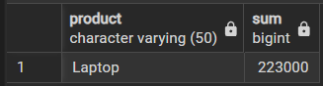

Learning Outcomes:

- Understood how data can be filtered to retrieve only relevant records from a database.
- Learnt how sorting improves readability and usefulness of query results in reports.
- Gained the ability to group data for analytical purposes.
- Clearly able to differentiate between row-level conditions and group-level conditions.
- Developed confidence in writing analytical SQL queries used in real-world scenarios.

