## 5. Results

This chapter presents the results of the experiments described in the Methods, where the order of result presentation generally matched the order given in the Methods.

### 5.1 Exploratory Data Analysis

#### 5.11 Missing Data Analysis

The proportion of missing MMR data varied by a large margin across income levels (see Figure 10, below). Generally, the proportion of missing data decreased as income level increased. The difference between the proportion of missing data in lower-middle and upper-middle income countries is larger than the difference between low and lower-middle income countries and the difference between high and upper-middle income countries. There was a slight downward trend in the proportion of missing data per year over time, with this trend being more noticeable in high and upper-middle income countries. For example, proportion of missing data decreased from under 25% and 35% pre-1995 to under 15% and 25% between 2000 and 2014 for high and upper-middle income countries, respectively. Interestingly, the proportion of missing data started increasing for high and upper-middle income countries post-2010, with the total increase being over 30%.

**Figure 10:** The proportion of missing MMR data per year for all countries in a specific income level between 1985 and 2018. The proportion of missing data across low-income countries was plotted in red, lower-middle in orange, upper-middle in blue, and high in green.

#### 5.12 Key Statistics in the Merged Input Data Before Pre-Processing

As described in Section 4.Generally, health outcomes improved as income level increased, as expected. Standard deviation in the outcome decreased as income level decreased, indicating a more uniform quality of care. While many of the important variables have low rates of missing data, some of the important socio-economic and quality of care features had increasing proportions of missing data as income level increased. For example, the dataset for the lowest income level countries was missing 58% of data regarding ‘women participating in own health care decisions (% of women age 15-49)’ while the dataset for the highest income countries was missing 99.9% (see Table 4). This feature was sourced from a Demographic Health Survey (DHS), which is normally collected in lower income countries, explaining the data disparity. This is a good trend to be aware of when analysing feature importance for features measured more frequently using DHS data.

According to Table 4, the national MMR estimates were subject to large outliers, as the mean values were larger than the median values for all income levels. Additionally, the standard deviation for the MMR estimates was large. The difference between mean and median, as well as the magnitude of the standard deviation, decreased as income level increased. This indicates that outliers will be more common for lower income countries, as they have a wider variety of possible MMR values than higher income countries.

**Table 10:** Mean, median, standard deviation and proportion of missing data of features with a meaningful relationship to MMR. The key summary statistics were presented per income level.

|  |  |  |  |  |  |
| --- | --- | --- | --- | --- | --- |
| **Feature** | **Income Level** | **Mean** | **Median** | **Standard Deviation** | **Proportion of Missing Data (%)** |
| WHO national MMR estimate | Low | 657 | 617 | 453 | 0 |
| Upper middle | 197 | 55 | 260 | 0 |
| Lower middle | 51 | 38 | 55 | 0 |
| High | 15 | 8 | 21 | 0 |
| Infant mortality rate (per 1,000 live births) | Low | 63 | 65 | 29 | 0 |
| Upper middle | 43 | 39 | 23 | 0 |
| Lower middle | 24 | 19 | 15 | 0 |
| High | 9 | 7 | 7 | 2 |
| Pregnant women receiving prenatal care (%) | Low | 74 | 85 | 23 | 28 |
| Upper middle | 81 | 86 | 18 | 65 |
| Lower middle | 92 | 96 | 10 | 78 |
| High | 93 | 97 | 8 | 95 |
| Women participating in own health care decisions (% of women age 15-49) | Low | 55 | 60 | 22 | 58 |
| Upper middle | 65 | 67 | 22 | 86 |
| Lower middle | 84 | 84 | 8.7 | 97 |
| High | 91 | 91 | NaN | 99.9 |
| Communicable, maternal, neonatal, and nutritional diseases prevalence in females (age standardized) (per 100,000 population) | Low | 79,399 | 84,661 | 14,140 | 77 |
| Upper middle | 73,030 | 73,279 | 9,389 | 84 |
| Lower middle | 62,248 | 63,092 | 10,658 | 86 |
| High | 38,835 | 36,807 | 11,821 | 87 |
| Survival to age 65, female (% of cohort) | Low | 59 | 58 | 13 | 0 |
| Lower-Middle | 71 | 73 | 12 | 0 |
| Upper-Middle | 79 | 80 | 8 | 0 |
| High | 87 | 88 | 5 | 0 |
| Unmet need for contraception | Low | 27 | 28 | 7 | 33 |
| Upper middle | 22 | 23 | 8 | 72 |
| Lower middle | 13 | 12 | 6 | 88 |
| High | 13 | 10 | 10 | 97 |

#### 5.13 Principal Component Analysis

The dense cluster of data in the bottom left of the Figures 6a and 6b correspond to the countries with the lowest MMRs and highest income levels, as expected. A country’s income level tended to decrease and its MMR tended to increase travelling up and to the right of Figures 6a and 6b, indicating an relationship between the two trends. There was no clustering by year (see Figure 6c), potentially due to heterogeneity in countries’ MMR ratios at time points (see Figure 3). The greater influence of income level on MMR compared to year was shown in Figure 3.

a) b)

c)

**Figure 6:** PCA projection of feature dataset onto first two principal components, which captured 30.8 and 8.6% of the data’s total variation, respectively. The PCA projection was coloured by the sample’s a) MMR ratio, b) income level, c) year.

#### 5.14 Correlation Analysis

analysed to provide were multiple instances of features with a high magnitude pair-wise Pearson correlation coefficient with MMR (see Table 6). The features with the top 5 highest magnitude coefficients measured a mixture of health-related and social outcomes, indicating the importance of using a wide range of features to predict maternal mortality.

**Table 6:** Features with the five highest magnitude pair-wise Pearson correlation coefficients with MMR.

|  |  |
| --- | --- |
| **Feature** | **Pair-wise Pearson Correlation Coefficient** |
| Women and girls who use menstrual materials (% of women and girls ages 15-49 who had a menstrual period within the last year) | 0.995959 |
| Probability of Survival to Age 5 | -0.869512 |
| Probability of Survival to Age 5, Female | -0.867849 |
| Probability of Survival to Age 5, Male | -0.867237 |
| 1.F.01 Maternal disorders prevalence (age standardized) (per 100 000 population) female ratio (national estimate, per 100,000 live births) | 0.848715 |

### 5.2 Data Distribution After Pre-Processing

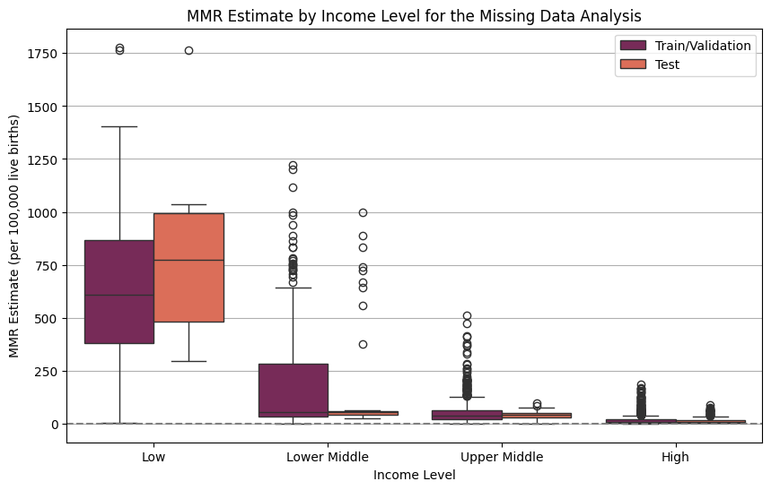

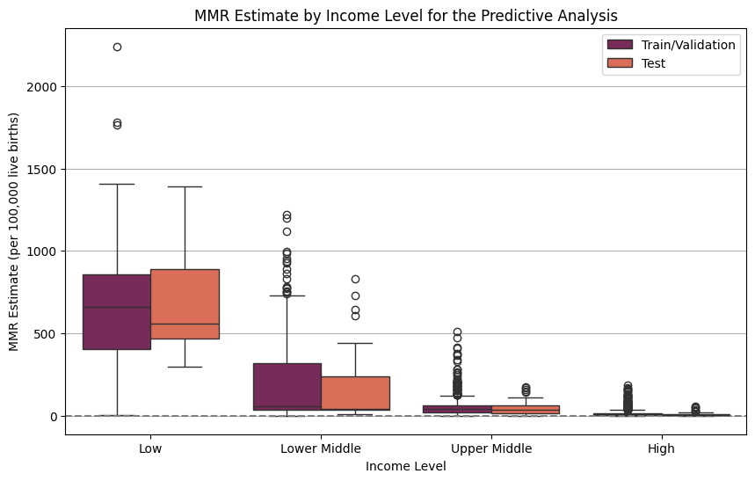

### 5.3 Base Model Results

#### 5.31 Base Model Performance on Different Feature Subsets and Missing Data Removal Thresholds

Look at correlation between the metrics, and can use later as a discussion point about comparative model performance

#### 5.32 Feature Importance Analysis

### 5.4 Ensemble Results

#### 5.41 Ensemble Performance with All Base Estimators

#### 5.42 Ensemble Performance with Different Combinations of Base Estimators

#### 5.43 Model Importance

#### 5.44 Uncertainty Analysis

### 5.5 Sensitivity Analysis

### 5.6 Comparison to Literature