## 9. Appendix

### 9.1 Additional Performance Metrics to Quantify Base Estimator Predictive Error on Different Feature Subsets and Missing Data Removal Thresholds

#### 9.11 Country-Level Prediction

##### 9.111 Random Forest

a)

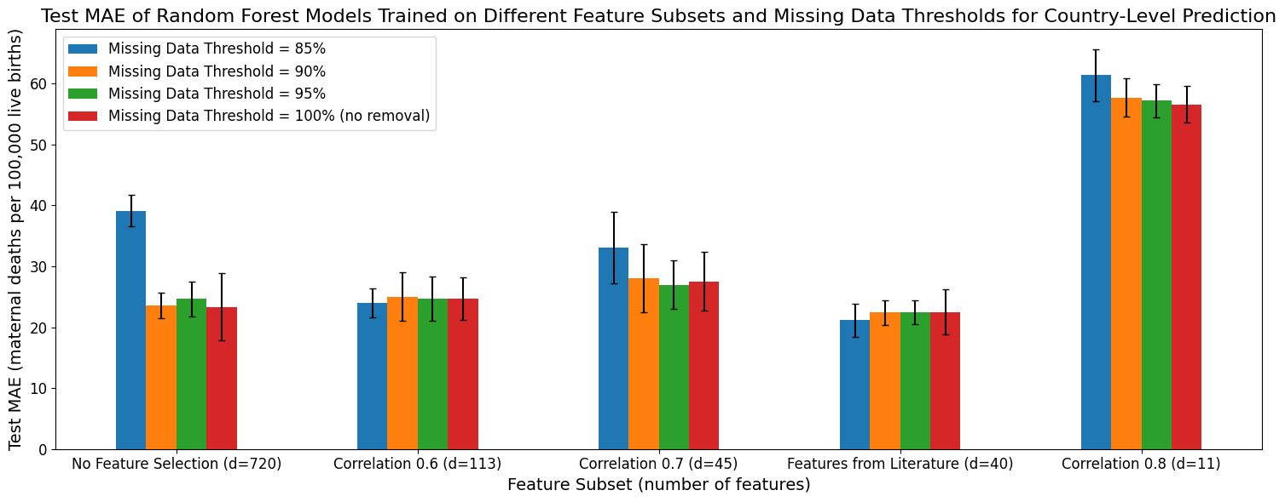

b)

c)

##### 9.112 XGBoost

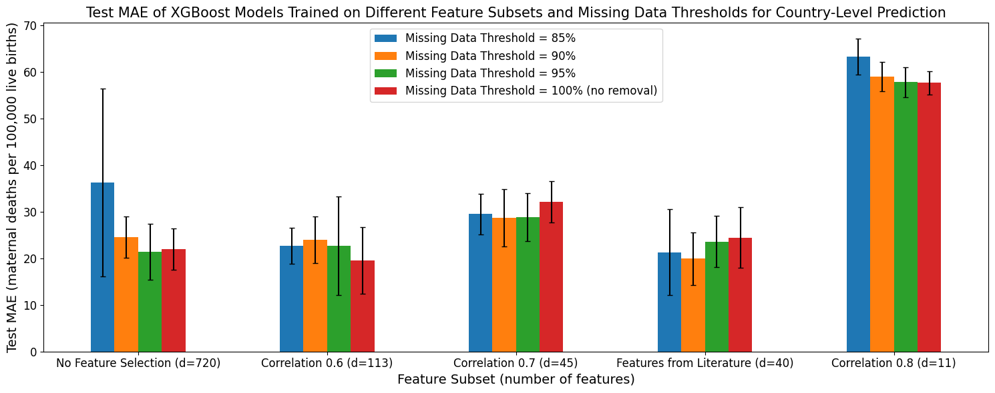

a)

b)

c)

##### 9.113 LightGBM

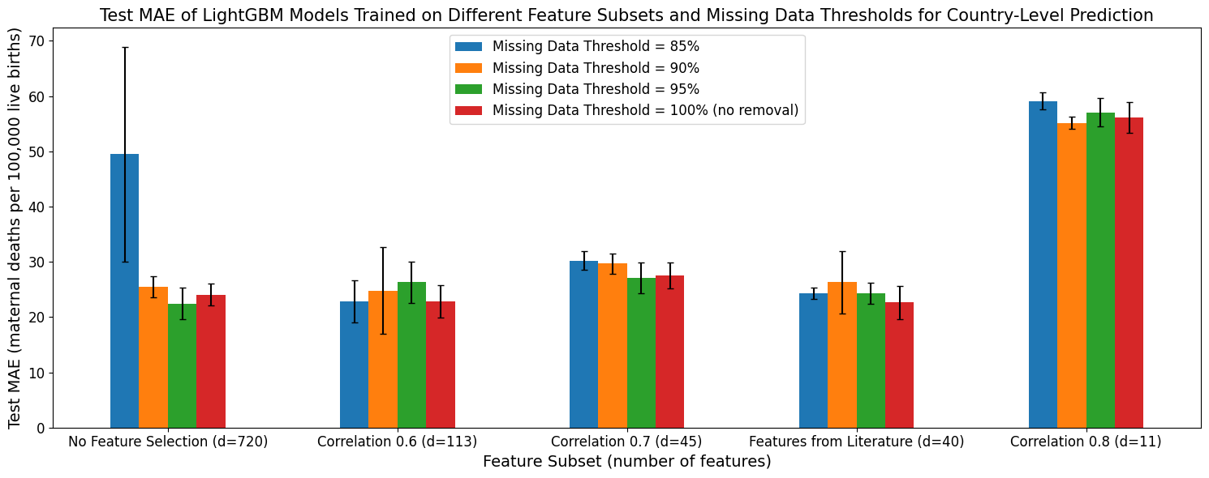

a)

b)

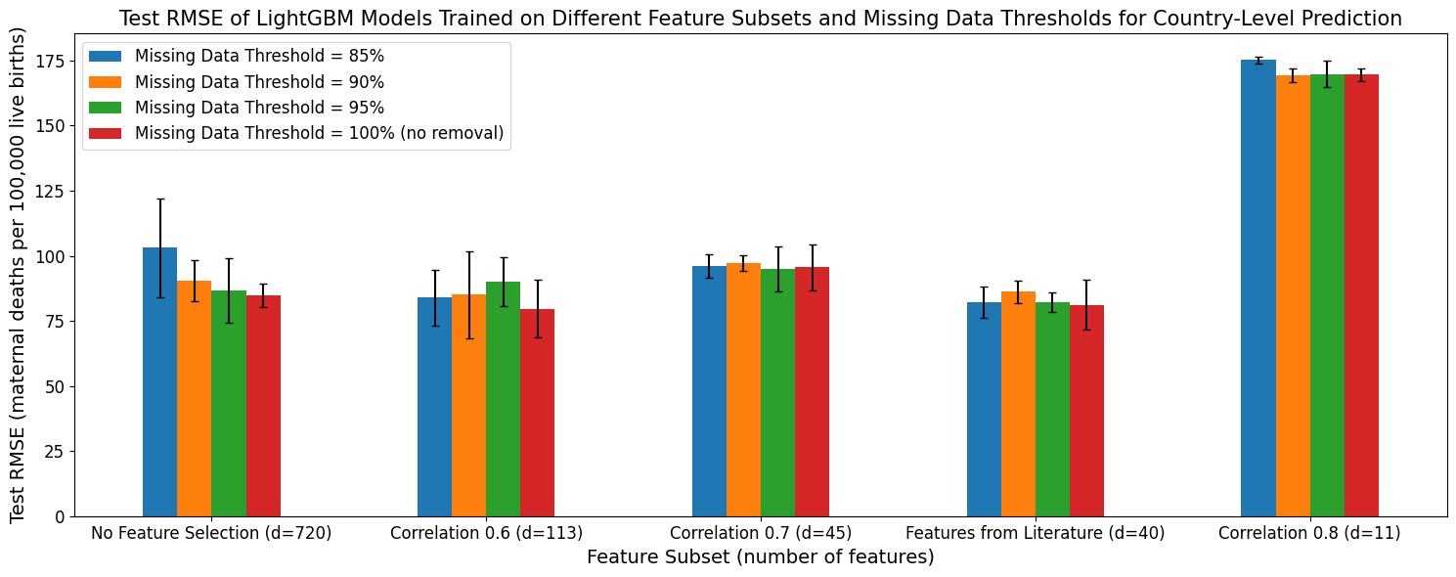

c)

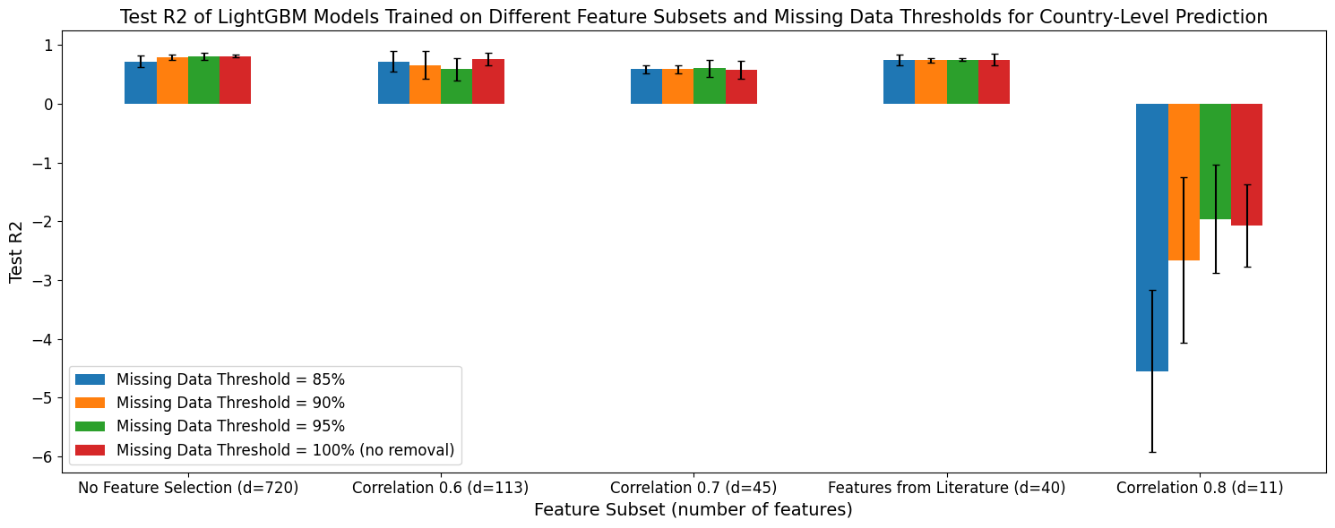

#### 9.12 Forecasting

##### 9.121 Random Forest

a)

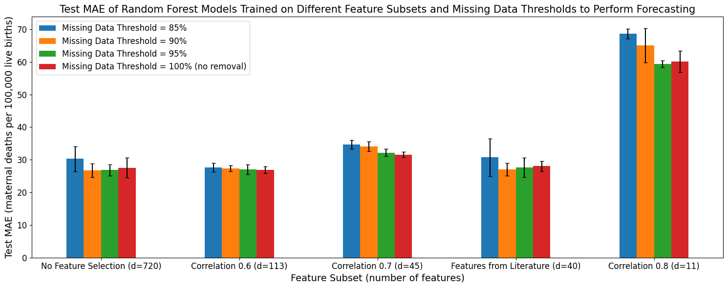

b)

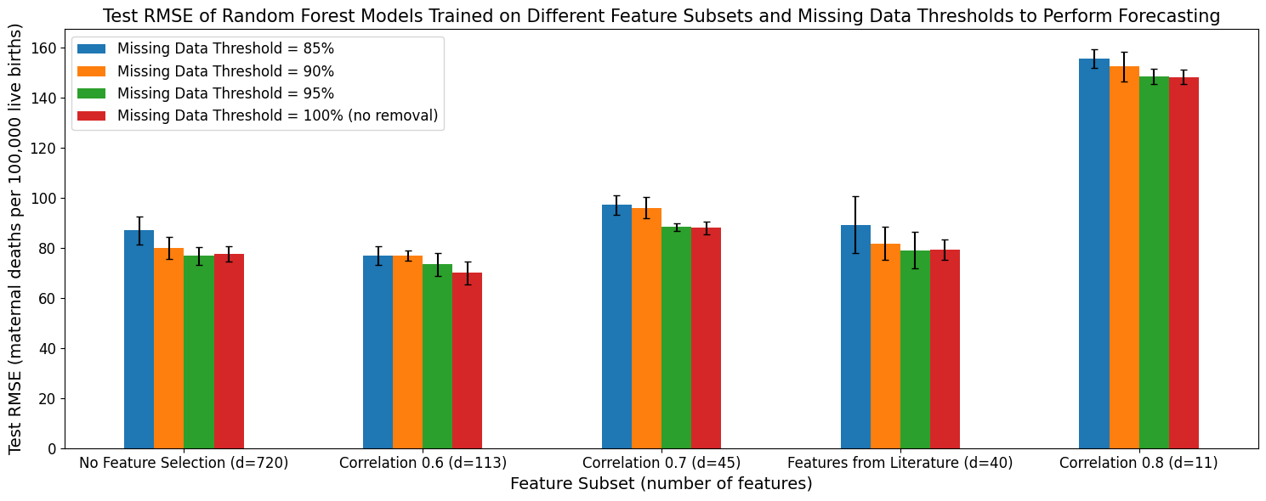

c)

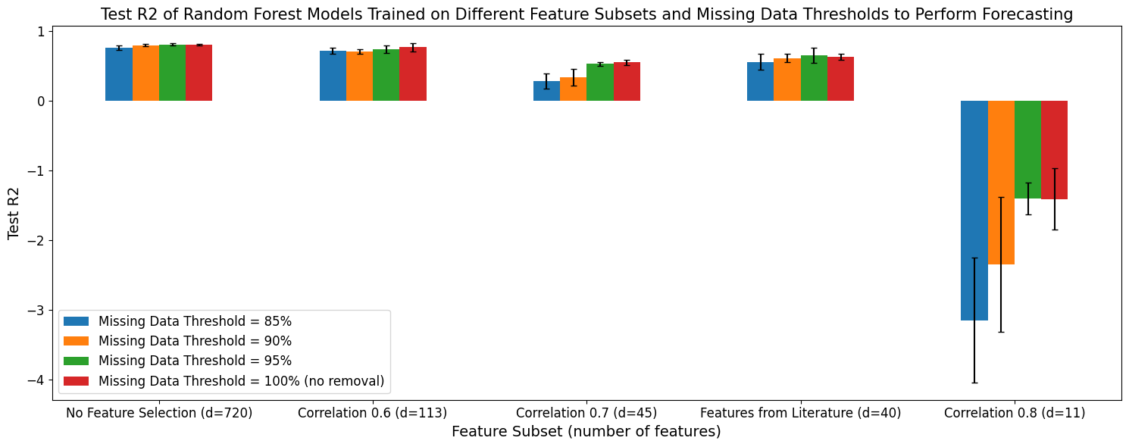

##### 9.122 XGBoost

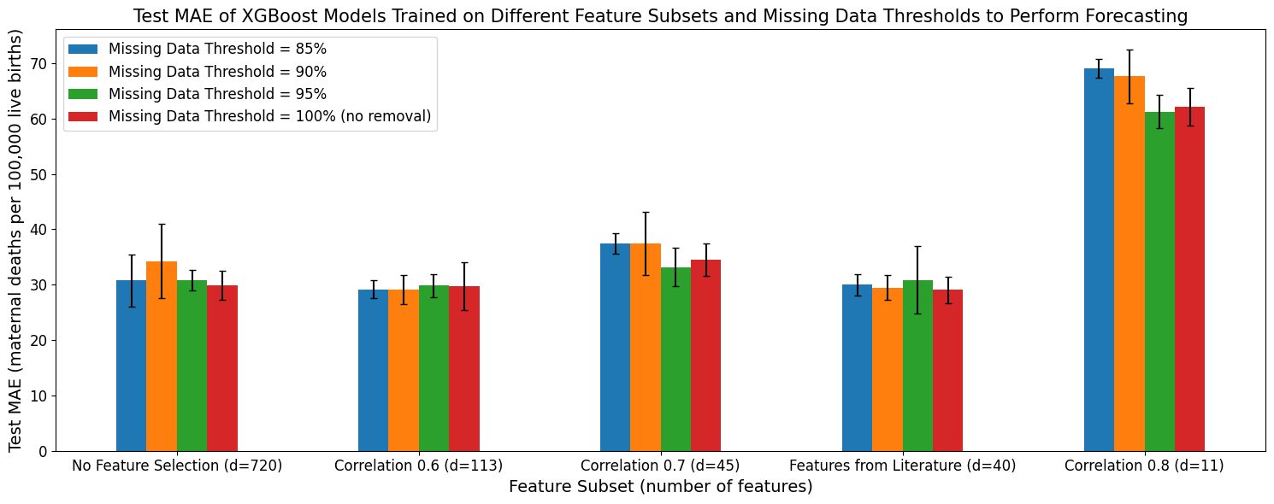

a)

b)

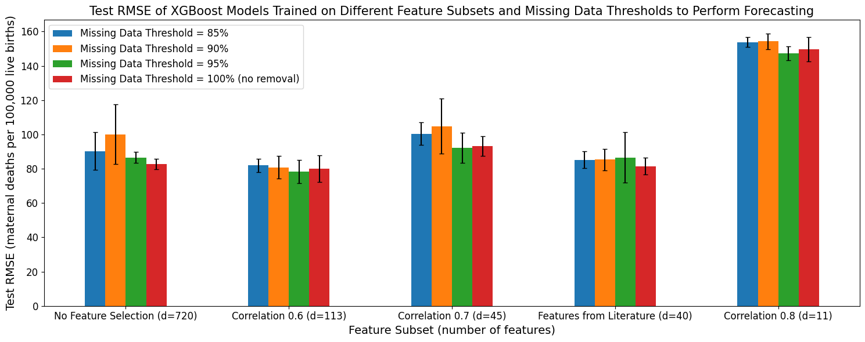

c)

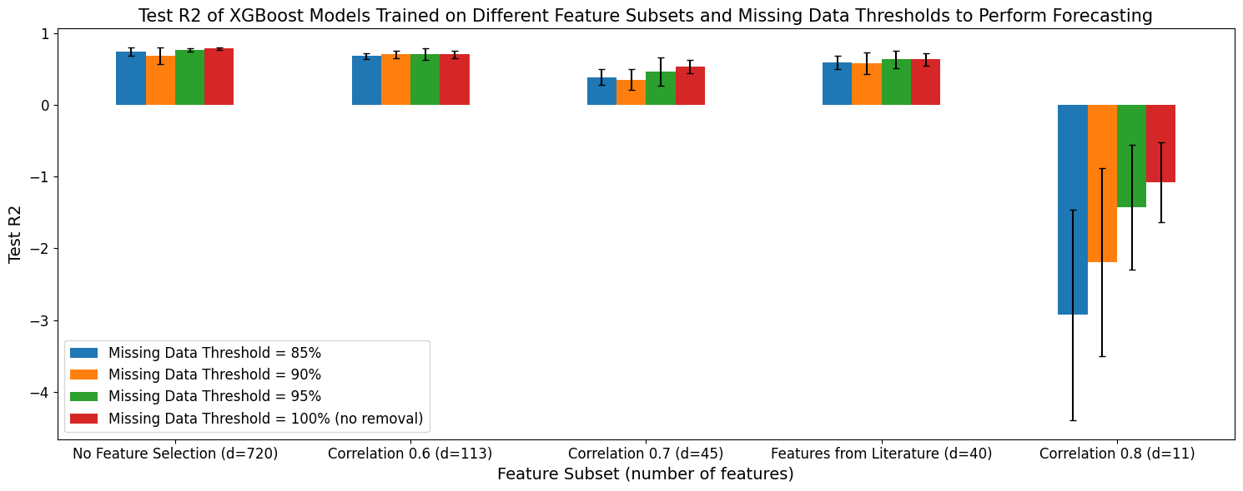

##### 9.123 LightGBM

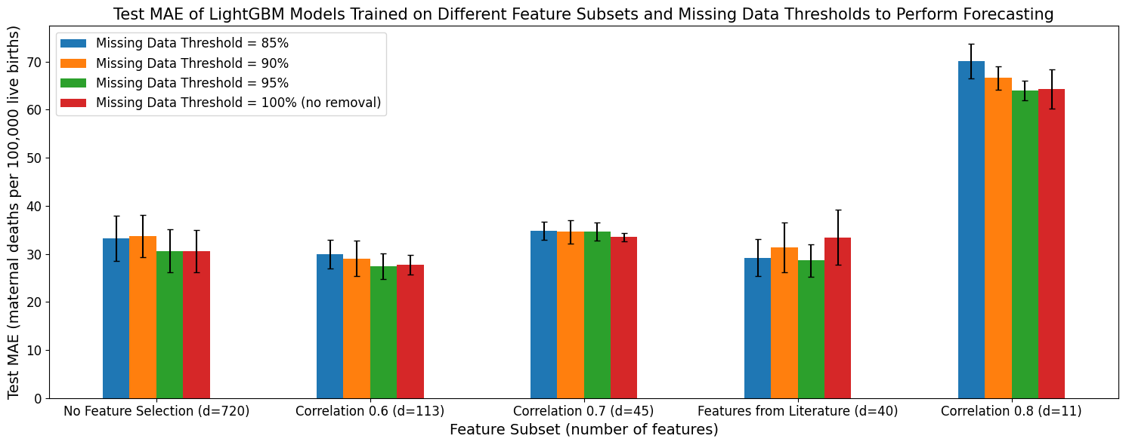

a)v

b)

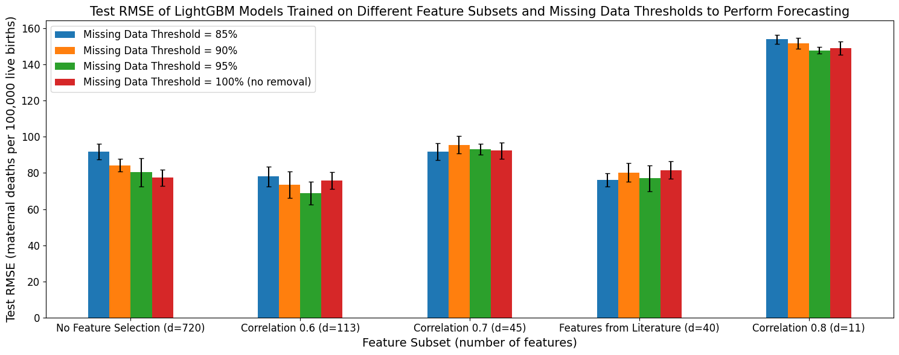

c)

### 9.2 Additional Performance Metrics to Compare Predictive Performance of Different Types of Base Estimators Trained Different Feature Subsets and Missing Data Removal Thresholds

#### 9.21: Country-Level Prediction

a)

b)

c)

#### 9.22: Forecasting

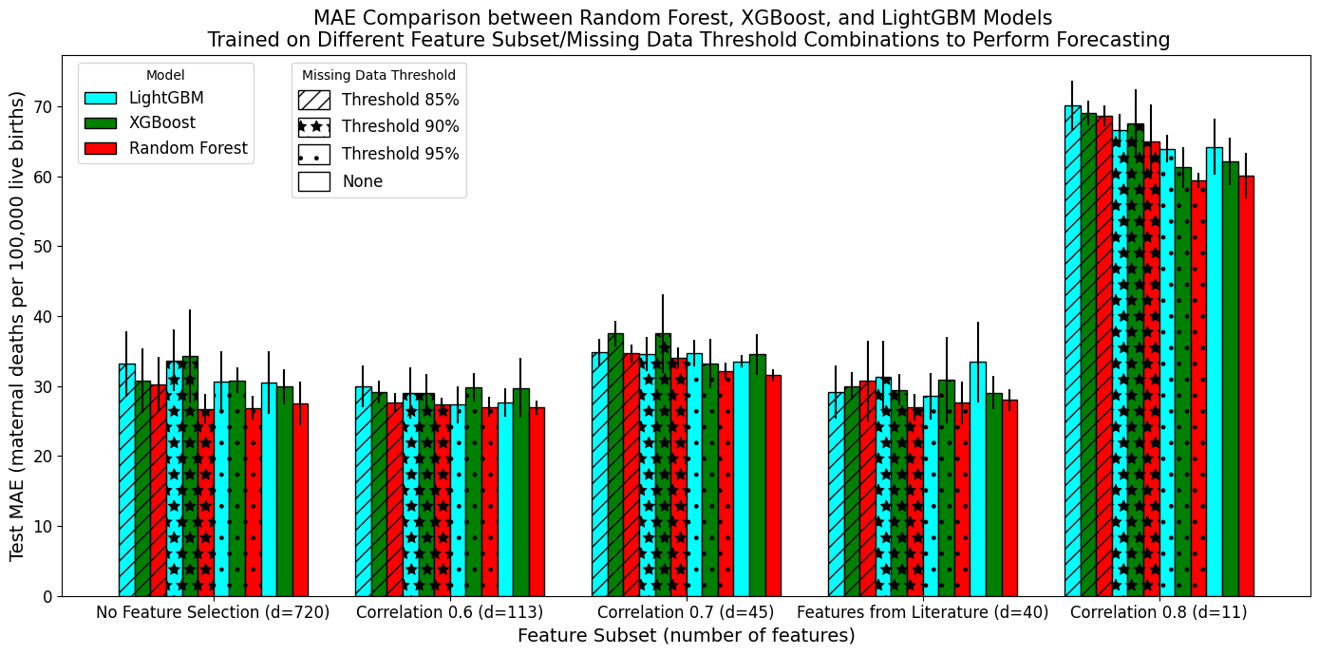

a)

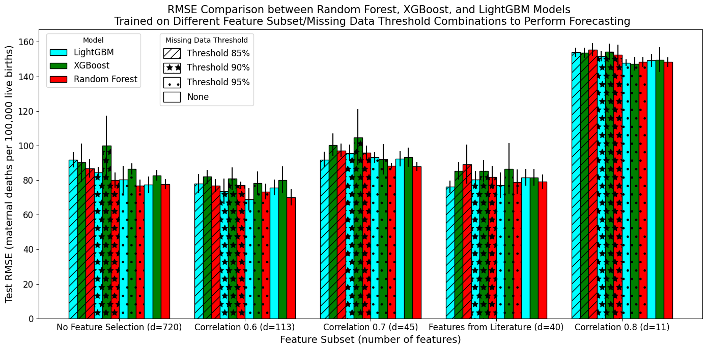

b)

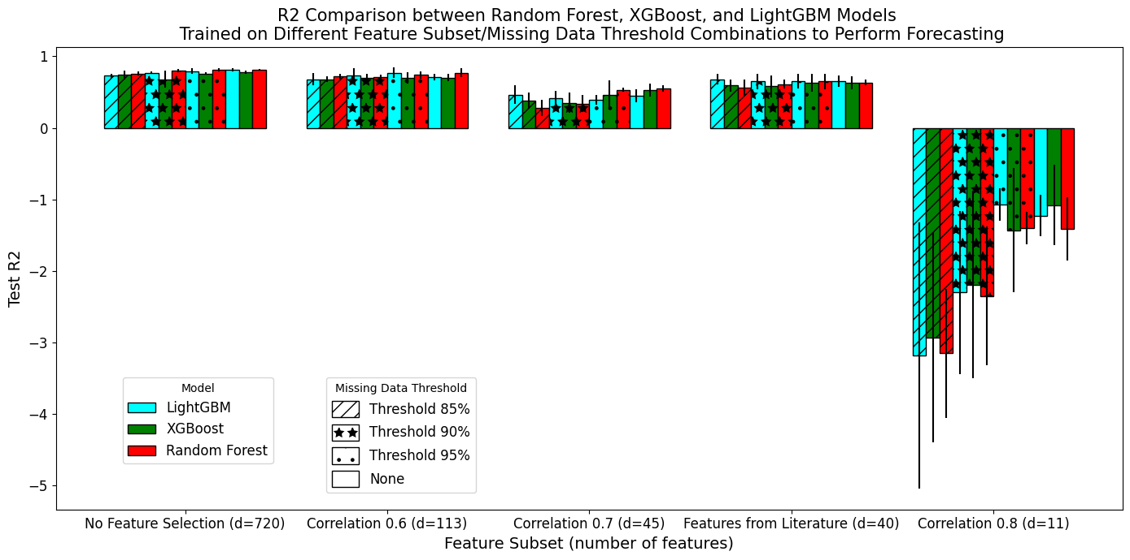

c)

### 9.3 Additional Performance Metrics to Compare Stacking versus Voting Ensemble Models

#### 9.311: Country-Level Prediction: Additional Performance Measures Comparing Stacking versus Voting Ensemble

a)

c)

b)

#### 9.312: Forecasting: Additional Performance Measures Comparing Stacking versus Voting Ensemble

b)

a)

c)

#### 9.321: Country-Level Prediction: Additional Performance Metrics to Compare Stacking versus Voting Ensemble Models Trained on All Base Estimators

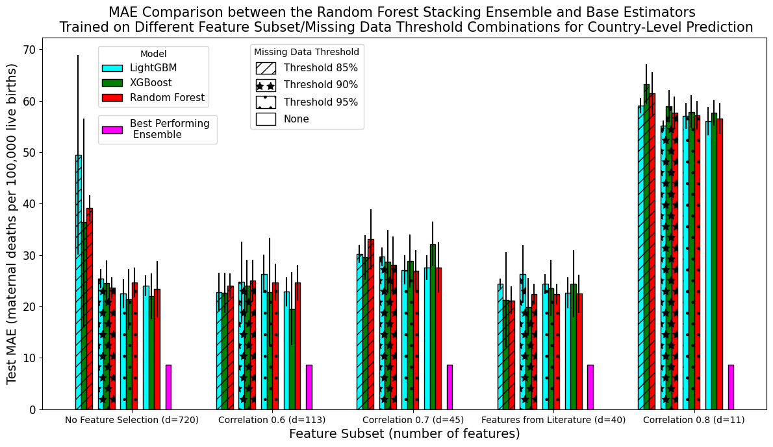

a)

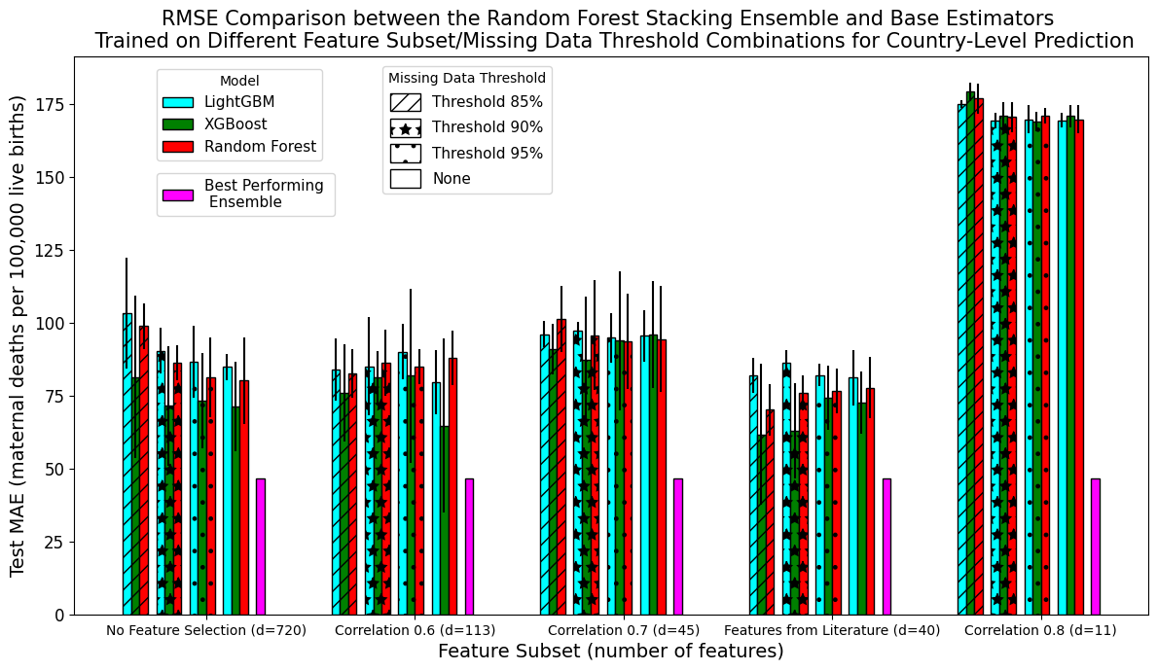

b)

c)

#### 9.322: Forecasting

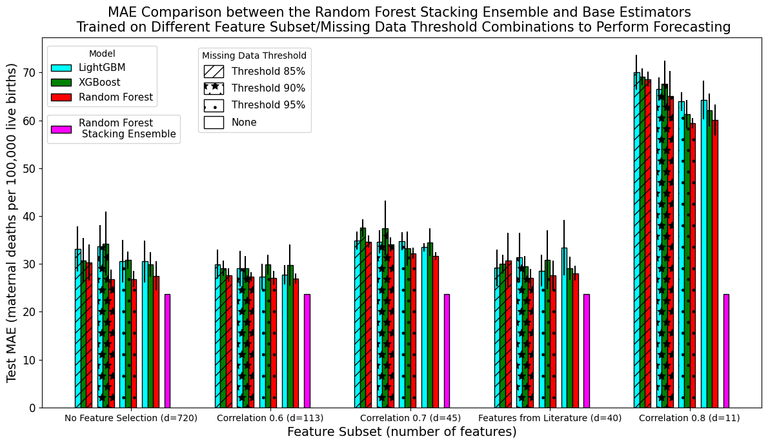

b)

a)

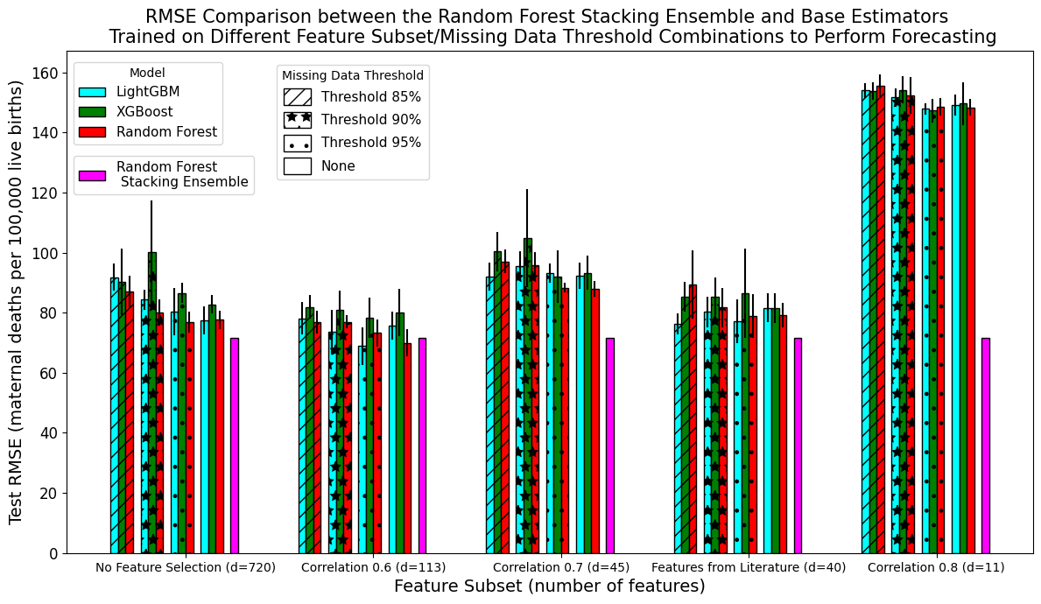

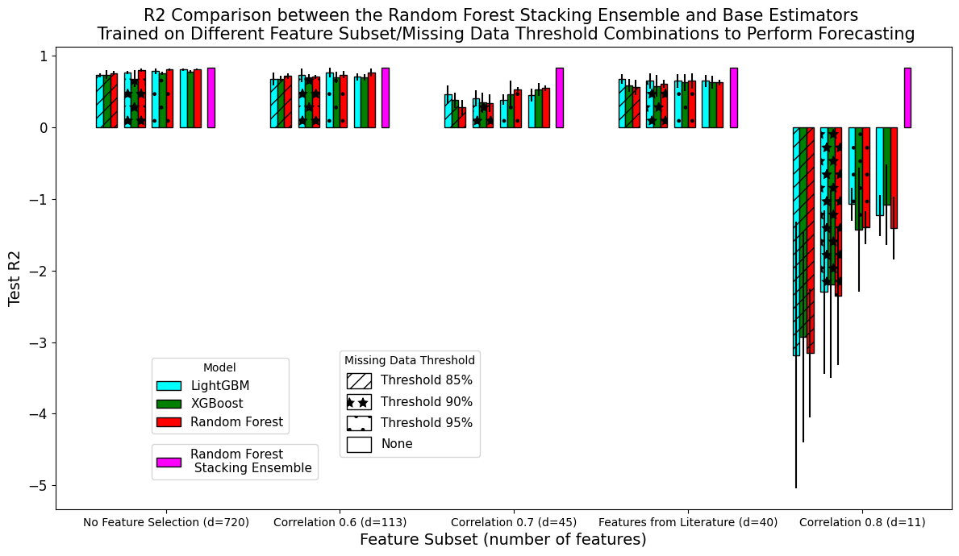

c)

### 9.4 Additional Performance Metrics to Compare Random Forest Stacking Ensemble with Base Estimators

#### 9.41: Country-Level Prediction

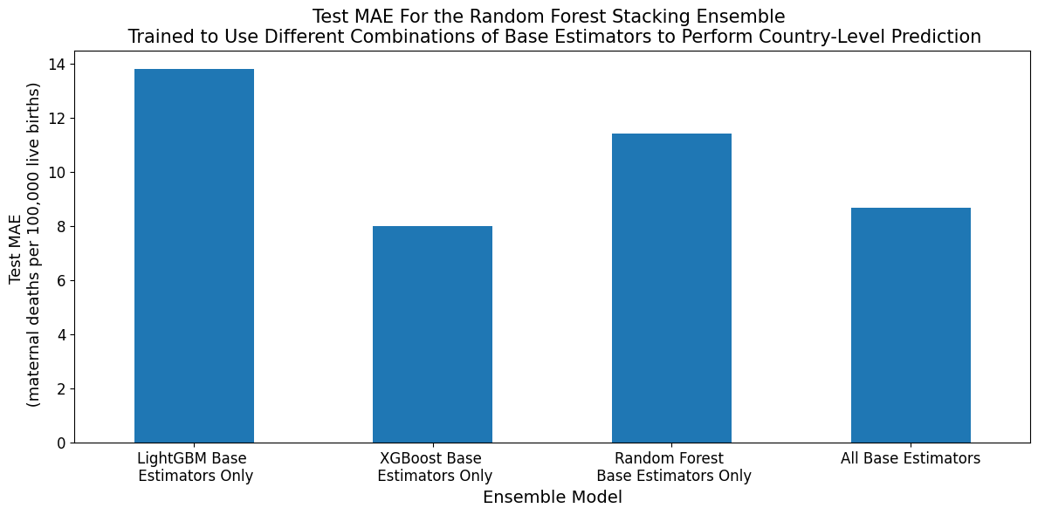

a)

b)

c)

#### 9.42: Forecasting

a)

b)

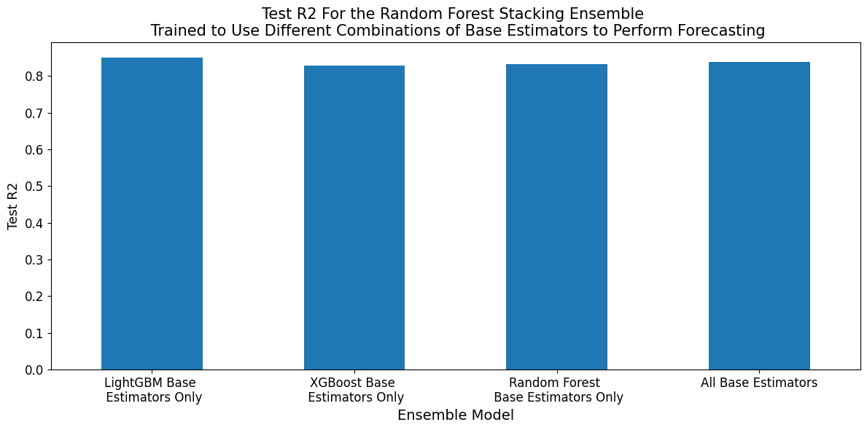

c)

### 9.5 Additional Performance Metrics for Use of Different Combinations of Base Estimators

#### 9.51: Country-Level Prediction

#### 9.52: Forecasting

### 9.6 Additional Performance Metrics for Sensitivity Analysis

#### 9.61: Country-Level Prediction

a)

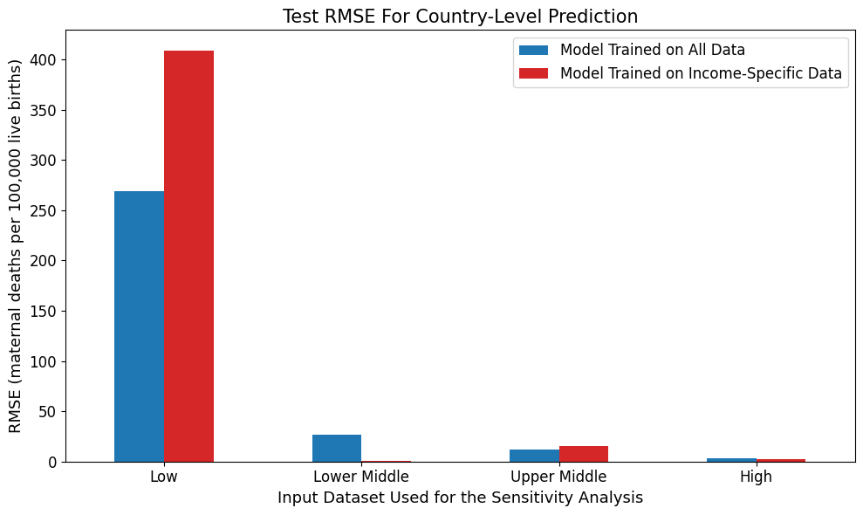

b)

c)

#### 9621: Forecasting

a)

b)

c)