## Missing Data

<https://www.tandfonline.com/doi/epdf/10.1080/08839510902872223?needAccess=true>

* Rates of less than 1% missing data aregenerally considered trivial, 1–5% manageable. However, 5–15% requiressophisticated methods to handle, and more than 15% may severely impactany kind of interpretation
* There are two common solutions to the problem of incomplete datathat are currently applied by researchers. The ﬁrst includes omittingthe instances having missing values (i.e., listwise deletion), which doesnot only seriously reduce the sample sizes available for analysis but alsoignores the mechanism causing the missingness. The problem with asmaller sample size is that it gives greater possibility of a nonsigniﬁcantresult, i.e., the larger the sample the greater the statistical power of thetest. The second solution imputes (or estimates) missing values from theexisting data. The major weakness of single imputation methods is thatthey underestimate uncertainty and so yield invalid tests and conﬁdenceintervals, since the estimated values are derived from the ones actuallypresent
* or data that is informatively missing (IM) or not missing atrandom (NMAR), then the mechanism is not only nonrandom and notpredictable from the other variables in the dataset but cannot be ignored,i.e., we have non ignorable missingness (Little and Rubin 1987; Schafer1997). In contrast to the MAR condition outlined above, IM arise whenthe probability that the defect rate is missing depends on the unobservedvalue of the defect rate itself. For example, software project managers maybe less likely to reveal projects with high defect rates. Since the pattern ofIM data is not random, it is not amenable to common MDTs and there areno statistical means to alleviate the problem
* Several methods have been proposed in the literature to treat missingdata when using DTs. Missing values can cause problems at two pointswhen using DTs: 1) when deciding on a splitting point (when growing thetree), and 2) when deciding into which daughter node each instance goes(when classifying an unknown instance).
* Multiple imputation (MI) is one of the most attractive methods forgeneral purpose handling of missing data in multivariate analysis. Rubin(1987, 1996) described MI as a three-step process. First, the missingentries of the incomplete datasets are imputed (or ﬁlled in), not once,but M times (M = 5 in Figure 1). The imputed values are drawn fora distribution (that can be different for each missing entry. This stepresults in M complete datasets as shown in Table 1, whereby two pairsof attributes are modelled with A1 having missing values and A2 valuescomplete or observed. Second, each of these M datasets can be analyzedusing complete data methods (analysis). This step results in M analyses.Finally, the results from the M complete datasets are combined, which alsoallows that the uncertainty regarding the imputation is taken into account(pooling or combining).
* Surrogate variable splitting (SVS) has been used for the classiﬁcationand regression tress (CART) system and further pursued by Therneau andAtkinson (1997) in recursive partitioning and regression tress (RPART).CART handles missing values in the database by substituting “surrogatesplitters.” Surrogate splitters are predictor variables that are not as goodat splitting a group as the primary splitter but which yield similar splittingresults; they mimic the splits produced by the primary splitter; the seconddoes second best, and so on. The surrogate splitter contains informationthat is typically similar to that which would be found in the primary splitter.
  + The surrogates are used for tree nodes when there are values missing.The surrogate splitter contains information that is typically similar to whatwould be found in the primary splitter. Both values for the dependentvariable (response) and at least one of the independent attributes takepart in the modelling. The surrogate variable used is the one that hasthe highest correlation with the original attribute (observed variable mostsimilar to the missing variable or a variable other than the optimal onethat best predicts the optimal split). The surrogates are ranked. Anyobservation missing on the split variable is then classiﬁed using the ﬁrstsurrogate variable, or if missing that, the second is used, and so on. TheCART system only handles missing values in the testing case, but RPARThandles them on both the training and testing cases.
  + The idea of surrogate splits solves the problem of missing values byidentifying the nodes where masking or disguise (when one attribute hidesthe importance of another attribute) of speciﬁc attributes occurs. This isas a result of its ability to making use of all the available data by involvingall the attributes when there is any observation missing the split attribute(Loh and Vanichsetakul 1988). By using surrogates, CART handles eachinstance individually, providing a far more accurate analysis. Also, otherincomplete data techniques treat all instances with missing values as ifthe instances all had the same unknown value; with that technique allsuch "missings" are assigned to the same bin. For SVS, each instance isprocessed using data speciﬁc to that instance; and this allows instanceswith different data patterns to be handled differently, which results ina better characterization of the data (Breiman et al. 1984).
  + owever,practical difﬁculties can affect the way surrogate splitting is implemented.For example, SVS ignores the quantity of missing values. Like a variabletaking a unique value for exactly one case in each class and missingon all other cases, yields the largest decrease in impurity (Gehrke, Loh,and Ramakrishnan 1999). In addition, the idea of surrogate splitting isreasonable if high correlations among the predictor variables exist. Sincethe “problem” attribute (the attribute with missing values) is cruciallydependent on the surrogate attribute in terms of a high correlation, whenthe correlation between the “problem” attribute and the surrogate is low,surrogate splitting becomes very clumsy and unsatisfactory. In other words,the method is highly dependent on the magnitude of the correlationbetween the original attribute and its surrogate
* want IMunifo data
* In fact, the error rate increase when50% of the values are missing in both the training and test sets is aboutone and a half times as big as the error rate increase when 15% of thevalues are missing on both sets
* M values entail more seriousdeterioration in predictive accuracy compared to randomly missing data(i.e., MCAR or MAR data). Overall, MCAR data have a lesser impact onclassiﬁcation accuracy with an error rate increase difference of about 4%(when compared with MAR data) and a much bigger difference of about10% (when compared with IM data).

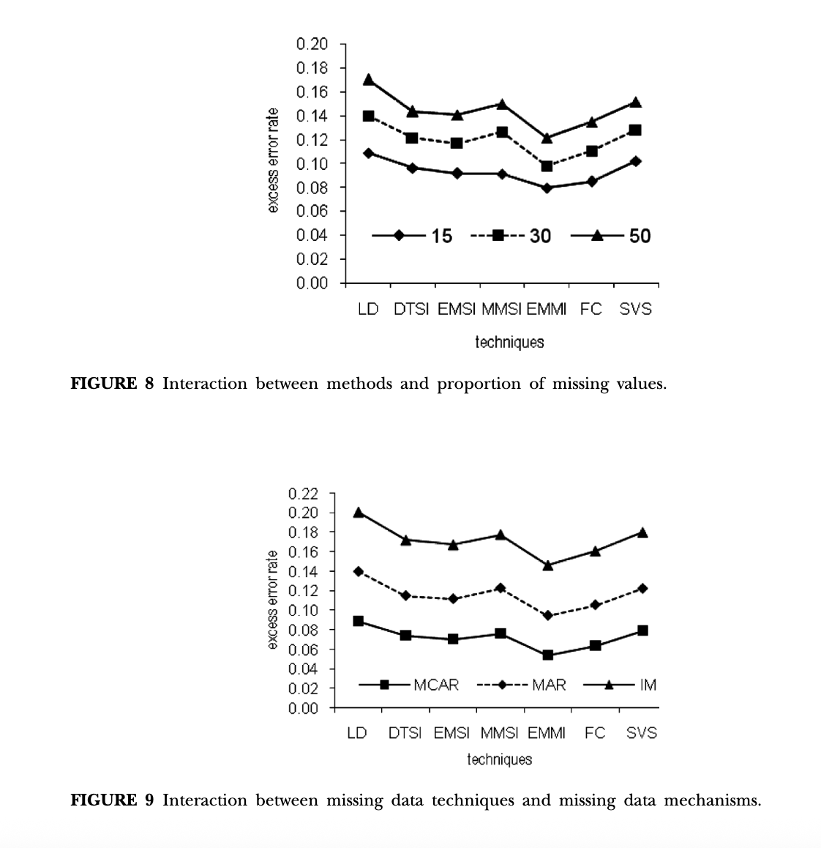

* The worse performance achieved by methods are for IM data, followedby MAR and MCAR data, respectively. This is in accordance with statisticaltheory which considers MCAR easier to deal with and IM data as verycomplex to deal with since it requires assumptions that cannot be validatedfrom the data at hand (Little and Rubin 1987). In addition, in manysettings the MAR assumption is more reasonable than the MCAR. In fact,an MAR method is valid if data are MCAR or MAR, but MCAR methodsare valid only if data are MCAR. This could be attributed to the superiorperformance of EMMI (an MAR method) and the substantially inferiorperformance of LD (an MCAR method)
* With this experimental set-up, it is easy to say with conviction that fromthe eight current techniques investigated that EMMI is the overall bestmethod for handling both incomplete training and test data. However,there are competitors like FC and DTSI which performed reasonablywell. One important advantage of FC over DTSI is that it can handlemissing values in both the training and test sets, while DTSI strugglesas a technique for handling incomplete test data and when all attributeshave missing values. The heavy dependence of DTSI on strong correlationsamong attributes might have attributed to its poor performance ascorrelations among attributes for some of the datasets were not strong
* The results also indicate that LD isthe worst method for handling incomplete data.
* Eventhough EMMI emerges as the overall best of the eight techniques, it hasAn Empirical Comparison of Techniques 401come under ﬁre by critics claiming that proper imputations, necessary forvalid inferences, are difﬁcult to produce, especially in data where multiplefactors are deﬁcient (Schafer 1997), and even then EMMI is biased insome cases (Robins and Wang 2000). Another argument against EMMI isthat it is much more difﬁcult to implement than some of the techniquesmentioned. One potential problem that was encountered in this researchis convergence of the EM algorithm (Wu 1983), especially for big datasetsand datasets with more than 30 attribute variables.
* Like DTSI, for all the datasets where the correlations among attributeswere found to be quite high, SVS (which relies heavily on strongconcordance between a primary splitter and its surrogate(s)), achievedgood results. However, SVS also struggles when missing values aredistributed among all the attributes. In fact, for a few datasets SVScollapsed completely when an instance was missing all the surrogates.However, some strategies when simulating the missingness among theattributes were used when the technique collapsed

<https://link.springer.com/article/10.1186/s40537-021-00516-9>

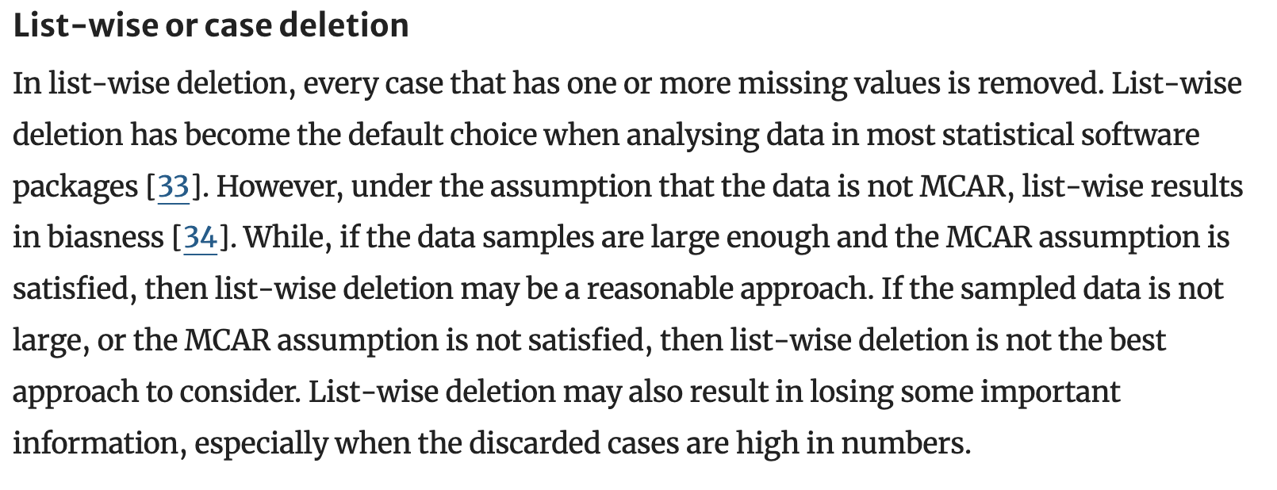

**missing value imputation: a review and analysis of the literature (2006-2017)**

<https://link.springer.com/article/10.1007/s10462-019-09709-4>

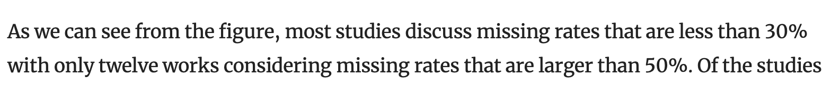

<https://link.springer.com/article/10.1007/s42979-022-01249-z>

* This study deals with missing data in maternal health records from Kawempe National Referral Hospital. The hospital mainly deals with maternal health services including antenatal care, intrapartum care and postnatal care for both mother and newborn.
* In the literature, there is no consensus on the exact proportion of missingness that is acceptable for quality statistical inference. Schafer [[11](https://link.springer.com/article/10.1007/s42979-022-01249-z#ref-CR11)] states that a 5% or less proportion of missingness has no effect on statistical analysis. On the other hand, Bennett [[12](https://link.springer.com/article/10.1007/s42979-022-01249-z#ref-CR12)] asserts that with more than 10% of the data missing, analysis will be biased. On the contrary, Tabachnick et al. [[13](https://link.springer.com/article/10.1007/s42979-022-01249-z#ref-CR13)] argue that it does not matter the proportion of missingness; rather it is the missing data mechanisms and patterns that have greater impact on analysis.
* etersen et al. [[19](https://link.springer.com/article/10.1007/s42979-022-01249-z#ref-CR19)] note that analysis on primary care data using only complete information could lead to misleading results.
* The proportion of missingness in the variables ranged from 1.4 to 20.7%
* Mode Imputation, MICE, KNN and RF
* Mar or mcar
* With the exception of LD, no statistically significant difference was noted in the performance of the imputation methods for treatment of missing data
* Predicting severe maternal morbidities

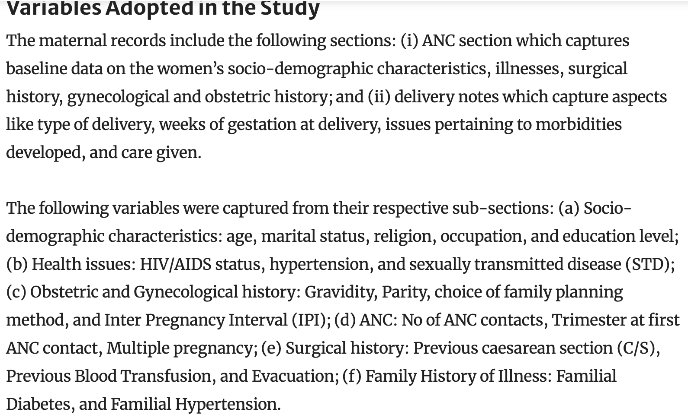

## Shapley

<https://dl.acm.org/doi/pdf/10.5555/3295222.3295230>

* The best explanation of a simple model is the model itself; it perfectly represents itself and is easy to understand. For complex models, such as ensemble methods or deep networks, we cannot use the original model as its own best explanation because it is not easy to understand. Instead, we must use a simpler explanation model, which we define as any interpretable approximation of the original model.
* Methods with explanation models matching Definition 1 attribute an effect φi to each feature, and summing the effects of all feature attributions approximates the output f(x) of the original model.
* For machine learning models this means that SHAP values of all the input features will always sum up to the difference between baseline (expected) model output and the current model output for the prediction being explained

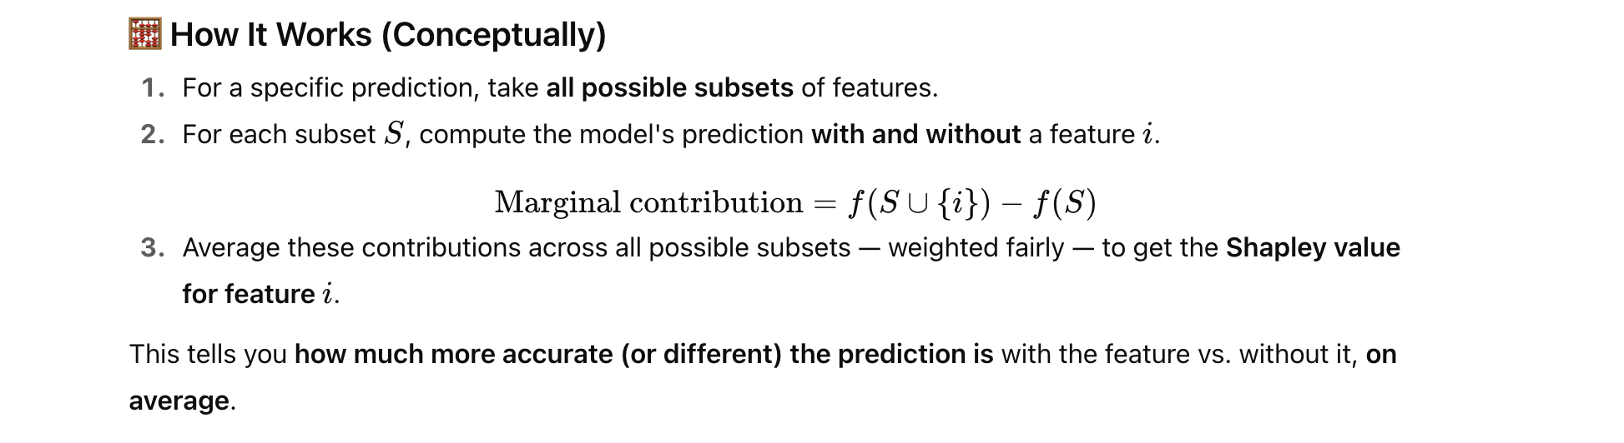

* Model agnostic

## Semi-Supervised Learning Extension

<https://alz-journals.onlinelibrary.wiley.com/doi/epdf/10.1002/alz.13441?getft_integrator=scopus&src=getftr&utm_source=scopus>

* Semi-supervised learning falls between supervised and unsupervisedML, using both labeled and unlabeled data. It is typically used in sce-narios in which there is a large amount of data available, yet only a smallproportion of samples have been labeled.Semi-supervised algorithms use the information from the unlabeleddata points to improve the performance of a model trained on the smallamount of labeled data. 69 Therefore, these approaches are most use-ful in applications in which labeled data are limited. Different typesof semi-supervised algorithms have been used for the classificationof AD and mild cognitive impairment (MCI) with datasets of differentmodalities, including brain imaging, 30,70-72 among others
* There are many examples from dementia research that demon-strate the superiority of semi-supervised algorithms for diagnosis orprognosis, relative to supervised algorithms based upon more limiteddata. Batmanghelich et al. 71 presented a framework for dimensional-ity reduction that showed a semi-supervised algorithm outperformedsupervised learning methods, for both classifier accuracy and areaunder the receiver operating characteristic curve (AUC). Filipovychand Davatzikos72 confirmed that in some scenarios, for example,in the absence of long-term follow-up evaluations, semi-supervisedtechniques may be preferable to identify individuals with progres-sive disorders, such as those at risk of conversion from MCI to AD.The high performance of semi-supervised algorithms in predictingMCI to AD conversion was also demonstrated in Moradi et al.
* Given the increasing amount of data available and the inherentuncertainty around labels (i.e., clinical diagnosis) in dementia research,semi-supervised learning provides the opportunity to combine pre-diction of clinically relevant features with the utility of unsupervisedlearning, making the most of the available data

<https://www.tandfonline.com/doi/epdf/10.1080/1744666X.2024.2359019?src=getftr&utm_source=scopus&getft_integrator=scopus>

Semi-supervised learning is a combination of supervised andunsupervised learning. In other words, both labeled and unla-beled data are used in semi-supervised learning [56]. Whilesupervised learning only uses labeled data, which are expen-sive and hard to get. Hence, supervised learning requires moretime and effort [57]. On the other hand, unlabeled data usedin unsupervised learning are cheap and have lower accuracy.Therefore, since both supervised and unsupervised learninghave some weaknesses, the idea of combining them has beenintroduced. Semi-supervised learning uses a small amount oflabeled data and many unlabeled data. In semi-supervisedlearning, the machine initially uses labeled data and then tries to predict unlabeled data using the labeled data. Themain purpose is to improve the classification [58,59].Semi-supervised learning is used in many fields, such as theclinical field. For instance, PheCAP is a semi-supervisedapproach used in phenotyping patients with some autoim-mune diseases such as MS, Rheumatoid Arthritis (RA), and IBD,which comprised Crohn’s Disease (CD) and ulcerative Colitis(UC) [60]. Comparison of semi-supervised learning with super-vised learning in detecting CD tissue from abdominalMagnetic Resonance Imaging (MRI) has demonstrated thatsemi-supervised learning has more accuracy and requires lesseffort and time, which were the strengths of semi-supervisedlearning in comparison to other machine learning models [61]

## Policy

- As discussed in Section 5.53, the features with the highest predictive power for country-level MMR predictions and MMR forecasts provided nationally aggregated information about the level and type of women’s employment, women’s knowledge of contraceptive options, and women’s nutritional status (Tables 13 and 14). In addition, the variables detailing the country’s income level, national life expectancy, fertility rates, presence of skilled health staff at birth, and percentage of teenage mothers were also among the features with the highest predictive power for country-level MMR predictions.

<https://cdn.who.int/media/docs/default-source/mca-documents/maternal-nb/ending-preventable-maternal-mortality_epmm_brief-230921.pdf?sfvrsn=f5dcf35e_5>

* In 2015, the strategies for Ending Preventable Maternal Mortality (EPMM), a global multi-partner initiative, outlined broad strategies for maternal health programmes.2 EPMM aims to improve maternal health and wellbeing and achieve the SDG target for MMR. Reaching the SDG targets is grounded in a holistic, human rights-based approach to sexual, reproductive, maternal and newborn health, and rests on the foundation of health system strengthening that supports effective implementation for universal health coverage.
* In an effort to accelerate progress toward the SDG targets and goals, EPMM has established coverage targets and milestones to track progress to 2030. These coverage targets and milestones were developed in consultation with relevant stakeholders and partners at national, regional and global level, and also ensured alignment with the targets and milestones launched by Every Newborn Action Plan (ENAP) in September 2020.

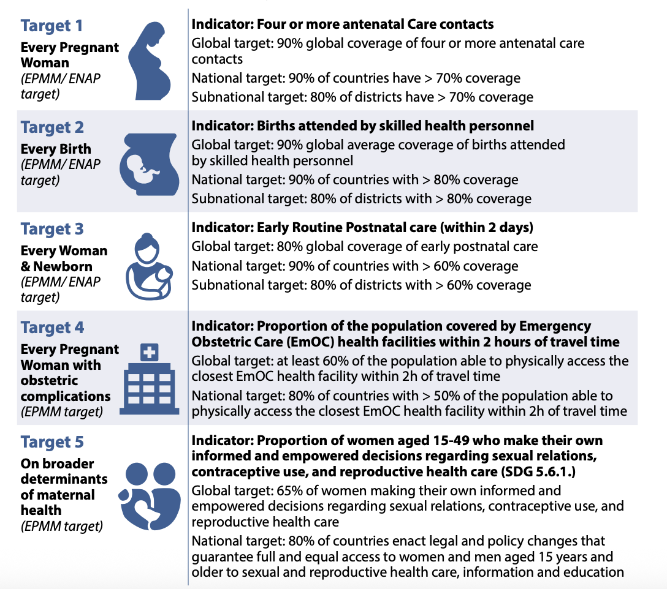

<https://www.nature.com/articles/s41591-023-02311-w/tables/4>

<https://www.nature.com/articles/s41591-023-02311-w>

* We found that individual interventions yielded fairly small reductions in maternal mortality, with the largest individual impact coming from increasing the number of women who deliver at facilities (projected global MMR in 2030 of 111, 95% UI = 94–129), followed by improving the quality of care at facilities (projected global MMR of 140, 95% UI = 113–159) (Table [4](https://www.nature.com/articles/s41591-023-02311-w#Tab4)). However, the potential gains from other individual policy interventions were relatively modest
* integrated strategies that include multiple interventions will probably be needed to substantially accelerate improvements in maternal mortality. Globally, we found that increasing facility births, improving the availability of clinical services at facilities and improving linkages to care (for example, recognition of complications and appropriate referrals and transportation) would yield large improvements, with a projected global MMR of 104 (95% UI = 87–121) in 2030 (Table [4](https://www.nature.com/articles/s41591-023-02311-w#Tab4)). However, we found that even with this set of interventions, the global SDG target would not be met if improvements in quality of care are neglected. Instead, we found that efforts to improve quality of care in addition to facility-based and linkage interventions will be necessary to potentially achieve the SDG target, yielding a projected global MMR of 72 (95% UI = 58–87) in 2030, with large improvements in LMICs
* Family planning interventions also offer the potential for meaningful improvements and can reduce deaths from abortion-related mortality and indirect causes (via reduced pregnancy exposure), which are largely unaffected by the other policy interventions that we modeled (Table [5](https://www.nature.com/articles/s41591-023-02311-w#Tab5)). Although all strategies reduced the total number of maternal deaths compared to our baseline scenario of current trends, we found small relative increases for particular causes of death in some scenarios (Table [5](https://www.nature.com/articles/s41591-023-02311-w#Tab5)). This finding reflects the fact that as more women survive pregnancy and labor, the number of deaths from subsequent risks may increase despite reductions in overall mortality, highlighting the need for a comprehensive view of maternal mortality that considers competing risks. For example, increasing the proportion of women who give birth in medical facilities is estimated to reduce total maternal deaths by nearly 30% but may lead to small increases in late and indirect maternal deaths as more women survive direct maternal complications and face these other risks (Table [5](https://www.nature.com/articles/s41591-023-02311-w#Tab5)).
* Although we found that an integrated strategy including facility-based and system-relevant interventions (Table [3](https://www.nature.com/articles/s41591-023-02311-w#Tab3)) could potentially achieve the SDG target in reducing maternal mortality, there is uncertainty around whether the goal could be achieved by 2030 (Fig. [1](https://www.nature.com/articles/s41591-023-02311-w#Fig1)). Instead, due to the multifactorial nature and many causes of maternal death, a comprehensive integrated strategy including community-based and family planning interventions will probably be needed to achieve the global SDG target by 2030, with a projected global MMR of 58 (95% UI = 46–70
* We found that an integrated strategy, including facility-based and system-relevant interventions, could substantially improve maternal health but it is unlikely to achieve the SDG global maternal mortality target by 2030 without also including community-based and family planning interventions as part of a comprehensive strategy. Among the interventions in such a strategy, we found that increasing the proportion of births that occur at health facilities is the single intervention with the largest impact on maternal mortality. However, while increasing facility delivery and linkages to care for complications from the community are necessary to substantially improve maternal health, these policies alone may not be sufficient if quality of care is not also improved.
* This finding echoes previous evaluations of real-world interventions. For example, Janani Suraksha Yojana, a conditional cash-transfer program to incentivize facility delivery in India, succeeded in substantially increasing facility births but had no significant effect on mortality due to lack of focus on the quality of facilities[30](https://www.nature.com/articles/s41591-023-02311-w#ref-CR30),[31](https://www.nature.com/articles/s41591-023-02311-w#ref-CR31). Similarly, the Better Birth trial succeed in improving the adherence of SBAs to essential birth practices but had no significant impact on health outcomes[32](https://www.nature.com/articles/s41591-023-02311-w#ref-CR32). These findings highlight the necessity of considering other contextual factors related to health system quality.
* The Guttmacher Institute Adding It Up report estimated that if all women had access to modern contraceptives and all pregnant women received quality care, maternal deaths would drop by 62% in LMICs[33](https://www.nature.com/articles/s41591-023-02311-w#ref-CR33), which is very similar to our comprehensive strategy that yields a 60.1% (95% UI = 54.9–65.0%) decrease globally. The report also estimated that meeting all needs for pregnancy-related care, with no change in levels of contraceptive care, would yield a 50% reduction in maternal deaths in LMICs[33](https://www.nature.com/articles/s41591-023-02311-w#ref-CR33), which is similar to our strategy including facility-based, system-relevant and quality-of-care interventions that yields an estimated 51.0% (95% UI = 45.1%–56.1%) global reduction. These findings are also similar to a previous analysis using the LiST model, which estimated that 51% of maternal deaths could be averted in 75 high-burden countries by achieving high coverage of ANC and care during labor and childbirth[34](https://www.nature.com/articles/s41591-023-02311-w#ref-CR34).
* Family planning interventions include reducing unmet need for contraception and reducing the proportion of induced abortions that are unsafe, allowing women more control to achieve their fertility preferences, which we assume are unaffected by these interventions. Community-based interventions include increased ANC visits to improve health status during pregnancy, for example, anemia, and improve recognition of complication danger signs, as well as increased coverage of home births attended by an SBA, who can provide basic interventions and refer complications to facilities for emergency care.

https://www.thelancet.com/journals/langlo/article/PIIS2214-109X(23)00468-0/fulltext

ackling maternal mortality will require broader actions that go beyond biomedical causes, which manifest at a late stage in the events between a healthy state and severe morbidity or death. Policy makers, particularly those in countries with high maternal mortality burden, must recognise that the main biomedical causes (eg, postpartum haemorrhage, pre-eclampsia, infection, and abortion) of preventable maternal deaths do not happen in isolation. That 121 countries have remained in the same mortality transition bracket for the past two decades is therefore unsurprising. For countries to progress across transition stages in their mortality reduction efforts, there must be renewed focus on strategies to address the underlying determinants described in the previous sections. Multisectoral action to promote social development and gender equality is necessary for sustainable reduction in maternal mortality. Although the implementation of these strategies (eg, improvements in social infrastructure and other social transformation programmes) is often slow to realise, their longer-term benefits are reasonably certain.

https://obgyn.onlinelibrary.wiley.com/doi/10.1111/1471-0528.12634

- for a paper giving example of study about education and maternal outcomes

https://www.thelancet.com/action/showPdf?pii=S2589-5370%2823%2900441-8

* Maternal nutritional deficiencies such as calcium deficiency increased the risk of pre-eclampsia (RR 4.06, 95% CI 3.29–7.20).40,41 Stratified analysis showed maternal anaemia was associated in LMICs with preterm birth (OR 4.07, 95% CI 1.92–8.65; 17 studies),42 low birthweight (OR 2.17, 95% CI 1.63–2.90; 24 studies),42 and, in sub-Saharan Africa, pre-eclampsia (OR 3.22, 95% CI 2.70–3.75; 4 studies).43
* Eighteen reviews reported age, education, socioeconomic status, and internal and external displacements as barriers to effective antenatal care, and their associated complications. Adolescents in sub-Saharan Africa were at higher risk of pre-eclampsia (OR 3.52, 95% CI 2.26–5.48; 3 studies) compared to adult women.55 Lower educational status was consistently associated with poor use of maternal health services and antenatal care56,57 and lack of formal education was associated with term stillbirth (OR ranges from 2.30 to 8.50; 2 studies).58 Conversely, a protective effect was observed for maternal education and having a low birthweight baby (OR 0.67, 95% CI 0.61–0.74; 35 studies),59 and women with secondary school education were less likely to have a small-for-gestational-age baby (RR 0.87, 95% CI 0.77–0.98; 1 study) than less educated women.60 Women experiencing poverty were more likely to experience stillbirth (3 studies),58 preterm birth (rural setting: RR 1.49, 95% CI 1.32–1.68; 1 study; urban setting: RR 1.21, 95% CI 1.00–1.46; 1 study), and low birthweight (OR 2.10, 95% CI 1.42–3.05; 1 study) than affluent women.60
* Education and empowerment of women are key reparative strategies to advance maternal health through better understanding of their own health issues, avoiding pregnancies at a young age, improving access to and use of contraception, seeking antenatal care early, and improved decision-making. Effective community and health systems investment is crucial in addressing vulnerabilities holistically
* Ensuring women can access various contraceptive methods is critical for them to space their pregnancies and prevent unintended pregnancies, thereby reducing unsafe abortions and high-risk births while simultaneously facilitating women’s bodily autonomy and choice and reducing gender inequality
* Given the paucity of evidence on reparative strategies versus the long list of threats and barriers identified in our review, studies on the best strategies to scale proven interventions for addressing leading causes of maternal mortality and morbidity should be top priority. High-quality evaluations of programmes, including their economic impact, should be conducted to scale up evidence-based recommendations at local, regional, and national levels
* Women’s vulnerabilities impact access to early pregnancy tests such as abdominal and pelvic ultrasound,38 which is critical to diagnose ectopic pregnancies and incomplete miscarriages. Pregnant adolescents were less likely to have an early ultrasound examination during pregnancy (aOR 0.72, 95% CI 0.59–0.90) than adult women.39 Compared to women with no formal education, those with 10 or more years of education were more likely to access early pregnancy ultrasound (aOR 10.3, 95% CI 5.55–19.0)

https://pophealthmetrics.biomedcentral.com/articles/10.1186/s12963-020-00245-w

* A global consensus has emerged as to core strategies to reducing maternal mortality. These consist of (1) family planning with related reproductive health services, (2) skilled care during pregnancy and childbirth, (3) timely emergency obstetric care, and (4) immediate postnatal care [[28](https://pophealthmetrics.biomedcentral.com/articles/10.1186/s12963-020-00245-w#ref-CR28)]. In contrast with the other three interventions, which focus on reducing risk among women who are or recently were pregnant, family planning programs reduce maternal mortality by (1) reducing the number of pregnancies that occur and (2) reducing the proportion of pregnancies that are deemed to be “higher-risk” [[16](https://pophealthmetrics.biomedcentral.com/articles/10.1186/s12963-020-00245-w#ref-CR16)]. Fewer pregnancies translate into a reduction in the number of times that women are exposed to the risk of maternity-related mortality, an impact that compounds over time as fewer births yields successive generations of smaller cohorts of women of reproductive age. Contraceptive use is a key direct determinant of fertility reduction [[5](https://pophealthmetrics.biomedcentral.com/articles/10.1186/s12963-020-00245-w#ref-CR5), [9](https://pophealthmetrics.biomedcentral.com/articles/10.1186/s12963-020-00245-w#ref-CR9), [23](https://pophealthmetrics.biomedcentral.com/articles/10.1186/s12963-020-00245-w#ref-CR23)], the other “proximate determinants” being marriage/sexual exposure, postpartum infecundability, and induced abortion [[6](https://pophealthmetrics.biomedcentral.com/articles/10.1186/s12963-020-00245-w#ref-CR6)]. Contraceptive use also lowers the risk of maternal mortality per birth, as measured by the MMR, by preventing high-risk births, that is, births to women who are “too young” or “too old,” birth intervals that are “too close,” and high-parity births (i.e., “too many”) [[8](https://pophealthmetrics.biomedcentral.com/articles/10.1186/s12963-020-00245-w#ref-CR8), [23](https://pophealthmetrics.biomedcentral.com/articles/10.1186/s12963-020-00245-w#ref-CR23)]. Family planning has been estimated to have reduced maternal mortality levels in various countries by magnitudes ranging from 6 to 60% [[1](https://pophealthmetrics.biomedcentral.com/articles/10.1186/s12963-020-00245-w#ref-CR1), [7](https://pophealthmetrics.biomedcentral.com/articles/10.1186/s12963-020-00245-w#ref-CR7)] − 44% globally [[16](https://pophealthmetrics.biomedcentral.com/articles/10.1186/s12963-020-00245-w#ref-CR16)], as well as lowering infant mortality and abortion rates, especially unsafe abortions [[13](https://pophealthmetrics.biomedcentral.com/articles/10.1186/s12963-020-00245-w#ref-CR13), [26](https://pophealthmetrics.biomedcentral.com/articles/10.1186/s12963-020-00245-w#ref-CR26)]. Mbizvo and Burke [[14](https://pophealthmetrics.biomedcentral.com/articles/10.1186/s12963-020-00245-w#ref-CR14)] estimate that globally family planning could prevent up to 30% of maternal deaths going forward
* Indonesia has been among the global leaders in family planning. The success of the national family planning program is evidenced by the sharp increase in the contraceptive prevalence rate (CPR) among married women from 8% in the early 1970s to 60% in 2002, while during the same time period the total fertility rate (TFR) was reduced by nearly one-half from 5.0 to 2.6 [[18](https://pophealthmetrics.biomedcentral.com/articles/10.1186/s12963-020-00245-w#ref-CR18), [22](https://pophealthmetrics.biomedcentral.com/articles/10.1186/s12963-020-00245-w#ref-CR22)]. Although the rate of growth in contraceptive use has slowed since the early of 2000s, CPR reached 63% in 2017 and the TFR fell to 2.3
* To what extent can the decline in the GFR be attributed to increases in contraceptive use? As shown in Fig. [3](https://pophealthmetrics.biomedcentral.com/articles/10.1186/s12963-020-00245-w#Fig3), since the start of the national family planning program in the early of 1970s, the CPR increased sharply to over 40% in the early 1990s and to 63% in 2017, while TFR declined sharply from just under 6 in the early 1970s to 2.3 in 2017, although the rates of decline have slowed considerably since the early 2000s. Unmet need for family planning (UNFP) declined from 17.0% in 1991 to 10.6% in 2017
* The Indonesian national family planning program has over a period spanning just under 50 years (i.e., since 1970) which made a major contribution to the reduction of maternal mortality in the country. Had there not been any increase in the contraceptive prevalence rate from 1970 to 2017, it is estimated that there would have been at least 592,472 and as many as 663,000 additional maternal deaths during this period. This amounts to a 38–43% reduction. The maternal mortality rate, or the number of maternal deaths per 1000 women in a given year, fell by nearly 82% during this period. These estimates are plausible when compared with other global estimates
* In view of the success of national family planning efforts in achieving relatively high levels of contraceptive use, can family planning be expected to continue to make major future contributions to reducing maternal mortality? It is estimated that if the CPR were to be increased to 70% and unmet need for family planning reduced from 10 to 7% by 2030, an additional 35,897 (range 34,621–37,186) maternal deaths could be averted over and above the contributions of improvements in maternal health care in the country, a 19–20% reduction. If the CPR were instead to be increased to 75% and UNFP reduced to 5% by 2030, the number of additional maternal deaths averted would rise to 53,247 (range 51,971–54,536), a 28–29% reduction. However, even in the most optimistic scenario, there would still be over 13,000 maternal deaths in the year 2030, and the maternal mortality ratio would still be 125 maternal deaths per 100,000 live births, considerably above the global SDG target of less than 70 maternal deaths per 100,000 live births. Further advances in the provision of high-quality maternal health services by the health system to address risk once women become pregnant will be required in order to reach the SDG target
* These challenges are formidable indeed. Some assistance in reaching the ambitious targets may come from the expansion of the national social health insurance scheme, the *Jaminan Kesehatan Nasional* (JKN). JKN population coverage reached 80% by the end of 2019, with the ultimate objective of achieving universal coverage. The JKN is likely to extend the reach of contraceptive services and supplies to areas that have limited private sector market penetration and make access to long-acting and permanent contraceptive methods more financially accessible.

https://obgyn.onlinelibrary.wiley.com/doi/10.1111/1471-0528.12634

* A significant association between low education and severe maternal outcomes (adjusted odds ratio, aOR, 2.07; 95% confidence interval, 95% CI, 1.46–2.95), maternal near miss (aOR 1.80; 95% CI 1.25–2.57), and maternal death (aOR 5.62; 95% CI 3.45–9.16) was observed. This relationship persisted in countries with medium HDIs (aOR 2.36; 95% CI 1.33–4.17) and low HDIs (aOR 2.65; 95% CI 1.54–2.57). Less educated women also had increased odds of presenting to the hospital in a severe condition (i.e. with organ dysfunction on arrival or within 24 hours: aOR 2.06; 95% CI 1.36–3.10). The probability that a woman received magnesium sulphate for eclampsia or had a caesarean section significantly increased as education level increased (*P*< 0.05).
* Education has been shown to have a profound effect on a mother's use of maternal health services,[**10**](https://obgyn.onlinelibrary.wiley.com/doi/10.1111/1471-0528.12634#bjo12634-bib-0010) and a global analysis of predictors of maternal mortality showed that levels of female literacy and schooling were significantly associated with maternal death.[**11**](https://obgyn.onlinelibrary.wiley.com/doi/10.1111/1471-0528.12634#bjo12634-bib-0011) A recent WHO-led analysis of maternal outcomes following delivery in 23 LMICs showed that, compared against women with more than 12 years of education, women with no education had 2.7 times the risk of maternal mortality.
* We stratified the analyses by HDI groups to further explore education level as an inequity factor in different settings. The level of education ceased to be a significant factor in relation to adverse maternal outcomes in the higher HDI countries. In contrast, the associations got stronger among middle and lower HDI level countries. This suggests that in countries with higher economic and social development, functioning healthcare systems can compensate for the inequality associated with educational attainment, whereas in less developed countries it still causes a discrepancy in terms of outcomes, access to services, and coverage of interventions such as caesarean section. It should be noted here that we did not have information on the indications for caesarean sections or emergency caesarean section status defined by decision or operation time.[**24**](https://obgyn.onlinelibrary.wiley.com/doi/10.1111/1471-0528.12634#bjo12634-bib-0024) Education is a marker of social development and inclusion, and although it is difficult to disentangle the intrinsic contribution of education to improved maternal outcomes in our analysis, it strongly indicates that less advantageous populations face additional barriers in reaching high-quality care.
* One of the possible underlying reasons for this strong relationship between education level and severe maternal outcomes is that less educated women might experience longer primary and secondary delays in deciding to seek and reach care, respectively.[**19**](https://obgyn.onlinelibrary.wiley.com/doi/10.1111/1471-0528.12634#bjo12634-bib-0019), [**20**](https://obgyn.onlinelibrary.wiley.com/doi/10.1111/1471-0528.12634#bjo12634-bib-0020) Our current analysis demonstrates that less educated women are indeed more likely to arrive at hospital presenting with organ dysfunction or death; however, a recent systematic review reports that focusing on the first two delays may mask the fact that many health facilities in developing countries are still chronically under-resourced and unable to effectively manage severe obstetric complications.[**21**](https://obgyn.onlinelibrary.wiley.com/doi/10.1111/1471-0528.12634#bjo12634-bib-0021) In our study, which included several types of healthcare facility in each country, the results further suggest that there is disparity between lower and higher education quartiles in terms of the coverage of evidence-based interventions, such as magnesium sulphate for the treatment of eclampsia, or a caesarean section, which in many cases is a life-saving surgery, indicating delays in receiving timely quality of care while at the healthcare facility. Therefore, assessing and improving the quality of care and management for these cases using tools such as the WHO Maternal Near-Miss Approach, or the Maternal Death Surveillance and Response, will be crucial.[**13**](https://obgyn.onlinelibrary.wiley.com/doi/10.1111/1471-0528.12634#bjo12634-bib-0013), [**22**](https://obgyn.onlinelibrary.wiley.com/doi/10.1111/1471-0528.12634#bjo12634-bib-0022), [**23**](https://obgyn.onlinelibrary.wiley.com/doi/10.1111/1471-0528.12634#bjo12634-bib-0023)

https://onlinelibrary.wiley.com/doi/epdf/10.1111/j.1728-4465.2013.00365.x

* Adolescent childbearing is considered undesirable because of the negative effects it has ongirls’ health and economic well-being and also on the health of the infant. Teen pregnancy isassociated with high levels of maternal death, early neonatal death, postpartum hemorrhage low birth-weight, and preterm delivery
* Mayorreported in 2004 that complications from pregnancy and childbirth were the leading causes ofdeath among young women between the ages of 15 and 19 in developing countries. Furthermore,adolescent pregnancy is considered both a cause and consequence of socioeconomic disadvan-tage. Adolescent motherhood may result in lost income and productivity, and is also seen assymptomatic of preexisting gender inequality, poverty, and poor economic prospects for women

https://academic.oup.com/jeea/article/21/5/2172/7060387

* A wave of quota adoption swept through developing countries, with 22 countries reforming during 1990–2015, the period we analyze. We first demonstrate that quota legislation leads to a sharp increase in the share of parliamentary seats held by women. We then show that quota adoption is associated with an 8%–12% decline in the MMR. The dynamic impacts are persistent, in fact increasing over time, consistent with women who enter parliament after quotas remaining through a 5-year term, and with the efforts of parliamentarians cumulating over time. Quota impacts are increasing in the pre-intervention level of MMR, consistent with the low hanging fruit argument. They are also increasing in the share of seats reserved, and finding this dose–response relationship increases our confidence that we capture impacts of quota adoption rather than a confounder.
* In response to growing awareness of women’s rights in civil society, in 1990 the UN Economic and Social Council set a target of 30% female representation in decision making bodies by 1995 (Pande and Ford [2012](javascript:;)). The passage of gender quotas followed this and accelerated after the unanimous signing of the Beijing Platform for Action by all UN delegates at the Fourth World Conference on Women in 1995 (Krook [2010](javascript:;); Inter-Parliamentary Union [2015](javascript:;)). Since 1990, 22 countries in sub-Saharan Africa, the Middle East, and South and East Asia have implemented constitutionally protected quotas reserving seats in parliament for women, mostly after 1995. We observe an uptick in quotas particularly after year 2000, driven by sub-Saharan Africa
* We investigated whether an increased presence of women in parliament modified female education and fertility, among demand side determinants of MMR. Bhalotra and Clarke ([2013](javascript:;)) provide quasi-experimental evidence that expanding female education brings MMR down, and many studies document a positive association of fertility with MMR (Girum and Wasie [2017](javascript:;)). We find an increase of 0.5 years in the education of young women and a decline in the total fertility rate of 6%–7%, consistent with the observed expansion of contraceptive coverage and women’s schooling.[15](javascript:;)
* On education, we study girls and boys aged 15–19 at the time of the reform, finding that attainment increases significantly more for girls than for boys (Figure [8](javascript:;) and [Online Appendix Table A11](https://oup.silverchair-cdn.com/oup/backfile/Content_public/Journal/jeea/21/5/10.1093_jeea_jvad012/2/jvad012_bhalotra_etal_onlineappendix_politicsmmr.pdf?Expires=1761842352&Signature=bMs6goow-5br4TWmu-2zexN-Ndcc0qZgI6rVbb1Uhr5F1UUB1d3NiTawvhNJkOgGYxWE6VpgeQL~P0~uVSrSfnU1A3TJoEUaL73kZr2OJwYY8E~-DeKq~dzOd2gOoxUdCBL4XQPSaXs2CumyNuhYYa5vjQDv74NmTJU4xBZ5gvA8l3OgcTqelH1sxXQUG07WCT4JLXMSw54smLwpKl7DfbUQ2heAOEG5YeYe4yaqXUNBUrLob99QsJIcwTzRxDXXc2Yvqry0AVq9Xa2ZPtc2tPhlSih-bBnBbO6w3M~SUow0ceCvvwnY6cd~wCCqDE8XbPXYLzZjQ5Vo3OwKcDPYNA__&Key-Pair-Id=APKAIE5G5CRDK6RD3PGA)). This result is in line with evidence from India that quotas for women in local government led to an increase in girl’s schooling, the suggested channel being an increase in female aspiration
* We investigate whether gender quotas influence the reproductive health services that have become conventional wisdom for policy (Jamison et al. [2013](javascript:;); WHO [2014](javascript:;)), based on scientific consensus on their relevance to MMR reduction. Antenatal care is critical to identifying life threatening conditions such as pre-eclampsia and eclampsia early on, and having births attended by a skilled professional can reduce mortality from uterine bleeding and post-partum infection (Jamison et al. [2013](javascript:;); WHO [2014](javascript:;)). Contraceptive coverage may reduce fertility, and high fertility is a proximate cause of MMR (Girum and Wasie [2017](javascript:;)). Contraceptive coverage can also lower MMR without changing fertility by lengthening birth spacing or by substituting unsafe abortion (Miller and Valente [2016](javascript:;)).
* Figure [6](javascript:;) panels (a)–(c) shows increased rates of coverage along these three dimensions of reproductive health in the years following quotas (and this also holds in the standard event study, see [Online Appendix Figure A36](https://oup.silverchair-cdn.com/oup/backfile/Content_public/Journal/jeea/21/5/10.1093_jeea_jvad012/2/jvad012_bhalotra_etal_onlineappendix_politicsmmr.pdf?Expires=1761842352&Signature=bMs6goow-5br4TWmu-2zexN-Ndcc0qZgI6rVbb1Uhr5F1UUB1d3NiTawvhNJkOgGYxWE6VpgeQL~P0~uVSrSfnU1A3TJoEUaL73kZr2OJwYY8E~-DeKq~dzOd2gOoxUdCBL4XQPSaXs2CumyNuhYYa5vjQDv74NmTJU4xBZ5gvA8l3OgcTqelH1sxXQUG07WCT4JLXMSw54smLwpKl7DfbUQ2heAOEG5YeYe4yaqXUNBUrLob99QsJIcwTzRxDXXc2Yvqry0AVq9Xa2ZPtc2tPhlSih-bBnBbO6w3M~SUow0ceCvvwnY6cd~wCCqDE8XbPXYLzZjQ5Vo3OwKcDPYNA__&Key-Pair-Id=APKAIE5G5CRDK6RD3PGA)). The single coefficient models ([Online Appendix Table A9](https://oup.silverchair-cdn.com/oup/backfile/Content_public/Journal/jeea/21/5/10.1093_jeea_jvad012/2/jvad012_bhalotra_etal_onlineappendix_politicsmmr.pdf?Expires=1761842352&Signature=bMs6goow-5br4TWmu-2zexN-Ndcc0qZgI6rVbb1Uhr5F1UUB1d3NiTawvhNJkOgGYxWE6VpgeQL~P0~uVSrSfnU1A3TJoEUaL73kZr2OJwYY8E~-DeKq~dzOd2gOoxUdCBL4XQPSaXs2CumyNuhYYa5vjQDv74NmTJU4xBZ5gvA8l3OgcTqelH1sxXQUG07WCT4JLXMSw54smLwpKl7DfbUQ2heAOEG5YeYe4yaqXUNBUrLob99QsJIcwTzRxDXXc2Yvqry0AVq9Xa2ZPtc2tPhlSih-bBnBbO6w3M~SUow0ceCvvwnY6cd~wCCqDE8XbPXYLzZjQ5Vo3OwKcDPYNA__&Key-Pair-Id=APKAIE5G5CRDK6RD3PGA)) show statistically significant increases in the share of coverage (in percentage points) of 5.8 in skilled birth attendance, 4.7 in prenatal care, and (less precise estimates) of 1.7 in modern contraceptive use.[13](javascript:;) Univariate descriptive associations of MMR with reproductive health coverage indicators on our analysis sample are in [Online Appendix Table A10](https://oup.silverchair-cdn.com/oup/backfile/Content_public/Journal/jeea/21/5/10.1093_jeea_jvad012/2/jvad012_bhalotra_etal_onlineappendix_politicsmmr.pdf?Expires=1761842352&Signature=bMs6goow-5br4TWmu-2zexN-Ndcc0qZgI6rVbb1Uhr5F1UUB1d3NiTawvhNJkOgGYxWE6VpgeQL~P0~uVSrSfnU1A3TJoEUaL73kZr2OJwYY8E~-DeKq~dzOd2gOoxUdCBL4XQPSaXs2CumyNuhYYa5vjQDv74NmTJU4xBZ5gvA8l3OgcTqelH1sxXQUG07WCT4JLXMSw54smLwpKl7DfbUQ2heAOEG5YeYe4yaqXUNBUrLob99QsJIcwTzRxDXXc2Yvqry0AVq9Xa2ZPtc2tPhlSih-bBnBbO6w3M~SUow0ceCvvwnY6cd~wCCqDE8XbPXYLzZjQ5Vo3OwKcDPYNA__&Key-Pair-Id=APKAIE5G5CRDK6RD3PGA). A 1 percentage point increase in the share of attended births, prenatal care, and access to contraception, respectively, is associated with declines in MMR of 4.4%, 4.0%, and 6.3%, magnitudes that make the identified impacts on MMR plausible.