

PROJECT

INSTRUCTOR
Engr.Usama Riaz

GROUP
Rozalia Sheraz - BSSE23093
Hazira Azam – BSSE23019
Laiba Alam - BSSE23061
Abdullah Jabar - BSSE23073

REPORT

1. Project Overview
This project is a full-stack web-based Accountancy System designed to facilitate transaction management, payments, and real-time financial reporting for organizations. Built using HTML, CSS, JavaScript, PHP, and MySQL, it provides secure authentication, transaction recording, payment tracking, and advanced report generation, offering both department-wise and company-wide financial visibility.

2. Functional Description
User Registration & Authentication
- Users can register and log in using a secure PHP session-based authentication system.
- Session control restricts unauthorized access to the system's internal functionalities.
Transaction Module
- Users can add incoming (e.g. revenue) and outgoing (e.g. expense) transactions.
- Transactions are linked to departments and accounts.
- Each transaction is assigned a unique reference number and supports descriptions and optional links to "To Accounts".
Payment Module
- Users can record payments against existing transactions.
- A special Record Payment action redirects to a filtered list of eligible transactions, making selection intuitive.
- Once a payment is made, its details are saved in the payments table, preserving metadata like amount, payment method, and timestamp.
Invoice Module
- Users can generate invoices from completed payments.
- Invoices are saved and accessible for later download or print.
- The system handles invoice assignment, formatting, and archiving.
Reports Module
- Offers four key financial reports:
  - Profit & Loss Report — summarizes income vs. expenses.
  - Cash Flow Report — tracks money in/out across time.
  - Departmental Summary — transaction and payment data per department.
  - Single Department Report — financials focused on one department.
- Reports can be filtered by department or cover the whole company.
Profile Overview
- Displays personal user information and account summary post-login.
Quick Actions Dashboard
Accessible directly after login:
- Add Transaction
- Record Payment
- Generate Invoice
- Generate Reports
Each button links to the respective module for efficient workflow.

3. Database Schema Overview
ER Diagram Explanation (Client Account System)
This ER diagram models a client account management system for an accountancy or finance platform. Here's a breakdown of the key components:
1. Entities and Attributes
Each box represents an entity (i.e., a table in a relational database), and the ovals attached to each box are attributes (i.e., columns in the table).

a. USERS
- Attributes:
  - UserID (Primary Key)
  - FirstName, MiddleName, LastName
  - Email, Password, PhoneNumber, Age, DateOfBirth
- Relationships:
  - Has a CLIENT ACCOUNT
  - Belongs to a Department
  - Can ask for a REPORT
  - Can receive INVOICE

b. CLIENT ACCOUNT
- Attributes:
  - AccountID (Primary Key)
  - AccountType, Balance, Status, CreationDate
  - PaymentMethod, UserID (Foreign Key)
- Relationships:
  - Performs TRANSACTION

c. TRANSACTION
- Attributes:
  - TransactionID (Primary Key)
  - TransactionType, TransactionDate, TransactionTime
  - Amount, PaymentMethod
  - AccountID, UserID (Both are Foreign Keys)
- Relationships:
  - Generates REPORT

d. REPORTS
- Attributes:
  - ReportID (Primary Key)
  - DateGeneration, PeriodCovered, ReportType

e. DEPARTMENT
- Attributes:
  - DepartmentID (Primary Key)
  - DepartmentName
- Relationship:
  - Linked with USERS (each user belongs to one department)

f. INVOICE
- Attributes:
  - InvoiceID (Primary Key)
  - IssueDate, DueDate, Status, TotalAmount, DiscountAmount, TaxAmount
- Relationships:
  - Received by USERS
  - Facilitates PAYMENT

g. PAYMENT
- Attributes:
  - PaymentID (Primary Key)
  - PaymentDate, AmountPaid
- Relationships:
  - Connected to INVOICE (pays for it)

Relationships and Cardinality
- A user has one or more accounts and can perform transactions.
- A transaction is linked to both a user and a client account.
- Each transaction can generate one or more reports.
- Users can belong to a department and may request reports.
- A user can receive multiple invoices, and each invoice can be paid via a payment.

How This ER Diagram Maps to a Relational Database
In a relational database, each entity in the ER diagram is represented as a table, and attributes become columns in that table.
For example:
- USERS table will have columns like: UserID, FirstName, Email, Password, etc.
- CLIENT_ACCOUNT table will have: AccountID, AccountType, Balance, UserID (as a foreign key from USERS).
Foreign Keys:
- These are used to establish relationships between tables. For instance:
  - The UserID in CLIENT_ACCOUNT is a foreign key referring to USERS.
  - The AccountID in TRANSACTION refers to CLIENT_ACCOUNT.
Primary Keys:
- Every table has a Primary Key (like UserID, AccountID, TransactionID) that uniquely identifies each record in that table.

Key Benefits of Using a Relational Database Model:
- Data Integrity: Maintained using foreign key constraints.
- Scalability: Can handle many users, accounts, and transactions efficiently.
- Normalization: Data is split into related tables to avoid redundancy.
- Security: User information and transaction data are stored separately with proper relationships.
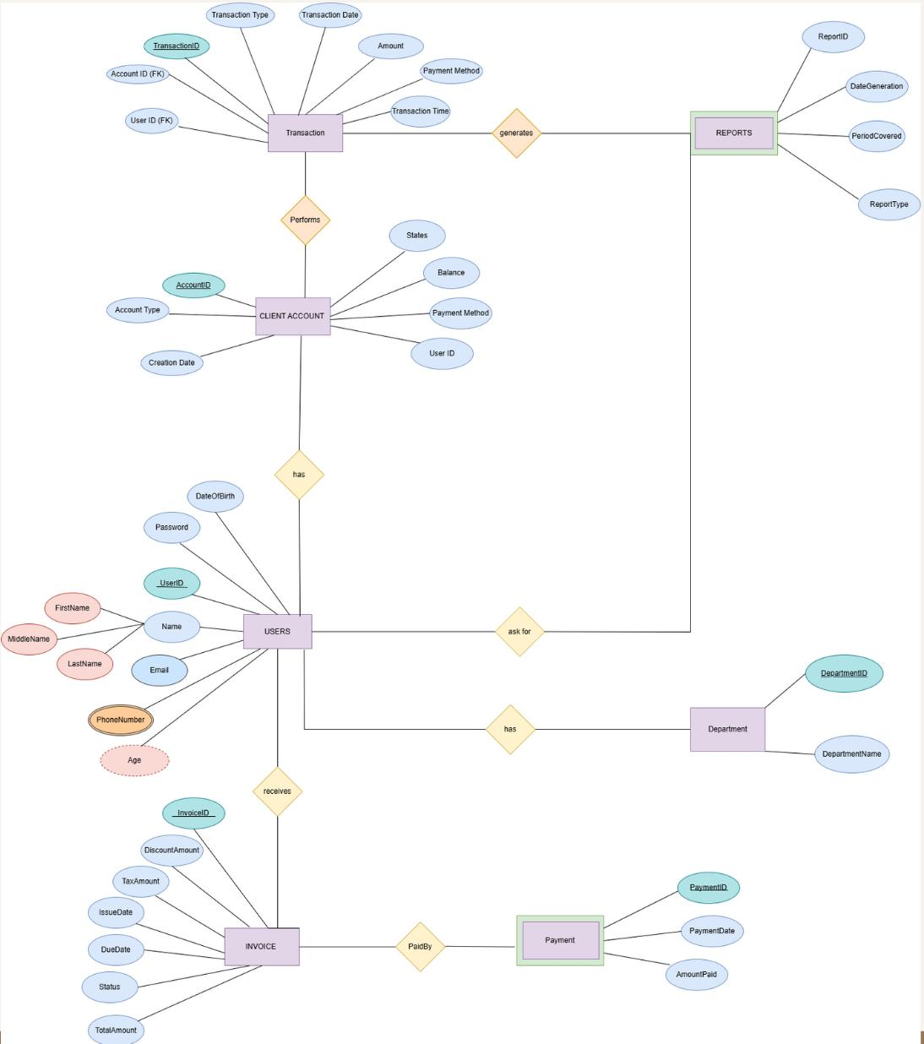

4. Front-End Technologies
- HTML5: Layout structure and semantic elements.
- CSS3: Custom styling with responsive layouts.
- JavaScript: Client-side interactivity, validation, and AJAX-based content updates.
- Bootstrap: Some components styled using Bootstrap classes for responsiveness.
- Visual Hierarchy: Menu sidebar, dashboard cards, and modals are structured for user-friendly navigation.

5. Backend Implementation
- Language: PHP (procedural + modular pattern)
- Database Layer: PDO (PHP Data Objects) for secure interaction with MySQL
- Sessions: Used for user authentication
- AJAX Handlers: Used to fetch transactions dynamically
- Modular Files:
  - config.php: DB config and credentials
  - database.php: DB connection class
  - record-transaction.php, transactions.php, record-payment.php — handle respective logic
  - reports.html and dynamic PHP endpoints for financial summaries

6. Security Measures
- Passwords stored securely (note: hash encryption could be added)
- Session-based login prevents unauthorized access
- Input validation using both client-side (JavaScript) and server-side (PHP)

7. Testing & Validation
- Login System tested for invalid inputs and session hijacking
- Transactions tested for:
  - Missing values
  - Invalid amounts
  - Duplicate entries
- Payments tested to ensure linkage with valid transactions
- Reports validated using sample data for consistency and accuracy

8. Reports Sample Queries (Conceptual)
Profit/Loss Report Query:
sql
SELECT
department,
SUM(CASE WHEN transaction_type = 'incoming' THEN amount ELSE 0 END) AS income,
SUM(CASE WHEN transaction_type = 'outgoing' THEN amount ELSE 0 END) AS expense
FROM transactions
GROUP BY department;
Cash Flow:
SELECT
DATE(created_at) as date,
SUM(CASE WHEN transaction_type = 'incoming' THEN amount ELSE 0 END) AS inflow,
SUM(CASE WHEN transaction_type = 'outgoing' THEN amount ELSE 0 END) AS outflow
FROM transactions
GROUP BY DATE(created_at);

9. Challenges & Resolutions
Challenge | Resolution
Associating payments with transactions | Used transaction IDs and reference linking
Report filtering and summarization | Used conditional SQL aggregation
Real-time invoice creation | Payment → invoice mapping using PHP
Keeping UI consistent | Created reusable components in /components/

SNIPPETS

Login Page:
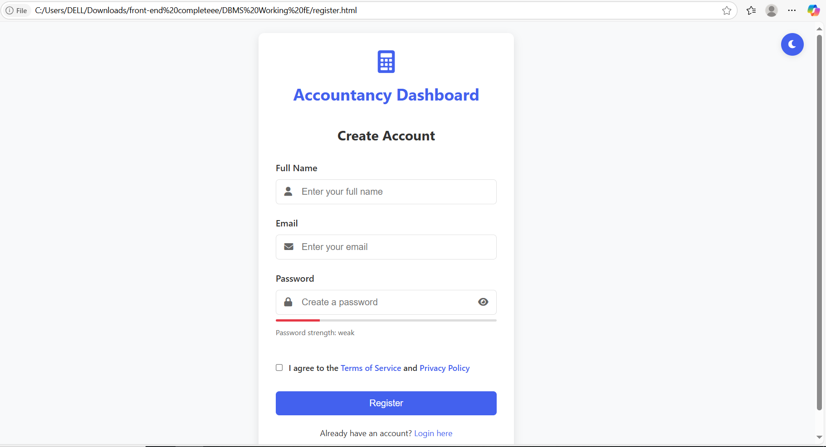
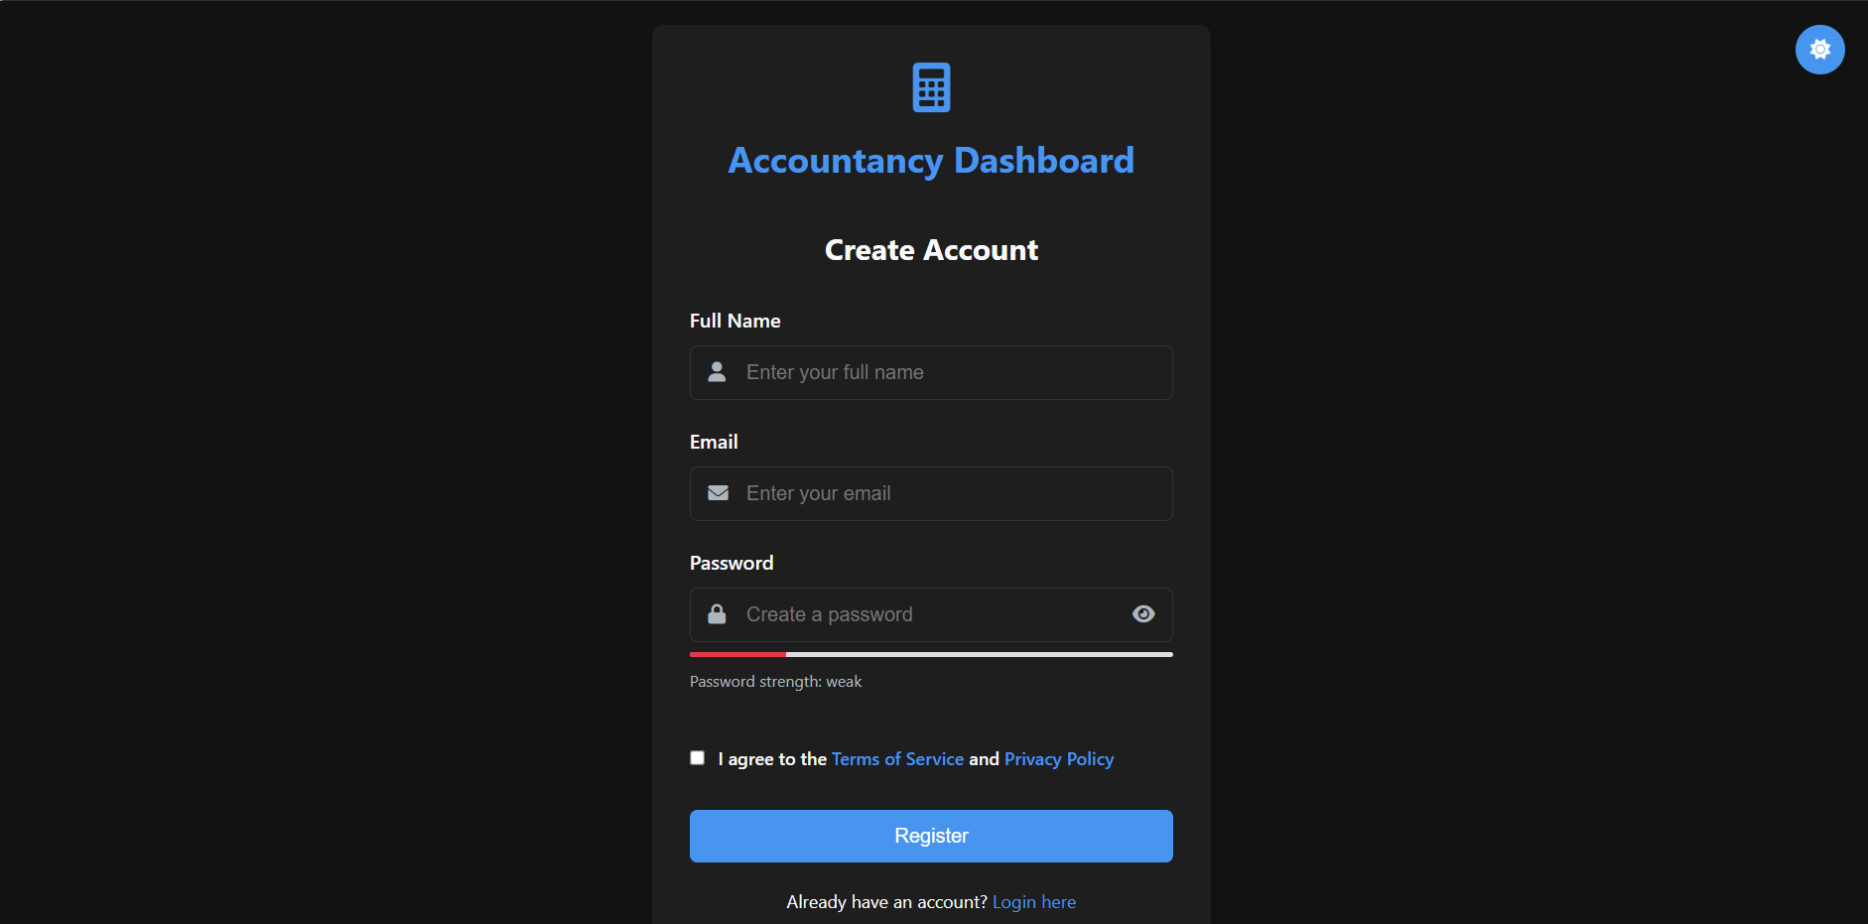

Crediantials Entry:
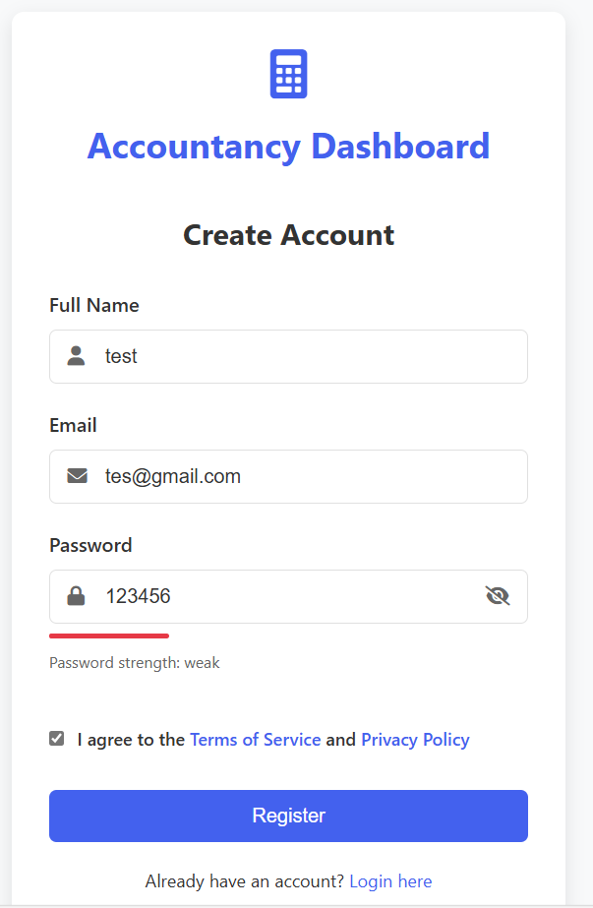
Database Updation:
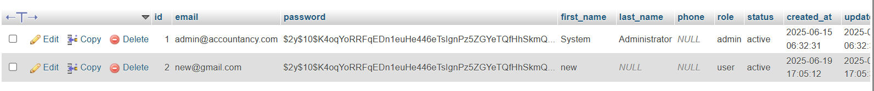

Dashboard:

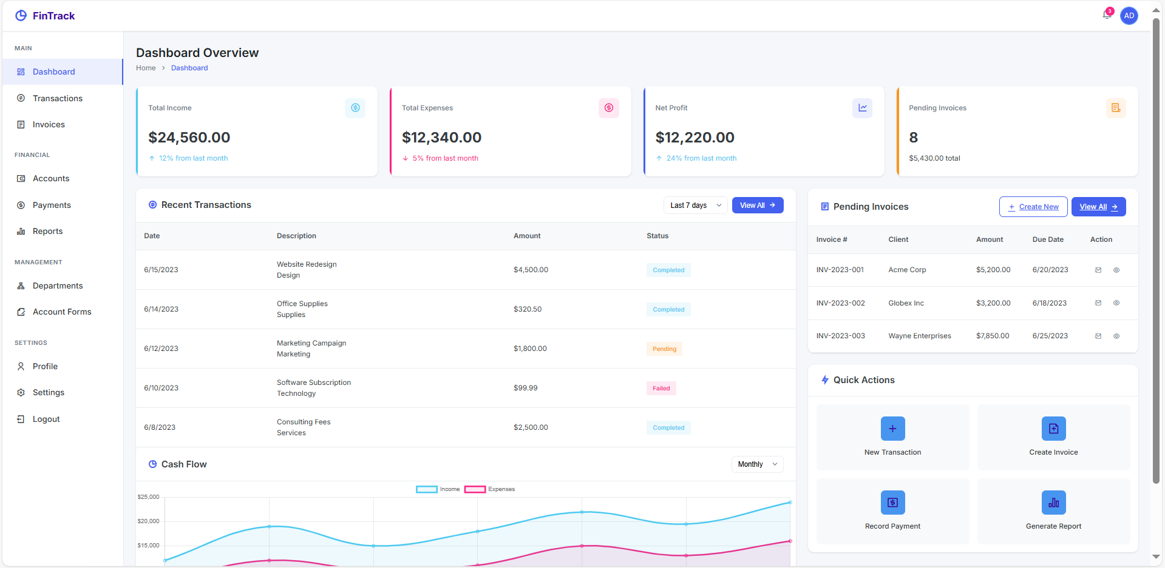

New Transaction:
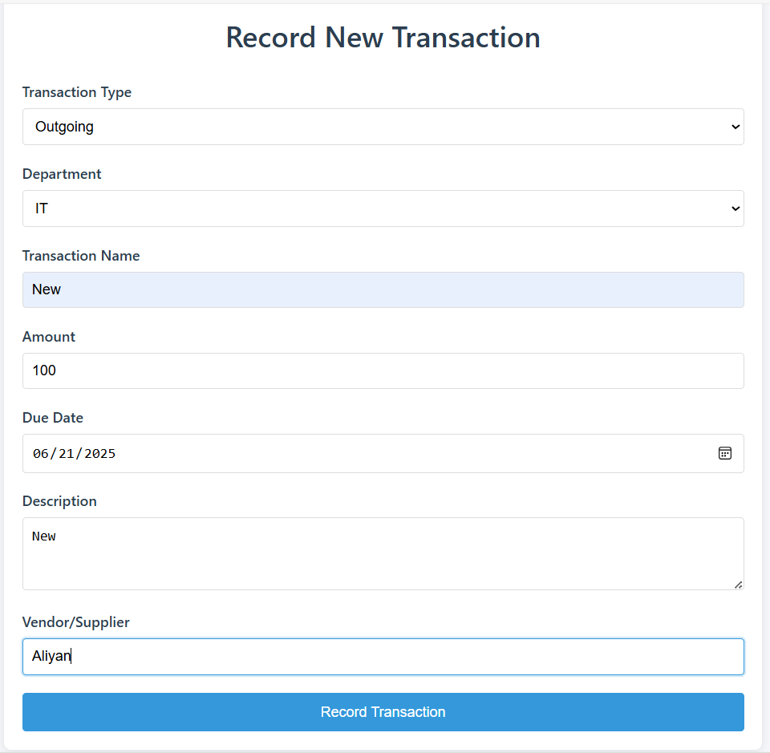

Transactions list:
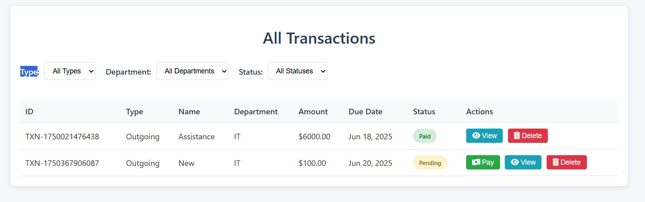
Delete Operation:
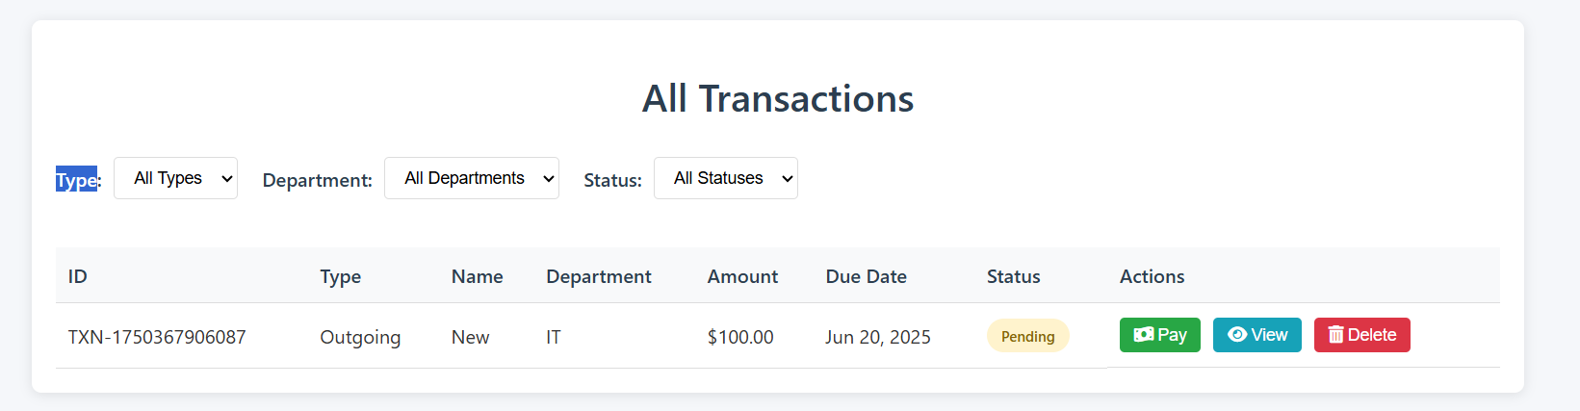

Can view:
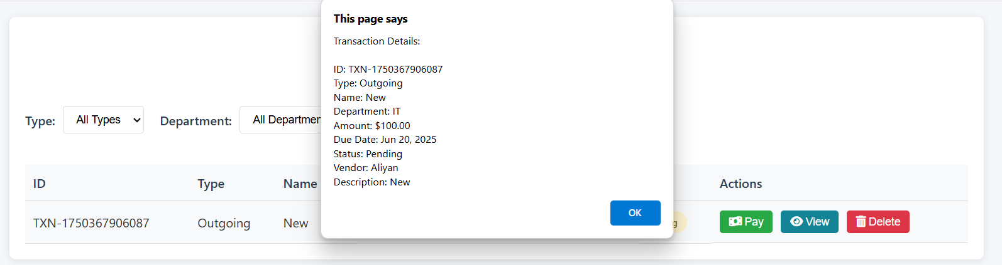

Payment:
By clicking pay, entered to this page for payment:
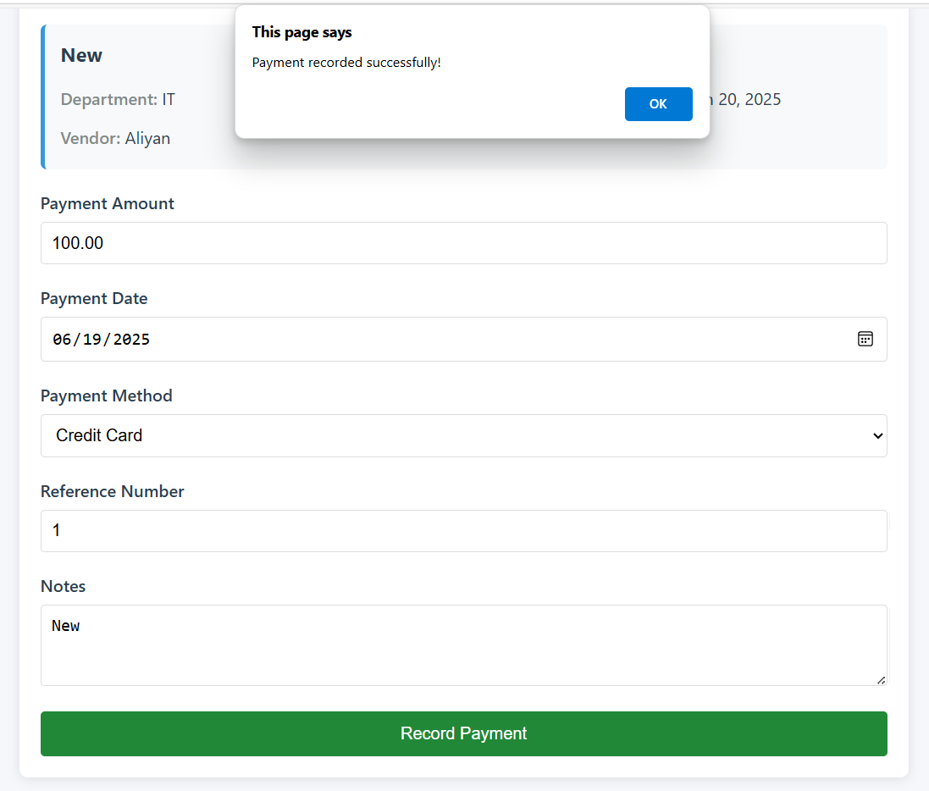

Database Updation:

List of payments:
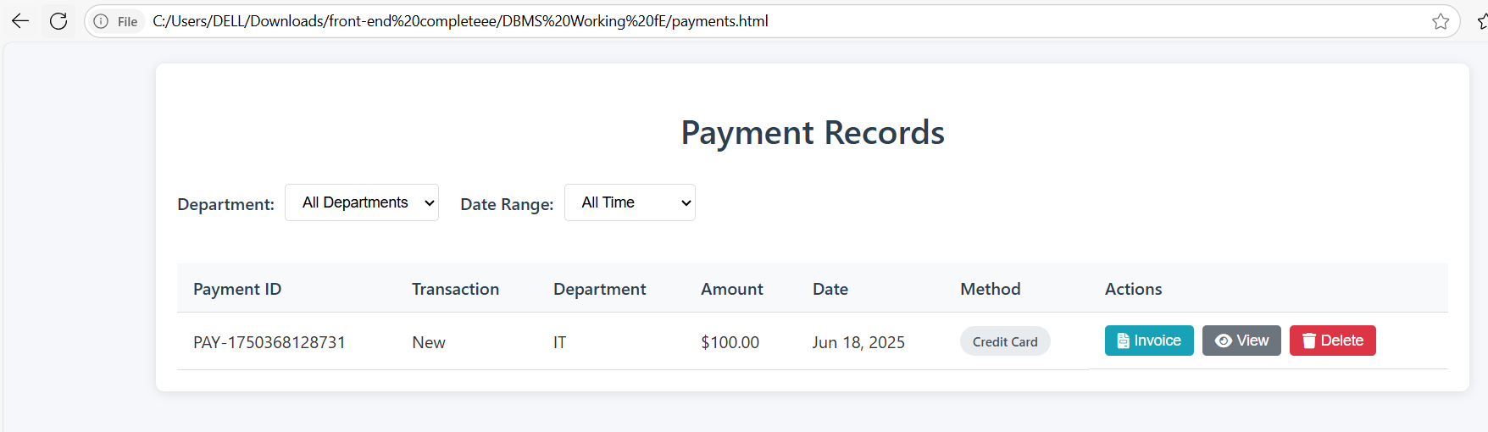

Database Updation:

View Invoice:
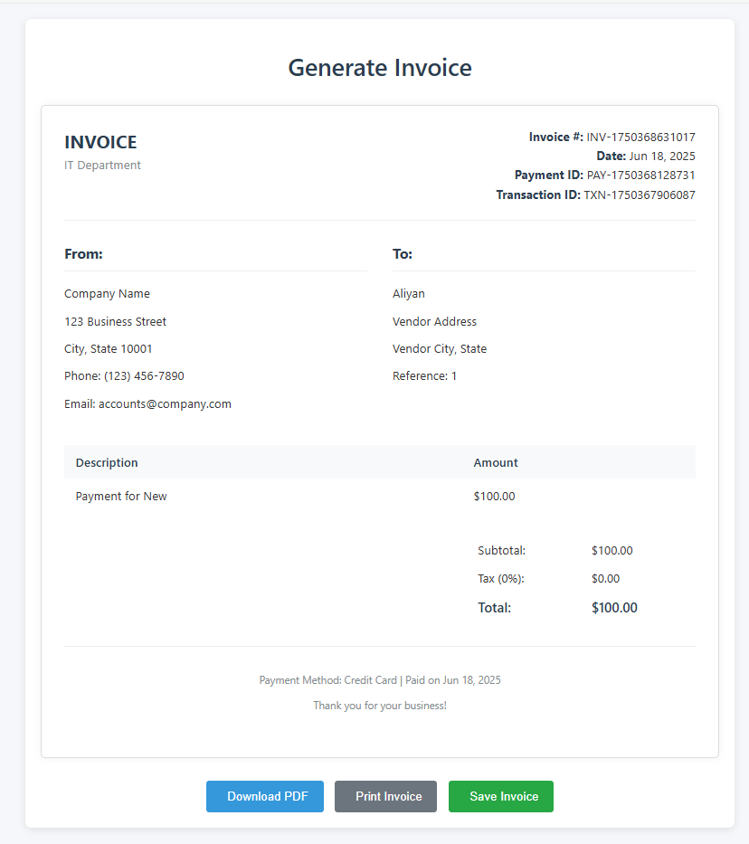
List of invoices:
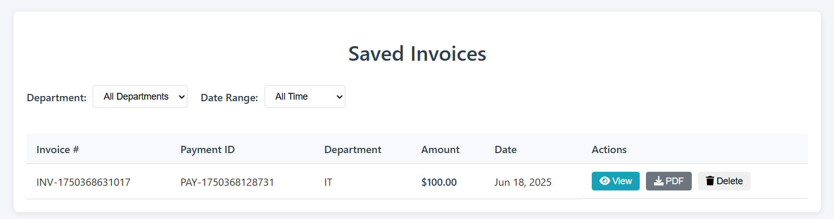

Report Generation:
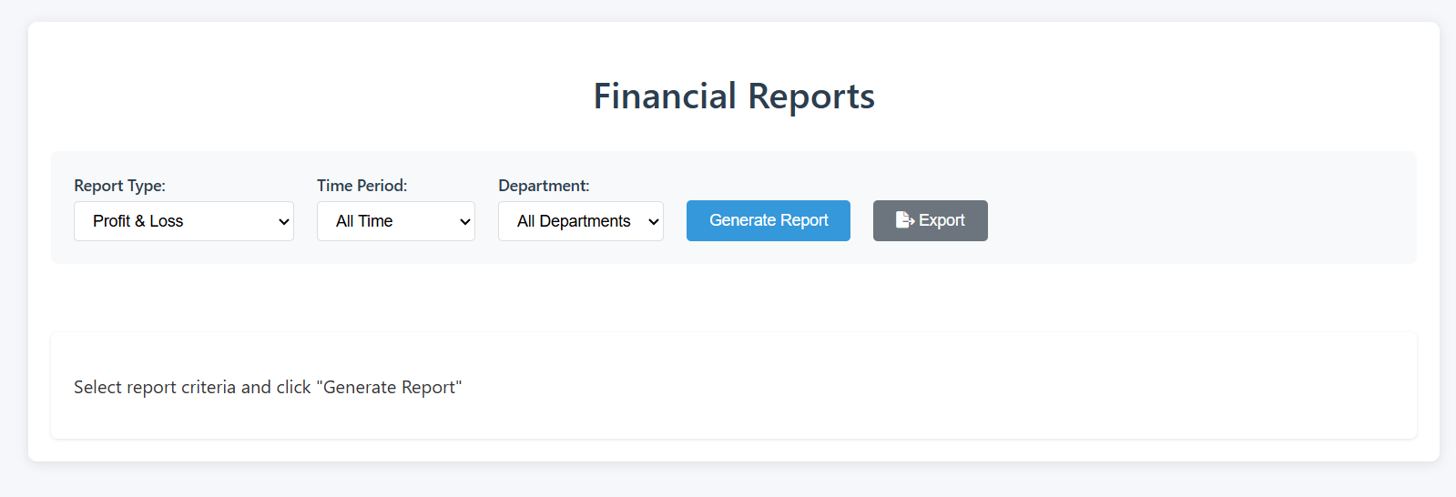
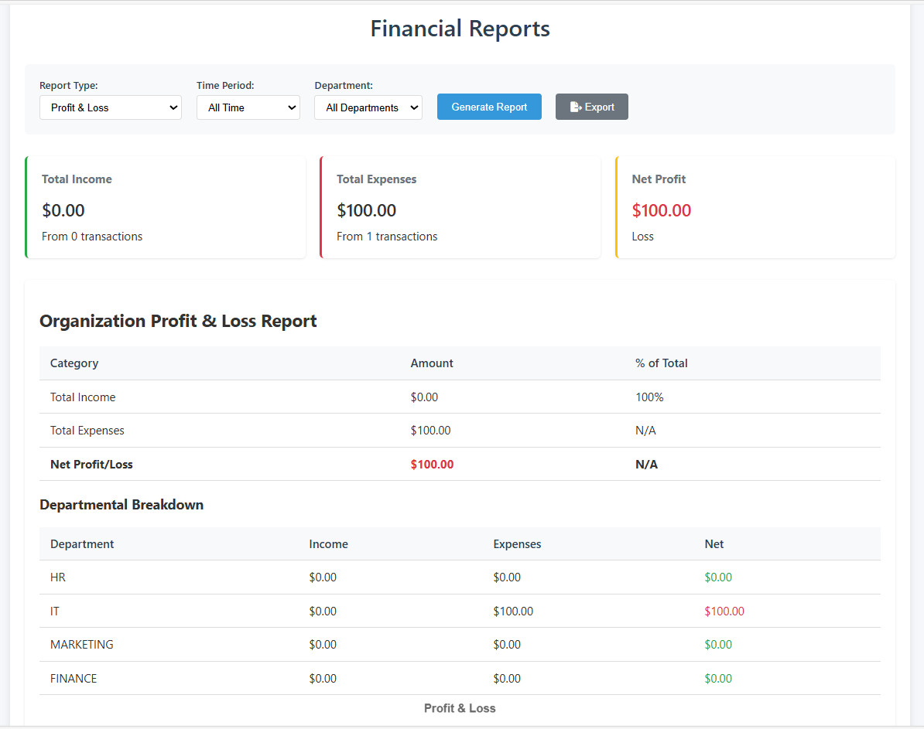
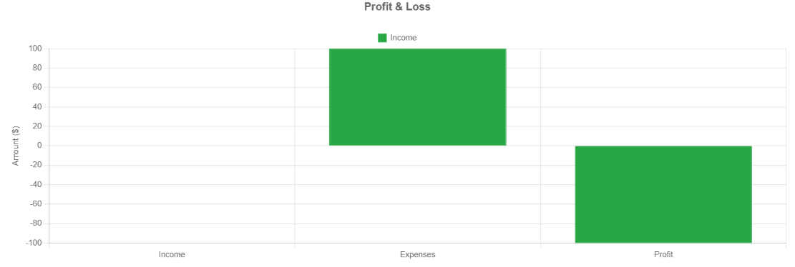

12. Conclusion
The Web-Based Accountancy System fulfills all requirements of the open-ended lab with a complete feature set, logical flow, and dynamic reporting engine. With clean design, secure backend, and real-world extensibility (like PDF exports, graphs), this system demonstrates not only technical competence but also a practical understanding of database-driven applications.

