Parallel Programming Exercise 8 – 10

Author: | 李昌樺 (R11525006@ntu.edu.tw)
Student ID | R11525006
Department | Engineering Science and Ocean Engineering
(If you and your team member contribute equally, you can use (co-first author), after each name.)

Problem and Proposed Approach
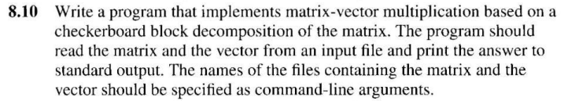
- 初始化mpi環境 => 處理器id=MyRank , 處理器總數=Numprocs
- 讀入矩陣與向量，將2維矩陣轉為1維陣列
- Id 0 Bcast向量並將1維陣列scatter出去。
- 計算處理器負責的陣列乘上對應的向量值總和。
- 把計算結果Gather回到Id 0。

Theoretical Analysis Model
(Try to give the time complexity of the algorithm, and analyze your program with iso-efficiency metrics)
n²
iso-efficiency:C²log²p

Performance Benchmark
(Give your idea or concept of how you design your program.)
Table 1. The execution time
Processors | 1 | 4 | 9 | 16
Real execution time | 3.258436 | 0.855621 | 0.415533 | 0.282164
Estimate execution  time | 3.258436 | 0.814609 | 0.362048 | 0.203652
Speedup | 1.000000 | 3.808270 | 7.841582 | 11.548022
Karp-flatt metrics |  | 0.0168 | 0.0185 | 0.0257

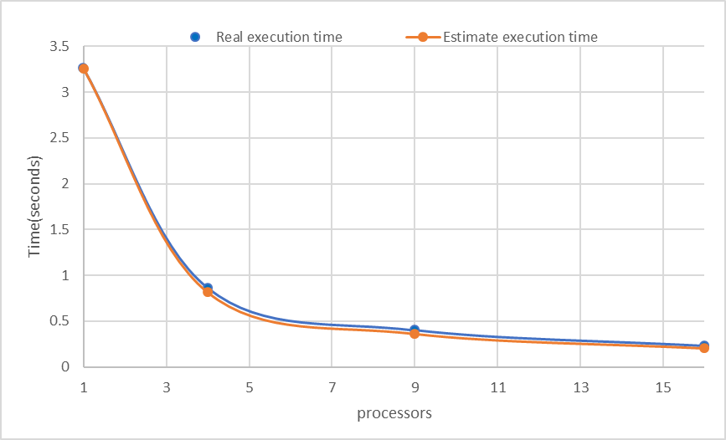

Conclusion and Discussion
(Discuss the following issues of your program)
- What is the speedup respect to the number of processors used?
Speedup的倍數隨處理器個數越來越大越不接近所使用的處理器個數，代表這個程式不太適合用來進行平行化的電腦計算。
- How can you improve your program further more?
可能要減少溝通時間，或者讀檔方式要換比較省時的。
- How does the communication and cache affect the performance of your program?
溝通滿大部分的影響了程式的執行效率。
- How does the Karp-Flatt metrics and Iso-efficiency metrics reveal?
Karp-Flatt 因為每次執行所使用的processor都不同這也導致了不準確性很高，但從
計算出來的結果判斷，Karp-Flatt的值在往上增加，因此推測這個程式受到溝通的影響比較嚴重。
Iso-efficiency: C²log²P，p在log2內但外面有乘C²所以延展性可能不會太好。

Appendix(optional):

