Parallel Programming Exercise 4– 12

Author: | 李昌樺 (R11525006@ntu.edu.tw)
Student ID | R11525006
Department | Engineering Science and Ocean Engineering
(If you and your team member contribute equally, you can use (co-first author), after each name.)

Problem and Proposed Approach
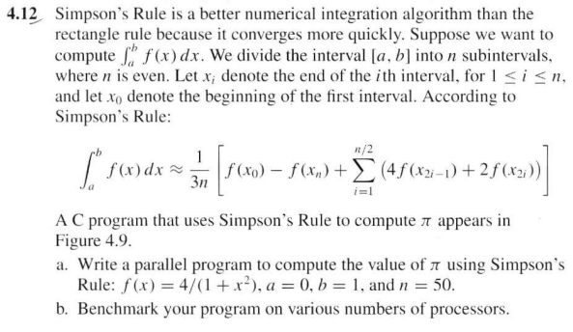
- 初始化mpi環境 => 處理器id=rank , 處理器總數=size
- 積分上下限0 -> 1 將x(i)切成0:50 n=50
- 將x(i)從1:25平行化，每個處理器分到連續的x(i)值,low_value <= x(i) <= high_value
- 每個rank計算自己的local sum
- 使用mpi_reduce將每個local sum匯集至rank0的global sum
- Rank0計算(f(0)-f(n)+global sum)/3*n

Theoretical Analysis Model
(Try to give the time complexity of the algorithm, and analyze your program with iso-efficiency metrics)
(n/2)/p+log ^{p}
Iso-efficiency: C log P

Performance Benchmark
(Give your idea or concept of how you design your program.)

Table 1. The execution time
Processors | 1 | 2 | 3 | 4 | 5 | 6 | 7 | 8
Real execution time | 0.000615 | 0.000609: | 0.000558 | 0.000508 | 0.000553 | 0.000230 | 0.000194 | 0.000371
Estimate execution  time | 0.000615 | 0.000308 | 0.000205 | 0.000154 | 0.000123 | 0.000103 | 0.000088 | 0.000077
Speedup | 1 | 1.009852 | 1.102151 | 1.210630 | 1.112116 | 2.673913 | 3.170103 | 1.657682
Karp-flatt metrics |  | 0.980488 | 0.860976 | 0.768022 | 0.873984 | 0.248780 | 0.201355 | 0.546574

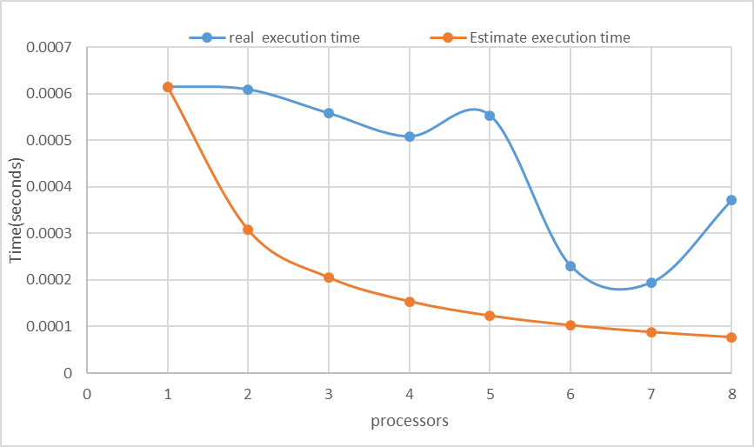

Conclusion and Discussion
(Discuss the following issues of your program)
- What is the speedup respect to the number of processors used?
Speedup倍率並沒有非常的明顯，代表平行化的效益不是很好。
可能是因為n=50可以平行的部分不夠大。
- How can you improve your program further more?
目前程式中有很多不可平行化的部分，或許可以想一些更成熟的方法將其工作給分配出去。
- How does the communication and cache affect the performance of your program?
溝通的部分只有一個mpi_reduce,而資料截斷也都以連續為主。不會太過影響執行效率。
反而是不可平行化部分過多而拉低了平行效率。
- How does the Karp-Flatt metrics and Iso-efficiency metrics reveal?
Karp-Flatt 從2 -> 5 來看大概都再0.85徘徊，所以不可平行化才是減少效率的主要
原因。而5 -> 6、7卻又突然往下掉，或許是因為分配到了速度較快的處理
器而導致的。
Iso-efficiency: C log P ，p在log裡面代表這個程式應該要有良好的延展性。

Appendix(optional):

使用fortran90所寫的程式
module load mpi/openmpi-3.0.0/gcc485
mpif90 –o 4.12 4.12.f90
qsub 4.12.sh !!!(sh檔是用textbook所寫，需先將dos轉為unix)

程式執行結果
