Parallel Programming Exercise 5 – 11

Author: | 李昌樺 (R11525006@ntu.edu.tw)
Student ID | R11525006
Department | Engineering Science and Ocean Engineering
(If you and your team member contribute equally, you can use (co-first author), after each name.)

Problem and Proposed Approach
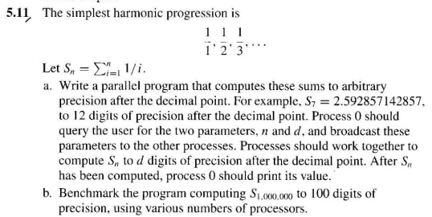
- 初始化mpi環境 => 處理器id=rank , 處理器總數=size
- Rank0廣播n與d的值
- 將n個數字平行化，處理rank+1+k*size的值,k從0開始
- 每個rank計算自己的local sum
- 使用mpi_reduce將每個local sum匯集至rank0的global sum

Theoretical Analysis Model
(Try to give the time complexity of the algorithm, and analyze your program with iso-efficiency metrics)
n/p+log ^{p}
iso-efficiency:C log P

Performance Benchmark
(Give your idea or concept of how you design your program.)

Table 1. The execution time
Processors | 1 | 2 | 3 | 4 | 5 | 6 | 7 | 8
Real execution time | 0.011113 | 0.005842 | 0.003742 | 0.003383 | 0.002406 | 0.002026 | 0.001866 | 0.001777
Estimate execution  time | 0.01113 | 0.005557 | 0.003704 | 0.002778 | 0.002223 | 0.001852 | 0.001588 | 0.001778
Speedup | 1 | 1.902260 | 2.969802 | 3.284954 | 4.618869 | 5.485192 | 5.955520 | 6.253799
Karp-flatt metrics |  | 0051381 | 0.005084 | 0.072558 | 0.020629 | 0.018771 | 0.029230 | 0.039889

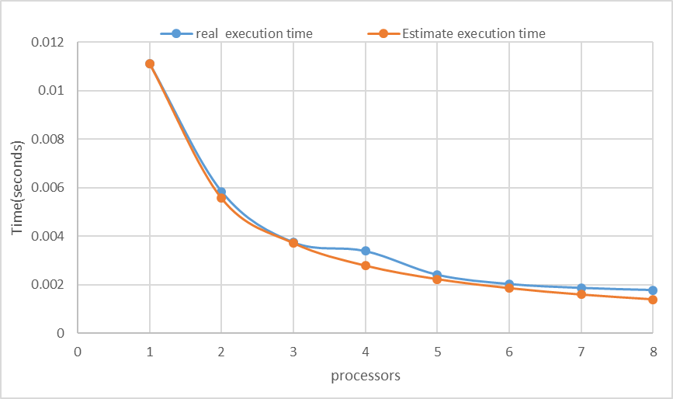

Conclusion and Discussion
(Discuss the following issues of your program)
- What is the speedup respect to the number of processors used?
前5顆處理器speedup的倍率都很接近處理器個數，6、7、8則稍微下降。
- How can you improve your program further more?
目前無法精確算到小數點100位以下，希望未來可以學習新的方法加以改進。
- How does the communication and cache affect the performance of your program?
目前的平行化方式為rank+1+k*size, k=0開始，這導致每個處理器所處理的資料並不連貫，快取記憶體無法包含全部數字。如果以連貫的方式切割可以再提高計算速度。
- How does the Karp-Flatt metrics and Iso-efficiency metrics reveal?
Karp-Flatt 因為每次執行所使用的processor都不同這也導致了不準確性很高，但從
計算出來的結果判斷，溝通的部分並沒有很大的影響執行效率，而且從
Speedup來看，有非常高的倍數所以平行化效率很好。
Iso-efficiency: C log P ，p在log內代表這個程式應該要有良好的延展性。

Appendix(optional):

使用fortran90所寫的程式
module load mpi/openmpi-3.0.0/gcc485
mpif90 –o 5.11 5.11.f90
qsub 5.11.sh !!!(sh檔是用textbook所寫，需先將dos轉為unix)

程式執行結果

