**Computer Vision HW3 Report**

Student ID: R12942159

Name: 邱亮茗

**Part 1.**

**• Paste your warped canvas**



**Part 2.**

**• Paste the function code *solve_homography(u, v)* & *warping( )* (both forward & backward)**

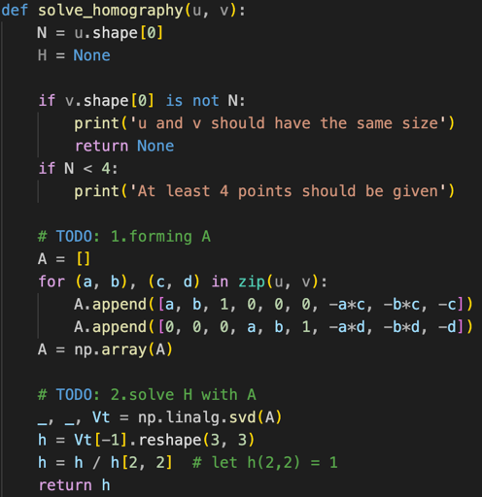

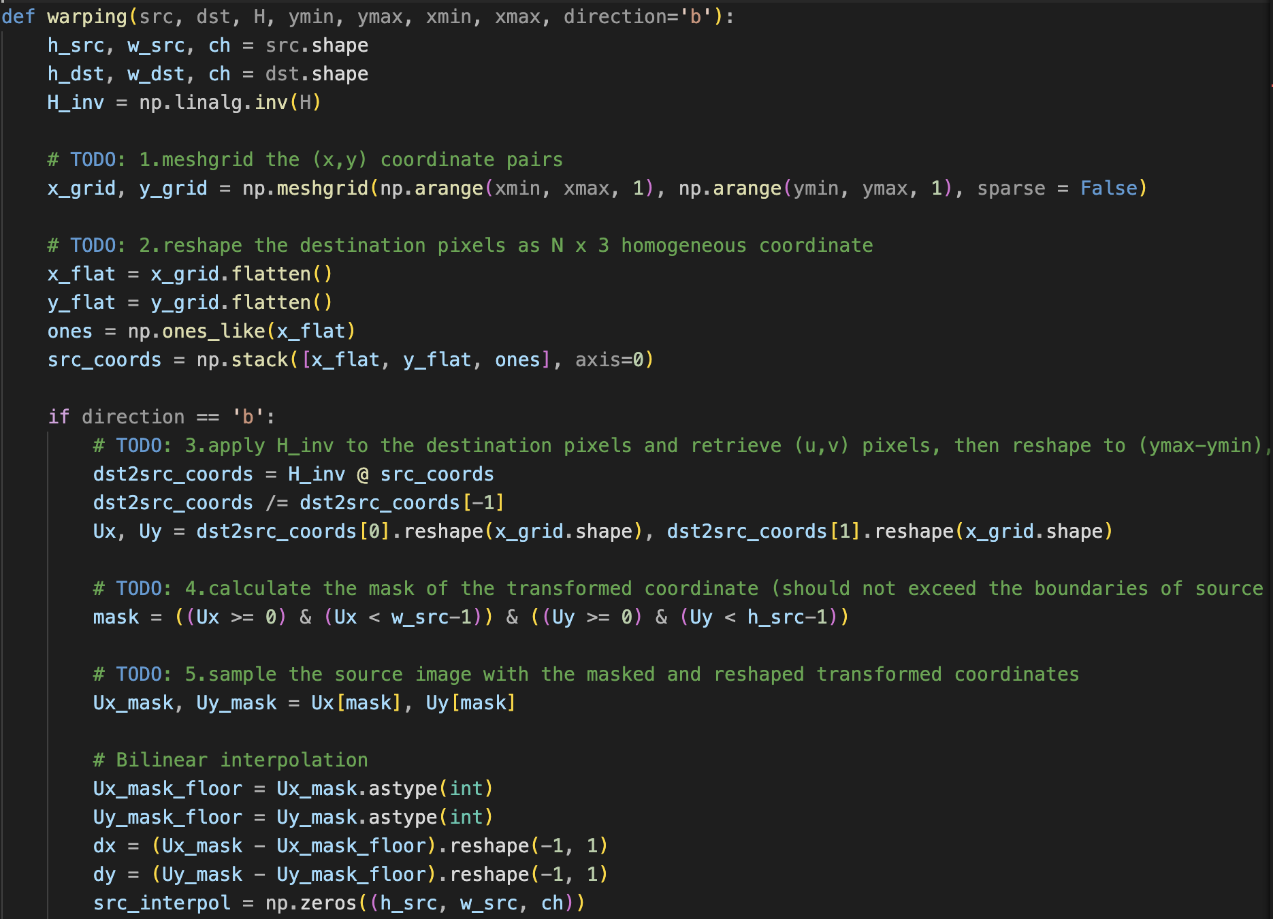

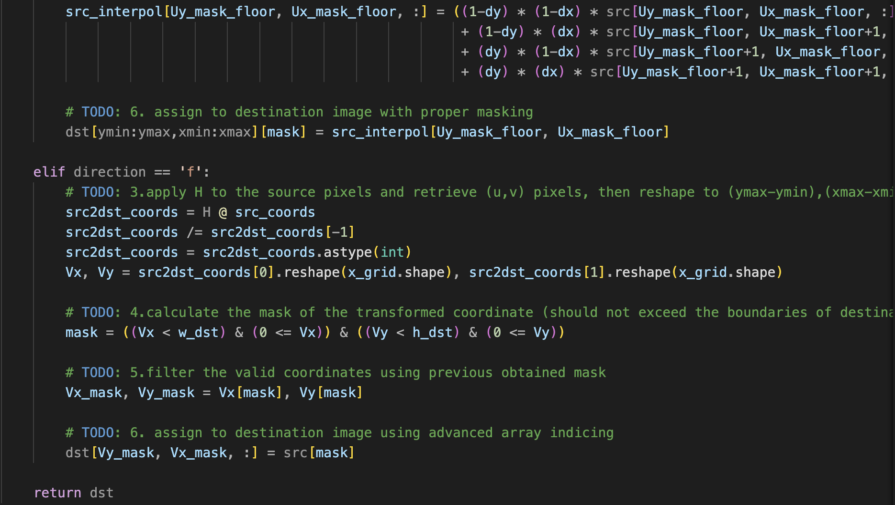

**• Briefly introduce the interpolation method you use**

Bilinear interpolation is a method used to estimate the value of a function—such as pixel intensity—at a non-integer coordinate by computing the weighted average of its four nearest neighboring pixels.

For example, given a point (x,y) that lies between four known pixel values—​ (top-left), ​ (top-right), ​ (bottom-left), and ​ (bottom-right)—the value at (x,y) is calculated as follows:

Where .

**Part 3.**

**• Paste the 2 warped images and the link you find**

**• Discuss the difference between 2 source images, are the warped results the same or different?**

**• If the results are the same, explain why. If the results are different, explain why?**

**Part 4.**

**• Paste your stitched panorama**

**• Can all consecutive images be stitched into a panorama?**

**• If yes, explain your reason. If not, explain under what conditions will result in a failure?**