Inw3D Generation Service

Approved Origin Architecture

STATUS  Proposed |  | OWNER  Project Lead |  | LAST UPDATED  September 5, 2026

Authors | Inw3D Generation project team
Reviewers | Project sponsor and infrastructure owner
Related docs | Specs 001–002; approved server evidence held separately
Scope | Public web entry, approved origin, outbound tunnel, private GPU compute, security, and operations

1. Abstract
This RFC defines the zero-recurring-cost public entry architecture for the Inw3D Generation Service. A web client reaches a no-cost delegated hostname at Cloudflare; Cloudflare terminates public TLS and forwards application traffic through an outbound-only Cloudflare Tunnel to the institutionally approved production origin. The origin is a required part of every public request path, not a nominal or fallback host.
The approved origin provides the web entry point, request routing, health handling, and a controlled maintenance response. Generation remains private on the RTX 5070 compute role, using the existing API, serial job queue, SQLite state, and ComfyUI or Hunyuan3D workflow. No router port forwarding or public application, database, model, or administration port is permitted.

2. Goals and Non-Goals
Goals | Non-Goals
Make the approved server mandatory for every production request. | Purchase or renew a .com domain.
Publish the service with zero recurring infrastructure cost. | Expose the GPU, model UI, database, or admin ports publicly.
Use an outbound-only tunnel with no router port forwarding. | Replace the existing generation pipeline or model workflow.
Keep jobs private with per-job authorization and safe logs. | Provide accounts, payments, multi-tenant isolation, or a general VPN.

3. Background and Problem Statement
The project must publish a browser-accessible 3D generation workflow while keeping recurring infrastructure cost at zero. The server address documented in the project approval is mandatory for production use. At the same time, directly publishing that address or exposing local service ports would enlarge the attack surface and make router, firewall, certificate, and IP-change handling part of the application design.
Cloudflare Tunnel resolves this conflict by letting the approved origin establish outbound connections to Cloudflare. External clients see the Cloudflare edge, while the approved origin remains authoritative for the application path. The preferred public name is a free delegated hostname such as inw3dgen.is-a.dev; a paid .com domain is outside the current zero-cost constraint.

4. Proposed Architecture

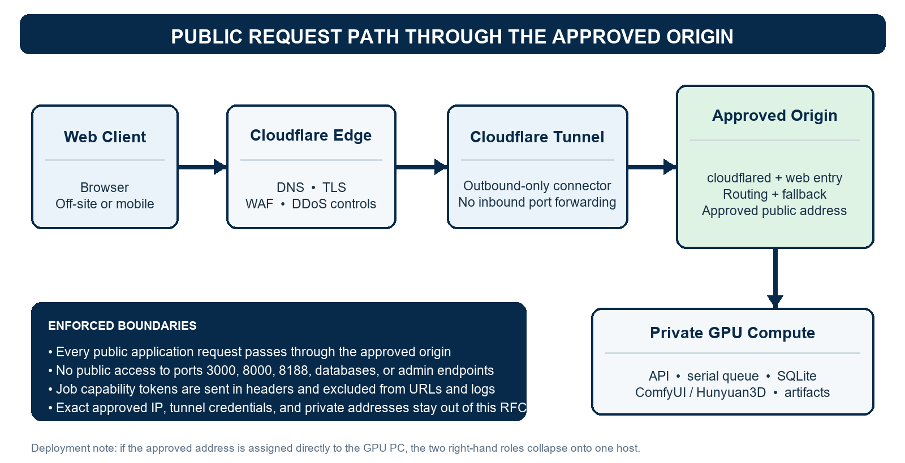
Figure 1. Approved-origin outbound tunnel architecture and trust boundaries.

Core components

Component | Responsibility | Key technology | Failure behavior
Cloudflare edge | Public DNS, TLS, edge filtering, and request forwarding | Free DNS, Universal SSL, edge controls | Returns an edge error when no healthy tunnel exists
Tunnel connector | Maintains outbound connections from the approved origin | cloudflared as an auto-starting Windows service | Reconnects with backoff; never opens an inbound listener
Approved origin | Mandatory web entry, validation, routing, job state, and fallback response | Reverse proxy or web API plus SQLite | Serves maintenance state when compute is unavailable
Private GPU compute | Runs one 3D generation job at a time | RTX 5070, ComfyUI or Hunyuan3D, local artifacts | Fails the job safely; remains unreachable from the internet
Observability and recovery | Health, structured logs, backup, revocation, and restore evidence | Job ID correlation; Windows service and disk monitoring | Escalates after three failed automatic recovery attempts

5. Request Lifecycle
A. A user opens the accepted public hostname from a browser on any external network.
B. Cloudflare resolves DNS, negotiates Universal SSL, and applies edge security controls before forwarding traffic.
C. An existing outbound tunnel connection carries the request to cloudflared on the approved production origin.
D. The origin serves the UI or validates an image upload, creates an opaque job ID and capability token, and records the job in SQLite.
E. The serial queue dispatches one generation job at a time to the private GPU compute service; internal service ports stay on loopback or a private network.
F. The browser polls status using X-Job-Token. The API returns queued, running, succeeded, failed, or expired without placing secrets in URLs.
G. On success, the origin authorizes preview or download and streams the artifact. On compute failure it returns a safe terminal error; when compute is unavailable it serves a project-owned maintenance response.

6. API and Data Contracts

Primary job contract

Field | Type | Required | Notes
image_file | binary | Yes | Validated image; size capped by the API contract
job_id | opaque string | Response | Non-sequential correlation identifier
X-Job-Token | secret header | Protected calls | Per-job capability; excluded from URL and logs
status | enum | Yes | queued, running, succeeded, failed, or expired
progress | integer | When running | Best-effort 0–100 progress indicator
output_url | relative URL | On success | Requires the same job capability
error_code | safe string | On failure | Stable class without internal paths or secrets

Contract guarantees

• Job IDs are opaque and non-sequential; possession of a valid per-job token is required for status and artifact access.
• X-Job-Token is carried in a request header, never in a query string, analytics field, or project-controlled log.
• Upload type and size are validated before queueing; the service rejects unsupported content without invoking the GPU workflow.
• Status transitions are monotonic, terminal states are immutable, and output publication is atomic after validation.
Related contract: specs/001-local-3d-generation/contracts/openapi.yaml
Deployment contract: accepted hostname → Cloudflare edge → Tunnel → approved origin → private compute

7. Consistency and Idempotency

SQLite is the source of truth for job metadata on the approved origin. Queue admission and state transition occur in one controlled path, while generated artifacts are written to a temporary location and atomically published only after completion. Repeated reads are safe; repeated submissions create a new job unless a future explicit idempotency key is introduced.
Scenario | Guarantee | Operational handling
Duplicate status or download read | Read-only and safe to repeat | Return the same authorized state or artifact
Repeated submission | Creates a separate job in this release | UI prevents accidental double-submit; future key may deduplicate
Process restart | Persisted jobs remain auditable | Recover queued work where safe; mark interrupted work failed otherwise
Partial artifact write | Never exposed as a completed output | Write temporary file, validate, then atomically rename

8. Security and Privacy

• Trust boundaries: public client ↔ Cloudflare; Cloudflare Tunnel ↔ approved origin; approved origin ↔ private GPU compute.
• Exposure: no inbound port forwarding and no direct public access to ports 3000, 8000, 8188, SQLite, model storage, or admin endpoints.
• Secrets: protect tunnel credentials and per-job tokens; support credential revocation and rotation; do not commit credentials to Git.
• Data minimization: log request and job identifiers, state, duration, and error class; exclude tokens, exact approved IP, private addresses, and uploaded content.
• Abuse controls: edge rate limits, upload limits, strict MIME and file validation, bounded queue length, and request timeouts before GPU execution.

9. Operational Readiness
Signal | Target | Alert trigger | Recovery action
External availability | Hostname reaches approved origin | Three failed probes | Restart entry service; verify route
Tunnel recovery | Reconnect within 5 minutes | No health after 5 minutes | Restart cloudflared; reissue if required
Origin path compliance | All public tests traverse origin | Any bypass | Disable route; block release
Public port exposure | Zero direct app or admin ports | Any external access | Close rule; investigate
Secret leakage | Zero matches in logs or Git | Any match | Revoke; remove exposure; document incident
Rollout: local health → tunnel dry run → external end-to-end test → recovery and revocation drills → production cutover. Roll back by disabling the published hostname route while preserving local generation and diagnostic logs.

10. Alternatives Considered

Alternative | Decision | Rationale
Buy inw3dgen.com | Rejected for this release | Registration and renewal violate the zero-recurring-cost constraint
Direct A record and inbound HTTPS | Rejected | Publishes the approved address and requires inbound firewall or router exposure
Tunnel directly to the GPU while bypassing the approved origin | Rejected | Conflicts with the approved-server requirement and weakens operational control
Managed cloud hosting | Deferred | Adds recurring cost and moves generation data outside the current local-first scope

11. Open Questions
• Which free delegated hostname is finally accepted and active: inw3dgen.is-a.dev or another approved no-cost name?
• Is the approved public address assigned to a separate origin host, or directly to the RTX 5070 PC so both roles collapse onto one machine?
• Which Windows service identity and startup policy will own cloudflared and the web entry process on the approved origin?
• What retention period is approved for uploads, generated artifacts, job metadata, and operational logs?

12. Decision and Next Steps
Adopt the approved-origin, outbound-only Cloudflare Tunnel architecture. The approved server remains mandatory in the production request path, the GPU workflow stays private, and the public name must incur no recurring charge. A paid .com name, direct inbound exposure, or a tunnel that bypasses the approved origin is not part of this release.
Milestone | Completion evidence | Owner
M1 Lock deployment facts | Accepted free hostname, approved-origin role, and host placement recorded | Project lead
M2 Establish entry path | cloudflared service healthy; hostname routes to approved-origin health endpoint | Infrastructure owner
M3 Validate generation | Off-site browser completes submit, status, preview, and download through the origin | Application team
M4 Harden and cut over | No exposed ports; recovery, backup, credential revocation, and log checks pass | Project lead and reviewers

Use footnotes for definitions, assumptions, or terms that need precision without interrupting the main narrative.

