CGJ, Coles Group Ltd.
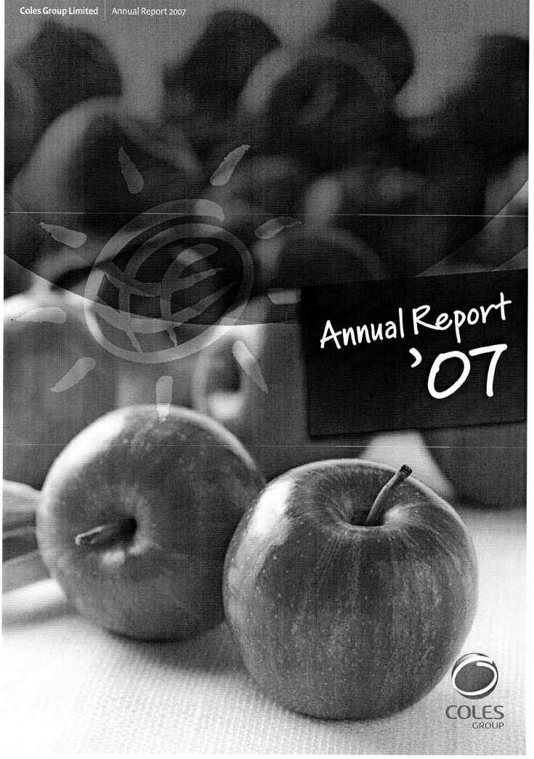

A Year in Review
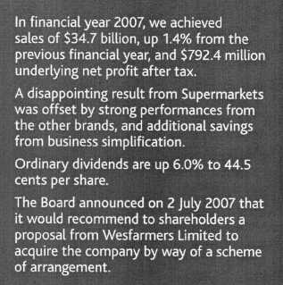
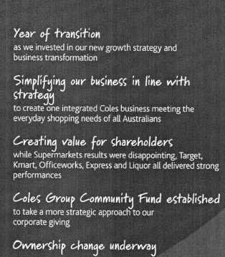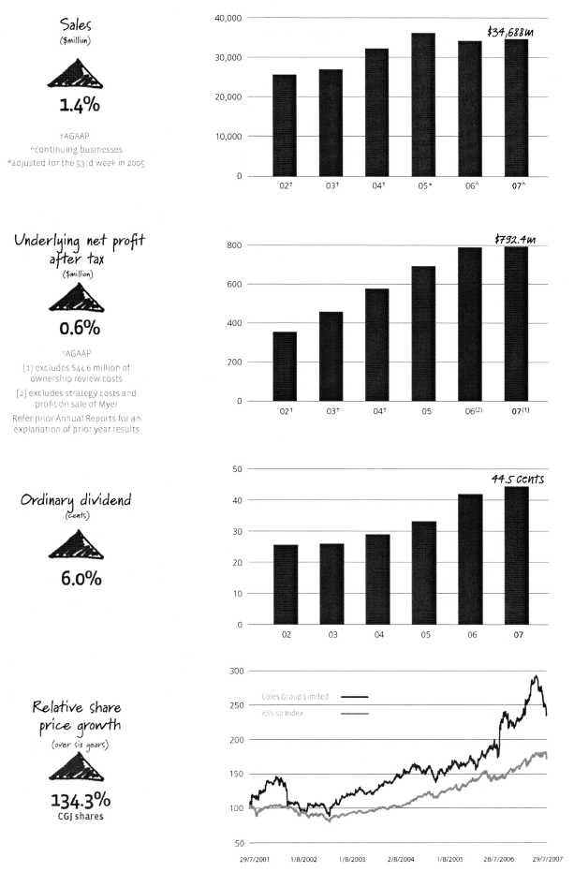

A Challenging Year
Q. Why did the Board decide to sell the Company?
Chairman, Rick Allert: The Board was first approached about ownership in August last year shortly after we had outlined our new growth strategy to shareholders.
After taking advice from our external advisers, the Board rejected the proposal from the KKR-led consortium on the basis that it substantially undervalued the Company and was highly conditional.
In order that shareholders could see the value to be created by the Company remaining independent and pursuing its growth strategy, we provided financial guidance to the market for both the 2007 and 2008 financial years on September 21 2006.
Regrettably, on February 23 2007, it became necessary to advise shareholders that guidance for 2008 was being revised to take account of the anticipated impact on earnings of a lower than expected sales performance in Supermarkets. This meant that forecast earnings would increase by around 20% rather than 30%.
At the same time, the Board announced that following approaches from a number of parties, it would explore all ownership options, including sale in whole or in part of the Company, to determine whether additional shareholder value could be created under alternative scenarios.
Q. Why did the Board recommend the Wesfarmers proposal?
RA: Following a rigorous process during which we looked at all options and formal bids were invited and received, the Board announced on July 2 2007 that it would recommend to shareholders a proposal from Wesfarmers Limited to acquire the Company by way of a scheme of arrangement to be approved at a meeting of shareholders.
Wesfarmers subsequently enhanced its proposal through the inclusion of Wesfarmers Partially Protected Shares (WPPS) as part of the scrip component of its offer.
The Independent Expert, Grant Samuel & Associates, has found the enhanced proposal, whilst not in the fair value range, is on an overall basis in the best interests of shareholders in the absence of a superior proposal.
The Board believes that the Wesfarmers' proposal, incorporating a mix of cash and scrip, provides Coles shareholders with an attractive opportunity to both continue to benefit from the growth of Coles' businesses and to earn higher dividends as shareholders of the expanded Wesfarmers.
Q. What parts of the new strategy have gone well?
Chief Executive Officer, John Fletcher: We have made strong
progress in simplifying our business in line with our strategy to create one integrated Coles business meeting the everyday shopping needs of all Australians. During the 2007 financial year,
we significantly exceeded our savings target of $70 million and are well on track to achieve total annual savings of more than $363 million by the end of the 2008 financial year.
We have also continued to make good progress in transforming the systems and processes that support the movement of products from suppliers to stores, with the opening of six new state-of-the-art distribution centres.
I am particularly pleased about the performance of Target, Officeworks, Kmart, Coles Express and Liquor, each delivering results in line with their new strategy.
Q. So what went wrong in Supermarkets?
jF: Our strategy included the rebranding of Bi-Lo stores to Coles. Our execution of this initiative was poor and we did not deliver the planned customer value proposition. This, in turn, impacted sales and earnings. Remedial plans have now been developed and are being implemented to ensure that we get the product and value equation right for customers.
We have also launched new initiatives to improve our fresh produce offer through the 'Love Fresh' campaign, which has received a positive response from customers.
While we still have some way to go to achieve sustainable sales and earnings growth in Supermarkets, the team know what they need to do and have plans in place to get there.
Q. How did the rest of the business perform?
RA: We said at the start of the 2007 financial year that it would be a year of transition as we invested in our new growth strategy and business transformation.
While the contribution from Supermarkets to the full-year profit result was lower than anticipated, this was offset by strong performances from our other businesses.
JF: Target's result was outstanding, reinforcing its position as Australia's most successful apparel retailer. Kmart also gained real earnings traction under its new strategy to improve margins by lowering reliance on promotional activity. Officeworks again demonstrated its unique position in the office products market, and our Coles Express convenience stores continued to grow strongly.
Coles Liquor performed very well, with the successful consolidation and integration of acquisitions, and the roll-out of the 1st Choice network ahead of expectations.
Q. How do you feel about setting the Company?
RA: The Board believes this outcome is good for shareholders, for customers and for team members. Our shareholders can continue as investors in Coles' businesses with the opportunity to share in potential operational upside. Customers will continue to have access to an Australian-owned business, managed by a company with a track record of strong financial and operational performance. Team members will get to work for another great Australian company.

Implementing Our Strategy
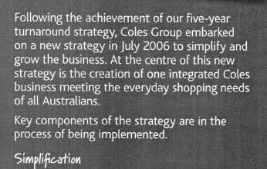
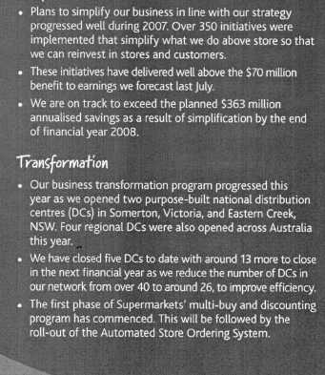
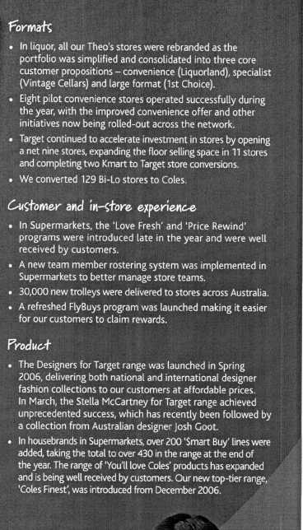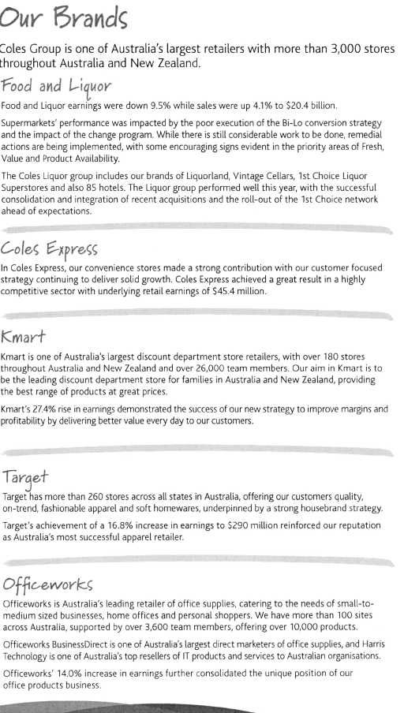
It was a very challenging year in Supermarkets, mainly due to the poor execution of the Bi-Lo rebranding, as well as the amount of change impacting the business.
In the second half of the year, we focused on four priority areas: Bi-Lo, Fresh, Availability and Value in a challenging and increasingly competitive environment. Good progress was made in growing sales in fresh, investing in better value for our customers, and improving on-shelf product availability.
In Bi-Lo, the business was stabilised and the sales decline was arrested in both the 129 converted and 71 unconverted stores.
Trials are underway in several converted Bi-Lo stores and the early customer response has been positive, however, we will continue to refine this offer before considering wider implementation of a sustainable solution.
Through our 'Love Fresh' program, we are seeing more of our customers purchasing our quality fresh food products at competitive prices.
While product availability issues throughout the year impacted our customers, this has now stabilised and is improving as we focus on consistency across our stores.
On the value front we introduced several hundred innovative housebrand products. The development of our family of brands represents our commitment to giving our customers quality, value and choice.
'You'll love Coles' offers our customers great products equivalent to market-leading prices. We also have hundreds of new '$mart Buy' products offering very good quality at the lowest price. Our top tier, 'Coles Finest', stands for inspirational quality.
Also this year we launched 'Price Rewind', a marketing program to lower prices for our customers. We're 'rewinding' prices on hundreds of items, focusing on products that matter most to our customers.
We continue to support Australian growers, purchasing over $2.5 billion in fresh produce and meat each year. This year, 97 per cent of our fresh food and 85 per cent of our grocery products were sourced from Australia.
We opened 20 new supermarkets and divested 12, taking our total store network to 745 stores nationally.
While it has been a difficult year for Supermarkets, we are clear on the customer priorities and the need to effectively manage the business change program and strengthen our organisational capability. In the year ahead, we will continue with our aim to offer our customers something better, every day.
Food & Liquor | 2007 | 2006 | Change
Sales (Sm) | 20,437 | 19,626 | 4.1%
Retail EBIT ($m) (1) | 693.3 | 766.3 | -9.5%
Retail margin (1) | 3.39 | 3.90 | -51bps

(1) 2006: Excludes strategic initiative costs ($214.4m)
At Coles Liquor, it's been a year of growth in an extremely competitive market where customers have enjoyed greater choice and value than ever before.
Each of our retail brands — Liquorland, Vintage Cellars and 1st Choice — has grown. We have increased our store portfolio by 16 to a total of 751 stores.
During the year we integrated our acquisitions, Hedley, Mr Corks and Talbot, to our common branding, systems and supply chain. This huge project, involving 46 hotel and 137 retail sites, was completed in less than 12 months and has been welcomed by team members and customers.
C/ivin5 uc-I-orvierc 5rea-t-ranle, unbeaf-abie value and a unictueexperienc,e
We grew our hotel portfolio by 16 to a total of 85 hotels, with new sites in WA, SA and Queensland. Our Eastern states' hotel portfolio now stretches from the NSW border to Palm Cove in Far North Queensland. New bar, bistro and gaming initiatives have been very popular with customers.
Our 1st Choice Liquor Superstore rollout continued with 20 additional large format stores bringing the total to 39, including 24 stores trading in the fast-growing Queensland market. The team is focused on giving customers great range, unbeatable value and a unique retail experience.
We upgraded 51 Liquorland stores, and have now completed refurbishment of 200 stores, giving our customers convenience and a bright new store environment where it is easy to find the products they want.
Vintage Cellars, our specialist wine brand, further strengthened its position with successful releases of the Grange and Penfolds Bin ranges, and some exciting new international wines. The Vintage Cellars Wine Club is among the most successful of its kind in Australia and its membership base continues to grow.
Product differentiation has been a key focus across the Liquor business with a range of new and exclusive products introduced to customers throughout the year, including the St Andrews wine range, Tangled Vine casks, Lachlan Ridge casks, Pizzazz sparkling wines and Hammer 'N' Tongs draught beer. Our merchandise team scours Australia and the world to bring our customers exciting new products and greater choice — and more exclusives are on the way.
Next year we will build on our momentum by continuing our successful store roll-out and refurbishments, optimising our hotel portfolio and delivering an outstanding liquor offer to customers across all our hotels and retail brands.
 | 2007 | 2006 | Change
Sales ($m) | 5,793 | 6,187 | -6.4%
Retail EBIT ($m) o) | 45.4 | 30.0 | 51.3%

(1) | 2007: Excludes $345 million for renegotiated Coles Express leases previously expensed under AIFRS.
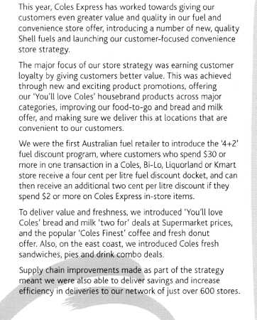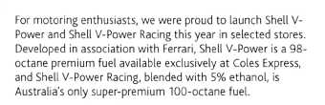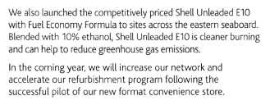
Kmart has had a challenging but exciting year, focusing on the reinvigoration of our product offer. This improvement, combined with an increased number of store refurbishments, has positioned Kmart for profitable growth next financial year.
This year, Kmart remained a destination for customer favourites like childrenswear, men's underwear, toys, footwear, DVDs, camping and fishing. Customers responded well to the tremendous range we offered, with something for all the family, from toys to manchester, clothes and barbecues. We again gave customers a mix of our own, excellent value brands such as GirlXpress, Now, Jackeroo and Rivergum, and the national brands our customers love.
We are focused on a big, bright future for Kmart. We are building a strong business that will deliver every day value to our customers and is flexible to their needs, wants and shopping habits.
Our team members form the heart of Kmart. We are proud of their commitment to providing the best customer shopping experience, and are focused on building capability and helping develop their careers.
We opened six new stores this year, while nine underperforming stores were closed, bringing our total portfolio to 168 stores across Australia and 14 in New Zealand. We have plans underway to open more stores in both countries next year.
Our foundation is 'A Good Life Is Affordable at Kmart', and we make affordability a priority. This year we have acted on that promise by improving our offer to customers in Home (sheets, pillows and storage), Women (seasonal and fashion basics, underwear, footwear, wellbeing and cosmetics), Family (for men and for children) and Entertainment and Recreation (from the family barbecue to beach volleyball, from the latest MP3 or video games to backyard cricket).
Kmart Tyre and Auto Service is Australia's largest automotive service, repair and tyre retailer, offering consistent high quality in products and service. This year we sold our tyre wholesale business, and we focused on integrating the 96 sites we purchased the previous year from Shell. We now have a network of 267 stores in excellent locations, and we are Australia's largest single employer of mechanics and apprentices.
With a leading range of national brands and our own brands, a major focus on the continuous improvement of our customer experience and in-store execution and a great Kmart team, we look forward to an exciting year of growth.
 | 2007 | 2006 | Change
Sales ($m) | 3,889 | 4,001 | -2.8%
Retail EBIT (Srn)o) | 96.8 | 76.0 | 27.4%
Retail margino) | 2.49 | 1.90 | 59bps

(1) 2006. Exciudes strategic initiative costs ($12.8m)
 | 2007 | 2006 | Change
Sales (Sm) | 3,306 | 3,170 | 4.3?'6
Retail EBIT (Sm)''' ) | 290.0 | 248.3 | 16.8%
Retail margin o) | 8.77 | 7.83 | 94bps

(1) 2006: Excludes strategic initiative costs (514.6rn)
This year, at Target we continued our very successful strategy of providing our customers with fashionable and affordable merchandise across all categories.
Our focus on delivering differentiated fashion merchandise created strong customer demand in our childrenswear and menswear businesses. The women's apparel, footwear and homewares businesses also helped to consolidate our reputation as a destination for wanted on-trend products across all of our merchandise categories.
Our Designers for Target program, introduced ahead of the Spring Racing Carnival in October, was an instant hit with customers keen to own on-trend designer garments at discount department store prices. The March launch of the Stella McCartney for Target collection was an unprecedented success and further reinforced Target as a destination for affordable fashion. We are planning to grow this component of our business with more exciting and highly sought after designer collaborations next year.
As well as enhancing our merchandise offer, we have undertaken significant work to improve our customers' in-store shopping experience, by introducing our ambience program. The program improves stores with enhancements including new flooring, better fixture and aisle positions, new fixtures, large graphic treatments and painting. The ambience program helps Target to be consistent with the style of our products, delivering a light, clean and easy place to shop and also highlighting the products we offer.
This year, we gained traction in our strategy of expanding the Target store network, opening a net nine stores. We
look forward to bringing the Target brand to more Australian communities as a major shopping destination as our store roll-out program continues in 2008.
As well as opening new stores, this year we completed refurbishment works at 11 stores, and replaced nine stores. Five of these replacements were Target Country stores, which were replaced with full line Target stores to provide customers in these communities with a more comprehensive offer.
Looking ahead, we will continue to open new stores and improve the shopping experience in our existing store network. We will also further enhance our merchandise selections to make sure our customers have access to exciting, on-trend, affordable merchandise.
 | 2007 | 2006 | Change
Sales (Sm) | 1,262 | 1,229 | 2.7%
Retail EBIT ($m) (1) | 85.4 | 74.9 | 14.0%
Retail margino) | 6.77 | 6.09 | 68bps

(1) 2006: Excludes strategic initiative costs ($1.7 m)
Customers, including small and medium businesses, home offices, students, teachers and parents, come to Officeworks to source office products and solutions that help and inspire them to work more efficiently and create the most effective office space.
Our well known promotional events, including Back-to-School, Tax Time and The Works, again proved popular with our customers.
Fashion stationery continues to be a huge success and we have built on this, adding colourful new ranges of manila and suspension folders, expanding our housebrand range and adding new specialty paper.
We successfully launched the new Microsoft Vistam platform and Office 2007TM1 suite. The new shredder range, as well as data storage and computer networking products, have been popular.
In line with our strategy to accelerate our store roll-out, we opened 14 new Officeworks stores this year and closed two, bringing our total to 107 across the country. In Harris Technology, we opened one Business Centre, the ninth in the network, and refurbished two others.
This year, we introduced 'Knowledgeworks', a program to improve the product knowledge and selling skills of our customer facing teams. This has been delivered to more than 4,000 team members through 45 online training modules.
We centralised the management of our retail and direct supply chains, working hard to reduce total supply chain costs while delivering faster and more efficient service to our stores and customers.
During the year, we completed a major IT project and relaunched a strengthened website www.officeworks.com.au , offering improved functionality and product searching. We will continue to develop our web presence to give customers a simple and exciting online shopping experience.
We celebrated Harris Technology's 20th birthday during the year, and also upgraded the Harris Technology website www.harristechnology.com.au to improve navigation and product searching.
In 2008, we will continue to build on and improve our core range of stationery, consumables and technology, and copy and print services. We will again accelerate the growth of our store network as well as refurbishing our existing stores. We'll continue to develop and grow our direct channel, with a focus on improving our online shopping experience. In Harris Technology we'll focus on opening new stores to reach new markets and customers.
Officeworks is well positioned to continue delivering strong returns and growth in the year ahead.
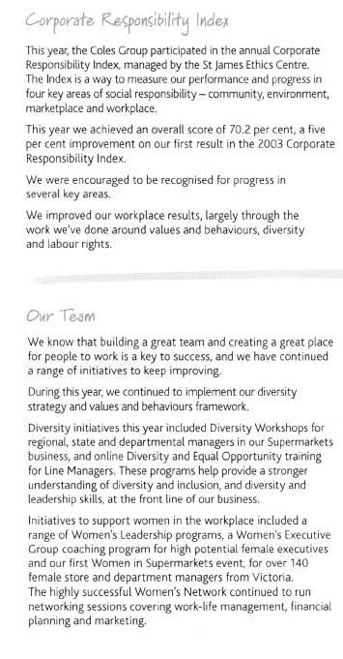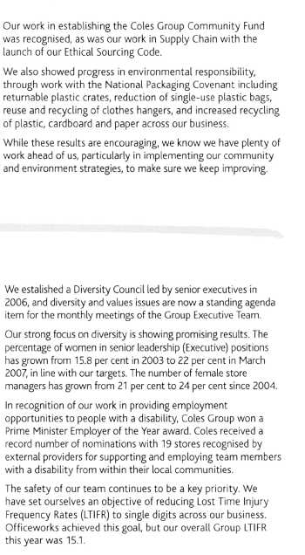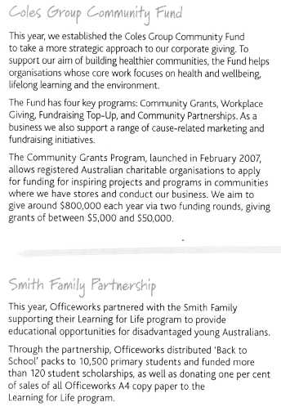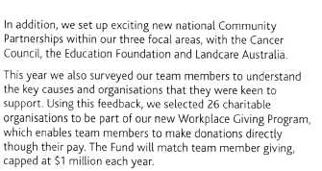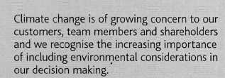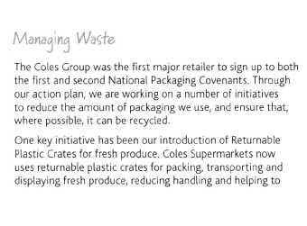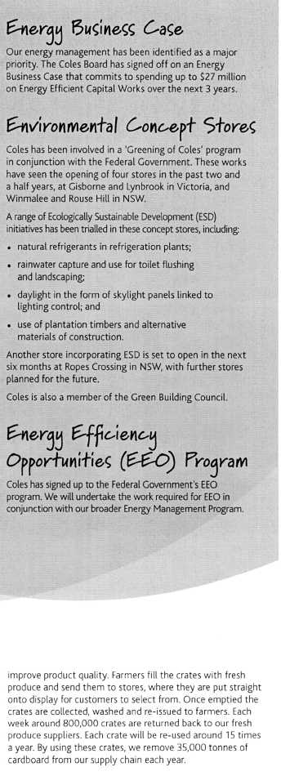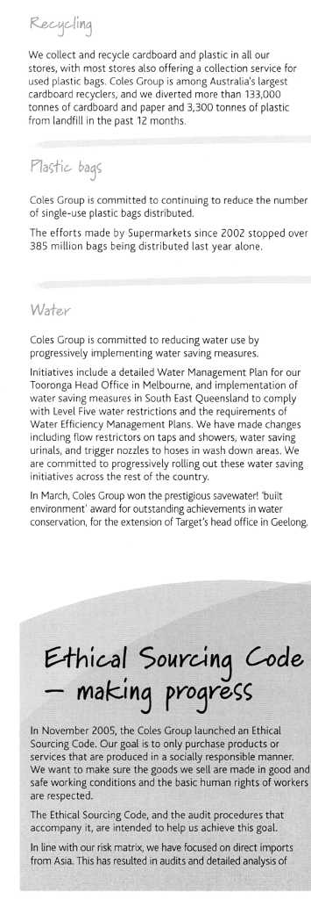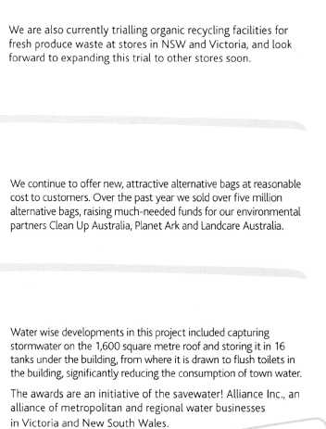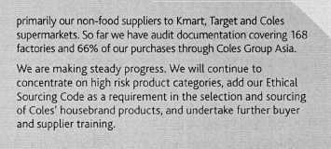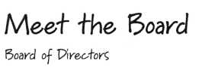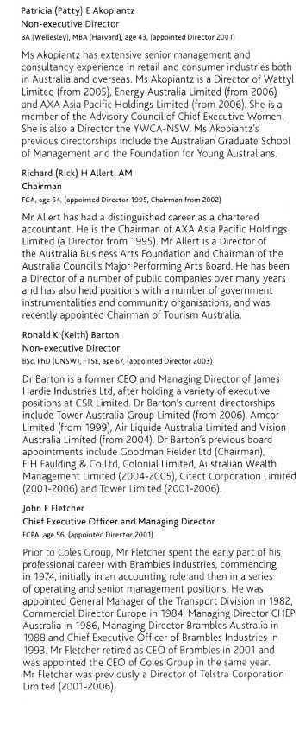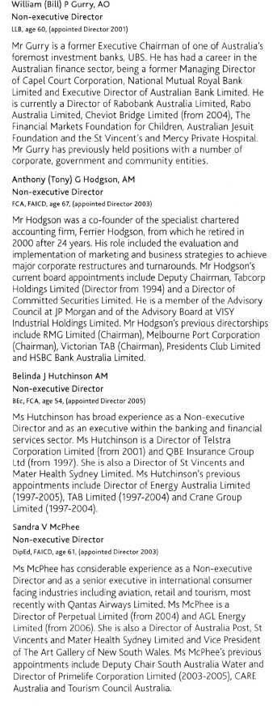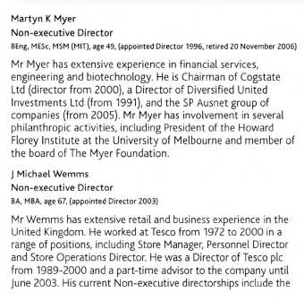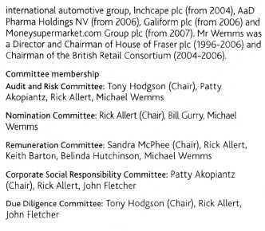

Corporate Governance
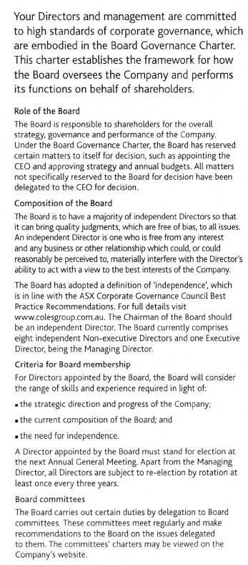
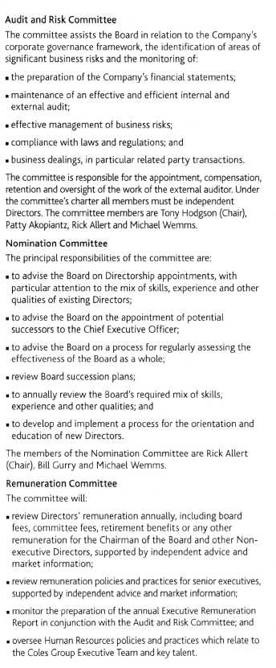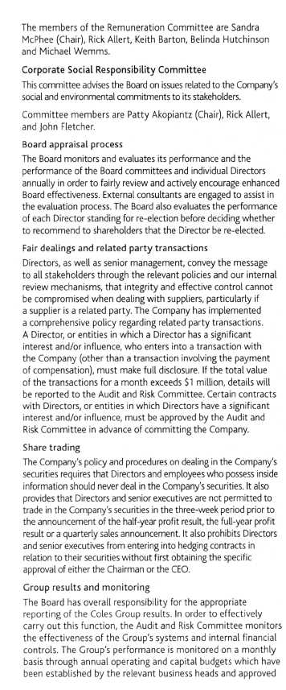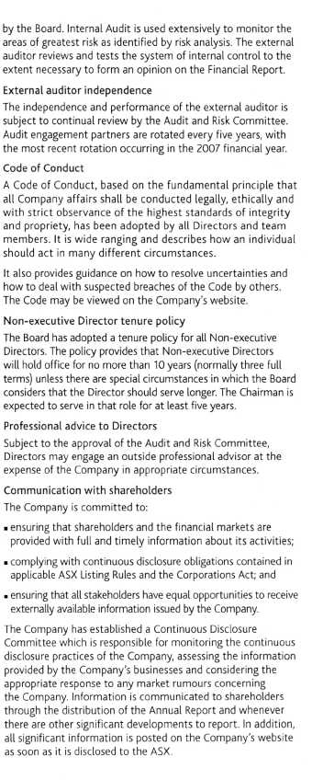
The Annual General Meeting, along with profit and sales presentations, is also broadcast live on the website. A copy of all the governance policies referred to in this report are also able to be viewed on the Company's website.
Donations
The Board's decision to contribute to the major political parties, federally and in the states, is motivated by its desire to see a strong political system that supports the democratic process in Australia.
Commitments made to political parties at the federal and state levels during the year were:
Australian Labor Party | $82,000
Liberal Party of Australia | $82,000
National Party of Australia | $23,500

ASX corporate governance recommendations
At the date of this report the Company complies with the ASX Principles of Good Corporate Governance and Best Practice Recommendations.
The information required to be disclosed by those recommendations is found both in this Corporate Governance section and in the Directors' Report on pages 33-34 of this report.

Financial Statements

Income Statement
For the 52 weeks ended 29 July 2007 (2006 30 July)
 | 2007 $m | 2006 $m
Continuing operations
Revenue from sale of goods (excluding goods and services tax) | 34,687.9 | 34,212.0
Other operating revenue (excluding finance income) | 126.5 | 91.8
Cost of goods sold | (26,316.1) | (26,160.8)
Gross profit | 8,498.3 | 8,143.0
Other income | 257.4 | 134.4
Advertising expenses | (340.6) | (358.8)
Selling and occupancy expenses | (5,838.6) | (5,662.3)
Administrative expenses | (1,518.1) | (1,427.3)
Finance income | 33.3 | 25.0
Finance costs | (136.1) | (123.9)
Share of profit of joint venture accounted for using the equity method | 35.3 | 21.9
Profit before income tax expense | 990.9 | 752.0
Income tax expense | (270.8) | (215.6)
Profit from continuing operations | 720.1 | 536.4
Profit from discontinued operations | 27.7 | 627.2
Profit for the yearo) | 747.8 | 1,163.6
Earnings per share for profit from continuing operations attributable
to the ordinary equity holders of the Company
Basic earnings per share | 60.2 cents | 43.0 cents
Diluted earnings per share | 59.6 cents | 42.6 cents
Earnings per share for profit attributable to the ordinary equity holders
of the Company
Basic earnings per share | 62.5 cents | 93.4 cents
Diluted earnings per share | 61.9 cents | 92.4 cents

(1) | The profit for the year ended 29 July 2007 was $747.8 million. After adjusting for costs associated with the ownership review of 544.6 million, the profit for the year would have been 5792.4 million. Refer to note 5 for further information on segment results.
 | The profit for the year ended 30 July 2006 was $1,163.6 million. After adjusting for the gain on disposal of Myer of $583.7 million and strategic initiative costs of $207.4 million, the profit for the year would have been $787.3 million.
The above Income Statement should be read in conjunction with the accompanying notes.

Balance Sheet
As at 29 July 2007 (2006 as at 30 July)
 | 2007 $m | 2006 $m
Current assets
Cash and cash equivalents | 546.1 | 485.6
Trade and other receivables | 428.8 | 390.8
Inventories | 2,946.5 | 2,851.8
Derivative financial instruments | 1.7 | 1.4
Assets classified as held for sale | 26.1 | 151.7
Total current assets | 3,949.2 | 3,881.3
Non current assets
Receivables | 41.2 | 43.7
Investments | 7.4 | 125.0
Derivative financial instruments | 6.8 | 9.4
Property, plant and equipment | 3,460.0 | 3,133.3
Investment properties | 7.6 | 7.6
Deferred tax assets | 501.1 | 484.5
Intangible assets | 1,670.2 | 1,412.2
Retirement benefit asset | 77.6 | 38.3
Total non current assets | 5,771.9 | 5,254.0
Total assets | 9,721.1 | 9,135.3
Current liabilities
Trade and other payables | 3,057.9 | 3,080.3
Interest bearing liabilities | 200.0 | 30.2
Derivative financial instruments | 62.4 | 24.0
Tax liabilities | 38.8 | 66.4
Provisions | 622.0 | 761.9
Total current liabilities | 3,981.1 | 3,962.8
Non current liabilities
Payables |  | 23.0
Interest bearing liabilities | 1,285.9 | 974.0
Derivative financial instruments | 21.7 | 16.1
Deferred tax liabilities | 85.6 | 77.6
Provisions | 291.9 | 320.7
Other | 148.1 | 163.1
Total non current liabilities | 1,833.2 | 1,574.5
Total liabilities | 5,814.3 | 5,537.3
Net assets | 3,906.8 | 3,598.0
Equity
Contributed equity | 2,198.9 | 2,144.2
Reserves | (16.2) | 3.9
Retained profits | 1,724.1 | 1,449.9
Total equity | 3,906.8 | 3,598.0

The above Balance Sheet should be read in conjunction with the accompanying notes.

Statement of Recognised Income and Expense
For the 52 weeks ended 29 July 2007 (2006 30 July)
 | 2007 $m | I | 2006 $m
Foreign currency translation reserve
Exchange differences on translation of foreign operations | 7.2 |  | (7.3)
Cash flow hedge reserve
Net hedging losses recognised directly in equity | (64.6) |  | (11.5)
Net hedging gains transferred to the Income Statement | (0.2) |  | —
Net hedging losses/(gains) transferred to inventory | 12.3 |  | (8.6)
Retained profits
Actuarial gains on defined benefit plan | 38.7 |  | 17.4
 | (6.6) |  | (10.0)
Income tax on equity items | 4.3 |  | 0.8
Net expenses recognised directly in equity | (2.3) |  | (9.2)
Profit for the year | 747.8 |  | 1,163.6
Total recognised income for the year | 745.5 |  | 1,154.4
Effects of change in accounting policy — financial instruments
Adjustment on adoption of AASB 132 and AASB 139, net of tax:
Retained profits |  |  | (20.7)11)
Reserves |  |  | 6.0(1)
 |  |  | (14.7)

(1) | As permitted, on adoption of AASB 132 Financial Instruments: Disclosure and Presentation and AASB 139 Financial Instruments: Recognition and Measurement, Coles Group elected to recognise an opening balance adjustment at 1 August 2005. Further information on adoption of these standards is available in the 2006 Full Annual Report.
The above Statement of Recognised Income and Expense should be read in conjunction with the accompanying notes.

Cash Flow Statement
For the 52 weeks ended 29 July 2007 (2006 30 July)
 | Inflows/(outflows)
 | 2007 $m | 2006 $m
Cash flows from operating activities
Receipts from customers (inclusive of goods and services tax) | 37,249.3 | 39,814.5
Payments to suppliers and employees (inclusive of goods and services tax) | (35,920.0) | (38,012.2)
Distributions received from joint venture partnership | 2.3 | 10.2
Finance income received | 36.8 | 23.6
Finance costs paid | (112.9) | (112.8)
Income tax paid | (313.0) | (422.7)
Net cash from operating activities | 942.5 | 1,300.6
Cash flows from investing activities
Payments for property, plant and equipment and intangible assets | (1,040.8) | (1,043.1)
Payments for purchase of licences | (8.0)
Payments for purchase of businesses and controlled entities, net of cash acquired | (145.2) | (202.5)
Payments for purchase of joint venture | (7.3) | (0.9)
Proceeds on sale of licences | 4.9
Proceeds on sale of property, plant and equipment | 169.8 | 19.9
Proceeds on sale of businesses and controlled entities, net of transaction costs | 11.1 | 1,309.9
Proceeds on sale of investments | 158.5 | 13.3
Net cash from investing activities | (857.0) | 96.6
Cash flows from financing activities
Proceeds from contributions to equity | 76.9 | 122.5
Payments for purchases of buy-back shares, including transaction costs | (78.4) | (838.2)
Proceeds from borrowings | 5,883.7 | 8,309.2
Repayments of borrowings | (5,402.5) | (8,496.9)
Dividends paid | (500.7) | (453.1)
Net cash from financing activities | (21.0) | (1,356.5)
Net increase in cash held | 64.5 | 40.7
Cash at the start of the year | 481.6 | 440.9
Cash at the end of the year | 546.1 | 481.6

The above Cash Flow Statement should be read in conjunction with the accompanying notes

Ntes to and Forming Part of the Financial Statements
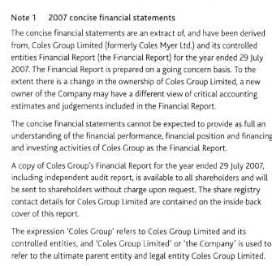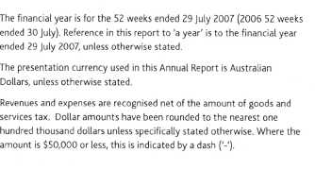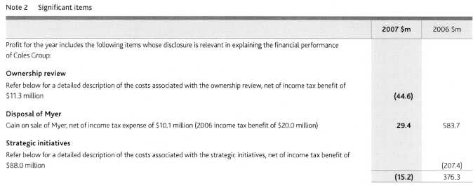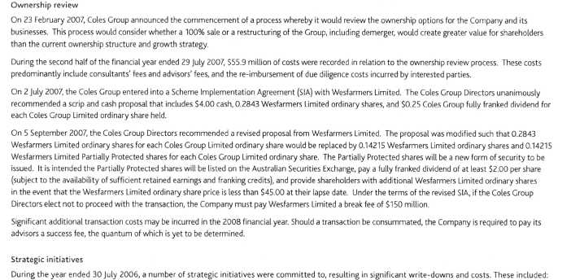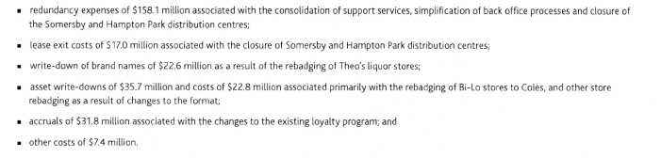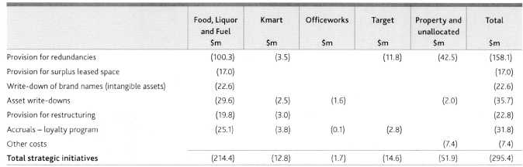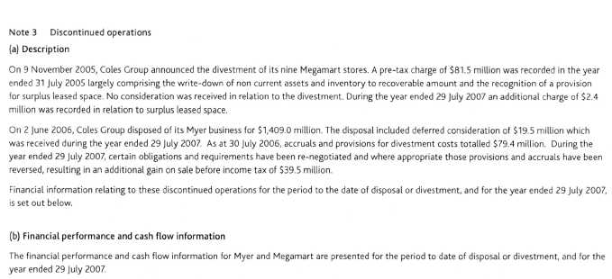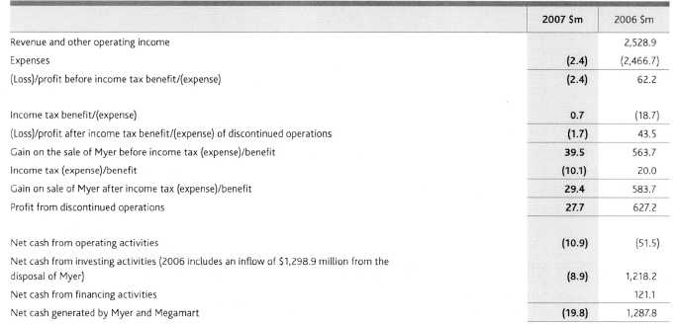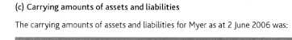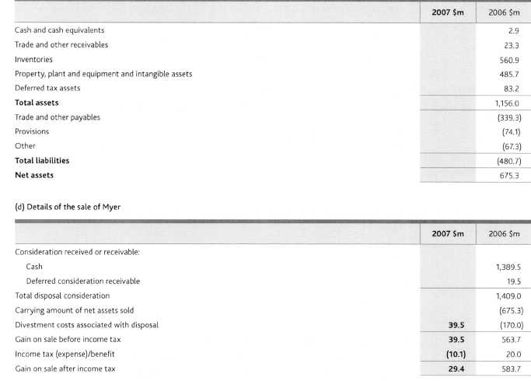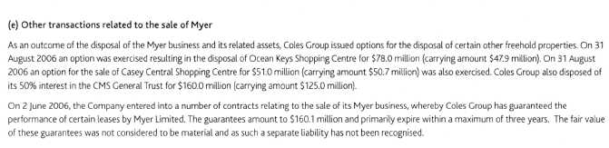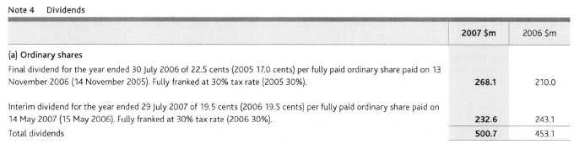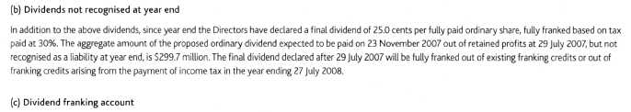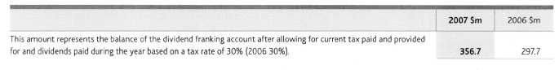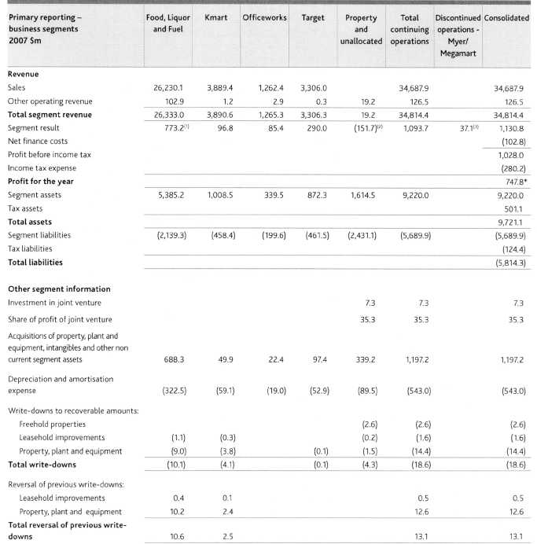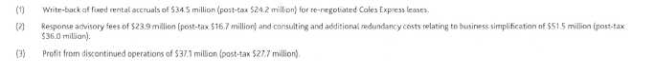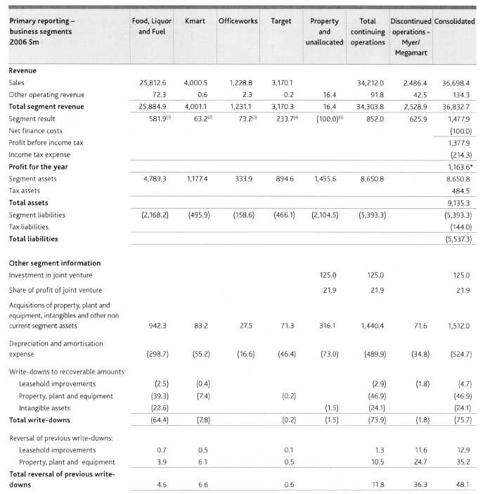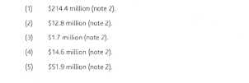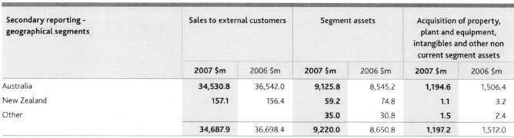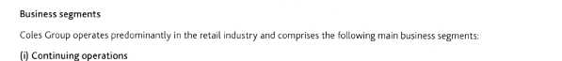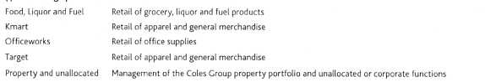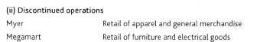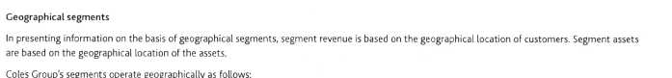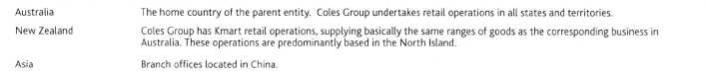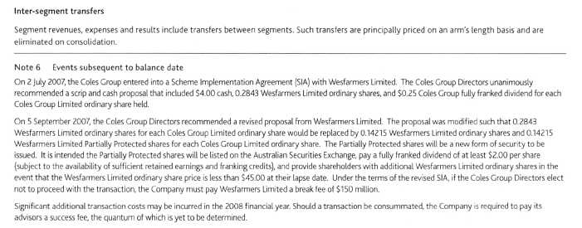

Directors' Report
The Directors present their report for the financial year comprising the 52 weeks ended 29 July 2007.
Principal activities
The principal activity of Coles Group during the year was retailing, further details of which are set out on the inside cover to page 15 of the Annual Report.
Directors
The Directors of Coles Group during the period from 31 July 2006 to the date of this report and particulars of their qualifications, experience, special responsibilities and directorships in other listed companies are set out on pages 16-17 of the Annual Report.
Details of the qualifications and experience of the Company Secretary are also set out on the inside back cover of the Annual Report.
Board committees
The Board committees during the year were the Audit and Risk Committee, the Nomination and Remuneration Committee, the Nomination Committee, the Remuneration Committee, the Corporate Social Responsibility Committee arid the Due Diligence Committee. The composition of these committees and their functions is set out in the Corporate Governance Statement on pages 18-21 of the Annual Report.
Dividends
Details of dividends paid during the financial year and to be paid in respect of the financial year are set out on page 29 of the Annual Report.
Review and results of operations and likely future developments The consolidated net profit of the Coles Group for the financial year was $747.8 million.
The operations of the Coles Group during the financial year, the results of those operations, the financial position of the Coles Group and the Group's business strategies and future prospects are reviewed in:
Year in Review see the inside front cover to page 1
Q&A with the Chairman and CEO see pages 2-3
Operational Review see pages 4-15
Further details of likely future developments in the operations of the Coles Group are referred to in the Q&A with the Chairman and CEO on pages 2-3 of the Annual Report.
Further information in relation to these likely future developments has been omitted from this Directors' Report, as to include it would be likely to result in unreasonable prejudice to the Cotes Group.
State of affairs
Particulars of the significant changes in the state of affairs of the Coles Group during the financial year are as follows:
an on-market buy-back totaling $73.2 million was conducted;
the Company commenced an ownership review (see Note 2, page 26)
Events after the end of the financial year
On 5 September 2007, Coles Group and Wesfarmers Limited announced an enhanced Wesfarmers' proposal to acquire the Company (see Note 6, page 32)
Except as otherwise referred to in this report, the Directors are not aware of any matter or circumstance that has arisen since the end of the financial year that has significantly affected, or may significantly affect, the operations, results of operations or state of affairs of the Coles Group in future financial years.
Environmental
The Coles Group is committed to conducting its business activities with respect for the environment while continuing to meet expectations of shareholders, team members, customers and suppliers. The Coles Group is committed to achieving a level of environmental performance which meets or exceeds Commonwealth, state or local regulatory requirements, and to improve its use of natural resources and minimise waste where practicable.
The Directors are not aware of any material breaches of environmental regulations during the year. During the period from 31 July 2006 to the date of this report no particular and significant environmental regulation under a law of the Commonwealth or of a state or territory has applied to the Coles Group or its operations.
Indemnity and insurance
Coles Group has entered into a Good Faith Protection and Access Deed in the form approved by shareholders at the 1999 Annual General Meeting with Non-executive Directors of the Company. The Deed provides for indemnification of the directors to the maximum extent permitted under law and does not indemnify for any liability involving a lack of good faith. Rule 70 of the Company's constitution also provides an indemnity in favour of officers (including the Directors and Company Secretary) of Coles Group Limited (and such other officers and former officers of the Coles Group as the Directors decide) against liabilities incurred while acting as such officers to the extent permitted by law.
No Director or officer of Coles Group has received the benefit of an indemnity from the Company during or since the end of the year. Coles Group maintains a Directors' and Officers' insurance policy. Due to confidentiality obligations and undertakings of the policy, no further details in respect of the premium or policy can be disclosed.
Directors' interests in Coles Group Shares
Ordinary shares in which a Director has a relevant interest
Patty Akopiantz | 3,253
Rick Allert | 25,569
Keith Barton | 10,200
John Fletcher - 1,204,458
Bill Gurry | 140,000
Tony Hodgson | 6,000
Belinda Hutchinson | 42,000
Sandra McPhee | 7,539
Michael Wemms | 208

Note:
1 John Fletcher also holds 1,704,500 executive options, and 374,000 performance shares.
Details of options on issue at the date of this report and of shares issued as a result of an exercise of an option during or since the end of the financial year are set out in note 36 of the Full Financial Report.
Remuneration Report
As required by the Corporations Act, the Company's Remuneration Report is set out on pages 35 to 50 of the Annual Report.
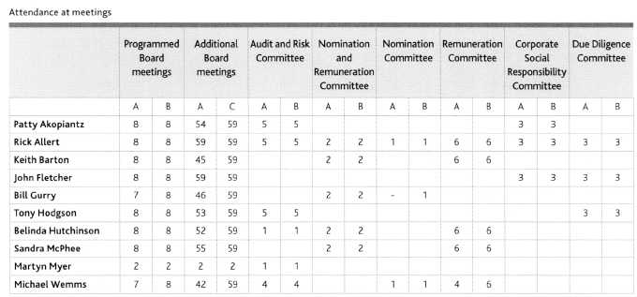
A = Number of meetings attended
B = Number of meetings held while in office
C = Number of meetings held while in office which the Director was eligible to attend. All Directors may attend Board committee meetings if they choose to.
Other Board committee meetings held during the year were attended by Rick Allert (2/2) and John Fletcher (2/2).
Audit and non-audit services
A copy of the auditor's independence declaration is included on page 51 of the Annual Report.
During the year, the auditor, PricewaterhouseCoopers, was paid the following amounts in relation to non-audit services provided to the Coles GrouP
 | $'000
Acquisitions/Divestments | 730
Sales certificates under leases | 450
Taxation advice | 98
Other | 82
 | 1,360

The Directors are satisfied, based upon the advice of the Audit and Risk Committee, that the provision of non-audit services outlined above by the auditor during the year is compatible with the general standard of independence for auditors imposed by the Corporations Act.
The reason for forming this opinion is that the unique knowledge of the Coles Group possessed by the auditor places the audit firm in a position to provide these services in the most efficient manner, in areas where the Directors and management consider audit risk to be low.
Rounding
Coles Group Limited is a company of the kind referred to in the Australian Securities and Investments Commission Class Order 98/0100 dated 10 July 1998. As a result, amounts in this report and accompanying financial statements have, where applicable, been rounded to the nearest one hundred thousand dollars except where otherwise indicated.
Signed in accordance with a resolution of the Board of Directors:
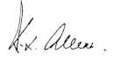
Rick Allert
Chairman
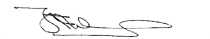
John Fletcher
Chief Executive Officer and Managing Director
19 September 2007
In the 2007 Remuneration Report, the expression 'Coles Group' refers to Coles Group Limited and its controlled entities, and 'Coles Group Limited' or the Company' is used to refer to the ultimate parent entity and legal entity Coles Group Limited.
In accordance with the remuneration reporting requirements of the Corporations Act 2001 and Accounting Standard AASB 124 Related Party Disclosures, this report details the remuneration arrangements for both the Company's and Coles Group's Key Management Personnel (KMP).
In accordance with the requirements of AASB 124, KMP include:
The Chairman and Non-executive Directors of Coles Group Limited;
Mr John Fletcher, the Chief Executive Officer and Managing Director of Coles Group Limited; and
Those executives who have the authority and responsibility for planning, directing and controlling the activities of the Company and Coles Group. During the 2007 financial year, these individuals were Mr Larry Davis, Mr Tim Hammon, Ms Launa Inman, Mr Fraser MacKenzie and Mr Mick McMahon (for further details regarding these individuals, refer note 37 of the Full Financial Report). In identifying executives for inclusion in the group of KMP, consideration was given to the following additional criteria: the relative size of the business managed by the individual with relative size assessed on the basis of sales and/or a contribution to the consolidated result, the relative degree of decision making authority or autonomy inherent in an individual's role and the extent to which the individual's performance was visible to external stakeholders.
The same group of individuals is regarded as KMP for both the Company and Coles Group disclosure purposes.
In addition, in accordance with the Corporations Act 2001, this report also details the Company's and Coles Group's five most highly remunerated officers during both the 2006 and 2007 financial years.
This report forms part of the Directors' Report and is set out under the following headings:
Principles applied in the determination of remuneration Group performance and the link with remuneration Non-executive Director remuneration
Chief Executive Officer and Managing Director and other KMP remuneration
Summary of employment contracts Details of KMP remuneration KMP at risk remuneration KMP share-based remuneration
The information provided under headings A and C through H includes remuneration disclosures that are required under AASB 124. These disclosures have been transferred from the Financial Report and have been audited. The disclosures under heading B are additional disclosures required by the Corporations Act 2001 and are not required to be and have not been audited.
Glossary of terms used in this report
CEO | Chief Executive Officer
CSSG | Comparative store sales growth
EBIT | Earnings before interest and tax
EPS | Earnings per share
KMP | Key Management Personnel
LTI | Long-term incentive
LTRP | Leveraged Transformation Reward Program
N PAT | Net profit after tax
ROI | Return on investment
SEOP | Senior Executive Option Plan
SEPSP | Senior Executive Performance Share Plan
STI | Short-term incentive
TFR | Total fixed remuneration
TSR | Total shareholder return

A. Principles applied in the determination of remuneration The Remuneration Committee
On 21 September 2006 the Board approved the separation of the Nomination and Remuneration Committee into two separate committees, being the Nomination Committee and the Remuneration Committee (the Committee).
The Committee plays a key role in setting Coles Group's remuneration framework and policy and in the determination of remuneration amounts paid to KMP. The Committee is responsible for:
annually reviewing independent expert advice on the level of remuneration paid to the CEO and for reporting to the Board accordingly;
annually reviewing and advising the Board on the components of remuneration of those executives who report directly to the CEO;
reviewing management's recommendations in relation to the Coles Group's remuneration framework generally and specifically in relation to the linking of remuneration to performance; and
reviewing the remuneration report.
The Committee comprises at least three Non-executive Directors, with the Committee's Chairman appointed by the Board. The Committee meets at least three times per year and other Directors, not being members of the Committee, may attend meetings. Other Coles Group executives and/or parties external to the Coles Group may attend at the invitation of the Chairman of the Committee. The following independent Non-executive Directors were members of the Committee from 21 September 2006: Sandra McPhee (Chair), Rick Allert, Keith Barton, Belinda Hutchinson and Michael Wemms. In addition the following Non-executive Directors were members of the predecessor Nomination and Remuneration Committee prior to 21 September 2006: Rick Allert (Chair), Sandra McPhee, Keith Barton, Bill Gurry and Belinda Hutchinson.
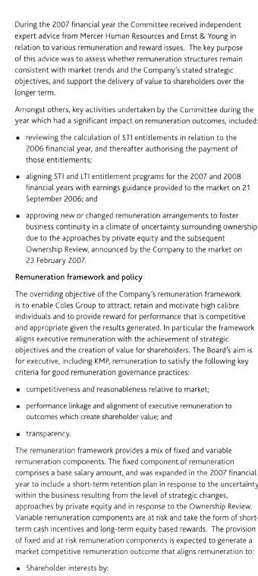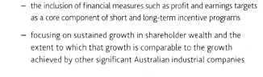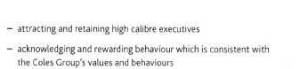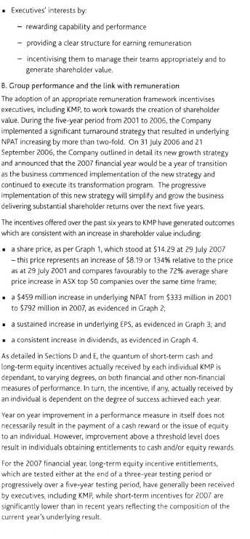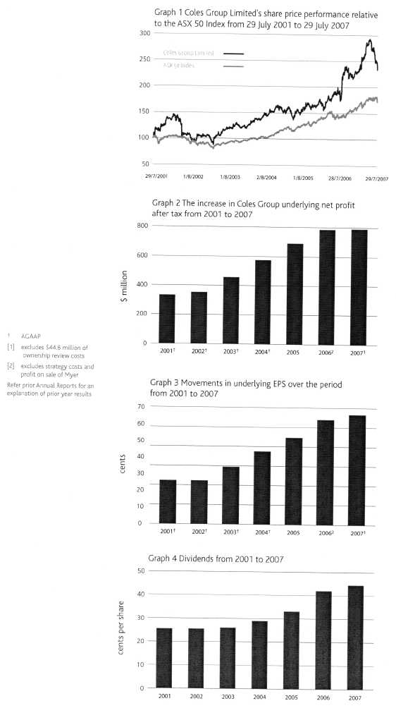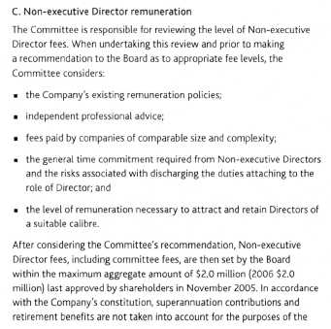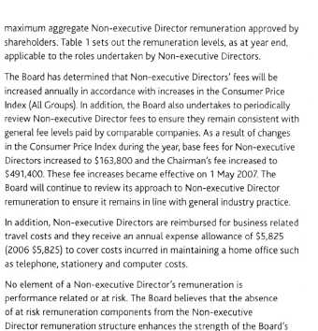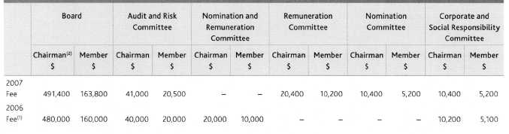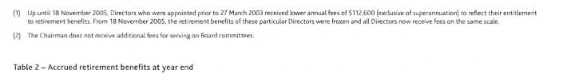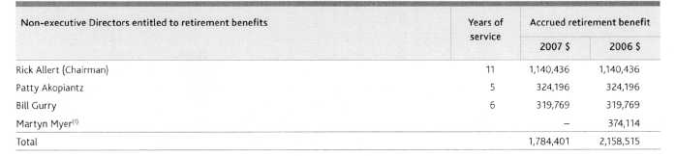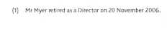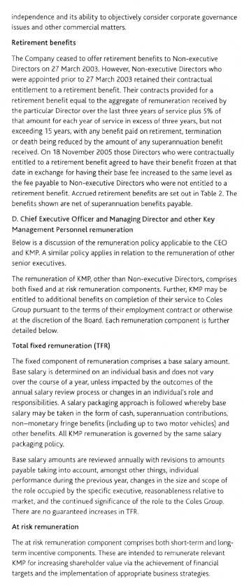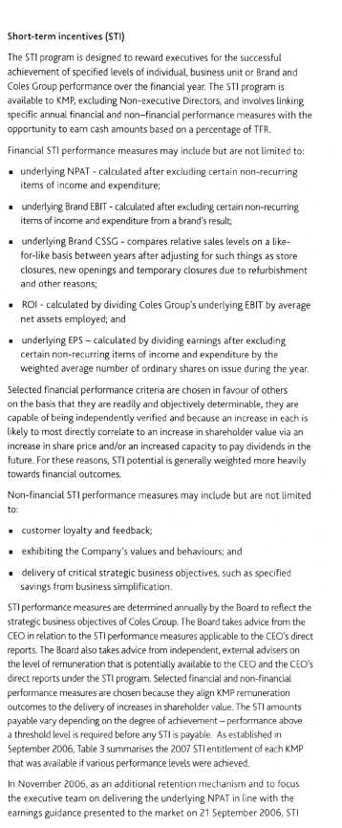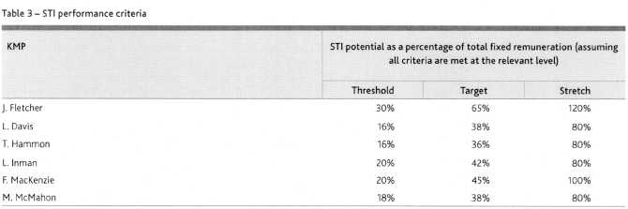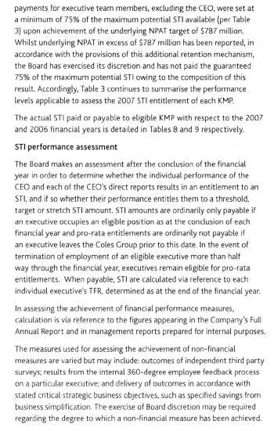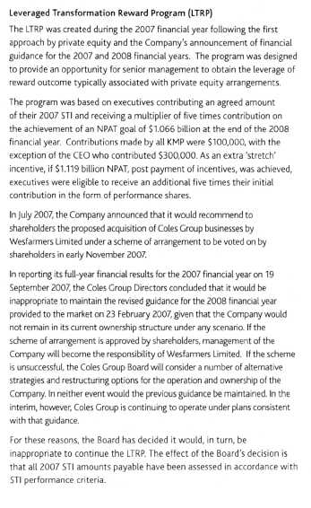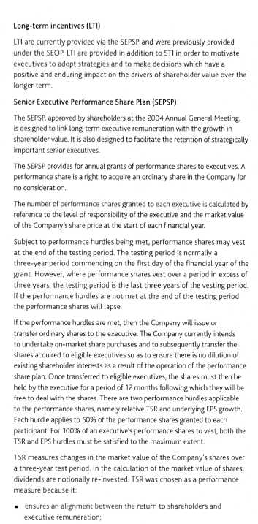
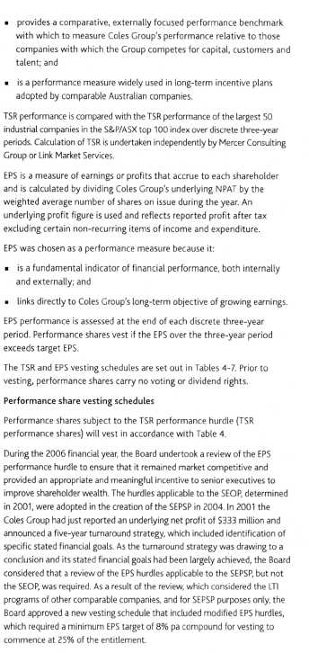
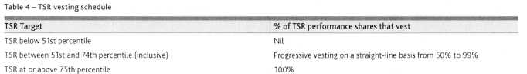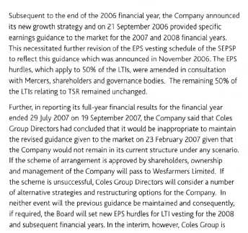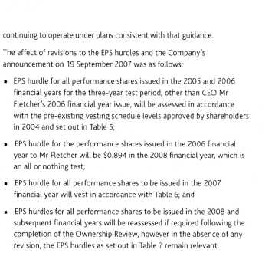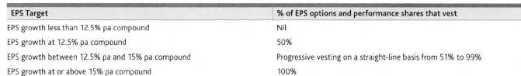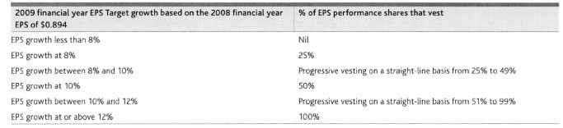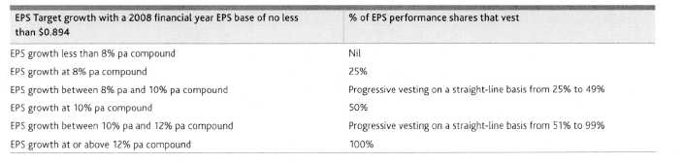
Details of the impact of modifications to the terms of performance shares are set out in note 36 of the Full Financial Report.
If a participant ceases to be employed due to death, disability, retrenchment or retirement prior to the three-year testing date, pro-rata vesting will occur, subject to performance hurdles being met. In this situation the performance hurdles will be tested at the next half or full financial year end following cessation of employment.
Senior Executive Option Plan (SEOP)
Prior to the introduction of the SEPSP, the Company operated the SEOP. The SEOP provided for market priced options to be issued to senior executives. The SEOP has now been replaced by the SEPSP. However; as some options granted under the SEOP still remain on issue, including those granted to the CEO, a brief description of the SEOP is set out below.
Subject to performance hurdles being met and the payment of the relevant exercise price, an option confers a right in favour of the executive to purchase ordinary shares in the Company. The exercise price of each option is generally determined via reference to the weighted average market price of the Company's shares, as quoted on the ASX, during the 10 trading days prior to the day on which the option is issued.
Executives generally received one grant of options, which, subject to performance hurdles being met, vests progressively over a five-year period. Supplementary grants were given to executives who were promoted. In general there is no vesting during the first two years post issue. After two years, 40% of the options granted may vest, followed by 20% for each of the next three years.
Consistent with the SEPSP, TSR and EPS performance hurdles are also used for the purposes of determining whether options granted under the SEOP actually vest. Except for 1,500,000 options granted to the CEO in 2003, all other options on issue vest subject to the EPS hurdle as detailed in Table 5 and a TSR hurdle which provides progressive vesting of options between the 50th and 65th percentiles.
Other than the 1,500,000 options granted to the CEO, achievement of either EPS or TSR hurdle results in the options vesting.
In respect to the tranche of 1,500,000 options granted to the CEO in November 2003, 50% vest subject to the achievement of the TSR hurdle and 50% vest subject to the achievement of the EPS hurdle. The TSR hurdle for this particular tranche of options is set out in Table 4.
Options ordinarily lapse if performance hurdles are not achieved within the five-year period post grant date or if an executive resigns prior to completion of the required vesting periods. However, the Board, in its discretion, may decide that options will vest notwithstanding that performance targets have not been met or in the instance where an executive resigns prior to the completion of the required vesting period. In addition, where an executive leaves the Coles Group as a result of death, disability, retirement or retrenchment, they are, subject to performance hurdles being met, entitled to options on a pro-rata basis to the date of their departure.
Board discretion regarding change of control
The current LTI rules incorporate Board discretion with regard to the proportion of unvested awards, which should be permitted to vest in the event of a change of control. At the date of signing this report, the Board has not exercised its discretion.
Valuation of LTI equity based remuneration
In accordance with the requirements of the Accounting Standards, remuneration as disclosed in Tables 8 and 9 includes a proportion of the notional value of equity instruments, being options and performance shares, granted or outstanding during the financial year. The notional value of these equity instruments is determined as at the grant date and is progressively allocated over the instrument's vesting period. The notional value of equity instruments may change where conditions attached to the instruments are changed. Any effect on the notional value resulting from a change in condition is allocated prospectively over the instrument's remaining vesting period. Amounts included in remuneration are not necessarily indicative of the benefit, if any, that an individual may ultimately receive should the equity instruments vest. The notional value of performance shares issued in 2005, 2006 and 2007 and options issued in earlier years has been determined in accordance with AASB 2 Share-based Payment. Equity instruments are valued by independent valuers. Performance shares are valued using the Monte-Carlo pricing model, which incorporates market based performance conditions such as TSR. Options are valued using the Black-Scholes pricing model.
Where options are subject to performance conditions, a 50% probability has been applied to the Black-Scholes valuation. Performance share and option amounts are expensed over their vesting period and as such enter into the determination of net profit. Details of the assumptions which have been used in the valuations are set out in note 36 of the Full Financial Report.
Retirement benefits
Where an executive's employment with the Coles Group is terminated, termination entitlements are paid in accordance with contractual obligations or otherwise at the discretion of the Board.
E. Summary of employment contracts
Section E contains a summary of the employment contract for each KMP, excluding Non-executive Directors whose details of employment are set out in Section C. Each summary excludes details in relation to an executive's remuneration and STI arrangements where they are disclosed elsewhere in this report.
Further, each employment contract provides that each KMP may be entitled to an allocation of performance shares subject to performance hurdles being met and the rules applicable to the LTI plan. The number of performance shares that each may receive is determined annually by the Board. Table 12 sets out the number of performance shares that were allocated to KMP during the year ended 29 July 2007.
Unless otherwise noted, each employment contract is open ended and includes standard termination clauses that provide that the Company may terminate an executive's employment at any time by providing 12 months notice or payment in lieu of notice.
An executive's employment may also be terminated without notice or payment in lieu of notice where circumstances warrant summary dismissal. Unless otherwise noted, KMP may resign at any time by providing six months notice.
John Fletcher — Chief Executive Officer and Managing Director
Mr Fletcher's employment contract was entered into on 3 September 2001 and has been extended such that it is now open ended. It provides an entitlement to:
receive a car allowance of $60,000 per year plus reimbursement for maintenance and fuel costs;
receive 2,500,000 options with such options vesting at a rate of 500,000 per year over the five-year period to 3 September 2006 subject always to performance hurdles being met; and
receive a pro-rata entitlement to an STI in the event that Mr Fletcher's employment ceases in the second half of a financial year. In this instance the amount of an STI payable will be calculated via reference to normal performance criteria. Mr Fletcher is not eligible to receive any STI amount with respect to a financial year if employment ceases in the first half of that financial year.
In addition to the options issued pursuant to the terms of Mr Fletcher's contract, in November 2003 shareholders approved the grant of an additional 1,500,000 options, exercisable in two equal tranches in September 2005 and 2006. The performance hurdles applying to these particular options were changed during the 2005 financial year to make them consistent with the hurdles applying to performance shares. There was no impact on Mr Fletcher's remuneration in any year as a result of the change to performance hurdles. Unless the Board decides otherwise, these options expire one year after the date on which Mr Fletcher ceases employment with the Company.
Mr Fletcher may resign from the Company at any time subject to the provision of 12 months notice. However, Mr Fletcher need not provide 12 months notice and may resign immediately in the event of a 'fundamental change' to his role, such as ceasing to be the most senior executive of the Coles Group or a demonstrable inability to work with the Board.
Larry Davis — Managing Director Kmart
Mr Davis' current employment contract was entered into on 14 February 2005 and is open ended. It provides for the reimbursement of reasonable costs incurred in relocating to the United States in the event of the termination of employment.
Further, Mr Davis' options are subject to service hurdles only as a retention mechanism and were based on the need to replicate similar conditions that applied in North America in relation to share option plans at the time.
Tim Hammon — Chief Officer, Corporate and Property Services
Mr Hammon's employment contract, which was current during the 2007 financial year, was entered into on 1 February 2002 and, as agreed by ancillary arrangement, concluded through redundancy on 31 July 2007.
As a result of Mr Hammon's departure through redundancy from the Company, Mr Hammon's employment contract provided for 12 months
notice or payment in lieu of notice from his departure date, being 31 July 2007, and the Board approved the following termination provisions:
consistent treatment with other members of the Coles Group Executive Team with respect to any Board discretion exercised in favour of executives regarding LTI entitlements;
a payment of $250,000 in recognition by the Company for deferral by Mr Hammon of his departure date to 31 July 2007; and
outplacement services at the cost of the Company.
Launa Inman — Managing Director Target
Ms Inman's current employment contract was entered into on 12 December 2005 and is open ended. It provides for the:
payment of prescribed annual retention cash amounts and the issue of 22,000 performance shares per year for each year that Ms Inman remains with the Company up to the year ending 31 July 2008. In respect of the years ending July 2007 and 2008 the prescribed cash amounts are $150,000 and $200,000 respectively (July 2006 $100,000).
In the climate of uncertainty due to the private equity approaches, commencement of the Ownership Review process and the competitive environment for talent, the Company entered into the following ancillary provisions for Ms Inman:
the payment of a cash-based retention bonus of $382,500, based on continued employment with the Company until the earlier of three months after the completion of a corporate transaction or 31 March 2008; and
in the event of a corporate transaction, a cash payment of $850,000 in lieu of options and performance shares due to vest in the 2009 financial year. The payment will only be made if Board discretion is exercised such that no awards due to be measured in the 2009 financial year are vested early. The amount of the cash payment will be reduced to reflect any portion of awards due to be measured in the 2009 financial year that are vested due to the Board exercising its discretion.
Fraser MacKenzie — Chief Financial Officer
Mr MacKenzie's employment contract was for a minimum fixed term to 30 April 2007. Mr MacKenzie agreed to extend his departure date to 31 July 2007 and the Board approved the following retirement provisions for Mr MacKenzie:
a payment of $250,000 in recognition by the Company for deferral by Mr MacKenzie of his retirement date from 30 April 2007 to 31 July 2007;
reimbursement of travel and accommodation costs incurred while commuting between Melbourne and Sydney during the period 1 May 2007 to 31 July 2007; and
consistent treatment with other members of the Coles Group Executive Team with respect to any Board discretion exercised in favour of executives regarding LTI entitlements.
Mick McMahon — Chief Operating Officer, Coles Retail
Mr McMahon was appointed as Chief Operating Officer, Coles Retail on 23 February 2007. Mr McMahon's TFR and participation in the STI and LTI programs were reviewed in light of the substantial increase in his job size
and accountabilities and were realigned to reflect this change in role and the Company's market positioning policy, with a new employment contract entered effective from 23 February 2007. The contract is open ended.
In the climate of uncertainty due to the private equity approaches, commencement of the Ownership Review process and the competitive environment for talent, the Company entered into the following ancillary provisions for Mr McMahon:
payment of an additional cash bonus of $250,000 based upon a combined stretch EBIT target for Supermarkets, Liquor, and Coles Express for the 2007 financial year. This target was not achieved and hence no bonus payment has been made;
payment of a cash-based retention bonus of $625,000, based on continued employment with the Company until the earlier of three months after the completion of a corporate transaction or 31 March 2008; and
payment of a cash bonus should the Board of Directors recommend a corporate sale transaction to shareholders and the transaction is completed. The payment will be between $150,000 and $350,000 depending on the success of the outcome and the level of value delivered to shareholders.
F. Details of Key Management Personnel remuneration
The details of remuneration paid or payable to KMP during the 2007 and 2006 financial years are set out in Tables 8 and 9 respectively. Unless otherwise indicated, the individuals listed were regarded as KMP for the whole of the relevant financial year.
Table 8 - Remuneration for the 2007 financial year
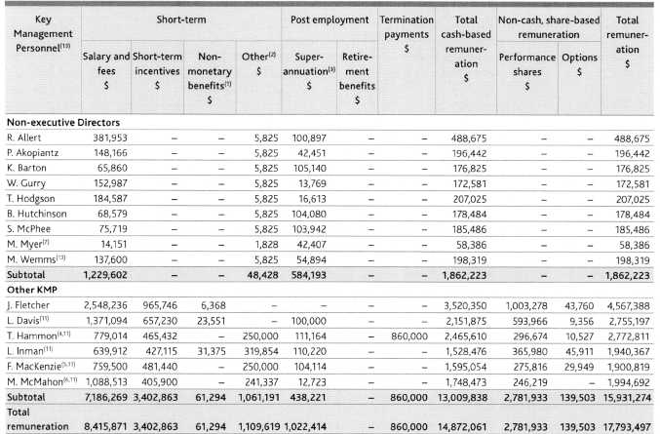
Footnotes in relation to remuneration paid in the 2007 and 2006 financial years and as disclosed in Tables 8 and 9 respectively.
Non-monetary amounts include costs relating to fringe benefits which are available as part of normal salary packaging arrangements and may include motor vehicles, accommodation, travel, insurance and tax planning fees.
The other benefits figures include annual expense allowances for Non-executive Directors, sign on bonuses and payments for continued service. There will be additional benefits in future years if continued service conditions are fulfilled. In particular included in other benefits are accrued cash-based retention bonuses for Ms Inman of $319,854 and Mr McMahon of $241,337.
Other benefits have been presented on an accruals basis in accordance with Accounting Standard requirements. Where a KMP's employment is terminated but they nonetheless receive an amount in lieu of a payment for continued service, that amount is included as a component of the KMP's termination remuneration.
The Coles Group is not required to make superannuation contributions in respect to overseas nationals who hold certain business visas.
Consistent with Mr Hammon's position as Chief Officer, Corporate and Property Services becoming redundant on 31 July 2007, Mr Hammon's remuneration for the 2007 financial year and up to 31 July 2007 (as disclosed in Table 8) includes the following amounts:
$860,000 in lieu of notice of Mr Hammon's employment not extending beyond 1 August 2007; and
a $250,000 payment in recognition for deferral by Mr Hammon of his departure date to 31 July 2007, which has been disclosed as other remuneration. For the purposes of this report and particularly Tables 10 and 11, the amount paid in relation to deferral of Mr Hammon's departure date was not considered as an STI as it was not contemplated in Mr Hammon's 2007 incentive plan and was in addition to Mr Hammon's salary, STI and non-cash share-based remuneration earned during this period.
Mr Hammon's other remuneration amount in 2006 included a special $300,000 discretionary bonus, which was awarded in recognition of Mr Hammon's significant contribution to the Myer sale process. For the purposes of this report and particularly Table 10, the amount was not considered as an STI as it was not contemplated in Mr Hammon's 2006 incentive plan.
Mr MacKenzie's other remuneration amount in 2007 includes $250,000 paid by the Company in recognition for deferral by Mr MacKenzie of his retirement date from 30 April 2007 to 31 July 2007.
Mr McMahon was appointed as a KMP in the role of Chief Operating Officer, Coles Retail on 23 February 2007. All components of his remuneration have been included in Table 8 for the full 2007 financial year.
Mr Myer retired as a Director on 20 November 2006. Mr Myer's remuneration up to his date of retirement is included in Table 8.
Mr Gurry previously received fees for acting as Chairman of the Coles Myer Superannuation Fund. His retirement from this position in 2003 resulted in a decrease in his anticipated retirement benefit compared with the prior year.
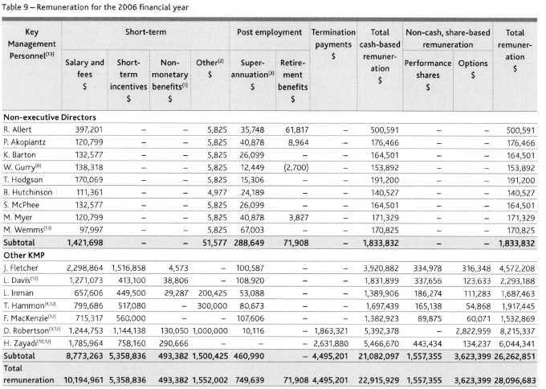
(9) Ms Robertson's remuneration for the 2006 financial year and up to 31 May 2006 (as disclosed in Table 9) included the following amounts: $1,827,983 in lieu of notice and in lieu of Ms Robertson's employment not extending beyond 1 June 2007 (of which $30,706 had been accrued as remuneration in the prior year);
a $750,000 retention bonus and a $250,000 Myer divestment transaction completion bonus. The aggregate of these amounts is disclosed as other remuneration. For the purposes of this report and particularly Table 10, neither of these amounts are considered to be an SI I as they were not contemplated in Ms Robertson's 2006 incentive plan;
An STI of 51,144,138;
$35,338 as a reasonable allowance to cover Ms Robertson's relocation to the United States; and
$2,822,959 which was attributable to the value of options held by Ms Robertson which the Board, in its discretion, decided would vest in favour of Ms Robertson as part of her termination entitlement (note, the value of the options has been disclosed in Table 9 as a component of share-based remuneration). In the ordinary course, these particular options would potentially have vested in the 2007 financial year subject to the achievement of the relevant performance hurdles. The value attributed to these options does not represent a cash cost to the Company.
(10) Consistent with Mr Zayadi's role as Managing Director Food, Liquor and Fuel becoming redundant in March 2006, Mr Zayadi received termination entitlements which included $1,872,000 in lieu of notice, a further amount of $748,800 which was contractually payable on separation of employment and an amount of $11,080 in relation to a reimbursement of taxation adviser fees. In addition, the Board, in its discretion, decided that options that were otherwise due to vest during the 2007 financial year would vest as at the date of Mr Zayadi's termination. these options were originally subject to a length of service hurdle only and were not subject to TSR or EPS performance hurdles. The value attributed to these options does not represent a cash cost to the Company.
In addition to the CEO and in accordance with Section 300A(1)(c) of the Corporations Act 2001, these five executives received the highest remuneration amounts in respect of the 2007 financial year.
In addition to the CEO and in accordance with Section 300A(1)(c) of the Corporations Act 2001, these five executives received the highest remuneration amounts in respect of the 2006 financial year.
(13) For full details regarding related party transactions with Non-executive Directors and other KMP, refer to note 37 of the Full Financial Report. In particular during the year ended 29 July 2007, Mr Wemms provided services in the amount of $126,000 (2006 $60,000) to Coles Group Limited. At balance date, the amount payable to Mr Wemms was 5126,000 (2006 $60,000). The consulting services were not provided in his capacity as a Director and hence have not been included in Tables 8 and 9 above.
Table 10 shows the actual STI payment as a percentage of the payment that would have been due had the stretch STI criteria been met.
Table 10 — Extent of STI entitlement
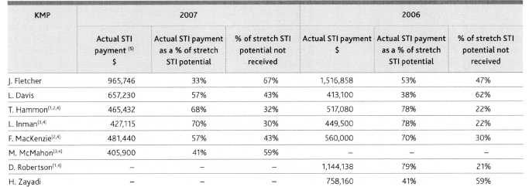
Ms Robertson's actual 2006 STI amount excludes $750,000 paid as a retention bonus and $250,000 paid in relation to Ms Robertson's contribution to the divestment of Myer. Similarly, Mr Hammon's actual 2006 STI amount excludes $300,000 paid in relation to Mr Hammon's contribution to the divestment of Myer.
Mr MacKenzie's actual 2007 STI excludes $250,000 paid by the Company in recognition for deferral by Mr MacKenzie of his retirement date. Similarly Mr Hammon's actual 2007 STI excludes 5250,000 paid by the Company in recognition for deferral by Mr Hammon of his departure date.
Ms Inman's and Mr McMahon's 2007 STI amounts exclude accrued retention bonuses of $319,854 and $241,337 respectively arising from retention arrangements.
All amounts detailed in footnotes (1) to (3) above have been excluded from the STI amounts on the basis that in each instance, the amounts ultimately paid were not contemplated in the relevant individual's original potential stretch STI amount (being the maximum STI that was potentially available in the ordinary course of business).
(5) All STI amounts in respect to the 2007 financial year will be paid subsequent to year end. The minimum potential value of the STI granted in respect of the 2007 and 2006 financial years was $Nil. The maximum value of the STI granted in the 2007 and 2006 financial years is the actual STI payment. There is no retesting of the STI entitlement and the unvested portion is forfeited.
G. Key Management Personnel at risk remuneration
Table 11 details the relative proportion of remuneration paid in 2007 to KMP, other than Non-executive Directors, which was dependent upon the achievement of specific performance levels versus that which was not. No component of the remuneration of Non-executive Directors is at risk.
Table 11 — The extent to which remuneration is at risk
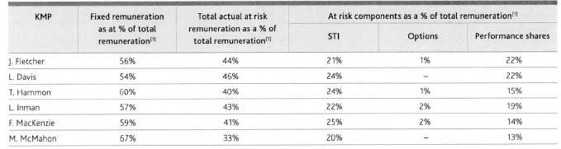
(1) For the purposes of calculating the percentages disclosed in Table 11:
Total remuneration excludes amounts payable on termination and the value of options, which vest on the termination of KMP. On the same basis, fixed remuneration excludes amounts referrable to termination remuneration entitlements;
Fixed remuneration includes amounts payable to Mr McMahon ($241,337), Ms Inman ($319,854), Mr MacKenzie ($250,000) and Mr Hammon ($250,000). In each instance the payment of the amount was only contingent on service being rendered over a specified period of time and as such is not considered to be at risk.
These adjustments have been made to reflect total remuneration and fixed remuneration payable in the ordinary course of business excluding the impact of termination events.
H. Key Management Personnel share-based remuneration
Details of the terms and conditions of each grant of options and performance shares provided to KMP and which enter into the calculation of their remuneration in the current and future reporting periods are detailed in Table 12.
Table 12 - KMP's option and performance share entitlements
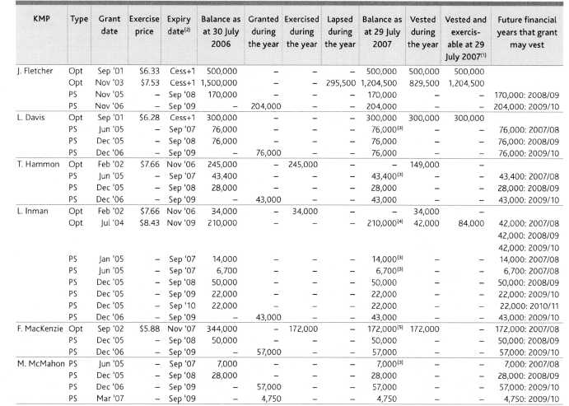
There are no options on issue which have vested but which are contractually unable to be exercised. Cess +1 denotes that the options expire one year after the cessation of an individual's employment. Subsequent to balance date, 76.8% of these performance shares have vested and 23.2% have lapsed. Subsequent to balance date, 37,380 of these options have vested.
(5) Subsequent to balance date, these options have vested.
In accordance with section 300A(1)(e) of the Corporations Act 2001, Table 13 shows the value of performance shares granted during the year as part of certain KMP's remuneration, the value of any options exercised by KMP during the year (calculated as at the date of exercise) and the value of any options held by those KMP that lapsed during the year (calculated as at the date of lapse). No new options were granted to any KMP during the year.
Table 13 — The value of performance shares and options granted
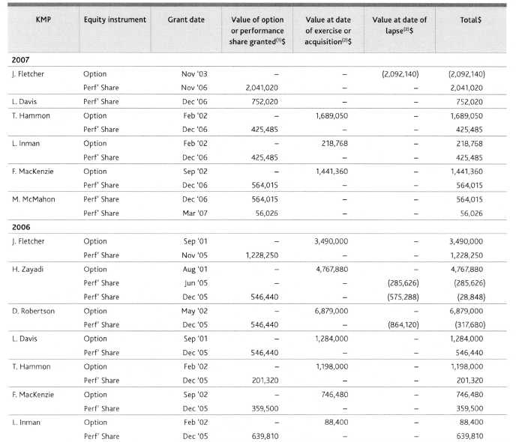
The value of each option and performance share granted has been determined in accordance with AASB 2. The minimum total value of the grant, if the applicable performance conditions are not met, is $Nil.
The value of each option exercised is based on the market price of the Company's share as at the date of exercise less the exercise price of the option. Where an option has lapsed out of the money, the value was determined as the difference between the exercise price of the option less the market price of the Company's shares as at the date the option lapsed. The value of each performance share that vested is equivalent to the market price of the Company's shares on the date the share was acquired by an executive.

Directors' Declaration
The Directors' declare that in their opinion, the concise financial report of the Coles Group for the year ended 29 July 2007 as set out in pages 21 to 32 complies with Australian Accounting Standard AASB 1039 Concise Financial Reports. The financial statements and specific disclosures included in this concise financial report have been derived from the full financial report for the year ended 29 July 2007. The concise financial report cannot be expected to provide as full an understanding of the financial performance, financial position, and financing and investing activities of the Coles Group as the full financial report, which is available on request. This declaration is made in accordance with a resolution of the Directors of Coles Group Limited.
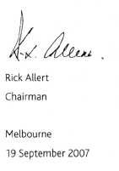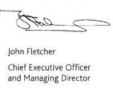

Auditor's Independence Declaration
As lead auditor for the audit of Coles Group Limited for the 52 weeks ended 29 July 2007, I declare that to the best of my knowledge and belief, there have been:
no contraventions of the auditor independence requirements of the Corporations Act 2001 in relation to the audit; and
no contraventions of any applicable code of professional conduct in relation to the audit.
This declaration is in respect of Coles Group Limited and the entities it controlled during the period.
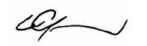
Con Grapsas Partner PricewaterhouseCoopers
Melbourne
19 September 2007

Independent Audit Report
The accompanying concise financial report of Coles Group Limited comprises the balance sheet as at 29 July 2007, the income statement, statement of recognised income and expense and cash flow statement for the 52 weeks ended on that date and related notes, derived from the audited financial report of Coles Group Limited for the 52 weeks ended 29 July 2007. The concise financial report does not contain all the disclosures required by the Australian Accounting Standards.
Directors' Responsibility for the Concise Financial Report
The Directors are responsible for the preparation and presentation of the concise financial report in accordance with Accounting Standard AASB 1039 Concise Financial Reports, and the Corporations Act 2001. This responsibility includes establishing and maintaining internal control relevant to the preparation of the concise financial report; selecting and applying appropriate accounting policies; and making accounting estimates that are reasonable in the circumstances.
Auditor's Responsibility
Our responsibility is to express an opinion on the concise financial report based on our audit procedures. We have conducted an independent audit, in accordance with Australian Auditing Standards, of the financial report of Coles Group Limited for the 52 weeks ended 29 July 2007. Our audit report on the financial report for the 52 weeks was signed on 19 September 2007 and was not subject to any modification. The Australian Auditing Standards require that we comply with relevant ethical requirements relating to audit engagements and plan and perform the audit to obtain reasonable assurance whether the financial report for the 52 weeks is free from material misstatement.
Our procedures in respect of the concise financial report included testing that the information in the concise financial report is derived from, and is consistent with, the financial report for the 52 weeks, and examination on a test basis, of evidence supporting the amounts and other disclosures which were not directly derived from the financial report for the 52 weeks. These procedures have been undertaken to form an opinion whether, in all material respects, the concise financial report complies with Accounting Standard AASB 1039 Concise Financial Reports.
Our procedures include reading the other information in the Annual Report to determine whether it contains any material inconsistencies with the concise financial report.
For further explanation of an audit, visit our website http://www.pwc.com/au/financialstatementaudit.
Our audit did not involve an analysis of the prudence of business decisions made by directors or management.
We believe that the audit evidence we have obtained is sufficient and appropriate to provide a basis for our audit opinion.
Independence
In conducting our audit, we have complied with the independence requirements of the Corporations Act 2001. We confirm that the independence declaration required by the Corporations Act 2001, provided to the directors of Coles Group Limited on 19 September 2007, would be in the same terms if provided to the directors as at the date of this auditor's report.
Auditor's opinion
In our opinion, the concise financial report of Coles Group Limited for the 52 weeks ended 29 July 2007 complies with Australian Accounting Standard AASB 1039 Concise Financial Reports.
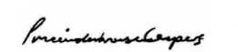
PricewaterhouseCoopers
Melbourne
19 September 2007
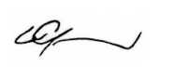
Con Grapsas
Partner

Details of Shareholdings
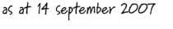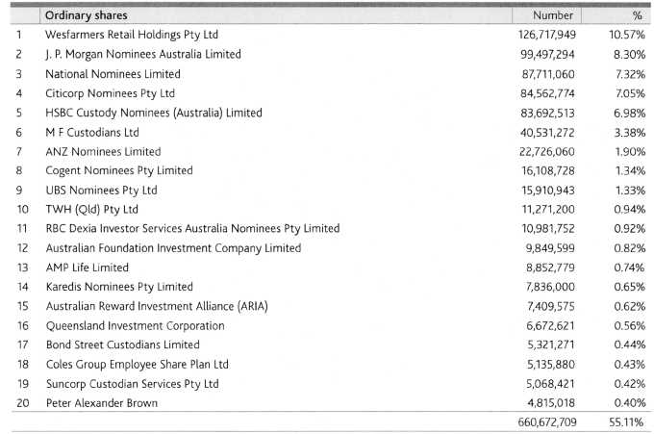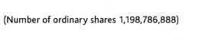
Shareholder analjcis
Substantial shareholders
The names of substantial shareholders in Coles Group Limited and the number of shares in which each has an interest as disclosed in substantial shareholder notices given to the Company as at 14 September 2007 were as follows:
Wesfarmers Limited and its associates | 144,581,288
Commonwealth Bank of Australia and its associates | 71,944,935

Distribution of holdings
Number of holders (and numbers of securities) by size of holding at 14 September 2007 were as follows:
 |  |  |  |  | Asa
 | Ordinary shares |  | Executive share options |  |  | Performance shares
 | Securities | Holders | Securities I | Holders |  | Securities | Holders
1 to 1,000 | 139,815,148 | 238,780
1,001 to 5,000 | 156,287,901 | 76,923 | 19,045 | 5 |  | 166,369 | 53
5,001 to 10,000 | 58,790,141 | 8,397 | 50,137 | 8 |  | 254,364 | 38
10,001 to 100,000 | 94,849,513 | 4,659 | 2,464,264 | 72 |  | 2,743,314 | 108
100,001 and over | 749,044,185 | 210 | 3,256,500 | 8 |  | 1,011,200 | 5
Total | 1,198,786,888 | 328,969 | 5,789,946 | 93 |  | 4,175,247 | 204

Shareholder enquiries
Investors seeking information about their shareholding should contact the Company's Share Registry. Shareholders should have their Securityholder Reference Number (SRN) or Holder Identification Number (HIN) available when contacting the Share Registry.
Share Registry contact details Link Market Services Limited Level 9, 333 Collins Street Melbourne VIC 3000
Locked Bag A14, Sydney South NSW 1235
Telephone (within Australia): 1300 130 278 Telephone (outside Australia): +61 2 8280 7768 Fax: +61 2 9287 0309
Email: colesgroup@linkmarketservices.com.au
Shareholders on-line www.linkmarketservices.com.au/colesgroup
The Link Market Services website provides Coles Group shareholders with the following information:
balances of current and previous holdings; your current communication election; your dividend information; and whether your TFN or ABN has been quoted.
You can also access dividend statements on-line and update your details.
Voting rights
Ordinary shares — entitle the holder to one vote, except on a poll where each share is entitled to one vote.
Dividends
A fully franked final dividend of 25.0 cents per share will be paid on all fully paid ordinary shares on the Share Registry at 16 November 2007 (record date). The dividend is payable on 23 November 2007.
Shareholders may have their dividends paid directly into any bank or building society account within Australia by advising their details to the Company's Share Registry. Payments to shareholders with an Australian address are made by direct credit only.
Company Secretary
Richard Dammery, LLB, BA (Hons), PhD (Cantab)
Richard Dammery is General Counsel and Company Secretary. Prior to joining Coles Group in 2005, his previous roles included Corporate Counsel of the Telecom Corporation of New Zealand, and running several business units of that company's Australian subsidiary, AAPT Limited.
How to contact us
Coles Group Limited Registered Office 800 Toorak Road Tooronga Victoria 3146, Australia
Telephone: +61 3 9829 3111
Facsimile: +61 3 9829 6787
Website
The Annual and Full Financial Reports are available on our website:
www.colesgroup.com.au Coles Group Investor Relations
800 Toorak Road
Tooronga Victoria 3146, Australia. Telephone: +61 3 9829 4521 Facsimile: +61 3 9829 5424
Email: investor.relations@colesgroup.com.au
2007 Annual Report
The 2007 Annual Report is a concise summary of our activities and financial position. The Concise Financial Statements are derived from the Financial Report. These statements cannot be expected to provide as full an understanding of the financial performance, financial position and investing activities of the Coles Group as the Financial Report. You may obtain a copy of the Financial Report (see above for contact details).
The expression 'Coles Group' refers to Coles Group Limited and its controlled entities, and 'Coles Group Limited' or 'the Company' is used to refer to the ultimate parent entity and legal entity Coles Group Limited.
The financial year is for the 52 weeks ended 29 July 2007. Reference in this report to 'a year' is to the financial year ended 29 July 2007 unless otherwise stated. All figures are expressed in Australian currency unless otherwise stated.
Revenues and expenses are recognised net of the amount of Goods and Services Tax.
Coles Group Limited ABN 11 004 089 936
Printed on Monza Recycled Art Paper, with 55% recycled content and balance from sustainable plantation timbers. No elemental chlorine was used during paper manufacture

Financial Statements - Full

Income Statements
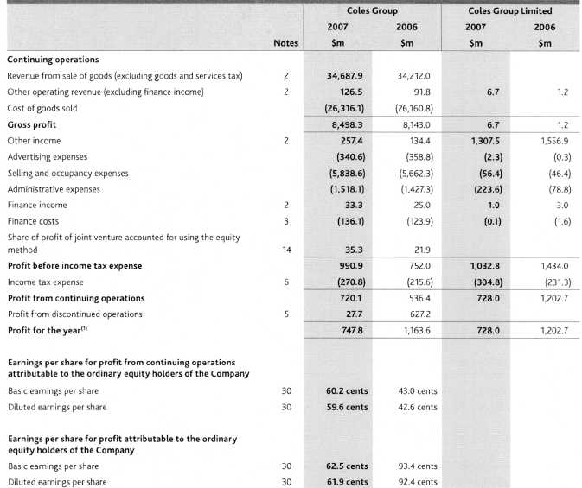
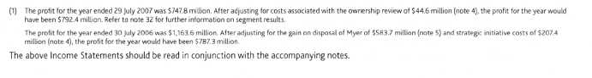

Balance Sheets
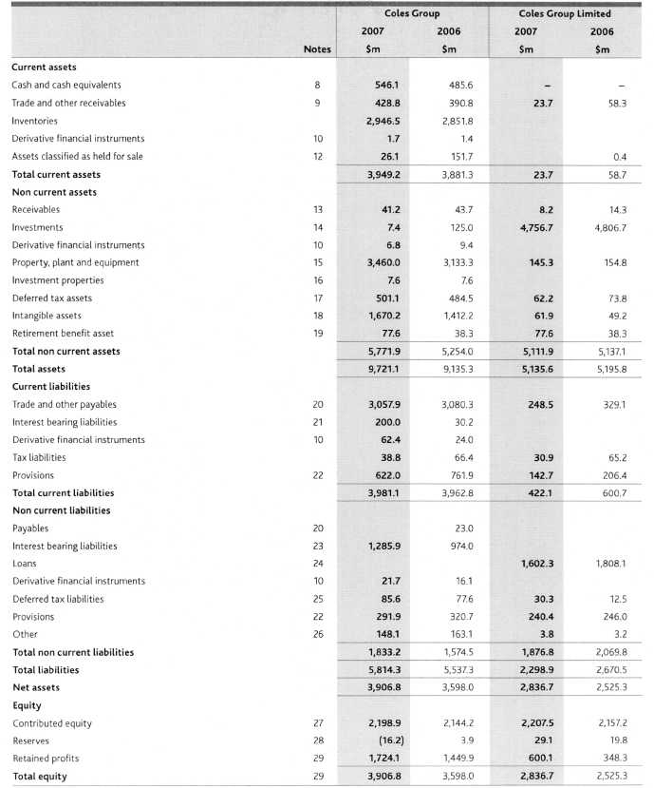

Statements of Recognised Income and Expense
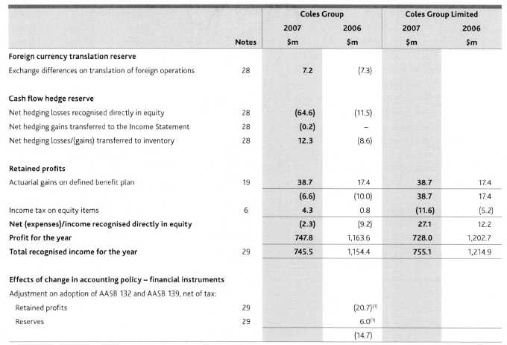

Cash Flow Statements
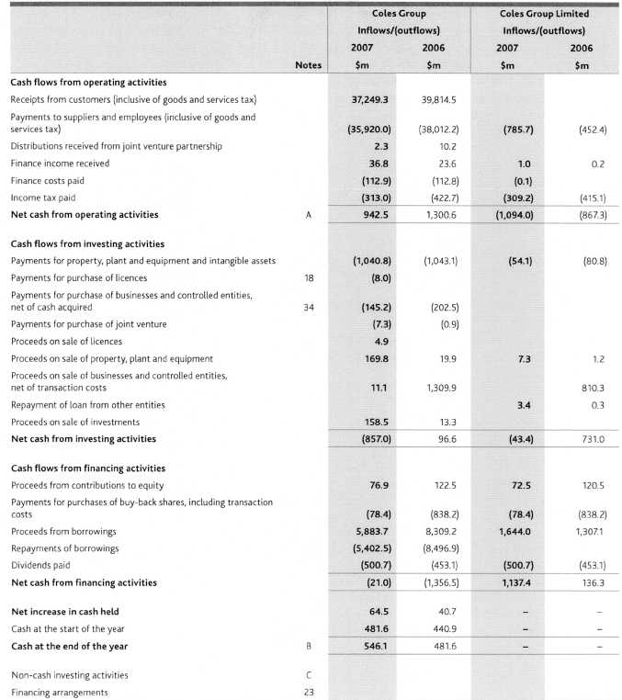
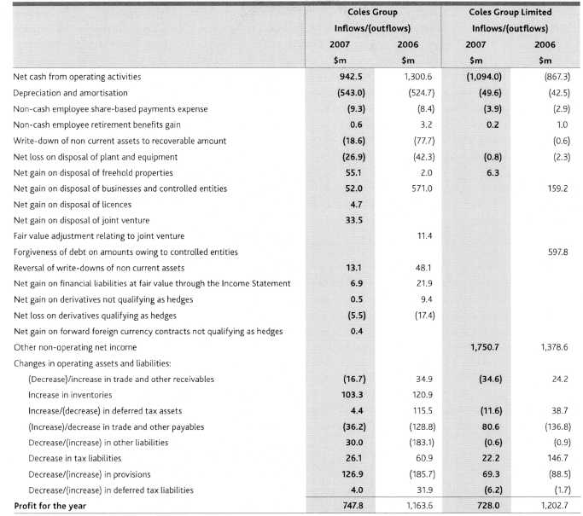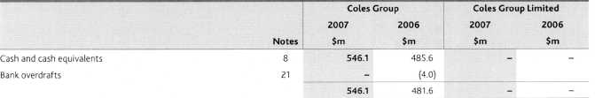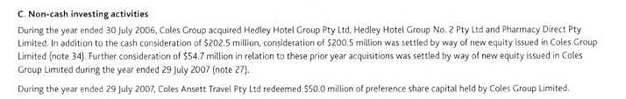

Notes to and Forming Part of the Financial Statements - Full
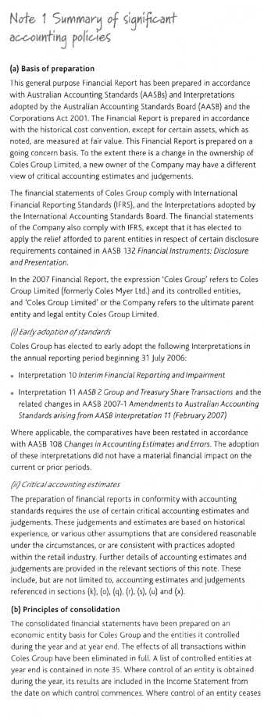
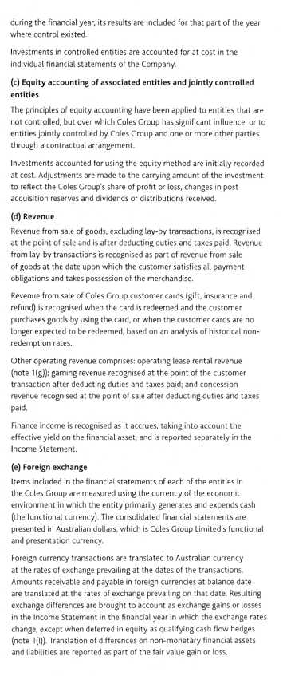
The results and financial position of foreign operations that have a functional currency different from the presentation currency are translated into the presentation currency as follows:
assets and liabilities are translated at the rates of exchange prevailing at balance date;
income and expenses are translated at an average rate for the year, which approximates the exchange rate at the dates of the transactions; and
equity items are translated at historical rates.
Exchange differences arising on translation are taken directly to the foreign currency translation reserve. When a foreign operation is sold, the cumulative foreign currency differences included in the foreign currency translation reserve are recognised in the Income Statement as part of the gain or loss on sale.
(f) Income tax
Income tax expense/(benefit) is the expected tax payable/(receivable) on the taxable income for the period, using tax rates enacted or substantively enacted at the reporting date. These amounts are adjusted by changes in deferred tax assets and liabilities attributable to temporary differences between the tax bases of assets and liabilities and their carrying amounts in the financial statements, and to unused tax losses.
Current and deferred taxes attributable to amounts recognised directly in equity are also recognised directly in equity.
Deferred tax balances are determined using the balance sheet method, which calculates temporary differences based on the carrying amounts of an entity's assets and liabilities in the Balance Sheet and their associated tax bases. The amount of deferred tax provided is based on the expected manner of realisation of the asset or settlement of the liability, using tax rates enacted or substantively enacted at reporting date.
Deferred tax assets for temporary differences and unused tax losses are recognised only to the extent that it is probable that future taxable profits will be available against which the assets can be utilised.
(/) Tax consolidation legislation
Coles Group Limited and its wholly owned controlled Australian entities formed a tax consolidated Group effective 29 July 2002. As a result Coles Group Limited is taxed as a single entity. Tax sharing and tax funding agreements have been put in place between the members of the tax consolidated Group.
Under the tax funding agreement, the members of the tax consolidated Group agree to compensate Coles Group Limited for any tax payable assumed and are compensated for any current receivable and deferred tax assets relating to unused tax losses or unused tax credits that are transferred to Coles Group Limited under the tax consolidation legislation. The funding amounts are determined by reference to the amounts in the wholly owned entities' financial statements.
Amounts receivable or payable by Coles Group Limited under an accounting tax funding agreement with the tax consolidated subsidiaries, are recognised separately as inter-company amounts receivable or payable.
Leases
(I) Operating leases
Coles Group as a tenant leases real estate, stores, office facilities and warehouses. These leases result in substantially all of the risks and benefits of ownership of the property being retained by the lessors, and accordingly, in the financial statements they are classified as operating leases. Payments made under operating leases are expensed on a straight-line basis over the term of the lease. Refer note 31(c) for details of non-cancellable operating lease commitments.
Lease incentives received on entering into operating leases are recognised as liabilities and are amortised over the lease term. The amortised lease incentive is recognised as a reduction to selling and occupancy expenses in the Income Statement.
The present value of future payments for surplus leased space under non-cancellable operating leases that are onerous contracts is recognised as a liability, on the basis described in the accounting policy note for onerous contracts (note 1(x)).
(0 Operating lease rental revenue
Operating lease revenue consists of rentals from investment properties and sub lease rentals. Rentals received under operating leases are recognised on a straight-line basis over the term of the lease.
(iii) Arrangements containing a /ease
Arrangements that are dependent on the use of a specified asset, and convey to Coles Group a right to use the asset, are assessed annually to determine whether the arrangement contains a lease.
If an arrangement is identified to contain a lease, the arrangement is then further assessed to determine whether the lease is a finance lease, by assessing the extent to which Coles Group, as lessee, retains substantially all of the risks and rewards of ownership. Alternatively the arrangement may be treated as an operating lease as described above. Refer note 31(b) for details of other expenditure commitments for arrangements containing a lease.
This policy of treating arrangements which convey to Coles Group a right to use a specified asset as leases was adopted for the first time in the current financial year. The change in policy was necessary following the adoption of Interpretation 4 Determining Whether An Arrangement Contains a Lease (February 2007). The new policy has been applied retrospectively and comparative information in relation to other expenditure commitments for the year ended 30 July 2006 has been restated accordingly. Contracted other expenditure commitments due in: less than one year increased by $73.1 million; later than one but not later than five years increased by $284.6 million; and later than five years increased by $211.5 million. There was no impact on the consolidated financial statements of the Group or the earnings per share, as all material affected arrangements identified as leases were assessed as operating in nature.
Fair value estimation
The fair value of financial assets and financial liabilities must be estimated for recognition, measurement and disclosure purposes.
The fair value of financial instruments traded in active markets (such as publicly traded derivatives, and trading and available-for-sale securities) is based on quoted market prices at the balance sheet date. The quoted market price used for financial assets held by Coles Group is the current bid price and for financial liabilities is the current ask price.
The fair value of financial instruments that are not traded in an active market is determined using valuation techniques. Coles Group uses a variety of methods, including discounted cash flows to calculate the fair value of financial instruments. These calculations are performed using current market inputs, which may include the use of interest and forward exchange rates ruling at balance date. Coles Group makes assumptions concerning these valuations that are based on market conditions existing at each balance date. Quoted market prices or dealer quotes for similar instruments are used for long-term debt instruments held.
The nominal value of trade receivables and payables are assumed to approximate their fair values. The fair value of financial liabilities for disclosure purposes is estimated by discounting the future contractual cash flows at the current market interest rate that is available to Coles Group for similar financial instruments.
Cash and cash equivalents
Cash and cash equivalents include cash at bank, cash on hand, and bank deposits. The carrying amount of these assets approximates their fair value due to the short term to maturity.
Trade and other receivables
Trade and other receivables are recognised at nominal amounts as they are due for settlement no more than 30 days from the date of recognition. A provision for doubtful debts (impairment loss) is recognised when collection of the full amount in accordance with the original terms is no longer probable. Bad debts specifically provided for in previous years are eliminated against the provision for doubtful debts. In all other cases, bad debts are written-off as an expense directly in the Income Statement.
(k) Inventories
At balance date all inventories on hand or in transit are valued at the lower of cost and net realisable value. Cost is determined using the weighted average cost method, after deducting any purchase settlement discount and including logistics expenses incurred in bringing the inventories to their present location and condition.
Volume-related supplier rebates and supplier promotional rebates are recognised as a reduction in the cost of inventory and are recorded as a reduction of cost of goods sold when the inventory is sold.
The net realisable value of inventories is the estimated selling price in the ordinary course of business less estimated costs to sell. It approximates fair value less cost to sell. The key assumptions, which require the use of management judgement, are the variables affecting the estimated costs to sell and the expected selling price. These key assumptions are reviewed annually. Any reassessment of cost to sell or selling price in a particular year will affect the cost of goods sold (either increasing or decreasing).
(t) Derivatives
Derivatives are initially recognised at fair value on the date a derivative contract is entered into and are subsequently remeasured to their fair value. The method of recognising the resulting gain or loss depends on whether the derivative is designated as a hedging instrument, and if so, the nature of the item being hedged. At the inception of a hedge transaction, the relationship between the hedging instrument and hedged item is documented. Coles Group also documents its assessment, both at hedge inception and on an ongoing basis, of whether the derivatives that are used in hedging transactions have been and will continue to be, highly effective in offsetting changes in fair values or cash flows of hedged items.
fair value hedge
Changes in the fair value of derivatives that are designated and qualify as fair value hedges are recorded in the Income Statement, together with any changes in the fair value of the hedged asset or liability that are attributable to the hedged risk.
(//) Cash flowhedge
The effective portion of changes in the fair value of derivatives that are designated and qualify as cash flow hedges is recognised directly in equity in the cash flow hedge reserve. Amounts accumulated in equity are recycled in the Income Statement in the periods when the hedged item will affect profit or loss. However, when the forecast transaction that is hedged results in the recognition of a non-financial asset (for example, inventory) or a non-financial liability, the gains and losses previously deferred in equity are transferred from equity and included in the measurement of the initial cost or carrying amount of the asset or liability. The gain or loss relating to the ineffective portion is recognised immediately in the Income Statement.
07) Derivatives that do not quality for hedge accounting
Certain derivative instruments do not qualify for hedge accounting. Changes in the fair value of any derivative instrument that does not qualify for hedge accounting are recognised immediately in the Income Statement.
Assets (or disposal groups) classified as held for sale and discontinued operations
Non current assets (or disposal groups), whose carrying amount will be recovered principally through a sale transaction rather than through continuing use, are classified as held for sale and are stated at the lower of their carrying amount and fair value less costs to sell.
An impairment loss is recognised for any initial or subsequent write-down of the asset (or disposal group) to fair value less costs to sell. A gain is recognised for any subsequent increases in fair value less costs to sell of an asset (or disposal group), but not in excess of any cumulative impairment loss previously recognised. A gain or loss not previously recognised by the date of the sale of the non current asset (or disposal group) is recognised at the date of sale.
Non current assets (including those that are part of a disposal group) are not depreciated or amortised while they are classified as held for sale. Interest and other expenses attributable to the liabilities of a disposal group classified as held for sale continue to be recognised.
A discontinued operation is a component of an entity that has been disposed of or is classified as held for sale, which represents a separate major line of business, and is part of a single co-ordinated plan to dispose of such a line of business or is a subsidiary acquired exclusively with a view to resale.
Investments in financial assets
Investments are classified into the following categories: financial assets at fair value through the profit and loss, held-to-maturity financial assets, and available-for-sale financial assets. The classification depends on the purpose for which the investments are held. Management determines the classification of held-to-maturity assets at initial recognition and re-evaluates this designation at each reporting date.
Available-for-sale financial assets and financial assets at fair value through the profit and loss are subsequently carried at fair value. Realised and unrealised gains and losses arising from changes in the fair value of financial assets at fair value through the profit and loss are included in the Income Statement in the period in which they arise. Unrealised gains and losses arising from changes in the fair value of financial assets classified as available-for-sale are recognised in equity in the available-for-sale fair value reserve. When securities classified as available-for-sale are sold or impaired, the accumulated fair value adjustments are included in the Income Statement as gains and losses from investment securities. The fair values of quoted investments are based on current bid prices.
Property, plant and equipment
Freehold land and buildings are stated at cost less accumulated depreciation and impairment. Leasehold improvements are stated at cost less accumulated amortisation and impairment (note 1(r)). Cost includes expenditure that is directly attributable to the acquisition of the item.
Depreciation and amortisation is provided on a straight-line basis, on all property, plant and equipment, over their estimated useful lives. The rates used for each class of assets are as follows:
Buildings | 1.5%
Plant and equipment | 5% — 33%
Leasehold improvements | shorter of unexpired period of the lease
 | or the improvement's useful life

Useful lives and the residual value of property, plant and equipment are reviewed annually. Judgement is applied in determining the useful lives of property, plant and equipment. These judgements are supported by consultation with internal technical experts. Any reassessment of useful lives and residual value in a particular year will affect the depreciation and amortisation expense (either increasing or decreasing) from the date of reassessment through to the end of the reassessed useful life for both the current and future years.
Costs incurred subsequent to an asset's initial recognition are included in the asset's carrying amount or recognised as a separate asset, as appropriate, only when it is probable that future economic benefits associated with the item will flow to Coles Group and the cost of the item can be reliably measured. Repairs and maintenance are charged to the Income Statement during the financial period in which they are incurred.
Net gains and losses on disposals are determined by comparing the proceeds of each disposed asset with its carrying amount, and are included in the Income Statement as other income or selling and occupancy expenses respectively.
(p) Investment properties
Property is classified as an investment property, where an insignificant portion of the property is held for Coles Group's own use. Investment properties are measured at fair value. Valuations are made with sufficient regularity to ensure the carrying amount of property does not differ materially from its fair value at balance date.
Annual internal assessments are made, supplemented by independent assessments at least every three years. Potential capital gains tax is not taken into account in determining revaluation amounts unless it is probable that a liability will crystallise.
(q) Intangible assets
Goodwill and other intangible assets with indefinite lives, including brand names and licences are carried at cost, less any accumulated impairment losses. Refer note 1(r).
Intangible assets with finite useful lives, including computer software and co-branded operating rights, are carried at cost less any accumulated amortisation and impairment losses.
Useful lives of intangible assets with finite lives are reviewed annually. Any reassessment of useful lives in a particular year will affect the amortisation expense (either increasing or decreasing) through to the end of the reassessed useful life for both the current and future years.
(/) Goodwill
Where an entity or operation is acquired, the goodwill represents the difference between the cost of the business acquisition over the net fair value of the identifiable assets, liabilities and contingent liabilities acquired. Goodwill is allocated to the cash generating units (CGUs), for the purpose of impairment testing, based on an assessment of the group of CGUs sharing the synergies embodied in the goodwill acquired.
(n) Brand names
Brand names purchased by Coles Group are measured at fair value on acquisition.
Gaming licences
Gaming licences purchased by Coles Group, are measured at fair value on acquisition. Licences have indefinite lives where they have unlimited legal lives and are unlikely to become commercially obsolete.
Computer software
All costs directly incurred in the purchase or development of major computer software or subsequent upgrades and material enhancements, which can be reliably measured and are not integral to a related asset, are capitalised as intangible assets. Direct costs may include internal payroll and on-costs for employees directly associated with the project. Costs incurred on computer software maintenance or during the planning (research) phase are expensed as incurred. Computer software is amortised over the period of time during which the benefits are expected to arise, being five to seven years.
(v) Ca -branded operating rights
Coles Group holds the right to operate certain Shell fuel and convenience outlets and certain Shell car service workshops around Australia. For the Shell fuel and convenience outlets, an exclusive 20 year supply agreement for fuel and lubricant products is in place, which allows for the sites to be branded both 'Coles Express' and 'Shell'. Under a related co-terminus agreement, the Shell car service workshops, largely located next to the co-branded 'Coles Express' and 'Shell' sites, are branded 'Kmart Tyre and Auto'.
Amortisation of the co-branded operating rights commences on the date of the agreement, and is spread over the life of the supply agreement. Co-branded operating rights are tested for impairment where events or circumstances indicate that impairment may exist.
(r) Impairment of assets
(/) Non-financial assets
The recoverable amount of non-financial assets, excluding deferred tax assets, retirement benefit assets and inventories are reviewed at each reporting date to determine whether there is any indication of impairment. If any such indication exists, the asset is tested for impairment by comparing its recoverable amount to its carrying amount.
Assets with indefinite useful lives are not subject to amortisation and are tested on an annual basis for impairment, or where an indication of impairment exists. Assets that are subject to amortisation are reviewed for impairment whenever events or changes in circumstances indicate that the carrying amount may not be recoverable. The recoverable amount is estimated for an individual asset, or if it is not possible to estimate the recoverable amount for an individual asset, the recoverable amount of the CGU to which the asset belongs is determined. For store assets, the appropriate CGU is an individual store.
An impairment loss is recognised as an expense when the carrying amount of an asset or CGU exceeds its recoverable amount. Recoverable amount is determined as the higher of fair value less costs to sell and value in use. Impairment losses recognised in respect of CGUs are allocated first to reduce the carrying amount of any goodwill allocated to the CGU (group of CGUs) and then to reduce the carrying amount of the other assets in the CGU or group of CGUs on a pro-rata basis.
In calculating value in use, the cash flows include the net amount expected to be recovered through the cash inflows and outflows arising from the continued use and subsequent disposal of an asset or CGU. Cash flow estimates do not include any cash inflows and outflows expected to arise from future restructurings which are not yet committed, or from improving or enhancing an asset's or CGU's performance. In assessing value in use, the estimated cash flows are discounted to their present value using a pre-tax discount rate that reflects the current market assessment of the risks specific to the asset or CGU.
An impairment toss recognised in prior periods for an asset (other than goodwill) is reversed if there has been a favourable change in the estimates used to determine the asset's recoverable amount since the last impairment loss was recognised. The increased carrying amount of an asset due to a reversal of an impairment loss does not exceed the carrying amount that would have been determined (net of amortisation or depreciation) had no impairment loss been recognised for the asset in prior periods.
(ii) Financial assets
An assessment for impairment is carried out at each reporting date based on the existence of objective evidence of impairment.
For financial assets carried at cost or amortised cost, the amount of any loss will be recognised in the Income Statement. The amount of any impairment is calculated as the difference between the carrying amount of the asset, or group of assets and the estimated future cash flows.
For available-for-sale financial assets, any potential impairment is measured on the same basis as financial assets at cost. However, cumulative losses are recognised directly in equity and will only be removed and recognised in the Income Statement, where there is an extended period during which the carrying amount of the financial asset has been below the acquisition cost or the instrument is settled.
Trade and other payables
Trade and other payables, including accruals, represent liabilities for goods and services provided to Coles Group, prior to balance date, which were unpaid. The amounts are unsecured and are usually paid between seven and 60 days after recognition.
Other payables also include the liability for:
Coles Group customer cards and gift vouchers, The key assumption in measuring the liability for gift cards and vouchers is the expected redemption rates by customers. Expected redemption rates are reviewed annually. Any reassessment of expected redemption rates in a particular year will affect the revenue recognised from expiry of gift cards and vouchers (either increasing or decreasing).
loyalty program. The key assumptions in measuring the liability are redemption rates and cost per point redeemed, which are reviewed via an annual actuarial assessment. Any reassessment of expected redemption rates or cost per point in a particular year will affect the expense recognised for the loyalty program (either increasing or decreasing).
Interest bearing liabilities and finance costs
Interest bearing liabilities, unless designated at fair value through the Income Statement, are initially recognised at their fair value, net of transaction costs incurred. Subsequent measurement is at amortised cost with any difference between the net proceeds and the maturity amount recognised in the Income Statement over the period of the borrowings using the effective interest rate method. Foreign currency denominated borrowings are translated at exchange rates ruling at reporting date.
The treatment for interest bearing liabilities designated as hedged items in fair value hedge relationships through the Income Statement is set out in note 1(l).
Finance costs include interest expense, amortisation of discounts or premiums relating to borrowings, amortisation of ancillary costs incurred in connection with the arrangement of borrowings and the unwinding of the discount on provision balances. Finance costs are brought to account in determining profit for the year.
(u) Employee entitlements
Annual leave entitlements
Liabilities for annual leave entitlements are accrued based on statutory and contractual requirements, including related on-costs. They are measured using the rates expected to be paid when the obligations are settled, and are discounted using the Commonwealth Government fixed coupon bond rates, where the effect of discounting is material.
Long service leave entitlements
Liabilities for long service leave entitlements are accrued at the present value of expected future payments to be made resulting from services provided by employees up to balance date.
Liabilities for long service leave entitlements, which are not expected to be paid or settled within 12 months, are discounted using the rates attaching to Commonwealth Government fixed coupon bond rates with similar maturity terms.
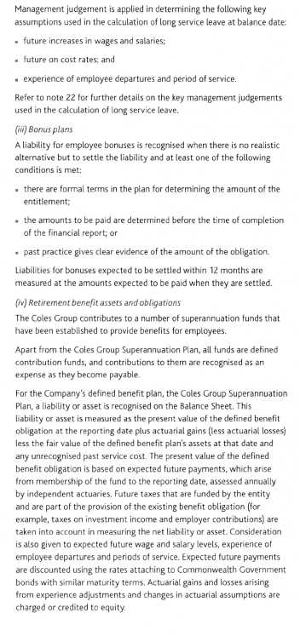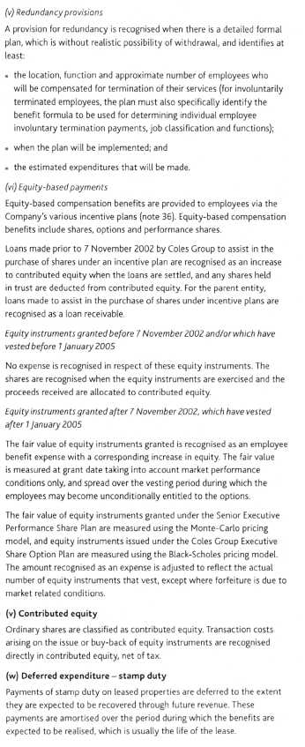
(x) Provisions
(i) Onerous contracts
A provision for onerous contracts is recognised when the expected benefits to be derived from a contract are less than the unavoidable costs of meeting the obligations under that contract, and only after any impairment losses on assets dedicated to that contract have been recognised. The unavoidable costs are calculated as the lower of the cost of fulfilling the contract and any compensation or penalties arising from the failure to fulfil it.
The provision recognised is based on the difference between the estimated cash flows to meet the unavoidable costs and the estimated cash flows to be received, having regard to the risks of the activities relating to the contract. The net estimated cash flows are discounted using the rates attaching to Commonwealth Government bonds with similar maturity terms, where the effect of discounting is material.
(ii)Workers' compensation and self-insurance
Coles Group is self-insured for costs relating to workers' compensation and general liability claims. Provisions are recognised based on claims reported, and an estimate of claims incurred but not yet reported, prior to reporting date.
These provisions are determined on a discounted basis, utilising an actuarially determined method, which is based on various assumptions including but not limited to future inflation, investment return, average claim size and claim administration expenses. These assumptions are reviewed annually and any reassessment of these assumptions will affect the workers' compensation expense (either increasing or decreasing the expense).
(iii) Restructuring provisions
A provision for restructuring is recognised when an obligating event has occurred, and at a minimum there is a detailed formal plan, which has either been announced or is in the process of being implemented, and at least identifies:
the business or part of a business impacted by the plan; the principal locations affected; and the expenditures that will be made.
(iv) Dividends
Provision is made for the amount of any dividend declared by the Directors on or before the end of the financial year but not distributed at balance date.
(y) Acquisitions of assets (including business combinations)
The purchase method of accounting is used for all acquisitions of assets (including business combinations) regardless of whether equity instruments or other assets are acquired. Cost is measured as the fair value of the assets given up, shares issued or liabilities undertaken at the date of acquisition plus incidental costs directly attributable to the acquisition. Where equity instruments are issued in an acquisition, the value of the instruments is their market price as at the acquisition date, unless the notional price at which they could be placed in the market is a better indicator of fair value.
Identifiable assets acquired and liabilities and contingent liabilities assumed in a business combination are measured at their fair values at the acquisition date. The excess of the cost of acquisition over the fair value of Coles Group's share of the identifiable net assets acquired is recorded as goodwill (note 1(q)). If the cost of acquisition is less than the fair value of the net assets of the subsidiary acquired, the difference is recognised directly in the Income Statement.
(z) Goods and Services Tax (GST)
Revenues, expenses and assets are generally recognised net of the amount of GST. Where GST is incurred on purchases and is not recoverable from the Australian Taxation Office (ATO), it is included as part of the cost of acquisition of an asset or as part of an item of expense. Receivables and payables are stated with the amount of GST included. The net amount of GST recoverable from, or payable to, the ATO is included as a current asset or liability on the Balance Sheet.
Cash flows are included in the Cash Flow Statement on a gross basis. The GST components of cash flows arising from investing and financing activities, which are recoverable from, or payable to the ATO, are classified as operating cash flows.
(aa) Earnings per share
Basic earnings per share
Basic earnings per share is determined by dividing profit for the year by the weighted average number of ordinary shares outstanding during the financial year.
Diluted earnings per share
Diluted earnings per share adjusts basic earnings per share to take into account the weighted average number of shares assumed to have been issued for no consideration in relation to dilutive potential ordinary shares. The number of ordinary shares assumed to be issued for no consideration represents the difference between the number that would have been issued at the exercise price and the number that would have been issued at the average market price.
The identification of dilutive potential ordinary shares is based on net profit or loss from continuing ordinary operations and is applied on a cumulative basis, taking into account the incremental earnings and incremental number of shares for each series of potential ordinary shares.
(ab) Rounding of amounts
Dollar amounts have been rounded to the nearest one hundred thousand dollars unless specifically stated otherwise. Where the amount is $50,000 or less, this is indicated by a dash ('—'). For the purposes of notes 36 and 37 a dash indicates a NIL balance.
(ac) Segment reporting
Individual business segments have been identified on the basis of grouping individual products and services subject to similar risks and returns. The business segments reported are Food, Liquor and Fuel; Kmart; Officeworks; Target; Property and unallocated; and discontinued operations (where applicable).
(ad) New accounting standards and interpretations
Certain new accounting standards and interpretations have been published that are not mandatory for the 29 July 2007 reporting period. Assessment of the impact of these new standards and interpretations on the Coles Group is set below:
AASB 7 Financial Instruments: Disclosures and AASB 2005-10 Amendments to Australian Accounting Standards [AASB 132, AASB 101, AASB 114, AASB 117, AASB 133, AASB 139, AASB 1, AASB 4, AASB 1023 and AASB 1038]
AASB 7 and AASB 2005-10 are applicable to annual reporting periods beginning on or after 1 January 2007. Coles Group has elected not to early adopt AASB 7 or the related amendments. Application of AASB 7 and the related amendments will not affect any of the amounts currently recognised in the financial statements, but will impact the type of information disclosed in relation to the Coles Group's financial statements.
(ii) AASB 1 First Time Adoption of Australian Equivalents to International Financial Reporting Standards (February 2007)
This standard is applicable to annual reporting periods beginning on or after 1 January 2008. This standard is a compilation of all amendments to AASB 1, with new amendments including 2007-2 and 2005-10. Amendments contained in AASB 2007-2 have been adopted by Coles Group however those contained in AASB 2005-10 have not been adopted due to the fact that the related AASB 7 has not been early adopted.
AASB 8 Operating Segments (February 2007) and related amendment AASB 2007-3 Amendments to Australian Accounting Standards arising from AASB 8 (February 2007) [AASB 5, AASB 6, AASB 102, AASB 107, AASB 119, AASB 127, AASB 134, AASB 136, AASB 1023, AASB 1038]
AASB 8 and AASB 2007-3 are applicable to annual reporting periods beginning on or after 1 January 2009. Cotes Group has elected not to early adopt AASB 8 and related amendments. The application of AASB 8 and related amendments will not affect amounts currently recognised in the financial statements but may impact on the level of detail disclosed in relation to the reported segments.
2007-6 Amendments to Australian Accounting Standards arising from AASB 123 [AASB 1, AASB 101, AASB 107, AASB 111, AASB 116 & AASB 138 Interpretations 1 & 12]
AASB 123 and AASB 2007-6 are applicable to annual reporting periods beginning on or after 1 January 2009. Coles Group has elected not to early adopt AASB 123 and related amendments.
An assessment of the impact of AASB 123 and related amendments is currently being performed and as yet it is not possible to make a reliable measurement of the financial impact.
AASB 2007-4 Amendments to Australian Accounting Standards arising from ED 151 and Other Amendments [AASB 1, AASB 2, AASB 3, AASB 4, AASB 5, AASB 6, AASB 7, AASB 102, AASB 107, AASB 108, AASB 110, AASB 112, AASB 114, AASB 116, AASB 117, AASB 118, AASB 119, AASB 120, AASB 121, AASB 127, AASB 128, AASB 129, AASB 130, AASB 131, AASB 132, AASB 133, AASB 134, AASB 136, AASB 137, AASB 138, AASB 139, AASB 141, AASB 1023 & AASB 1038]
AASB 2007-4 is applicable to annual reporting periods beginning on or after 1 July 2007. Coles Group has elected not to early adopt this amendment. Adoption of this amendment is not expected to have a material financial impact, however it may impact on the classification on individual Income Statement and Balance Sheet items. The effect of these impacts are currently being assessed.
Interpretation 13 Customer Loyalty Programmes
Interpretation 13 is applicable to annual reporting periods beginning on or after 1 July 2008. Coles Group has elected not to early adopt this Interpretation. An assessment of the impact of Interpretation 13 is currently being performed and as yet it is not possible to make a reliable estimate of the financial impact.
Interpretation 14 AASB 119 - The Limit on a Defined Benefit Asset, Minimum Funding Requirements and their Interaction
Interpretation 14 is applicable to annual reporting periods beginning on or after 1 January 2008. Coles Group has elected not to early adopt this Interpretation. An assessment of the impact of Interpretation 14 is currently being performed and as yet it is not possible to make a reliable estimate of the financial impact.
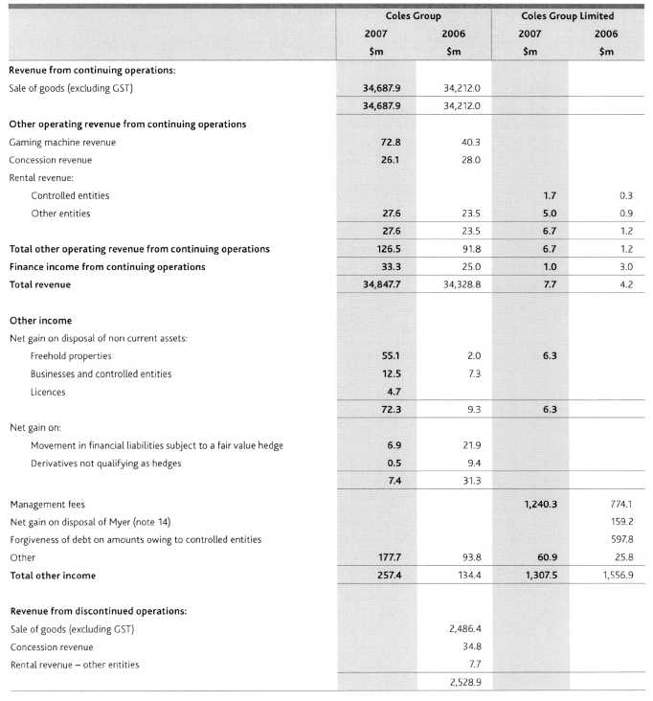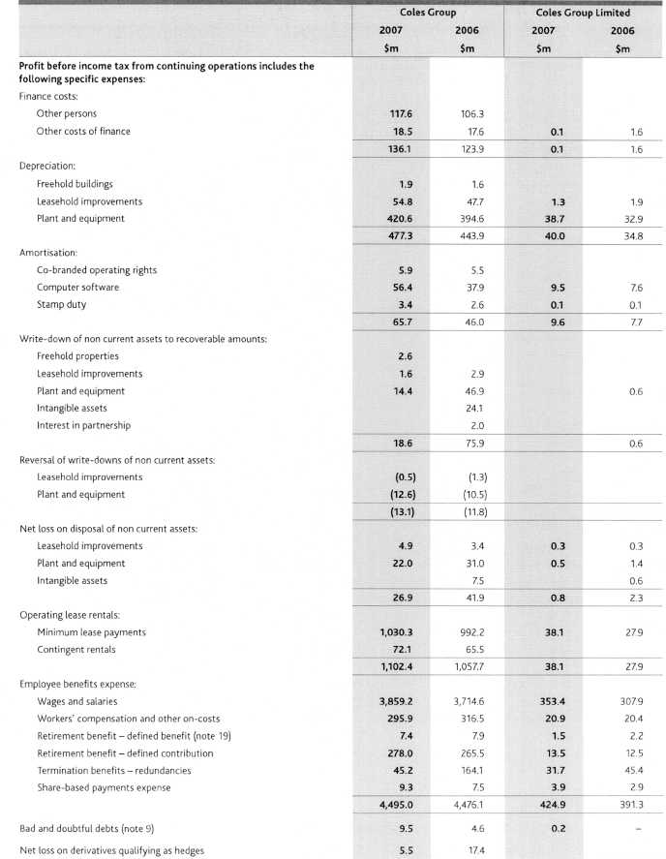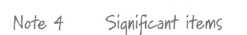
 | Coles Group
 | 2007 | 2006
 | $m | $m
Profit for the year includes the following items whose disclosure is relevant in explaining the financial
performance of Coles Group:
Ownership review
Refer below for a detailed description of the costs associated with the ownership review, net of income tax
benefit of $11.3 million | (44.6)
Disposal of Myer
Gain on sale of Myer, net of income tax expense of $10.1 million (2006 income tax benefit of $20.0 million)
(note 5) | 29.4 | 583.7
Strategic initiatives
Refer below for a detailed description of the costs associated with the strategic initiatives, net of income tax
benefit of $88.0 million |  | (207.4)
 | (15.2) | 376.3

Ownership review
On 23 February 2007, Coles Group announced the commencement of a process whereby it would review the ownership options for the Company and its businesses. This process would consider whether a 100% sale or a restructuring of the Group, including demerger, would create greater value for shareholders than the current ownership structure and growth strategy.
During the second half of the financial year ended 29 July 2007, $55.9 million of costs were recorded in relation to the ownership review process. These costs predominately include consultants' fees and advisors' fees, and the re-imbursernent of due diligence costs incurred by interested parties.
On 2 July 2007, the Coles Group entered into a Scheme Implementation Agreement (SIA) with Wesfarmers Limited. The Coles Group Directors unanimously recommended a scrip and cash proposal that included $4.00 cash, 0.2843 Wesfarmers Limited ordinary shares, and $0.25 Coles Group fully franked dividend for each Coles Group Limited ordinary share held.
On 5 September 2007, the Coles Group Directors recommended a revised proposal from Wesfarmers Limited. The proposal was modified such that 0.2843 Wesfarmers Limited ordinary shares for each Coles Group Limited ordinary share would be replaced by 0.14215 Wesfarmers Limited ordinary shares and 0.14215 Wesfarmers Limited Partially Protected shares for each Coles Group Limited ordinary share. The Partially Protected shares will be a new form of security to be issued. It is intended the Partially Protected shares will be listed on the Australian Securities Exchange, pay a fully franked dividend of at least $2.00 per share (subject to the availability of sufficient retained earnings and franking credits), and provide shareholders with additional Wesfarmers Limited ordinary shares in the event that the Wesfarmers Limited ordinary share price is less than $45.00 at their lapse date. Under the terms of the revised SIA, if the Coles Group Directors elect not to proceed with the transaction, the Company must pay Wesfarmers Limited a break fee of $150.0 million.
Significant additional transaction costs may be incurred in the 2008 financial year. Should a transaction be consummated, the Company is required to pay its advisors a success fee, the quantum of which is yet to be determined.
Strategic initiatives
During the year ended 30 July 2006, a number of strategic initiatives were committed to, resulting in significant write-downs and costs. These included:
redundancy expenses of $158.1 million associated with the consolidation of support services, simplification of hack office processes and closure of the Somersby and Hampton Park distribution centres;
lease exit costs of $17.0 million associated with the closure of Somersby and Hampton Park distribution centres;
write-down of brand names of $22.6 million as a result of the rebadging of Theo's liquor stores;
asset write-downs of $35.7 million and costs of $22.8 million associated primarily with the rebadging of Bi-Lo stores to Coles, and other store rebadging as a result of changes to the format;
accruals of $31.8 million associated with the changes to the existing loyalty program; and
other costs of $7.4 million.
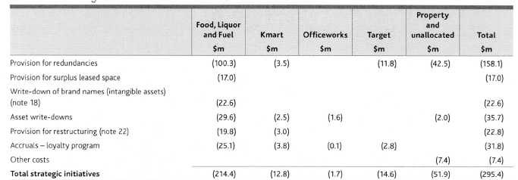
Nofe 5 Picc-ontinuec.1 operations
Description
On 9 November 2005, Coles Group announced the divestment of its nine Megamart stores. A pre-tax charge of $81.5 million was recorded in the year ended 31 July 2005 largely comprising the write-down of non current assets and inventory to recoverable amount and the recognition of a provision for surplus leased space. No consideration was received in relation to the divestment. During the year ended 29 July 2007 an additional charge of $2.4 million was recorded in relation to surplus leased space.
On 2 June 2006, Coles Group disposed of its Myer business for $1,409.0 million. The disposal included deferred consideration of $19.5 million which was received during the year ended 29 July 2007. As at 30 July 2006, accruals and provisions for divestment costs totalled $79.4 million. During the year ended 29 July 2007, certain obligations and requirements have been re-negotiated and where appropriate those provisions and accruals have been reversed, resulting in an additional gain on sale before income tax of $39.5 million.
Financial information relating to these discontinued operations for the period to the date of disposal or divestment, and for the year ended 29 July 2007 is set out below.
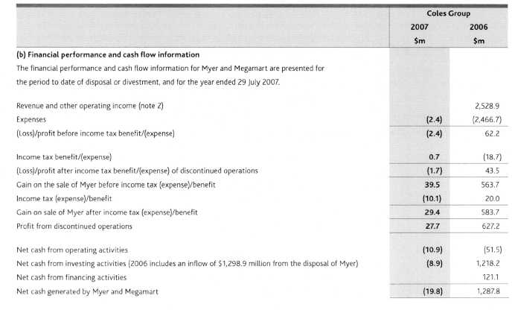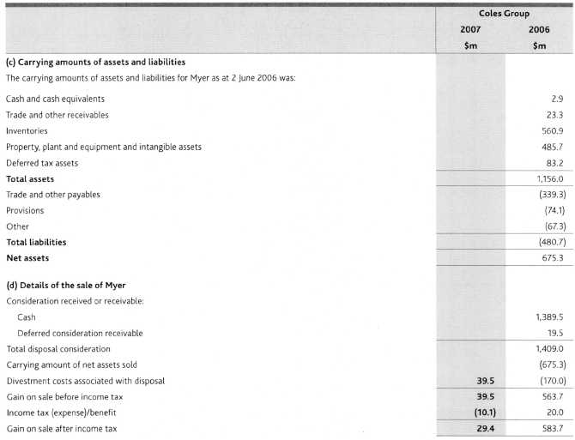
(e) Other transactions related to the sale of Myer
As an outcome of the disposal of the Myer business and its related assets, Coles Group issued options for the disposal of certain other freehold properties. On 31 August 2006 an option was exercised resulting in the disposal of Ocean Keys Shopping Centre for $78.0 million (carrying amount $47.9 million). On 31 August 2006 an option for the sale of Casey Central Shopping Centre for $51.0 million (carrying amount $50.7 million) was also exercised. Coles Group also disposed of its 50% interest in the CMS General Trust for $160.0 million (carrying amount $125.0 million).
On 2 June 2006, the Company entered into a number of contracts relating to the sale of its Myer business, whereby Coles Group has guaranteed the performance of certain leases by Myer Limited. The guarantees amount to $160.1 million and primarily expire within a maximum of three years. The fair value of these guarantees was not considered to be material and as such a separate liability has not been recognised.
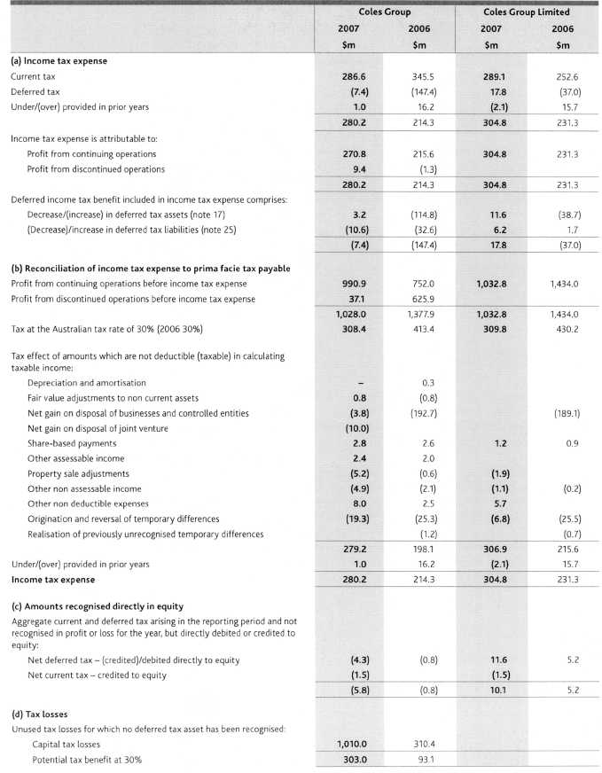
All unused tax losses were incurred by Australian entities. All unused tax losses remaining as at 29 July 2007 are not subject to time limits for recovery.
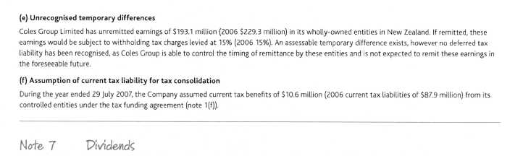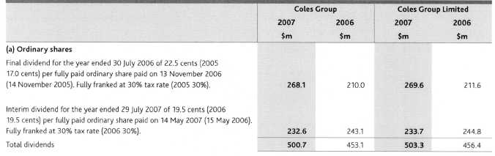
Dividends not recognised at year end
In addition to the above dividends, since year end the Directors have declared a final dividend of 25.0 cents per fully paid ordinary share, fully franked based on tax paid at 30%. The aggregate amount of the proposed ordinary dividend expected to be paid on 23 November 2007 out of retained profits at 29 July 2007, but not recognised as a liability at year end, is $299.7 million. The final dividend declared after 29 July 2007 will be fully franked out of existing franking credits or out of franking credits arising from the payment of income tax in the year ending 27 July 2008.
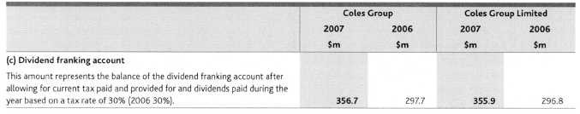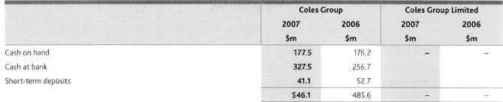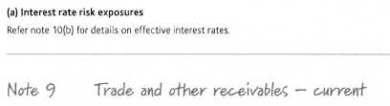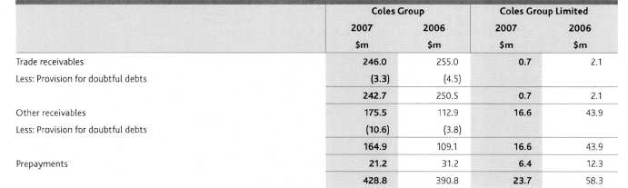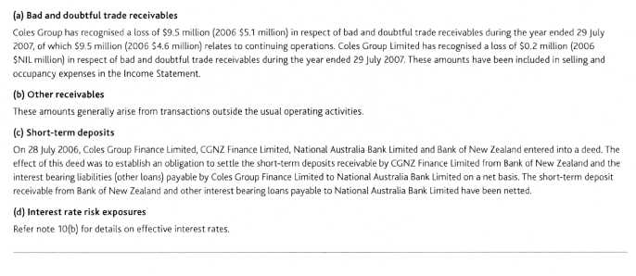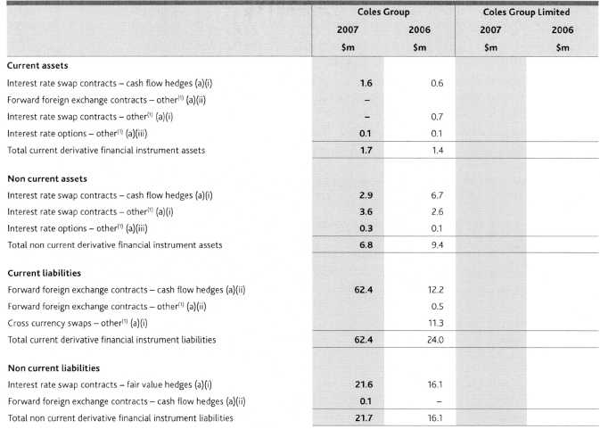
(1) Derivative financial instruments classified as 'other' are economic hedges that do not qualify for hedge accounting treatment under AASB 139.
(a) Instruments used by Coles Group
Coles Group is party to derivative financial instruments in the normal course of business in order to manage its exposure to the fluctuations in interest and foreign exchange rates in accordance with the Group's financial and capital risk management policies (note 11).
(1) Swaps
At balance date, the fixed interest rates on swaps varied from 4.8% to 7.4% . The terms and notional principal amounts of Coles Group's major outstanding contracts at balance date were:
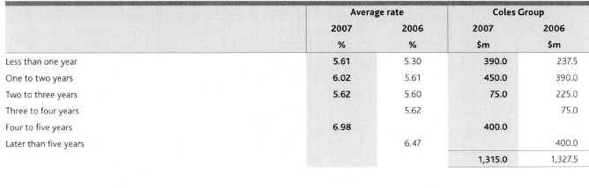
The terms, notional principal amounts and outstanding contracts by classification for Coles Group were:
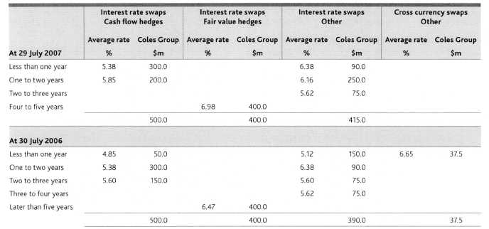
(ii) Forward foreign exchange contracts
The settlement dates, dollar amounts to be received and contractual exchange rates of Coles Group's major outstanding contracts at balance date were:
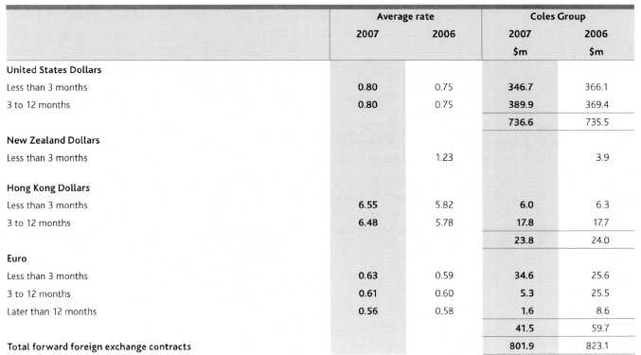
The net deferred loss on hedges of anticipated future transactions hedged by the use of forward foreign exchange contracts was $62.5 million at balance date, which has been included in the cash flow hedge reserve (2006 $12.2 million loss).
The settlement dates, dollar amounts to be received and contractual exchange rates for Coles Group's major outstanding contracts by classification were:
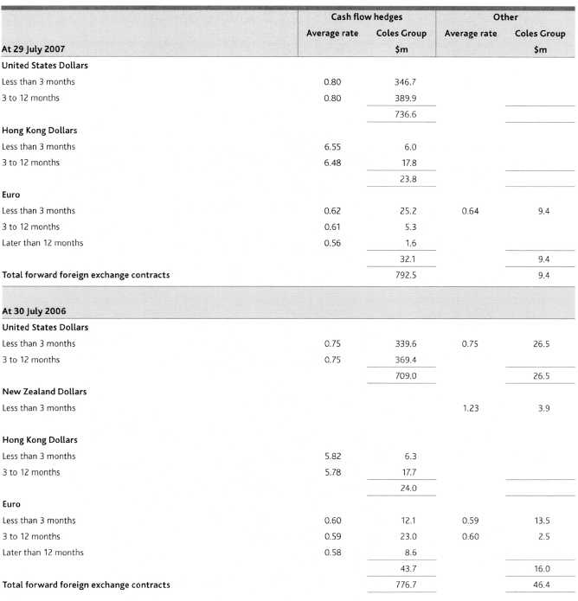
(iii) Interest rate options - other
The terms and notional principal amounts of Coles Group's major outstanding interest rate option contracts at balance date were:
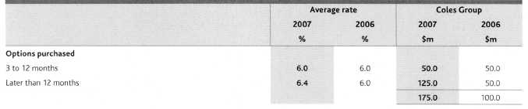
(b) Interest rate risk exposures
Coles Group's exposure to interest rate risk and the effective interest rates on financial instruments were:
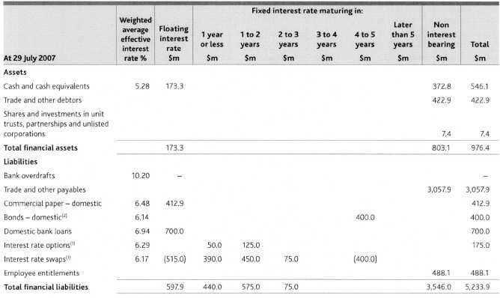
Notional principal amounts
Face value
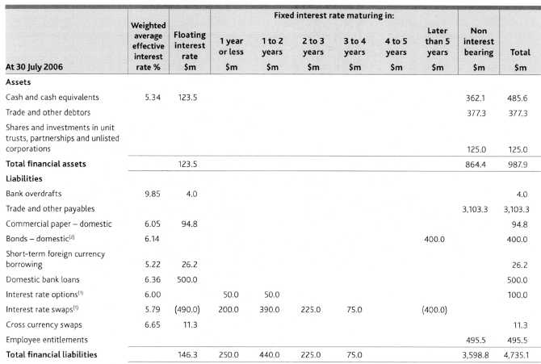
Notional principal amounts
Face value
Note 11financial and c-apii-al risk. rvlanajenienl-
Coles Group is exposed to a variety of financial risks, including foreign exchange risk, interest rate risk, funding risk and credit risk. Coles Group's overall risk management program seeks to minimise potential adverse effects on the financial performance of the Coles Group.
These risks are managed in accordance with Board approved policies which: outline the manner in which the Group manages its financial risk; detail who is responsible for the identification and management of these risks; and set out the risk management instruments that Coles Group is permitted to use.
The Group has centralised the management of financial risk in its Group Treasury department, and all financial transactions are undertaken by authorised Treasury personnel in the name of Coles Group Finance Limited. Speculative position taking is prohibited.
Foreign exchange risk management
Foreign exchange risk in Coles Group arises from imported merchandise, other purchases (including capital expenditure), foreign currency denominated borrowings and offshore investments (New Zealand).
The foreign exchange risk on merchandise is managed in order to maintain a fully hedged position of all material exposures at all times. Exposures arising from merchandise imports are managed by the use of forward exchange contracts and currency options.
All exposures arising from other purchases and foreign currency denominated borrowings are economically hedged. A combination of cross currency swaps and forward contracts are used to eliminate exchange rate risk associated with these exposures.
The translation exposure arising from the Coles Group's New Zealand net assets is not hedged due to the immaterial value of the net assets relative to the rest of the Coles Group.
Interest rate risk
Interest rate risk in Coles Group arises from both the volume of debt and the timing of interest rate settings. A combination of interest rate swaps, options, forward rate agreements and futures are used to achieve the desired mix of fixed and floating rate debt, and to retain the opportunity to benefit from interest rate reductions.
Generally, a level of approximately 50% of Coles Group's core debt is covered at fixed interest rates of beyond 12 months in maturity. T he remainder of the exposures are managed with strategies of 12 months or less in maturity. All interest rate hedge cover is spread across a range of maturity dates.
Coles Group has fixed coupon bonds on issue. In line with the Group's interest rate risk strategy, the bonds were swapped to floating rates via interest rate swaps. This transaction was designated as a fair value hedging relationship and the changes in the fair value of the hedged item are offset against the changes in the value of the interest rate swaps.
Funding risk
Coles Group finances its operations by a combination of reinvestment of retained profits, long and short-term bank debt, capital market debt and leases. Funding risk is the risk that Coles Group may not be able to access funding when required, for both day-to-day requirements and to support the strategic activities of the Coles Group.
Funding risk is managed by maintaining sufficient undrawn committed bank facilities, a diverse range of available funding sources, both domestic and international, and sound relationships with key financial institutions. Strategic funding risk is also managed by maintaining a prudent spread of debt maturities, arranging funding ahead of requirements and an investment grade credit rating.
Coles Group's long-term credit rating remained stable during the year. As at 12 September 2007, Coles Group Limited is rated Baa2 (Review - Uncertain) by Moody's and BBB (CreditWatch — Positive) by Standard and Poor's.
Credit risk
When Coles Group invests surplus cash, or commits to a future financial settlement (for example, forward foreign exchange contracts or options) with an external counterparty, there is a risk that the counterparty will default prior to settlement. Coles Group manages this risk by limiting its credit exposure to any single counterparty, and by ensuring that financial transactions are prudently spread across, and only undertaken with approved, highly rated counterparties.
Coles Group's exposures to counterparties and their credit ratings are routinely monitored.
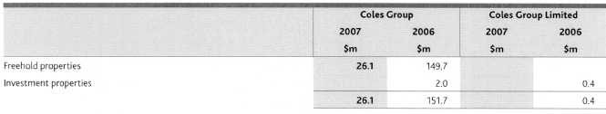
The properties identified as held for sale are reported in the Property and unallocated reporting segment in note 32.
Note 13 Kec-eivablec Pion current
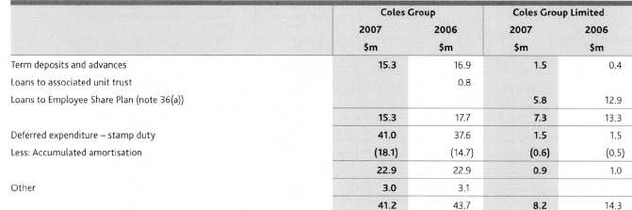
Interest rate risk exposures
Refer note 10(b) for details on effective interest rates.
Fair values
The fair values and carrying values of non current receivables of the Coles Group are as follows:
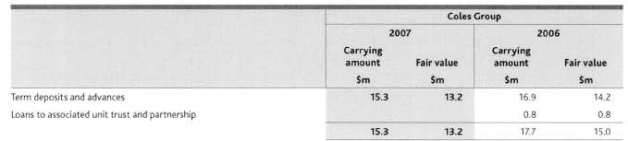
The fair values are based on cash flows discounted using current lending rates ranging from 7.0% to 10.2%
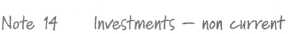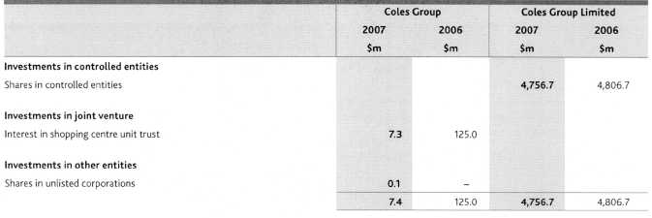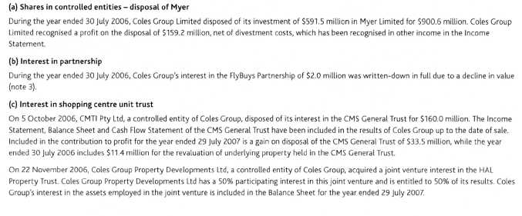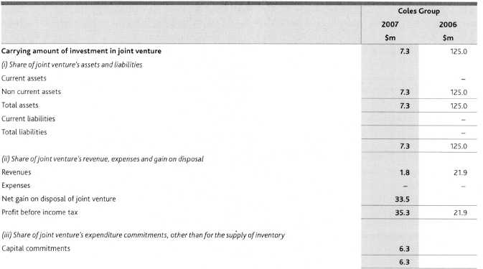
(d) Interests in joint venture and other associated entities
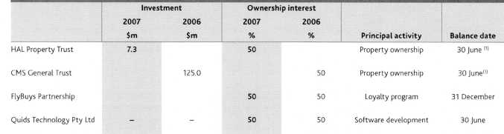
(1) | The Income Statements, Balance Sheets and Cash Flow Statements of the HAL Property Trust and the CMS General Trust (Trusts) for the year ended 29 jury 2007 (2006 30 July) have been included in the results of Coles Group for the periods during which the Coles Group had joint control over these Trusts.
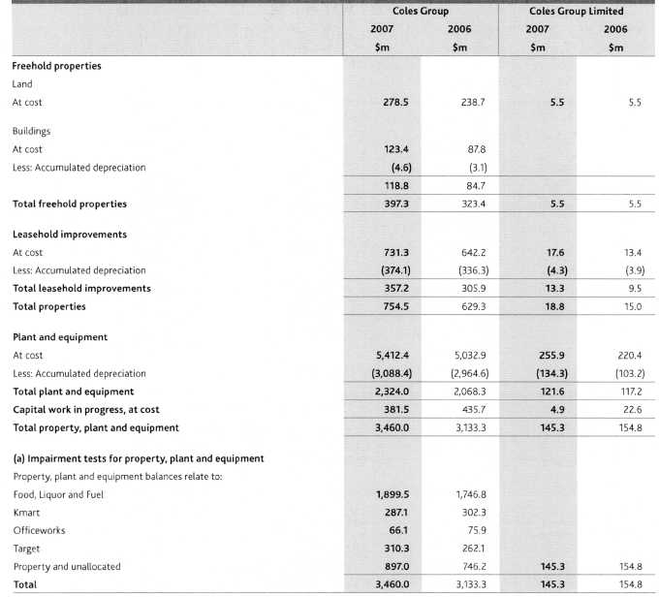
For the purposes of impairment testing, each store is a cash generating unit. Impairment reviews were performed by comparing the carrying value of assets with the recoverable amount of the cash generating units to which assets have been allocated.
Recoverable amounts for cash generating units are based on value in use, which is calculated from cash flow projections using the latest results for the year ended 29 July 2007. The key assumptions for the value in use calculations are those regarding discount rates, growth rates and the remaining useful life of assets.
Impairments and reversal of impairments result from a range of circumstances relating to store specific issues and the local trading environment, and are recognised in selling and occupancy expenses in the Income Statements.
By segment:
The growth rates beyond five years have been extrapolated using an appropriate industry growth rate.
The pre-tax discount rates used to calculate value in use range from 11% to 14% (2006 11% to 14%). The discount rate is derived from Coles Group's weighted average cost of capital.
(b) Reconciliations
Reconciliations of the carrying amount of each class of property, plant and equipment are set out below:
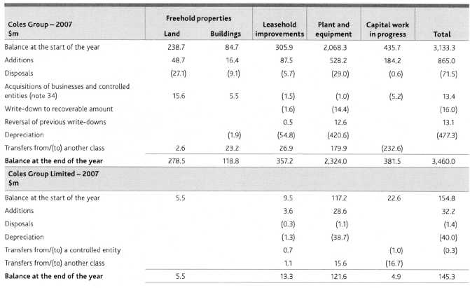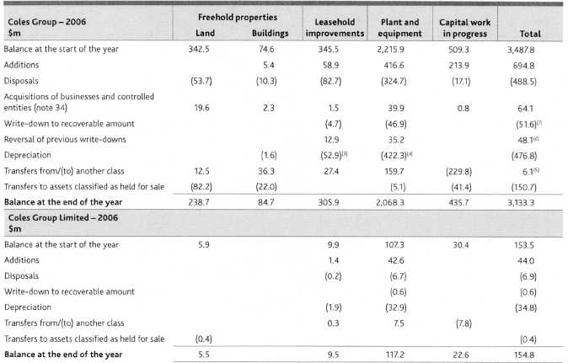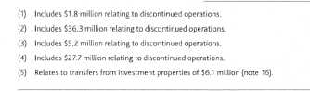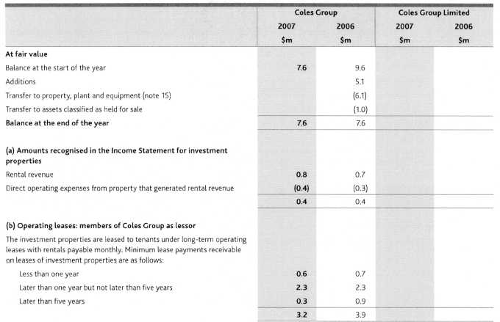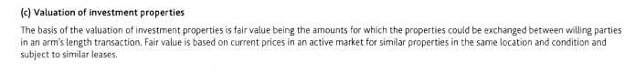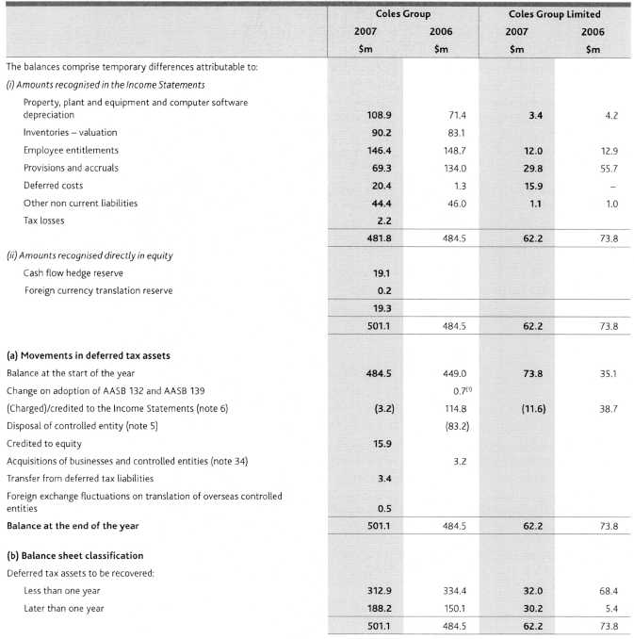
Ill As permitted, on adoption of AASB 132 Financial Instruments: Disclosure and Presentation and AASB 139 Financial Instruments: Recognition and Measurement, Coles Group elected to recognise an opening balance adjustment at 1 August 2005. Further information on adoption of these standards is available in the 2006 Full Annual Report.
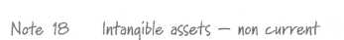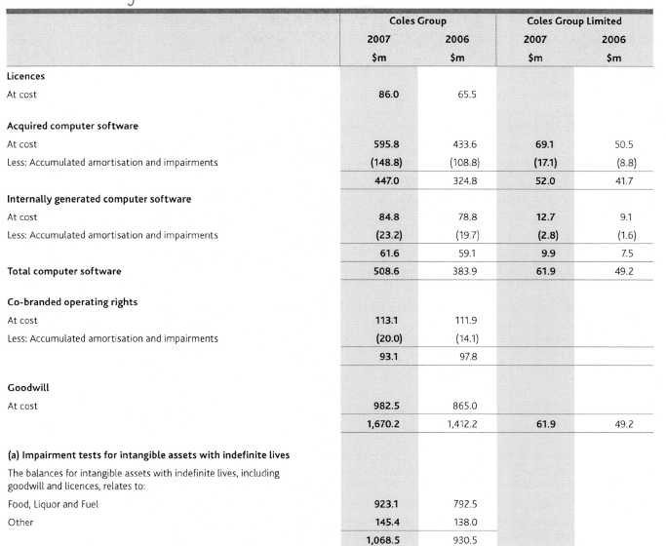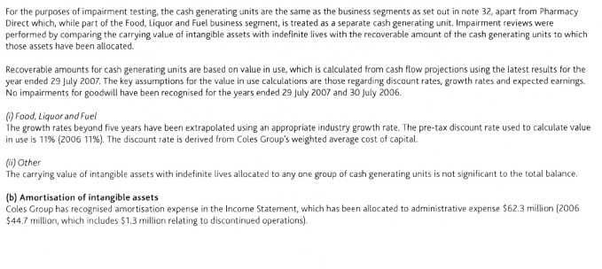
(c) Reconciliations
Reconciliations of the carrying amount of each class of intangible asset are set out below:
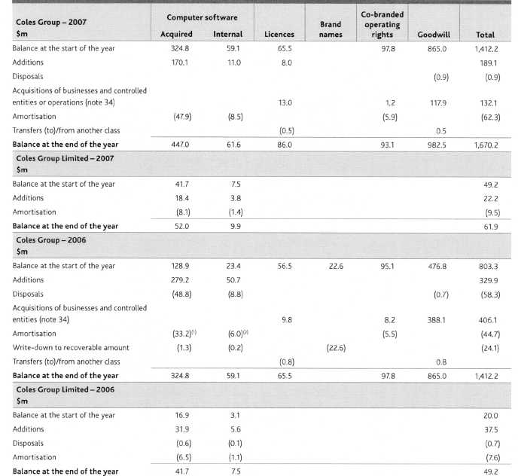
(1) Includes $1.1 million relating to discontinued operations.
(4 Includes $0.2 million relating to discontinued operations.
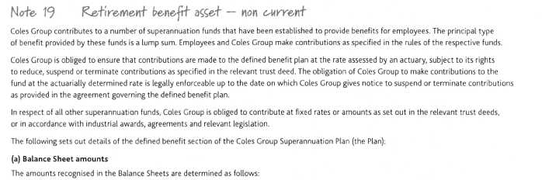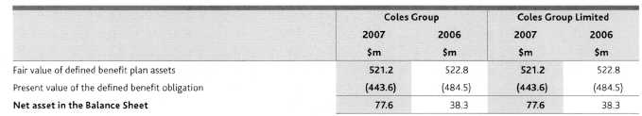
The Company has recognised an asset in the Balance Sheet in respect of its defined benefit superannuation arrangement. The Company is currently benefiting from this Plan surplus in the form of a reduction in the required contribution rate, based on the advice of the Plan's actuary.
The Company may at any time by notice to the Trustee, terminate its contributions. The employer has a liability to pay the monthly contributions prior to the effective date of the notice, but there is no requirement for an employer to pay any further contributions, irrespective of the financial condition of the Plan.
Categories of plan assets
The major categories of the Plan's assets are as follows:
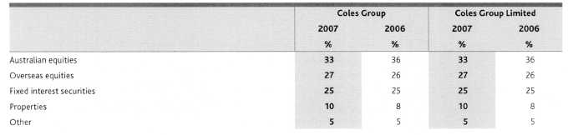
The fair value of the Plan's assets includes no amounts relating to:
. any of the Company's own financial instruments; and
. any property occupied by, or other assets used by, Coles Group Limited or its controlled entities.
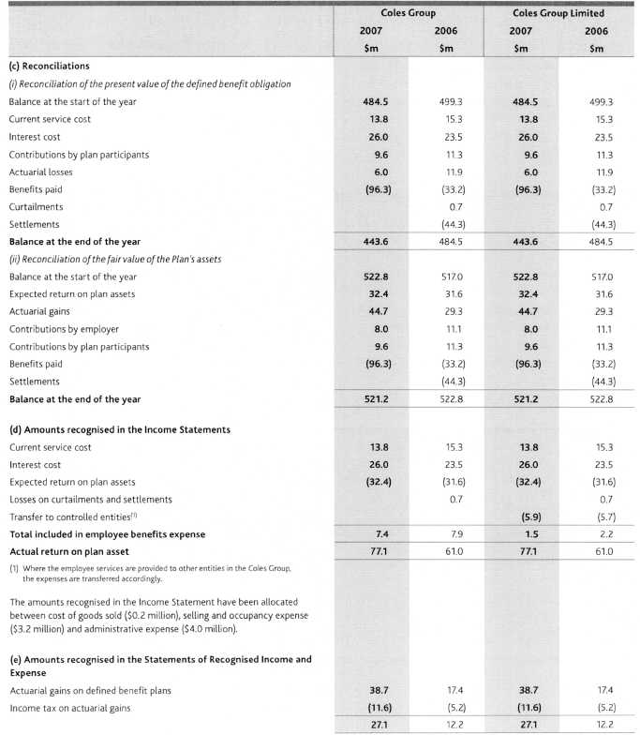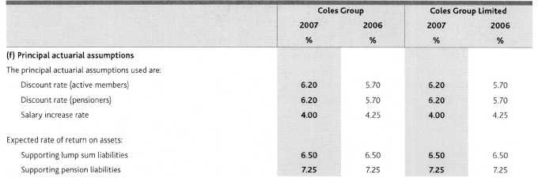
The expected return on the Plan's assets is determined by weighting the expected long-term return for each asset class by the benchmark allocation of assets to each class and allowing for correlations of the investment returns between asset classes. The returns for each asset class are net of investment tax and investment fees. An allowance for the asset based administration expenses has been deducted from the expected return.
Employer contributions
The method used to determine the employer contribution recommendations at the last actuarial review was the Target Funding method. Under the Target Funding method, the employer contribution rate is set at a level such that the Plan's assets are expected to exceed the Plan's liabilities by a specified margin within a specified period of time. The current contribution recommended in the actuarial review as at 1 July 2006 is NIL% of the salaries of all members for the period from 1 March 2007 to 30 June 2008; and 6.0% of the salaries of all members for the period thereafter.
Total employer contributions expected to be paid by Coles Group for the year ended 28 July 2008 are $0.6 million.
The economic assumptions adopted for the last actuarial review of the Plan as at 1 July 2006 were:
Weighted-average assumptions:
Expected rate of return on the Plan's assets | 6.50%
Expected salary increase rate | 3.50%

Net financial position of the Plan
In accordance with AAS 25 Financial Reporting by Superannuation Plans the most recent financial position of the Plan was:
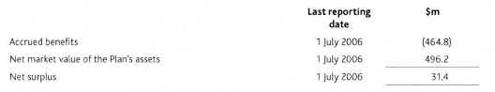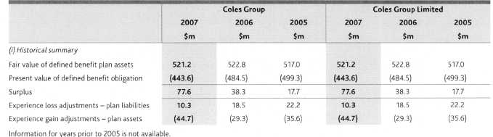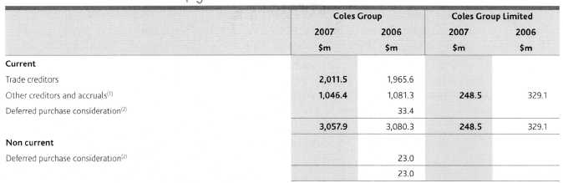
Payables to related parties are disclosed in note 38.
Deferred purchase consideration related to the acquisition of Hedley Hotel Group Pty Ltd, Hedley Hotel No.2 Pty Ltd and Pharmacy Direct Pty Limited.
Note 21 Interact bearin3 JiabilitieS — c-wrrent
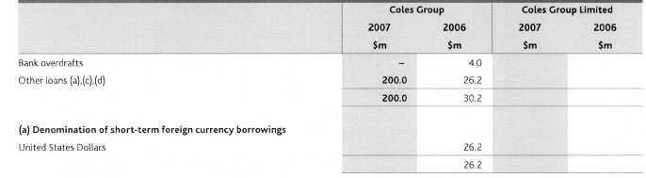
Assets pledged as security
Refer to note 23(b).
Other loans
Other loans are due for repayment within two months of balance date with an interest rate of 7.20% (2006 5.22%) .
(d) Fair value
The fair value and carrying values of other loans of Coles Group are as follows:
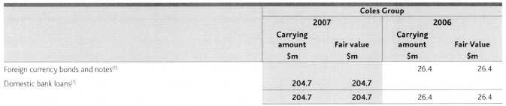
(1) Carrying amount includes accrued interest of $4.7 million (2006 50.2 million).
(e) Interest rate risk exposures
Refer to note 10(b) for details on effective interest rates.
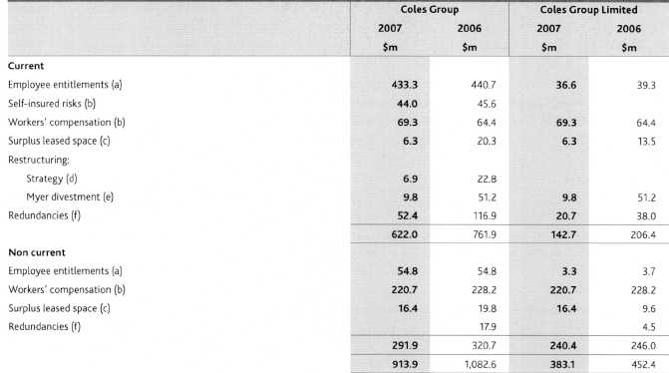
(a) Employee entitlements
The provision for employee entitlements comprises amounts for annual leave and long service leave. The following assumptions were used in measuring the long service leave provision for the year ended 29 July 2007:
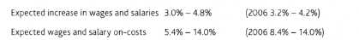
Accrued labour costs are included in trade and other payables (note 20).
Workers' compensation and self-insured risks
The workers' compensation and self-insured risk provisioning relates to commitments of up to 50 years (2006 18 years). Actual compensation paid may vary where accidents and claims incurred vary from those estimated. Refer note 1(x) for a description of the provision.
Surplus leased space
The surplus leased space provision covers future payments for leased premises, which are onerous, net of actual and expected sub-leasing revenue, and relates to commitments of up to 10 years (2006 11 years). Actual lease payments may vary from the amounts provided where alternate uses are found for these premises, including attraction of new tenants. Refer note 1(g) for a description of the provision.
Restructuring - strategy
The provision for restructuring relates to the strategic initiatives detailed in note 4, and largely comprises costs associated with the rebadging of Bi-Lo stores to Coles, and other store rebadging as a result of changes in format.
Restructuring - Myer divestment
The provision for restructuring relates to the Myer divestment, which occurred on 2 June 2006, and largely comprises information technology change costs, and costs associated with removing the Myer name from Coles Group.
(f) Redundancies
The provision for redundancies relates primarily to the strategic initiatives detailed in note 4, and largely comprises costs associated with the consolidation of support services and simplification of back office processes.
(g) Movements in provisions
Movements in each class of provision during the financial year, other than employee entitlements, are set out below:
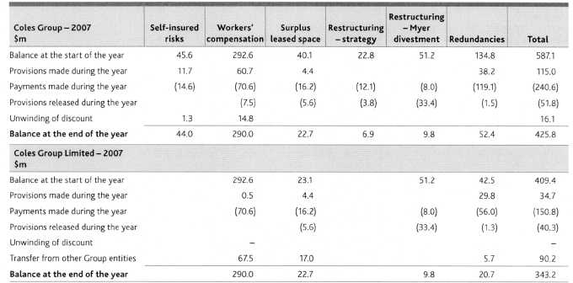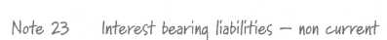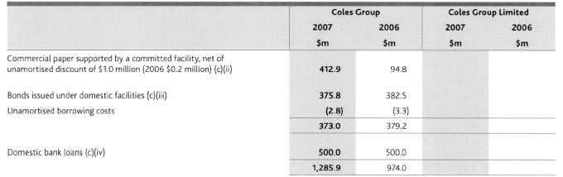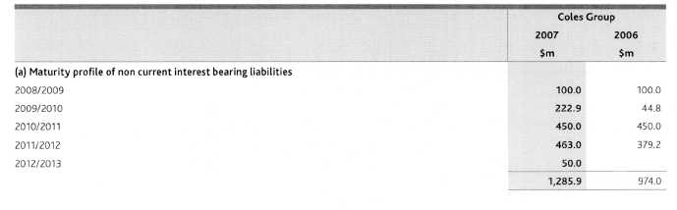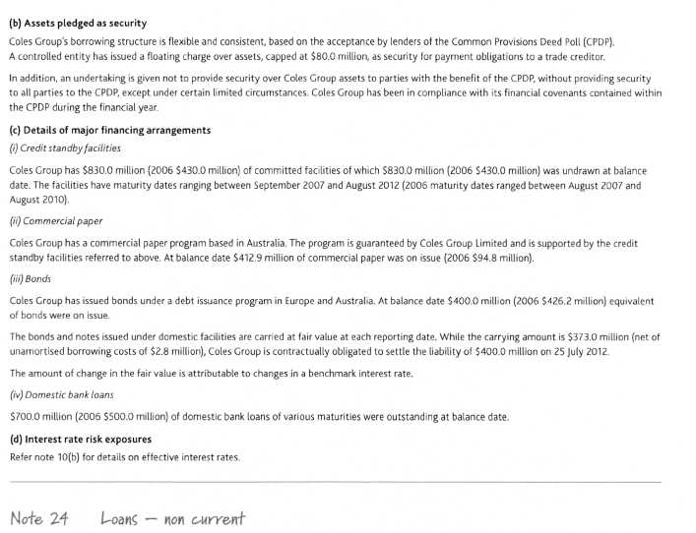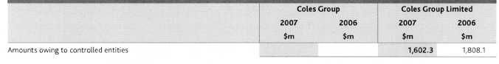
During the year ended 30 July 2006, Myer Limited and The Myer Emporium Limited forgave a loan receivable from the Company of $597.8 million. The amount forgiven was recorded as other income in the Income Statement.
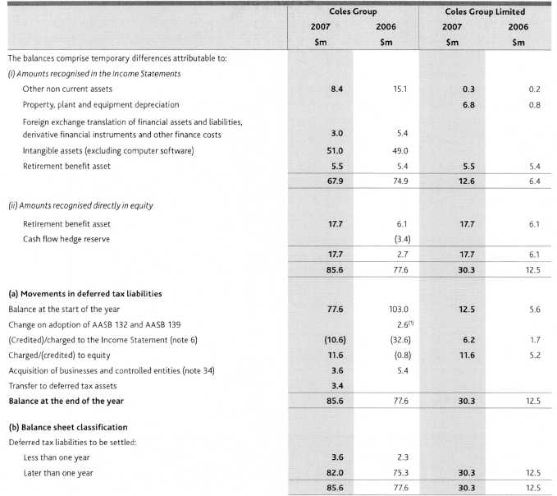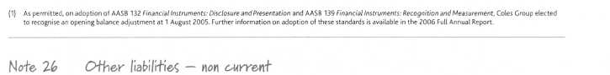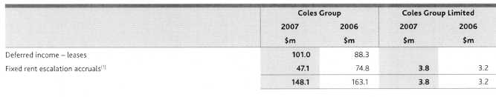
(1) | During the year ended 29 July 2007, leases containing rental escalation clauses were renegotiated for Coles Express and resulted in a write-back of fixed rental accruals of 534.5 million.
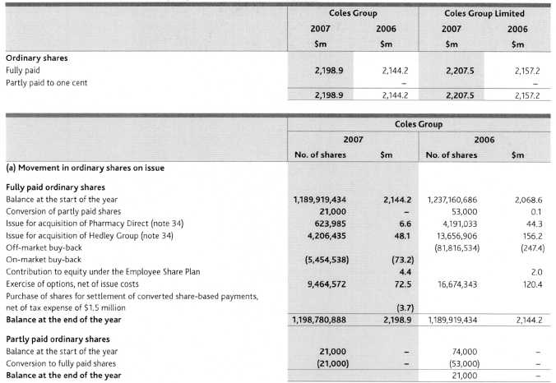
Terms and conditions
(i) Ordinary shares
Ordinary shares entitle the holder to participate in the dividends of the Company and the proceeds on winding up of the Company. Fully paid ordinary shares entitle the holder to one vote, except on a poll, where each share is entitled to one vote. Partly paid shares do not have any voting rights, until fully paid (except with respect to any proposal to vary the rights of these shareholders).
At 29 July 2007, there were NIL partly paid shares on issue (2006 21,000 partly paid shares on issue, on which a further $1.99 per share was uncalled).
Dividend reinvestment plan
The Company has a dividend reinvestment plan under which holders of ordinary shares have previously been able to elect to have their dividend entitlements satisfied by the issue of new fully paid ordinary shares. The plan has been suspended. All future dividends will be paid in cash.
Share buy-back
On 23 May 2006, the Company announced and commenced a capital management program to buy back up to $1.0 billion of shares.
On 10 July 2006, the Company purchased and cancelled 81,816,534 Coles Group Limited fully paid ordinary shares under an off-market buy-back.
The shares were acquired at $10.23 per share. The total cost of the off-market buy-back was $838.9 million, which included $1.9 million of transaction costs.
As announced in the Coles Group Share Buy-Back offer document on 23 May 2006, all of the Buy-Back Price above $3.00 per ordinary Coles Group Limited share acquired off-market has been treated for taxation purposes as a fully franked dividend. Accordingly, retained profits was reduced by $591.5 million and contributed equity was reduced by $247.4 million. In addition, the Company's dividend franking account was reduced by $274.8 million as a result of the off-market buy-back.
On 10 July 2006, the Company announced that the balance of the $1.0 billion capital management program (being $163.0 million) would be conducted by an on-market buy-back. At balance date, 5,454,538 Coles Group Limited fully paid ordinary shares had been purchased and cancelled under this program. The shares were acquired at prices ranging from $13.23 per share to $13.48 per share. The total cost of the on-market buy-back was $73.2 million, which included $0.1 million of transaction costs. At balance date the Company had not completed the on-market buy-back. Between balance date and reporting date, no additional shares have been purchased under this program.
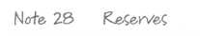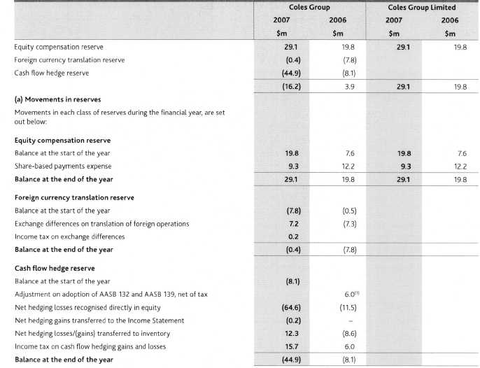
(1) As permitted, on adoption of AASB 132 Financial Instruments: Disclosure and Presentation and AASB 139 Financial Instruments: Recognition and Measurement, Coles Group elected to recognise an opening balance adjustment at 1 August 2005. Further information on adoption of these standards is available in the 2006 Full Annual Report.
Equity compensation reserve
The equity compensation reserve includes the amortised value of options and performance rights granted to employees.
Foreign currency translation reserve
The foreign currency translation reserve includes foreign currency translation differences on translation of foreign operations.
(d) Cash flow hedge reserve
The hedge reserve recognises the gains and losses on outstanding cash flow hedges to the extent that they are effective. Amounts are recognised in the Income Statement when the associated hedged transaction affects the Income Statement (note 1(0).
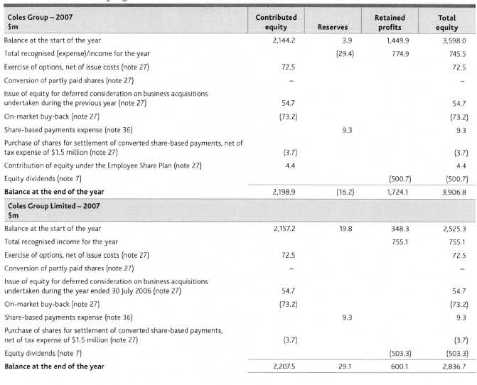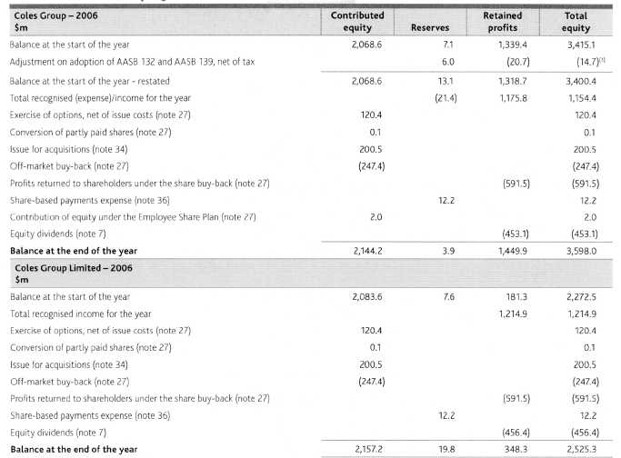
As permitted, on adoption of AASB 132 Financial Instruments: Disclosure and Presentation and AASB 139 Financial instruments: Recognition and Measurement, Coles Group elected to recognise an opening balance adjustment at 1 August ZOOS. Further information on adoption of these standards is available in the 2006 Full Annual Report.
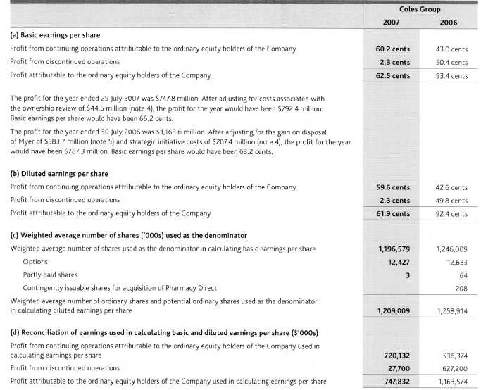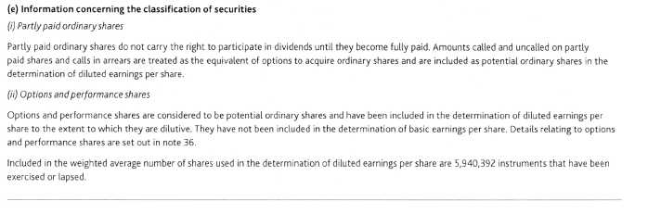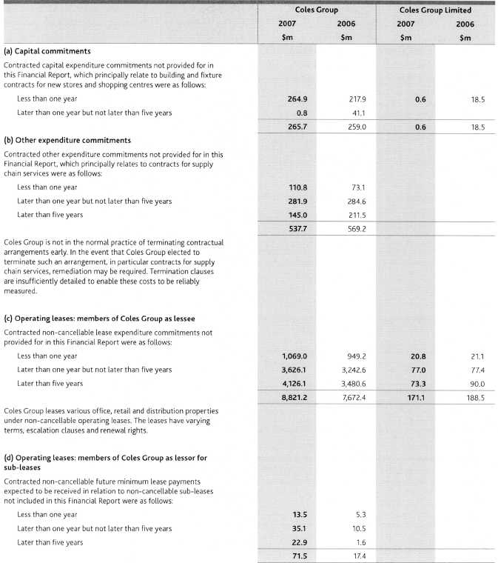
Operating leases: members of Coles Group as lessor for investment properties Refer note 16(b) for details.
Remuneration commitments
An executive's employment may be terminated at any time by providing six or 12 months payment in lieu of notice, depending on an individual's contractual terms, or payment of a redundancy in accordance with Coles Group policy. At 29 July 2007, the total potential commitment under such executive employment contracts, which is not recognised as a liability, is $35.0 million.
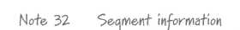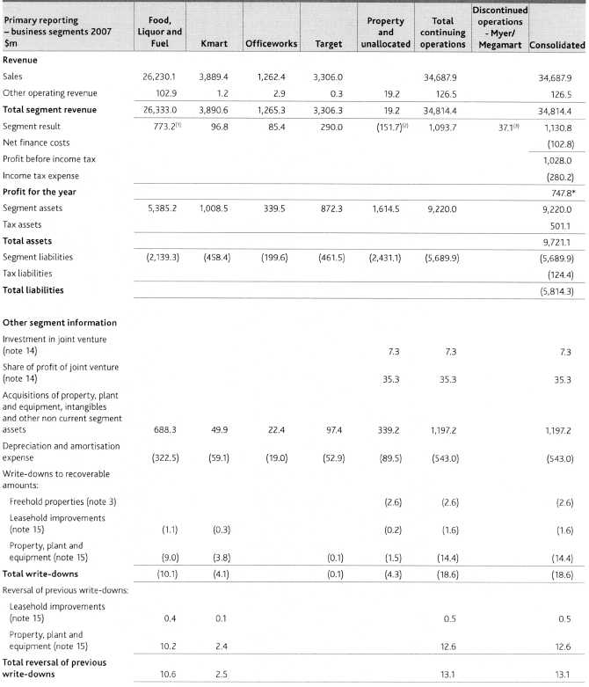
The profit for the year was $747.8 million. After adjusting for ownership review costs of $55.9 million (post-tax $44.6 million) (note 4) reported in the Property and unallocated segment, the profit for the year would have been $792.4 million. The result includes:
Write-back of fixed rental accruals of $34.5 million (post-tax $24.2 million) for renegotiated Coles Express leases.
Response advisory fees of $23.9 million (post-tax $16.7 million) and consulting and additional redundancy costs relating to business simplification of $51.5 million (post-tax $36.0 million).
(3) Profit from discontinued operations of $37.1 million (post-tax $27.7 million).
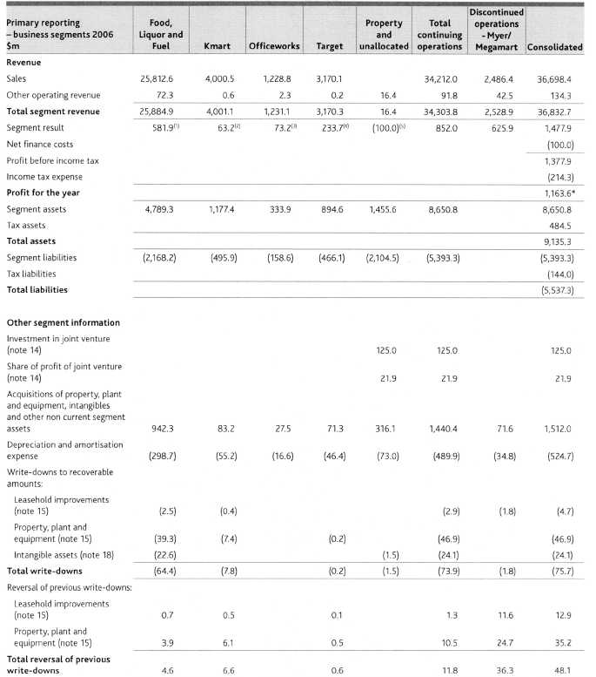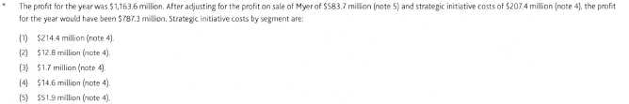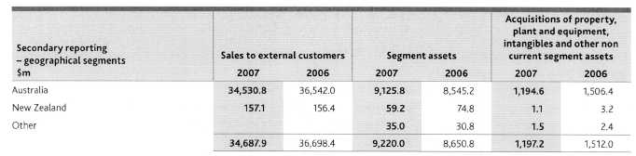
Business segments
Coles Group operates predominantly in the retail industry and comprises the following main business segments:
N Continuing operations
Food, Liquor and Fuel | Retail of grocery, liquor and fuel products
Kmart | Retail of apparel and general merchandise
Officeworks | Retail of office supplies
Target | Retail of apparel and general merchandise
Property and unallocated | Management of the Coles Group property portfolio and unallocated or corporate functions
(ii) Discontinued operations
Myer | Retail of apparel and general merchandise
Megamart | Retail of furniture and electrical goods

Geographical segments
In presenting information on the basis of geographical segments, segment revenue is based on the geographical location of customers. Segment assets are based on the geographical location of the assets.
Coles Group's segments operate geographically as follows:
Australia | The home country of the parent entity. Coles Group undertakes retail operations in all states and territories.
New Zealand | Coles Group has Kmart retail operations, supplying basically the same ranges of goods as the corresponding
 | business in Australia. These operations are predominantly based in the North Island.
Asia | Branch offices located in China.

Inter-segment transfers
Segment revenues, expenses and results include transfers between segments. Such transfers are principally priced on an arm's length basis and are eliminated on consolidation.
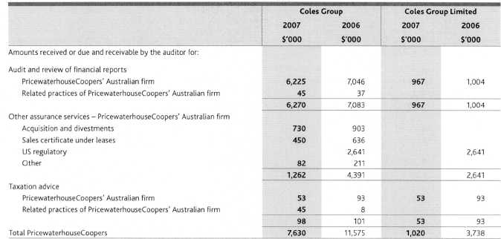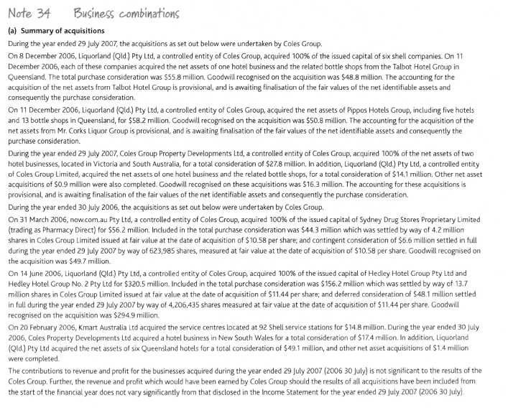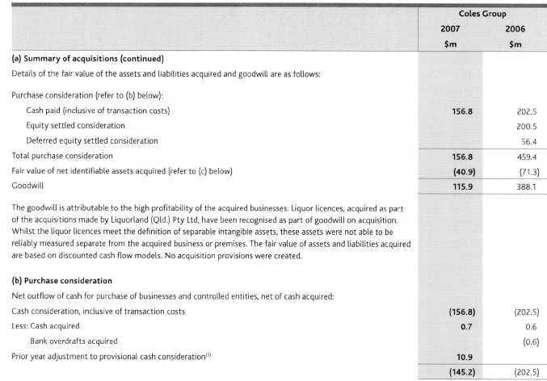
(1) | During the year ended 29 July 2007, adjustments to the provisional acquisition accounting for Sydney Drug Stores Proprietary Limited (trading as Pharmacy Direct), Hedley Hotel Group Pty Ltd and Hedley Hotel Group No. 2 Pty Ltd as reported in the 2006 Full Financial Report have been made. The key effects of these adjustments were to increase goodwill by $2.0 million, co-branded operating rights by $1.2 million, licences by $8.5 million, deferred tax liabilities by $2.2 million and to reduce purchase consideration paid (net of adjustments to cash acquired) by $10.9 million, inventories by 53.3 million and property, plant and equipment by $16.3 million.
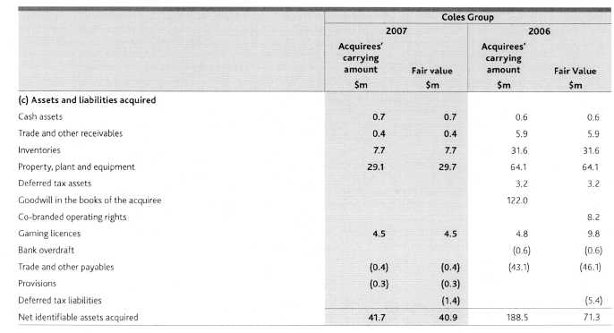
Note 35 Fartic-ularc in rotation to controlled entities
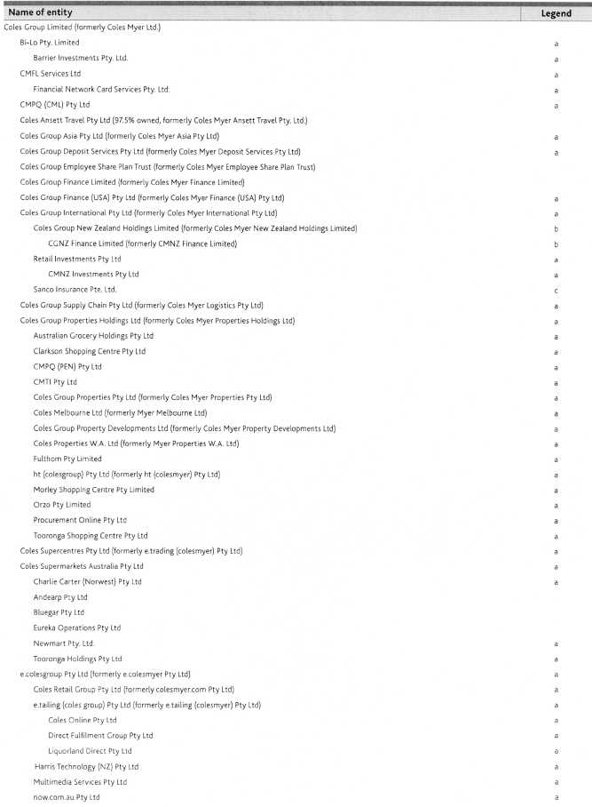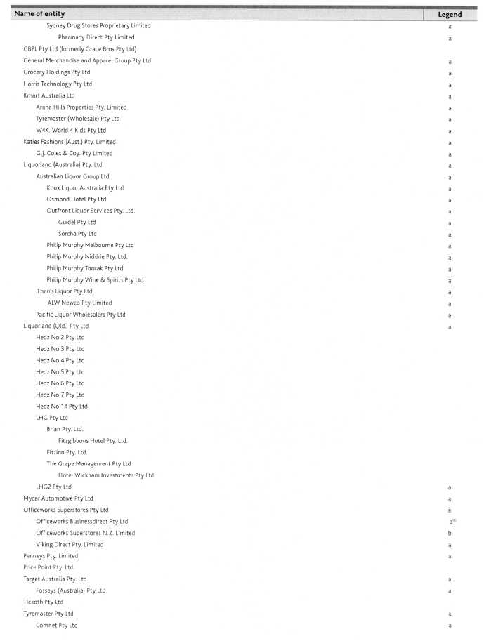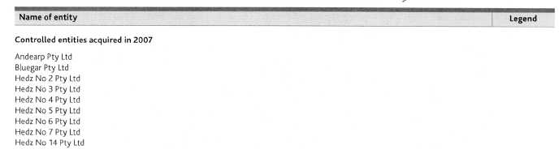
Except where shown, controlled entities are wholly owned and incorporated or established in Australia. The 2.5% of capital in Coles Ansett Travel Pty Ltd not owned by Coles Group gives rise to outside equity interests of SNIL. The balance date of all controlled entities, apart from the Coles Group Employee Share Plan Trust, was 29 July 2007. The Income Statement and Balance Sheet of the Coles Group Employee Share Plan Trust for the year ended 29 July 2007 (2006 30 July) have been included in the results of Coles Group.
Controlled entities carry on business in their countries of incorporation except Coles Group Asia Pty Ltd, which carries on business in China. Legend Deed of Cross Guarantee:
a | These companies and Coles Group Limited are party to a Deed of Cross Guarantee (the Deed) dated 28 July 2006. Under the Deed, each company guarantees the liabilities of all other companies that are party to the Deed. These companies form a Closed Group and are relieved from the requirements to prepare audited financial reports under the Corporations Act 2001 and Australian Securities and Investments Commission accounting and audit relief Class Orders.
 | (1) This company was added to the Deed by an Assumption Deed dated 27 July 2007.
b | Incorporated in New Zealand.
c | Incorporated in Singapore.
The Income Statement and Balance Sheet below represent companies, which are party to the Deed of Cross Guarantee. These companies form a Closed Group, which forms part of the Coles Group. Where necessary comparatives have been amended to appropriately reflect controlled entities included in the Closed Group. This information is provided in accordance with the requirements of Australian Securities and Investments Commission accounting and audit relief Class Orders.
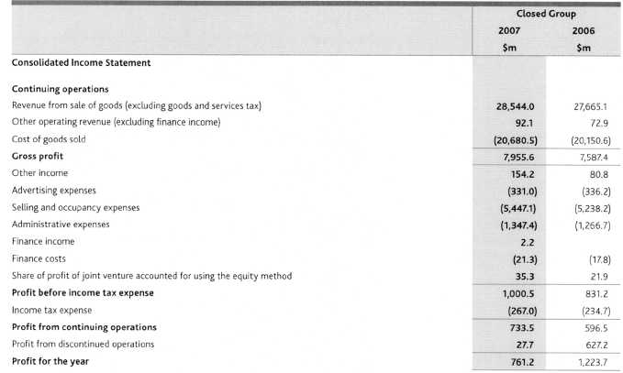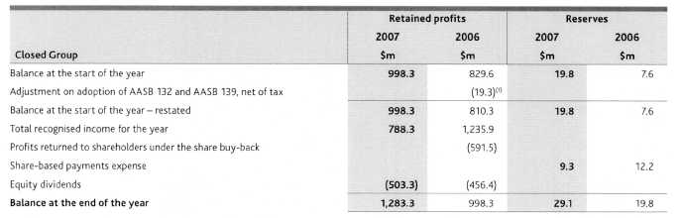
(11 As permitted, on adoption of AASB 132 Financial Instruments: Disclosure and Presentation and AASB 139 Financial Instruments: Recognition and Measurement, Coles Group elected to recognise an opening balance adjustment at 1 August 2005. Further information on adoption of these standards is available in the 2006 Full Annual Report.
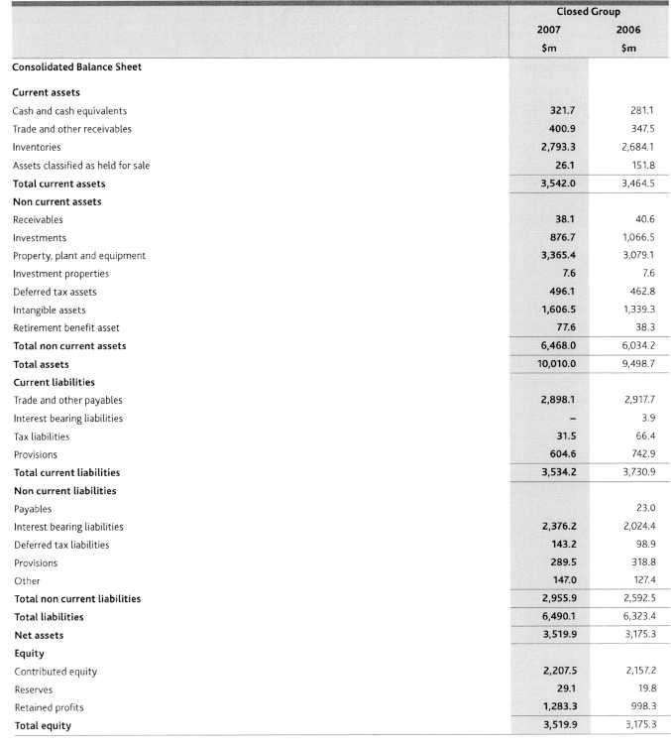
(a) Coles Group Employee Share Plan
Coles Group established a general employee share plan, the Coles Group Employee Share Plan (the Employee Share Plan), and the Coles Group Employee Share Plan Trust (the Employee Share Plan Trust). The Employee Share Plan Trust acquired Coles Group Limited fully paid ordinary shares (shares) and then invited eligible employees to purchase them. At Coles Group's discretion employees who had worked continuously for Coles Group for 12 months full-time, 12 months part-time, or 24 months casually, were eligible to purchase shares on the following bases:
Shares were purchased from the Employee Share Plan Trust at the average cost of the shares available for sale or such price as determined by the trustees of the Employee Share Plan Trust;
Employees pay for the shares by applying dividends on the shares and making voluntary payments;
No interest is charged on the outstanding purchase price;
Employees who left Coles Group within three years of acquiring shares under the Employee Share Plan forfeited their shareholding; and
A maximum of 20 years is allowed for the purchase price to be paid in full.
The number of shares offered to each employee depended on the employee's position and performance within the Cotes Group. At balance date, the following shares were on issue:
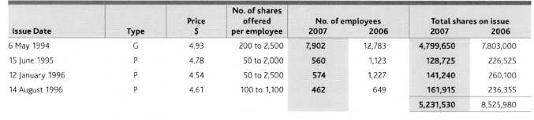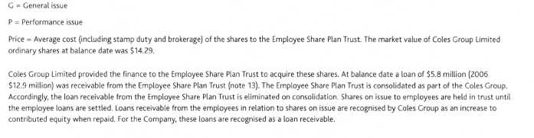
(b) Coles Group Executive Share Option Plans
Coles Group Limited established Executive Share Option Plans, under which options over unissued shares, and over issued shares held by the Employee Share Plan Trust, may be issued to executives at Coles Group Limited's discretion. Options are issued for SNIL consideration. Each option is over one share.
Options have no voting rights until exercised. The holders of options are entitled to participate in bonus share issues. Where options are over issued shares held by the Employee Share Plan Trust, consent is required from the trustees to make the necessary shares available.
Details of options granted under the Coles Group Executive Share Option Plans to 29 July 2007 are:
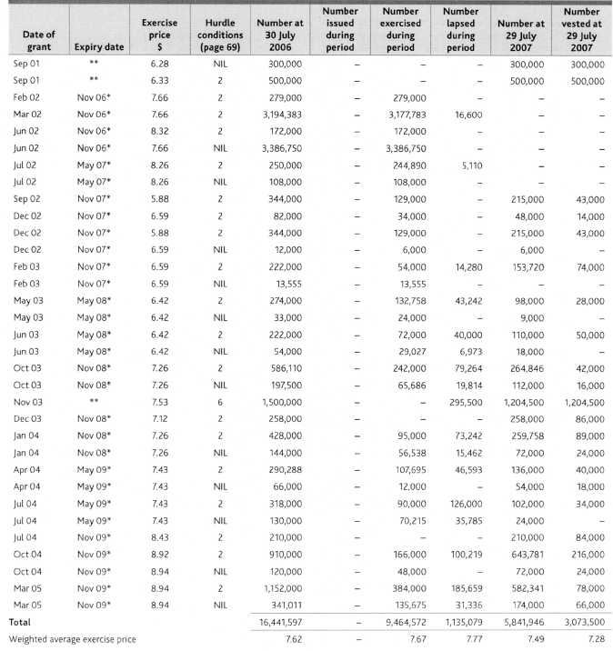
* | Expiry date is shown as the expected month only. The actual last exercise date is 60 days after the announcement of the results of Coles Group. Cessation of employment + 1 year.
Details of options granted under the Coles Group Executive Share Option Plans to 30 July 2006 are:
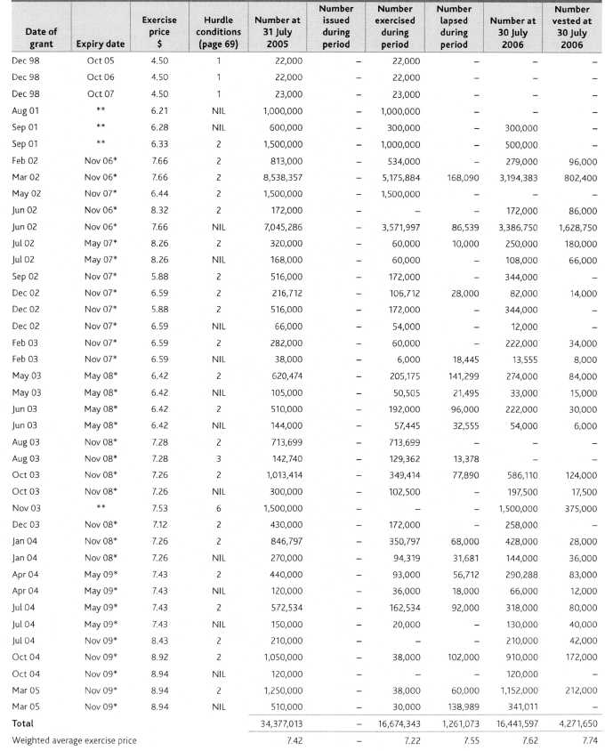
* | Expiry date is shown as the expected month only. The actual last exercise date is 60 days after the announcement of the results of Coles Group.
** | Cessation of employment + 1 year.
(c) Coles Group Senior Executive Performance Share Plan
Coles Group Limited has established a Senior Executive Performance Share Plan. A performance share is a right to acquire an ordinary share in Coles Group Limited for no consideration. Performance shares are issued for $N1L consideration. Performance shares have no voting rights until vested. The holders of performance shares are entitled to participate in bonus share issues.
Details of performance shares granted under the Senior Executive Performance Share Plan to 29 July 2007 are:
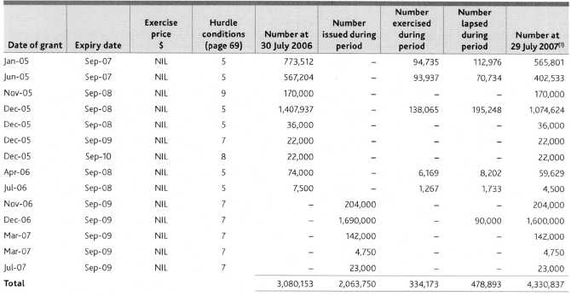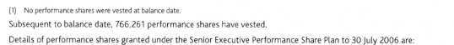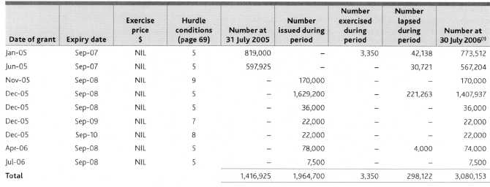
(1) No performance shares were vested at balance date.
 | Fair value of
 | shares at issue
 | date ) | 2007 | 2006
Exercise date to |  | Number | Number
(d) Options and performance shares exercised during the financial year
August 2005 | 9.74 |  | 754,936
September 2005 | 10.24 |  | 3,967,752
October 2005 | 9.93 |  | 2,979,809
November 2005 | 10.01 |  | 1,451,530
December 2005 | 10.05 |  | 451,200
January 2006 | 10.53 |  | 1,227,211
February 2006 | 10.11 |  | 162,100
March 2006 | 10.52 |  | 1,152,270
April 2006 | 10.85 |  | 1,699,134
May 2006 | 11.19 |  | 331,600
June 2006 | 11.41 |  | 1,056,875
July 2006 | 10.70 |  | 1,439,926
August 2006 | 13.34 | 862,966
September 2006 | 14.45 | 2,310,815
October 2006 | 14.02 | 3,574,856
November 2006 | 13.64 | 1,879,012
December 2006 | 13.45 | 88,277
January 2007 | 14.06 | 35,384
February 2007 | 14.92 | 118,165
March 2007 | 16.01 | 399,037
April 2007 | 17.06 | 404,365
May 2007 | 17.58 | 102,000
June 2007 | 16.60 | 11,868
July 2007 | 14.85 | 12,000
Total |  | 9,798,745 | 16,674,343

(1) Exercise dates are grouped by month, and the fair value of the shares at issue date is based on the weighted average of fair values on each issue date for that month.
Aggregate proceeds received by Coles Group Limited from employees on the exercise of options over unissued shares were $72,620,933 (2006 $120,372,463), and the fair value of those shares at issue date was $139,505,285 (2006 $174,375,296).
Subsequent to balance date, 6,000 options with a weighted average exercise price of $7.26 have been exercised and 50,193 options with a weighted average exercise price of $8.00 have lapsed.
(e) Expenses arising from share-based payments transactions
Total expenses arising from share-based payment transactions recognised during the period as part of employee benefit expense were as follows:
 | Coles Group |  | Coles Group Limited
 | 2007 | 2006 | 2007 | 2006
 | $'000 | $'000 | $'000 | $'000
Share option plan | 576 | 6,981 | 186 | 1,308
Performance share plan | 8,754 | 5,252 | 3,708 | 1,613
 | 9,330 | 12,233 | 3,894 | 2,921

The total share-based payments expense of $9.3 million (2006 $12.2 million) for the Coles Group includes SNIL (2006 $4.7 million) related to discontinued operations. Whilst the equity instruments are issued by Coles Group Limited, where the employee services are provided to other entities within the Coles Group the expenses are transferred accordingly.
Fair value of options and performance shares granted
Where options and performance shares are subject to performance hurdle conditions, these conditions include total shareholder return (TSR) and earnings per share growth (EPSG) metrics. Where the vesting of options is subject to performance hurdles, in general, either the TSR or EPSG hurdle must be satisfied. For performance shares, 50% of the shares are subject to TSR and 50% are subject to PSG.
The fair value of options has been determined using the Black-Scholes pricing model. Where options are subject to performance conditions, a 50% probability has been applied to the Black-Scholes valuation. The fair value of performance shares has been determined using the Monte-Carlo pricing model, which incorporates market based performance conditions such as TSR. Details in relation to the fair value of performance shares and options granted, and the assumptions that have been included in the valuations are included below:
 | Weighted average
 | 2007 | 2006
Fair value of performance shares subject to TSR ($) | 7.82 | 5.22
Fair value of performance shares subject to EPSG ($) | 12.33 | 9.20
Risk free interest rate (%) | 5.8 | 5.3
Expected volatility (%) | 20.0 | 18.0
Expected dividend yield (%) | 3.7 | 3.3
Expected life of equity instrument (months) | 32 | 33

The expected volatility is based on Coles Group Limited's historical share price volatility. The risk free interest rate is the yield at grant date on Australian Government Securities of appropriate term. The dividend yield is based on the recent dividend history of Coles Group Limited.
Modifications to the terms and conditions of options and performance shares
At inception of the Senior Executive Performance Share Plan (SEPSP), the EPSG hurdle was set such that the compound annual growth rate must equal or exceed 12.5% for a three year period. During the year ended 30 July 2006 this hurdle was modified such that the compound annual growth rate had to equal or exceed 8%. The pre-existing hurdle remained applicable for the purpose of testing EPSG in the first and second test years in relation to performance shares issued in the 2005 financial year and the first test year in relation to performance shares issued in the 2006 financial year.
Subsequent to the end of the 2006 financial year, the Company announced its new growth strategy and on 21 September 2006 provided specific earnings guidance to the market for the 2007 and 2008 financial years. This necessitated further revision of the EPSG vesting schedule of the SEPSP to reflect this guidance which was announced in November 2006. The EPSG hurdles, which apply to 50% of the LTIs, were amended in consultation with Mercers, shareholders and governance bodies. The remaining 50% of the LTIs relating to TSR remained unchanged.
Further, in reporting its full-year financial results for the financial year ended 29 July 2007 on 19 September 2007, the Company said that Coles Group Directors had concluded that it would be inappropriate to maintain the revised guidance given to the market on 23 February 2007 given that the Company would not remain in its current structure under any scenario. If the scheme of arrangement is approved by shareholders, ownership and management of the Company will pass to Wesfarmers Limited. If the scheme is unsuccessful, Coles Group Directors will consider a number of alternative strategies and restructuring options for the Company. In neither event will the previous guidance be maintained and consequently, if required, the Board will set new EPSG hurdles for LTI vesting for the 2008 and subsequent financial years. In the interim, however, Coles Group is continuing to operate under plans consistent with that guidance.
The effect of revisions to the EPSG hurdles and the Company's announcement on 19 September 2007 was as follows:
EPSG hurdle for all performance shares issued during the 2005 and 2006 financial years, other than CEO Mr Fletcher's issue during the 2006 financial year, were re-modified to again be assessed in accordance with the pre-existing vesting schedule levels approved by shareholders in 2004, such that the compound annual growth rate must equal or exceed 12.5% for a three year period.
EPSG hurdle for the performance shares issued during the year ended 2006 financial year to Mr Fletcher were re-modified to be assessed based on achieving an EPSG of $0.894 in the 2008 financial year, which is an all or nothing test for those shares.
EPSG hurdle for all performance shares issued during the 2007 financial year were modified such that an annual growth rate of at least 8% for a three year period must be achieved based on an EPSG target growth for the 2008 financial year of $0.894.
EPSG hurdle for all performance shares to be issued in the 2008 and subsequent financial years will be reassessed if required following the completion of the Ownership Review. In the absence of any revision, however, EPSG hurdle for all performance shares to be issued during the 2008 financial year and beyond were modified such that a compound annual growth rate of at least 8% for a three year period must be achieved based on an EPSG target growth for the financial year ended 27 July 2008 of $0.894.
These changes had no impact on the fair value of performance shares granted.
As an outcome of the disposal of the Myer business during the year ended 30 July 2006, options held by the Managing Director of Myer were modified. At the discretion of the Directors, the TSR and EPSG hurdles were waived and one million options were allowed to vest as part of a termination entitlement. The removal of these hurdles resulted in an additional non-cash charge of $2.8 million, which was included in the gain on sale of the Myer business.
(iii) Hurdle conditions
The performance hurdle conditions attaching to each tranche of options and performance shares are as follows:
1 | Net profit for the Coles Group must exceed specified targets set for any one of the financial years ended July 2000, 2001 and 2002; or
 | TSR over any one of the periods 16 October 1998 to 15 October 2000, 15 October 2001 or 15 October 2002 must equal or exceed the median return over the same period of a set list of top 100 industrial companies listed on the Australian Securities Exchange (ASX).
 | The profit hurdle was met for the financial year ended July 2000 and thus all options are exercisable.
2 | TSR must equal or exceed the median return over the relevant period of a list of top 50 industrial companies; or EPSG expressed as a compound annual growth rate must equal or exceed 12.5% over the relevant period.
3 | TSR must equal or exceed the median return over the relevant period of a list of top 50 industrial companies; or EPSG expressed as a compound annual growth rate must equal or exceed 15% over the relevant period.
4 | TSR must exceed the median return over the relevant period of a list of top 50 industrial companies; or EPSG expressed as a compound annual growth rate must equal or exceed 12.5% over the relevant period.
 | For hurdles 2, 3 and 4, the options will progressively vest according to the level of TSR or EPSG achieved each year. To the extent that TSR or EPSG is not achieved, the non-vested options will be carried forward to be retested in following years.
5 | 50% of the performance shares issued to individuals are subject to TSR. TSR for the three financial years from the year of grant must exceed the median return of a list of the top 50 industrial companies.
 | 50% of the performance shares are subject to EPSG. EPSG expressed as a compound annual growth rate must equal or exceed 12.5% for the three financial years from the year of grant, when compared with the earnings per share achieved for the year preceding the test period.
6 | When originally granted, these options were subject to the performance hurdle conditions described in footnote 4. During 2005, these hurdles were changed to those described in 5, however, the test period is the three years ending 30 July 2006.
7 | 50% of the performance shares are subject to TSR. TSR for the three financial years ending 26 July 2009 must exceed the median return of a list of the top 50 industrial companies.
 | 50% of the performance shares are subject to EPSG. EPSG is assessed on an annual growth rate of at least 8% for the 2009 financial year based on an EPSG target growth for the 2008 financial year of $0.894.
8 | TSR conditions are as per footnote 7, with the exception of the test period which is for the three years ending 25 July 2010.
 | 50% of the performance shares are subject to EPSG. EPSG is assessed on a compound annual growth rate of at least 8% based on the EPSG target growth for the 2008 financial year of not less than $0.894.
9 | 50% of the performance shares are subject to TSR. TSR for the three financial years from the year of grant must exceed the median return of a list of the top 50 industrial companies.
 | 50% of the performance shares are subject to EPSG. EPSG is assessed on achieving an EPSG of $0.894, which is an all or nothing test for these shares for the financial year ending 27 July 2008.
The Directors have discretion to disregard any changes in net profit, TSR or EPSG due to an anomaly, distortion or other event which is not directly related to the financial performance of any company or entity, or which would lead to an incorrect comparison.
Directors
The following persons were Directors of Coles Group Limited during the financial year:
Chairman — Non-executive
Rick Allert
Executive Director
John Fletcher
Non-executive Directors
Patty Akopiantz Keith Barton Bill Gurry Tony Hodgson Belinda Hutchinson Sandra McPhee
Martyn Myer (retired 20 November 2006)
Michael Wemms
Other key management personnel
The following persons also had responsibility for planning, directing and controlling the activities of the Coles Group, directly or indirectly during the financial year ended 29 July 2007 and the financial year ended 30 July 2006:
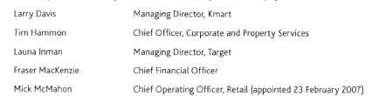
Former key management personnel
(c) Key management personnel remuneration
Coles Group as permitted has transferred the detailed remuneration disclosures to pages 35 to 50 of the Company's separate Annual Report under the heading 'Remuneration Report'.
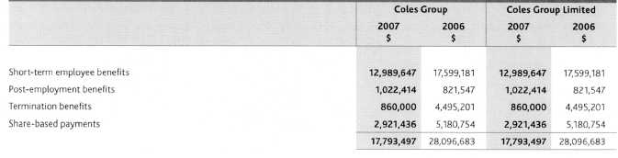
(d) Equity instrument disclosures relating to key management personnel
(i) Options and performance shares provided as remuneration
Details of options and performance shares provided to key management personnel of Coles Group are set out below. Further information on options and performance shares is set out in note 36.
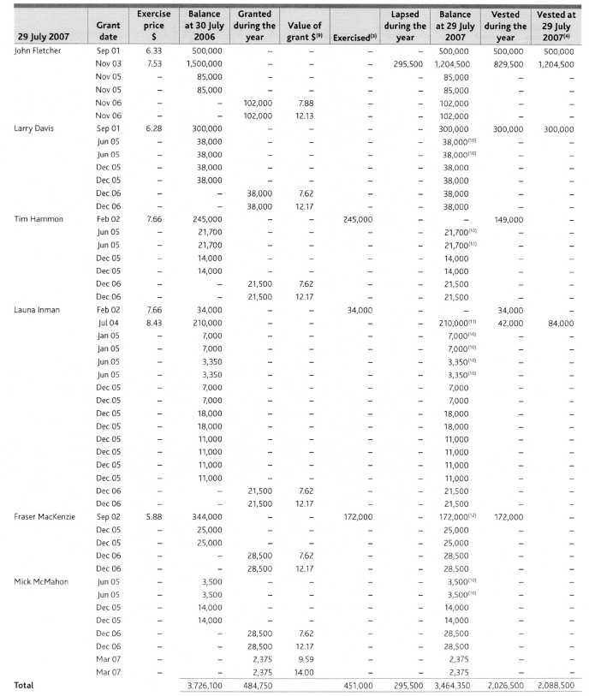
Refer footnotes on page 72.
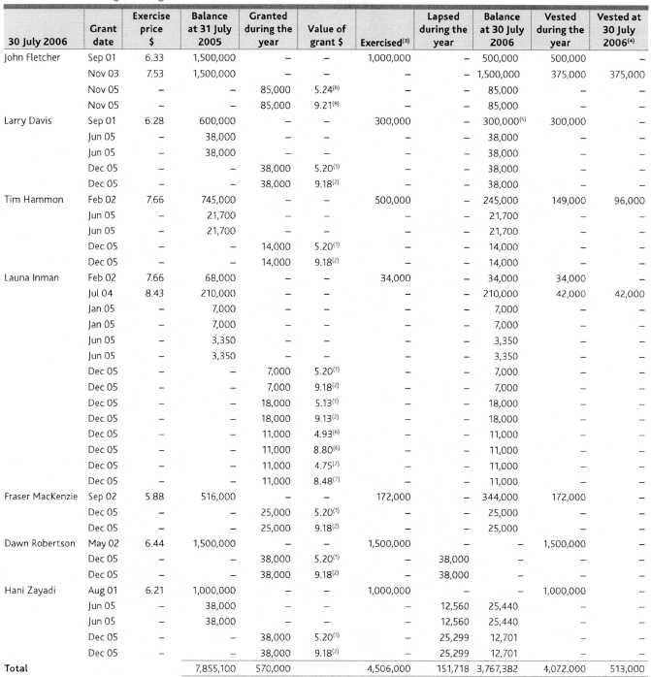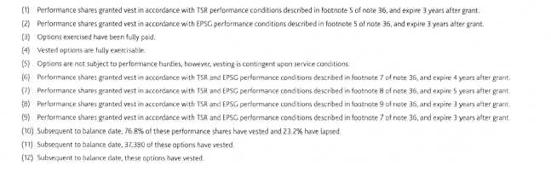
(ii) Key management personnel share holdings
The numbers of ordinary shares in Coles Group Limited held during the year by key management personnel of Coles Group, including their related parties, are set out below.
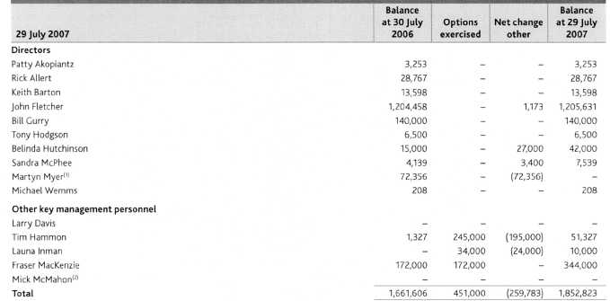
Mr Myer retired on 20 November 2006. At this time, Mr Myer held 1,537 ordinary shares in Coles Group Limited.
Mr McMahon was appointed on 23 February 2007. At this time, Mr McMahon held no ordinary shares in Coles Group Limited.
There were no shares granted to key management personnel during the year other than those described in note 37(d)(i).
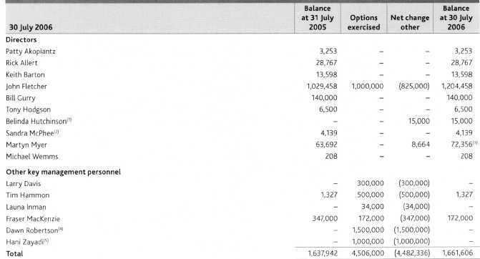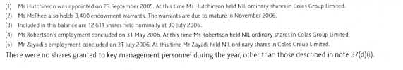
Loans to key management personnel
There were no loans made to key management personnel, including their related parties, during 2007 or 2006.
Other transactions with key management personnel
(1) Directors
Coles Group has a comprehensive Statement of Corporate Governance Principles. This Statement incorporates detailed policies in respect to Director-related party transactions. The major elements of the policy are:
Directors must advise the Company of all Director-related entities.
Where there are total transactions between Coles Group and a Director's related entities exceeding $1.0 million in any month, then the Director must supply Coles Group Limited with details of these transactions.
The following proposed contracts between Coles Group and Director-related entities must be approved by the Audit and Risk Committee prior to committing the Coles Group:
Contracts for the supply of goods and/or services which extend beyond one year, or where the total value of goods and/or services supplied under the contract will exceed $5.0 million in any one year;
All agreements to lease and/or leases of property; and
All agreements for the purchase or sale of freehold and/or Leasehold property except where the sale is by genuine public auction.
All transactions are to be subject to review by internal audit with periodic reports to the Audit and Risk Committee.
All transactions were on terms and conditions that were no more favourable to the Director-related entity than those available, or which might reasonably be expected to be available, on similar transactions to non-Director-related entities and were on an arm's length basis.
Retirement agreement
On 27 March 2003, Coles Group announced that Non-executive Directors appointed after that date will not receive retirement benefits. Coles Group Limited has an agreement with those Non-executive Directors appointed prior to 27 March 2003 for the provision of an allowance to be paid to each Director on his or her retirement or death.
Nature of terms and conditions: The agreement is in accordance with the provisions of the Constitution and the approval given at the Annual General Meeting held on 21 November 1989. The approval provides for the payment of a retirement allowance equal to the aggregate of remuneration received by the Director over the last three years of service or part thereof, plus 5% of that amount for each year of service in excess of three years but not exceeding a total of 15 years. Any benefit paid on retirement, termination or death is reduced by the amount of any superannuation benefit received. From 17 November 2005 (the date of Coles Group Limited's 2005 AGM), the Directors appointed prior to 27 March 2003 have agreed that their retirement benefits would be frozen.
Mr M.K. Myer
Coles Group had transactions with Director-related entities of Mr M.K. Myer. Mr M.K. Myer has no financial interest in these entities.
The type of transaction between the Director-related entities and Coles Group up to the date that Mr Myer ceased to be a Director was: Leasing property by Armidale No 2 Property Syndicate to the Coles Group in the normal day-to-day conduct of its business $302,133 (2006 $906,400) net of recoverable expenses. Leasing property by Tram Road Property Holdings Pty Ltd to the Coles Group in the normal day-to-day conduct of its business $120,750 (2006 $357,615) net of recoverable expenses.
Nature of terms and conditions: Rents based on market rates, paid net monthly.
Included in the above are amounts payable to the Director-related entity by Coles Group (current) at balance date of SNIL (2006 $NIL).
Mr A.G. Hodgson
Coles Group had transactions with a Director-related entity of Mr A.G. Hodgson. Mr A.G. Hodgson has no financial interest in this entity.
The type of transaction between the Director-related entity and Coles Group was: Goods purchased for resale by the Coles Group from Woolardene Partnership in the normal day-to-day conduct of its business $N1L (2006 $16,515).
Nature of terms and conditions: Payment subject to normal commercial arrangements.
Included in the above are amounts payable to the Director-related entity by Coles Group (current) at balance date of $NIL (2006 $NIL).
Mr J.M. Wemms
Coles Group had transactions with Mr J.M. Wemms, a Director of the Coles Group.
The type of transaction between Mr J.M. Wemms and Coles Group was: Consulting services provided by Mr J.M. Wemms to Coles Group Limited and the Coles Group $126,000 (2006 $60,000). The consulting services were not provided in his capacity as a Director.
Nature of terms and conditions: Payment subject to normal commercial arrangements.
Included in the above are amounts payable to the Director by Coles Group Limited and Coles Group (current) at balance date of $126,000 (2006 $60,000).
Coles Group has not had transactions with Director-related entities other than those specifically disclosed above.
Other directorships
Some Directors of Coles Group Limited are also Directors of public companies, which have transactions with Coles Group. The relevant Directors do not believe they have the capacity to control or significantly influence the financial or operating policies of those companies. The companies are therefore not considered to be Director-related entities for the purpose of the disclosure requirements of AASB 124 Related Party Disclosures.
Indemnity of officers
Article 70 of Coles Group Limited's Constitution obliges Coles Group Limited to indemnify, to the full extent the law permits, each person to whom the article applies for all losses and liabilities incurred by them as an officer of Coles Group Limited or of a related body corporate. This expressly covers costs and expenses in defending proceedings. The article applies to each person who is or has been a Director or Secretary and to any officer or former officer of Coles Group Limited or related body corporate as the Directors decide in each case. The article does not limit the power of Coles Group Limited to grant indemnities on different terms (subject to the limit imposed by law) and does not apply to a liability incurred before 15 April 1994. The article does not confer rights on a person who ceased to be a Director or Secretary before 20 November 1997.
Coles Group Limited has also entered into a Good Faith Protection and Access Deed (the Protection and Access Deed) with its Directors following shareholder approval to do so at the Annual General Meeting held on 18 November 1999. On 21 October 2003, Coles Group Limited entered into a Protection and Access Deed with Messrs Barton, Hodgson and Wemms and Ms McPhee. Additionally, on 21 October 2003, Coles Group Limited entered into a supplemental deed with each of Messrs Allert, Charlton (retired 26 November 2003), Fletcher, Liebler (retired 18 November 2004), Myer (retired 20 November 2006) and Gurry and Ms Akopiantz which contained a number of supplemental provisions to update the Protection and Access Deed for developments in the law and to ensure consistency with the form of the Protection and Access Deed entered into with Directors appointed during the 2003 year. Coles Group Limited entered into a further supplemental Protection and Access Deed with Ms Hutchinson on 30 April 2007. The deeds provide for indemnification of the Directors to the maximum extent permitted under law. They do not indemnify for any liability involving a lack of good faith.
No Director or officer of Coles Group Limited has received the benefit of an indemnity from the Company during or since the end of the year.
Coles Group Limited maintains a Directors' and Officers' insurance policy. Due to confidentiality obligations and undertakings of the policy, no further details in respect of the premium or policy can be disclosed.
(ii) Other key management personnel
There were no transactions between Coles Group Limited and any related parties of other key management personnel.
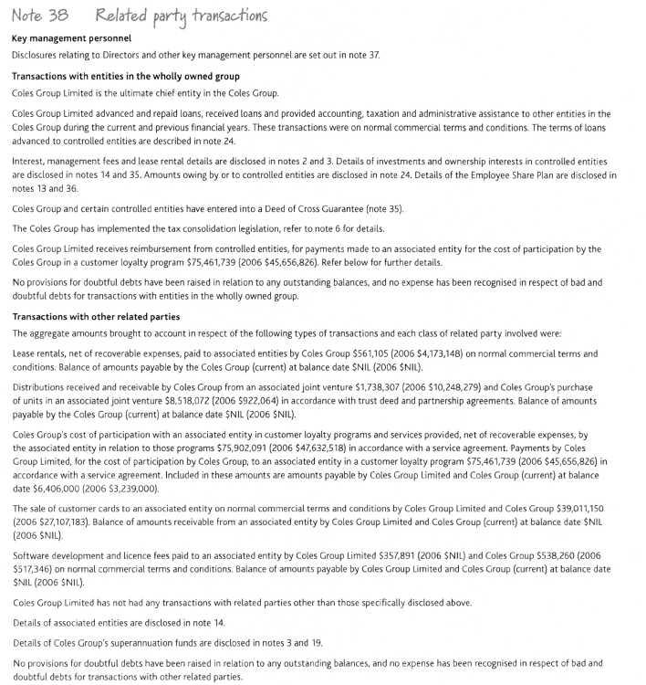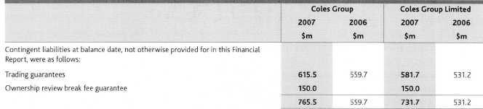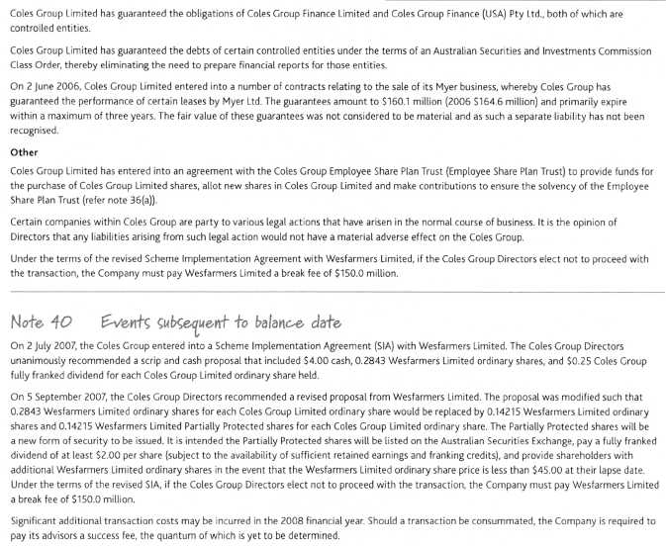

Directors' Declaration
The Directors declare that
(a) the financial statements and notes set out on pages 2 to 77 are in accordance with the Corporations Act 2001 and:
comply with the Accounting Standards, Corporations Regulations 2001 and other mandatory professional reporting requirements; and
give a true and fair view of Coles Group Limited and the Coles Group's financial position as at 29 July 2007 and of their performance, as represented by the results of their operations and their cash flows, for the 52 weeks ended on that date.
(b) in the opinion of the Directors:
the financial statements and notes are in accordance with the Corporations Act 2001; and
there are reasonable grounds to believe that Cotes Group Limited will be able to pay its debts as and when they become due and payable; and
the audited remuneration disclosures in the Directors' Report complies with AASB 124 Related Party Disclosures and the Corporations Regulations 2001; and
the members of the Closed Group identified in note 35 will be able to meet any obligations or Liabilities to which they are, or may become, subject by virtue of the Deed of Cross Guarantee.
(c) the Chief Executive Officer and the Chief Financial Officer have given declarations as required by section 295A of the Corporations Act 2001.
This declaration is made in accordance with a resolution of the Directors.
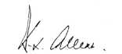
Rick Allert Chairman
Melbourne 19 September 2007
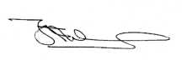
John Fletcher
Chief Executive Officer and Managing Director

Independent Auditor's Report
Report on the financial report and the AASB 124 Remuneration disclosures contained in the directors' report
We have audited the accompanying financial report of Coles Group Limited (the company), which comprises the balance sheet as at 29 July 2007, and the income statement, statement of recognised income and expenses and cash flow statement for the 52 weeks ended on that date, a summary of significant accounting policies, other explanatory notes and the directors' declaration for both Coles Group Limited and the Coles Group Limited Group (the consolidated entity). The consolidated entity comprises the company and the entities it controlled at the year end or from time to time during the financial year.
We have also audited the remuneration disclosures contained in the directors' report. As permitted by the Corporations Regulations 2001, the company has disclosed information about the remuneration of directors and executives (remuneration disclosures), required by Accounting Standard AASB 124 Related Party Disclosures, under the heading "remuneration report" in the directors' report and not in the financial report. The remuneration report contains information also, for which an auditors' opinion is not required and has not been formed. These disclosures have been identified as such.
Directors' responsibility for the financial report and the AASB 124 Remuneration disclosures contained in the directors' report
The directors of the company are responsible for the preparation and fair presentation of the financial report in accordance with Australian Accounting Standards (including the Australian Accounting Interpretations) and the Corporations Act 2001. This responsibility includes establishing and maintaining internal control relevant to the preparation and fair presentation of the financial report that is free from material misstatement, whether due to fraud or error; selecting and applying appropriate accounting policies; and making accounting estimates that are reasonable in the circumstances. In Note 1, the directors also state, in accordance with Accounting Standard AASB 101 Presentation of Financial Statements, that compliance with the Australian equivalents to International Financial Reporting Standards ensures that the financial report, comprising the financial statements and notes, complies with International Financial Reporting Standards.
The directors of the company are also responsible for the remuneration disclosures contained in the directors' report.
Auditor's responsibility
Our responsibility is to express an opinion on the financial report based on our audit. We conducted our audit in accordance with Australian Auditing Standards. These Auditing Standards require that we comply with relevant ethical requirements relating to audit engagements and plan and perform the audit to obtain reasonable assurance whether the financial report is free from material misstatement. Our responsibility is to also express an opinion on the remuneration disclosures contained in the directors' report based on our audit.
An audit involves performing procedures to obtain audit evidence about the amounts and disclosures in the financial report and the remuneration disclosures contained in the directors' report. The procedures selected depend on the auditor's judgement, including the assessment of the risks of material misstatement of the financial report and the remuneration disclosures contained in the directors' report, whether due to fraud or
error. In making those risk assessments, the auditor considers internal control relevant to the entity's preparation and fair presentation of the financial report and the remuneration disclosures contained in the directors' report in order to design audit procedures that are appropriate in the circumstances, but not for the purpose of expressing an opinion on the effectiveness of the entity's internal control. An audit also includes evaluating the appropriateness of accounting policies used and the reasonableness of accounting estimates made by the directors, as well as evaluating the overall presentation of the financial report and the remuneration disclosures contained in the directors' report.
Our procedures include reading the other information in the Annual Report to determine whether it contains any material inconsistencies with the financial report.
For further explanation of an audit, visit our website http://www.pwc.com/au/financialstatementaudit.
Our audit did not involve an analysis of the prudence of business decisions made by directors or management.
We believe that the audit evidence we have obtained is sufficient and appropriate to provide a basis for our audit opinions.
Independence
In conducting our audit, we have complied with the independence requirements of the Corporations Act 2001.
Auditor's opinion on the financial report
In our opinion:
_{(a}) the financial report of Coles Group Limited is in accordance with the Corporations Act 2001, including:
giving a true and fair view of the company's and consolidated entity's financial position as at 29 July 2007 and of their performance for the 52 weeks ended on that date; and
complying with Australian Accounting Standards (including the Australian Accounting Interpretations) and the Corporations Regulations 2001 and
(b) the consolidated financial statements and notes also comply with International Financial Reporting Standards as disclosed in Note 1.
Auditor's opinion on the AASB 724 Remuneration disclosures contained in the directors' report
In our opinion, the remuneration disclosures contained in the directors' report and identified as being subject to audit, comply with Accounting Standard AASB 124.
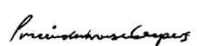
Pr cewaterhouseCoopers
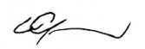
Con Grapsas Partner
Melbourne 19 September 2007

Corporate Directory
_{Registered Office}
_{800 Toorak Road}
Tooronga Vic 3146
_{Telephone: (03) 9829 3111}
Facsimile: (03) 9829 6787
Email info@colesgroup.com.au
WEBSITE
www.colesgroup.com.au
Corporate and Retail Support
800 Toorak Road
Tooronga Vic 3146
Telephone: (03) 9829 3111
_{Facsimile: (03) 9829 6787}
Food & Liquor
Coles Supermarkets
800 Toorak Road
Tooronga Vic 3146
Telephone: (03) 9829 5111
Facsimile: (03) 9829 6787
Bi-Lo
800 Toorak Road
Tooronga Vic 3146
Telephone: (03) 9829 5111
Facsimile: (03) 9829 6787
Liquor Group
800 Toorak Road
Tooronga Vic 3146
Telephone: (03) 9829 3111
Facsimile: (03) 9829 6787
Coles Express
800 Toorak Road
Tooronga Vic 3146
Telephone: (03) 9829 3111
Facsimile: (03) 9829 6787
Target
12-14 Thompson Road
North Geelong Vic 3215
Telephone: (03) 5246 2000
Facsimile: (03) 5246 2257
Kmart
800 Toorak Road
Tooronga Vic 3146
Telephone: (03) 9829 4111
Facsimile: (03) 9829 6787
Officeworks
Virginia Park 1 South Drive
236-262 East Boundary Road
Bentleigh East Vic 3165
Telephone: (03) 8575 1900
Facsimile: (03) 8575 1999

Company Directors

