CML, Coleys Myer Ltd.


Highlights
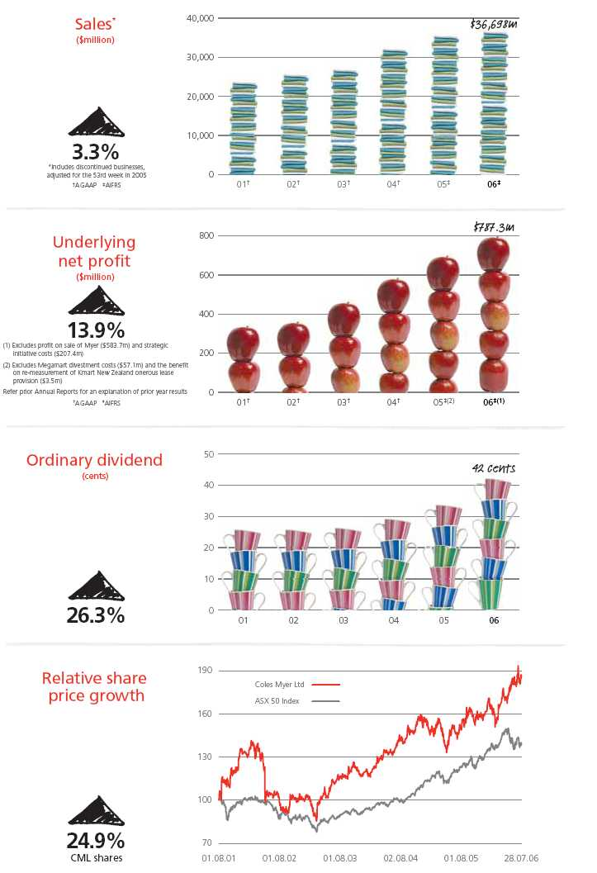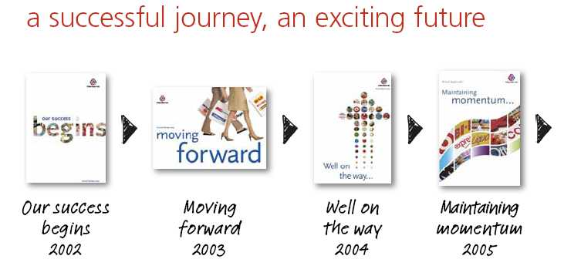
We started our five-year turnaround strategy in 2001 to substantially improve shareholder value by:
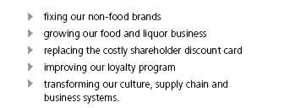
Since then, underlying net profit after tax has increased from $333 million to $787 million. Underlying earnings per share have risen from 26 cents to 63 cents, and ordinary dividends per share are up from 25.5 cents to 42 cents over the five years.
The performance of our non-food brands has improved dramatically, with underlying earnings before interest and tax up four-fold, from $101 million to $462 million.
Our largest business, food and liquor, has delivered consistent, solid growth, with underlying earnings before interest and tax rising by 55% to $786 million since 2001 and return on investment now over 34%.
Our fuel and convenience business, Coles Express, has been a successful alliance with Shell, supporting a discount fuel offer as a key element of our customer rewards program.
Replacing the costly shareholder discount scheme was an important step in fixing the financial health of the business and providing all of our customers with rewards.
We have worked hard at building one team, with one performance-based culture in which we reward leaders with incentives based on Group outcomes. We have developed common Groupwide values and behaviours – integrity, respect and recognition, passion for excellence and working together – developed by over 2,000 team members.
We have reduced the number of workplace injuries through a Groupwide safety program.
We have reduced duplication and costs as the platform for further integration and simplification of the Group.
Our business transformation program commenced in 2003 and is improving the efficiency of our business for customers, suppliers and shareholders.
We are improving product availability for customers, making life simpler for our store teams and reducing costs.
So far we have made great progress in developing or implementing:
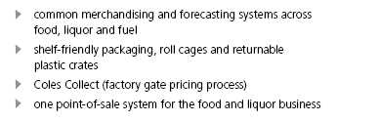
In the coming year we will be opening five distribution centres and piloting our automatic stock replenishment system.
The five-year transformation program – incorporating procurement, safety, IT and supply chain initiatives – is expected to deliver benefits of $425 million in financial year 2008.
Following the sale of Myer, we have the opportunity to rebrand our business and go forward as a new and simpler business. Subject to the approval of shareholders at our November Annual General Meeting, we will rename the Company ‘Coles Group Limited’.
Over the next few years, we will create a new integrated ‘everyday needs’ business, selling everything our customers need every day under the trusted “Coles” brand. We will invest to further grow our other successful retail businesses, Target and Officeworks.
We have adopted an integrated model for our everyday needs business – a model which has proven extremely successful internationally and which we are uniquely positioned to deliver in Australia. Coles, BI-LO, Liquor, Coles Express and Kmart will be progressively integrated with single buying, marketing, operations and support structures.
Our growth strategy will increase the return from our existing store network and create new opportunities to grow our business ahead of the market through reinvigorated stores, the creation of SuperCentres and a differentiated product offer.
The model we are creating will enable us to simplify our business processes and realise very significant cost savings to reward our shareholders while reinvesting in our competitive customer offer.
Thank you to our team members for being the heroes in our turnaround journey. Take a bow as we move towards an exciting future.
At the heart of our new business strategy is our goal to be customers’ first choice for their everyday shopping needs.
We can now gather information from all our stores at point-of-sale so that we can tailor our offer to the specific needs of customers and make sure we have the right products on the shelves every day.
We are also accelerating our store renewal program and increasing customer service levels in our supermarkets to provide a better shopping experience for our customers.
The value and convenience we offer will be enhanced by the further growth of our popular housebrand product range in supermarkets and expansion of direct sourcing of general merchandise across our businesses.
Our new customer initiatives will include the development of SuperCentres – destination shopping locations offering food, general merchandise and apparel under one roof.
At the other end of the store format scale, we are piloting new convenience stores, designed for time-poor customers looking for a top-up shop.
By understanding what customers want to buy, and how they want to shop, we can provide better service, convenience, products and rewards, through a choice of formats which deliver a consistent customer experience.
Chairman and CEO Q&As
Q. What have been the highlights of the year from a shareholder perspective?
Chairman, Rick Allert: There have been a number. In 2006, we achieved the aspirational earnings goal we set at the beginning of our five-year strategy to turn around the business and build sustainable returns for shareholders.
Since 2001, underlying earnings per share have more than doubled and the share price has increased by 92%. We have returned more than $1.5 billion to shareholders through share buy-backs, and ordinary dividends per share have gone up by 65%.
With the turnaround strategy completed, we have announced our next strategic direction that will create significant value for our shareholders through the creation of an integrated everyday needs business and the further growth of Target and Officeworks.
In this context, the Board also took the strategic decision to divest Myer.
Chief Executive Officer, John Fletcher: It is easy to forget how far the business has come in the past five years. Net profit after tax and return on investment have both more than doubled since 2001. Underlying earnings in the non-food brands have increased from $101 million to $462 million over the same period. And, in the food and liquor business, underlying earnings have grown by 55%.
Q. Why did you divest Myer?
RA: Myer is a great business as well as a great Australian icon. In 2005, the Board began a review of ownership options for Myer in the context of the development of the Group’s next strategic direction. We wanted to see if shareholder interests would be better served by the retention or divestment of Myer. The Board’s decision to sell was based on strategic fit and the opportunity to simplify the Group. We believed that divestment of Myer would enable the Group to grow faster, with sharpened management and financial focus on the core components of the business.
The sale price of $1.4 billion was a great outcome for our shareholders.
JF: This was the right decision for both businesses. We wish Myer well and we thank Dawn Robertson and the Myer management team for doing such a good job in steering the brand successfully through the ownership review and sale process.
Q. How has the food and liquor business performed?
JF: This was the toughest year of the turnaround journey for food and liquor as we reached the peak of implementing projects to transform the way we buy and transport product from suppliers to store shelves. But we have reversed the disappointing sales trend experienced earlier in the year by increasing service at checkouts and enhancing promotional offers.
RA: The food and liquor business is the engine room of the Group, with significant opportunities for further growth. We are continuing to invest in new and refurbished supermarkets and liquor outlets, as well as developing new product initiatives. In the past year, customers have responded very positively to our new housebrand strategy in supermarkets and to the roll out of the 1st Choice Liquor Superstore offer.
Q. How have you prepared the business for its next phase of growth?
JF: The transition from turnaround to growth is built on the foundations of our transformation program, which includes developing world class IT and supply chain systems. We will gain tools like common merchandising and forecasting systems, automated stock replenishment to make sure we always have the products our customers want to buy, when they want to buy them, and a new purpose-built distribution centre network.
The transformation program aims to improve product availability for customers, simplify processes for our store teams and suppliers and reduce costs. Transformation is giving us the tools and processes we need to bring our future strategy to life.
RA: A number of significant steps have already been taken to simplify the business. Management layers and duplication have already been removed from our key supermarkets business to make decision-making faster and bring managers closer to the stores.
Q. What will your new strategic direction bring for shareholders and customers?
RA: In developing our new strategic direction, we have looked at the world’s best retailers in terms not only of what they produce for their customers but also for their shareholders. We believe we have a strategy that will generate superior returns for shareholders, through the creation of a new business that will be the first choice for Australians’ everyday shopping needs, and the continuing growth of Target and Officeworks. A much simpler business model will enable us to reduce costs to reinvest in sales growth.
JF: The everyday needs business will offer food, liquor, fuel and general merchandise to customers through a range of store formats, from a small convenience store to a large SuperCentre. Customers will be able to choose where they shop according to their needs and know exactly what shopping experience to expect. We will be investing very significantly in new and upgraded supermarkets, as well as enhancing customer service levels. The number of team members working in offices will be reduced to enable us to put more team members in store.
Q. Why are you changing the Group’s name?
RA: Following the divestment of Myer, we will take the opportunity to rename and rebrand the Company to ‘Coles Group Limited’. Our new name is simpler, reflecting the fact that Myer is no longer a part of us and symbolising the significance of our supermarket business to the Group. Shareholders will be asked to approve the new name for the Group at the Annual General Meeting.
JF: Our new name and branding is part of this exciting strategic opportunity for us to simplify our business. Over time, our businesses will use the umbrella Coles brand increasingly, leveraging its strong reputation with both customers and shareholders.
Our food and liquor business continued to grow sales and earnings during a year of significant investment in transformation projects.
In the past year, we have opened 31 new supermarkets and renewed 36. In liquor, we have opened 17 1st Choice Superstores and renewed 57 Liquorland stores.
Looking forward we will focus on building a business that is closer to customers by simplifying our structure and reducing costs above store to invest more resources into stores – where it matters most.
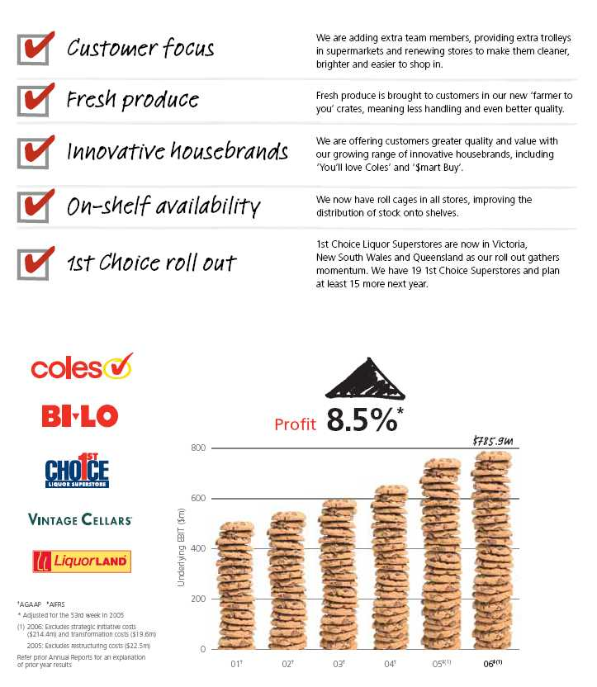
At Coles, we aim to offer great value and convenience.
Every week we offer over 2000 specials, plus specially-timed ‘mega sales’, to provide even more value to our customers.
We’re proud of the quality and value of our growing housebrand range. Customers doing their weekly shopping can choose ‘$mart Buy’ products for quality at the lowest price, or the ‘You’ll love Coles’ range which offers quality at least equal to the market leader, at a lower price. We work hard to source our housebrand products in Australia and to offer our customers the quality they expect at the prices they demand.
We’re proud of the quality and value of our growing housebrand range
Every year we support Australian growers, purchasing over $2.5 billion of fresh produce and meat. This year we sourced 97% of our fresh food and 85% of our grocery products from Australia.
Safety in our stores, for customers and team members, is very important to us. In the past year we have reduced work-related incidents and hours lost through injury, and also had a 30% reduction in our Lost Time Injury Frequency Rate.
This year, we introduced roll cages to our stores. These cages deliver stock faster and more safely from distribution centres to stores and onto shelves.
 | 2006 | 2005 | 2005
 | AIFRS | AIFRS | AIFRS | Change*
 | 52 weeks | 52 weeks | 53 weeks
Sales ($m) | 19,626 | 18,813 | 19,176 | 4.3%
Retail EBIT ($m)⁽¹⁾ | 785.9 | 724.6 | 759.6 | 8.5%
Retail margin (%)⁽¹⁾ | 4.00 | 3.85 | 3.96 | 15 bps

We also introduced our ‘farmer to you’ returnable plastic crates, reducing packaging waste and handling of fruit and vegetables, to improve quality for customers. We supported this roll out with a special ‘less handling means better quality’ marketing campaign.
We’re working hard to improve customer service in all our supermarkets
During the year we added 31 stores, to bring the total national network of Coles and BI-LO supermarkets to 737. We refurbished 36 supermarkets, and also converted four BI-LO stores into Coles supermarkets.
We are now progressively converting all our BI-LO stores to Coles supermarkets. We are maintaining value for BI-LO customers by offering an expanded range, including popular BI-LO Red Box products and the ‘Budget’ meat range.
As the conversions are completed, customers will find our terrific Coles range, offering value for all Australian shoppers, available in 40% more stores.
We are improving customer service in all our supermarkets, by putting more team members in stores, providing extra and better trolleys and having cleaner and brighter stores.
In the year ahead, Coles will continue to deliver value, quality, freshness and convenience to meet our customers’ everyday shopping needs.
We aim to be Australia’s best value liquor retailer, and we’ve made good progress this year.
This year, we added 148 stores and closed 52 to give a network of 735 liquor stores under our Liquorland, 1st Choice, Vintage Cellars, Theo’s and Hedley brands and had 69 hotels at year end.
Acquiring the Hedley Hotel Group brought us 102 liquor stores, 35 hotels, and potential sites for 17 1st Choice Liquor Superstores in the fast-growing Queensland market. We also entered Far North Queensland with this acquisition, further helping us toward our goal of leadership in the Queensland market.
Our 1st Choice Liquor Superstore roll out has gained momentum
Our 1st Choice Liquor Superstore roll out has gained momentum. Including our first stores in Victoria and New South Wales, at the end of the financial year we had 19 superstores open and plan to open at least 15 more in the year ahead.
Customers have welcomed the refurbishment of 57 of our Liquorland stores. As well as looking smarter, the stores are much easier for customers to ‘grab and go’, with a more tailored range, clear signage, open fridges and easier-to-reach shelves.
As part of the process to simplify our brand network and reduce operating costs, the Theo’s chain in NSW is being converted to our other liquor formats.
Next year, we will maintain our specialist offer with Vintage Cellars, grow convenience with Liquorland and continue our 1st Choice Liquor Superstore roll out.
 | 2006 | 2005 | 2005
 | AIFRS | AIFRS | AIFRS
 | 52 weeks | 52 weeks | 53 weeks | Change*
Sales ($m) | 6,187 | 5,380 | 5,494 | 15.0%
Retail EBIT ($m) | 30.0 | 21.6 | 24.0 | 38.9%

This year, we continued our journey to become Australia’s number one fuel and convenience retailer.
We now have almost 600 stores in convenient locations, offering competitive prices and the popular fuel discount scheme.
Convenient locations and popular fuel discount scheme
We partnered with Shell to launch Shell Optimax Extreme, Australia’s first super premium 100 octane, high performance 5% ethanol fuel offered exclusively at over 50 Coles Express sites in eastern Australia.
We also partnered with Shell to introduce ‘Fuel Economy Formula’.
Our convenience stores performed well with a reinvigorated offer to customers and a focus on service. This year we improved our convenience offer with the addition of ‘You’ll love Coles’ milk and bread and new food-to-go ranges.
We were able to improve food freshness and quality and save costs by bringing supply operations within the Coles Myer network.
Next year, we will keep looking for ways to give customers on-the-go better value and quality in fuel and convenience food.
no problem…
Our non-food brands have continued their turnaround path, improving their customer offers and growing sales and earnings in a challenging environment of record fuel prices.
Target is now one of Australia’s most successful retail businesses and Officeworks, the leading office supply retailer. The price achieved for the sale of Myer demonstrates the underlying value of this brand.
Kmart has focused on improving its quality of sales and will be an integral component of the new everyday needs business.
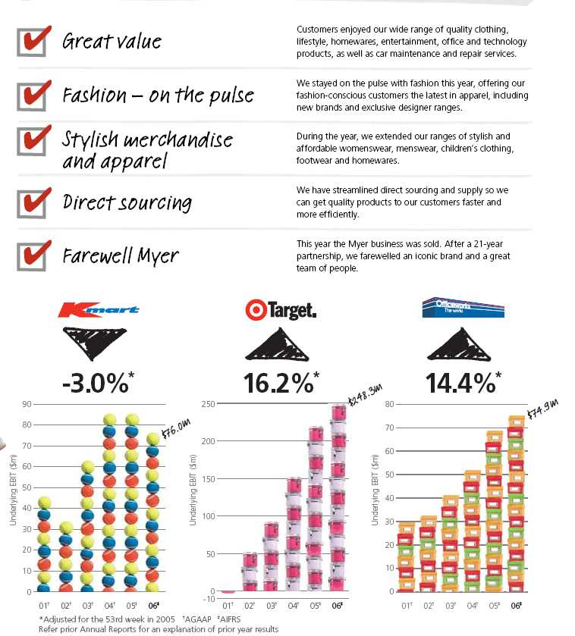
 | 2006 | 2005 | 2005
 | AIFRS | AIFRS | AIFRS
 | 52 weeks | 52 weeks | 53 weeks | Change*
Sales ($m) | 4,001 | 3,982 | 4,023 | 0.5%
Retail EBIT ($m)⁽¹⁾ | 76.0 | 78.3 | 85.5 | -3.0%
Retail margin (%)⁽¹⁾ | 1.90 | 1.97 | 2.13 | -7 bps

We take pride in helping our customers enjoy their leisure time at affordable prices.
Creating brighter more exciting stores for our customers
This year, we’ve improved our range of products, giving our customers the latest in basic fashion clothing, lifestyle, entertainment and homewares. Our exclusive brands including Living with Deborah Hutton, Patio by Jamie Durie, Jackeroo, Now and Girl Xpress continue to be popular.
Our targeted events, including our Easter, Toy and Home sales, again proved popular with our customers.
Seven new Kmart stores opened this year, bringing the total to 185, and we have plans underway for several more. We also refurbished seven stores. We added 91 new auto stores, including former Shell autoserv sites making us Australia’s largest car servicing network with 275 convenient locations.
Kmart Tyre and Auto Service had a challenging year as higher fuel prices affected customer spending on vehicle maintenance and repair.
Our team is vital to making our stores exciting for customers. We encourage career development, and we reward and recognise our great team members through our ‘Celebrate’ program.
We are getting products into stores and to customers faster and more efficiently by streamlining our supply chain, from both local and overseas suppliers. We’ve worked especially hard to get imported merchandise into stores faster.
Next year, some of our Kmart stores have the potential to be integrated into SuperCentres, offering customers an easy and convenient destination shopping experience.
Our focus is now on developing a great new range of general merchandise and apparel, combined with brighter stores to ensure we fulfil customers’ leisure lifestyle needs as part of the Coles everyday needs business.
* Adjusted for the 53rd week in 2005
(1) 2006: Excludes strategic initiative costs ($12.8m)
2005: Excludes the benefit on re-measurement of Kmart New Zealand onerous lease provision ($3.5m)
 | 2006 | 2005 | 2005
 | AIFRS | AIFRS | AIFRS
 | 52 weeks | 52 weeks | 53 weeks | Change*
Sales ($m) | 3,170 | 3,039 | 3,089 | 4.3%
Retail EBIT ($m)⁽¹⁾ | 248.3 | 213.6 | 218.8 | 16.2%
Retail margin (%)⁽¹⁾ | 7.83 | 7.03 | 7.09 | 80 bps

Target provides customers with great style, fashion and value. Our strategy is to be different, not only in the products we sell, but in how our stores look, and how we communicate with our customers.
Giving our customers great style, fashion and value
Our Target and Target Country stores offer customers across Australia a wide range of merchandise. Customers especially love our clothing, footwear and homewares, and we keep building on these strengths.
We again had great success this year with womenswear, menswear, children’s clothing and footwear. Our revitalised intimate apparel range was also very well received by customers. During the year, we extended our womenswear range, introducing ‘free fusion’, a brand for young, fashion-conscious women, and an exclusive limited range by acclaimed designer Gwendolynne.
In homewares, we continued to focus on stylish and affordable products. We used total room concepts to successfully showcase our new ranges to customers and the media. Our ‘jelli deli’ dog accessories were a fun fashion line which proved very popular with our customers.
This year, we streamlined inventory management, bringing Target Country into Target’s merchandise system.
We opened nine new stores, expanded nine stores and closed five smaller stores during the year, taking our network to 259 stores.
Next year, we will keep building on our strengths in clothing, footwear and homewares, giving our customers great style, fashion and value. We also aim to grow sales by accelerating our plans for new store openings, and we will refurbish key stores to display our new, differentiated look.
 | 2006 | 2005 | 2005
 | AIFRS | AIFRS | AIFRS
 | 52 weeks | 52 weeks | 53 weeks | Change*
Sales ($m) | 1,229 | 1,214 | 1,236 | 1.2%
Retail EBIT ($m)⁽¹⁾ | 74.9 | 65.5 | 68.4 | 14.4%
Retail margin (%)⁽¹⁾ | 6.09 | 5.40 | 5.53 | 69 bps

Officeworks delivered another year of solid growth, as we improved our quality range of office and technology products for home offices and small-to-medium businesses.
We keep improving our quality range of office and technology products
We opened eight new stores this year, taking our Officeworks retail network to 95 stores, as well as our eight Harris Technology Business Centres. We also opened our first new, smaller format store in Victoria, giving us greater flexibility and speed for future growth.
Strong promotional events continued to excite our customers during the year, especially our popular Back-to-School, The Works and Tax Time promotions.
We launched digital photo kiosks, a new contemporary stationery range and children’s educational stationery, and introduced FlyBuys in our retail stores.
We have kept our focus on improving our team with learning and development and attracting talented people with new recruitment branding. We have improved our safety culture and reduced injuries, making Officeworks a safer place to work and shop.
We have also had a strong focus on improving stock management this year.
We restructured Harris Technology early this financial year, removing a significant segment of unprofitable sales. While this impacted on our sales growth for the year, it has improved our overall profitability.
In the year ahead, we will keep building our core range of stationery, copy and print services and technology
* Adjusted for the 53rd week in 2005
(1) 2006: Excludes strategic consumables. initiative costs ($1.7m) will be expanding
To reward customers for shopping with us, we have continued to develop our comprehensive rewards program.
Our Gift Cards continue to become more popular
FlyBuys is Australia’s biggest customer loyalty program, with a membership of 2.5 million households. We will further enhance the program’s rewards in the year ahead.
The Coles Myer Source MasterCard program continues to deliver value to over one million Australians, offering a range of benefits, including bonus FlyBuys points, interest-free offers and regular savings on petrol, without having to pay an annual fee.
Our Gift Cards have grown in popularity with the introduction of new products including the official AFL-themed cards. We are always looking to introduce new and exciting products. We were the first retailer to introduce iTunes Music Cards in Australia.
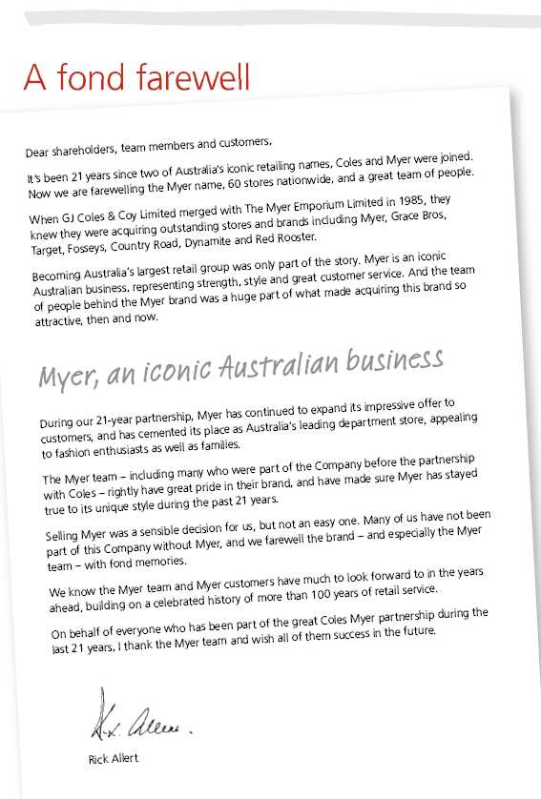
Meet the Board
Board of Directors
Left to right: Keith Barton, Sandra McPhee, Tony Hodgson, Martyn Myer, Belinda Hutchinson, John Fletcher, Rick Allert, Patty Akopiantz, Michael Wemms and Bill Gurry.
Patricia (Patty) E Akopiantz Non-executive Director
BA (Wellesley), MBA (Harvard), age 42, (appointed Director 2001)
Ms Akopiantz has extensive senior management and consultancy experience in retail and consumer industries both in Australia and overseas. Ms Akopiantz is a Director of Wattyl Limited (from 2005), Energy Australia Limited (from 2006) and AXA Asia Pacific Holdings Limited (from 2006). She is a member of the Advisory Council of the Australian Graduate School of Management and Chief Executive Women. She is also a Director of the Foundation for Young Australians and the YWCA-NSW.
Richard (Rick) H Allert, AM Chairman
FCA, age 63, (appointed Director 1995, Chairman from 2002)
Mr Allert has had a distinguished career as a chartered accountant. He is the Chairman of AXA Asia Pacific Holdings Limited (a Director from 1995). Mr Allert is a Director of the Australia Business Arts Foundation and Chairman of the Australia Council’s Major Performing Arts Board. He has been a Director of a number of public companies over many years and has also held positions with a number of government instrumentalities and community organisations.
Ronald K (Keith) Barton Non-executive Director
BSc, PhD (UNSW), FTSE, age 66, (appointed director 2003)
Dr Barton is a former Chief Executive Officer and Managing Director of James Hardie Industries Ltd, after holding a variety of executive positions at CSR Ltd. Dr Barton’s current Directorships include Tower Ltd (from 2001), Amcor Ltd (from 1999), Air Liquide Australia Limited and Vision Australia Limited (from 2004). Dr Barton’s previous board appointments include Goodman Fielder Ltd (Chairman), F H Faulding Ltd, Colonial Ltd and Australian Wealth Management Limited (2004-2005) and Citect Corporation Ltd (2001-2006).
John E Fletcher
Managing Director and Chief Executive Officer
FCPA, age 55, (appointed Director 2001)
Prior to Coles Myer, Mr Fletcher spent almost all his professional career with Brambles Industries, commencing in 1974, initially in an accounting role and then in a series of operating and senior management positions. He was appointed General Manager of the Transport Division in 1982, Commercial Director Europe in 1984, Managing Director CHEP Australia in 1986, Managing Director Brambles Australia in 1988 and Chief Executive Officer of Brambles Industries in 1993. Mr Fletcher retired as CEO of Brambles in 2001. Mr Fletcher was previously a Director of Telstra Corporation Limited (2001-2006).
William (Bill) P Gurry, AO Non-executive Director
LLB, age 59, (appointed Director 2001)
Mr Gurry is a former Executive Chairman of one of Australia’s foremost investment banks, UBS. He has had a career in the Australian finance sector, being a former Managing Director of Capel Court Corporation, National Mutual Royal Bank Limited and Executive Director of Australian Bank Limited. He is currently a Director of Rabobank Australia Limited, Rabo Australia Limited, Cheviot Bridge Limited (from 2004), The Financial Markets Foundation for Children, New Matilda Pty Ltd, Australian Jesuit Foundation and the St Vincent’s and Mercy Private Hospital. Mr Gurry has previously held positions with a number of corporate, government and community entities.

Anthony (Tony) G Hodgson Non-executive Director
FCA, FAICD, age 66, (appointed Director 2003)
Mr Hodgson was a co-founder of the specialist chartered accounting firm, Ferrier Hodgson, from which he retired in 2000 after 24 years. His role included the evaluation and implementation of marketing and business strategies to achieve major corporate restructures and turnarounds. Mr Hodgson’s current board appointments include Deputy Chairman (Chairman Audit Committee) Tabcorp Holdings Ltd (Director from 1994) and a Director of Committed Securities Limited. He is a member of the Advisory Council at JP Morgan and of the Advisory Board at VISY Industrial Holdings Limited. Mr Hodgson’s previous directorships include RMG Limited (Chairman), Melbourne Port Corporation (Chairman), Victorian TAB (Chairman), Presidents Club Limited and HSBC Bank Australia Ltd.
Belinda Hutchinson Non-executive Director
BEc, FCA, age 53, (appointed Director 2005)
Ms Hutchinson has broad experience as a Non-executive Director and as an executive within the banking and financial services sector. Ms Hutchinson is a Director of Telstra Corporation Limited (from 2001) and QBE Insurance Group Ltd (from 1997). She is also a Director of St Vincents and Mater Health Sydney Limited and President of the State Library of New South Wales Council. Ms Hutchinson’s previous appointments include Director of Energy Australia Limited (1997-2005) TAB Limited (1997-2004) and Crane Group Limited (1997-2004).
Sandra V McPhee Non-executive Director
DipEd, FAICD, age 60, (appointed Director 2003)
Ms McPhee has considerable experience as a Non-executive Director and as a senior executive in international consumer facing industries including aviation, retail and tourism, most recently with Qantas Airways Limited. Ms McPhee is a Director of Perpetual Limited (from 2004). She is also a Director of Australia Post, The Art Gallery of NSW and St Vincents and Mater Health. Ms McPhee’s previous appointments include Deputy Chair South Australia Water, and Director of Primelife Corporation Limited (2003-2005), CARE Australia and Tourism Council Australia.

Martyn K Myer Non-executive Director
BEng, MESc, MSM (MIT), age 49, (appointed Director 1996)
Mr Myer has extensive experience in financial services, engineering and biotechnology. He is Chairman of Cogstate Ltd (Director from 2000), a software company providing cognitive performance testing software to the pharmaceutical clinical trials market, a Director of Diversified United Investments Ltd (from 1991), the SP Austnet group of companies (from 2005), and from 1994 until 2002 was Managing Director of Merlyn Asset Management Pty Ltd, a boutique funds management company. Prior to his move to the financial services industry, he had experience with some of Australia’s leading manufacturers. Mr Myer has involvement in several philanthropic activities, including President of the Howard Florey Institute at the University of Melbourne and Member of the Board of The Myer Foundation. Previous appointments include Director of The Myer Family Company Pty Ltd and The Myer Family Office Pty Ltd.
Michael Wemms Non-executive Director
BA, MBA, age 66, (appointed Director 2003)
Mr Wemms has extensive retail and business experience in the United Kingdom. He worked at Tesco from 1972 to 2000 in a range of positions, including Store Manager, Personnel Director and Store Operations Director. He was a Director of Tesco plc from 1989-2000 and a part-time advisor to the company until June 2003. His current Non-executive Directorships include the international automotive group, Inchcape plc (from 2004) and Majid Al Futtaim Group LLC of Dubai. Mr Wemms is also Chairman of House of Fraser plc (Director from 1996) and was previously the Chairman of the British Retail Consortium (2004-2006).
Committee membership
Audit and Risk Committee: Tony Hodgson (Chair), Patty Akopiantz, Rick Allert, Martyn Myer, Michael Wemms
Nomination and Remuneration Committee: Rick Allert (Chair), Keith Barton, Bill Gurry, Belinda Hutchinson, Sandra McPhee,
Corporate Social Responsibility Committee: Rick Allert (Chair), Patty Akopiantz, John Fletcher, Martyn Myer

Corporate Governance
Your Directors and management are committed to high standards of corporate governance, which are embodied in the Board Governance Charter. This charter establishes the framework for how the Board oversees the Company and performs its functions on behalf of shareholders.
Role of the Board
The Board is responsible to shareholders for the overall strategy, governance and performance of the Company. Under the Board Governance Charter, the Board has reserved certain matters to itself for decision, such as appointing the CEO and approving strategy and annual budgets. All matters not specifically reserved to the Board for decision have been delegated to the CEO for decision.
Composition of the Board
The Board is to have a majority of independent Directors so that it can bring quality judgments, which are free of bias, to all issues. An independent Director is one who is free from any interest and any business or other relationship which could, or could reasonably be perceived to, materially interfere with the Director’s ability to act with a view to the best interests of the Company.
The Board has adopted a definition of ‘independence’, which is in line with the ASX Corporate Governance Council Best Practice Recommendations. For full details visit www.colesmyer.com. The Chairman of the Board should be an independent Director. The Board currently comprises nine independent Non-executive Directors and one Executive Director, being the Managing Director.
Criteria for Board membership
For Directors appointed by the Board, the Board will consider the range of skills and experience required in light of:
n | the strategic direction and progress of the Company;
n | the current composition of the Board; and
n | the need for independence.
A Director appointed by the Board must stand for election at the next annual general meeting. Apart from the Managing Director, all Directors are subject to re-election by rotation at least once every three years.
Board committees
The Board carries out certain duties by delegation to Board committees. These committees meet regularly and make recommendations to the Board on the issues delegated to them. The committees’ charters may be viewed on the Company’s website.
Audit and Risk Committee
The committee assists the Board in relation to the Company’s corporate governance framework, the identification of areas of significant business risks and the monitoring of:
n | the preparation of the Company’s financial statements;
n | maintenance of an effective and efficient internal and external audit;

n | effective management of business risks;
n | compliance with laws and regulations; and
n | business dealings, in particular related party transactions.
The committee is responsible for the appointment, compensation, retention and oversight of the work of the external auditor. Under the committee’s charter all members must be independent Directors. The committee members are Tony Hodgson (Chair), Patty Akopiantz, Rick Allert, Martyn Myer and Michael Wemms.
Nomination and Remuneration Committee
The principal responsibilities of the committee are:
n | to advise the Board on directorship appointments, with particular attention to the mix of skills, experience and other qualities of existing Directors;
n | to advise the Board on the appointment of potential successors to the Chief Executive Officer;
n | to review Board succession plans;
n | to review independent experts’ advice and then advise the Board annually on:
 | • | Chief Executive Officer’s remuneration
 | • | Non-executive Directors’ remuneration
n | to annually review the Board’s required mix of skills, experience and other qualities;
n | to develop and implement a process for the orientation and education of new Directors;
n | to review and advise the Board annually on the components of remuneration for executives reporting directly to the Chief Executive Officer;
n | review management’s recommendations and advise the Board on:
 | • | performance-linked compensation packages for management
 | • | executives’ retirement, pension and superannuation schemes
 | • | employee equity participation schemes
n | to review management’s recommendations and advise the Board on succession plans and leadership development plans for key senior positions within the Company;
n | to review the Company’s industrial relations strategy; and
n | to review strategic human resources matters.
Committee members are Rick Allert (Chair), Keith Barton, Bill Gurry, Belinda Hutchinson and Sandra McPhee. Subsequent to the end of the financial year, the Board decided to separate this committee into a Nomination Committee and a Remuneration Committee. The members of the Nomination Committee are Rick Allert (Chair), Bill Gurry and Michael Wemms. The members of the Remuneration Committee are Sandra McPhee (Chair), Rick Allert, Keith Barton, Belinda Hutchinson and Michael Wemms.
Corporate Social Responsibility Committee
This committee advises the Board on issues related to the Company’s social and environmental commitments to its stakeholders. Committee members are Rick Allert (Chair), Patty Akopiantz, John Fletcher and Martyn Myer.
Board appraisal process
The Board monitors and evaluates its performance and the performance of the Board committees and individual Directors annually in order to fairly review and actively encourage enhanced Board effectiveness. External consultants are engaged to assist in the evaluation process. The Board also evaluates the performance of each Director standing for re-election before deciding whether to recommend to shareholders that the Director be re-elected.
Fair dealings and related party transactions
Directors, as well as senior management, convey the message to all stakeholders through the relevant policies and our internal review mechanisms, that integrity and effective control cannot be compromised when dealing with suppliers, particularly if a supplier is a related party. The Company has implemented a comprehensive policy regarding related party transactions. A Director, or entities in which a Director has a significant interest and/or influence, who enters into a transaction with the Company (other than a transaction involving the payment of compensation), must make full disclosure. If the total value of the transactions for a month exceeds $1 million, details will be reported to the Audit and Risk Committee. Certain contracts with Directors, or entities in which Directors have a significant interest and/or influence, must be approved by the Audit and Risk Committee in advance of committing the Company.
Share trading
The Company’s policy and procedures on dealing in the Company’s securities requires that Directors and employees who possess inside information should never deal in the Company’s securities. It also provides that Directors and senior executives are not permitted to trade in the Company’s securities in the three-week period prior to the announcement of the half-year profit result, the full-year profit result or a quarterly sales announcement. It also prohibits Directors and senior executives from entering into hedging contracts in relation to their securities without first obtaining the specific approval of either the Chairman or the CEO.
Group results and monitoring
The Board has overall responsibility for the appropriate reporting of the CML Group results. In order to effectively carry out this function, the Audit and Risk Committee monitors the effectiveness of the Group’s systems and internal financial controls. The Group’s performance is monitored on a monthly basis through annual operating and capital budgets which have been established by the relevant business heads and approved by the Board. Internal Audit is used extensively to monitor the areas of greatest risk as identified by risk analysis. The external auditor reviews and tests the system of internal control to the extent necessary to form an opinion on the Financial Report.
External auditor independence
The independence and performance of the external auditor is subject to continual review by the Audit and Risk Committee. Audit engagement partners are rotated every five years, with the most recent rotation occurring in the 2002 financial year.
Code of Conduct
A Code of Conduct, based on the fundamental principle that all Company affairs shall be conducted legally, ethically and with strict observance of the highest standards of integrity and propriety, has been adopted by all Directors and employees. It is wide ranging and describes how an individual should act in many different circumstances.
It also provides guidance on how to resolve uncertainties and how to deal with suspected breaches of the Code by others. The Code may be viewed on the Company’s website.
Non-executive Director tenure policy
The Board has adopted a tenure policy for all Non-executive Directors.
The policy provides that Non-executive Directors will hold office for no more than 10 years (normally three full terms) unless there are special circumstances in which the Board considers that the Director should serve longer. The Chairman is expected to serve in that role for at least five years.
Professional advice to Directors
Subject to the approval of the Audit and Risk Committee, Directors may engage an outside professional advisor at the expense of the Company in appropriate circumstances.
Communication with shareholders
The Company is committed to:
n | ensuring that shareholders and the financial markets are provided with full and timely information about its activities;
n | complying with continuous disclosure obligations contained in applicable Australian Stock Exchange (ASX) Listing Rules and the Corporations Act; and
n | ensuring that all stakeholders have equal opportunities to receive externally available information issued by the Company.
The Company has established a Continuous Disclosure Committee which is responsible for monitoring the continuous disclosure practices of the Company, assessing the information provided by the Company’s businesses and considering the appropriate response to any market rumours concerning the Company. Information is communicated to shareholders through the distribution of the Annual Report and whenever there are other significant developments to report. In addition, all significant information is posted on the Company’s website as soon as it is disclosed to the ASX.
The annual general meeting, along with profit and sales presentations, is also broadcast live on the website. A copy of all the governance policies referred to in this report are also able to be viewed on the Company’s website.
Donations
The Board’s decision to contribute to the major political parties,
federally and in the states, is motivated by its desire to see a strong
political system that supports the democratic process in Australia.
Commitments made to political parties at the federal and state
levels during the year were:
Australian Labor Party | $82,000
Liberal Party of Australia | $82,000
National Party of Australia | $23,500
ASX corporate governance recommendations
At the date of this report the Company complies with the ASX
Principles of Good Corporate Governance and Best Practice
Recommendations.
The information required to be disclosed by those recommendations
is found both in this Corporate Governance section and in the
Directors’ Report on pages 39-40 of this report.

Financial Statements - Concise

Income Statements
For the 52 weeks ended 30 July 2006 (2005: 53 weeks ended 31 July)
 | 2006 $m | 2005⁽¹⁾ $m
Continuing operations
Revenue from sale of goods (excluding goods and services tax) | 34,212.0 | 33,018.2
Other operating revenue (excluding finance income) | 91.8 | 71.9
Cost of goods sold | (26,160.8) | (25,305.3)
Gross profit | 8,143.0 | 7,784.8
Other income | 134.4 | 68.3
Advertising expenses | (358.8) | (296.2)
Selling and occupancy expenses | (5,662.3) | (5,424.7)
Administrative expenses | (1,427.3) | (1,142.0)
Finance income | 25.0 | 29.0
Finance costs | (123.9) | (84.2)
Share of profit of joint venture accounted for using the equity method | 21.9 | 37.0
Profit before income tax expense | 752.0 | 972.0
Income tax expense | (215.6) | (285.9)
Profit from continuing operations | 536.4 | 686.1
Profit/(loss) from discontinued operations | 627.2 | (48.2)
Profit for the year⁽²⁾ | 1,163.6 | 637.9
Earnings per share for profit from continuing operations attributable to the ordinary equity
holders of the Company
Basic earnings per share | 43.0 cents | 51.8 cents
Diluted earnings per share | 42.6 cents | 52.2 cents
Earnings per share for profit attributable to the ordinary equity holders of the Company
Basic earnings per share | 93.4 cents | 47.9 cents
Diluted earnings per share | 92.4 cents | 48.5 cents

(1) | The Income Statement for the year ended 31 July 2005 has not been restated as permitted by AASB 132 Financial Instruments: Disclosure and Presentation and AASB 139 Financial Instruments: Recognition and Measurement which have been adopted from 1 August 2005.
(2) | The profit for the year ended 30 July 2006 was $1,163.6 million. After adjusting for the gain on disposal of Myer of $583.7 million and strategic initiative costs of $207.4 million, the profit for the year would have been $787.3 million.
 | The profit for the year ended 31 July 2005 was $637.9 million. After adjusting for the Kmart New Zealand onerous lease provision re-measurement benefit of $3.5 million and the Megamart divestment costs of $57.1 million, the profit for the year would have been $691.5 million.
The above income statement should be read in conjunction with the accompanying notes.

Balance Sheet
As at 30 July 2006 (2005: as at 31 July)
 | 2006 $m | 2005⁽¹⁾ $m
Current assets
Cash and cash equivalents | 485.6 | 440.9
Trade and other receivables | 390.8 | 557.1
Inventories | 2,851.8 | 3,261.6
Derivative financial instruments | 1.4
Assets classified as held for sale | 151.7
Total current assets | 3,881.3 | 4,259.6
Non current assets
Receivables | 43.7 | 51.9
Investments | 125.0 | 144.9
Derivative financial instruments | 9.4
Property, plant and equipment | 3,133.3 | 3,487.8
Investment properties | 7.6 | 9.6
Deferred tax assets | 484.5 | 449.0
Intangible assets | 1,412.2 | 803.3
Retirement benefit asset | 38.3 | 17.7
Total non current assets | 5,254.0 | 4,964.2
Total assets | 9,135.3 | 9,223.8
Current liabilities
Trade and other payables | 3,080.3 | 3,018.8
Interest bearing liabilities | 30.2 | 216.0
Derivative financial instruments | 24.0
Tax liabilities | 66.4 | 127.3
Provisions | 761.9 | 600.8
Total current liabilities | 3,962.8 | 3,962.9
Non current liabilities
Payables | 23.0
Interest bearing liabilities | 974.0 | 1,213.3
Derivative financial instruments | 16.1
Deferred tax liabilities | 77.6 | 103.0
Provisions | 320.7 | 317.9
Other | 163.1 | 211.6
Total non current liabilities | 1,574.5 | 1,845.8
Total liabilities | 5,537.3 | 5,808.7
Net assets | 3,598.0 | 3,415.1
Equity
Contributed equity | 2,144.2 | 2,068.6
Reserves | 3.9 | 7.1
Retained profits | 1,449.9 | 1,339.4
Total equity | 3,598.0 | 3,415.1
(1) The Balance Sheet for the year ended 31 July 2005 has not been restated as permitted by AASB 132 Financial Instruments: Disclosure and Presentation and AASB 139
Financial Instruments: Recognition and Measurement which were adopted from 1 August 2005.
The above balance sheet should be read in conjunction with the accompanying notes.

Statement of Recognised Income & Expense
For the 52 weeks ended 30 July 2006 (2005: 53 weeks ended 31 July)
 | 2006 $m | 2005⁽¹⁾ $m
Foreign currency translation reserve
Exchange differences on translation of foreign operations | (7.3) | (0.5)
Cash flow hedge reserve
Net hedging losses recognised directly in equity | (11.5)
Net hedging gains transferred to financial liabilities | –
Net hedging gains transferred to inventory | (8.6)
Retained profits
Actuarial gain on defined benefit plan | 17.4 | 2.7
 | (10.0) | 2.2
Income tax on equity items | 0.8 | (0.9)
Net (expenses)/income recognised directly in equity | (9.2) | 1.3
Profit for the year | 1,163.6 | 637.9
Total recognised income for the year | 1,154.4 | 639.2
Effects of change in accounting policy – financial instruments
Adjustment on adoption of AASB 132 and AASB 139, net of tax:
– Retained profits | (20.7)
– Reserves | 6.0
 | (14.7)
(1) The Statement of Recognised Income and Expenses for the year ended 31 July 2005 has not been restated as permitted by AASB 132 Financial Instruments: Disclosure
and Presentation and AASB 139 Financial Instruments: Recognition and Measurement which have been adopted from 1 August 2005.
The above statement of recognised income and expenses should be read in conjunction with the accompanying notes.

Cash Flow Statement
For the 52 weeks ended 30 July 2006 (2005: 53 weeks ended 31 July)
 | Inflows/(outflows)
 | 2006 $m | 2005⁽¹⁾ $m
Cash flows from operating activities
Receipts from customers (inclusive of goods and services tax) | 39,814.5 | 39,251.4
Payments to suppliers and employees (inclusive of goods and services tax) | (38,012.2) | (37,659.7)
Distributions received from joint venture partnership | 10.2 | 10.1
Finance income received | 23.6 | 28.9
Finance costs paid | (112.8) | (71.1)
Income tax paid | (422.7) | (402.5)
Net cash from operating activities | 1,300.6 | 1,157.1
Cash flows from investing activities
Payments for property, plant and equipment and intangible assets | (1,043.1) | (925.0)
Payments for purchase of businesses and controlled entities, net of cash acquired | (202.5) | (120.0)
Payments for purchase of other investments |  | (2.0)
Payment for purchase of joint venture | (0.9) | (1.3)
Proceeds on sale of property, plant and equipment | 19.9 | 23.8
Proceeds on sale of businesses and controlled entities, net of transaction costs | 1,309.9 | 3.9
Proceeds on sale of other investments | 13.3
Net cash from investing activities | 96.6 | (1,020.6)
Cash flows from financing activities
Proceeds from contributions to equity | 122.5 | 120.0
Payments for purchases of buy-back shares, including transaction costs | (838.2) | (704.4)
Proceeds from borrowings | 8,309.2 | 3,171.7
Repayments of borrowings | (8,496.9) | (2,691.6)
Dividends paid | (453.1) | (433.2)
Net cash from financing activities | (1,356.5) | (537.5)
Net increase/(decrease) in cash held | 40.7 | (401.0)
Cash at the start of the year | 440.9 | 841.9
Cash at the end of the year | 481.6 | 440.9
(1) The Cash Flow Statement for the year ended 31 July 2005 has not been restated as permitted by AASB 132 Financial Instruments: Disclosure and Presentation and
AASB 139 Financial Instruments: Recognition and Measurement which were adopted from 1 August 2005.
The above cash flow statement should be read in conjunction with the accompanying notes.

Notes to and Forming Part of the Financial Statements
Notes to the concise financial statements
Note 1: 2006 concise financial statements
The concise financial statements are an extract of, and have been derived from, Coles Myer Ltd and its controlled entities Financial Report for the year ended 30 July 2006. The concise financial statements cannot be expected to provide as full an understanding of the financial performance, financial position and financing and investing activities of the CML Group as the Financial Report.
A copy of the CML Group’s Financial Report for the year ended 30 July 2006, including independent audit report, is available to all shareholders and will be sent to shareholders without charge upon request. CML share registry contact details are contained on the inside back cover of this report.
The expression ‘CML Group’ refers to Coles Myer Ltd and its controlled entities as a whole.
The financial year is for the 52 weeks ended 30 July 2006 (2005: 53 weeks ended 31 July). Reference in this report to ‘a year’ is to the financial year ended 30 July 2006, unless otherwise stated.
The presentation currency used in this report is Australian Dollars, unless otherwise stated.
Revenues and expenses are recognised net of the amount of goods and services tax. Dollar amounts have been rounded to the nearest tenth of a million dollars unless specifically stated otherwise. Where the amount is $50,000 or less, this is indicated by a dash (‘–’).
These are the first CML Group concise financial statements to be prepared in accordance with the Australian equivalents to International Financial Reporting Standards (AIFRS). AASB 1
First-time Adoption of Australian Equivalents to International Financial Reporting Standards has been applied in preparing these financial statements.
The financial statements of Coles Myer Ltd until 31 July 2005, had been prepared in accordance with previous Australian Generally Accepted Accounting Principles (AGAAP). AGAAP differs in certain respects from AIFRS. When preparing the financial statements for the year ended 30 July 2006, management adopted certain changes to the accounting valuation and consolidation methods applied in the previous AGAAP financial statements to comply with AIFRS. With the exception of financial instruments, the comparative figures were restated to reflect these adjustments. The CML Group has taken the exemption available under AASB 1 to only apply AASB 132 Financial Instruments: Disclosure and Presentation and AASB 139 Financial Instruments: Recognition and Measurement from 1 August 2005.
Further detail on the explanation of the transition to AIFRS can be found in note 40 of the Financial Report.
Note 2: Significant items | 2006 $m | 2005 $m
Profit for the year includes the following items, whose disclosure is relevant in explaining
the financial performance of the CML Group
Disposal of Myer
Gain on sale of Myer, net of income tax benefit of $20.0 million (note 3) | 583.7
Strategic initiatives
Refer below for a detailed description of the costs associated with the strategic initiatives, net of income
tax benefit of $88.0 million | (207.4)
Megamart divestment costs
Write-down of non current assets and inventory to recoverable amount, and provision for surplus leased
space, net of income tax benefit of $24.4 million |  | (57.1)
 | 376.3 | (57.1)

Strategic initiatives
During the year ended 30 July 2006, a number of strategic initiatives were committed to, resulting in significant write-downs and costs. These include:
n | redundancy expenses of $158.1 million associated with the consolidation of support services, simplification of back office processes and closure of the Somersby and Hampton Park distribution centres;
n | lease exit costs of $17.0 million associated with the closure of Somersby and Hampton Park distribution centres;
n | write-down of brand names of $22.6 million as a result of the rebadging of Theo’s liquor stores;
n | asset write-downs of $35.7 million and costs of $22.8 million associated primarily with the rebadging of BI-LO stores to Coles, and other store rebadging as a result of changes to the format;
n | accruals of $31.8 million associated with the changes to the existing loyalty program; and
n | other costs of $7.4 million.

 | Food, Liquor |  |  |  | Property &
2006 $m | & Fuel | Kmart | Officeworks | Target | Unallocated | Total
Provision for redundancies | (100.3) | (3.5) |  | (11.8) | (42.5) | (158.1)⁽¹⁾
Provision for surplus lease space | (17.0) |  |  |  |  | (17.0)
Write-down of brand names (intangible assets) | (22.6) |  |  |  |  | (22.6)
Asset write-downs | (29.6) | (2.5) | (1.6) |  | (2.0) | (35.7)
Provision for restructuring | (19.8) | (3.0) |  |  |  | (22.8)
Accruals – loyalty program | (25.1) | (3.8) | (0.1) | (2.8) |  | (31.8)
Other costs |  |  |  |  | (7.4) | (7.4)⁽²⁾
Total strategic initiatives | (214.4) | (12.8) | (1.7) | (14.6) | (51.9) | (295.4)

(1) | Includes $23.3 million paid during the year ended 30 July 2006.
(2) | Includes $6.8 million paid during the year ended 30 July 2006.
Note 3: Discontinued operations
A. Description
On 9 November 2005, CML Group announced the divestment of its nine Megamart stores. A pre-tax charge of $81.5 million was recorded in the year ended 31 July 2005, largely comprising the write-down of non current assets and inventory to recoverable amount and the recognition of a provision for surplus lease space. No consideration was received in relation to the divestment.
On 2 June 2006, CML Group disposed of its Myer business for $1,409.0 million. The disposal includes deferred consideration receivable of $19.5 million.
Financial information relating to these discontinued operations for the period to the date of disposal or divestment is set out below. Divestment costs have been included in profit before income tax expense.
B. Financial performance and cash flow information
The financial performance and cash flow information for Myer and Megamart are presented for the period to date of disposal or divestment and for the year ended 31 July 2005.
 | 2006 $m | 2005 $m
Revenue and other operating income | 2,528.9 | 3,200.8
Expenses | (2,466.7) | (3,269.6)
Profit/(loss) before income tax (expense)/benefit | 62.2 | (68.8)
Income tax (expense)/benefit | (18.7) | 20.6
Profit/(loss) after income tax expense of discontinued operations | 43.5 | (48.2)
Gain on the sale of Myer before income tax benefit | 563.7
Income tax benefit | 20.0
Gain on sale of Myer after income tax benefit | 583.7
Profit/(loss) from discontinued operations | 627.2 | (48.2)
Net cash from operating activities | (51.5) | 9.0
Net cash from investing activities
(2006 includes an inflow of $1,298.9 million from the disposal of Myer) | 1,218.2 | 32.4
Net cash from financing activities | 121.1 | (41.8)
Net cash generated by Myer and Megamart | 1,287.8 | (0.4)
C. Carrying amount of assets and liabilities
The carrying amounts of assets and liabilities for Myer as at 2 June 2006 and 31 July 2005 are:
 | 2006 $m | 2005 $m
Cash and cash equivalents | 2.9 | 27.4
Trade and other receivables | 23.3 | 264.1
Inventories | 560.9 | 525.7
Property, plant and equipment and intangible assets | 485.7 | 401.1
Deferred tax assets | 83.2 | 74.9
Total assets | 1,156.0 | 1,293.2
Trade and other payables | (339.3) | (305.1)
Provisions | (74.1) | (74.6)
Other | (67.3) | (69.9)
Total liabilities | (480.7) | (449.6)
Net assets | 675.3 | 843.6

D. Details of the sale of Myer | 2006 $m
Consideration received or receivable:
Cash | 1,389.5
Deferred consideration receivable | 19.5
Total disposal consideration | 1,409.0
Carrying amount of net assets sold | (675.3)
Divestment costs associated with Myer disposal | (170.0)⁽¹⁾
Gain on sale of Myer before income tax expense | 563.7
Income tax benefit | 20.0
Gain on sale of Myer after income tax expense | 583.7

(1) Includes $90.6 million of divestment costs settled in cash.
E. Other transactions related to the sale of Myer
As an outcome of the disposal of the Myer business and its related assets, the CML Group has issued options for the disposal of certain other freehold properties. On 31 August 2006 an option was exercised resulting in the disposal of Ocean Keys Shopping Centre for $78.0 million (carrying value $47.9 million). On 31 August 2006 an option for the sale of Casey Central Shopping Centre for $51.0 million (carrying value $50.7 million) was also exercised. The CML Group has also agreed to dispose of its 50% interest in the CMS General Trust for an amount in excess of its carrying value.
In addition, the CML Group entered into a number of contingent lease liabilities relating to the sale of its Myer business, whereby the CML Group has guaranteed the performance of certain leases by Myer Ltd. The guarantees amount to $164.6 million and primarily expire within a maximum of four years.
Note 4: Dividends
 | 2006 $m | 2005 $m
Ordinary shares
Final dividend for the year ended 31 July 2005 of 17.0 cents (2004 15.0 cents) per fully paid ordinary share
paid on 14 November 2005 (8 November 2004). Fully franked at 30% tax rate (2004 30%). | 210.0 | 182.6
Interim dividend for the year ended 30 July 2006 of 19.5 cents (2005 16.25 cents) per fully paid ordinary
share paid 15 May 2006 (9 May 2005). Fully franked at 30% tax rate (2005 30%). | 243.1 | 199.9
Non-redeemable reset convertible preference shares (ReCAPS)
Dividend of $3.2589 per share paid 30 November 2004. Fully franked at 30% tax rate. |  | 22.8
Dividend of $3.2411 per share paid 31 May 2005. Fully franked at 30% tax rate. |  | 22.7
Final dividend of $0.7479 per share paid 12 July 2005 upon conversion of the ReCAPS into contributed equity.
Fully franked at 30% tax rate. |  | 5.2
Total dividends | 453.1 | 433.2

Dividends not recognised at year end
In addition to the above dividends, since year end the Directors have declared a final dividend of 22.5 cents per fully paid ordinary share, fully franked based on tax paid at 30%. The aggregate amount of the proposed ordinary dividend expected to be paid on 13 November 2006 out of retained profits at 30 July 2006, but not recognised as a liability at year end, is $267.7 million. The final dividend declared after 30 July 2006 will be fully franked out of existing franking credits or out of franking credits arising from the payment of income tax in the year ending 29 July 2007.
Franking credits
Franking credits of $297.7 million (2005 $411.8 million), at 30%, are available for the CML Group and will enable the payment of franked dividends for at least the next year.
Note 5: Impact on transition to AIFRS
Reconciliations and descriptions of the effect of transition from previous AGAAP to AIFRS on the CML Group’s equity and profit for the
year are provided in note 40 of the Financial Report. A summary of this information is provided below.
Impact on total equity as at 31 July 2005 reported under previous AGAAP
 | $m
Total equity as at 31 July 2005 as reported under AGAAP | 3,730.0
Consolidation of the Coles Myer Employee Share Plan Trust | (18.2)
Asset impairment | (76.4)
Defined benefit superannuation plan | 12.4
Employee entitlements | 4.6
Goodwill amortisation | 10.0
Lay-bys and sales returns | (40.1)
Leases – fixed rental and incentives adjustment | (108.9)
Reversal of property revaluations | (76.1)
Income tax – buildings, gaming licenses and brand names | (21.9)
Other | (0.3)
Total equity as at 31 July 2005 – restated under AIFRS | 3,415.1
Impact on profit for the year ended 31 July 2005 reported under previous AGAAP
 | $m
Profit for the year ended 31 July 2005 as reported under AGAAP | 624.5
Consolidation of the Coles Myer Employee Share Plan Trust | (3.5)
Asset impairment | 8.6
Defined benefit superannuation plan | 4.0
Employee entitlements | (2.0)
Goodwill amortisation | 10.0
Lay-bys and sales returns | (6.0)
Leases – fixed rental and incentives adjustment | (8.6)
Revaluation of properties to fair value | 15.0
Share-based payments | (5.4)
Other | 1.3
Profit for the year ended 31 July 2005 – restated under AIFRS | 637.9
Impact on cash flow statement for the year ended 31 July 2005
The adoption of AIFRS has not resulted in any material adjustments to the Cash Flow Statement.
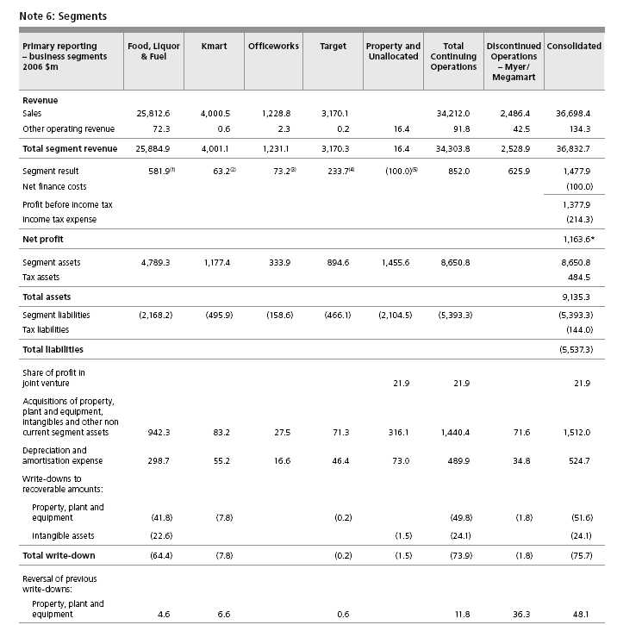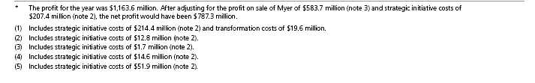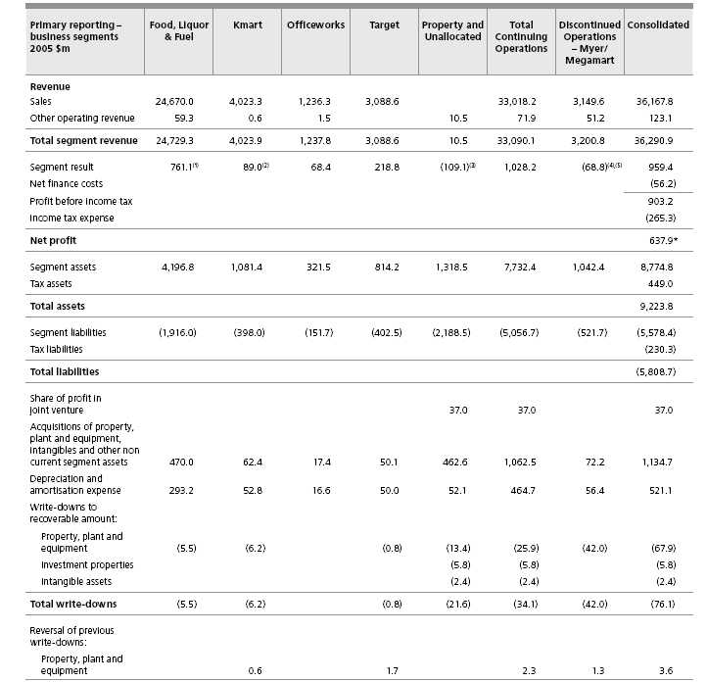
* | The profit for the year was $637.9 million. After adjusting for the Kmart New Zealand onerous lease contract provision re-measurement benefit of $3.5 million and the Megamart divestment costs of $57.1 million, the profit for the year would have been $691.5 million.

(1) | Includes $22.5 million of restructuring costs.
(2) | Includes $3.5 million benefit on re-measurement of the Kmart New Zealand onerous lease provision.
(3) | Includes supply chain transformation costs of $43.2 million.
(4) | Includes $5.0 million of lease surrender income and $5.3 million of costs relating to unredeemed gift vouchers.
(5) | Includes $81.5 million of Megamart divestment costs.

 |  |  |  |  | Acquisition of property, plant and
Secondary |  |  |  |  | equipment, intangibles and other non
reporting – |  |  |  |  | current segment assets
geographical | Sales to external customers |  | Segment assets
segments | 2006 $m | 2005 $m | 2006 $m | 2005 $m | 2006 $m | 2005 $m
Australia | 36,542.0 | 35,999.3 | 8,545.2 | 8,451.6 | 1,506.4 | 1,130.6
New Zealand | 156.4 | 168.5 | 74.8 | 291.5 | 3.2 | 2.1
Other |  |  | 30.8 | 31.7 | 2.4 | 2.0
 | 36,698.4 | 36,167.8 | 8,650.8 | 8,774.8 | 1,512.0 | 1,134.7

Business segments
The CML Group operates predominantly in the retail industry and comprises the following main business segments:
Continuing Operations:
Food, Liquor & Fuel | Retail of grocery, liquor and fuel products
Kmart | Retail of apparel and general merchandise
Officeworks | Retail of office supplies
Target | Retail of apparel and general merchandise
Property and Unallocated | Management of the CML property portfolio and unallocated or corporate functions
Discontinued Operations:
Myer | Retail of apparel and general merchandise
Megamart | Retail of furniture and electrical goods
Geographical segments
In presenting information on the basis of geographical segments, segment revenue is based on the geographical location of customers.
Segment assets are based on the geographical location of the assets.
The CML Group’s business segments operate geographically as follows:
Australia | The home country of the parent entity
The CML Group undertakes retail operations in all states and territories
New Zealand | The CML Group has Kmart retail operations, supplying basically the same ranges of goods as the
 | corresponding business in Australia. These operations are predominantly based in the North Island
Asia | Branch offices located in China

Intersegment transfers
Segment revenues, expenses and results include transfers between segments. Such transfers are principally priced on an arm’s length basis and are eliminated on consolidation.
The CML Group has certain investments in joint ventures and other associates. Segment disclosures relating to these investments have not been included, as they are not considered to be material.

Directors' Report
Directors’ report
The Directors present their report for the financial year comprising the 52 weeks ended 30 July 2006.
Principal activities
The principal activity of the CML Group during the year was retailing, further details of which are set out from the inside front cover to page 21 of the Annual Report.
Directors
The Directors of CML during the period from 1 August 2005 to the date of this report and particulars of their qualifications, experience, special responsibilities and Directorships in other listed companies are set out on pages 22-23 of the Annual Report. Details of the qualifications and experience of the Company Secretary are also set out on the inside back cover of the Annual Report.
Board committees
The Board committees during the year were the Audit and Risk Committee, the Nomination and Remuneration Committee, and the Corporate Social Responsibility Committee. The composition of these committees and their functions is set out in the Corporate Governance Statement on pages 24-26 of the Annual Report. Subsequent to year end the Board decided to separate the Nomination and Remuneration Committee into a Nomination Committee and a Remuneration Committee.
Dividends
Details of dividends paid during the financial year and to be paid in respect of the financial year are set out on page 34 of the Annual Report.
Review and results of operations and likely future developments
The consolidated profit for the year of the CML Group was $1,164 million.
The operations of the CML Group during the financial year, the results of those operations, the financial position of the CML Group and the Group’s business strategies and future prospects are reviewed in:
n | 2006 in Review, see from the inside front cover to page 3
n | Q&A with the Chairman and CEO, see pages 6-7
n | Operational Review, see pages 8-21
Further details of likely future developments in the operations of the CML Group are referred to in the Q&A with the Chairman and CEO on pages 6-7 and also pages 4-5 of the Annual Report.
Further information in relation to these likely future developments has been omitted from this Directors’ Report, as to include it would be likely to result in unreasonable prejudice to the CML Group.
State of affairs
Particulars of the significant changes in the state of affairs of the CML Group during the financial year are as follows:
n | The sale of the Myer business for $1.4 billion;
n | An off-market share buy-back totalling $837 million was completed;

n | The acquisition of the Hedley Hotel Group for $320 million; and
n | Incurred costs of $295 million in relation to strategic initiatives.
Events after the end of the financial year
On 18 August 2006 the Company received a conditional offer from a leveraged buy-out consortium offering to acquire the Company at an indicative price of $14.50 per share. The Board, after considering the offer and the advice of expert consultants, rejected the offer. The Directors are not aware of any other matter or circumstance that has arisen since the end of the financial year that has significantly affected, or may significantly affect, the operations, results of operations or state of affairs of the CML Group in future financial years.
Environmental
The CML Group is committed to conducting its business activities with respect for the environment while continuing to meet expectations of shareholders, employees, customers and suppliers. The CML Group is committed to achieving a level of environmental performance which meets or exceeds Commonwealth, state or local regulatory requirements, and to improve its use of natural resources and minimise waste where practicable.
The Directors are not aware of any material breaches of environmental regulations during the year. During the period from 1 August 2005 to the date of this report, no particular and significant environmental regulation under a law of the Commonwealth or of a state or territory has applied to the CML Group or its operations.
Indemnity and insurance
CML has entered into a Good Faith Protection and Access Deed in the form approved by shareholders at the 1999 annual general meeting with Non-executive Directors of the Company. The Deed provides for indemnification of the Directors to the maximum extent permitted under law and does not indemnify for any liability involving a lack of good faith. Article 70 of the Company’s constitution also provides an indemnity in favour of officers (including the Directors and Company Secretary) of CML (and such other officers and former officers of the CML Group as the Directors decide) against liabilities incurred while acting as such officers to the extent permitted by law.
No Director or officer of CML has received the benefit of an indemnity from the Company during or since the end of the year. CML maintains a Directors’ and Officers’ insurance policy. Due to confidentiality obligations and undertakings of the policy, no further details in respect of the premium or policy can be disclosed.
Rounding
Coles Myer Ltd is a company of the kind referred to in the Australian Securities & Investments Commission Class Order 98/0100 dated 10 July 1998. As a result, amounts in this report and accompanying financial statements have, where applicable, been rounded to the nearest one hundred thousand dollars except where otherwise indicated.
Remuneration Report
As required by the Corporations Act, the Company’s remuneration report is set out on pages 41-56 of the Annual Report.
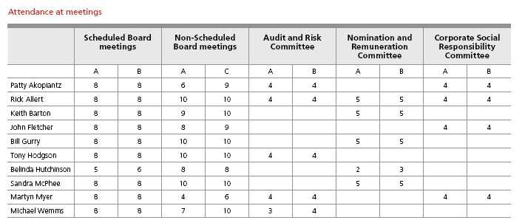
A = Number of meetings attended
B = Number of meetings held while in office
C = Number of meetings held while in office which the Director was eligible to attend.
All Directors may attend Board committee meetings if they choose to. Other Board committee meetings held during the year were attended by Rick Allert (5/5), John Fletcher (8/8), Bill Gurry (1/1) and Tony Hodgson (4/4).
Directors’ interests in CML Shares
Ordinary shares in which a Director has a relevant interest
Patty Akopiantz | 3,253
Rick Allert | 25,569
Keith Barton | 10,200
John Fletcher⁽¹⁾ | 1,204,458
Bill Gurry | 140,000
Tony Hodgson | 6,000
Belinda Hutchinson | 15,000
Sandra McPhee⁽²⁾ | 4,139
Martyn Myer | 1,537
Michael Wemms | 208

Notes:
(1) John Fletcher also holds a relevant interest in 1,704,500 options over CML shares.
(2) Sandra McPhee also holds a relevant interest in 3,400 endowment warrants over CML shares.
Details of options on issue at the date of this report and of shares issued as a result of an exercise of an option during or since the end of the financial year are set out in the Financial Report.
Audit and non-audit services
A copy of the auditor’s independence declaration is included on page 57 of the Annual Report.
During the year, the auditor, PricewaterhouseCoopers, was paid the following amounts in relation to non-audit services provided to the CML Group:
 | $’000
U.S. regulatory | 2,641
Sales certificates under leases | 636
Acquisitions/divestments | 903
Taxation advice | 93
Other | 211
 | 4,484

The Directors are satisfied, based upon the advice of the Audit and Risk committee, that the provision of non-audit services outlined above by the auditor during the year is compatible with the general standard of independence for auditors imposed by the Corporations Act. The reason for forming this opinion is that the Audit and Risk committee has reviewed all non-audit services to ensure they do not affect the impartiality and objectivity of the audit. The unique knowledge of the CML Group possessed by the auditor places the audit firm in a position to provide these services in the most efficient manner.
Signed in accordance with a resolution of the Board of Directors:
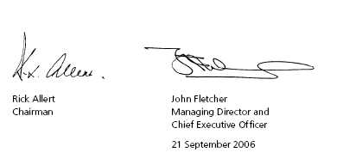
Remuneration report
In accordance with the remuneration reporting requirements of the Corporations Act 2001 and Accounting Standard AASB 124 ‘Related Party Disclosures’, this report details the remuneration arrangements for both the Company’s and Consolidated Entity’s Key Management Personnel (KMP).
In accordance with the requirements of AASB 124, KMP include:
n | The Chairman and Non-executive Directors of Coles Myer Ltd;
n | Mr John Fletcher, the Managing Director and Chief Executive Officer of Coles Myer Ltd; and
n | Those executives who have the authority and responsibility for planning, directing and controlling the activities of Coles Myer Ltd and the Consolidated Entity. During the 2006 financial year, these individuals included Mr Hani Zayadi, Ms Dawn Robertson, Mr Larry Davis, Mr Tim Hammon, Mr Fraser MacKenzie and Ms Launa Inman. In identifying executives for inclusion in the group of KMP, consideration was given to the following additional criteria: the relative size of the business managed by the individual with relative size assessed on the basis of sales and/or a contribution to the consolidated result, the relative degree of decision making authority or autonomy inherent in an individual’s role and the extent to which the individual’s performance was visible to external stakeholders.
The same group of individuals are regarded as KMP for both Coles Myer Ltd and Consolidated Entity disclosure purposes.
In addition, in accordance with the Corporations Act 2001, this report also details the Company’s and the Consolidated Entity’s five most highly remunerated officers during both the 2005 and 2006 financial years.
This report forms part of the Directors’ Report and is set out under the following headings:
A. | Principles applied in the determination of remuneration generally
B. | Group performance and the link with remuneration
C. | Non-executive Director remuneration
D. | Managing Director and Chief Executive Officer and other Key Management Personnel remuneration
E. | Summary of employment contracts
F. | Details of Key Management Personnel remuneration
G. | At risk remuneration
H. | Share based remuneration
The information provided under headings A and C through H includes remuneration disclosures that are required under AASB 124. These disclosures have been transferred from the Financial Report and have been audited. The disclosures in section B are additional disclosures required by the Corporations Act 2001 and are not required to be and have not been audited.
Glossary of terms used in this report
CEO | – | Chief Executive Officer
CML | – | Coles Myer Ltd
CSSG | – | Comparative store sales growth
EBIT | – | Earnings before interest and tax
EPS | – | Earnings per share
KMP | – | Key Management Personnel
LTI | – | Long-term incentive
NPAT | – | Net profit after tax
ROI | – | Return on investment
SEOP | – | Senior Executive Option Plan
SEPSP | – | Senior Executive Performance Share Plan
STI | – | Short-term incentive
TFR | – | Total fixed remuneration
TSR | – | Total shareholder return

A. Principles applied in the determination of remuneration generally The Nomination and Remuneration Committee (the Committee)
The Committee plays a key role in setting the CML Group’s remuneration framework and policy and in the determination of remuneration amounts paid to KMP. The Committee is responsible for:
n | advising the Board on matters concerning the appointment of new Directors and the CEO;
n | advising the Board on general matters of succession planning;
n | annually reviewing independent expert advice on the level of remuneration paid to the CEO and for reporting to the Board accordingly;
n | annually reviewing and advising the Board on the components of remuneration of those executives who report directly to the CEO;
n | reviewing management’s recommendations in relation to the CML Group’s remuneration framework generally and specifically in relation to the linking of remuneration to performance; and
n | reviewing the remuneration report.
The Committee comprises at least three Non-executive Directors, with the Committee’s Chairman appointed by the Board. The Committee meets at least three times per year and other Directors, not being members of the Committee, may attend meetings. Other CML executives and/or parties external to the CML Group may attend at the invitation of the Chairman of the Committee. The following independent Non-executive Directors were members of the Committee during 2006: Rick Allert (Chair), Keith Barton, Bill Gurry, Belinda Hutchinson and Sandra McPhee.
During the 2006 financial year the Committee received independent expert advice from Mercer Human Resources on the level of remuneration paid to KMP. Ernst & Young was also retained to provide advice on how the CML Group’s LTI program could be best structured and operated in the coming years so as to remain consistent with market trends and deliver sustained increases in shareholder value over the longer term.
Amongst others, key activities undertaken by the Committee during the year which had a significant impact on remuneration outcomes, included:
n | reviewing the calculation of STI entitlements in relation to the 2005 financial year, and thereafter authorising the payment of those entitlements;
n | authorising the adoption of the LTI entitlement program for 2006; and
n | consideration of appropriate succession planning strategies in relation to roles occupied by the executive leadership team.
CML’s KMP remuneration framework and policy
The overriding objective of CML’s KMP remuneration framework is to enable CML to attract, retain and motivate top quality individuals and to ensure reward for performance is competitive and appropriate given the results generated. In particular the framework aligns executive remuneration with the achievement of strategic objectives and the creation of value for shareholders. The Board ensures that KMP remuneration satisfies the following key criteria for good remuneration governance practices:
n | competitiveness and reasonableness relative to market;
n | performance linkage and alignment of executive remuneration to outcomes which create shareholder value; and
n | transparency.
The KMP remuneration framework provides a mix of fixed and variable remuneration components. Variable remuneration components are at risk and take the form of short-term cash incentives and long-term equity based rewards. The provision of fixed and at risk remuneration components is expected to generate a market competitive remuneration outcome that aligns remuneration to:
n | Shareholder interests by:
 | • | the inclusion of financial measures such as profit and earnings targets as a core component of short and long-term incentive programs
 | • | focusing on sustained growth in shareholder wealth and the extent to which that growth is comparable to the growth achieved by other significant Australian industrial companies
 | • | attracting and retaining high calibre executives
 | • | acknowledging and rewarding behaviour which is consistent with the CML Group’s values and behaviours

n | KMP’s interests by:
 | • | rewarding capability and performance
 | • | providing a clear structure for earning remuneration
 | • | incentivising them to appropriately manage their teams to generate shareholder value.
B. Group performance and the link with remuneration
The adoption of an appropriate remuneration framework incentivises KMP to work towards the creation of shareholder value. Over the past five years, the success of offering incentives to KMP has generated outcomes which are consistent with an increase in shareholder value including:
n | a share price, as per Graph 1, which stood at $11.70 at 28 July 2006 – this price represents an increase of $6.30 or 92% relative to the price as at 1 August 2001 and compares favourably to the 39% average share price increase in ASX top fifty companies over the same time frame;
n | a $454 million increase in underlying net profit after tax from $333 million in 2001 to $787 million in 2006 – underlying profit after tax has more than doubled over the 5 year period, as evidenced in Graph 2;
n | a sustained increase in earnings per share, as evidenced in Graph 3;
n | the return of more than $1.5 billion to shareholders through share buy-backs, and dividends have increased as evidenced in Graph 4; and
n | the divestment of Myer for $1.4 billion during 2006.
As detailed in Section D, the quantum of short-term cash and long-term equity incentives actually received by each individual key management person is dependant, to varying degrees, on both financial and other non-financial measures of performance. In turn, the incentive, if any, actually received by an individual is dependent on the degree of success achieved each year. Year on year improvement in a performance measure in itself does not necessarily result in the payment of a cash reward or the issue of equity to an individual. However, improvement above a minimum level does result in individuals obtaining entitlements to cash and/or equity rewards. Underlying net profit after tax, being an indicator of CML Group performance, is one measure that is used to determine whether KMP are entitled to an annual cash incentive. Earnings per share is a CML Group performance measure used to determine whether KMP are entitled to equity incentives.
Over the last five years, actual increases in underlying net profit after tax have been sufficient to mean that cash incentive amounts referrable to that particular performance measure have generally been payable. Similarly, over that period sufficient increases in earnings per share have generally resulted in equity-based incentives in the form of options vesting in favour of KMP.
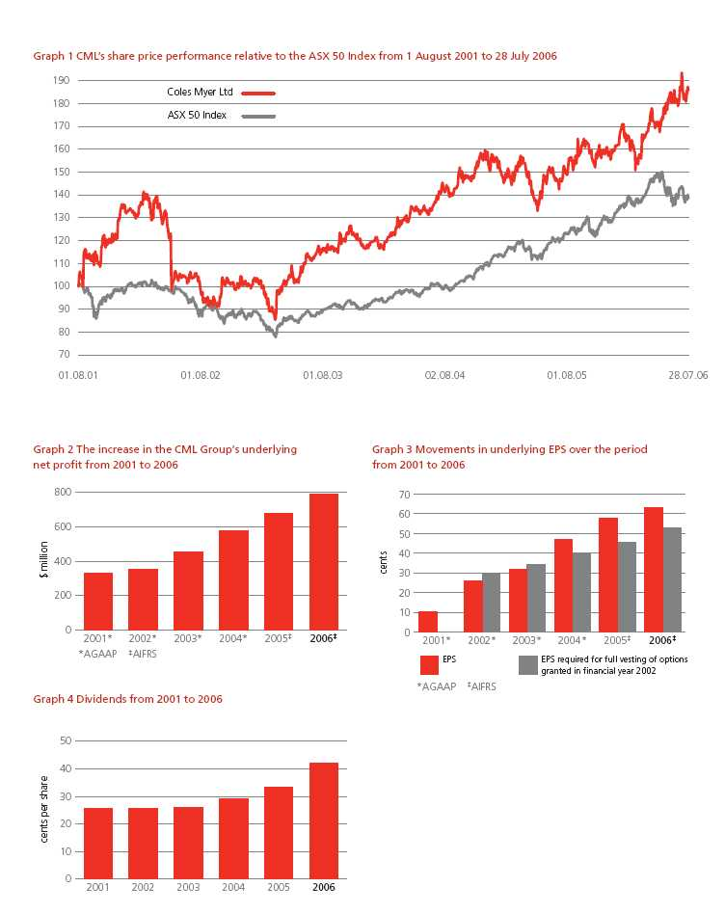
C. Non-executive Director remuneration
The Committee is responsible for reviewing the level of Non-executive Director fees. When undertaking this review and prior to making a recommendation to the Board as to appropriate fee levels, the Committee considers:
n | the Company’s existing remuneration policies;
n | independent professional advice;
n | fees paid by companies of comparable size and complexity;
n | the general time commitment required from Non-executive Directors and the risks associated with discharging the duties attaching to the role of Director; and
n | the level of remuneration necessary to attract and retain Directors of a suitable calibre.
After considering the Committee’s recommendation, Non-executive Director fees, including committee fees, are then set by the Board within the maximum aggregate amount of $2 million (2005 $1.5 million) last approved by shareholders in November 2005. In accordance with CML’s constitution, superannuation contributions and retirement benefits are not taken into account for the purposes of the maximum aggregate Non-executive Director remuneration approved by shareholders. Table 1 sets out the remuneration levels applicable to the roles undertaken by Non-executive Directors.
The Board has determined that Non-executive Directors’ fees will be increased annually in accordance with increases in the Consumer Price Index (All Groups). In addition, the Board also undertakes to periodically review Non-executive Director fees to ensure they remain consistent with general fee levels paid by comparable companies. As a result of a market review during the year, base fees for Non-executive Directors increased to $160,000 and the Chairman’s fee increased to $480,000. These fee increases became effective on 1 May 2006. The Board will continue to review its approach to Non-executive Director remuneration to ensure it remains in line with general industry practice.
In addition, Non-executive Directors are reimbursed for business related travel costs and they receive an annual expense allowance of $5,825 (2005 $5,825) to cover costs incurred in maintaining a home office such as telephone, stationery and computer costs.
No element of a Non-executive Director’s remuneration is performance related or at risk. The Board believes that the absence of at risk remuneration components from the Non-executive Director remuneration structure enhances the strength of the Board’s independence and its ability to objectively consider corporate governance issues and other commercial matters.
Retirement benefits
The Company ceased to offer retirement benefits to Non-executive Directors on 27 March 2003. However, Non-executive Directors who were appointed prior to 27 March 2003 retained their contractual entitlement to a retirement benefit. Their contracts provided for a retirement benefit equal to the aggregate of remuneration received by the particular Director over the last three years of service plus 5% of that amount for each year of service in excess of three years, but not exceeding 15 years, with any benefit paid on retirement, termination or death being reduced by the amount of any superannuation benefit received. On 18 November 2005 those Directors who were contractually entitled to a retirement benefit agreed to have their benefit frozen at that date in exchange for having their base fee increased to the same level as the fee payable to Non-executive Directors who were not entitled to a retirement benefit. Accrued retirement benefits are set out in Table 2. The benefits shown are net of superannuation benefits payable.
Table 1 – Directors’ base fees (inclusive of superannuation entitlements)
 |  |  |  |  | Nomination and |  | Corporate and Social
 | Board |  | Audit and Risk Committee |  | Remuneration Committee |  | Responsibility Committee
 | Chairman⁽²⁾ | Member | Chairman | Member | Chairman | Member | Chairman | Member
 | $ | $ | $ | $ | $ | $ | $ | $
2006 Fee⁽¹⁾ | 480,000 | 160,000 | 40,000 | 20,000 | 20,000 | 10,000 | 10,200 | 5,100
2005 Fee | 337,900 | 149,800 | 30,700 | 10,200 | 10,200 | 5,100 | 10,200 | 5,100

(1) | Up until 18 November 2005, Directors who were appointed prior to 27 March 2003 received lower annual fees of $112,600 (exclusive of superannuation) to reflect their entitlement to retirement benefits. From 18 November 2005, the retirement benefits of these particular Directors were frozen and all Directors now receive fees on the same scale.
(2) | The Chairman does not receive additional fees for serving on Board committees.

Table 2 – Accrued retirement benefits at year end |  | Accrued retirement benefit
Non-executive Directors entitled to retirement benefits | Years of service | 2006 $ | 2005 $
Rick Allert (Chairman) | 10 | 1,140,436 | 1,078,619
Patty Akopiantz | 4 | 324,196 | 315,232
Bill Gurry | 5 | 319,769 | 322,469
Martyn Myer | 9 | 374,114 | 370,287
Total |  | 2,158,515 | 2,086,607

D. Managing Director and Chief Executive Officer and other Key Management Personnel remuneration
The remuneration of KMP (other than Non-executive Directors) comprises both fixed and at risk remuneration components. Further, KMP may be entitled to a retirement benefit on completion of their service to the CML Group pursuant to the terms of their employment contract or otherwise at the discretion of the Board. Each remuneration component is further detailed below.
Total fixed remuneration (TFR)
The fixed component of remuneration comprises a base salary amount. Base salary is determined on an individual basis and does not vary over the course of a year. A salary packaging approach is followed whereby base salary may be taken in the form of cash, superannuation contributions, non–monetary fringe benefits (including up to two motor vehicles) and other benefits. All KMP remuneration is governed by the same salary packaging policy.
Base salary amounts are reviewed annually with revisions to amounts payable taking into account, amongst other things, individual performance during the previous year, changes in the size and scope of the role occupied by the specific executive and the continued significance of the role to the CML Group. There are no guaranteed increases in TFR.
At risk remuneration
The at risk remuneration component comprises both short-term and long-term incentive components. These are intended to remunerate relevant KMP for increasing shareholder value via the achievement of financial targets and the implementation of appropriate business strategies. Such strategies include business acquisition and divestment plans, new property acquisitions to enable development of new stores in key geographic areas and capital management initiatives.
Short-term incentives (STI)
The STI program is available to KMP (excluding Non-executive Directors), and involves linking specific annual financial and non–financial performance measures with the opportunity to earn cash amounts based on a percentage of TFR. The STI program is designed to reward executives for the successful achievement of specified levels of individual, business unit or Brand and CML Group performance over the financial year.
STI performance measures are determined annually by the Board to reflect the strategic business objectives of the CML Group. The Board takes advice from the CEO in relation to the STI performance measures applicable to the CEO’s direct reports. The Board also takes advice from independent, external advisers on the level of remuneration that is potentially available to the CEO and the CEO’s direct reports under the STI program. The STI amounts payable vary depending on the degree of achievement – performance above a threshold level is required before any STI is payable.
Table 3 summarises the criteria entering into the calculation of each executive’s potential 2006 STI entitlement and the percentage of each executive’s TFR that was available if various performance levels were achieved.
The actual STI paid to eligible KMP with respect to the 2006 and 2005 financial years is detailed in Tables 7 and 8 respectively.
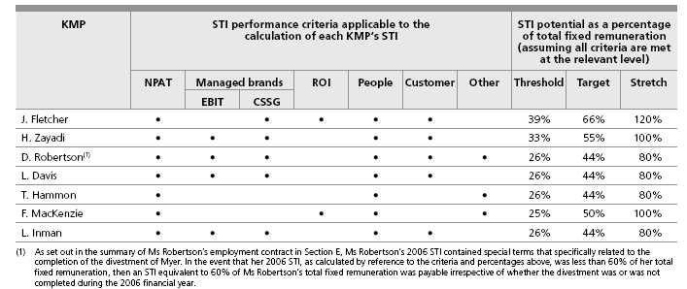
STI performance criteria
A summary of each STI performance criteria and the methods used to assess whether the performance criteria is satisfied are set out below. These criteria have been adopted because they directly align KMP remuneration outcomes to the delivery of increases in shareholder value.
n | Underlying NPAT, managed brand’s underlying EBIT, CSSG and ROI.
 | Underlying NPAT is a CML Group performance measure calculated after excluding certain non-recurring items of income and expenditure. Managed brand’s underlying EBIT and underlying CSSG are brand specific performance measures that are used to assess the performance of those KMP who have responsibility for managing a CML brand. Underlying EBIT is calculated after excluding certain non-recurring items of income and expenditure from a brand’s result. Underlying CSSG compares relative sales levels on a like-for-like basis between years after adjusting for such things as store closures, new store openings and temporary store closures due to refurbishments and other reasons.
 | ROI is a CML Group performance measure calculated by dividing the CML Group’s underlying EBIT by average net assets employed.
 | The performance criteria described above are calculated via reference to the figures appearing in the Company’s Annual Report and in management reports prepared for internal purposes. These particular financial performance criteria were chosen in favour of others on the basis that they are readily and objectively determinable, they are capable of being independently verified and because an increase in each is likely to most directly correlate to an increase in shareholder value via an increase in share price and/or an increased capacity to pay dividends in the future. For these reasons, STI potential is generally weighted more heavily towards financial outcomes.

n | Customer
 | The Customer performance criteria is a brand specific performance measure. Performance is assessed based on the results arising from customer surveys and the degree of loyalty customers exhibit to a particular brand as a place to shop. An external third party conducts the survey and the degree of customer loyalty is assessed on a five-point scale. Achievement of a specified level of improvement in customer loyalty relative to the prior year results in an STI entitlement.
n | People
 | The People performance measure is used to assess the extent to which an individual executive behaves in a manner consistent with the CML Group’s values and behaviours. At the core of the CML Group’s value and behaviours framework is an expectation that all individuals will focus on delighting our customers, being the best team and growing shareholder value. A 360-degree feedback process is undertaken in July of each year to assess the extent to which individual executives adhere to CML’s values and behaviours. This process involves obtaining feedback on a particular executive from a range of parties including the executive’s peers and direct reports, the CEO and the Board.
n | Other
 | Other performance criteria are adopted which are specific to the nature of each executive’s role. Such other performance criteria can be linked to cost control targets, the acquisition of new store sites, the delivery of critical strategic business objectives and to an increase in earnings per share.
STI performance assessment
The Board makes an assessment after the conclusion of the financial year in order to determine whether the individual performance of the CEO and each of the CEO’s direct reports results in an entitlement to an STI, and if so whether their performance entitles them to a threshold, target or stretch STI amount. STI amounts are ordinarily only payable if an executive occupies an eligible position as at the conclusion of each financial year and pro-rata entitlements are ordinarily not payable if an executive leaves the CML Group prior to this date. However, the Board does have discretion to negotiate alternate outcomes in the event of an executive’s termination. When payable, STI are calculated via reference to each individual executive’s TFR, determined as at the end of the financial year.
Long-term incentives (LTI)
LTI are provided via the Senior Executive Performance Share Plan (SEPSP) and the Senior Executive Option Plan (SEOP). LTI are provided in addition to STI in order to motivate executives to adopt strategies and to make decisions which have a positive and enduring impact on the drivers of shareholder value over the longer term.
Senior Executive Performance Share Plan (SEPSP)
The SEPSP, approved by shareholders at the 2004 annual general meeting, is designed to link long-term executive remuneration with the growth in shareholder value. It is also designed to facilitate the retention of strategically important senior executives.
The SEPSP provides for annual grants of performance shares to executives. A performance share is a right to acquire an ordinary share in the Company for no consideration.
The number of performance shares granted to each executive is calculated by reference to the level of responsibility of the executive and the market value of the Company’s share price at the start of each financial year.
Subject to performance hurdles being met, performance shares may vest at the end of the testing period. The testing period is a three year period commencing on the first day of the financial year of the grant. If the performance hurdles are not met at the end of the testing period the performance shares will lapse.
If the performance hurdles are met, then the Company will issue or transfer ordinary shares to the executive. The Company currently intends to undertake on-market share purchases and to subsequently transfer the shares acquired to eligible executives so as to ensure there is no dilution of existing shareholder interests as a result of the operation of the performance share plan. Once transferred to eligible executives, the shares must then be held by the executive for a period of 12 months following which they will be free to deal
with the shares. There are two performance hurdles applicable to the performance shares, namely relative total shareholder return (TSR) and underlying earnings per share (EPS) growth. Each hurdle applies to 50% of the performance shares granted to each participant. For 100% of an executive’s performance shares to vest, both the TSR and EPS hurdles must be satisfied to the maximum extent.
TSR measures changes in the market value of the Company’s shares over a three-year test period. In the calculation of the market value of shares, dividends are notionally re-invested. TSR was chosen as a performance measure because it:
n | ensures an alignment between the return to shareholders and executive remuneration;
n | provides a comparative, externally focused performance benchmark with which to measure the CML Group’s performance relative to those companies with which the Group competes for capital, customers and talent; and
n | is a performance measure widely used in long-term incentive plans adopted by comparable Australian companies.
TSR performance is compared with the TSR performance of the largest 50 industrial companies in the S&P/ASX Top 100 index over discrete three-year periods. Calculation of TSR is undertaken independently by Mercer Consulting Group or Link Market Services.
EPS is a measure of earnings or profits that accrue to each shareholder and is calculated by dividing the CML Group’s underlying net profit after tax by the weighted average number of shares on issue during the year. An underlying profit figure is used and reflects reported profit after tax excluding certain non-recurring items of income and expenditure.
EPS was chosen as a performance measure because it:
n | is a fundamental indicator of financial performance, both internally and externally; and
n | links directly to the CML Group’s long-term objective of growing earnings.
EPS performance is assessed at the end of each discrete three-year period. Performance shares vest if the EPS over the three year period exceeds target EPS.
The TSR and EPS vesting schedules are set out in Tables 4-6. Prior to vesting, performance shares carry no voting or dividend rights.
Performance share vesting schedules
Performance shares subject to the TSR performance hurdle (TSR performance shares) will vest in accordance with Table 4.
Table 4 – TSR vesting schedule
TSR Target % of TSR performance shares that vest
TSR below 51st percentile Nil
TSR between 51st and 74th percentile (inclusive) Progressive vesting on a straight-line basis from 50% to 99%
TSR at or above 75th percentile 100%
During the 2006 financial year, the Board undertook a review of the EPS performance hurdle to ensure that it remained market competitive and provided an appropriate and meaningful incentive to senior executives to improve shareholder wealth. The hurdles applicable to the SEOP, determined in 2001, were adopted in the creation of the SEPSP in 2004. In 2001 the CML Group had just reported an underlying net profit of $333 million and announced a five year turnaround strategy. As the strategy was drawing to a conclusion and its financial goals had been largely achieved, the Board considered that the scope for further compound double-digit increases in EPS growth had diminished and that a review of the EPS hurdles applicable to SEPSP (but not the SEOP) was required. As a result of the review, which considered the LTI programs of other comparable companies, and for SEPSP purposes only, the Board approved a new vesting schedule that is inclusive of modified, more progressive EPS hurdles.
The Board considers that these new hurdles, whilst difficult to achieve, provide senior management with a more reasonable degree of incentive potential than would have been the case had the pre-existing hurdles continued to be applied. The new EPS vesting schedule, as set out in Table 5, is applicable when determining whether EPS performance hurdles have been met in the third test year in relation to performance shares issued in the 2005 financial year and in the second and third test years in relation to performance shares issued in the 2006 financial year. The new vesting schedule is also applicable in determining whether performance shares issued in the 2007 financial year and subsequent financial years will vest. The pre-existing vesting schedule, as set out in Table 6, remains applicable for the purposes of determining whether EPS performance hurdles have been met in the first and second test years in relation to performance shares issued during the 2005 financial year and the first test year in relation to performance shares issued during the 2006 financial year.
If a participant ceases to be employed due to death, disability, retrenchment or retirement prior to the three-year testing date, pro-rata vesting will occur, subject to performance hurdles being met. In this situation the performance hurdles will be tested at the next half or full financial year end following cessation of employment.
Senior Executive Option Plan (SEOP)
Prior to the introduction of the SEPSP, the Company operated the SEOP. The SEOP provided for market priced options to be issued to senior executives. The SEOP has now been replaced by the SEPSP. However, as some options granted under the SEOP still remain on issue (including those granted to the CEO), a brief description of the SEOP is set out below.
Subject to performance hurdles being met and the payment of the relevant exercise price, an option confers a right in favour of the executive to purchase ordinary shares in the Company. The exercise price of each option is determined via reference to the weighted average market price of the Company’s shares, as quoted on the ASX, during the 10 trading days prior to the day on which the option is issued.
Executives generally received one grant of options, which, subject to performance hurdles being met, vests progressively over a five-year period. Supplementary grants were given to executives who were promoted. In general there is no vesting during the first two years post issue. After two years, 40% of the options granted may vest, followed by 20% for each of the next three years.
Consistent with the SEPSP, TSR and EPS performance hurdles are also used for the purposes of determining whether options granted under the SEOP actually vest. Except for 1,500,000 options granted to the CEO in 2003, all other options on issue vest subject to the EPS hurdles as detailed in Table 6 and a TSR hurdle which provides progressive vesting of options between the 50th and 65th percentiles.
Table 5 – The new EPS vesting schedule
EPS Target | % of EPS performance shares that vest
EPS growth less than 8% pa compound | Nil
EPS growth at 8% pa compound | 25%
EPS growth between 8% pa and 10% pa compound | Progressive vesting on a straight-line basis from 25% to 49%
EPS growth at 10% pa compound | 50%
EPS growth between 10% pa and 12% pa compound | Progressive vesting on a straight-line basis from 51% to 99%
EPS growth at or above 12% pa compound | 100%
Table 6 – The pre-existing EPS vesting schedule
EPS Target | % of EPS options and performance shares that vest
EPS growth less than 12.5% pa compound | Nil
EPS growth at 12.5% pa compound | 50%
EPS growth between 12.5% pa and 15% pa compound | Progressive vesting on a straight-line basis from 51% to 99%
EPS growth at or above 15% pa compound | 100%

Other than the 1,500,000 options granted to the CEO, achievement of either EPS or TSR hurdle results in the options vesting.
In respect to the tranche of 1,500,000 options granted to the CEO in November 2003, 50% vest subject to the achievement of the TSR hurdle and 50% vest subject to the achievement of the EPS hurdle. The TSR hurdle for this particular tranche of options is set out in Table 4.
Options ordinarily lapse if performance hurdles are not achieved within the five-year period post grant date or if an executive resigns prior to completion of the required vesting periods. However, the Board, in its discretion, may decide that options will vest notwithstanding that performance targets have not been met or in the instance where an executive resigns prior to the completion of the required vesting period. In addition, where an executive leaves the CML Group as a result of death, disability, retirement or retrenchment, they are, subject to performance hurdles being met, entitled to options on a pro-rata basis to the date of their departure.
Valuation of LTI equity based remuneration
In accordance with the requirements of the Accounting Standards, remuneration as disclosed in Tables 7 and 8 includes a proportion of the notional value of equity instruments, being options and performance shares, granted or outstanding during the financial year. The notional value of these equity instruments is determined as at the grant date and is progressively allocated over the instrument’s vesting period. Amounts included in remuneration are not necessarily indicative of the benefit (if any) that an individual may ultimately receive should the equity instruments vest. The notional value of performance shares issued in 2005 and 2006 and options issued in earlier years has been determined in accordance with AASB 2 ‘Share-based Payment’. Equity instruments are valued by independent valuers. Performance shares are valued using the Monte-Carlo pricing model, which incorporates market based performance conditions such as TSR. Options are valued using the Black-Scholes pricing model. Where options are subject to performance conditions, a 50% probability has been applied to the Black-Scholes valuation. Performance share and option amounts are expensed over their vesting period and as such enter into the determination of net profit.
Retirement benefits
Where an executive’s employment with the CML Group is terminated, termination entitlements are paid in accordance with contractual obligations or otherwise at the discretion of the Board.
E. Summary of employment contracts
Section E contains a summary of the employment contract for each Key Management Person (excluding Non-executive Directors whose details of employment are set out in section C). Each summary excludes details in relation to an executive’s remuneration and STI arrangements where they are disclosed elsewhere in this report.
Unless otherwise noted, each employment contract is open ended and includes standard termination clauses that provide that the Company may terminate an executive’s employment at any time by providing 12 months notice or payment in lieu of notice.
An executive’s employment may also be terminated without notice or payment in lieu of notice where circumstances warrant summary dismissal. Unless otherwise noted, KMP may resign at any time by providing six months notice. Further, each employment contract provides that each KMP may be entitled to an allocation of performance shares subject to performance hurdles being met and the rules applicable to the long-term incentive plan. The number of performance shares that each may receive is determined annually by the Board. Table 11 sets out the number of performance shares that were allocated to KMP during the year ended 30 July 2006.
John Fletcher – Managing Director and Chief Executive Officer
Mr Fletcher’s employment contract was entered into on 3 September 2001 and has been extended such that it is now open ended. It provides an entitlement to:
n | receive a car allowance of $60,000 per year plus reimbursement for maintenance and fuel costs;
n | receive 2,500,000 options with such options vesting at a rate of 500,000 per year over the five year period to 3 September 2006 subject always to performance hurdles being met; and
n | receive a pro-rata entitlement to an STI in the event that Mr Fletcher’s employment ceases in the second half of a financial year. In this instance the amount of an STI payable will be calculated via reference to normal performance criteria. Mr Fletcher is not eligible to receive any STI amount with respect to a financial year if employment ceases in the first half of that financial year.
In addition to the options issued pursuant to the terms of Mr Fletcher’s contract, in November 2003 shareholders approved the grant of an additional 1,500,000 options, exercisable in two equal tranches in September 2005 and 2006. The performance hurdles applying to these particular options were changed during the 2005 financial year to make them consistent with the hurdles applying to performance shares. There was no impact on Mr Fletcher’s remuneration in any year as a result of the change to performance hurdles. Unless the Board decides otherwise, these options expire one year after the date on which Mr Fletcher ceases employment with the Company.
Mr Fletcher may resign from the Company at any time subject to the provision of 12 months notice. However, Mr Fletcher need not provide 12 months notice and may resign immediately in the event of a ‘fundamental change’ to his role (such as ceasing to be the most senior executive of the CML Group or a demonstrable inability to work with the Board).
As a result of Mr Fletcher’s contract being extended, and as approved by shareholders at the 2005 annual general meeting, 170,000 performance shares were allocated under the terms of the SEPSP. These performance shares impact the calculation of Mr Fletcher’s remuneration in the 2006, 2007 and 2008 financial years.
Hani Zayadi – Group Managing Director Food, Liquor and Fuel (from 22 December 2004 until 20 March 2006)
Mr Zayadi’s current employment contract was entered into on 15 April 2005 and concluded on 31 July 2006 as a result of his departure from the CML Group. Mr Zayadi’s employment contract provided for:
n | reimbursement of reasonable costs incurred in relocating to Canada in the event of the termination of employment;
n | an entitlement to an amount of not less than 50% of the annual STI entitlement if employment is terminated by the Company other than for poor performance;
n | the issue of options that are subject to service hurdles only as a retention mechanism. The inclusion of a service hurdle reflected the need to replicate terms and conditions ordinarily found in share option plans in North America; and
n | Mr Zayadi to be restrained from taking up a role with certain competitors for a 12-month period post termination of employment with the Company.
Dawn Robertson – Managing Director Myer (from 4 April 2002 until 31 May 2006)
Ms Robertson’s primary employment contract was entered into on 4 April 2002. In view of the CML Group’s consideration of the future of Myer during 2005, it became necessary for the primary employment contract to be complemented by an ancillary contract which was entered into on 9 November 2005. The ancillary contract became operable and certain terms of the primary contract lapsed upon the execution of a contract to divest the Myer business. In view of the successful divestment of the Myer business, the summary of contractual terms noted below reflects those that applied in the normal course and those that became operable upon divestment.
The primary employment contract stated that Ms Robertson was:
n | entitled to a retention payment of $368,459 on 1 June 2007;
n | eligible to receive a pro-rata STI payment in the event of termination;
n | entitled to three business class air fares to the United States for herself and each of her dependent children each year until December 2006;
n | required to give 12 months notice of termination; and
n | restrained from taking up a role with certain competitors for a 12-month period post termination of employment with the Company.
The ancillary employment contract provided that in the event that the divestment of Myer was completed during the 2006 financial year and provided Ms Robertson did not take up employment with the Myer group then Ms Robertson would:
n have an entitlement to a retention bonus of $750,000;
n | cease to be employed by the Company and date of termination would be as at the date the Myer divestment occurred;
n | retain an entitlement to $368,459 which would otherwise have been due under the terms of the primary contract had employment by the CML Group continued to 1 June 2007;
n | have a 2006 STI entitlement determined in accordance with the terms in the ancillary contract such that the STI terms in the primary contract would lapse. The STI terms in the ancillary contract provided:
- for a pro-rata STI payment calculated under the NPAT, brand EBIT and CSSG components (as detailed in Table 3). For the purposes of determining the eligibility for a NPAT STI component, a forecast of NPAT as at the date of termination was to be used. Eligibility to brand EBIT and CSSG STI components was to be determined on the basis of a comparison of actual to budgeted outcomes assessed as at the date of termination
- for an entitlement to an amount determined by the Board in relation to the Customer and People STI components subject only to that amount being at least as much, in percentage terms, as the aggregate entitlement to NPAT, brand EBIT and CSSG STI components bore to the maximum amount available
- that in the event that the STI as calculated by reference to the preceding paragraphs was less than 60% of TFR, a further amount was payable to ensure that an STI equivalent to 60% of TFR was paid
- for a further bonus of $250,000 if, at the date of the completion of the Myer divestment, Myer’s EBIT for the 2006 financial year was expected to be, in the opinion of the CEO, greater than $80 million
n | subject to the Board’s discretion, have share option entitlements vest as at the date of termination; and
n | cease to have any entitlement to performance shares, such that performance shares previously granted would lapse.
Fraser MacKenzie – Chief Financial Officer
Mr MacKenzie’s employment contract is for a minimum fixed term to 30 April 2007. It provides for Mr MacKenzie to be:
n | eligible to receive a possible annual STI subject to Mr MacKenzie remaining in an eligible position for the full financial year. If employment ceases on 30 April 2007 as a result of his retirement then he will be entitled to a pro-rata STI bonus for the 2007 financial year; and
n | eligible to receive the balance of the remuneration otherwise payable over the period from the date of notice of termination to 30 April 2007 in the event that the Company terminates his employment prior to that date.
Tim Hammon – Chief Officer Corporate and Property Services
In addition to contractual outcomes disclosed elsewhere in this report, Mr Hammon’s employment contract provides for an annual STI subject to Mr Hammon remaining in an eligible position for the full financial year and him remaining as an employee of the Company until 1 October following the completion of the annual bonus period which concludes at the end of each financial year.
Larry Davis – Managing Director Kmart
In addition to contractual outcomes disclosed elsewhere in this report, Mr Davis’ employment contract provides for the reimbursement of reasonable costs incurred in relocating to the United States in the event of the termination of employment. Further, Mr Davis’ options are subject to service hurdles only as a retention mechanism and were based on the need to replicate similar conditions that applied in North America in relation to share option plans.
Launa Inman – Managing Director Target
Ms Inman’s current employment contract was entered into on 12 December 2005 and is open ended. It provides for the:
n | reimbursement of any costs that may be incurred if Ms Inman were to re-locate to Geelong within a period of two years post 14 February 2005; and
n | payment of prescribed annual cash amounts and the issue of 22,000 performance shares per year for each year that Ms Inman remains with the Company up to the year ending 31 July 2008.
 | In respect to the years ending July 2007 and 2008 the prescribed cash amounts are $150,000 and $200,000 respectively.
F. Details of Key Management Personnel remuneration
The details of remuneration paid or payable to KMP during the 2006 and 2005 financial years are set out in Tables 7 and 8 respectively. Unless otherwise indicated, the individuals listed were regarded as KMP for the whole of the relevant financial year.
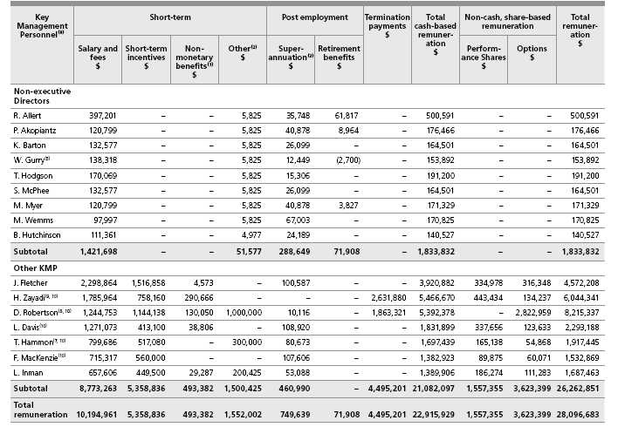
Footnotes in relation to remuneration paid in the 2005 and 2006 financial years (as disclosed in Table 7 and 8).
(1) | Non-monetary amounts include costs relating to fringe benefits which are available as part of normal salary packaging arrangements and may include motor vehicles, accommodation, travel, insurance and tax planning fees.
(2) | The other benefits figures include sign on bonuses and payments for continued service. There will be additional benefits in future years if continued service conditions are fulfilled. Other benefits have been presented on an accruals basis in accordance with Accounting Standard requirements. Where a KMP’s employment is terminated but they nonetheless receive an amount in lieu of a payment for continued service, that amount is included as a component of the KMP’s termination remuneration.
(3) | The CML Group is not required to make superannuation contributions in respect to overseas nationals who hold certain business visas.
(4) | Mr Leibler retired from office on 18 November 2004. The amount of $5,818 shown in the 2005 remuneration table represents the retirement benefit accrued during the 2005 financial year through to the date of his retirement. The actual retirement amount received by Mr Leibler on 18 November 2004 was $374,560, having been accrued during Mr Leibler’s tenure as a Director. Mr Leibler’s fees were paid to Arnold Bloch Leibler, a firm of which he is a partner. Accordingly, superannuation contributions were not payable.
(5) | Mr Gurry previously received fees for acting as Chairman of the Coles Myer Superannuation Fund. His retirement from this position in 2002 resulted in a decrease in his anticipated retirement benefit compared with the prior year.
(6) | Mr Cain, a former Group Managing Director Food, Liquor and Fuel, ceased employment on 3 January 2005. His termination benefits included a termination payment of 12 months salary ($1,800,000) in lieu of notice. CML also paid $10,000 for legal fees and $20,350 for financial advice. In addition, Mr Cain received an amount of $282,639 in exchange for agreeing to extend his restraint period from 12 months to 18 months. Mr Cain’s 2005 termination benefit also includes an amount of $249,395, being the unamortised portion of options vested. Mr Cain ceased acting as Group Managing Director Food, Liquor and Fuel on 22 December 2004 and ceased employment with the Company on 3 January 2005.
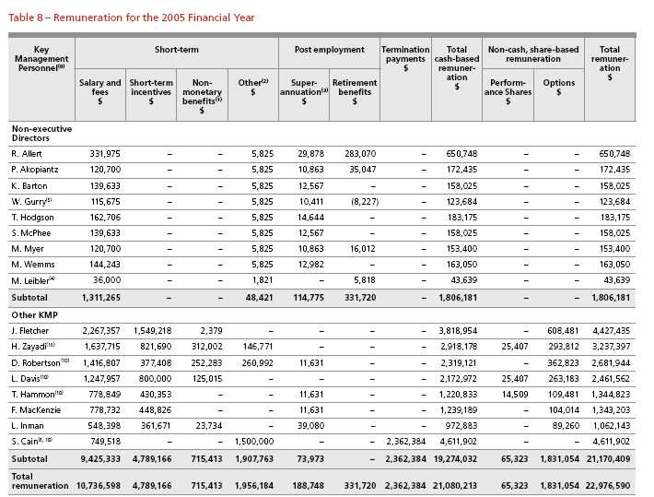
(7) | Mr Hammon’s other remuneration amount includes a special $300,000 discretionary bonus which was awarded in recognition of Mr Hammon’s significant contribution to the Myer sale process. For the purposes of this report and particularly Tables 9 and 10, the amount is not considered as an STI as it was not contemplated in Mr Hammon’s 2006 incentive plan.
(8) | Ms Robertson’s remuneration for the 2006 financial year and up to 31 May 2006 (as disclosed in Table 7) included the following amounts:
 | n | $1,827,983 in lieu of notice and in lieu of Ms Robertson’s employment not extending beyond 1 June 2007 (of which $30,706 had been accrued as remuneration in the prior year);
 | n | a $750,000 retention bonus and a $250,000 Myer divestment transaction completion bonus. The aggregate of these amounts is disclosed as other remuneration. For the purposes of this report and particularly Tables 9 and 10, neither of these amounts are considered to be an STI as they were not contemplated in Ms Robertson’s 2006 incentive plan;
 | n | An STI of $1,144,138;
 | n | $35,338 as a reasonable allowance to cover Ms Robertson’s relocation to the United States; and
 | n | $2,822,959 which was attributable to the value of options held by Ms Robertson which the Board, in its discretion, decided would vest in favour of Ms Robertson as part of her termination entitlement (note, the value of the options has been disclosed in Table 7 as a component of share based remuneration). In the ordinary course, these particular options would potentially have vested in the 2007 financial year subject to the achievement of the relevant performance hurdles. The value attributed to these options does not represent a cash cost to CML.
(9) | Consistent with Mr Zayadi’s role as Managing Director Food, Liquor and Fuel becoming redundant in March 2006, Mr Zayadi received termination entitlements which included $1,872,000 in lieu of notice, a further amount of $748,800 which was contractually payable on separation of employment and an amount of $11,080 in relation to a reimbursement of taxation adviser fees. In addition, the Board, in its discretion, decided that options that were otherwise due to vest during the 2007 financial year would vest as at the date of Mr Zayadi’s termination. These options were originally subject to a length of service hurdle only and were not subject to TSR or EPS performance hurdles. The value attributed to these options does not represent a cash cost to CML.
(10) | In addition to the Chief Executive Officer and in accordance with Section 300A(1)(c) of the Corporations Act 2001, these five executives received the highest remuneration amounts in respect to each of the 2005 and 2006 financial years.
Table 9 shows the actual STI payment as a percentage of the payment that would have been due had the stretch STI criteria been met.
Table 9 – Extent of STI entitlement
 |  | 2006 |  |  | 2005
 |  | Actual STI |  |  | Actual STI
 |  | payment as a | % of stretch STI |  | payment as a | % of stretch STI
 | Actual STI | % of stretch STI | potential not | Actual STI | % of stretch STI | potential not
KMP | payment $ ⁽²⁾ | potential | received | payment $ | potential | received
J. Fletcher | 1,516,858 | 53% | 47% | 1,549,218 | 57% | 43%
H. Zayadi | 758,160 | 41% | 59% | 821,690 | 58% | 42%
D. Robertson⁽¹⁾ | 1,144,138 | 79% | 21% | 377,408 | 32% | 68%
L. Davis | 413,100 | 38% | 62% | 800,000 | 74% | 26%
T. Hammon⁽¹⁾ | 517,080 | 78% | 22% | 430,353 | 66% | 34%
F. MacKenzie | 560,000 | 70% | 30% | 448,826 | 59% | 41%
L. Inman | 449,500 | 78% | 22% | 361,671 | 70% | 30%

(1) | Ms Robertson’s actual 2006 STI amount excludes $750,000 paid as a retention bonus and $250,000 paid in relation to Ms Robertson’s contribution to the divestment of Myer. Similarly, Mr Hammon’s actual 2006 STI amount excludes $300,000 paid in relation to Mr Hammon’s contribution to the divestment of Myer. These amounts have been excluded on the basis that in each instance, the amounts ultimately paid were not contemplated in the relevant individual’s original potential stretch STI amount (being the maximum STI that was potentially available in the ordinary course of business).
(2) | With the exception of respective STI amounts paid at the time when termination entitlements were settled in relation to Ms Robertson and Mr Zayadi, all other STI amounts in respect to the 2006 financial year will be paid subsequent to year end. There is no retesting of the STI entitlement and the unvested portion is forfeited.
G. At risk remuneration
Table 10 details the relative proportion of remuneration paid in 2006 to KMP (other than Non-executive Directors) which was dependent upon the achievement of specific performance levels versus that which was not. No component of the remuneration of Non-executive Directors is at risk.
Table 10 – The extent to which remuneration is at risk
 |  | Total actual at | At risk components as a % of total remuneration⁽¹⁾
 | Fixed remuneration | risk remuneration
 | as at % of total | as a % of total
KMP | remuneration⁽¹⁾ | remuneration⁽¹⁾ | STI | Options | Performance
 |  |  |  |  | shares
J. Fletcher | 53% | 47% | 33% | 7% | 7%
H. Zayadi | 61% | 39% | 22% | 4% | 13%
D. Robertson | 61% | 39% | 33% | 6% | 0%
L. Davis | 62% | 38% | 18% | 5% | 15%
T. Hammon | 54% | 46% | 32% | 4% | 10%
F. MacKenzie | 54% | 46% | 36% | 4% | 6%
L. Inman | 56% | 44% | 27% | 6% | 11%

(1) | For the purposes of calculating the percentages disclosed in Table 10:
 | n | Total remuneration excludes amounts payable on termination and the value of options which vest on the termination of KMP. On the same basis, fixed remuneration excludes amounts referrable to termination remuneration entitlements;
 | n | At risk remuneration excludes bonus amounts paid to Mr Hammon ($300,000) and Ms Robertson ($250,000), being amounts that were not contemplated in their original 2006 STI plans (respectively); and
 | n | Fixed remuneration includes amounts payable to Ms Robertson ($750,000) and Ms Inman ($200,425). In each instance the payment of the amount was only contingent on service being rendered over a specified period of time and as such is not considered to be at risk.
 | These adjustments have been made to reflect total remuneration, fixed remuneration and at risk remuneration payable in the ordinary course of business excluding the impact of termination events and bonuses awarded at the discretion of the Board and which were not contemplated in original 2006 STI plans.
H. Share-based remuneration
Details of the terms and conditions of each grant of options and performance shares provided to KMP and which enter into the calculation of their remuneration in the current and future reporting periods are detailed in Table 11.
Table 11 – KMP’s option and performance share entitlements
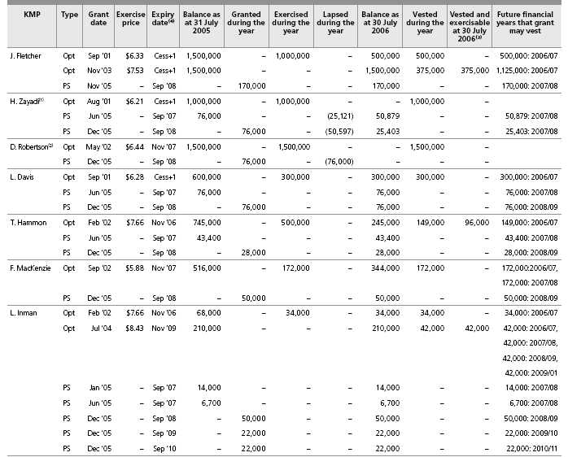
(1) | Subsequent to the conclusion of the financial year, and on 31 July 2006, Mr Zayadi’s employment ceased. On 31 July 2006, Mr Zayadi’s entitlement to 152,000 performance shares previously issued to him was reduced on a pro-rata basis such that Mr Zayadi had, as at that date, an entitlement to 76,282 performance shares.
 | The vesting of these performance shares is contingent on performance hurdles being met as at 28 January 2007. In addition, the terms of Mr Zayadi’s termination agreement also resulted in a revision to the terms under which options were held by Mr Zayadi. 500,000 options which were originally due to vest in the 2007 financial year vested unconditionally prior to balance date. The value of performance shares and options enters into the calculation of Mr Zayadi’s 2006 remuneration but only to the extent that value was not previously recognised in remuneration attributed to Mr Zayadi in an earlier year. The value attributed to these options does not represent a cash cost to CML.
(2) | Ms Robertson’s employment contract provided that if the sale of Myer was concluded during 2006 and if Ms Robertson did not accept the new Myer Group’s offer of employment, then Ms Robertson’s outstanding share option entitlements would, subject only to the Board’s discretion, vest as at the date of Ms Robertson’s termination. The Board decided that two tranches of 500,000 share options that were otherwise scheduled to vest during both of the 2007 and 2008 financial years would vest early as at the date of Ms Robertson’s termination. Ms Robertson has since exercised these options, and as result acquired 1,000,000 shares in the Company. The value attributed to these options has been included in the determination of Ms Robertson’s termination remuneration amount, as disclosed in Table 7.
 | The value attributed to these options does not represent a cash cost to CML. Ms Robertson’s employment contract also provided that Ms Robertson’s performance shares would lapse as at the date of termination and accordingly do not enter into the calculation of Ms Robertson’s 2006 remuneration.
(3) | There are no options on issue which have vested but which are contractually unable to be exercised.
(4) | Cess +1 denotes that the options expire one year after the cessation of an individual’s employment.
In accordance with section 300A(1)(e) of the Corporations Act 2001, Table 12 shows the value of performance shares granted during the year as part of certain KMP’s remuneration, the value of any options exercised by KMP during the year (calculated as at the date of exercise) and the value of any options held by those KMP that lapsed during the year (calculated as at the date of lapse). No new options were granted to any KMP during the year.
Table 12 – The value of performance shares and options granted
 |  |  | Value of option or | Value at date
 |  |  | performance share | of exercise or | Value at date of
 | Equity |  | granted⁽¹⁾ | acquisition⁽²⁾ | lapse⁽²⁾ | Total
KMP | instrument | Grant date | $ | $ | $ | $
2006
J. Fletcher | Option | Sep ’01 | – | 3,490,000 | – | 3,490,000
 | Perf’ Share | Nov ‘05 | 1,228,250 | – | – | 1,228,250
H. Zayadi | Option | Aug ’01 | – | 4,767,880 | – | 4,767,880
 | Perf’ Share | Jun ‘05 | – | – | (285,626) | (285,626)
 | Perf’ Share | Dec ‘05 | 546,440 | – | (575,288) | (28,848)
D. Robertson | Option | May ’02 | – | 6,879,000 | – | 6,879,000
 | Perf’ Share | Dec ‘05 | 546,440 | – | (864,120) | (317,680)
L. Davis | Option | Sep ’01 | – | 1,284,000 | – | 1,284,000
 | Perf’ Share | Dec ‘05 | 546,440 | – | – | 546,440
T. Hammon | Option | Feb ’02 | – | 1,198,000 | – | 1,198,000
 | Perf’ Share | Dec ‘05 | 201,320 | – | – | 201,320
F. MacKenzie | Option | Sep ‘02 | – | 746,480 | – | 746,480
 | Perf’ Share | Dec ‘05 | 359,500 | – | – | 359,500
L. Inman | Option | Feb ‘02 | – | 88,400 | – | 88,400
 | Perf’ Share | Dec ‘05 | 639,810 | – | – | 639,810
2005
J. Fletcher | Option | Sep ’01 | – | 2,990,000 | – | 2,990,000
H. Zayadi | Option | Aug ’01 | – | 1,570,000 | – | 1,570,000
 | Perf’ Share | Jun ‘05 | 427,500 | – | – | 427,500
D. Robertson | Option | May ’02 | – | 3,318,621 | – | 3,318,621
L. Davis | Option | Sep ’01 | – | 2,994,000 | – | 2,994,000
 | Perf’ Share | Jun ‘05 | 427,500 | – | – | 427,500
T. Hammon | Option | Dec ‘98 | – | 212,850 | – | 212,850
 | Option | Oct ‘01 | – | 473,000 | – | 473,000
 | Option | Apr ‘00 | – | – | (346,150) | (346,150)
 | Perf’ Share | Jun ‘05 | 244,125 | – | – | 244,125
L. Inman | Option | Feb ‘02 | – | 165,920 | – | 165,920
 | Option | Apr ‘00 | – | – | (150,500) | (150,500)
 | Perf’ Share | Jun ‘05 | 116,438 | – | – | 116,438
F. MacKenzie | Option | Sep ‘02 | – | 1,300,320 | – | 1,300,320
S. Cain | Option | Aug ‘03 | – | – | (5,530,387) | (5,530,387)

(1) | The value of each option and performance share granted has been determined in accordance with AASB 2.
(2) | The value of each option exercised is based on the market price of the Company’s share as at the date of exercise less the exercise price of the option. Where an option has lapsed out of the money, the value was determined as the difference between the exercise price of the option less the market price of the Company’s shares as at the date the option lapsed. The value of each performance share that vested is equivalent to the market price of the Company’s shares on the date the share was acquired by an executive.
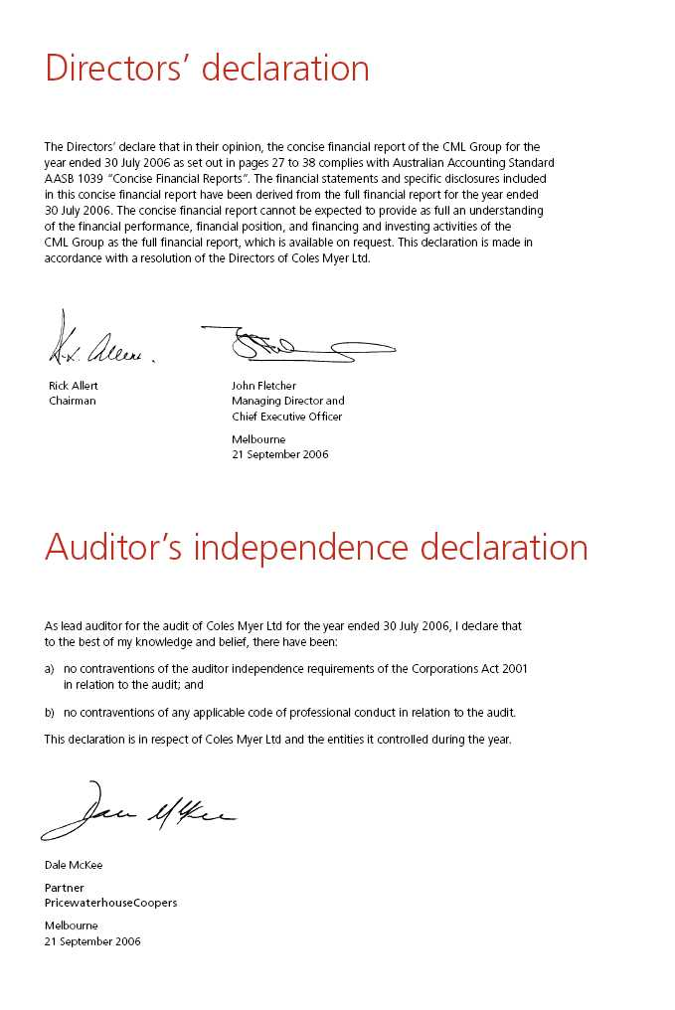
Independent audit report to the members of Coles Myer Ltd
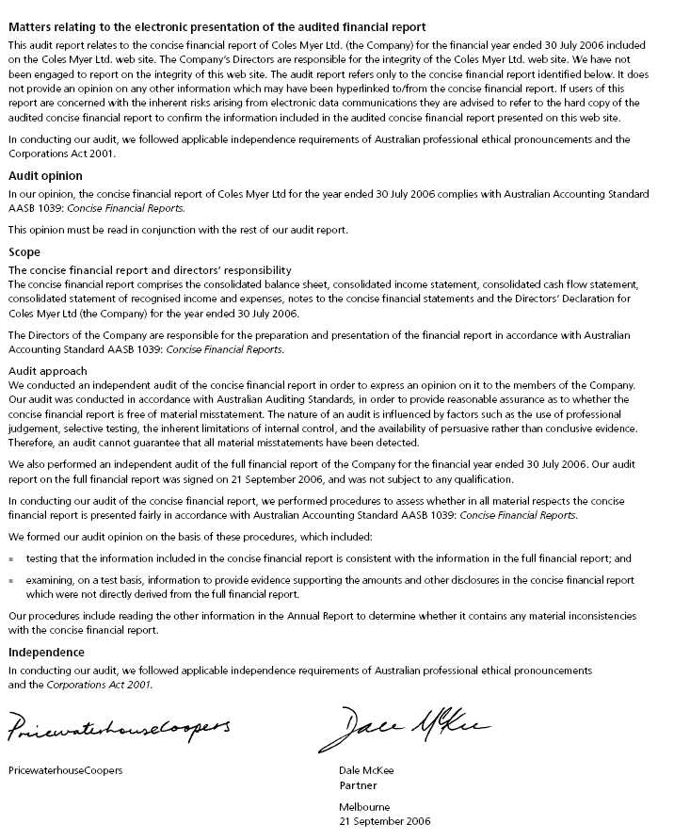

Details of Shareholdings
as at 8 September 2006
Ordinary shares |  | Number | %
1. | National Nominees Limited | 109,925,390 | 9.22%
2. | Westpac Custodian Nominees Limited | 104,186,704 | 8.74%
3. | J. P. Morgan Nominees Australia Limited | 100,765,498 | 8.45%
4. | Premier Investments Limited | 69,500,000 | 5.83%
5. | Citicorp Nominees Pty Ltd | 59,648,149 | 5.00%
6. | ANZ Nominees Limited | 53,990,908 | 4.53%
7. | M F Custodians Ltd | 30,563,255 | 2.56%
8. | RBC Dexia Investor Services Australia Nominees Pty Limited | 22,053,041 | 1.85%
9. | Cogent Nominees Pty Limited | 20,950,017 | 1.76%
10. | T.W. Hedley Pty. Ltd. | 11,271,200 | 0.95%
11. | Australian Foundation Investment Company Limited | 9,849,599 | 0.83%
12. | UBS Nominees Pty Ltd | 9,284,762 | 0.78%
13. | Coles Myer Employee Share Plan Ltd. | 7,569,430 | 0.63%
14. | Karedis Nominees Pty Limited | 7,536,000 | 0.63%
15. | HSBC Custody Nominees (Australia) Limited | 6,026,759 | 0.51%
16. | AMP Life Limited | 5,628,550 | 0.47%
17. | Australian Reward Investment Alliance (ARIA) | 4,860,388 | 0.41%
18. | Queensland Investment Corporation | 4,132,388 | 0.35%
19. | Mr Peter Alexander Brown | 3,898,635 | 0.32%
20. | Perpetual Trustee Company Limited | 3,486,775 | 0.28%
 |  | 645,127,448 | 54.10%
(Number of fully paid ordinary shares: 1,192,473,404)

Substantial shareholders
The names of substantial shareholders in CML and the number of shares in which each has an interest as disclosed in substantial
shareholder notices given to CML as at 8 September 2006 were as follows:
S. Lew Custodians Pty. Ltd. and its associates | 69,530,160

Distribution of holdings
Number of holders (and number of securities) by size of holding at 8 September 2006 were as follows:
 |  |  | Executive party
 | Ordinary shares |  | paid shares |  | Executive share options |  | Performance shares
Size of holding | Holders | Securities | Holders | Securities | Holders | Securities | Holders | Securities
1–1,000* | 256,822 | 151,567,043 |  |  |  |  | 2 | 2,000
1,001–5,000 | 82,635 | 166,510,423 | 2 | 5,000 |  |  | 25 | 77,012
5,001–10,000 | 8,857 | 61,687,769 | 1 | 6,000 | 201 | 1,251,727 | 52 | 367,267
10,001–100,000 | 4,959 | 100,236,344 |  |  | 284 | 9,050,704 | 102 | 2,238,667
100,001 and over | 212 | 712,471,825 |  |  | 17 | 5,170,200 | 2 | 322,000
 | 353,485 | 1,192,473,404 | 3 | 11,000 | 502 | 15,472,631 | 183 | 3,006,946
*3,396 ordinary shareholders holding a total of 45,584 shares held less than the marketable parcel of $500

Shareholder information
Shareholder enquiries
Investors seeking information about their shareholding should contact the Company’s Share Registry. Shareholders should have their Securityholder Reference Number (SRN) or Holder Identification Number (HIN) available when contacting the Share Registry.
Share Registry contact details
Link Market Services Limited Level 12, 680 George Street Sydney NSW 2000 Locked Bag A14, Sydney South NSW 1235
Telephone (within Australia): 1300 130 278 Telephone (outside Australia): +61 2 8280 7768 Fax: +61 2 9287 0309 Email: colesmyer@linkmarketservices.com.au
Shareholders on-line www.linkmarketservices.com.au/colesmyer
The Link Market Services website provides CML shareholders with the following information:
n | balances of current and previous holdings;
n | your current communication election;
n | your dividend information; and
n | whether your TFN or ABN has been quoted.
You can also access dividend statements on-line and update your details.
Voting rights
n | Fully paid ordinary shares – entitle the holder to one vote, except on a poll where each share is entitled to one vote; and
n | Executive partly paid ordinary shares – no vote until fully paid.
Dividends
A fully franked final dividend of 22.5 cents per share will be paid on all fully paid ordinary shares on the Share Registry at 20 October 2006 (record date). The dividend is payable on 13 November 2006. Shareholders may have their dividends paid directly into any bank or building society account within Australia by advising their details to the Company’s Share Registry.
Company Secretaries
Tim Hammon, LLB, BComm
Mr Hammon is Chief Officer, Corporate and Property Services. Prior to joining CML in 1996 he had 18 years experience with the law firm Mallesons Stephen Jaques, including several years as Managing Partner of its Melbourne and Sydney offices.
Peter Patterson, LLM, FCIS
Mr Patterson is Deputy Company Secretary. Prior to joining CML in 2003, his previous roles included Company Secretary and General Counsel of Bonlac Foods Limited and Crane Group Limited.
How to contact us
Coles Myer Ltd Registered Office
800 Toorak Road
Tooronga Victoria 3146, Australia
Telephone: +61 3 9829 3111 Facsimile: +61 3 9829 6787
Website
The Annual, Full Financial and Corporate Social Responsibility Reports are available on our website:
www.colesmyer.com
Coles Myer Investor Relations
800 Toorak Road
Tooronga Victoria 3146, Australia.
Email: investor.relations@colesmyer.com.au
Telephone: +61 3 9829 4521 Facsimile: +61 3 9829 5424
2006 Annual Report
The 2006 Annual Report is a concise summary of our activities and financial position. The Concise Financial Statements are derived from the Financial Report. These statements cannot be expected to provide as full an understanding of the financial performance, financial position and investing activities of the CML Group as the Financial Report. You may obtain a copy of the Financial Report (see above for contact details).
In the Annual Report 2006, the expression ‘CML Group’ or ‘the Company’ refers to Coles Myer Ltd and its controlled entities as a whole.
The financial year is for the 52 weeks ended 30 July 2006. Reference in this report to ‘a year’ is to the financial year ended 30 July 2006 unless otherwise stated. All figures are expressed in Australian currency unless otherwise stated.
Revenues and expenses are recognised net of the amount of Goods and Services Tax.
Coles Myer Ltd ABN: 11 004 089 936
Printed on Monza Recycled Art Paper, with 55% recycled content and balance from sustainable plantation timbers. No elemental chlorine was used during paper manufacture
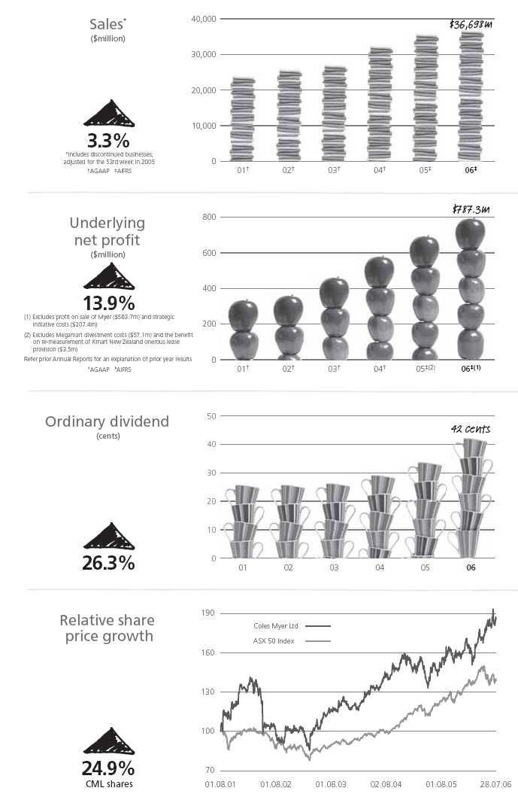

Financial Statements

Income Statements
For the 52 weeks ended 30 July 2006 (2005 53 weeks ended 31 July)
 |  | CML Group |  |  | CML
 |  | 2006 | 2005⁽¹⁾ | 2006 |  | 2005⁽¹⁾
 | Notes | $m | $m | $m |  | $m
Continuing operations
Revenue from sale of goods (excluding goods and services tax) | 2 | 34,212.0 | 33,018.2
Other operating revenue (excluding finance income) | 2 | 91.8 | 71.9 | 1.2 |  | 2.3
Cost of goods sold |  | (26,160.8) | (25,305.3)
Gross profit |  | 8,143.0 | 7,784.8 | 1.2 |  | 2.3
Other income | 2 | 134.4 | 68.3 | 1,556.9 |  | 1,063.6
Advertising expenses |  | (358.8) | (296.2) | (0.3) |  | (1.0)
Selling and occupancy expenses |  | (5,662.3) | (5,424.7) | (46.4) |  | (41.5)
Administrative expenses |  | (1,427.3) | (1,142.0) | (78.8) |  | (122.7)
Finance income | 2 | 25.0 | 29.0 | 3.0 |  | 3.7
Finance costs | 3 | (123.9) | (84.2) | (1.6) |  | (185.3)
Share of profit of joint venture accounted for using the equity
method | 14 | 21.9 | 37.0
Profit before income tax expense |  | 752.0 | 972.0 | 1,434.0 |  | 719.1
Income tax expense | 6 | (215.6) | (285.9) | (231.3) |  | (212.6)
Profit from continuing operations |  | 536.4 | 686.1 | 1,202.7 |  | 506.5
Profit/(loss) from discontinued operations | 5 | 627.2 | (48.2)
Profit for the year⁽²⁾ |  | 1,163.6 | 637.9 | 1,202.7 |  | 506.5
Earnings per share for profit from continuing operations
attributable to the ordinary equity holders of the Company
Basic earnings per share | 30 | 43.0 cents | 51.8 cents
Diluted earnings per share | 30 | 42.6 cents | 52.2 cents
Earnings per share for profit attributable to the ordinary
equity holders of the Company
Basic earnings per share | 30 | 93.4 cents | 47.9 cents
Diluted earnings per share | 30 | 92.4 cents | 48.5 cents

(1) | The Income Statements for the year ended 31 July 2005 have not been restated as permitted by AASB 132 Financial Instruments: Disclosure and Presentation and AASB 139 Financial Instruments: Recognition and Measurement, which have been adopted from 1 August 2005 (note 40).
(2) | The profit for the year ended 30 July 2006 was $1,163.6 million. After adjusting for the gain on disposal of Myer of $583.7 million (note 5) and strategic initiative costs of $207.4 million (note 4), the profit for the year would have been $787.3 million.
 | The profit for the year ended 31 July 2005 was $637.9 million. After adjusting for the Kmart New Zealand onerous lease provision re-measurement benefit of $3.5 million and the Megamart divestment costs of $57.1 million (note 4), the profit for the year would have been $691.5 million.
The above Income Statements should be read in conjunction with the accompanying notes.

Balance Sheets
As at 30 July 2006 (2005 as at 31 July)
 |  | CML Group |  |  | CML
 |  | 2006 | 2005⁽¹⁾ | 2006 |  | 2005⁽¹⁾
 | Notes | $m | $m | $m |  | $m
Current assets
Cash and cash equivalents | 8 | 485.6 | 440.9 | – |  | –
Trade and other receivables | 9 | 390.8 | 557.1 | 58.3 |  | 14.6
Inventories |  | 2,851.8 | 3,261.6
Derivative financial instruments | 10 | 1.4
Assets classified as held for sale | 12 | 151.7 |  | 0.4
Total current assets |  | 3,881.3 | 4,259.6 | 58.7 |  | 14.6
Non current assets
Receivables | 13 | 43.7 | 51.9 | 14.3 |  | 18.0
Investments | 14 | 125.0 | 144.9 | 4,806.7 |  | 4,668.2
Derivative financial instruments | 10 | 9.4
Property, plant and equipment | 15 | 3,133.3 | 3,487.8 | 154.8 |  | 153.5
Investment properties | 16 | 7.6 | 9.6
Deferred tax assets | 17 | 484.5 | 449.0 | 73.8 |  | 35.1
Intangible assets | 18 | 1,412.2 | 803.3 | 49.2 |  | 20.0
Retirement benefit asset | 19 | 38.3 | 17.7 | 38.3 |  | 17.7
Total non current assets |  | 5,254.0 | 4,964.2 | 5,137.1 |  | 4,912.5
Total assets |  | 9,135.3 | 9,223.8 | 5,195.8 |  | 4,927.1
Current liabilities
Trade and other payables | 20 | 3,080.3 | 3,018.8 | 329.1 |  | 163.5
Interest bearing liabilities | 21 | 30.2 | 216.0
Derivative financial instruments | 10 | 24.0
Tax liabilities |  | 66.4 | 127.3 | 65.2 |  | 124.0
Provisions | 22 | 761.9 | 600.8 | 206.4 |  | 96.2
Total current liabilities |  | 3,962.8 | 3,962.9 | 600.7 |  | 383.7
Non current liabilities
Payables | 20 | 23.0
Interest bearing liabilities | 23 | 974.0 | 1,213.3
Loans | 24 |  |  | 1,808.1 |  | 2,046.5
Derivative financial instruments | 10 | 16.1
Deferred tax liabilities | 25 | 77.6 | 103.0 | 12.5 |  | 5.6
Provisions | 22 | 320.7 | 317.9 | 246.0 |  | 216.5
Other | 26 | 163.1 | 211.6 | 3.2 |  | 2.3
Total non current liabilities |  | 1,574.5 | 1,845.8 | 2,069.8 |  | 2,270.9
Total liabilities |  | 5,537.3 | 5,808.7 | 2,670.5 |  | 2,654.6
Net assets |  | 3,598.0 | 3,415.1 | 2,525.3 |  | 2,272.5
Equity
Contributed equity | 27 | 2,144.2 | 2,068.6 | 2,157.2 |  | 2,083.6
Reserves | 28 | 3.9 | 7.1 | 19.8 |  | 7.6
Retained profits | 29 | 1,449.9 | 1,339.4 | 348.3 |  | 181.3
Total equity | 29 | 3,598.0 | 3,415.1 | 2,525.3 |  | 2,272.5

(1) The Balance Sheets for the year ended 31 July 2005 have not been restated as permitted by AASB 132 Financial Instruments: Disclosure and Presentation and AASB 139 Financial Instruments: Recognition and Measurement, which have been adopted from 1 August 2005 (note 40).
The above Balance Sheets should be read in conjunction with the accompanying notes.

Statements of Recognised Income & Expenses
For the 52 weeks ended 30 July 2006 (2005 53 weeks ended 31 July)
 |  | CML Group |  |  | CML
 |  | 2006 | 2005⁽¹⁾ | 2006 |  | 2005⁽¹⁾
 | Notes | $m | $m | $m |  | $m
Foreign currency translation reserve
Exchange differences on translation of
foreign operations | 28 | (7.3) | (0.5)
Cash flow hedge reserve
Net hedging losses recognised directly in equity | 28 | (11.5)
Net hedging gains transferred to financial liabilities | 28 | –
Net hedging gains transferred to inventory | 28 | (8.6)
Retained profits
Actuarial gains on defined benefit plan | 19 | 17.4 | 2.7 | 17.4 |  | 2.7
 |  | (10.0) | 2.2 | 17.4 |  | 2.7
Income tax on equity items | 6 | 0.8 | (0.9) | (5.2) |  | (0.9)
Net (expenses)/income recognised directly in equity |  | (9.2) | 1.3 | 12.2 |  | 1.8
Profit for the year |  | 1,163.6 | 637.9 | 1,202.7 |  | 506.5
Total recognised income for the year | 29 | 1,154.4 | 639.2 | 1,214.9 |  | 508.3
Effects of change in accounting policy – financial instruments
Adjustment on adoption of AASB 132 and AASB 139, net of tax:
Retained profits | 29 | (20.7)
Reserves | 29 | 6.0
 |  | (14.7)

(1) The Statements of Recognised Income and Expenses for the year ended 31 July 2005 have not been restated as permitted by AASB 132 Financial Instruments: Disclosure and Presentation and AASB 139 Financial Instruments: Recognition and Measurement, which have been adopted from 1 August 2005 (note 40). The above Statements of Recognised Income and Expenses should be read in conjunction with the accompanying notes.

Cash Flow Statements
For the 52 weeks ended 30 July 2006 (2005 53 weeks ended 31 July)
 |  | CML Group |  |  | CML
 |  | Inflows/(outflows) |  | Inflows/(outflows)
 |  | 2006 | 2005⁽¹⁾ | 2006 | 2005⁽¹⁾
 | Notes | $m | $m | $m | $m
Cash flows from operating activities
Receipts from customers (inclusive of goods and services tax) |  | 39,814.5 | 39,251.4
Payments to suppliers and employees
(inclusive of goods and services tax) |  | (38,012.2) | (37,659.7) | (452.4) | (574.5)
Distributions received from joint venture partnership |  | 10.2 | 10.1
Finance income received |  | 23.6 | 28.9 | 0.2 | 1.6
Finance costs paid |  | (112.8) | (71.1) |  | (0.3)
Income tax paid |  | (422.7) | (402.5) | (415.1) | (399.6)
Net cash from operating activities | A | 1,300.6 | 1,157.1 | (867.3) | (972.8)
Cash flows from investing activities
Payments for property, plant and equipment and
intangible assets |  | (1,043.1) | (925.0) | (80.8) | (97.5)
Payments for purchase of businesses and controlled entities,
net of cash acquired | 34 | (202.5) | (120.0)
Payments for purchase of other investments |  |  | (2.0)
Payment for purchase of joint venture |  | (0.9) | (1.3)
Proceeds on sale of property, plant and equipment |  | 19.9 | 23.8 | 1.2 | 1.2
Proceeds on sale of businesses and controlled entities,
net of transaction costs |  | 1,309.9 | 3.9 | 810.3
Repayment of loan from other entities |  |  |  | 0.3 | 15.7
Proceeds on sale of other investments |  | 13.3
Net cash from investing activities |  | 96.6 | (1,020.6) | 731.0 | (80.6)
Cash flows from financing activities
Proceeds from contributions to equity |  | 122.5 | 120.0 | 120.5 | 108.0
Payments for purchases of buy-back shares,
including transaction costs |  | (838.2) | (704.4) | (838.2) | (704.4)
Proceeds from borrowings |  | 8,309.2 | 3,171.7 | 1,307.1 | 2,083.0
Repayments of borrowings |  | (8,496.9) | (2,691.6)
Dividends paid | 7 | (453.1) | (433.2) | (453.1) | (433.2)
Net cash from financing activities |  | (1,356.5) | (537.5) | 136.3 | 1,053.4
Net increase/(decrease) in cash held |  | 40.7 | (401.0) | – | –
Cash at the start of the year |  | 440.9 | 841.9 | – | –
Cash at the end of the year | B | 481.6 | 440.9 | – | –
Non-cash investing activities | C
Financing arrangements | 23
(1) The Cash Flow Statements for the year ended 31 July 2005 have not been restated as permitted by AASB 132 Financial Instruments: Disclosure and Presentation and
AASB 139 Financial Instruments: Recognition and Measurement, which have been adopted from 1 August 2005 (note 40).
The above Cash Flow Statements should be read in conjunction with the accompanying notes.

Notes:
A. Reconciliation of net cash from operating activities to profit for the year is as follows:
 |  | CML Group |  |  | CML
 |  | 2006 | 2005 | 2006 | 2005
 |  | $m | $m | $m | $m
Net cash from operating activities |  | 1,300.6 | 1,157.1 | (867.3) | (972.8)
Depreciation and amortisation |  | (524.7) | (521.1) | (42.5) | (30.2)
Non-cash employee share-based payments expense |  | (8.4) | (5.4) | (2.9) | (2.4)
Non-cash employee retirement benefits expense |  | 3.2 | 5.7 | 1.0 | 1.7
Write-down of non current assets to recoverable amount |  | (77.7) | (70.3) | (0.6) | (2.2)
Net loss on disposal of plant and equipment |  | (42.3) | (41.0) | (2.3) | (3.4)
Net gain on disposal of freehold properties |  | 2.0 | 3.6
Net gain on sale of businesses and controlled entities |  | 571.0 | 0.3 | 159.2
Forgiveness of debt on amounts owing to controlled entities |  |  |  | 597.8
Loss on liquidation of controlled entities |  |  |  |  | (55.1)
Reversal of write-downs of non current assets |  | 48.1 | 3.6
Net gain on financial liabilities at fair value through the Income Statement |  | 21.9
Net gain on derivatives not qualifying as hedges |  | 9.4
Fair value adjustment relating to joint venture |  | 11.4 | 28.8
Net loss on derivatives qualifying as hedges |  | (17.4)
Net loss from fair value adjustments on investment properties |  |  | (5.8)
Other non-operating net income |  |  |  | 1,378.6 | 1,410.1
Changes in operating assets and liabilities:
Increase in trade and other receivables |  | 34.9 | 23.3 | 24.2 | 10.0
Increase in inventories |  | 120.9 | 128.5
Increase in deferred tax assets |  | 115.5 | 66.5 | 38.7 | 15.1
(Increase)/decrease in trade and other payables |  | (128.8) | 46.9 | (136.8) | (16.8)
Increase in other liabilities |  | (183.1) | (177.6) | (0.9) | (0.4)
Decrease in tax liabilities |  | 60.9 | 40.0 | 146.7 | 172.5
Increase in provisions |  | (185.7) | (76.0) | (88.5) | (19.0)
Decrease/(increase) in deferred tax liabilities |  | 31.9 | 30.8 | (1.7) | (0.6)
Profit for the year |  | 1,163.6 | 637.9 | 1,202.7 | 506.5
B. Reconciliation of cash
For the purposes of the Cash Flow Statements, cash includes cash on hand and at bank, highly liquid short-term deposits, net of bank overdraft.
Cash at the end of the year as shown in the Cash Flow Statements is reconciled to the relevant Balance Sheet items as follows:
 |  | CML Group |  |  | CML
 |  | 2006 | 2005 | 2006 | 2005
 | Notes | $m | $m | $m | $m
Cash and cash equivalents | 8 | 485.6 | 440.9 | – | –
Bank overdraft | 21 | (4.0) | –
 |  | 481.6 | 440.9 | – | –

C. Non-cash investing activities
During 2006, the CML Group acquired Hedley Hotel Group Pty Ltd, Hedley Hotel Group No. 2 Pty Ltd and Pharmacy Direct Pty Limited. In addition to the cash consideration of $202.5 million, consideration of $200.5 million was settled by way of new equity issued in CML (note 34).
During 2005, the CML Group liquidated its investment in CMFL Holdings Pty Ltd and Charlot Pty Ltd. The non-cash movement of $55.1 million relates to the write-off of the carrying value of these liquidated entities.

Notes to and Forming Part of the Financial Statements
Note 1 Summary of significant accounting policies
(a) Basis of preparation
This general purpose Financial Report has been prepared in accordance with Australian Accounting Standards (AASBs) adopted by the Australian Accounting Standards Board (AASB) and the Corporations Act 2001. The Financial Report is prepared in accordance with the historical cost convention, except for certain assets, which as noted, are measured at fair value.
International Financial Reporting Standards (IFRS) form the basis of AASBs adopted by the AASB, and for the purpose of this report are called Australian Equivalents to IFRS (AIFRS) to distinguish them from the previous Australian Generally Accepted Accounting Principles (AGAAP).
In the 2006 Financial Report, the expression ‘CML Group’ refers to Coles Myer Ltd. and its controlled entities, and ‘CML’ is used to refer to the legal entity Coles Myer Ltd.
(i) Application of AASB 1 First-time Adoption of Australian Equivalents to International Financial Reporting Standards
This annual report is the first CML Group Financial Report to be prepared in accordance with AIFRS. The financial statements of the CML Group also comply with IFRS, and interpretations adopted by the International Accounting Standards Board. The parent entity’s financial statements also comply with AIFRS except that it has elected to apply the relief provided to parent entities in respect of certain disclosure requirements contained in AASB 132 Financial Instruments: Presentation and Disclosure. AASB 1 First-time Adoption of Australian Equivalents to International Financial Reporting Standards has been applied in preparing this Financial Report.
Up until 31 July 2005, the Financial Report of the CML Group had been prepared in accordance with previous AGAAP. AGAAP differs in certain respects from AIFRS. When preparing the Financial Report for the year ended 30 July 2006, management adopted certain changes to the accounting valuation and consolidation methods applied in the previous AGAAP Financial Report to comply with AIFRS. With the exception of financial instruments, the comparative figures were restated to reflect these adjustments. The CML Group has taken the exemption available under AASB 1 to only apply AASB 132 Financial Instruments: Disclosure and Presentation and AASB 139 Financial Instruments: Recognition and Measurement from 1 August 2005 (note 40).
(ii) Early adoption of standards
The CML Group has elected to early adopt the following standards to the annual reporting period beginning 1 August 2005:
n | AASB 119 Employee Benefits (December 2004).
n | AASB 2004-3 Amendments to Australian Accounting Standards (December 2004), amending AASB 1 First-time Adoption of Australian Equivalents to International Financial Reporting Standards; AASB 101 Presentation of Financial Statements; AASB
 | 124 Related Party Disclosures.
n | AASB 2005-1 Amendments to Australian Accounting Standards (May 2005), amending AASB 139 Financial Instruments: Recognition and Measurement.
n | AASB 2005-3 Amendments to Australian Accounting Standards (June 2005), amending AASB 119 Employee Benefits.
n | AASB 2005-4 Amendments to Australian Accounting Standards (June 2005), amending AASB 139 Financial Instruments: Recognition and Measurement; AASB 132 Financial Instruments: Disclosure and Presentation; AASB 1 First-time Adoption of Australian Equivalents to International Financial Reporting Standards; AASB 1023 General Insurance Contracts; AASB 1038 Life Insurance Contracts.

n | AASB 2005-6 Amendments to Australian Accounting Standards (June 2005), amending AASB 3 Business Combinations.
n | AASB 2006-1 Amendments to Australian Accounting Standards (January 2006), amending AASB 121 The Effects of Changes in Foreign Exchange rates.
n | UIG 8 Scope of AASB 2 (March 2006).
n | UIG 9 Reassessment of Embedded Derivatives (April 2006).
Where applicable, the comparatives have been restated in accordance with AASB 108 Changes in Accounting Estimates and Errors.
(iii) Critical accounting estimates
The preparation of financial reports in conformity with AIFRS requires the use of certain critical accounting estimates and judgements. These judgements and estimates are based on historical experience, or various other assumptions that are considered reasonable under the circumstances, or with practices adopted within the retail industry. Further details of accounting estimates are provided in the relevant sections of this note.
(b) Principles of consolidation
The consolidated financial statements have been prepared on an economic entity basis for CML and the entities it controlled during the year and at year end. The effects of all transactions within the CML Group have been eliminated in full. A list of controlled entities at year end is contained in note 35. Where control of an entity is obtained during the year, its results are included in the Income Statement from the date on which control commences. Where control of an entity ceases during the financial year, its results are included for that part of the year where control existed.
Investments in controlled entities are accounted for at cost in the individual financial statements of CML.
(c) Equity accounting of associated entities and jointly controlled entities
The principles of equity accounting have been applied to entities that are not controlled, but over which the CML Group has significant influence, or to entities jointly controlled by the CML Group and one or more other parties through a contractual arrangement.
Investments accounted for using the equity method are initially recorded at cost. Adjustments are made to the carrying amount of the investment to reflect the CML Group’s share of profit or loss, changes in post acquisition reserves and dividends or distributions received.
(d) Revenue
Revenue from sale of goods, excluding lay-by transactions, is recognised at the point of sale and is after deducting duties and taxes paid. Revenue from lay-by transactions is recognised as part of revenue from sale of goods at the date upon which the customer satisfies all payment obligations and takes possession of the merchandise.
Revenue from sale of CML customer cards (gift, insurance and refund) is recognised when the card is redeemed and the customer purchases goods by using the card, or when the customer cards are no longer expected to be redeemed, based on an analysis of historical non-redemption rates.
Other operating revenue comprises: operating lease rental revenue (note 1(g)(ii)); gaming revenue recognised at the point of the customer transaction after deducting duties and taxes paid; and concession revenue recognised at the point of sale after deducting duties and taxes paid.
Finance income is recognised as it accrues, taking into account the effective yield on the financial asset, and is reported separately in the Income Statement.
(e) Foreign exchange
Items included in the financial statements of each of the CML Group’s entities are measured using the currency of the economic environment in which the entity primarily generates and expends cash (‘the functional currency’). The consolidated financial statements are presented in Australian dollars, which is CML’s functional and presentation currency.
Foreign currency transactions are translated to Australian currency at the rates of exchange prevailing at the dates of the transactions. Amounts receivable and payable in foreign currencies at balance date are translated at the rates of exchange prevailing on that date. Resulting exchange differences are brought to account as exchange gains or losses in the Income Statement in the financial year in which the exchange rates change, except when deferred in equity as qualifying cash flow hedges (note 1(l)). Translation of differences on non-monetary financial assets and liabilities are reported as part of the fair value gain or loss.
The results and financial position of foreign operations that have a functional currency different from the presentation currency are translated into the presentation currency as follows:
n | assets and liabilities are translated at the rates of exchange prevailing at balance date;
n | income and expenses are translated at an average rate for the year, which approximates the exchange rate at the dates of the transactions; and
n | equity items are translated at historical rates.
Exchange differences arising on translation are taken directly to the foreign currency translation reserve. When a foreign operation is sold, the cumulative foreign currency differences included in the foreign currency translation reserve are recognised in the Income Statement as part of the gain or loss on sale.
(f) Income tax
Income tax expense/(benefit) is the expected tax payable/(receivable) on the taxable income for the period, using tax rates enacted or substantively enacted at the reporting date. These amounts are adjusted by changes in deferred tax assets and liabilities attributable to temporary differences between the tax bases of assets and liabilities and their carrying amounts in the financial statements, and to unused tax losses.
Current and deferred taxes attributable to amounts recognised directly in equity are also recognised directly in equity.
Deferred tax balances are determined using the balance sheet method, which calculates temporary differences based on the carrying amounts of an entity’s assets and liabilities in the Balance Sheet and their associated tax bases. The amount of deferred tax provided is based on the expected manner of realisation of the asset or settlement of the liability, using tax rates enacted or substantively enacted at reporting date.
Deferred tax assets for temporary differences and unused tax losses are recognised only to the extent that it is probable that future taxable profits will be available against which the assets can be utilised.
(i) Tax consolidation legislation
CML and its wholly owned controlled Australian entities formed a tax consolidated Group effective 29 July 2002. As a result CML is taxed as a single entity. Tax sharing and tax funding agreements have been put in place between the members of the tax consolidated Group.
Under the tax funding agreement, the members of the tax consolidated Group agree to compensate CML for any tax payable
assumed and are compensated for any current receivable and deferred tax assets relating to unused tax losses or unused tax credits that are transferred to CML under the tax consolidation legislation. The funding amounts are determined by reference to the amounts in the wholly owned entities’ financial statements.
Amounts receivable or payable under an accounting tax funding agreement with the tax consolidated subsidiaries, are recognised separately as inter-company amounts receivable or payable. Expenses and revenues arising under the tax sharing arrangement are recognised as a component of income tax expense or revenue.
(g) Leases
(i) Operating leases
The CML Group as a tenant leases real estate, stores, office facilities and warehouses. These leases result in substantially all of the risks and benefits of ownership of the property being retained by the lessors, and accordingly, in the financial statements they are classified as operating leases. Payments made under operating leases are expensed on a straight-line basis over the term of the lease. Refer note 31(b) for details of non-cancellable operating lease commitments.
Lease incentives received on entering into operating leases are recognised as liabilities and are amortised over the lease term. The amortised lease incentive is recognised as a reduction to selling and occupancy expenses in the Income Statement.
The present value of future payments for surplus leased space under non-cancellable operating leases that are onerous contracts is recognised as a liability, on the basis described in the accounting policy note for onerous contracts (note 1(x)).
(ii) Operating lease rental revenue
Operating lease revenue consists of rentals from investment properties and sub lease rentals. Rentals received under operating leases are recognised on a straight-line basis over the term of the lease.
(h) Fair value estimation
The fair value of financial assets and financial liabilities must be estimated for recognition, measurement and disclosure purposes.
The fair value of financial instruments traded in active markets (such as publicly traded derivatives, and trading and available-for-sale securities) is based on quoted market prices at the balance sheet date. The quoted market price used for financial assets held by the CML Group is the current bid price and for financial liabilities is the current ask price.
The fair value of financial instruments that are not traded in an active market is determined using valuation techniques. The CML Group uses a variety of methods, including discounted cash flows to calculate the fair value of financial instruments. These calculations are performed using current market inputs, which may include the use of interest and forward exchange rates ruling at balance date. The CML Group makes assumptions concerning these valuations that are based on market conditions existing at each balance date. Quoted market prices or dealer quotes for similar instruments are used for long-term debt instruments held.
The nominal value of trade receivables and payables are assumed to approximate their fair values. The fair value of financial liabilities for disclosure purposes is estimated by discounting the future contractual cash flows at the current market interest rate that is available to the CML Group for similar financial instruments.
(i) Cash and cash equivalents
Cash and cash equivalents include cash at bank, cash on hand, and bank deposits. The carrying amount of these assets approximates their fair value due to the short-term to maturity.
(j) Trade and other receivables
Trade and other receivables are recognised at nominal amounts as they are due for settlement no more than 30 days from the date of recognition. A provision for doubtful debts (impairment loss) is recognised when collection of the full amount in accordance with the original terms is no longer probable. Bad debts specifically provided for in previous years are eliminated against the provision for doubtful debts. In all other cases, bad debts are written-off as an expense directly in the Income Statement.
(k) Inventories
At balance date all inventories on hand or in transit are valued at the lower of cost and net realisable value. Cost is determined using the weighted average cost method, after deducting any purchase settlement discount and including logistics expenses incurred in bringing the inventories to their present location and condition.
Volume-related supplier rebates and supplier promotional rebates are recognised as a reduction in the cost of inventory and are recorded as a reduction of cost of goods sold when the inventory is sold.
The net realisable value of inventories is the estimated selling price in the ordinary course of business less estimated costs to sell (including marketing, selling and logistics costs). It approximates fair value less cost to sell. The key assumptions, which require the use of management judgement, are the variables affecting the estimated costs to sell and the expected selling price. These key assumptions are reviewed annually. Any reassessment of cost to sell or selling price in a particular year will affect the cost of goods sold (either increasing or decreasing).
(l) Derivatives
Derivatives are initially recognised at fair value on the date a derivative contract is entered into and are subsequently remeasured to their fair value. The method of recognising the resulting gain or loss depends on whether the derivative is designated as a hedging instrument, and if so, the nature of the item being hedged. At the inception of a hedge transaction, the relationship between the hedging instrument and hedged item is documented. The CML Group also documents its assessment, both at hedge inception and on an ongoing basis, of whether the derivatives that are used in hedging transactions have been and will continue to be, highly effective in offsetting changes in fair values or cash flows of hedged items.
(i) Fair value hedge
Changes in the fair value of derivatives that are designated and qualify as fair value hedges are recorded in the Income Statement, together with any changes in the fair value of the hedged asset or liability that are attributable to the hedged risk.
(ii) Cash flow hedge
The effective portion of changes in the fair value of derivatives that are designated and qualify as cash flow hedges is recognised directly in equity in the hedge reserve. Amounts accumulated in equity are recycled in the Income Statement in the periods when the hedged item will affect profit or loss. However, when the forecast transaction that is hedged results in the recognition of a non-financial asset (for example, inventory) or a non-financial liability, the gains and losses previously deferred in equity are transferred from equity and included in the measurement of the initial cost or carrying amount of the asset or liability. The gain or loss relating to the ineffective portion is recognised immediately in the Income Statement.
(iii) Derivatives that do not qualify for hedge accounting
Certain derivative instruments do not qualify for hedge accounting. Changes in the fair value of any derivative instrument that does not qualify for hedge accounting are recognised immediately in the Income Statement.
Prior to 1 August 2005
The CML Group was exposed to changes in interest rates and foreign exchange rates from its activities. These risks were hedged by the CML Group primarily through the use of derivatives, which mainly took the form of swaps, futures, forward contracts and options. Interest rate derivatives that were designated and were effective as hedges were deferred and amortised over the remaining life of the hedged items. Cross currency swaps were revalued at spot rates at balance date and movements were recognised in the Income Statement as gains and losses together with the foreign currency gains and losses on the underlying borrowings.
With respect to specific commitments, hedging was undertaken in order to avoid or minimise possible adverse financial effects of movements in exchange rates. Gains or costs arising upon entry into a hedging transaction intended to hedge the purchase or sale of goods and services, together with subsequent exchange gains or losses resulting from those transactions, were deferred in the Balance Sheet from the inception of the hedging transaction up to the date of the purchase or sale and included in the measurement of the purchase or sale. The net amounts receivable or payable under the hedging transaction were also recorded in the Balance Sheet. Any gains or losses arising on the hedging transaction after the recognition of the hedged purchase or sale were included in the Income Statement.
(m) Assets (or disposal groups) classified as held for sale and discontinued operations
Non current assets (or disposal groups), whose carrying amount will be recovered principally through a sale transaction rather than through continuing use, are classified as held for sale and are stated at the lower of their carrying amount and fair value less costs to sell.
An impairment loss is recognised for any initial or subsequent write-down of the asset (or disposal group) to fair value less costs to sell. A gain is recognised for any subsequent increases in fair value less costs to sell of an asset (or disposal group), but not in excess of any cumulative impairment loss previously recognised. A gain or loss not previously recognised by the date of the sale of the non current asset (or disposal group) is recognised at the date of sale.
Non current assets (including those that are part of a disposal group) are not depreciated or amortised while they are classified as held for sale. Interest and other expenses attributable to the liabilities of a disposal group classified as held for sale continue to be recognised.
A discontinued operation is a component of an entity that has been disposed of or is classified as held for sale, which represents a separate major line of business, and is part of a single co-ordinated plan to dispose of such a line of business or is a subsidiary acquired exclusively with a view to resale.
(n) Investments in financial assets
Investments are classified into the following categories: financial assets at fair value through the profit or loss, held-to-maturity financial assets, and available-for-sale financial assets. The classification depends on the purpose for which the investments are held. Management determines the classification of held-to-maturity assets at initial recognition and re-evaluates this designation at each reporting date.
Available-for-sale financial assets and financial assets at fair value through the profit and loss are subsequently carried at fair value. Realised and unrealised gains and losses arising from changes in the fair value of financial assets are included in the Income Statement in the period in which they arise. Unrealised gains and losses arising from changes in the fair value of non-monetary securities classified as available-for-sale are recognised in equity in the available-for-sale fair value reserve. When securities classified as available-for-sale are sold or impaired, the accumulated fair value adjustments are included in the Income Statement as gains and losses from investment securities.
The fair values of quoted investments are based on current bid prices.
Prior to 1 August 2005
The carrying amounts of all listed investments were stated at the lower of cost and recoverable amount. Dividends from all investments were brought to account when receivable.
(o) Property, plant and equipment
Freehold land and buildings are stated at cost less accumulated depreciation and impairment. Leasehold improvements are stated at cost less accumulated amortisation and impairment (note 1(r)). Cost includes expenditure that is directly attributable to the acquisition of the item.
Depreciation and amortisation is provided on a straight-line basis, on all property, plant and equipment, over their estimated useful lives. The rates used for each class of assets are as follows:
Buildings | 1.5%
Plant and equipment | 5% – 33%
Leasehold improvements | shorter of unexpired period of the lease
 | or the improvement’s useful life

Useful lives and the residual value of property, plant and equipment are reviewed annually. Judgement is applied in determining the useful lives of property, plant and equipment. These judgements are supported by consultation with internal technical experts. Any reassessment of useful lives and residual value in a particular year will affect the depreciation and amortisation expense (either increasing or decreasing) from the date of reassessment through to the end of the reassessed useful life for both the current and future years.
Costs incurred subsequent to an asset’s initial recognition are included in the asset’s carrying amount or recognised as a separate asset, as appropriate, only when it is probable that future economic benefits associated with the item will flow to the CML Group and the cost of the item can be reliably measured. Repairs and maintenance are charged to the Income Statement during the financial period in which they are incurred.
Net gains and losses on disposals are determined by comparing the proceeds of each disposed asset with its carrying amount, and are included in the Income Statement as other income or selling and occupancy expenses respectively.
(p) Investment properties
Property is classified as an investment property, where it is owned by the CML Group for the purpose of earning a rental stream. Investment properties are measured at fair value. Valuations are made with sufficient regularity to ensure the carrying amount of property does not differ materially from its fair value at balance date.
Annual internal assessments are made, supplemented by independent assessments at least every three years. Potential capital gains tax is not taken into account in determining revaluation amounts unless it is expected that a liability will crystallise.
(q) Intangible assets
Goodwill and other intangible assets with indefinite lives, including brand names and licences are carried at cost, less any accumulated impairment losses. Refer note 1(r)(i).
Intangible assets with finite useful lives, including computer software and co-branded operating rights, are carried at cost less any accumulated amortisation and impairment losses.
Useful lives of intangible assets with finite lives are reviewed annually. Any reassessment of useful lives in a particular year will affect the
amortisation expense (either increasing or decreasing) through to the end of the reassessed useful life for both the current and future years.
Effective 1 August 2005, the CML Group changed its accounting estimate with respect to the useful life of major investments of computer software. The previous estimate recognised that computer software had a useful life not exceeding five years irrespective of the size of the investment. The revised accounting estimate recognises that for major investments of computer software, the useful life will not exceed seven years. Other computer software projects will continue to have a useful life not exceeding five years. The impact of the change was immaterial for the year ended 30 July 2006.
(i) Goodwill
Where an entity or operation is acquired, the goodwill represents the difference between the cost of the business acquisition over the net fair value of the identifiable assets, liabilities and contingent liabilities acquired. Goodwill is allocated to the cash generating units (CGUs), for the purpose of impairment testing, based on an assessment of the group of CGUs sharing the synergies embodied in the goodwill acquired.
(ii) Brand names
Brand names purchased by the CML Group are measured at fair value on acquisition.
(iii) Gaming licences
Gaming licences purchased by the CML Group, are measured at fair value on acquisition. Licences have indefinite lives where they have unlimited legal lives and are unlikely to become commercially obsolete.
(iv) Computer software
All costs directly incurred in the purchase or development of major computer software or subsequent upgrades and material enhancements, which can be reliably measured and are not integral to a related asset, are capitalised as intangible assets. Direct costs may include internal payroll and on-costs for employees directly associated with the project. Costs incurred on computer software maintenance or during the planning (research) phase are expensed as incurred. Computer software is amortised over the period of time during which the benefits are expected to arise, being five to seven years. Amortisation commences once the computer software is available for use.
(v) Co-branded operating rights
The CML Group holds the right to operate certain Shell fuel and convenience outlets and certain Shell car service workshops around Australia. For the Shell fuel and convenience outlets, an exclusive 20 year supply agreement for fuel and lubricant products is in place, which allows for the sites to be branded both ‘Coles Express’ and ‘Shell’. Under a related co-terminus agreement, the Shell car service workshops, largely located next to the co-branded ‘Coles Express’ and ‘Shell’ sites, are branded ‘Kmart Tyre and Auto’.
Amortisation of the co-branded operating rights commences on the date of the agreement, and is spread over the life of the supply agreement. Co-branded operating rights are tested for impairment where events or circumstances indicate that impairment may exist.
(r) Impairment of assets
(i) Non-financial assets
The recoverable amount of non-financial assets, excluding deferred tax assets, retirement benefit assets and inventories are reviewed at each reporting date to determine whether there is any indication of impairment. If any such indication exists, the asset is tested for impairment by comparing its recoverable amount to its carrying amount.
Assets with indefinite useful lives are not subject to amortisation and are tested on an annual basis for impairment, or where an indication of impairment exists. Assets that are subject to amortisation are reviewed for impairment whenever events or changes in circumstances indicate
that the carrying amount may not be recoverable. The recoverable amount is estimated for an individual asset, or if it is not possible to estimate the recoverable amount for an individual asset, the recoverable amount of the CGU to which the asset belongs is determined. For store assets, the appropriate CGU is an individual store.
An impairment loss is recognised as an expense when the carrying amount of an asset or CGU exceeds its recoverable amount. Recoverable amount is determined as the higher of fair value less costs to sell and value in use. Impairment losses recognised in respect of CGUs are allocated first to reduce the carrying amount of any goodwill allocated to the CGU (group of CGUs) and then to reduce the carrying amount of the other assets in the CGU or group of CGUs on a pro-rata basis.
In calculating value in use, the cash flows include the net amount expected to be recovered through the cash inflows and outflows arising from the continued use and subsequent disposal of an asset or CGU. Cash flow estimates do not include any cash inflows and outflows expected to arise from future restructurings which are not yet committed, or from improving or enhancing an asset’s or CGU’s performance. In assessing value in use, the estimated cash flows are discounted to their present value using a pre-tax discount rate that reflects the current market assessment of the risks specific to the asset or CGU.
An impairment loss recognised in prior periods for an asset (other than goodwill) is reversed if there has been a favourable change in the estimates used to determine the asset’s recoverable amount since the last impairment loss was recognised. The increased carrying amount of an asset due to a reversal of an impairment loss does not exceed the carrying amount that would have been determined (net of amortisation or depreciation) had no impairment loss been recognised for the asset in prior periods.
(ii) Financial assets
An assessment for impairment is carried out at each reporting date based on the existence of objective evidence of impairment.
For financial assets carried at cost or amortised cost, the amount of any loss will be recognised in the Income Statement. The amount of any impairment is calculated as the difference between the carrying amount of the asset, or group of assets and the estimated future cash flows.
For available-for-sale financial assets, any potential impairment is measured on the same basis as financial assets at cost. However, cumulative losses are recognised directly in equity and will only be removed and recognised in the Income Statement, where there is an extended period during which the carrying amount of the financial asset has been below the acquisition cost or the instrument is settled.
(s) Trade and other payables
Trade and other payables, including accruals, represent liabilities for goods and services provided to the CML Group, prior to balance date, which were unpaid. The amounts are unsecured and are usually paid between seven and 60 days after recognition.
Other payables also include the liability for:
n | CML customer cards and gift vouchers. The key assumption in measuring the liability for gift cards and vouchers is the expected redemption rates by customers. Expected redemption rates are reviewed annually. Any reassessment of expected redemption rates in a particular year will affect the revenue recognised for gift cards and vouchers (either increasing or decreasing).
n | loyalty program. The key assumptions in measuring the liability are redemption rates and cost per point redeemed. These amounts are measured through an actuarial assessment. Expected redemption rates and cost per point redeemed assumptions are reviewed annually. Any reassessment of expected redemption rates or cost per point in a particular year will affect the expense recognised for the loyalty program (either increasing or decreasing).
(t) Interest bearing liabilities and finance costs
Interest bearing liabilities, unless designated at fair value through the Income Statement, are initially recognised at their fair value, net of transaction costs incurred. Subsequent measurement is at amortised cost with any difference between the net proceeds and the maturity amount recognised in the Income Statement over the period of the borrowings using the effective interest rate method. Foreign currency denominated borrowings are translated at exchange rates ruling at reporting date.
The treatment for interest bearing liabilities designated as hedged items in fair value hedge relationships through the Income Statement is set out in note 1(l)(i).
Finance costs include interest expense, amortisation of discounts or premiums relating to borrowings, amortisation of ancillary costs incurred in connection with the arrangement of borrowings and the unwinding discount on provision balances. Finance costs are brought to account in determining profit for the year.
Prior to 1 August 2005
Borrowings were carried at their principal amounts. Interest was recognised as an expense as it accrued. Long and medium-term borrowing expenses were amortised over the lesser of five years or the term of the relevant borrowing.
(u) Employee entitlements
(i) Annual leave entitlements
Liabilities for annual leave entitlements are accrued based on statutory and contractual requirements, including related on-costs. They are measured using the rates expected to be paid when the obligations are settled, and are discounted using the Commonwealth Government fixed coupon bond rates, where the effect of discounting is material.
(ii) Long service leave entitlements
Liabilities for long service leave entitlements are accrued at the present value of expected future payments to be made resulting from services provided by employees up to balance date. Liabilities for long service leave entitlements, which are not expected to be paid or settled within 12 months, are discounted using the rates attaching to Commonwealth Government fixed coupon bond rates with similar maturity terms.
Management judgement is applied in determining the following key assumptions used in the calculation of long service leave at balance date:
n | future increases in wages and salaries;
n | future on cost rates; and
n | experience of employee departures and period of service.
Refer to note 22 for further details on the key management judgements used in the calculation of long service leave.
(iii) Bonus plans
A liability for employee bonuses are recognised when there is no realistic alternative but to settle the liability and at least one of the following conditions is met:
n | there are formal terms in the plan for determining the amount of the entitlement;
n | the amounts to be paid are determined before the time of completion of the financial report; or
n | past practice gives clear evidence of the amount of the obligation.
Liabilities for bonuses expected to be settled within 12 months are measured at the amounts expected to be paid when they are settled.
(iv) Retirement benefit assets and obligations
The CML Group contributes to a number of superannuation funds that have been established to provide benefits for employees.
Apart from the Coles Myer Superannuation Plan, all funds are defined contribution funds, and contributions to them are recognised as an expense as they become payable. For CML’s defined benefit plan, the Coles Myer Superannuation Plan, a liability or asset is recognised on the Balance Sheet. This liability or asset is measured as the present value of the defined benefit obligation at the reporting date plus actuarial gains (less actuarial losses) less the fair value of the defined benefit plan’s assets at that date and any unrecognised past service cost. The present value of the defined benefit obligation is based on expected future payments, which arise from membership of the fund to the reporting date, assessed annually by independent actuaries. Consideration is given to expected future wage and salary levels, experience of employee departures and periods of service. Expected future payments are discounted using the rates attaching to Commonwealth Government bonds with similar maturity terms.
The CML Group expenses contributions to the defined benefit plan as they become due and payable. Actuarial gains and losses arising from experience adjustments and changes in actuarial assumptions are charged or credited to equity. Past service costs are recognised immediately in the Income Statement, unless the changes to the defined benefit plan are conditional on the employees remaining in service for a specified period of time (the vesting period). In this case, the past service costs are amortised on a straight-line basis over the vesting period. Future taxes that are funded by the entity and are part of the provision of the existing benefit obligation (for example, taxes on investment income and employer contributions) are taken into account in measuring the net liability or asset.
(v) Redundancy provisions
A provision for redundancy is recognised when there is a detailed formal plan, which is without realistic possibility of withdrawal, and identifies at least:
n | the location, function and approximate number of employees who will be compensated for termination of their services (for involuntarily terminated employees, the plan must also specifically identify the benefit formula to be used for determining individual employee involuntary termination payments, job classification and functions);
n | when the plan will be implemented; and
n | the estimated expenditures that will be made.
(vi) Equity-based payments
Equity-based compensation benefits are provided to employees via CML’s various incentive plans (note 36). Equity-based compensation benefits include shares, options and performance rights.
Loans made prior to 7 November 2002 by CML to assist in the purchase of shares under an incentive plan are recognised for the CML Group as an increase to contributed equity when the loans are settled, and any shares held in trust are deducted from contributed equity. For the parent entity, loans made to assist in the purchase of shares under incentive plans are recognised as a loan receivable.
Equity instruments granted before 7 November 2002 and/or which have vested before 1 January 2005
No expense is recognised in respect of these equity instruments. The shares are recognised when the equity instruments are exercised and the proceeds received are allocated to contributed equity.
Equity instruments granted after 7 November 2002 which have vested after 1 January 2005
The fair value of equity instruments granted is recognised as an employee benefit expense with a corresponding increase in equity. The fair value is measured at grant date taking into account market performance conditions only, and spread over the vesting period during which the employees may become unconditionally entitled to the options. The fair value of equity instruments granted under the Senior Executive Performance Share Plan are measured using the Monte-Carlo pricing model, and equity instruments issued under the Coles Myer Executive Share Option Plan are measured using the Black-Scholes pricing model. The amount recognised as an expense is adjusted to reflect the actual number of equity instruments that vest, except where forfeiture is due to market related conditions.
(v) Contributed equity
Ordinary shares are classified as contributed equity. Transaction costs arising on the issue or buy-back of equity instruments are recognised directly in contributed equity, net of tax.
(w) Deferred expenditure – stamp duty
Payments of stamp duty on leased properties are deferred to the extent they are expected to be recovered through future revenue. These payments are amortised over the period during which the benefits are expected to be realised, which is usually the life of the lease.
(x) Provisions
(i) Onerous contracts
A provision for onerous contracts is recognised when the expected benefits to be derived from a contract are less than the unavoidable costs of meeting the obligations under that contract, and only after any impairment losses to assets dedicated to that contract have been recognised. The unavoidable costs are calculated as the lower of the cost of fulfilling the contract and any compensation or penalties arising from the failure to fulfil it.
The provision recognised is based on the difference between the estimated cash flows to meet the unavoidable costs and the estimated cash flows to be received, having regard to the risks of the activities relating to the contract. The net estimated cash flows are discounted using the rates attaching to Commonwealth Government bonds with similar maturity terms, where the effect of discounting is material.
(ii) Workers’ compensation and self-insurance
The CML Group is self-insured for costs relating to workers’ compensation and general liability claims. Provisions are recognised based on claims reported, and an estimate of claims incurred but not yet reported, prior to reporting date. These provisions are determined on a discounted basis, utilising an actuarially determined method, which is based on various assumptions including but not limited to future inflation, investment return, average claim size and claim administration expenses. These assumptions are reviewed annually and any reassessment of these assumptions will affect the workers’ compensation expense (either increasing or decreasing the expense).
(iii) Restructuring provisions
A provision for restructuring is recognised when an obligating event has occurred, and at a minimum there is a detailed formal plan, which has either been announced or is in the process of being implemented, and at least identifies:
n | the business or part of a business impacted by the plan;
n | the principal locations affected; and
n | the expenditures that will be made.
(iv) Dividends
Provision is made for the amount of any dividend declared by the Directors on or before the end of the financial year but not distributed at balance date.
(y) Acquisitions of assets (including business combinations)
The purchase method of accounting is used for all acquisitions of assets (including business combinations) regardless of whether equity instruments or other assets are acquired. Cost is measured as the fair value of the assets given up, shares issued or liabilities undertaken at the date of acquisition plus incidental costs directly attributable to the acquisition. Where equity instruments are issued in an acquisition, the value of the instruments is their market price as at the acquisition date, unless the notional price at which they could be placed in the market is a better indicator of fair value.
Identifiable assets acquired and liabilities and contingent liabilities assumed in a business combination are measured at their fair values at the acquisition date. The excess of the cost of acquisition over the fair value of the CML Group’s share of the identifiable net assets acquired is recorded as goodwill (note 1(q)). If the cost of acquisition is less than the fair value of the net assets of the subsidiary acquired, the difference is recognised directly in the Income Statement.
(z) Goods and Services Tax (GST)
Revenues, expenses and assets are generally recognised net of the amount of GST. Where GST is incurred on purchases and is not recoverable from the Australian Taxation Office (ATO), it is included as part of the cost of acquisition of an asset or as part of an item of expense. Receivables and payables are stated with the amount of GST included. The net amount of GST recoverable from, or payable to, the ATO is included as a current asset or liability on the Balance Sheet.
Cash flows are included in the Cash Flow Statement on a gross basis. The GST components of cash flows arising from investing and financing activities, which are recoverable from, or payable to the ATO, are classified as operating cash flows.
(aa) Earnings per share
(i) Basic earnings per share
Basic earnings per share is determined by dividing profit for the year by the weighted average number of ordinary shares outstanding during the financial year.
Prior to 1 August 2005
Basic earnings per share was determined by dividing profit for the year less non-redeemable reset convertible preference shares (ReCAPS) dividends, by the weighted average number of ordinary shares outstanding during the financial year.
(ii) Diluted earnings per share
Diluted earnings per share adjusts basic earnings per share to take into account the after income tax effect of financing costs associated with dilutive potential ordinary shares and the weighted average number of shares assumed to have been issued for no consideration in relation to dilutive potential ordinary shares. The number of ordinary shares assumed to be issued for no consideration represents the difference between the number that would have been issued at the exercise price and the number that would have been issued at the average market price.
The identification of dilutive potential ordinary shares is based on net profit or loss from continuing ordinary operations and is applied on a cumulative basis, taking into account the incremental earnings and incremental number of shares for each series of potential ordinary shares.
(ab) Rounding of amounts
Dollar amounts have been rounded to the nearest tenth of a million dollars unless specifically stated otherwise. Where the amount is $50,000 or less, this is indicated by a dash (‘–’). For the purposes of notes 36 and 37 a dash indicates a nil balance.
(ac) Segment reporting
Individual business segments have been identified on the basis of grouping individual products and services subject to similar risks and returns. The business segments reported are Food, Liquor and Fuel; Kmart; Officeworks; Target; Property and unallocated; and discontinued operations (where applicable).
(ad) New accounting standards and UIG interpretations
Certain new accounting standards and UIG interpretations have been published that are not mandatory for the 30 July 2006 reporting period. The CML Group’s assessment of these new standards and interpretations is set out below:
(i) UIG 4 Determining Whether an Asset Contains a Lease
UIG 4 is applicable to annual reporting periods beginning on or after 1 January 2006. The CML Group has elected not to early adopt UIG 4. Instead it will apply UIG 4 and the related transitional provisions for the first time in its 2007 Financial Report. As a result, the CML Group will apply UIG 4 on the basis of facts and circumstances that existed as at 30 July 2006. An assessment of the impact of UIG 4 is currently being performed and as yet it is not possible to make a reliable measurement of the financial impact.
(ii) AASB 2005-5 Amendments to Australian Accounting Standards (June 2005)
AASB 2005-5 makes consequential amendments to AASB 1 First-time Adoption of Australian Equivalents to International Financial Reporting Standards and AASB 139 Financial Instruments: Recognition and Measurement, arising from the release of UIG 4 and UIG 5 Rights to Interest arising from Decommissioning, Restoration and Environmental Rehabilitation Funds (June 2005).
(iii) AASB 7 Financial Instruments: Disclosures and AASB 2005-10 Amendments to Australian Accounting Standards [AASB 132, AASB 101, AASB 114, AASB 117, AASB 133, AASB 139, AASB 1, AASB 4, AASB 1023 and AASB 1038] AASB 7 and AASB 2005-10 are applicable to annual reporting periods beginning on or after 1 January 2007. The CML Group has not early adopted AASB 7 or the related amendments. Application of AASB 7 and the related amendments will not affect any of the amounts currently recognised in the financial statements, but will impact the type of information disclosed in relation to the CML Group’s financial statements.
(iv) AASB 2005-9 Amendments to Australian Accounting Standards
[AASB 4, AASB 1023, AASB 139 and AASB 132]
AASB 2005-9 is applicable to annual reporting periods beginning on or after 1 January 2006. The amendments relate to the accounting for financial guarantee contracts. Application of the revised rules may result in the recognition of financial liabilities in the financial statements of the parent entity, CML, under guarantees given pursuant to the Deed of Cross Guarantee (note 35) in respect of amounts payable by wholly-owned subsidiaries. The parent entity and the CML Group may also have to recognise a liability in relation to guarantees given by subsidiaries in respect of leases of former subsidiaries (note 39). An assessment of the fair value of these guarantees is currently being performed, and as yet it is not possible to make a reliable measurement of the financial impact. The new rules will be implemented retrospectively with a restatement of comparatives as required by AASB 108 Accounting Policies, Changes in Accounting Estimates and Errors.
Note 2 Revenue and other income
 | CML Group |  |  | CML
 | 2006 | 2005 | 2006 |  | 2005
 | $m | $m | $m |  | $m
Revenue from continuing operations:
Sale of goods (excluding GST) | 34,212.0 | 33,018.2
 | 34,212.0 | 33,018.2
Other operating revenue from continuing operations
Gaming machine revenue | 40.3 | 29.7
Concession revenue | 28.0 | 25.1
Rental revenue:
Controlled entities |  |  | 0.3 |  | 1.0
Other entities | 23.5 | 17.1 | 0.9 |  | 1.3
 | 23.5 | 17.1 | 1.2 |  | 2.3
Total other operating revenue from continuing operations | 91.8 | 71.9 | 1.2 |  | 2.3
Finance income from continuing operations | 25.0 | 29.0 | 3.0 |  | 3.7⁽¹⁾
Total revenue | 34,328.8 | 33,119.1 | 4.2 |  | 6.0
Other income
Net gain on disposal of non current assets:
Freehold properties | 2.0 | 3.5
Businesses and controlled entities | 7.3 | 0.3
 | 9.3 | 3.8
Net gain on:
Financial liabilities at fair value through the Income Statement | 21.9
Derivatives not qualifying as hedges | 9.4
 | 31.3
Management fees |  |  | 774.1 |  | 1,051.8
Net gain on disposal of Myer (note 14) |  |  | 159.2
Forgiveness of debt on amounts owing to controlled entities (note 24) |  |  | 597.8
Other | 93.8 | 64.5 | 25.8 |  | 11.8
Total other income | 134.4 | 68.3 | 1,556.9 |  | 1,063.6
Revenue from discontinued operations:
Sale of goods (excluding GST) | 2,486.4 | 3,149.6
Concession revenue | 34.8 | 41.1
Rental revenue – other entities | 7.7 | 10.1
 | 2,528.9 | 3,200.8
(1) Includes interest from the Coles Myer Employee Share Plan Trust of $3.6 million.

 | CML Group |  |  | CML
 | 2006 | 2005 | 2006 |  | 2005
Note 3 Expenses | $m | $m | $m |  | $m
Profit before income tax from continuing operations
includes the following specific expenses:
Finance costs:
Controlled entities |  |  |  |  | 184.2
Other persons | 106.3 | 70.1
Other costs of finance | 17.6 | 14.1 | 1.6 |  | 1.1
 | 123.9 | 84.2 | 1.6 |  | 185.3
Depreciation:
Freehold buildings | 1.6 | 0.8
Leasehold improvements | 47.7 | 42.6 | 1.9 |  | 1.1
Plant and equipment | 394.6 | 384.9 | 32.9 |  | 27.0
 | 443.9 | 428.3 | 34.8 |  | 28.1
Amortisation:
Co-branded operating rights | 5.5 | 5.1
Computer software | 37.9 | 28.9 | 7.6 |  | 2.0
Stamp duty | 2.6 | 2.4 | 0.1 |  | 0.1
 | 46.0 | 36.4 | 7.7 |  | 2.1
Write-down of non current assets to recoverable amounts:
Freehold properties |  | 8.0 |  |  | 1.5
Leasehold improvements | 2.9 | 3.1
Plant and equipment | 46.9 | 14.8 | 0.6 |  | 0.4
Intangible assets | 24.1 | 2.4 |  |  | 0.3
Interest in partnership | 2.0
 | 75.9 | 28.3 | 0.6 |  | 2.2
Reversal of write-downs of non current assets:
Leasehold improvements | (1.3) | (0.5)
Plant and equipment | (10.5) | (1.8)
 | (11.8) | (2.3)
Net loss on disposal of non current assets:
Leasehold improvements | 3.4 | 4.0 | 0.3 |  | 0.9
Plant and equipment | 31.0 | 44.4 | 1.4 |  | 2.1
Intangible assets | 7.5 | 0.5 | 0.6 |  | 0.4
 | 41.9 | 48.9 | 2.3 |  | 3.4
Operating lease rentals:
Minimum lease payments | 992.2 | 906.9 | 27.9 |  | 24.8
Contingent rentals | 65.5 | 83.8
 | 1,057.7 | 990.7 | 27.9 |  | 24.8
Employee benefits expense:
Wages and salaries | 3,714.8 | 3,587.3 | 307.9 |  | 319.3
Workers’ compensation and other on-costs | 316.5 | 309.2 | 19.6 |  | 15.8
Retirement benefit – defined benefit (note 19) | 7.9 | 13.3 | 2.2 |  | 4.0
Retirement benefit – defined contribution | 236.8 | 254.5 | 12.5 |  | 11.8
Other post employment benefits expense | 5.8 | 28.6 | 2.9 |  | 5.4
Termination benefits – redundancies (note 4) | 158.1 |  | 42.5
Share-based payments expense | 7.5 | 4.9 | 2.9 |  | 2.4
 | 4,447.4 | 4,197.8 | 390.5 |  | 358.7
Net loss from fair value adjustments on investment properties (note 16) |  | 5.8
Loss on liquidation of controlled entities |  |  |  |  | 55.1
Bad and doubtful debts (note 9) | 4.6 | 5.2
Restructuring costs (note 4) | 22.8
Net loss on derivatives qualifying as hedges | 17.4

 | CML Group
 | 2006 | 2005
Note 4 Significant items | $m | $m
Profit for the year includes the following items whose disclosure is relevant in explaining the financial
performance of the CML Group:
Disposal of Myer
Gain on sale of Myer, net of income tax benefit of $20.0 million (note 5) | 583.7
Strategic initiatives
Refer below for a detailed description of the costs associated with the strategic initiatives, net of income tax
benefit of $88.0 million | (207.4)
Megamart divestment costs
Write-down of non current assets and inventory to recoverable amount, and provision for surplus leased
space, net of income tax benefit of $24.4 million |  | (57.1)
 | 376.3 | (57.1)

Strategic initiatives
During the year ended 30 July 2006, a number of strategic initiatives were committed to, resulting in significant write-downs and costs. These include:
n | redundancy expenses of $158.1 million associated with the consolidation of support services, simplification of back office processes and closure of the Somersby and Hampton Park distribution centres;
n | lease exit costs of $17.0 million associated with the closure of Somersby and Hampton Park distribution centres;
n | write-down of brand names of $22.6 million as a result of the rebadging of Theo’s liquor stores;
n | asset write-downs of $35.7 million and costs of $22.8 million associated primarily with the rebadging of BI-LO stores to Coles, and other store rebadging as a result of changes to the format;
n | accruals of $31.8 million associated with the changes to the existing loyalty program; and
n | other costs of $7.4 million.

 |  | Food, Liquor |  |  |  | Property and
 |  | and Fuel | Kmart | Officeworks | Target | unallocated | Total
 |  | $m | $m | $m | $m | $m | $m
Provision for redundancies |  | (100.3) | (3.5) |  | (11.8) | (42.5) | (158.1)⁽¹⁾
Provision for surplus lease space |  | (17.0) |  |  |  |  | (17.0)
Write-down of brand names (intangible
assets) (note 18) |  | (22.6) |  |  |  |  | (22.6)
Asset write-downs |  | (29.6) | (2.5) | (1.6) |  | (2.0) | (35.7)
Provision for restructuring (note 22) |  | (19.8) | (3.0) |  |  |  | (22.8)
Accruals – loyalty program |  | (25.1) | (3.8) | (0.1) | (2.8) |  | (31.8)
Other costs |  |  |  |  |  | (7.4) | (7.4)⁽²⁾
Total strategic initiatives |  | (214.4) | (12.8) | (1.7) | (14.6) | (51.9) | (295.4)
(1) | Includes $23.3 million paid during the year ended 30 July 2006.
(2) | Includes $6.8 million paid during the year ended 30 July 2006.

Note 5 Discontinued operations
(a) Description
On 9 November 2005, the CML Group announced the divestment of its nine Megamart stores. A pre-tax charge of $81.5 million was recorded in the year ended 31 July 2005 largely comprising the write-down of non current assets and inventory to recoverable amount and the recognition of a provision for surplus lease space. $NIL consideration was received in relation to the divestment.
On 2 June 2006, the CML Group disposed of its Myer business for $1,409.0 million. The disposal includes deferred consideration receivable of $19.5 million.
Financial information relating to these discontinued operations for the period to the date of disposal or divestment is set out below. Divestment costs have been included in profit before income tax expense.
 | CML Group
 | 2006 | 2005
 | $m | $m
(b) Financial performance and cash flow information
The financial performance and cash flow information for Myer and Megamart are presented for
the period to date of disposal or divestment, and for the year ended 31 July 2005.
Revenue and other operating income (note 2) | 2,528.9 | 3,200.8
Expenses | (2,466.7) | (3,269.6)
Profit/(loss) before income tax (expense)/benefit | 62.2 | (68.8)
Income tax (expense)/benefit | (18.7) | 20.6
Profit/(loss) after income tax (expense)/benefit of discontinued operations | 43.5 | (48.2)
Gain on the sale of Myer before income tax benefit | 563.7
Income tax benefit | 20.0
Gain on sale of Myer after income tax benefit | 583.7
Profit/(loss) from discontinued operations | 627.2 | (48.2)
Net cash from operating activities | (51.5) | 9.0
Net cash from investing activities (2006 includes an inflow of $1,298.9 million from the disposal of Myer) | 1,218.2 | 32.4
Net cash from financing activities | 121.1 | (41.8)
Net cash generated by Myer and Megamart | 1,287.8 | (0.4)
(c) Carrying amount of assets and liabilities
The carrying amounts of assets and liabilities for Myer as at 2 June 2006 and 31 July 2005 are:
Cash and cash equivalents | 2.9 | 27.4
Trade and other receivables | 23.3 | 264.1
Inventories | 560.9 | 525.7
Property, plant and equipment and intangible assets | 485.7 | 401.1
Deferred tax assets | 83.2 | 74.9
Total assets | 1,156.0 | 1,293.2
Trade and other payables | (339.3) | (305.1)
Provisions | (74.1) | (74.6)
Other | (67.3) | (69.9)
Total liabilities | (480.7) | (449.6)
Net assets | 675.3 | 843.6

 | CML Group
 | 2006
 | $m
(d) Details of the sale of Myer
Consideration received or receivable:
Cash | 1,389.5
Deferred consideration receivable | 19.5
Total disposal consideration | 1,409.0
Carrying amount of net assets sold | (675.3)
Divestment costs associated with Myer disposal | (170.0)⁽¹⁾
Gain on sale of Myer before income tax benefit | 563.7
Income tax benefit | 20.0
Gain on sale of Myer after income tax benefit | 583.7

(1) Includes $90.6 million of divestment costs settled in cash.
(e) Other transactions related to the sale of Myer
As an outcome of the disposal of the Myer business and its related assets, the CML Group has issued options for the disposal of certain other freehold properties. On 31 August 2006 an option was exercised resulting in the disposal of Ocean Keys Shopping Centre for $78.0 million (carrying amount $47.9 million). On 31 August 2006 an option for the sale of Casey Central Shopping Centre for $51.0 million (carrying amount $50.7 million) was also exercised. The CML Group has also agreed to dispose of its 50% interest in the CMS General Trust for an amount in excess of its carrying value.
On 2 June 2006, CML entered into a number of contracts relating to the sale of its Myer business, whereby the CML Group has guaranteed the performance of certain leases by Myer Limited. The guarantees amount to $164.6 million and primarily expire within a maximum of four years.
 | CML Group |  |  | CML
 | 2006 | 2005 | 2006 |  | 2005
Note 6 Income tax expense | $m | $m | $m |  | $m
(a) Income tax expense
Current tax | 345.5 | 350.1 | 252.6 |  | 214.1
Deferred tax | (147.4) | (97.4) | (37.0) |  | (14.6)
Under provided in prior years | 16.2 | 12.6 | 15.7 |  | 13.1
 | 214.3 | 265.3 | 231.3 |  | 212.6
Income tax expense is attributable to:
Profit from continuing operations | 215.6 | 285.9 | 231.3 |  | 212.6
Profit from discontinued operations | (1.3) | (20.6)
 | 214.3 | 265.3 | 231.3 |  | 212.6
Deferred income tax benefit included in income tax expense comprises:
Increase in deferred tax assets (note 17) | (114.8) | (66.5) | (38.7) |  | (15.1)
(Decrease)/increase in deferred tax liabilities (note 25) | (32.6) | (30.9) | 1.7 |  | 0.5
 | (147.4) | (97.4) | (37.0) |  | (14.6)
(b) Reconciliation of income tax expense to prima facie
tax payable
Profit from continuing operations before income tax expense | 752.0 | 972.0 | 1,434.0 |  | 719.1
Profit from discontinued operations before income tax expense | 625.9 | (68.8)
 | 1,377.9 | 903.2 | 1,434.0 |  | 719.1
Tax at the Australian tax rate of 30% (2005 30%) | 413.4 | 271.0 | 430.2 |  | 215.7
Tax effect of amounts which are not deductible (taxable) in calculating
taxable income:
Depreciation and amortisation | 0.3 | 0.2
Fair value adjustments to non current assets | (0.8) | (4.7)
Lease termination payments |  | 1.1
Gain on disposal of controlled entities and businesses | (192.7) |  | (189.1)
Share-based payments | 2.6 | 1.6 | 0.9 |  | 0.7
Other assessable income | 2.0 | 5.7
Other non assessable income | (2.7) | (3.4) | (0.2) |  | (0.3)
Other non deductible expenses | 2.5 | 3.2
Origination and reversal of temporary differences | (25.3) | (17.4) | (25.5) |  | (16.6)
Realisation of previously unrecognised temporary differences | (1.2) | (4.6) | (0.7)
 | 198.1 | 252.7 | 215.6 |  | 199.5
Under provided in prior years | 16.2 | 12.6 | 15.7 |  | 13.1
Income tax expense | 214.3 | 265.3 | 231.3 |  | 212.6
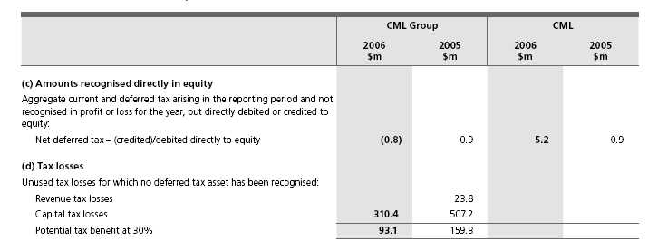
All unused tax losses were incurred by Australian entities. All unused tax losses remaining as at 30 July 2006 are not subject to time limits for recovery.
(e) Unrecognised temporary differences
CML has unremitted earnings of $229.3 million (2005 $218.1 million) in its wholly-owned entities in New Zealand. If remitted, these earnings would be subject to withholding tax charges levied at 15% (2005 15%). An assessable temporary difference exists, however no deferred tax liability has been recognised, as CML is able to control the timing of remittance by these entities and is not expected to remit these earnings in the foreseeable future.
(f) Assumption of current tax liability for tax consolidation
During the year ended 30 July 2006, the parent entity, CML assumed current tax liabilities of $87.9 million (2005 $133.9 million) from its controlled entities under the tax funding agreement (note 1(f)(i)).
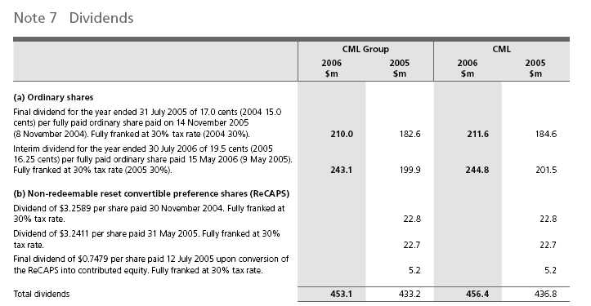
(c) Dividends not recognised at year end
In addition to the above dividends, since year end the Directors have declared a final dividend of 22.5 cents per fully paid ordinary share, fully franked based on tax paid at 30%. The aggregate amount of the proposed ordinary dividend expected to be paid on 13 November 2006 out of retained profits at 30 July 2006, but not recognised as a liability at year end, is $267.7 million. The final dividend declared after 30 July 2006 will be fully franked out of existing franking credits or out of franking credits arising from the payment of income tax in the year ending 29 July 2007.
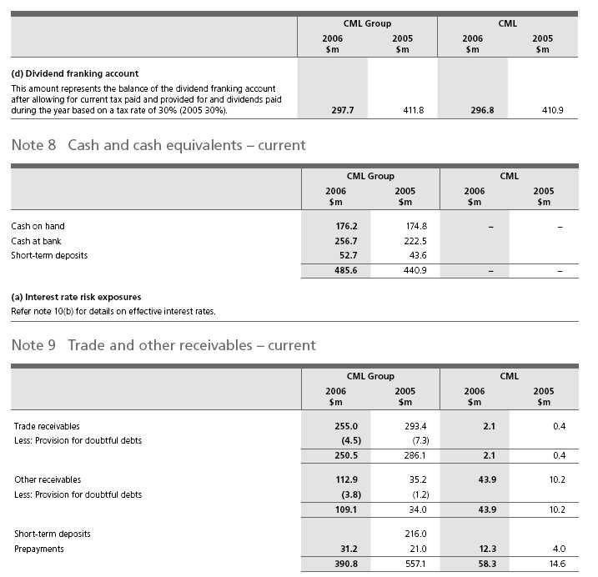
(a) Bad and doubtful trade receivables
The CML Group has recognised a loss of $5.1 million (2005 $6.2 million) in respect of bad and doubtful trade receivables during the year ended 30 July 2006, of which $4.6 million (2005 $5.2 million) relates to continuing operations. The loss has been included in selling and occupancy expenses in the Income Statement.
(b) Other receivables
These amounts generally arise from transactions outside the usual operating activities.
(c) Short-term deposits
On 28 July 2006, Coles Myer Finance Limited, CMNZ Finance Limited, National Australia Bank Limited and Bank of New Zealand entered into a deed. The effect of this deed was to establish an obligation to settle the short-term deposits receivable by CMNZ Finance Limited from Bank of New Zealand and the interest bearing liabilities (other loans) payable by Coles Myer Finance Limited to National Australia Bank Limited on a net basis. For the year ended 30 July 2006, the short-term deposit receivable from Bank of New Zealand and other interest bearing loans payable to National Australia Bank Limited have been disclosed on a net basis.
(d) Interest rate risk exposures
Refer note 10(b) for details on effective interest rates.
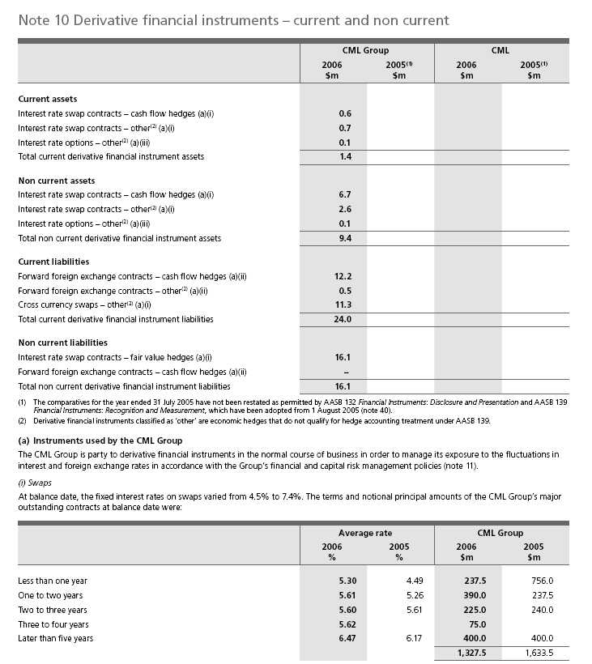
The terms, notional principal amounts and outstanding contracts at 30 July 2006 by classification for the CML Group were:
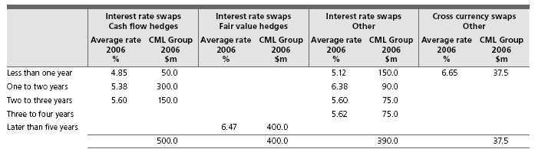
(ii) Forward foreign exchange contracts
The settlement dates, dollar amounts to be received and contractual exchange rates of the CML Group’s major outstanding contracts at balance date were:
 | Average rate |  | CML Group
 |  |  | 2006 | 2005
 | 2006 | 2005 | $m | $m
United States Dollars
Less than 3 months | 0.75 | 0.77 | 366.1 | 342.3
3 to 12 months | 0.75 | 0.76 | 369.4 | 194.7
 |  |  | 735.5 | 537.0
New Zealand Dollars
Less than 3 months | 1.23 |  | 3.9
Pounds Sterling
Less than 3 months |  | 0.43 |  | 0.3
Hong Kong Dollars
Less than 3 months | 5.82 | 5.90 | 6.3 | 0.1
3 to 12 months | 5.78 |  | 17.7
 |  |  | 24.0 | 0.1
Euro
Less than 3 months | 0.59 | 0.61 | 25.6 | 10.9
3 to 12 months | 0.60 | 0.61 | 25.5 | 6.8
Later than 12 months | 0.58 |  | 8.6
 |  |  | 59.7 | 17.7
Total forward foreign exchange contracts |  |  | 823.1 | 555.1

The net deferred loss on hedges of anticipated future transactions hedged by the use of forward foreign exchange contracts was $12.2 million at balance date which has been included in the cash flow hedge reserve (2005 $8.6 million gain).
The settlement dates, dollar amounts to be received and contractual exchange rates for the CML Group’s major outstanding contracts by classification at balance date were:
 | Cash flow hedges |  | Other
 |  | CML Group |  | CML Group
 | Average rate | 2006 | Average rate | 2006
 | 2006 | $m | 2006 | $m
United States Dollars
Less than 3 months | 0.75 | 339.6 | 0.75 | 26.5
3 to 12 months | 0.75 | 369.4
 |  | 709.0 |  | 26.5
New Zealand Dollars
Less than 3 months |  |  | 1.23 | 3.9
Hong Kong Dollars
Less than 3 months | 5.82 | 6.3
3 to 12 months | 5.78 | 17.7
 |  | 24.0
Euro
Less than 3 months | 0.60 | 12.1 | 0.59 | 13.5
3 to 12 months | 0.59 | 23.0 | 0.60 | 2.5
Later than 12 months | 0.58 | 8.6
 |  | 43.7 |  | 16.0
Total forward foreign exchange contracts |  | 776.7 |  | 46.4

(iii) Interest rate options – other
The terms and notional principal amounts of the CML Group’s major outstanding interest rate option contracts at balance date were:
 | Average rate |  | CML Group
 | 2006 | 2005 | 2006 | 2005
 | % | % | $m | $m
Options purchased
3 to 12 months | 6.0 |  | 50.0
Later than 12 months | 6.0 |  | 50.0
 |  |  | 100.0

(b) Interest rate risk exposures
The CML Group’s exposure to interest rate risk and the effective interest rates on financial instruments were:
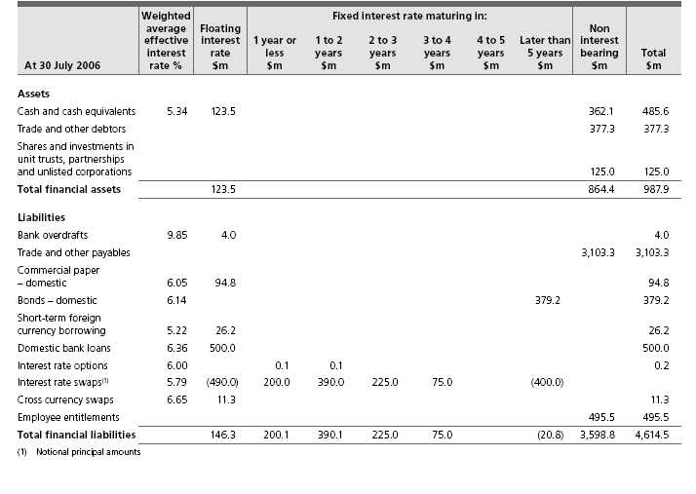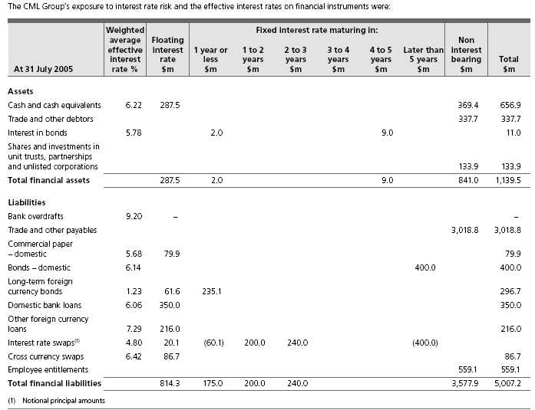
Note 11 Financial and capital risk management
The CML Group is exposed to a variety of financial risks, including foreign exchange risk, interest rate risk, funding risk and credit risk. The CML Group’s overall risk management program seeks to minimise potential adverse affects on the financial performance of the CML Group.
These risks are managed in accordance with Board approved policies which: outline the manner in which the Group manages its financial risk; detail who is responsible for the identification and management of these risks; and set out the risk management instruments that the CML Group is permitted to use.
The Group has centralised the management of financial risk in its Group Treasury department, and all financial transactions are undertaken by authorised Treasury personnel in the name of Coles Myer Finance Limited. Speculative position taking is prohibited.
(a) Foreign exchange risk management
Foreign exchange risk in the CML Group arises from imported merchandise, other purchases (including capital expenditure), foreign currency denominated borrowings and offshore investments (New Zealand).
Merchandise risk is managed in order to maintain a fully hedged position of all material exposures at all times. Exposures arising from merchandise imports are managed by the use of forward exchange contracts and currency options.
All exposures arising from other purchases and foreign currency denominated borrowings are fully hedged. A combination of cross currency swaps and forward contracts are used to eliminate exchange rate risk associated with these exposures.
The translation exposure arising from the CML Group’s New Zealand net assets is not hedged due to the immaterial value of the net assets relative to the rest of the CML Group.
(b) Interest rate risk
Interest rate risk in the CML Group arises from both the volume of debt and the timing of interest rate settings. A combination of interest rate swaps, options, forward rate agreements and futures are used to achieve the desired mix of fixed and floating rate debt, and to retain the opportunity to benefit from interest rate reductions.
Generally, a level of approximately 50% of the CML Group’s core debt is covered at fixed interest rates of beyond 12 months in maturity. The remainder of the exposures are managed with strategies of 12 months or less in maturity. All interest rate hedge cover is spread across a range of maturity dates.
The CML Group has fixed coupon bonds on issue. In line with the Group’s interest rate risk strategy, the bonds were swapped to floating rates via interest rate swaps. This transaction was designated as a fair value hedging relationship and the changes in the fair value of the hedged item are offset against the changes in the value of the interest rate swaps.
(c) Funding risk
The CML Group finances its operations by a combination of reinvestment of retained profits, long and short-term bank debt, capital market debt and leases. Funding risk is the risk that the CML Group may not be able to access funding when required, for both day-to-day requirements and to support the strategic activities of the CML Group.
Funding risk is managed by maintaining sufficient undrawn committed bank facilities, a diverse range of available funding sources, both domestic and international, and sound relationships with key financial institutions. Strategic funding risk is also managed by maintaining a prudent spread of debt maturities, arranging funding ahead of requirements and an investment grade credit rating.
The CML Group’s long-term credit rating remained stable during the year. Coles Myer Ltd. is rated Baa2 (Outlook – Developing) by Moody’s and BBB (CreditWatch – Developing) by Standard and Poor’s.
(d) Credit risk
When the CML Group invests surplus cash, or commits to a future financial settlement (for example, forward foreign exchange contracts or options) with an external counterparty, there is a risk that the counterparty will default prior to settlement. The CML Group manages this risk by limiting its credit exposure to any single counterparty, and by ensuring that financial transactions are prudently spread across, and only undertaken with approved, highly rated counterparties.
The CML Group’s exposures to counterparties and their credit ratings are routinely monitored.
Note 12 Assets classified as held for sale – current
 | CML Group |  |  | CML
 | 2006 | 2005 | 2006 |  | 2005
 | $m | $m | $m |  | $m
Freehold properties | 149.7
Investment properties | 2.0 |  | 0.4
 | 151.7 |  | 0.4
Note 13 Receivables – non current
 | CML Group |  |  | CML
 | 2006 | 2005 | 2006 |  | 2005
 | $m | $m | $m |  | $m
Term deposits and advances | 16.9 | 16.9 | 0.4 |  | 0.9
Loans to associated unit trust and partnership | 0.8 | 0.7
Loans to Employee Share Plan (note 36(a)) |  |  | 12.9 |  | 16.0
 | 17.7 | 17.6 | 13.3 |  | 16.9
Deferred expenditure – stamp duty | 37.6 | 41.3 | 1.5 |  | 1.5
Less: Accumulated amortisation | (14.7) | (13.9) | (0.5) |  | (0.4)
 | 22.9 | 27.4 | 1.0 |  | 1.1
Other | 3.1 | 6.9
 | 43.7 | 51.9 | 14.3 |  | 18.0

(a) Interest rate risk exposures
Refer note 10(b) for details on effective interest rates.
(b) Fair values
The fair values and carrying values of non current receivables of the CML Group are as follows:
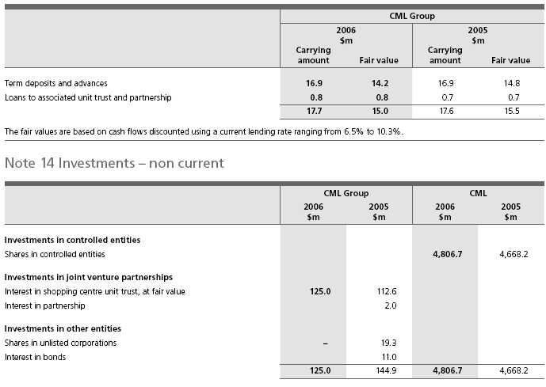
(a) Interest in partnership
During the year ended 30 July 2006, the interest in the FlyBuys Partnership of $2.0 million was written-down in full due to a decline in value (note 3).
(b) Shares in unlisted corporations
The CML Group has a 2% interest in Agentrics (formerly GlobalNetXchange Ltd). Agentrics is an international retail alliance that offers hosted software solutions for retail applications. On transition to AASB 132 Financial Instruments: Disclosure and Presentation and AASB 139 Financial Instruments: Recognition and Measurement, the investment was written-down in full. Further details are set out in note 40.
(c) Interest in bonds
During the year ended 30 July 2006, the interest in bonds was disposed of for $11.0 million. The quoted market value of the interest in bonds at 31 July 2005 was $11.0 million.
(d) Shares in controlled entities – disposal of Myer
During the year ended 30 July 2006, CML disposed of its investment of $591.5 million in Myer Limited for $900.6 million. CML recognised a profit on the disposal of $159.2 million, net of divestment costs, which has been recognised in other income in the Income Statement.
(e) Interest in shopping centre unit trust
Subsidiary CMTI Pty Ltd has a joint venture interest in CMS General Trust (a unit trust). CMTI has a 50% participating interest in this joint venture and is entitled to 50% of its results. The CML Group’s interest in the assets employed in the joint venture is included in the consolidated Balance Sheet, in accordance with the accounting policy described in note 1(c), under the following classifications:
 | CML Group
 | 2006 | 2005
 | $m | $m
Carrying amount of investment in joint venture | 125.0 | 112.6
(i) Share of joint venture’s assets and liabilities
Current assets | – | –
Non current assets | 125.0 | 112.6
Total assets | 125.0 | 112.6
Current liabilities | – | –
Total liabilities | – | –
 | 125.0 | 112.6
(ii) Share of joint venture’s revenue, expenses and results
Revenues | 21.9 | 37.0
Expenses | – | –
Profit before income tax | 21.9 | 37.0

(f) Interests in joint venture and other associated entities
 | Investment |  | Ownership interest
 | 2006 | 2005 | 2006 | 2005 | Principal
 | $m | $m | % | % | activity | Balance date
 |  |  |  |  | Property
CMS General Trust | 125.0 | 112.6 | 50 | 50 | ownership | 30 June⁽¹⁾
FlyBuys Partnership |  | 2.0 | 50 | 50 | Loyalty program | 31 December
 |  |  |  |  | Software
Quids Technology Pty Ltd | – | – | 50 | 50 | development | 30 June
(1) The Income Statement, Balance Sheet and Cash Flow Statement of the Trust for the year ended 30 July 2006 (31 July 2005) have been included in the results
of the CML Group.

Note 15 Property, plant and equipment – non current
 | CML Group |  |  | CML
 | 2006 | 2005 | 2006 |  | 2005
 | $m | $m | $m |  | $m
Freehold properties
Land
At cost | 238.7 | 342.5 | 5.5 |  | 5.9
Buildings
At cost | 87.8 | 84.3
Less: Accumulated depreciation | (3.1) | (9.7)
 | 84.7 | 74.6
Total freehold properties | 323.4 | 417.1 | 5.5 |  | 5.9
Leasehold improvements
At cost | 642.2 | 745.2 | 13.4 |  | 12.5
Less: Accumulated depreciation | (336.3) | (399.7) | (3.9) |  | (2.6)
Total leasehold improvements | 305.9 | 345.5 | 9.5 |  | 9.9
Total properties | 629.3 | 762.6 | 15.0 |  | 15.8
Plant and equipment
At cost | 5,032.9 | 5,854.9 | 220.4 |  | 220.1
Less: Accumulated depreciation | (2,964.6) | (3,639.0) | (103.2) |  | (112.8)
Total plant and equipment | 2,068.3 | 2,215.9 | 117.2 |  | 107.3
Capital work in progress, at cost | 435.7 | 509.3 | 22.6 |  | 30.4
Total property, plant and equipment | 3,133.3 | 3,487.8 | 154.8 |  | 153.5
(a) Impairment tests for property, plant and equipment
Property, plant and equipment balances relate to:
Food, Liquor and Fuel | 1,746.8 | 1,702.7
Kmart | 302.3 | 290.5
Officeworks | 75.9 | 63.0
Target | 262.1 | 250.2
Property and unallocated | 746.2 | 772.2
Discontinued operations |  | 409.2
Total | 3,133.3 | 3,487.8

For the purposes of impairment testing, each store is a cash generating unit. Impairment reviews were performed by comparing the carrying value of assets with the recoverable amount of the cash generating units to which assets have been allocated.
Recoverable amounts for cash generating units are based on value in use, which is calculated from cash flow projections using the latest results for the year ended 30 July 2006. The key assumptions for the value in use calculations are those regarding discount rates, growth rates and the remaining useful life of assets.
Impairments and reversal of impairments, result from a range of circumstances relating to store specific issues and the local trading environment, and are recognised in selling and occupancy expenses in the Income Statements.
By segment:
For conservatism the growth rates beyond five years have been extrapolated using an appropriate industry growth rate.
The pre-tax discount rates used to calculate value in use range from 11% to 14% (2005 10% to 14.5%) . The discount rate is derived from CML Group’s weighted average cost of capital.
(b) Reconciliations
Reconciliations of the carrying amount of each class of property, plant and equipment are set out below:
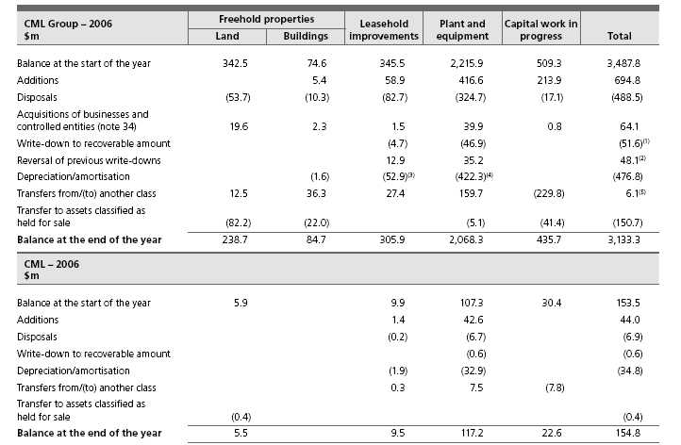
(1) | Includes $1.8 million relating to discontinued operations.
(2) | Includes $36.3 million relating to discontinued operations.
(3) | Includes $5.2 million relating to discontinued operations.
(4) | Includes $27.7 million relating to discontinued operations.
(5) | Relates to transfers from investment properties of $6.1 million (note 16).
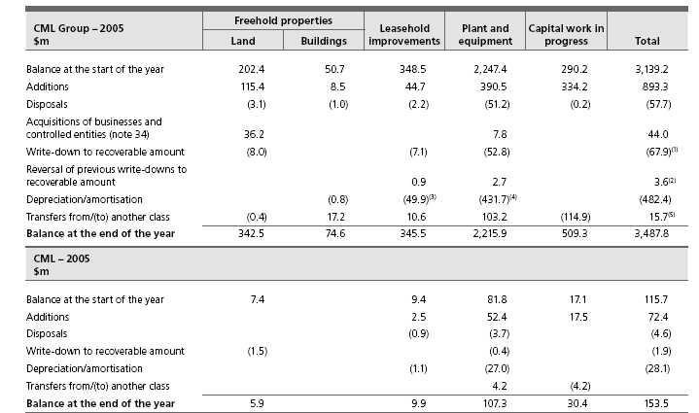
(1) | Includes $42.0 million relating to discontinued operations.
(2) | Includes $1.3 million relating to discontinued operations.
(3) | Includes $7.3 million relating to discontinued operations.
(4) | Includes $46.8 million relating to discontinued operations.
(5) | Relates to transfers from investment properties of $15.7 million (note 16).
Note 16 Investment properties – non current
 | CML Group |  |  | CML
 | 2006 | 2005 | 2006 |  | 2005
 | $m | $m | $m |  | $m
At fair value
Balance at the start of the year | 9.6 | 25.5
Additions | 5.1 | 5.6
Net loss from fair value adjustment |  | (5.8)
Transfer to property, plant and equipment (note 15) | (6.1) | (15.7)
Transfer to assets classified as held for sale | (1.0)
Balance at the end of the year | 7.6 | 9.6
(a) Amounts recognised in the Income Statement for
investment properties
Rental revenue | 0.7 | 0.9
Direct operating expenses from property that generated rental revenue | (0.3) | (0.6)
 | 0.4 | 0.3
(b) Operating leases: members of the CML Group as lessor
The investment properties are leased to tenants under long-term
operating leases with rentals payable monthly. Minimum lease payments
receivable on leases of investment properties are as follows:
Less than one year | 0.7 | 0.6
Later than one year but not later than five years | 2.3 | 2.4
Later than five years | 0.9 | 1.5
 | 3.9 | 4.5

(c) Valuation of investment properties
The basis of the valuation of investment properties is fair value being the amounts for which the properties could be exchanged between willing parties in an arm’s length transaction. Fair value is based on current prices in an active market for similar properties in the same location and condition and subject to similar leases.
Note 17 Deferred tax assets – non current
 | CML Group |  |  | CML
 | 2006 | 2005 | 2006 |  | 2005
 | $m | $m | $m |  | $m
The balances comprise temporary differences attributable to:
(i) Amounts recognised in the Income Statements
Property, plant and equipment and computer software depreciation | 71.4 | 77.5 | 4.2 |  | 9.4
Inventories – valuation | 83.1 | 85.2
Employee entitlements | 148.7 | 167.7 | 12.9 |  | 13.1
Provisions and accruals | 135.3 | 58.1 | 55.7 |  | 11.9
Other non current liabilities | 46.0 | 60.5 | 1.0 |  | 0.7
 | 484.5 | 449.0 | 73.8 |  | 35.1
(a) Movements in deferred tax assets
Balance at the start of the year | 449.0 | 382.5 | 35.1 |  | 20.0
Change on adoption of AASB 132 and AASB 139 (note 40) | 0.7
Credited/(charged) to the Income Statement (note 6) | 114.8 | 66.5 | 38.7 |  | 15.1
Disposal of controlled entity (note 5) | (83.2)
Acquisitions of businesses and controlled entities (note 34) | 3.2
Balance at the end of the year | 484.5 | 449.0 | 73.8 |  | 35.1
(b) Balance sheet classification
Deferred tax assets to be recovered:
Less than one year | 150.1 | 115.5 | 5.4 |  | 17.0
Later than one year | 334.4 | 333.5 | 68.4 |  | 18.1
 | 484.5 | 449.0 | 73.8 |  | 35.1

Note 18 Intangible assets – non current
 | CML Group |  |  | CML
 | 2006 | 2005 | 2006 |  | 2005
 | $m | $m | $m |  | $m
Brand names
At cost |  | 22.6
Licences
At cost | 65.5 | 56.5
Acquired computer software
At cost | 433.6 | 226.9 | 50.5 |  | 19.3
Less: Accumulated amortisation and impairments | (108.8) | (98.0) | (8.8) |  | (2.4)
 | 324.8 | 128.9 | 41.7 |  | 16.9
Internally generated computer software
At cost | 78.8 | 41.2 | 9.1 |  | 3.5
Less: Accumulated amortisation and impairments | (19.7) | (17.8) | (1.6) |  | (0.4)
 | 59.1 | 23.4 | 7.5 |  | 3.1
Total computer software | 383.9 | 152.3 | 49.2 |  | 20.0
Co-branded operating rights
At cost | 111.9 | 103.7
Less: Accumulated amortisation and impairments | (14.1) | (8.6)
 | 97.8 | 95.1
Goodwill
At cost | 945.9 | 558.0
Less: Accumulated amortisation and impairments | (80.9) | (81.2)
 | 865.0 | 476.8
 | 1,412.2 | 803.3 | 49.2 |  | 20.0
(a) Impairment tests for intangible assets with indefinite lives
The balances for intangible assets with indefinite lives, including goodwill,
brand names and licences, relates to:
Food, Liquor and Fuel | 792.5 | 484.9
Other | 138.0 | 71.0
 | 930.5 | 555.9

For the purposes of impairment testing, the cash generating units are the same as the business segments as set out in note 32. Impairment reviews were performed by comparing the carrying value of intangible assets with indefinite lives with the recoverable amount of the cash generating units to which those assets have been allocated.
Recoverable amounts for cash generating units are based on value in use, which is calculated from cash flow projections using the latest results for the year ended 30 July 2006. The key assumptions for the value in use calculations are those regarding discount rates, growth rates and expected earnings. No impairments for goodwill have been recognised for the years ended 30 July 2006 and 31 July 2005.
(i) Food, Liquor and Fuel
The growth rates beyond five years have been extrapolated using an appropriate industry growth rate. The pre-tax discount rate used to calculate value in use is 11% (2005 10%). The discount rate is derived from the CML Group’s weighted average cost of capital.
(ii) Other
The carrying value of intangible assets with indefinite lives allocated to any one group of cash generating units is not significant to the total balance.
(b) Reconciliations
Reconciliations of the carrying amount of each class of intangible asset are set out below:
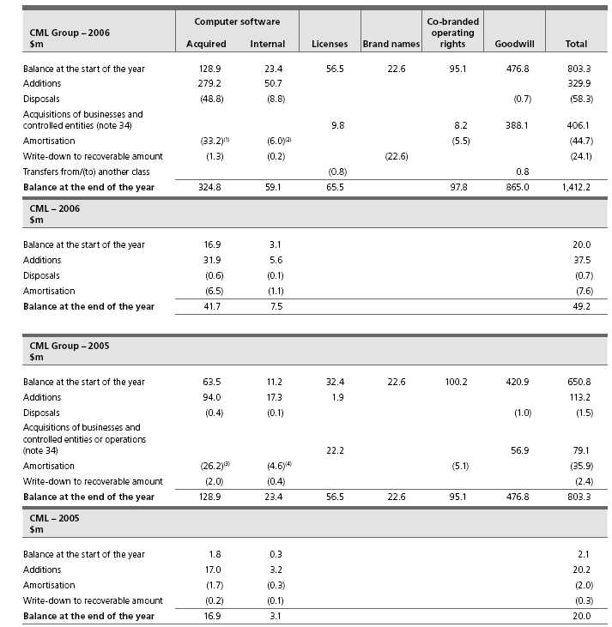
(1) | Includes $1.1 million relating to discontinued operations.
(2) | Includes $0.2 million relating to discontinued operations.
(3) | Includes $1.6 million relating to discontinued operations.
(4) | Includes $0.3 million relating to discontinued operations.
Note 19 Retirement benefit asset – non current
The CML Group contributes to a number of superannuation funds that have been established to provide benefits for employees. The principal type of benefit provided by these funds is a lump sum. The members and the CML Group make contributions as specified in the rules of the respective funds.
The CML Group is obliged to ensure that contributions are made to the defined benefit plan at the rate assessed by an actuary, subject to its rights to reduce, suspend or terminate contributions as specified in the relevant trust deed. The obligation of the CML Group to make contributions to the fund at the actuarially determined rate is legally enforceable up to the date on which the CML Group gives notice to suspend or terminate contributions as provided in the agreement governing the defined benefit plan.
In respect of all other superannuation funds, the CML Group is obliged to contribute at fixed rates or amounts as set out in the relevant trust deeds, or in accordance with industrial awards, agreements and relevant legislation.
The following sets out details of the defined benefit section of the Coles Myer Superannuation (the Plan):
(a) Balance Sheet amounts
The amounts recognised in the Balance Sheets are determined as follows:
 | CML Group |  |  | CML
 | 2006 | 2005 | 2006 |  | 2005
 | $m | $m | $m |  | $m
Fair value of defined benefit plan assets | 522.8 | 517.0 | 522.8 |  | 517.0
Present value of the defined benefit obligation | (484.5) | (499.3) | (484.5) |  | (499.3)
Net asset in the Balance Sheet | 38.3 | 17.7 | 38.3 |  | 17.7

Coles Myer Ltd. has recognised an asset in the Balance Sheet in respect of its defined benefit superannuation arrangement. If a surplus exists in the Plan, Coles Myer Ltd. will be able to take advantage of it in the form of a reduction in the required contribution rate, depending on the advice of the Plan’s actuary.
The Company may at any time by notice to the Trustee, terminate its contributions. The employer has a liability to pay the monthly contributions prior to the effective date of the notice, but there is no requirement for an employer to pay any further contributions, irrespective of the financial condition of the Plan.
(b) Categories of plan assets
The major categories of the Plan’s assets are as follows:
 |  | CML Group |  |  | CML
 | 2006 |  | 2005 | 2006 |  | 2005
 | % |  | % | % |  | %
Australian equities | 36 |  | 35 | 36 |  | 35
Overseas equities | 26 |  | 27 | 26 |  | 27
Fixed interest securities | 25 |  | 25 | 25 |  | 25
Properties | 8 |  | 8 | 8 |  | 8
Other | 5 |  | 5 | 5 |  | 5

The fair value of the Plan’s assets includes no amounts relating to:
n | any of the Company’s own financial instruments; and
n | any property occupied by, or other assets used by, Coles Myer Ltd. or its controlled entities.

 | CML Group |  |  | CML
 | 2006 | 2005 | 2006 |  | 2005
 | $m | $m | $m |  | $m
(c) Reconciliations
(i) Reconciliation of the present value of the defined benefit obligation
Balance at the start of the year | 499.3 | 481.5 | 499.3 |  | 481.5
Current service cost | 15.3 | 17.3 | 15.3 |  | 17.3
Interest cost | 23.5 | 26.6 | 23.5 |  | 26.6
Contributions by plan participants | 11.3 | 10.5 | 11.3 |  | 10.5
Actuarial losses | 11.9 | 32.9 | 11.9 |  | 32.9
Benefits paid | (33.2) | (69.5) | (33.2) |  | (69.5)
Curtailments | 0.7 |  | 0.7
Settlements | (44.3) |  | (44.3)
Balance at the end of the year | 484.5 | 499.3 | 484.5 |  | 499.3
(ii) Reconciliation of the fair value of the Plan’s assets
Balance at the start of the year | 517.0 | 490.8 | 517.0 |  | 490.8
Expected return on plan assets | 31.6 | 30.6 | 31.6 |  | 30.6
Actuarial gains | 29.3 | 35.6 | 29.3 |  | 35.6
Contributions by employer | 11.1 | 19.0 | 11.1 |  | 19.0
Contributions by plan participants | 11.3 | 10.5 | 11.3 |  | 10.5
Benefits paid | (33.2) | (69.5) | (33.2) |  | (69.5)
Settlements | (44.3) |  | (44.3)
Balance at the end of the year | 522.8 | 517.0 | 522.8 |  | 517.0
(d) Amounts recognised in the Income Statements
Current service cost | 15.3 | 17.3 | 15.3 |  | 17.3
Interest cost | 23.5 | 26.6 | 23.5 |  | 26.6
Expected return on plan assets | (31.6) | (30.6) | (31.6) |  | (30.6)
Losses on curtailments and settlements | 0.7 |  | 0.7
Transfer to controlled entities⁽¹⁾ |  |  | (5.7) |  | (9.3)
Total included in employee benefits expense | 7.9 | 13.3 | 2.2 |  | 4.0
Actual return on plan asset | 61.0 | 66.2 | 61.0 |  | 66.2
(1) Where the employee services are provided to other entities in the Group the
expenses are transferred accordingly.
The amounts recognised in the Income Statement have been allocated
between cost of goods sold ($0.2 million), selling and occupancy expense
($3.8 million) and administrative expense ($3.9 million).
(e) Amounts recognised in the Statement of
Recognised Income and Expenses
Actuarial gains on defined benefit plans | 17.4 | 2.7 | 17.4 |  | 2.7
Income tax on actuarial gains | (5.2) | (0.9) | (5.2) |  | (0.9)
 | 12.2 | 1.8 | 12.2 |  | 1.8

 | CML Group |  |  | CML
 | 2006 | 2005 | 2006 |  | 2005
 | % | % | % |  | %
(f) Principal actuarial assumptions
The principal actuarial assumptions used are:
Discount rate (active members) | 5.70 | 5.10 | 5.70 |  | 5.10
Discount rate (pensioners) | 5.70 | 5.10 | 5.70 |  | 5.10
Salary increase rate | 4.25 | 4.25 | 4.25 |  | 4.25
Expected rate of return on assets:
Supporting lump sum liabilities | 6.50 | 6.50 | 6.50 |  | 6.50
Supporting pension liabilities | 7.25 | 7.25 | 7.25 |  | 7.25

The expected return on the Plan’s assets is determined by weighting the expected long-term return for each asset class by the benchmark allocation of assets to each class and allowing for correlations of the investment returns between asset classes. The returns for each asset class are net of investment tax and investment fees. An allowance for the asset based administration expenses has been deducted from the expected return.
(g) Employer contributions
The method used to determine the employer contribution recommendations at the last actuarial review was the Target Funding method. Under the Target Funding method, the employer contribution rate is set at a level such that the Plan’s assets are expected to exceed the Plan’s liabilities by a specified margin within a specified period of time. The current contribution recommended in the actuarial review as at 1 July 2005 is 9.5% of the salaries of all members.
Total employer contributions expected to be paid by the CML Group for the year ended 29 July 2007 are $13.8 million.
The economic assumptions adopted for the last actuarial review of the Plan as at 1 July 2005 were:
Weighted-average assumptions:
Expected rate of return on the Plan’s assets | 6.50%
Expected salary increase rate | 4.25%

(h) Net financial position of the Plan
In accordance with AAS 25 Financial Reporting by Superannuation Plans the most recent financial position of the Coles Myer Superannuation Plan was:
 | Last reporting
 | date | $m
Accrued benefits | 1 July 2005 | (492.2)
Net market value of the Plan’s assets | 1 July 2005 | 507.5
Net surplus | 1 July 2005 | 15.3

 | CML Group |  |  | CML
 | 2006 | 2005 | 2006 |  | 2005
 | $m | $m | $m |  | $m
(i) Historical Summary
Fair value of defined benefit plan assets | 522.8 | 517.0 | 522.8 |  | 517.0
Present value of defined benefit obligation | (484.5) | (499.3) | (484.5) |  | (499.3)
Surplus | 38.3 | 17.7 | 38.3 |  | 17.7
Experience losses adjustments – plan liabilities | 18.5 | 22.2 | 18.5 |  | 22.2
Experience (gain) adjustments – plan assets | (29.3) | (35.6) | (29.3) |  | (35.6)
Information for years prior to 2005 is not available.
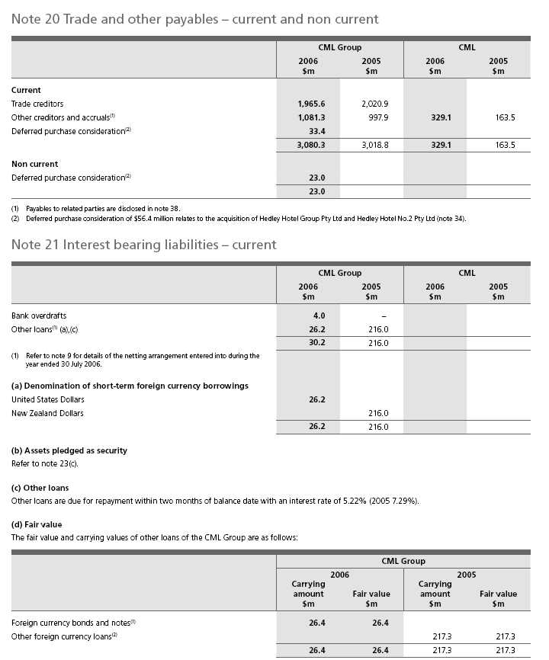
(1) | Carrying amount includes accrued interest of $0.2 million.
(2) | Carrying amount includes accrued interest of $1.3 million.
(e) Interest rate risk exposures
Refer to note 10(b) for details on effective interest rates.
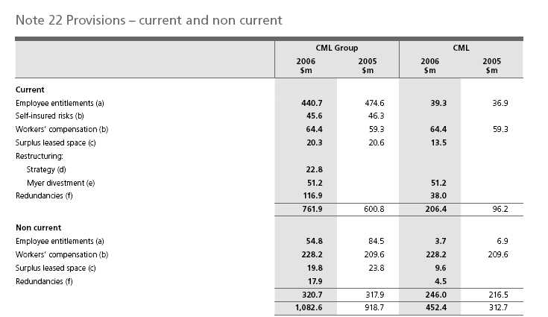
(a) Employee entitlements
The provision for employee entitlements comprises amounts for annual leave and long service leave. The following assumptions were used in measuring the long service leave provision for the year ended 30 July 2006:
Expected increase in wages and salaries | 3.2% – 4.2% | (2005 1.4% – 4.2%)
Expected wages and salary on-costs | 8.4% – 14.0% | (2005 8.6% – 12.8%)

Accrued labour costs are included in trade and other payables (note 20).
(b) Workers’ compensation and self-insured risks
The workers’ compensation and self-insured risk provisioning relates to commitments of up to 18 years (2005 17 years). Actual compensation paid may vary where accidents and claims incurred vary from those estimated. Refer note 1(x) for a description of the provision.
(c) Surplus leased space
The surplus lease provision covers future payments for leased premises, which are onerous, net of actual and expected sub-leasing revenue, and relates to commitments of up to 11 years (2005 12 years). Actual lease payments may vary from the amounts provided where alternate uses are found for these premises, including attraction of new tenants. Refer note 1(g) for a description of the provision.
(d) Restructuring – strategy
The provision for restructuring relates to the strategic initiatives detailed in note 4, and largely comprises costs associated with the rebadging of Bi-Lo stores to Coles, and other store rebadging as a result of changes in format.
(e) Restructuring – Myer divestment
The provision for restructuring relates to the Myer divestment, which occurred on 2 June 2006, and largely comprises information technology change costs, property related costs and costs associated with removing the Myer name from the CML Group.
(f) Redundancies
The provision for redundancies relates to the strategic initiatives detailed in note 4, and largely comprises costs associated with the consolidation of support services, simplification of back office processes, and closure of the Somersby and Hampton Park distribution centres.
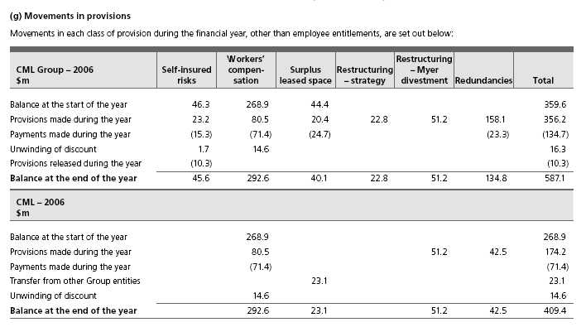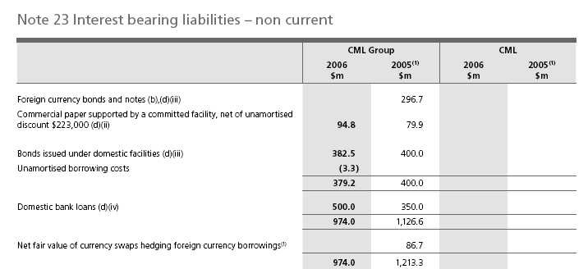
(1) | The interest bearing liabilities have not been restated as permitted by AASB 132 Financial Instruments: Disclosure and Presentation and AASB 139 Financial Instruments: Recognition and Measurement, which have been adopted from 1 August 2005 (note 40).

 | CML Group
 | 2006 | 2005
 | $m | $m
(a) Maturity profile of interest bearing liabilities
2006/2007 |  | 86.6
2007/2008 |  | 150.0
2008/2009 | 100.0 | 90.0
2009/2010 | 44.8 | 400.0
2010/2011 | 450.0
2011/2012 | 379.2 | 400.0
 | 974.0 | 1,126.6
(b) Denomination of long-term foreign currency borrowings
United States Dollars |  | 26.4
Japanese Yen |  | 270.3
 |  | 296.7

(c) Assets pledged as security
At balance date, all foreign currency borrowings were fully hedged. The CML Group’s borrowing structure is flexible and consistent, based on the acceptance by lenders of the Common Provisions Deed Poll (CPDP) and the Standard Coles Myer Negative Pledge (‘the Negative Pledge’). The CPDP has replaced the Negative Pledge and has been accepted by all lenders to the CML Group. The last remaining borrowings that have the Negative Pledge as credit support mature in September 2006. A controlled entity has issued a floating charge over assets, capped at $80.0 million, as security for payment obligations to a trade creditor.
In addition, an undertaking is given not to provide security over CML Group assets to parties with the benefit of the CPDP or Negative Pledge, without providing security to all parties to the CPDP or Negative Pledge, except under certain limited circumstances. The CML Group has been in compliance with its financial covenants contained within the CPDP and Negative Pledge during the financial year.
(d) Details of major financing arrangements
(i) Credit standby facilities
The CML Group has $430.0 million (2005 $430.0 million) of committed facilities of which $430.0 million (2005 $430.0 million) was undrawn at balance date. The facilities have maturity dates ranging between August 2007 and August 2010 (2005 maturity dates ranged between August 2006 and May 2010).
(ii) Commercial paper
The CML Group has a commercial paper program based in Australia. The program is guaranteed by Coles Myer Ltd. and is supported by the credit standby facilities referred to above. At balance date $94.8 million of commercial paper was on issue (2005 $79.9 million).
(iii) Bonds
The CML Group has issued bonds under a debt issuance program in Europe and Australia. At balance date $426.2 million (2005 $696.7 million) equivalent of bonds were on issue.
The bonds and notes issued under domestic facilities are carried at fair value at each reporting date. While the carrying amount is $379.2 million (net of unamortised borrowing costs of $3.3 million), the CML Group is contractually obligated to settle the liability of $400.0 million on 25 July 2012.
The amount of change in the fair value is attributable to changes in a benchmark interest rate.
(iv) Domestic bank loans $500.0 million (2005 $350.0 million) of domestic bank loans of various maturities were outstanding at balance date.
(e) Interest rate risk exposures
Refer note 10(b) for details on effective interest rates.
 | CML Group |  |  | CML
 | 2006 | 2005 | 2006 | 2005
Note 24 Loans – non current | $m | $m | $m | $m
Amounts owing to controlled entities⁽¹⁾ |  |  | 1,808.1 | 2,046.5
(1) Loans owing to controlled entities are non-interest bearing, apart from an amount of $1,948.7 million included in the balance at 31 July 2005.
During the year ended 30 July 2006, Myer Limited and The Myer Emporium Limited forgave a loan receivable from CML of $597.8 million.
The amount forgiven was recorded as other income in the Income Statement.
Note 25 Deferred tax liabilities – non current
 | CML Group |  |  | CML
 | 2006 | 2005 | 2006 | 2005
 | $m | $m | $m | $m
The balances comprise temporary differences attributable to:
(i) Amounts recognised in the Income Statements
Other non current assets | 15.1 | 40.6 | 0.2 | 0.3
Property, plant and equipment depreciation |  |  | 0.8
Foreign exchange translation of financial assets and liabilities,
derivative financial instruments and other finance costs | 5.4 | 4.8
Intangible assets (excluding computer software) | 49.0 | 52.3
Retirement benefit asset | 5.4 | 4.4 | 5.4 | 4.4
 | 74.9 | 102.1 | 6.4 | 4.7
(ii) Amounts recognised directly in equity
Retirement benefit asset | 6.1 | 0.9 | 6.1 | 0.9
Cash flow hedge reserve | (3.4)
 | 2.7 | 0.9 | 6.1 | 0.9
 | 77.6 | 103.0 | 12.5 | 5.6
(a) Movements in deferred tax liabilities
Balance at the start of the year | 103.0 | 126.3 | 5.6 | 4.2
Change on adoption of AASB 132 and AASB 139 (note 40) | 2.6
(Charged)/credited to the Income Statement (note 6) | (32.6) | (30.9) | 1.7 | 0.5
(Charged)/credited to equity | (0.8) | 0.9 | 5.2 | 0.9
Acquisition of businesses and controlled entities (note 34) | 5.4 | 6.7
Balance at the end of the year | 77.6 | 103.0 | 12.5 | 5.6
(b) Balance sheet classification
Deferred tax liabilities to be settled:
Less than one year | 2.3 | 9.7
Later than one year | 75.3 | 93.3 | 12.5 | 5.6
 | 77.6 | 103.0 | 12.5 | 5.6

Note 26 Other liabilities – non current
 | CML Group |  |  | CML
 | 2006 |  | 2005 | 2006 | 2005
 | $m |  | $m | $m | $m
Deferred income – lease incentives | 88.3 |  | 90.5
Fixed rent escalation accruals | 74.8 |  | 121.1 | 3.2 | 2.3
 | 163.1 |  | 211.6 | 3.2 | 2.3
Note 27 Contributed equity
 | CML Group |  |  | CML
 | 2006 |  | 2005 | 2006 | 2005
 | $m |  | $m | $m | $m
Ordinary shares
Fully paid | 2,144.2 | 2,068.6 |  | 2,157.2 | 2,083.6
Partly paid to one cent | – |  | – | – | –
 | 2,144.2 | 2,068.6 |  | 2,157.2 | 2,083.6
 |  |  | CML Group
 | 2006 |  |  | 2005
 | No. of shares |  | $m | No. of shares | $m
(a) Movement in ordinary shares on issue
Fully paid ordinary shares
Balance at the start of the year | 1,237,160,686 |  | 2,068.6 | 1,225,410,546 | 1,608.1
Conversion from partly paid shares | 53,000 |  | 0.1 | 40,000 | 0.1
Contribution to equity under the Employee Share Plan |  |  | 2.0 |  | 3.0
Exercise of options | 16,674,343 |  | 120.4 | 15,082,345 | 107.9
Issue for acquisition of Pharmacy Direct (note 34) | 4,191,033 |  | 44.3
Issue for acquisition of Hedley Group (note 34) | 13,656,906 |  | 156.2
Off-market buy-back | (81,816,534) |  | (247.4) | (70,433,916) | (215.7)
On-market buy-back |  |  |  | (12,221,111) | (115.4)
ReCAPS conversion |  |  |  | 79,282,822 | 680.6
Balance at the end of the year | 1,189,919,434 |  | 2,144.2 | 1,237,160,686 | 2,068.6
Partly paid ordinary shares
Balance at the start of the year | 74,000 |  | – | 114,000 | –
Conversion to fully paid shares | (53,000) |  | – | (40,000) | –
Balance at the end of the year | 21,000 |  | – | 74,000 | –

Note 26 Other liabilities – non current
 | CML Group |  |  | CML
 | 2006 |  | 2005 | 2006 | 2005
 | $m |  | $m | $m | $m
Deferred income – lease incentives | 88.3 |  | 90.5
Fixed rent escalation accruals | 74.8 |  | 121.1 | 3.2 | 2.3
 | 163.1 |  | 211.6 | 3.2 | 2.3
Note 27 Contributed equity
 | CML Group |  |  | CML
 | 2006 |  | 2005 | 2006 | 2005
 | $m |  | $m | $m | $m
Ordinary shares
Fully paid | 2,144.2 | 2,068.6 |  | 2,157.2 | 2,083.6
Partly paid to one cent | – |  | – | – | –
 | 2,144.2 | 2,068.6 |  | 2,157.2 | 2,083.6
 |  |  | CML Group
 | 2006 |  |  | 2005
 | No. of shares |  | $m | No. of shares | $m
(a) Movement in ordinary shares on issue
Fully paid ordinary shares
Balance at the start of the year | 1,237,160,686 |  | 2,068.6 | 1,225,410,546 | 1,608.1
Conversion from partly paid shares | 53,000 |  | 0.1 | 40,000 | 0.1
Contribution to equity under the Employee Share Plan |  |  | 2.0 |  | 3.0
Exercise of options | 16,674,343 |  | 120.4 | 15,082,345 | 107.9
Issue for acquisition of Pharmacy Direct (note 34) | 4,191,033 |  | 44.3
Issue for acquisition of Hedley Group (note 34) | 13,656,906 |  | 156.2
Off-market buy-back | (81,816,534) |  | (247.4) | (70,433,916) | (215.7)
On-market buy-back |  |  |  | (12,221,111) | (115.4)
ReCAPS conversion |  |  |  | 79,282,822 | 680.6
Balance at the end of the year | 1,189,919,434 |  | 2,144.2 | 1,237,160,686 | 2,068.6
Partly paid ordinary shares
Balance at the start of the year | 74,000 |  | – | 114,000 | –
Conversion to fully paid shares | (53,000) |  | – | (40,000) | –
Balance at the end of the year | 21,000 |  | – | 74,000 | –

(b) Terms and conditions
(i) Ordinary shares
Ordinary shares entitle the holder to participate in the dividends of the Company and the proceeds on winding up of the Company. Fully paid ordinary shares entitle the holder to one vote, except on a poll, where each share is entitled to one vote. Partly paid shares do not have any voting rights, until fully paid (except with respect to any proposal to vary the rights of these shareholders).
At 30 July 2006, there were 21,000 (2005 74,000) partly paid shares on issue, on which a further $1.99 per share is uncalled.
(ii) Non-redeemable reset convertible preference shares (ReCAPS)
On 18 December 2000, the Company allotted 7,000,000 ReCAPS with an issue price of $100 per share. On 12 July 2005, at the option of the Company, all ReCAPS were converted to ordinary shares. An additional 79,282,822 fully paid ordinary shares were allotted under the terms of the ReCAPS. Shareholders received a preferential, non-cumulative dividend of at least 6.5% per annum until the time of conversion. ReCAPS dividends were paid in priority to any dividends declared on ordinary shares. ReCAPS shareholders were not entitled to vote at any general meetings, except in the following circumstances:
a) | on a proposal:
 | (i) | to reduce the share capital of the Company;
 | (ii) | that affected rights attached to the ReCAPS;
 | (iii) | to wind up the Company;
 | (iv) | for the disposal of the whole of the property, business and undertakings of the Company;
b) | on a resolution to approve the terms of a buy-back agreement;
c) | during a period in which a dividend or part of a dividend on the ReCAPS was in arrears;
d) | during the winding up of the Company.
In the event of the winding up of the Company, ReCAPS would have ranked ahead of the ordinary shares.
(iii) Dividend reinvestment plan
The Company has a dividend reinvestment plan under which holders of ordinary shares have previously been able to elect to have their dividend entitlements satisfied by the issue of new fully paid ordinary shares. The plan has been suspended. All future dividends will be paid in cash.
(iv) Share buy-back
On 10 July 2006 (2005 27 May 2005) the Company purchased and cancelled 81,816,534 (2005 70,433,916) CML fully paid ordinary shares under an off-market buy-back. The shares were acquired at $10.23 (2005 $8.30) per share. The total cost of the off-market buy-back was $838.9 million (2005 $589.0 million), which included $1.9 million of transaction costs (2005 $4.4 million). At balance date $0.7 million of the total transaction costs of $1.9 million were unpaid.
As announced in the CML Share Buy-Back offer document on 23 May 2006 (2005 17 March 2005), all of the Buy-Back Price above $3.00 (2005 $3.00) per ordinary CML share acquired off-market has been treated for taxation purposes as a fully franked dividend. Accordingly, retained profits have been reduced by $591.5 million (2005 $373.3 million) and contributed equity has been reduced by $247.4 million (2005 $215.7 million). In addition, the Company’s dividend franking account has been reduced by $274.8 million (2005 $174.1 million) as a result of the off-market buy-back.
On 10 July 2006 the Company announced its intention to buy back CML fully paid ordinary shares up to the total value of $163.0 million on-market. At the date of reporting, no shares have been purchased under this program.
On 23 May 2005 the Company announced its intention to buy back up to 15 million CML fully paid ordinary shares on-market. Between 7 June 2005 and 25 July 2005 the Company purchased and cancelled 12,221,111 CML fully paid ordinary shares at prices between $9.18 and $9.63 per share. Contributed equity was reduced by the total cost of $115.4 million.
 | CML Group |  |  | CML
 | 2006 | 2005 | 2006 |  | 2005
Note 28 Reserves | $m | $m | $m |  | $m
Equity compensation reserve | 19.8 | 7.6 | 19.8 |  | 7.6
Foreign currency translation reserve | (7.8) | (0.5)
Cash flow hedge reserve | (8.1)
 | 3.9 | 7.1 | 19.8 |  | 7.6
(a) Movements in reserves
Movements in each class of reserves during the financial year,
are set out below:
Equity compensation reserve
Balance at the start of the year | 7.6 | 2.2 | 7.6 |  | 2.2
Share-based payments option expense | 12.2 | 5.4 | 12.2 |  | 5.4
Balance at the end of the year | 19.8 | 7.6 | 19.8 |  | 7.6
Foreign currency translation reserve
Balance at the start of the year | (0.5)
Exchange differences on translation of foreign operations | (7.3) | (0.5)
Balance at the end of the year | (7.8) | (0.5)
Cash flow hedge reserve
Balance at the start of the year
Adjustment on adoption of AASB 132 & AASB 139, net of tax | 6.0
Net hedging losses recognised directly in equity | (11.5)
Net hedging gains transferred to financial liabilities | –
Net hedging losses recognised directly in equity for forecast purchases | (8.6)
Income tax on cash flow hedging gains and losses | 6.0
Balance at the end of the year | (8.1)

(b) Equity compensation reserve
The equity compensation reserve includes the amortised value of options and performance rights granted to employees.
(c) Foreign currency translation reserve
The foreign currency translation reserve includes foreign currency translation differences on translation of foreign operations post transition to AIFRS. The reserve is recognised in the Income Statement when the net investment is disposed of (note 1(e)).
(d) Cash flow hedge reserve
The hedge reserve recognises the gains and losses on outstanding cash flow hedges to the extent that they are effective. Amounts are recognised in the Income Statement when the associated hedged transaction affects the Income Statement (note 1(l)(ii)).
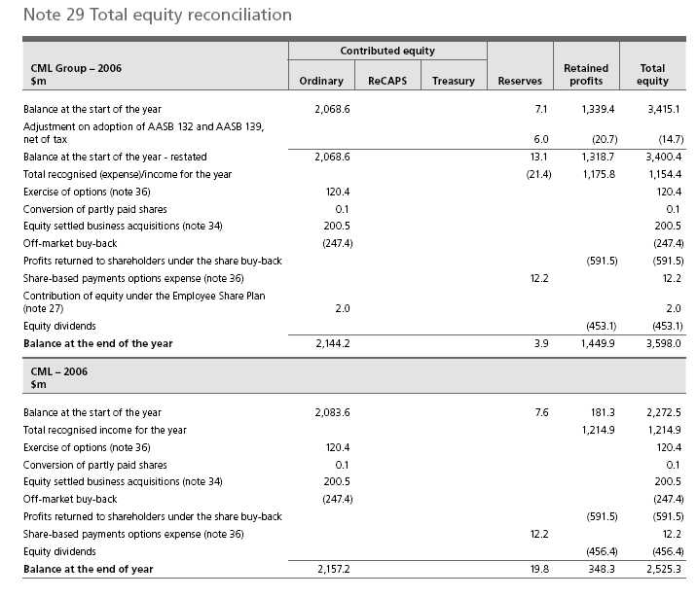
 | Contributed equity
CML Group – 2005 |  |  |  |  | Retained | Total
$m | Ordinary | ReCAPS | Treasury | Reserves | profits | equity
Balance at the start of the year | 1,608.1 | 680.6 | (12.3) | 2.2 | 1,506.2 | 3,784.8
Total recognised (expense)/income for the year |  |  |  | (0.5) | 639.7 | 639.2
Exercise of options (note 36) | 107.9 |  |  |  |  | 107.9
Conversion of ReCAPS | 680.6 | (680.6)
Conversion of partly paid shares | 0.1 |  |  |  |  | 0.1
Disposal of treasury stock |  |  | 12.3 |  |  | 12.3
On-market buy-back | (115.4) |  |  |  |  | (115.4)
Off-market buy-back | (215.7) |  |  |  |  | (215.7)
Profits returned to shareholders under the share buy-back |  |  |  |  | (373.3) | (373.3)
Share-based payments options expense (note 36) |  |  |  | 5.4 |  | 5.4
Contribution of equity under the Employee Share Plan
(note 27) | 3.0 |  |  |  |  | 3.0
Equity dividends |  |  |  |  | (433.2) | (433.2)
Balance at the end of the year | 2,068.6 |  |  | 7.1 | 1,339.4 | 3,415.1
CML – 2005
$m
Balance at the start of the year | 1,626.1 | 680.6 |  | 2.2 | 483.1 | 2,792.0
Total recognised income for the year |  |  |  |  | 508.3 | 508.3
Exercise of options (note 27) | 107.9 |  |  |  |  | 107.9
Conversion of ReCAPS | 680.6 | (680.6)
Conversion of partly paid shares | 0.1 |  |  |  |  | 0.1
On-market buy-back | (115.4) |  |  |  |  | (115.4)
Off-market buy-back | (215.7) |  |  |  |  | (215.7)
Profits returned to shareholders under the share buy-back |  |  |  |  | (373.3) | (373.3)
Share-based payments options expense (note 36) |  |  |  | 5.4 |  | 5.4
Equity dividends |  |  |  |  | (436.8) | (436.8)
Balance at the end of the year | 2,083.6 |  |  | 7.6 | 181.3 | 2,272.5

 | CML Group
Note 30 Earnings per share | 2006 | 2005
(a) Basic earnings per share
Profit from continuing operations attributable to the ordinary equity holders of the Company | 43.0 cents | 51.8 cents
Profit/(loss) from discontinued operations | 50.4 cents | (3.9) cents
Profit attributable to the ordinary equity holders of the Company | 93.4 cents | 47.9 cents
The profit for the year ended 30 July 2006 was $1,163.6 million. After adjusting for the gain on disposal of
Myer of $583.7 million and strategic initiative costs of $207.4 million, the profit for the year would have been
$787.3 million. Basic earnings per share would have been 63.2 cents.
The profit for the year ended 31 July 2005 was $637.9 million. After adjusting for the Kmart New Zealand
onerous lease provision re-measurement benefit of $3.5 million and the Megamart divestment costs of $57.1
million, the profit for the year would have been $691.5 million. Basic earnings per share would have been
52.3 cents.
(b) Diluted earnings per share
Profit from continuing operations attributable to the ordinary equity holders of the Company | 42.6 cents | 52.2 cents
Profit/(loss) from discontinued operations | 49.8 cents | (3.7) cents
Profit attributable to the ordinary equity holders of the Company | 92.4 cents | 48.5 cents
(c) Weighted average number of shares (’000s) used as the denominator
Weighted average number of shares used as the denominator in calculating basic earnings per share | 1,246,009 | 1,225,620
Options | 12,633 | 13,155
Partly paid shares | 64 | 86
Contingently issuable shares for acquisition of Pharmacy Direct | 208
Preference shares |  | 75,237
Weighted average number of ordinary shares and potential ordinary shares used as the denominator in
calculating diluted earnings per share | 1,258,914 | 1,314,098
(d) Reconciliation of earnings used in calculating earnings per share ($’000s)
(i) Basic earnings per share
Profit from continuing operations attributable to the ordinary equity holders of the Company | 536,374 | 686,100
Dividends on ReCAPS |  | (50,700)
Profit from continuing operations attributable to the ordinary equity holders of the Company used in
calculating basic earnings per share | 536,374 | 635,400
Profit from discontinued operations | 627,200 | (48,200)
Profit attributable to the ordinary equity holders of the Company used in calculating basic earnings per share | 1,163,574 | 587,200
(ii) Diluted earnings per share
Profit from continuing operations attributable to the ordinary equity holders of the Company used in
calculating basic earnings per share | 536,374 | 635,400
Dividends on ReCAPS |  | 50,700
Profit from continuing operations attributable to the ordinary equity holders of the Company used in
calculating diluted earnings per share | 536,374 | 686,100
Profit/(loss) from discontinued operations | 627,200 | (48,200)
Profit attributable to the ordinary equity holders of the Company used in calculating diluted earnings per share | 1,163,574 | 637,900

(e) Information concerning the classification of securities
(i) Partly paid ordinary shares
Partly paid ordinary shares do not carry the right to participate in dividends until they become fully paid. Amounts called and uncalled on partly paid shares and calls in arrears are treated as the equivalent of options to acquire ordinary shares and are included as potential ordinary shares in the determination of diluted earnings per share.
(ii) Options and performance shares
Options and performance shares are considered to be potential ordinary shares and have been included in the determination of diluted earnings per share to the extent to which they are dilutive. They have not been included in the determination of basic earnings per share. Details relating to options and performance shares are set out in note 36.
Included in the weighted average number of shares used in the determination of diluted earnings per share is 5,684,460 instruments that have been exercised or lapsed.
(iii) ReCAPS
Refer to note 27(b)(ii).
Note 31 Commitments for expenditure
 | CML Group |  |  | CML
 | 2006 | 2005 | 2006 |  | 2005
 | $m | $m | $m |  | $m
(a) Capital commitments
Contracted capital expenditure commitments not provided for in this
Financial Report, which principally relate to building and fixture contracts
for new stores and shopping centres were as follows:
Less than one year | 217.9 | 270.1 | 18.5 |  | 0.9
Later than one year but not later than five years | 41.1 | 0.7
 | 259.0 | 270.8 | 18.5 |  | 0.9
(b) Operating leases: members of the CML Group as lessee
Contracted non-cancellable lease expenditure commitments not provided
for in this Financial Report were as follows:
Less than one year | 949.2 | 988.0 | 21.1 |  | 19.9
Later than one year but not later than five years | 3,242.6 | 3,506.7 | 77.4 |  | 73.2
Later than five years | 3,480.6 | 4,333.9 | 90.0 |  | 101.4
 | 7,672.4 | 8,828.6 | 188.5 |  | 194.5
The CML Group leases various office, retail and distribution properties
under non-cancellable operating leases. The leases have varying terms,
escalation clauses and renewal rights.
(c) Operating leases: members of the CML Group as lessor for
sub-leases
Contracted non-cancellable future minimum lease payments expected to
be received in relation to non-cancellable sub-leases not included in this
financial report were as follows:
Less than one year | 5.3 | 4.2
Later than one year but not later than five years | 10.5 | 8.5
Later than five years | 1.6 | 4.9
 | 17.4 | 17.6
(d) Operating leases: members of the CML Group as lessor for
investment properties
Refer note 16(b) for details.
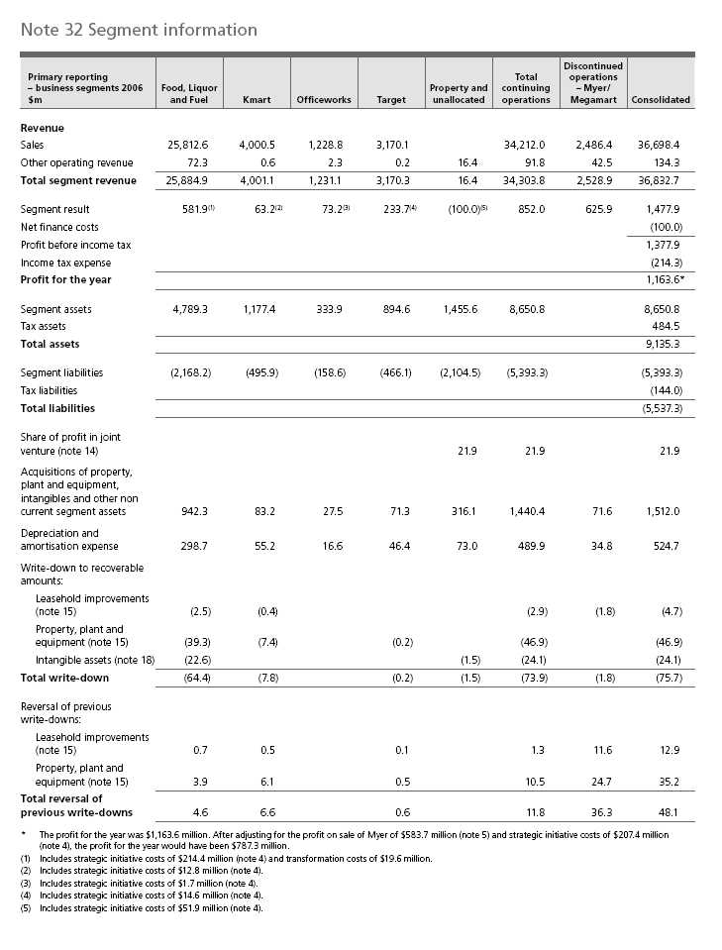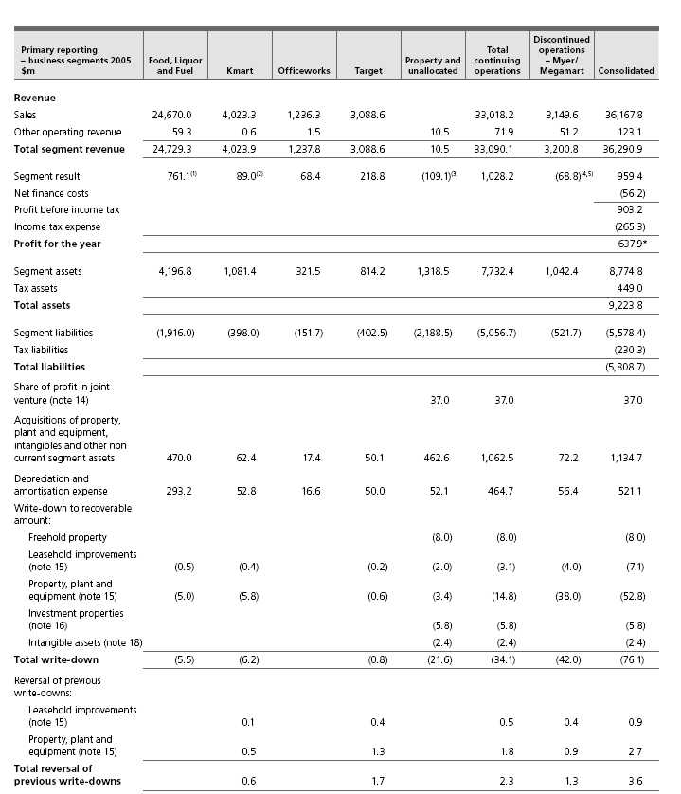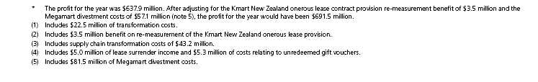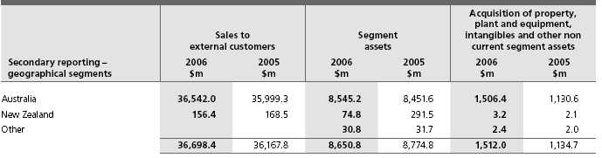
The CML Group operates predominantly in the retail industry and comprises the following main business segments:
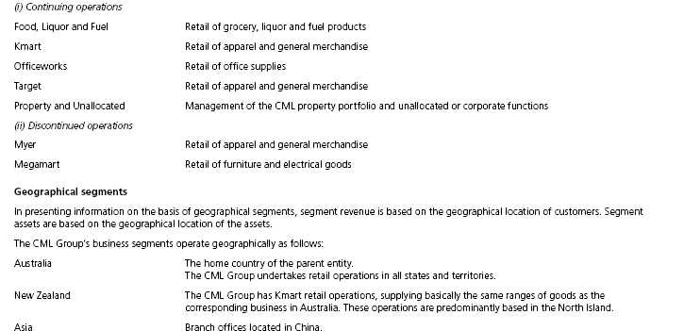
Inter-segment transfers
Segment revenues, expenses and results include transfers between segments. Such transfers are principally priced on an arm’s length basis and are eliminated on consolidation.
The CML Group has certain investments in joint ventures and other associates. Segment disclosures relating to these investments have not been included, as they are not considered to be material.
 | CML Group |  |  | CML
 | 2006 | 2005 | 2006 |  | 2005
Note 33 Auditor’s remuneration | $’000 | $’000 | $’000 |  | $’000
Amounts received or due and receivable by the auditor for:
Audit and review of financial reports | 7,046 | 6,338 | 1,004 |  | 873
Other assurance services
IFRS accounting services |  | 1,184 |  |  | 1,184
Acquisitions and divestments | 903
Sales certificates under leases | 636 | 452
Advice on accounting standards |  | 251 |  |  | 205
U.S. regulatory | 2,641 | 1,064 | 2,641 |  | 1,064
Other | 211
 | 4,391 | 2,951 | 2,641 |  | 2,453
Taxation advice | 93 | 91 | 93 |  | 91
Total PricewaterhouseCoopers | 11,530 | 9,380 | 3,738 |  | 3,417

Note 34 Business combinations
(a) Summary of acquisitions
During the year ended 30 July 2006, the acquisitions as set out below were undertaken by the CML Group.
On 31 March 2006, now.com.au Pty Ltd, a wholly-owned subsidiary of the CML Group, acquired 100% of the issued capital of Sydney Drug Stores Pty Ltd (trading as Pharmacy Direct) for $56.2 million. Included in the total purchase consideration is $44.3 million which has been settled by way of 4.2 million shares in Coles Myer Ltd. issued at fair value at the date of acquisition of $10.58 per share; and contingent consideration of $6.6 million also to be settled by way of shares, measured at fair value at the date of acquisition of $10.58 per share. The contingent consideration is dependent on regulatory outcomes. The contingent amount has been recognised in full as deferred consideration (note 20) on the basis that it is considered probable based on the existing regulatory environment, and the amount can be reliably measured. Goodwill recognised on the acquisition was $50.4 million. At the date of this financial report, owing largely to the unresolved contingency, the accounting for Sydney Drug Stores Pty Ltd is considered provisional.
On 14 June 2006, Liquorland (Qld) Pty Ltd, a wholly-owned subsidiary of the CML Group, acquired 100% of the issued capital of Hedley Hotel Group Pty Ltd and Hedley Hotel Group No. 2 Pty Ltd for $320.5 million. Included in the total purchase consideration is $156.2 million which has been settled by way of 13.7 million shares in Coles Myer Ltd. issued at fair value at the date of acquisition of $11.44 per share; and deferred consideration of $49.8 million (note 20) also to be settled by way of shares measured at fair value at the date of acquisition of $11.44 per share. Goodwill recognised on the acquisition was $292.1 million. The accounting for Hedley Hotel Group Pty Ltd and Hedley Hotel Group No. 2 Pty Ltd is provisional. Finalisation of the acquisition accounting is awaiting resolution of outstanding warranty issues and completion of valuation reports.
On 20 February 2006, Kmart Australia Pty Ltd acquired the service centres located at 92 Shell service stations for $14.8 million. During the year ended 30 July 2006, Coles Myer Property Developments Ltd acquired a hotel business in New South Wales for a total consideration of $17.4 million. In addition, Liquorland (Qld) Pty Ltd acquired the net assets of six Queensland hotels for a total consideration of $49.1 million, and other net asset acquisitions of $1.4 million were completed.
During the year ended 31 July 2005, Liquorland (Qld) Pty Ltd acquired the net assets of seven Queensland hotels and freehold properties for $116.5 million, and other net asset acquisitions of $3.7 million were completed.
The contributions to revenue and profit for the businesses acquired during the year ended 30 July 2006 is not significant to the results of the CML Group. Further, the revenue and profit which would have been earned by the CML Group should the results of all acquisitions have been included from the start of the financial year does not vary significantly from that disclosed in the Income Statement for the year ended 30 July 2006.
 | CML Group |  |  | CML
 | 2006 | 2005 | 2006 |  | 2005
 | $m | $m | $m |  | $m
(a) Summary of acquisitions (continued)
Details of the fair value of the assets and liabilities acquired and goodwill
are as follows:
Purchase consideration (refer to (b) below):
Cash paid (net of transaction costs) | 202.5 | 120.2
Equity settled consideration | 200.5
Deferred equity settled consideration | 56.4
Total purchase consideration | 459.4 | 120.2
Fair value of net identifiable assets acquired (refer to (c) below) | (71.3) | (63.3)
Goodwill | 388.1 | 56.9
The goodwill is attributable to the high profitability of the acquired
businesses. Liquor licences, acquired as part of the acquisitions made by
Liquorland (Qld) Pty Ltd, have been recognised as part of goodwill on
acquisition. Whilst the liquor licences meet the definition of separable
intangible assets, these assets were not able to be reliably measured
separate from the acquired business or premises. The fair value of assets
and liabilities acquired are based on discounted cash flow models. No
acquisition provisions were created.
(b) Purchase consideration
Net outflow of cash to purchase businesses and controlled entities,
net of cash acquired:
Cash consideration, net of transaction costs | (202.5) | (120.2)
Less: Cash acquired | 0.6 | 0.2
Bank overdrafts acquired | (0.6)
Net outflow of cash for purchase of businesses and controlled entities,
net of cash acquired | (202.5) | (120.0)
 |  | CML Group
 | 2006 |  |  | 2005
 | Acquirees’ |  | Acquirees’
 | carrying |  | carrying
 | amount | Fair value | amount |  | Fair value
 | $m | $m | $m |  | $m
(c) Assets and liabilities acquired
Cash assets | 0.6 | 0.6 | 0.2 |  | 0.2
Trade and other receivables | 5.9 | 5.9 | 1.2 |  | 1.2
Inventories | 31.6 | 31.6 | 2.4 |  | 2.4
Property, plant and equipment | 64.1 | 64.1 | 44.0 |  | 44.0
Deferred tax assets | 3.2 | 3.2
Goodwill in the books of the acquiree | 122.0
Co-branded operating rights |  | 8.2
Gaming licences | 4.8 | 9.8 | 22.2 |  | 22.2
Bank overdraft | (0.6) | (0.6)
Trade and other payables | (43.1) | (46.1)
Deferred tax liabilities |  | (5.4) |  |  | (6.7)
Net identifiable assets acquired | 188.5 | 71.3 | 70.0 |  | 63.3

Note 35 Particulars in relation to controlled entities
Name of entity | Legend
Coles Myer Ltd.
Bi-Lo Pty. Limited | a(1)
Barrier Investments Pty. Ltd. | a
CMFL Services Ltd | a(1)
Financial Network Card Services Pty. Ltd. | a(1)
CMPQ (CML) Pty Ltd | a(1)
Coles Ansett Travel Pty Ltd (97.5% owned, formerly Coles Myer Ansett Travel Pty. Ltd.)
Coles Myer Asia Pty Ltd | a(1)
Coles Myer Deposit Services Pty Ltd | a
Coles Myer Employee Share Plan Trust
Coles Myer Finance Limited
Coles Myer Finance (USA) Pty Ltd | a
Coles Myer International Pty Ltd | a(1)
Coles Myer New Zealand Holdings Limited | c
CMNZ Finance Limited | c
Retail Investments Pty Ltd | a(1)
CMNZ Investments Pty Ltd | a(1)
Sanco Insurance Pte. Ltd. | d
Coles Myer Logistics Pty Ltd | a(1)
Coles Myer Properties Holdings Ltd | a(1)
Australian Grocery Holdings Pty Ltd | a(1)
Clarkson Shopping Centre Pty Ltd | a(1)
CMPQ (PEN) Pty Ltd | a(1)
CMTI Pty Ltd | a(1)
Coles Group Pty Ltd (formerly Coles Myer Properties Pty Ltd) | a(1)
Coles Melbourne Ltd (formerly Myer Melbourne Ltd) | a(1)
Coles Myer Property Developments Ltd | a(1)
Coles Properties W.A. Ltd (formerly Myer Properties W.A. Ltd) | a(1)
Fulthom Pty Limited | a(1)
ht (colesmyer) Pty Ltd | a(1)
Morley Shopping Centre Pty Limited | a(1)
Orzo Pty Limited | a(1)
Procurement Online Pty Ltd | a(1)
Tooronga Shopping Centre Pty Ltd | a(1)
Coles Supermarkets Australia Pty Ltd | a(1)
Charlie Carter (Norwest) Pty Ltd | a(1)
Eureka Operations Pty Ltd
Newmart Pty. Ltd. | a(1)
Tooronga Holdings Pty Ltd | a(1)
e.colesmyer Pty Ltd | a(1)
Coles Retail Group Pty Ltd (formerly colesmyer.com Pty Ltd) | a(1)
e.tailing (colesmyer) Pty Ltd | a(1)
Coles Online Pty Ltd | a(1)
Direct Fulfilment Group Pty Ltd | a(1)
Liquorland Direct Pty Ltd | a(1)
e.trading (colesmyer) Pty Ltd | a(1)
Harris Technology (NZ) Pty Ltd | a(1)
Multimedia Services Pty Ltd | a(1)
now.com.au Pty Ltd | a(1)

Name of entity | Legend
Sydney Drug Stores Proprietary Limited | a
Pharmacy Direct Pty Limited | a
GBPL Pty Ltd (formerly Grace Bros Pty Ltd)
General Merchandise and Apparel Group Pty Ltd | a(1)
Grocery Holdings Pty Ltd | a(1)
Harris Technology Pty Ltd | a(1)
Kmart Australia Ltd | a(1)
Arana Hills Properties Pty. Limited | a
Tyremaster (Wholesale) Pty Ltd | a(1)
W4K. World 4 Kids Pty Ltd | a(1)
Katies Fashions (Aust.) Pty. Limited | a(1)
G.J. Coles & Coy. Pty Limited | a(1)
Liquorland (Australia) Pty. Ltd. | a(1)
Australian Liquor Group Ltd | a
Knox Liquor Australia Pty Ltd | a
Osmond Hotel Pty Ltd | a
Outfront Liquor Services Pty. Ltd. | a
Guidel Pty Ltd | a
Sorcha Pty Ltd | a
Philip Murphy Melbourne Pty Ltd | a
Philip Murphy Niddrie Pty. Ltd. | a
Philip Murphy Toorak Pty Ltd | a
Philip Murphy Wine & Spirits Pty Ltd | a
Theo’s Liquor Pty Ltd | a(1)
ALW Newco Pty Limited | a(1)
Pacific Liquor Wholesalers Pty Ltd | a(1)
Liquorland (Qld.) Pty Ltd | a(1)
LHG Pty Ltd (formerly Hedley Hotel Group Pty Ltd)
Brian Pty. Ltd.
Fitzgibbons Hotel Pty. Ltd.
Fitzinn Pty. Ltd.
The Grape Management Pty Ltd
Hotel Wickham Investments Pty Ltd
LHG2 Pty Ltd (formerly Hedley Hotel Group No. 2 Pty Ltd) | a
Mycar Automotive Pty Ltd | a(1)
Officeworks Superstores Pty Ltd | a(1)
Officeworks Businessdirect Pty Ltd
Officeworks Superstores N.Z. Limited | c
Viking Direct Pty. Limited | a
Penneys Pty. Limited | a(1)
Price Point Pty. Ltd.
Target Australia Pty. Ltd. | a(1)
Fosseys (Australia) Pty Ltd | a(1)
Tickoth Pty Ltd
Tyremaster Pty Ltd | a(1)
Comnet Pty Ltd | a(1)

Name of entity | Legend
Controlled entities sold in 2006
Myer Limited | b
The Myer Emporium Limited | b

Except where shown, controlled entities are wholly owned and incorporated or established in Australia. The 2.5% of capital in Coles Ansett Travel Pty Ltd not owned by the CML Group gives rise to outside equity interests of $NIL. The balance date of all controlled entities, apart from the Coles Myer Employee Share Plan Trust, was 30 July 2006. The Income Statement and Balance Sheet of the Coles Myer Employee Share Plan Trust for the year ended 30 July 2006 (31 July 2005) have been included in the results of the CML Group.
Controlled entities carry on business in their countries of incorporation except Coles Myer Asia Pty Ltd, which carries on business in China.
Legend
Deed of Cross Guarantee:
a | These companies and CML are party to a new Deed of Cross Guarantee (‘the Deed’) dated 28 July 2006. Under this Deed, each company guarantees the liabilities of all other companies that are party to the Deed. These companies form a Closed Group and are relieved from the requirements to prepare audited financial reports under the Corporations Act 2001 and Australian Securities and Investments Commission accounting and audit relief Class Orders.
 | (1) | These companies and CML were party to the original Deed of Cross Guarantee dated 23 September 1992. This Deed was revoked on 28 July 2006 by Revocation Deed and replaced with the new Deed as detailed above.
b | These companies and CML were party to the original Deed of Cross Guarantee dated 23 September 1992 and were subject to a Notice of Disposal dated 2 June 2006.
c | Incorporated in New Zealand.
d | Incorporated in Singapore.
The Income Statement and Balance Sheet below represent companies, which are party to the Deed of Cross Guarantee. These companies form a Closed Group, which forms part of the CML Group. This information is provided in accordance with the requirements of Australian Securities and Investments Commission accounting and audit relief Class Orders.
 | 2006 | 2005
 | $m | $m
Consolidated Income Statement
Profit before income tax expense | 794.8 | 926.3
Income tax expense | (238.1) | (273.8)
Profit from continuing operations | 556.7 | 652.5
Profit/(loss) from discontinued operations | 627.2 | (48.2)
Profit for the year | 1,183.9 | 604.3
Consolidated Balance Sheet
Current assets
Cash and cash equivalents | 281.1 | 360.9
Trade and other receivables | 351.5 | 247.3
Inventories | 2,684.1 | 3,103.3
Assets classified as held for sale | 151.8
Total current assets | 3,468.5 | 3,711.5
Non current assets
Receivables | 40.4 | 60.5
Investments | 1,383.5 | 664.0
Property, plant and equipment | 3,079.1 | 3,448.9
Investment properties | 7.6 | 9.6
Deferred tax assets | 460.2 | 434.2
Intangible assets | 1,116.4 | 703.7
Retirement benefit asset | 38.3 | 17.7
Total non current assets | 6,125.5 | 5,338.6
Total assets | 9,594.0 | 9,050.1
Current liabilities
Trade and other payables | 2,917.7 | 2,869.1
Interest bearing liabilities | 3.9
Derivative financial instruments | 12.3
Tax liabilities | 64.4 | 122.3
Provisions | 742.9 | 582.4
Total current liabilities | 3,741.2 | 3,573.8
Non current liabilities
Payables | 23.0
Interest bearing liabilities | 2,142.9 | 1,939.6
Deferred tax liabilities | 98.9 | 124.9
Provisions | 318.8 | 315.4
Other | 127.4 | 188.0
Total non current liabilities | 2,711.0 | 2,567.9
Total liabilities | 6,452.2 | 6,141.7
Net assets | 3,141.8 | 2,908.4
Equity
Contributed equity | 2,157.2 | 2,083.6
Reserves | 11.5 | 7.6
Retained profits | 973.1 | 817.2
Total equity | 3,141.8 | 2,908.4

Note 36 Share-based payments
(a) Coles Myer Employee Share Plan
CML established a general employee share plan, the Coles Myer Employee Share Plan (the Plan), and the Coles Myer Employee Share Plan Trust (‘the Trust’). The Trust acquired CML fully paid ordinary shares (shares) and then invited eligible employees to purchase them. At CML’s discretion employees who had worked continuously for the CML Group for 12 months full-time, 12 months part-time, or 24 months casually, were eligible to purchase shares on the following bases:
n | Shares were purchased from the Trust at the average cost of the shares available for sale or such price as determined by the Trust;
n | Employees pay for the shares by applying dividends on the shares and making voluntary payments;
n | No interest is charged on the outstanding purchase price;
n | Employees who left the CML Group within three years of acquiring shares under the Plan forfeited their shareholding; and
n | A maximum of 20 years is allowed for the purchase price to be paid in full.

The number of shares offered to each employee depended on the employee’s position and performance within the CML Group. At balance date,
the following shares were on issue:
 |  | Price | No. of shares offered | No. of employees |  | Total shares on issue
Issue date | Type | $ | per employee | 2006 | 2005 | 2006 | 2005
6 May 1994 | G | 4.93 | 200 to 2,500 | 12,783 | 14,701 | 7,803,000 | 8,984,200
15 June 1995 | P | 4.78 | 50 to 2,000 | 1,123 | 1,320 | 226,525 | 266,125
12 January 1996 | P | 4.54 | 50 to 2,500 | 1,227 | 1,472 | 260,100 | 311,310
14 August 1996 | P | 4.61 | 100 to 1,100 | 649 | 725 | 236,355 | 263,795
 |  |  |  |  |  | 8,525,980 | 9,825,430

G = General issue
P = Performance issue
Price = Average cost (including stamp duty and brokerage) of the shares to the Trust. The market value of CML ordinary shares at balance date was $11.70.
CML provided the finance to the Trust to acquire these shares. At balance date a loan of $12.9 million (2005 $16.0 million) was receivable from the Trust (note 13). The Trust is consolidated as part of the CML Group. Accordingly, the loan receivable from the Trust is eliminated on consolidation. Shares on issue to employees are held in trust until the employee loans are settled. Loans receivable from the employees in relation to shares on issue are recognised by the CML Group as an increase to contributed equity when repaid. For the parent entity, these loans are recognised as a loan receivable.
(b) Coles Myer Executive Share Option Plans
CML established Executive Share Option Plans, under which options over unissued shares, and over issued shares held by the Trust, may be issued to executives at CML’s discretion. Options are issued for $NIL consideration. Each option is over one share.
Options have no voting rights until exercised. The holders of options are entitled to participate in bonus share issues. Where options are over issued shares held by the Trust, the Trust’s consent is required to make the necessary shares available.
Details of options granted under the Coles Myer Executive Share Option Plans to 30 July 2006 are:
 |  |  |  | Hurdle |  |  | Number
 |  | Exercise price |  | conditions | Number at | Number issued | exercised | Number lapsed | Number at | Number vested
Date of grant |  | Expiry date | $ | (page 67) | 31 July 2005 | during period | during period | during period | 30 July 2006 | at 30 July 2006
Dec 98 |  | Oct 05 | 4.50 | 1 | 22,000 | – | 22,000 | – | – | –
Dec 98 |  | Oct 06 | 4.50 | 1 | 22,000 | – | 22,000 | – | – | –
Dec 98 |  | Oct 07 | 4.50 | 1 | 23,000 | – | 23,000 | – | – | –
Aug 01 |  | ** | 6.21 | NIL | 1,000,000 | – | 1,000,000 | – | – | –
Sep 01 |  | ** | 6.28 | NIL | 600,000 | – | 300,000 | – | 300,000 | –
Sep 01 |  | ** | 6.33 | 3 | 1,500,000 | – | 1,000,000 | – | 500,000 | –
Feb 02 |  | Nov 06* | 7.66 | 3 | 813,000 | – | 534,000 | – | 279,000 | 96,000
Mar 02 |  | Nov 06* | 7.66 | 3 | 8,538,357 | – | 5,175,884 | 168,090 | 3,194,383 | 802,400
May 02 |  | Nov 07* | 6.44 | 3 | 1,500,000 | – | 1,500,000 | – | – | –
Jun 02 |  | Nov 06* | 8.32 | 3 | 172,000 | – | – | – | 172,000 | 86,000
Jun 02 |  | Nov 06* | 7.66 | NIL | 7,045,286 | – | 3,571,997 | 86,539 | 3,386,750 | 1,628,750
Jul 02 |  | May 07* | 8.26 | 3 | 320,000 | – | 60,000 | 10,000 | 250,000 | 180,000
Jul 02 |  | May 07* | 8.26 | NIL | 168,000 | – | 60,000 | – | 108,000 | 66,000
Sep 02 |  | Nov 07* | 5.88 | 3 | 516,000 | – | 172,000 | – | 344,000 | –
Dec 02 |  | Nov 07* | 6.59 | 3 | 216,712 | – | 106,712 | 28,000 | 82,000 | 14,000
Dec 02 |  | Nov 07* | 5.88 | 3 | 516,000 | – | 172,000 | – | 344,000 | –
Dec 02 |  | Nov 07* | 6.59 | NIL | 66,000 | – | 54,000 | – | 12,000 | –
Feb 03 |  | Nov 07* | 6.59 | 3 | 282,000 | – | 60,000 | – | 222,000 | 34,000
Feb 03 |  | Nov 07* | 6.59 | NIL | 38,000 | – | 6,000 | 18,445 | 13,555 | 8,000
May 03 |  | May 08* | 6.42 | 3 | 620,474 | – | 205,175 | 141,299 | 274,000 | 84,000
May 03 |  | May 08* | 6.42 | NIL | 105,000 | – | 50,505 | 21,495 | 33,000 | 15,000
Jun 03 |  | May 08* | 6.42 | 3 | 510,000 | – | 192,000 | 96,000 | 222,000 | 30,000
Jun 03 |  | May 08* | 6.42 | NIL | 144,000 | – | 57,445 | 32,555 | 54,000 | 6,000
Aug 03 |  | Nov 08* | 7.28 | 3 | 713,699 | – | 713,699 | – | – | –
Aug 03 |  | Nov 08* | 7.28 | 4 | 142,740 | – | 129,362 | 13,378 | – | –
Oct 03 |  | Nov 08* | 7.26 | 3 | 1,013,414 | – | 349,414 | 77,890 | 586,110 | 124,000
Oct 03 |  | Nov 08* | 7.26 | NIL | 300,000 | – | 102,500 | – | 197,500 | 17,500
Nov 03 |  | ** | 7.53 | 7 | 1,500,000 | – | – | – | 1,500,000 | 375,000
Dec 03 |  | Nov 08* | 7.12 | 3 | 430,000 | – | 172,000 | – | 258,000 | –
Jan 04 |  | Nov 08* | 7.26 | 3 | 846,797 | – | 350,797 | 68,000 | 428,000 | 28,000
Jan 04 |  | Nov 08* | 7.26 | NIL | 270,000 | – | 94,319 | 31,681 | 144,000 | 36,000
Apr 04 |  | May 09* | 7.43 | 3 | 440,000 | – | 93,000 | 56,712 | 290,288 | 83,000
Apr 04 |  | May 09* | 7.43 | NIL | 120,000 | – | 36,000 | 18,000 | 66,000 | 12,000
Jul 04 |  | May 09* | 7.43 | 3 | 572,534 | – | 162,534 | 92,000 | 318,000 | 80,000
Jul 04 |  | May 09* | 7.43 | NIL | 150,000 | – | 20,000 | – | 130,000 | 40,000
Jul 04 |  | Nov 09* | 8.43 | 3 | 210,000 | – | – | – | 210,000 | 42,000
Oct 04 |  | Nov 09* | 8.92 | 3 | 1,050,000 | – | 38,000 | 102,000 | 910,000 | 172,000
Oct 04 |  | Nov 09* | 8.94 | NIL | 120,000 | – | – | – | 120,000 | –
Mar 05 |  | Nov 09* | 8.94 | 3 | 1,250,000 | – | 38,000 | 60,000 | 1,152,000 | 212,000
Mar 05 |  | Nov 09* | 8.94 | NIL | 510,000 | – | 30,000 | 138,989 | 341,011 | –
Total |  |  |  |  | 34,377,013 | – | 16,674,343 | 1,261,073 | 16,441,597 | 4,271,650
Weighted average exercise price |  |  |  |  | 7.42 | – | 7.22 | 7.55 | 7.62 | 7.74
* | Expiry date is shown as the expected month only. The actual last exercise date is 60 days after the announcement of the results of the CML Group.
** | Cessation of employment + 1 year.
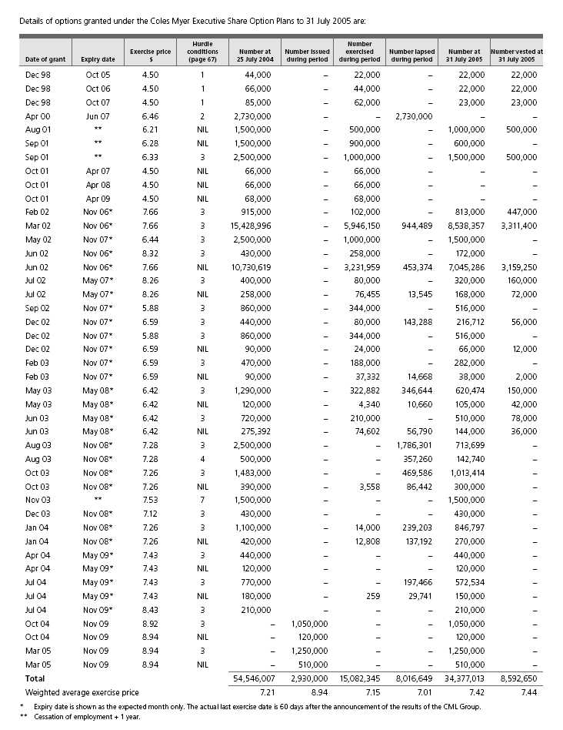
(c) Coles Myer Senior Executive Performance Share Plan
CML has established a Senior Executive Performance Share Plan. A performance share is a right to acquire an ordinary share in CML for no consideration. Performance shares are issued for $NIL consideration. Performance shares have no voting rights until vested. The holders of performance shares are entitled to participate in bonus share issues.
Details of performance shares granted under the Senior Executive Performance Share Plan to 30 July 2006 are:
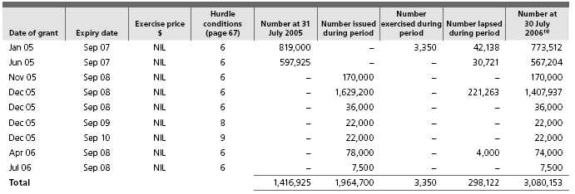
(1) No performance shares were vested at balance date.
Details of performance shares granted under the Senior Executive Performance Share Plan to 31 July 2005 are:
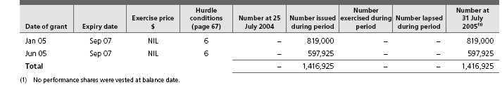
 | Fair value of
 | shares at issue
 | date⁽¹⁾ | 2006 | 2005
Exercise date ⁽¹⁾ | $ | Number | Number
(d) Options and performance shares exercised during the financial year
August 2004 | 8.77 |  | 169,200
September 2004 | 9.37 |  | 1,456,860
October 2004 | 9.26 |  | 4,919,538
November 2004 | 9.84 |  | 3,020,968
December 2004 | 9.75 |  | 2,056,349
January 2005 | 9.68 |  | 912,267
February 2005 | 9.47 |  | 83,444
March 2005 | 9.71 |  | 1,408,689
April 2005 | 9.28 |  | 247,473
May 2005 | 8.98 |  | 80,820
June 2005 | 9.46 |  | 219,452
July 2005 | 9.47 |  | 507,285
August 2005 | 9.74 | 754,936
September 2005 | 10.24 | 3,967,752
October 2005 | 9.93 | 2,979,809
November 2005 | 10.01 | 1,451,530
December 2005 | 10.05 | 451,200
January 2006 | 10.53 | 1,227,211
February 2006 | 10.11 | 162,100
March 2006 | 10.52 | 1,152,270
April 2006 | 10.85 | 1,699,134
May 2006 | 11.19 | 331,600
June 2006 | 11.41 | 1,056,875
July 2006 | 10.70 | 1,439,926
Total |  | 16,674,343 | 15,082,345

(1) Exercise dates are grouped by month, and the fair value of the shares at issue date is based on the weighted average of fair values on each issue date for that month.
Aggregate proceeds received by CML from employees on the exercise of options over unissued shares were $120,372,463 (2005 $107,893,543), and the fair value of those shares at issue date was $174,375,296 (2005 $143,682,286).
Subsequent to balance date, 1,018,566 options have been exercised and 372,100 options have lapsed.
(e) Expenses arising from share-based payments transactions
Total expenses arising from share-based payment transactions recognised during the period as part of employee benefit expense were as follows:
 | CML Group |  |  | CML
 | 2006 | 2005 | 2006 | 2005
 | $’000 | $’000 | $’000 | $’000
Share option plan | 6,981 | 4,455 | 1,308 | 2,097
Performance share plan | 5,252 | 895 | 1,613 | 280
 | 12,233 | 5,350 | 2,921 | 2,377

The total share-based payments expense of $12.2 million (2005 $5.4 million) for the CML Group includes $4.7 million (2005 $0.5 million) related to discontinued operations. Whilst the equity instruments are issued by CML, where the employee services are provided to other entities within the Group the expenses are transferred accordingly.
(i) Fair value of options and performance shares granted:
Where options and performance shares are subject to performance hurdle conditions, these conditions include total shareholder return (TSR) and earnings per share growth (EPSG) metrics. Where the vesting of options is subject to performance hurdles, in general, either the TSR or EPSG hurdle must be satisfied. For performance shares, 50% of the shares are subject to TSR and 50% are subject to EPSG.
The fair value of options has been determined using the Black-Scholes pricing model. Where options are subject to performance conditions, a 50% probability has been applied to the Black-Scholes valuation. The fair value of performance shares has been determined using the Monte-Carlo pricing model, which incorporates market based performance conditions such as TSR. Details in relation to the fair value of performance shares and options granted, and the assumptions that have been included in the valuations are included below:
 | Weighted average
 | 2006 | 2005
Fair value of performance shares subject to TSR ($) | 5.22 | 2.58
Fair value of performance shares subject to EPSG ($) | 9.20 | 8.62
Fair value of options ($) |  | 2.00
Risk free rate (%) | 5.3 | 5.3
Expected volatility (%) | 18.0 | 21.7
Expected dividend yield (%) | 3.3 | 3.5
Expected life of equity instrument (months) | 33 | 37

The expected volatility is based on CML’s historical share price volatility. The risk free rate is the yield at grant date on Australian Government Securities of appropriate term. The dividend yield is based on the recent dividend history of CML.
(ii) Modifications to the terms and conditions of options and performance shares:
At inception of the Senior Executive Performance Share Plan, the EPSG hurdle was set such that the compound annual growth rate must equal or exceed 12.5% for a three year period. During 2006 this hurdle was modified such that the compound annual growth rate must now equal or exceed 8%. The pre-existing hurdle remains applicable for the purpose of testing EPSG in the first and second test years in relation to performance shares issued in 2005 and the first test year in relation to performance shares issued in 2006. This change had no impact on the fair value of performance shares granted.
As an outcome of the disposal of the Myer business, options held by the Managing Director of Myer were modified. At the discretion of the Directors, the TSR and EPSG hurdles were waived and one million options were allowed to vest as part of a termination entitlement. The removal of these hurdles resulted in an additional non-cash charge of $2.8 million, which has been included in the gain on sale of the Myer business.
The performance hurdle conditions attaching to each tranche of options are as follows:
1 | Net profit for the CML Group must exceed specified targets set for any one of the financial years ended July 2000, 2001 and 2002; or
 | TSR over any one of the periods 16 October 1998 to 15 October 2000, 15 October 2001 or 15 October 2002 must equal or exceed the median return over the same period of a set list of top 100 industrial companies listed on the Australian Stock Exchange (ASX).
 | The profit hurdle was met for the financial year ended July 2000 and thus all options are exercisable.
2 | TSR over any one of the periods 1 March 2000 to 28 February 2003, 29 February 2004, or 28 February 2005 must equal or exceed the median return over the same period of a set list of top 100 industrial companies listed on the ASX.
 | The hurdles were not met and the options lapsed during 2005.
3 | TSR must equal or exceed the median return over the relevant period of a list of top 50 industrial companies; or EPSG expressed as a compound annual growth rate must equal or exceed 12.5% over the relevant period.
4 | TSR must equal or exceed the median return over the relevant period of a list of top 50 industrial companies; or EPSG expressed as a compound annual growth rate must equal or exceed 15% over the relevant period.
5 | TSR must exceed the median return over the relevant period of a list of top 50 industrial companies; or EPSG expressed as a compound annual growth rate must equal or exceed 12.5% over the relevant period.
 | For hurdles 3, 4 and 5, the options will progressively vest according to the level of TSR or EPSG achieved each year. To the extent that TSR or EPSG is not achieved, the non-vested options will be carried forward to be retested in following years.
6 | 50% of the performance shares issued to individuals are subject to TSR. TSR for the three financial years from the year of grant must exceed the median return of a list of the top 50 industrial companies.
 | 50% of the performance shares are subject to EPSG. EPSG expressed as a compound annual growth rate must equal or exceed 12.5% for the three financial years from the year of grant, when compared with the earnings per share achieved for the year preceding the test period. During 2006 this hurdle rate was changed to 8%. For performance shares issued in 2005 this new rate is only applicable to the third test year, and for performance shares issued in 2006 this new rate is only applicable to the second and third test years.
7 | When originally granted, these options were subject to the performance hurdle conditions described in footnote 5. During 2005, these hurdles were changed to those described in 6, however, the test period is the three years ending 30 July 2006.
8 | The conditions associated with these performance shares are per 6, with the exception of the test period, which is for the three years ending 26 July 2009.
9 | The conditions associated with these performance shares are per 6, with the exception of the test period which is for the three years ending 25 July 2010.
The Directors have discretion to disregard any changes in net profit, TSR or EPSG due to an anomaly, distortion or other event which is not directly related to the financial performance of any company or entity, or which would lead to an incorrect comparison.
Note 37 Key management personnel disclosures
(a) Directors
The following persons were Directors of CML during the financial year:
Chairman – Non-executive
Rick Allert
Executive Director
John Fletcher
Non-executive Directors
Patty Akopiantz Keith Barton Bill Gurry Tony Hodgson
Belinda Hutchinson (appointed 23 September 2005) Sandra McPhee Martyn Myer Michael Wemms
(b) Other key management personnel
The following persons also had responsibility for planning, directing and controlling the activities of the CML Group, directly or indirectly during the financial year ended 30 July 2006 and the financial year ended 31 July 2005:
Larry Davis | Managing Director, Target (until 14 February 2005)
 | Managing Director, Kmart (appointed 15 February 2005)
Tim Hammon | Chief Officer, Corporate and Property Services
Launa Inman | Managing Director, Target (appointed 14 February 2005)
Fraser MacKenzie | Chief Financial Officer
Dawn Robertson | Managing Director, Myer (until 31 May 2006)
Hani Zayadi | Managing Director, Kmart (until 22 December 2004)
 | Group Managing Director, Food, Liquor and Fuel (appointed 22 December 2004 until 20 March 2006)
Former key management personnel
Steven Cain | Group Managing Director, Food, Liquor and Fuel (until 22 December 2004)
Mark Leibler | Non-executive Director (retired 18 November 2004)

(c) Key management personnel remuneration
The CML Group as permitted has transferred the detailed remuneration disclosures to pages 41 to 56 of the Company’s separate Annual Report
under the heading ‘Remuneration Report’.
 | CML Group |  |  | CML
 | 2006 | 2005 | 2006 | 2005
 | $ | $ | $ | $
Short-term employee benefits | 17,599,181 | 18,197,361 | 17,599,181 | 18,197,361
Post-employment benefits | 821,547 | 520,468 | 821,547 | 520,468
Termination benefits | 4,495,201 | 2,362,384 | 4,495,201 | 2,362,384
Share-based payments | 5,180,754 | 1,896,377 | 5,180,754 | 1,896,377
 | 28,096,683 | 22,976,590 | 28,096,683 | 22,976,590
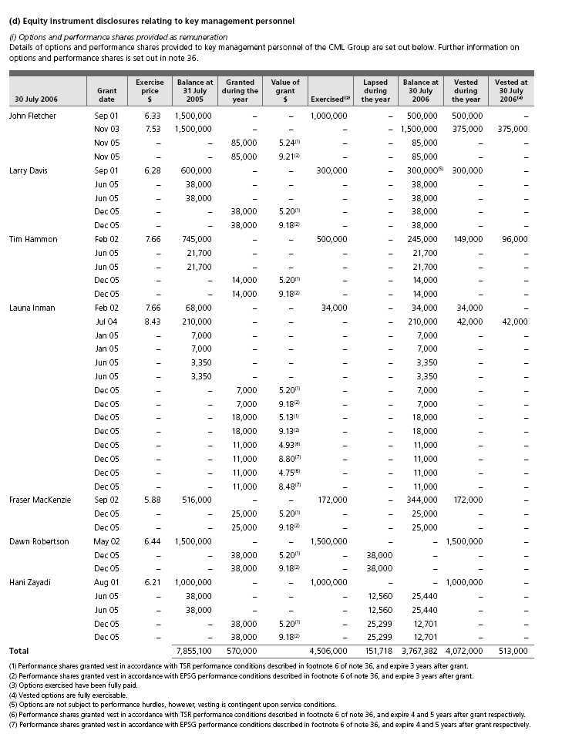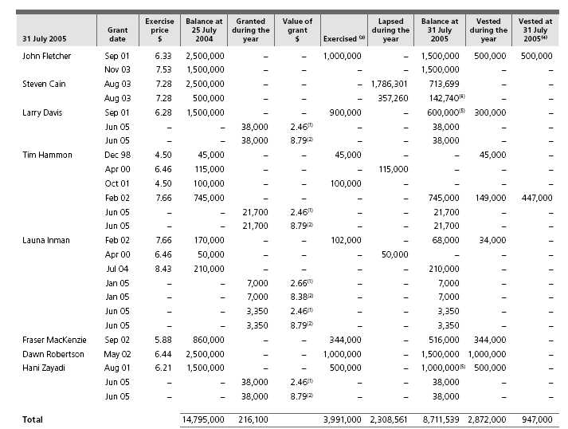
(1) | Performance shares granted vest in accordance with TSR performance conditions described in footnote 6 of note 36, and expire 3 years after grant.
(2) | Performance shares granted vest in accordance with EPSG performance conditions described in footnote 6 of note 36, and expire 3 years after grant.
(3) | Options exercised have been fully paid.
(4) | Vested options are fully exercisable.
(5) | Options are not subject to performance hurdles, however, vesting is contingent upon service conditions.
(6) | Subsequent to balance date 13,378 options lapsed.
(ii) Key management personnel share holdings
The numbers of ordinary shares in CML held during the year by key management personnel of the CML Group, including their related parties, are set out below.
 | Balance at | Options | Net change | Balance at
30 July 2006 | 31 July 2005 | exercised | other | 30 July 2006
Directors
Patty Akopiantz | 3,253 | – | – | 3,253
Rick Allert | 28,767 | – | – | 28,767
Keith Barton | 13,598 | – | – | 13,598
John Fletcher | 1,029,458 | 1,000,000 | (825,000) | 1,204,458
Bill Gurry | 140,000 | – | – | 140,000
Tony Hodgson | 6,500 | – | – | 6,500
Belinda Hutchinson⁽¹⁾ | – | – | 15,000 | 15,000
Sandra McPhee⁽²⁾ | 4,139 | – | – | 4,139
Martyn Myer | 63,692 | – | 8,664 | 72,356⁽³⁾
Michael Wemms | 208 | – | – | 208
Other key management personnel
Larry Davis | – | 300,000 | (300,000) | –
Tim Hammon | 1,327 | 500,000 | (500,000) | 1,327
Launa Inman | – | 34,000 | (34,000) | –
Fraser MacKenzie | 347,000 | 172,000 | (347,000) | 172,000
Dawn Robertson⁽⁴⁾ | – | 1,500,000 | (1,500,000) | –
Hani Zayadi⁽⁵⁾ | – | 1,000,000 | (1,000,000) | –
Total | 1,637,942 | 4,506,000 | (4,482,336) | 1,661,606

(1) Ms Hutchinson was appointed on 23 September 2005. At this time Ms Hutchinson held NIL ordinary shares in CML. (2) Ms McPhee also holds 3,400 endowment warrants. The warrants are due to mature in November 2006.
(3) Included in this balance are 12,611 shares held nominally at 30 July 2006.
(4) Ms Robertson’s employment concluded on 31 May 2006. At this time Ms Robertson held NIL ordinary shares in CML. (5) Mr Zayadi’s employment concluded on 31 July 2006. At this time Mr Zayadi held NIL ordinary shares in CML.
There were no shares granted to key management personnel during the year, other than those described in note 37(d)(i).
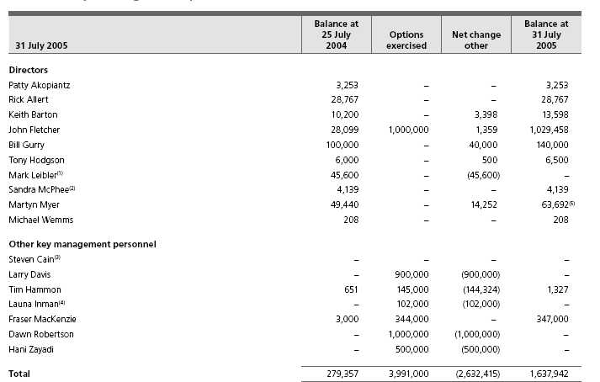
(1) | Mr Leibler retired on 18 November 2004. At this time Mr Leibler held 45,100 ordinary shares in CML.
(2) | Ms McPhee also holds 3,400 endowment warrants.
(3) | Mr Cain ceased being a member of other key management personnel on 22 December 2004.
(4) | Ms Inman became a member of other key management personnel on 14 February 2005.
(5) | Included in this balance are 15,294 shares held nominally at 31 July 2005.
Included in the above movements is the conversion of ReCAPS to ordinary shares that occurred on 12 July 2005. At 25 July 2004, ReCAPS were held by Keith Barton (300), John Fletcher (120) and Martyn Myer (900).
There were no shares granted to key management personnel during the year, other than those described in note 37(d)(i).
(e) Loans to key management personnel
There were no loans made to key management personnel, including their related parties, during 2006 or 2005.
(f) Other transactions with key management personnel
(i) Directors
The CML Group has a comprehensive Statement of Corporate Governance Principles. This Statement incorporates detailed policies in respect to Director-related party transactions. The major elements of the policy are:
n | Directors must advise the Company of all Director-related entities.
n | Where there are total transactions between the CML Group and a Director’s related entities exceeding $1.0 million in any month, then the Director must supply CML with details of these transactions.
n | The following proposed contracts between the CML Group and Director-related entities must be approved by the Audit and Risk Committee prior to committing the CML Group:
 | • | Contracts for the supply of goods and/or services which extend beyond one year, or where the total value of goods and/or services supplied under the contract will exceed $5 million in any one year;
 | • | All agreements to lease and/or leases of property; and
 | • | All agreements for the purchase or sale of freehold and/or leasehold property except where the sale is by genuine public auction.
n | All transactions are to be subject to review by internal audit with periodic reports to the Audit and Risk Committee.
All transactions were on terms and conditions that were no more favourable to the Director-related entity than those available, or which might reasonably be expected to be available, on similar transactions to non-Director-related entities and were on an arm’s length basis.
Retirement agreement
On 27 March 2003, CML announced that Non-executive Directors appointed after that date will not receive retirement benefits. CML has an agreement with those Non-executive Directors appointed prior to 27 March 2003 for the provision of an allowance to be paid to each Director on his or her retirement or death.
Nature of terms and conditions: The agreement is in accordance with the provisions of the Constitution and the approval given at the Annual General Meeting held on 21 November 1989. The approval provides for the payment of a retirement allowance equal to the aggregate of remuneration received by the Director over the last three years of service or part thereof, plus 5% of that amount for each year of service in excess of three years but not exceeding a total of 15 years. Any benefit paid on retirement, termination or death is reduced by the amount of any superannuation benefit received. From 17 November 2005 (the date of CML’s 2005 AGM), the Directors appointed prior to 27 March 2003 have agreed that their retirement benefits would be frozen.
Mr M.K. Myer
The CML Group had transactions with Director-related entities of Mr. M.K. Myer. Mr. M.K. Myer has no financial interest in these entities.
The type of transaction between the Director-related entities and the CML Group was: Leasing property by Armidale No 2 Property Syndicate to the CML Group in the normal day-to-day conduct of its business $906,400 (2005 $906,400) net of recoverable expenses. Leasing property by Tram Road Property Holdings Pty Ltd to the CML Group in the normal day-to-day conduct of its business $357,615 (2005 $217,592 for the period 18 December 2004 to 31 July 2005) net of recoverable expenses.
Nature of terms and conditions: Rents based on market rates, paid net monthly.
Included in the above are amounts payable to the Director-related entity by the CML Group (current) at balance date of $NIL (2005 $NIL).
Mr A.G. Hodgson
The CML Group had transactions with a Director-related entity of Mr A.G. Hodgson. Mr A.G. Hodgson has no financial interest in this entity.
The type of transaction between the Director-related entity and the CML Group was: Goods purchased for resale by the CML Group from Woolardene Partnership in the normal day-to-day conduct of its business $16,515 (2005 $NIL).
Nature of terms and conditions: Payment subject to normal commercial arrangements.
Included in the above are amounts payable to the Director-related entity by the CML Group (current) at balance date of $NIL (2005 $NIL).
Mr J.M. Wemms
The CML Group had transactions with Mr J.M. Wemms, a Director of the CML Group.
The type of transaction between Mr J.M. Wemms and the CML Group was: Consulting services provided by Mr J.M. Wemms to CML and the CML Group $60,000 (2005 $NIL). The consulting services were not provided in his capacity as a Director.
Nature of terms and conditions: Payment subject to normal commercial arrangements.
Included in the above are amounts payable to the Director by CML and the CML Group (current) at balance date of $60,000 (2005 $NIL).
CML has not had transactions with Director-related entities other than those specifically disclosed above.
Other Directorships
Some Directors of CML are also Directors of public companies, which have transactions with the CML Group. The relevant Directors do not believe they have the capacity to control or significantly influence the financial or operating policies of those companies. The companies are therefore not considered to be Director-related entities for the purpose of the disclosure requirements of AASB 124.
Indemnity of officers
Article 70 of CML’s Constitution obliges CML to indemnify, to the full extent the law permits, each person to whom the article applies for all losses and liabilities incurred by them as an officer of CML or of a related body corporate. This expressly covers costs and expenses in defending proceedings. The article applies to each person who is or has been a Director or Secretary and to any officer or former officer of CML or related body corporate as the Directors decide in each case. The article does not limit the power of CML to grant indemnities on different terms (subject to the limit imposed by law) and does not apply to a liability incurred before 15 April 1994. The article does not confer rights on a person who ceased to be a Director or Secretary before 20 November 1997.
CML has also entered into a Good Faith Protection and Access Deed (‘the Deed’) with its Directors following shareholder approval to do so at the Annual General Meeting held on 18 November 1999. On 21 October 2003, CML entered into a Deed with Messrs Barton, Hodgson and Wemms and Ms McPhee. Additionally, on 21 October 2003, CML entered into a supplemental deed with each of Messrs Allert, Charlton (retired 26 November 2003), Fletcher, Liebler (retired 18 November 2004), Myer and Gurry and Ms Akopiantz which contained a number of supplemental provisions to update the Deed for developments in the law and to ensure consistency with the form of the Deed entered into with Directors appointed during the 2003 year. The Deeds provide for indemnification of the Directors to the maximum extent permitted under law. They do not indemnify for any liability involving a lack of good faith.
No Director or officer of CML has received the benefit of an indemnity from the Company during or since the end of the year.
CML maintains a Directors’ and Officers’ insurance policy. Due to confidentiality obligations and undertakings of the policy, no further details in respect of the premium or policy can be disclosed.
(ii) Other key management personnel
There were no transactions between the CML Group and any related parties of other key management personnel.
Note 38 Related party transactions
Key management personnel
Disclosures relating to Directors and other key management personnel are set out in note 37.
Transactions with entities in the wholly owned group
CML is the ultimate chief entity in the CML Group.
CML advanced and repaid loans, received loans and provided accounting, taxation and administrative assistance to other entities in the CML Group during the current and previous financial years. These transactions were on normal commercial terms and conditions. The terms of loans advanced to controlled entities are described in note 24.
Dividends, interest, management fee and lease rental details are disclosed in notes 2 and 3. Details of investments and ownership interests in controlled entities are disclosed in notes 14 and 35. Amounts owing by or to controlled entities are disclosed in note 24. Details of the Employee Share Plan are disclosed in notes 13 and 36.
CML and certain controlled entities have entered into a Deed of Cross Guarantee (note 35).
The CML Group has implemented the tax consolidation legislation, refer to note 6 for details.
CML receives reimbursement from controlled entities, for payments made to an associated entity for the cost of participation by the CML Group in a customer loyalty program $45,656,826 (2005 $56,559,990). Refer below for further details.
No provisions for doubtful debts have been raised in relation to any outstanding balances, and no expense has been recognised in respect of bad and doubtful debts for transactions with entities in the wholly owned group.
Transactions with other related parties
The aggregate amounts brought to account in respect of the following types of transactions and each class of related party involved were:
Lease rentals, net of recoverable expenses, paid to associated entities by the CML Group $4,173,148 (2005 $3,935,810) on normal commercial terms and conditions. Balance of amounts payable by the CML Group (current) at balance date $NIL (2005 $NIL).
Distributions received and receivable by the CML Group from an associated joint venture $10,248,279 (2005 $8,169,525) and the CML Group’s purchase of units in an associated joint venture $922,064 (2005 $1,292,563) in accordance with Trust Deed and Partnership Agreements. Balance of amounts payable by the CML Group (current) at balance date $NIL (2005 $NIL).
The CML Group’s cost of participation with an associated entity in customer loyalty programs and services provided, net of recoverable expenses, by the associated entity in relation to those programs $47,632,518 (2005 $58,223,889) in accordance with a service agreement. Payments by CML, for the cost of participation by the CML Group, to an associated entity in a customer loyalty program $45,656,826 (2005 $56,559,990) in accordance with a service agreement. Included in these amounts are amounts payable by CML and the CML Group (current) at balance date $3,239,000 (2005 $5,329,268).
The sale of customer cards to an associated entity on normal commercial terms and conditions by CML and the CML Group $27,107,183 (2005 $24,773,406). Balance of amounts receivable from an associated entity by CML and the CML Group (current) at balance date $NIL (2005 $NIL).
Software development and licence fees paid to an associated entity by CML $NIL (2005 $25,555) and by the CML Group $517,346 (2005 $934,084) on normal commercial terms and conditions. Balance of amounts payable by CML and the CML Group (current) at balance date $NIL (2005 $NIL).
CML has not had any transactions with related parties other than those specifically disclosed above.
Details of associated entities are disclosed in note 14.
Details of CML Group’s superannuation funds are disclosed in notes 3 and 19.
No provisions for doubtful debts have been raised in relation to any outstanding balances, and no expense has been recognised in respect of bad and doubtful debts for transactions with other related parties.
Note 39 Contingent liabilities
 | CML Group |  |  | CML
 | 2006 | 2005 | 2006 |  | 2005
 | $m | $m | $m |  | $m
Contingent liabilities at balance date, not otherwise provided for
in this financial report, were as follows:
Trading guarantees | 559.7 | 341.3 | 531.2 |  | 313.8

CML has guaranteed the obligations of Coles Myer Finance Ltd. and Coles Myer Finance (USA) Ltd., both of which are controlled entities.
CML has guaranteed the debts of certain controlled entities under the terms of an Australian Securities and Investments Commission Class Order, thereby eliminating the need to prepare financial reports for those entities.
On 2 June 2006, CML entered into a number of contracts relating to the sale of its Myer business, whereby the CML Group has guaranteed the performance of certain leases by Myer Ltd. The guarantees amount to $164.6 million and primarily expire within a maximum of four years.
Other
CML has entered into an agreement with the Coles Myer Employee Share Plan Trust to provide funds for the purchase of CML shares, allot new shares in CML and make contributions to ensure the solvency of the Trust (refer note 36(a)).
Certain companies within the CML Group are party to various legal actions that have arisen in the normal course of business. It is the opinion of Directors that any liabilities arising from such legal action would not have a material adverse effect on the CML Group.
Note 40 Explanation of transition to Australian Equivalents to IFRS
1. Reconciliation of equity reported under previous Australian Generally Accepted Accounting Principles (AGAAP) to equity under Australian equivalents to IFRS (AIFRS)
(a) At the date of transition to AIFRS: 26 July 2004
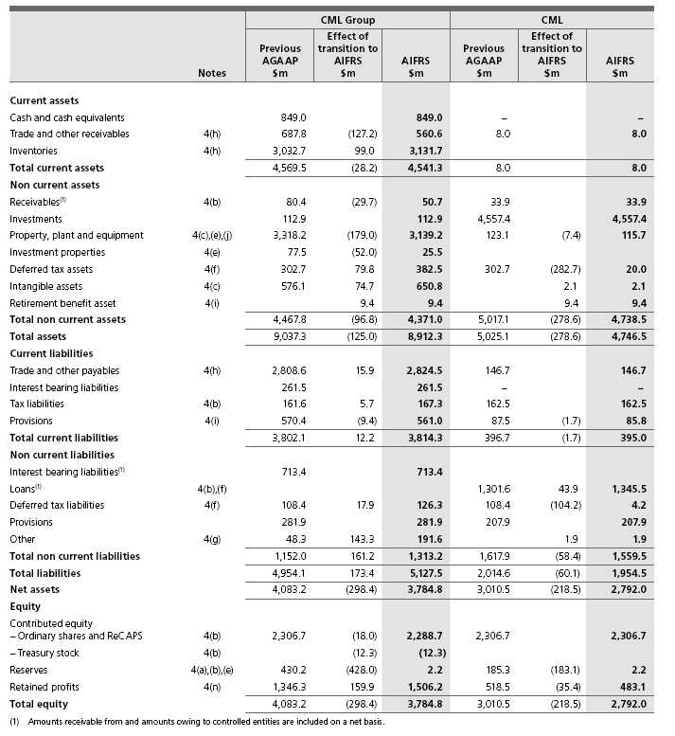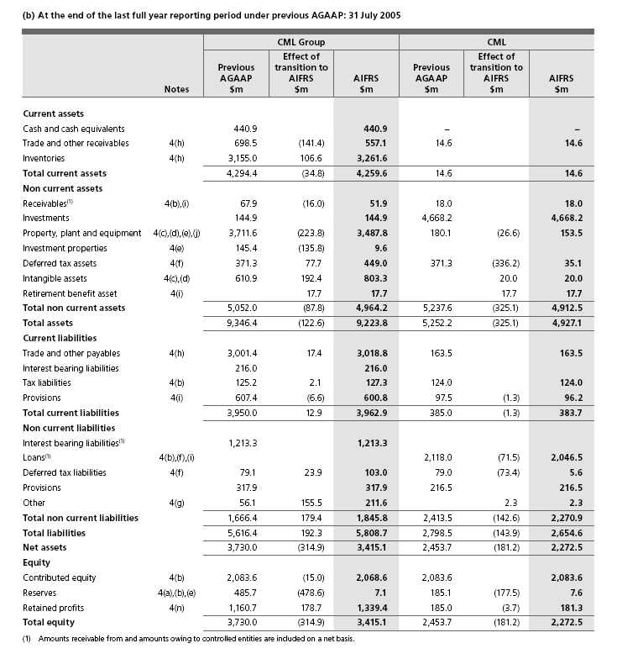
(c) At the date of transition to AASB 132 and AASB 139: 1 August 2005
 |  |  | CML Group
 |  | 31 July 2005 | 1 August AIFRS | 1 August 2005
 |  | AIFRS | Adoption | AIFRS
 | Notes | $m | $m | $m
Current assets
Cash and cash equivalents |  | 440.9 |  | 440.9
Trade and other receivables |  | 557.1 |  | 557.1
Derivative financial instrument | 4(k) |  | 9.4 | 9.4
Inventories |  | 3,261.6 |  | 3,261.6
Total current assets |  | 4,259.6 | 9.4 | 4,269.0
Non current assets
Receivables | 4(k) | 51.9 | (4.1) | 47.8
Investments | 4(k) | 144.9 | (19.3) | 125.6
Derivative financial instrument | 4(k) |  | 4.3 | 4.3
Property, plant and equipment |  | 3,487.8 |  | 3,487.8
Investment properties |  | 9.6 |  | 9.6
Deferred tax assets | 4(f),(k) | 449.0 | 0.7 | 449.7
Intangible assets |  | 803.3 |  | 803.3
Retirement benefit asset |  | 17.7 |  | 17.7
Total non current assets |  | 4,964.2 | (18.4) | 4,945.8
Total assets |  | 9,223.8 | (9.0) | 9,214.8
Current liabilities
Trade and other payables |  | 3,018.8 |  | 3,018.8
Interest bearing liabilities | 4(k) | 216.0 | 2.2 | 218.2
Derivative financial instrument | 4(k) |  | 1.0 | 1.0
Tax liabilities |  | 127.3 |  | 127.3
Provisions |  | 600.8 |  | 600.8
Total current liabilities |  | 3,962.9 | 3.2 | 3,966.1
Non current liabilities
Interest bearing liabilities | 4(k) | 1,213.3 | (88.6) | 1,124.7
Derivative financial instrument | 4(k) |  | 88.5 | 88.5
Deferred tax liabilities | 4(f),(k) | 103.0 | 2.6 | 105.6
Provisions |  | 317.9 |  | 317.9
Other |  | 211.6 |  | 211.6
Total non current liabilities |  | 1,845.8 | 2.5 | 1,848.3
Total liabilities |  | 5,808.7 | 5.7 | 5,814.4
Net assets |  | 3,415.1 | (14.7) | 3,400.4
Equity
Contributed equity – Ordinary shares and ReCAPS |  | 2,068.6 |  | 2,068.6
Reserves | 4(k) | 7.1 | 6.0 | 13.1
Retained profits | 4(k),(n) | 1,339.4 | (20.7) | 1,318.7
Total equity |  | 3,415.1 | (14.7) | 3,400.4

2. Reconciliation of profit under previous AGAAP to profit under Australian equivalents to IFRS (AIFRS) (a) Reconciliation of profit for the year ended 31 July 2005
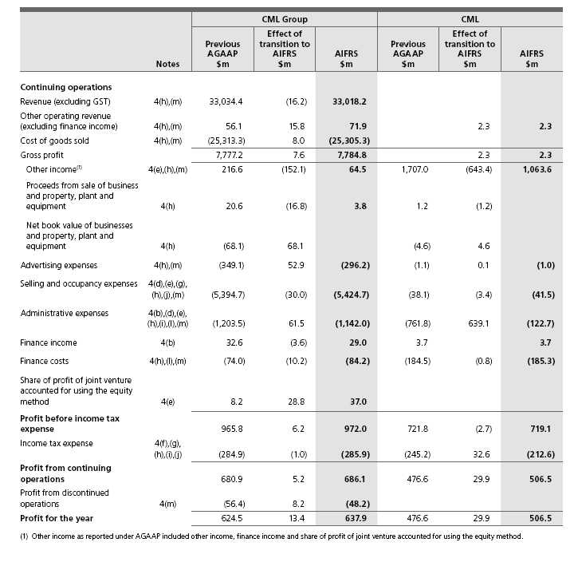
3. | Reconciliation of Cash Flow Statements for the year ended 31 July 2005
 | The adoption of AIFRS has not resulted in any material adjustments to the Cash Flow Statements.
4. | Notes to the reconciliations
 | The following notes to the reconciliations describe the significant changes to the Company’s accounting policies on adoption of AIFRS and their impact on the CML Group and the parent entity, CML. While all changes are relevant for the CML Group, only some changes apply to the parent entity. Where changes in accounting policies apply for the parent entity, specific reference is made.
 | These notes should be read in conjunction with the annual report for the year ended 31 July 2005, for a description of other accounting policies not affected by the adoption of AIFRS.
 | (a) | AASB 1 First time adoption of Australian Equivalents to International Financial Reporting Standards
 | CML Group and the parent entity have taken advantage of a number of exemptions from AIFRS standards provided by AASB 1 to which reference is made under the analysis of each standard to which each exemption applies.
 | Under the transitional rules of AASB 1, an election has been made to reset the foreign currency translation reserve for the CML Group to $NIL on transition to AIFRS on 25 July 2004. This election has resulted in the transfer of $47.5 million from the foreign currency translation reserve to retained profits.
 | (b) | AASB 2 Share-based Payment
 | On adoption of AASB 2, equity instruments issued to employees are recognised as an expense over the relevant vesting periods. Under the previous accounting policy an expense was not recognised for equity instruments issued.
 | The expense is determined with reference to the fair value of the equity instruments issued. Under an optional exemption provided by AASB 1 and adopted by CML, only those equity instruments granted after 7 November 2002 and vesting after 1 January 2005 are accounted for in this manner.
 | The Coles Myer Employee Share Plan Trust (the Trust) administers the Company’s share-based payment plans. Under AIFRS the Income Statement, Balance Sheet and Cash Flow Statements of the Trust are consolidated into the CML Group, with appropriate elimination entries recorded.
 | Loans to employees made by the Trust for equity instruments are also accounted for under the optional exemption provided by AASB 1 and adopted by CML, which applies to loans made to employees for the purchase of equity instruments prior to 7 November 2002. These loans receivable by the Trust are derecognised and adjusted against contributed equity. As the loans are settled through application of dividends related to the equity instruments or through additional loan repayments, the contributed equity is treated as not issued until settled.

(i) | Impact on the transition balance sheet – as at 25 July 2004
 | On transition to AIFRS, the CML Group recognised a decrease of $2.2 million in opening retained profits to reflect the amortisation of the equity instruments issued to employees over the relevant vesting period, with a corresponding increase to an equity compensation reserve. The parent entity recognised a similar adjustment, however $0.8 million of the decrease in opening retained profits was charged to other controlled entities and therefore resulted in a corresponding decrease to loans payable to controlled entities.
 | Consolidation of the Trust resulted in the elimination of loans receivable by the CML Group from the Trust of $29.7 million, recognition of a tax liability of $5.7 million, a decrease in contributed equity for treasury shares in CML of $12.3 million and loans to employees of $21.6 million, off-set by the consolidation of retained profits in the Trust of $1.5 million.
(ii) | Impact on the year ended 31 July 2005
 | The CML Group has recognised an additional amount of $5.4 million as remuneration expense, included in administrative expenses, with a corresponding increase to the equity compensation reserve. The parent entity recognised a similar adjustment, however $3.0 million of the additional charge to remuneration expense was recharged to other controlled entities and therefore resulted in a corresponding decrease to loans payable to controlled entities.
 | Consolidation of the Trust resulted in the elimination of loans receivable by the CML Group from the Trust of $16.0 million, with corresponding recognition of: the impact of historical gains on disposal of shares of $3.4 million by the Trust and loans to employees of $18.4 million as a decrease in contributed equity; a tax liability of $2.1 million; retained losses in the Trust of $3.4 million (adjusted for historical transactions between CML and the Trust); and the results of the Trust of $3.6 million finance expense, $0.1 million of administrative income, and elimination of $3.7 million of inter-company dividends. The finance expense of $3.6 million was reclassified to finance income, to ensure appropriate elimination of inter-company balances on consolidation.
(c) AASB 138 Intangible Assets
Under the previous policy CML had recognised liquor licences on acquisition. Under AIFRS, whilst liquor licences meet the definition of separable intangible assets, they are not reliably measurable separate from the acquired business or premises. Therefore on transition the balance has been transferred to goodwill under transitional provisions contained in AASB 1.
Under the previous policy CML had recognised computer software as property, plant and equipment. Under AASB 138 where computer software is not an integral part of the computer hardware it is required to be recognised as an intangible asset.
(i) | Impact on the transition balance sheet – as at 25 July 2004
 | On transition to AIFRS, the balance of liquor licences for the CML Group of $298.8 million has been transferred to goodwill. In addition, there was a reclassification of $74.7 million and $2.1 million from property, plant and equipment to intangible assets in relation to computer software for the CML Group and the parent entity respectively.
(ii) Impact on the year ended 31 July 2005
An additional reclassification of $77.6 million and $17.9 million were made from property, plant and equipment to intangible assets for the CML Group and parent entity respectively.
(d) AASB 3 Business Combinations
CML has adopted the optional exemption provided by AASB 1 to not re-open acquisition accounting which occurred before the date of transition to AIFRS. As noted at item (c) above, liquor licences acquired as part of a business combination are not recognised separately as an intangible asset. Accordingly, liquor licences acquired after the transition to AIFRS have been recognised as goodwill or incorporated in property values where relevant.
Under the previous accounting policy goodwill was amortised over the period in which the benefits were expected to arise. Under AASB 3, goodwill is no longer amortised, but instead is subject to impairment testing at each reporting date.
(i) Impact on the transition balance sheet – as at 25 July 2004
On transition to AIFRS, a deferred tax liability of $16.5 million was recognised by the CML Group for gaming licences and brand names, with opening retained profits reduced accordingly.
(ii) Impact on the year ended 31 July 2005
Amortisation expense, as reported in administrative expenses, for the CML Group decreased by $10.0 million, with a corresponding increase to the goodwill balance.
The CML Group acquired seven hotels and freehold properties. Under the previous policy liquor licences were recognised as an intangible asset. Under AASB 138, $48.0 million of liquor licences have not met the criteria for separate recognition as an intangible asset and have been recorded as goodwill.
The CML Group disposed of Queensland hotels including associated liquor licences. Under AIFRS, profit on disposals, as reported in selling and occupancy expenses, increased by $1.2 million, owing to the fact that liquor licences acquired as part of a business combination are no longer recognised separately as an intangible asset, with a corresponding increase to goodwill.
Gaming licences valued at $22.2 million have been recognised separately as an intangible asset by the CML Group with a corresponding decrease to property, plant and equipment. A related deferred tax liability of $6.7 million has been recorded, resulting in a corresponding increase to goodwill.
(e) AASB 116 Property, Plant and Equipment and AASB 140 Investment Property
Under CML’s previous accounting policy freehold land and buildings and investment properties were measured at their fair value. Under AIFRS the Company has elected to measure freehold land and buildings at cost and investment properties at fair value.
Under CML’s previous accounting policy fair value increments and decrements, to the extent that they offset a previous increment in the same class of assets, were recorded in the asset revaluation reserve. Under AIFRS, changes in the fair value of investment properties are recognised in the Income Statement on an asset by asset basis. As a result, under AIFRS the asset revaluation reserve will no longer be utilised, and it has been transferred to retained profits.
Under CML’s previous accounting policy proceeds on sale of non current assets are to be included as revenue. Under AIFRS, the net profit/(loss) on sale will be disclosed in the Income Statement.
Under AASB 140, a property should be classified as an investment property only where an insignificant portion of a property is held for the Company’s own use.
Under AASB 5, where it is highly probable that assets will be sold within 12 months, those assets should be classified as current assets.
(i) | Impact on the transition balance sheet – as at 25 July 2004
 | CML has elected to restate certain freehold properties to their depreciated historical cost on transition. As a result for the CML Group, freehold property has reduced by $31.1 million, investment property has reduced by $3.8 million, with a corresponding reduction in the asset revaluation reserve by $34.9 million. Freehold property in the parent entity has reduced by $5.3 million, with a corresponding reduction in the asset revaluation reserve. Other freehold properties have been recorded at their existing AGAAP fair values as deemed cost on transition under an optional election provided by AASB 1.
 | On transition, the remaining asset revaluation reserve for the CML Group of $442.8 million and $180.0 million of asset revaluation reserves for the parent entity have been transferred to retained profits, after reduction for reversal of revaluation to property, plant and equipment separately detailed.
 | As a result of the change in definition of an investment property, on transition the CML Group reclassified $48.2 million from investment property to freehold property.
 | On transition, the CML Group increased deferred tax liabilities and reduced opening retained profits by $5.4 million in relation to tax base differences on buildings.
(ii) | Impact on the year ended 31 July 2005
 | The CML Group recorded $83.8 million of property acquisitions as investment property under the previous policy during the year ended 31 July 2005. Under AASB 140, these properties have been reclassified as freehold property.

(e)
(ii) | Impact on the year ended 31 July 2005 (continued)
 | An increase of $28.8 million was recognised in CML Group’s share of net profit from the CMS General Trust, with a corresponding decrease recognised in the asset revaluation reserve. Other revaluation amounts recorded for AGAAP by the CML Group in the asset revaluation reserve were also adjusted to the Income Statement and resulted in an increase to administrative expenses of $12.7 million and $1.4 million for decrements in the value of freehold property and investment property respectively. Reported other income by the CML Group increased by $0.2 million as a result of increments in the value of investment property reclassified from the asset revaluation reserve.
 | For the parent entity, revaluation amounts of $0.2 million of decrements recorded for AGAAP in the asset revaluation reserve during the year ended 31 July 2005 were recognised as an increase to administrative expenses. In addition a further $1.3 million of decrements on freehold property were recognised as an administrative expense.
 | As a result of elections made to restate certain freehold properties to their depreciated historical cost, freehold property for the CML Group has reduced by $41.2 million for increments recognised during the year ended 31 July 2005, with a corresponding reduction in the asset revaluation reserve by $41.2 million.
 | As a result of the reclassification from investment to freehold property, depreciation expense reported in selling and occupancy expenses for the CML Group, increased by $0.8 million and loss on disposal of freehold property, reported in administrative expenses, decreased by $0.9 million due to the lower carrying value under AIFRS. Property, plant and equipment increased by $0.1 million in total.
(f) AASB 112 Income Taxes
Under the previous accounting policy deferred tax balances were determined using the Income Statement method. Items were only tax-effected if they were included in the determination of pre-tax accounting profit or loss and/or taxable income or loss and current and deferred taxes could not be recognised directly in equity.
Under AASB 112, deferred tax balances are determined using the balance sheet method, which calculates temporary differences based on the carrying amounts of an entity’s assets and liabilities in the Balance Sheet and their associated tax bases. In addition, current and deferred taxes attributable to amounts recognised directly in equity are also recognised directly in equity.
The CML Group has recorded additional deferred income tax liabilities in relation to tax base differences on buildings, gaming licences and brand names. These were not required under the Income Statement approach. Refer (d)(i) and (e)(i).
In addition, from a parent entity perspective under the previous accounting policy, which was based on the requirements of UIG Abstract 52 Income Tax Accounting under the Tax Consolidation System, both current and deferred tax balances for the wholly-owned subsidiaries in the tax-consolidated group were recognised by CML as the head entity.
In order to ensure consistency with the broad principles of AASB 112, UIG Abstract 52 was superseded by UIG Interpretation 1052 Tax Consolidation Accounting, which requires wholly-owned subsidiaries to recognise their own current and deferred taxes. The current tax liability or asset, and any tax losses or tax credits are then transferred to the head entity. The key impact of this change in policy is that deferred tax balances related to temporary differences are now recognised in the books of the wholly-owned subsidiaries included in the tax-consolidation and not in the books of the parent entity.
The impact of this change on transition at 25 July 2004 for the parent entity was a reduction in deferred tax assets of $282.8 million, deferred tax liabilities of $107.0 million, opening retained profits of $220.5 million and an increase in loans payable to controlled entities of $44.7 million.
At 31 July 2005, the impact of this policy change for the parent entity was a reduction in deferred tax assets of $334.8 million, deferred tax liabilities of $77.0 million, opening retained profits of $220.5 million, income tax expense of $32.6 million and loans payable to controlled entities of $70.0 million.
The net effect on deferred tax assets is summarised below:
 |  | CML Group |  | CML
 |  | 31 July 2005 | 25 July 2004 | 31 July 2005 | 25 July 2004
 | Notes | $m | $m | $m | $m
Leases | (g) | 46.6 | 43.0 | 0.7 | 0.6
Revenue | (h) | 3.4 | 3.2
Employee benefits | (i) | (3.6) | (2.8) | (2.1) | (0.5)
Impairment of assets | (j) | 32.7 | 36.4
Tax-consolidation | (f) |  |  | (334.8) | (282.8)
Other reclassifications |  | (1.4)
Increase in deferred tax assets |  | 77.7 | 79.8 | (336.2) | (282.7)
Financial instruments⁽¹⁾ | (k) | 0.7

The net effect on the deferred tax liabilities is summarised below:
 |  | CML Group |  |  | CML
 |  | 31 July 2005 | 25 July 2004 |  | 31 July 2005 | 25 July 2004
 | Notes | $m |  | $m | $m | $m
Business combinations | (d) | 23.2 |  | 16.5
Property | (e) | 5.4 |  | 5.4
Revenue | (h) | (8.6) |  | (6.8)
Employee benefits | (i) | 3.6 |  | 2.8 | 3.6 | 2.8
Tax-consolidation | (f) |  |  |  | (77.0) | (107.0)
Other reclassifications |  | 0.3
Increase in deferred tax liabilities |  | 23.9 |  | 17.9 | (73.4) | (104.2)
Financial instruments⁽¹⁾ | (k) | 2.6

(1) On adoption of AASB 132 and AASB 139 on 1 August 2005 a deferred tax liability of $2.6 million and a deferred tax asset of $0.7 million were recognised.
(g) AASB 117 Leases
Under the previous accounting policy, lease payments on operating leases were expensed as they were incurred. Under AASB 117, where leases include fixed rental increases, the lease payments must be expensed on a straight-line basis over the lease term. Under the current interpretation, factors such as the time value of money, anticipated inflation, or expected future revenues cannot be used to allocate scheduled rent increases. In the early years of the lease, rental expense will be greater than rental payments, which will result in the accumulation of a liability that will be released to income in the later years of the lease, when rental expense is required to be less than rental payments.
Under the previous accounting policy, lease incentives received from landlords at the inception of leases were deferred and amortised over the period of the lease, up to the first market rent review. Under AASB 117, lease incentives are amortised over the lease term. This has resulted in incentives being amortised over a longer period.
(i) | Impact on the transition balance sheet – as at 25 July 2004
 | As a result of the change in accounting treatment for fixed rental increases, on transition to AIFRS the CML Group recognised a liability of $112.0 million, a deferred tax asset of $33.6 million, and opening retained profits decreased by $78.4 million. The parent entity recognised a liability of $1.9 million, a deferred tax asset of $0.6 million, and opening retained profits decreased by $1.3 million.
 | As a result of the change in accounting treatment for lease incentives, on transition to AIFRS deferred income increased by $31.3 million, deferred tax assets increased by $9.4 million, and opening retained profits decreased by $21.9 million for the CML Group.
(ii) | Impact on the year ended 31 July 2005
 | The liability for fixed rental increments for the CML Group was increased by $12.9 million to $124.9 million, resulting in an increase to rental expense, as included in selling and occupancy expenses, of $12.9 million and a tax benefit of $3.9 million, with recognition of a related deferred tax asset of $3.9 million. The liability for the parent entity increased by $0.4 million, with a corresponding increase in selling and occupancy expenses, recognition of a further $0.1 million increase to the deferred tax asset, and a tax benefit of $0.1 million.
 | As a result of the change in accounting treatment for lease incentives, the AIFRS adjustment for deferred income recognised at 25 July 2004 by the CML Group was decreased by $0.7 million, resulting in a benefit to rental expense, as reported in selling and occupancy expense, of $0.7 million and a tax expense of $0.3 million, with a decrease to the related deferred tax asset of $0.3 million.
(h) AASB 118 Revenue
Under the previous accounting policy, non-merchandise allowances and rebates were recorded as revenue. Under AIFRS these items have been offset against the related expense.
Under the previous accounting policy, revenue for rental income was recognised as non-operating revenue. Under AIFRS rental income is considered to be operating revenue.
Under the previous accounting policy, proceeds less the net written-down value of assets disposed were recognised as other income, regardless of whether this resulted in a net gain or loss. Under AIFRS only net gains by classification can be recognised in other income.
Under the previous accounting policy, ‘lay-by’ transactions were recognised at the point of sale. Under AASB 118, lay by transactions are recognised at a later date when the customer satisfies all payment obligations and takes possession of the merchandise.
Under the previous accounting policy, sales were recognised net of sales returns, however, at the reporting date a provision for sales returns was not recorded. Under AASB 118, a provision for sales returns must be recognised.
(i) | Impact on the transition balance sheet – as at 25 July 2004
 | On transition to AIFRS, all outstanding lay-by transactions have been derecognised by the CML Group. Receivables decreased by $127.2 million, inventory increased by $99.0 million, accrued liabilities increased by $5.1 million, and deferred tax liabilities decreased by $6.8 million. The net impact of this was to reduce opening retained profits by $26.5 million.
 | On transition to AIFRS, the CML Group recognised a provision for sales returns of $10.8 million, a deferred tax asset of $3.2 million, and a reduction to opening retained profits of $7.6 million.

(ii) | Impact on the year ended 31 July 2005
 | De-recognition of lay-by transactions for the CML Group resulted in a further decrease to receivables of $14.2 million, and deferred tax liabilities of $1.8 million, while inventory and accrued liabilities increased by a further $7.6 million and $0.8 million respectively. The impact of this was to reduce sales by $15.9 million, cost of goods sold by $8.6 million and tax expense by $1.8 million.
 | As a result of the recognition by the CML Group of an additional sales provision in accrued liabilities of $0.7 million, deferred tax assets increased by $0.2 million. The impact of this was to decrease sales by $1.5 million and cost of goods sold by $0.8 million, with a related income tax benefit of $0.2 million.
 | In addition, to reclassify the non-merchandise allowances and rebates for the CML Group from revenue to off-set the related expenses it was necessary to decrease other income by $164.4 million, with corresponding decreases in advertising expenses of $66.8 million, selling and occupancy expenses of $27.7 million and administrative expenses of $69.9 million. For the parent entity, a reclassification of $641.1 million from other income to administrative expenses was necessary to off-set expenses for which the CML entity is reimbursed by other controlled entities. Other immaterial reclassifications of $0.1 million were made to finance costs and advertising expenses.
 | Lease rental income for the CML Group of $27.2 million and the parent entity of $2.3 million were reclassified from other income to other operating revenue. Other commissions for the CML Group of $1.4 million previously reported as other operating revenue were reclassified to other income.
 | Under the previous accounting policy, $50.4 million of proceeds for the CML Group and $1.2 million for the parent entity, adjusted for the net written-down value of assets disposed, were recognised as other income. Under AIFRS, the net loss of $51.3 million for the CML Group has been transferred to selling and occupancy expenses of $49.3 million, and administrative expenses of $2.0 million. While the net loss for the parent entity of $3.2 million has been transferred to selling and occupancy expenses.
(i) AASB 119 Employee Benefits
Under the previous accounting policy, an asset or liability was not recognised for the actuarially determined surplus or deficit of the defined benefit superannuation plan.
Under AASB 119, net surpluses or deficits that arise within the defined benefit superannuation plan must be recognised as an asset or liability in the Balance Sheet.
Under AASB 119, CML has elected to recognise actuarial gains and losses directly in retained profits. Other components of retirement benefit costs have been recognised in the Income Statement.
Under the previous accounting policy, liabilities for annual leave entitlements were accrued at nominal amounts and were not discounted. Under AASB 119, leave entitlements are discounted.
(i) | Impact on the transition balance sheet – as at 25 July 2004
 | An actuarial valuation of the defined benefit superannuation plan has been performed in accordance with AASB 119. On transition to AIFRS, the CML Group and parent entity recognised a defined benefit superannuation asset of $9.4 million, a deferred tax liability of $2.8 million, and opening retained profits increased by $6.6 million.
 | As a result of the change in accounting treatment for annual leave entitlements, the provision for employee entitlements of the CML Group decreased by $9.4 million, deferred tax assets decreased by $2.8 million, and opening retained profits increased by $6.6 million. For the parent entity, the provision for employee entitlements decreased by $1.7 million, the deferred tax asset decreased by $0.5 million and opening retained profits increased by $1.2 million.
(ii) | Impact on the year ended 31 July 2005
 | The defined benefit superannuation asset of the CML Group increased by a further $8.3 million to $17.7 million, resulting in a reduction in defined benefit expense, as included in administrative expenses, of $5.7 million, an increase to retained profits of $1.8 million (net of tax expense of $0.8 million), recognition of an income tax expense of $1.7 million with a corresponding increase to deferred tax liability of $0.8 million and reduction in deferred tax asset of $1.7 million. The adjustment for the parent entity was the same as for the CML Group, except for $2.3 million of the reduction in defined benefit expense (net of tax expense), which was attributed to other controlled entities, and resulted in a corresponding increase to loans payable to controlled entities.
 | As a result of the change in accounting treatment for annual leave entitlements, the AIFRS adjustment to provision for employee entitlements recognised by the CML Group at 25 July 2004 of $9.4 million was decreased by $2.8 million, with a corresponding increase in annual leave expense, as included in administrative expenses. The related deferred tax asset increased by $0.9 million, resulting in a tax benefit of $0.9 million. For the parent entity, the AIFRS adjustment to provision for employee entitlements decreased by $0.4 million to $1.3 million, resulting in an increase to annual leave expense. The related deferred tax asset increased by $0.1 million, with a corresponding tax benefit recorded.
(j) AASB 136 Impairment of Assets
Under the previous accounting policy, the cash generating unit (CGU), which determines the level at which asset impairment is assessed, was the brand. In addition, an assessment is made of the carrying value of clearly redundant assets using discounted cash flows. The CML Group’s interpretation of AASB 136 is that the CGU, and the level at which impairment is assessed on store assets, is an individual store. Therefore, impairment is assessed by comparing the carrying value of store assets to their recoverable amount. Intangible assets, including goodwill, which are not subject to amortisation are tested for impairment annually based on a grouping of CGUs.
(i) | Impact on the transition balance sheet – as at 25 July 2004
 | On transition to AIFRS the carrying value of plant and equipment decreased by $121.4 million, deferred tax assets increased by $36.4 million, and opening retained profits decreased by $85.0 million.
(ii) | Impact on the year ended 31 July 2005
 | At 31 July 2005 the adjustment for AIFRS to the carrying value of plant and equipment reversed by $12.3 million, resulting in a net reduction in selling and occupancy expenses of $8.6 million, net of a tax expense of $3.7 million. Accordingly deferred tax assets decreased by $3.7 million.
(k) | AASB 132 Financial Instruments: Disclosure and Presentation and AASB 139 Financial Instruments: Recognition and Measurement
CML has adopted the exemption available under AASB 1 to apply AASB 132 and AASB 139 from 1 August 2005. This allows CML to apply previous AGAAP principles to comparative information of financial instruments within the scope of these standards.
From 1 August 2005 CML complied with AASB 132 and AASB 139. Under AASB 139 derivative financial instruments are recorded on the balance sheet and measured at fair value. In the case of cash flow hedges, where hedge effectiveness tests are met, changes in fair value will be recognised directly in equity and recycled through the Income Statement when the underlying hedged item is recorded in the Income Statement. Ineffectiveness outside the prescribed range precludes the use of hedge accounting, in which case the fair value changes are recognised directly in the Income Statement. Changes in the fair value of derivatives that are designated and qualify as fair value hedges are recorded in the Income Statement, together with any changes in the fair value of the hedged asset or liability that are attributable to the hedged risk. Certain derivative instruments do not qualify for hedge accounting. Changes in the fair value of any derivative instrument that does not qualify for hedge accounting are recognised immediately in the Income Statement.
Under CML’s previous accounting policy, borrowing costs were recorded in non current assets and amortised on a straight line basis in the Income Statement. Under AIFRS, interest bearing liabilities are recorded net of related borrowing costs. These borrowing costs are amortised in the Income Statement using the effective interest rate methodology.
CML had on issue 7,000,000 ReCAPS that were treated as equity. On 12 July 2005 the ReCAPS were converted to ordinary shares. Under AASB 132 the ReCAPS would have been reclassified as debt, and dividends paid would have been recorded as interest expense. AASB 132 and AASB 139 were not applicable until 1 August 2005, and accordingly, there was no impact on the treatment of the ReCAPS.
(i) Impact on the transition balance sheet – as at 1 August 2005
On transition to AIFRS, the CML Group recognised a current derivative financial asset of $8.6 million, a deferred income tax liability of $2.6 million, and a cash flow hedge reserve of $6.0 million.
In addition to appropriately record the CML Group’s hedging activity, the CML Group recognised current and non current derivative financial assets of $0.8 million and $4.3 million respectively, current and non current derivative financial liabilities of $1.0 million and $1.8 million respectively, an increase to current and non current interest bearing liabilities of $2.2 million, a deferred tax asset of $0.7 million, and retained profits was reduced by $1.4 million. The net fair value adjustments of $86.7 million on currency swap hedges of foreign currency borrowings were reclassified from non current interest bearing liabilities to non current derivative financial liabilities.
Unamortised borrowing costs of $4.1 million were reclassified from non current receivables to non current interest bearing liabilities.
Under the previous accounting policy, the investment in Agentrics (formerly GNX) was valued at historical cost, with its value being assessed based on the cost savings to the business. Under AIFRS the investment is carried at fair value, which is determined based on expected future cash flows from dividends and the final sale of the shares. No such cash flows are anticipated. Accordingly, the investment of $19.3 million was written-off against retained profits on 1 August 2005.
(l) AASB 137 Provisions, Contingent Liabilities and Contingent Assets
Under the current accounting policy long-term provisions are calculated annually and the movement is taken to the respective related expense. Under AASB 137, where discounting is used, the carrying amount of a provision increases each period to reflect the passage of time. This increase is recognised as a finance cost.
(i) Impact on the year ended 31 July 2005
For the year ended 31 July 2005 expenses of $11.3 million and $0.7 million were classified as finance costs rather than as an administrative expense for the CML Group and parent entity respectively.
(m) Allocation of AIFRS Income Statement adjustments to discontinued operations
Profit from discontinued operations for the year ended 31 July 2005 comprises:
 |  | Effect of
 | Previous | transition to
 | AGAAP | AIFRS | AIFRS
 | $m | $m | $m
Revenue from sale of goods | 3,150.8 | (1.2) | 3,149.6
Other operating revenue | 41.2 | 10.0 | 51.2
Cost of goods sold | (1,973.5) | 1.4 | (1,972.1)
Gross profit | 1,218.5 | 10.2 | 1,228.7
Other income | 46.8 | (37.9) | 8.9
Advertising expenses | (125.4) | 13.9 | (111.5)
Selling and occupancy | (905.0) | 8.9 | (896.1)
Administrative expenses | (309.8) | 12.1 | (297.7)
Finance costs |  | (1.1) | (1.1)
Profit before income tax expense | (74.9) | 6.1 | (68.8)
Income tax expense | 18.5 | 2.1 | 20.6
Profit for the year | (56.4) | 8.2 | (48.2)

(n) Retained profits
The effect on retained profits of the changes set out above are as follows:
 |  | CML Group |  | CML
 |  | 31 July 2005 | 25 July 2004 | 31 July 2005 | 25 July 2004
 | Notes | $m | $m | $m | $m
Foreign currency translation reserve | (a) | 47.5 | 47.5
Asset revaluation reserve | (e) | (442.8) | (442.8) | (179.8) | (180.0)
Share-based payments – options | (b) | 7.6 | 2.2 | 3.8 | 1.4
Share-based payments – Trust consolidation | (b) | 3.2 | 3.4
Business combinations | (d) | (11.2)
Property | (e) | (15.0) |  | 1.3
Income taxes | (d),(e),(f) | 21.9 | 21.9 | 187.8 | 220.5
Leases | (g) | 108.9 | 100.3 | 1.6 | 1.3
Revenue | (h) | 40.1 | 34.1
Employee benefits | (i) | (17.0) | (13.2) | (11.0) | (7.8)
Impairment of assets | (j) | 76.4 | 85.0
Other |  | 1.7 | 1.7
Impact on retained profits at end of period |  | (178.7) | (159.9) | 3.7 | 35.4
Financial instruments⁽¹⁾ | (k) | 20.7
Impact on retained profits at 1 August 2005 |  | (158.0)
(1) Additionally, on the adoption of AASB 132 and AASB 139 on 1 August 2005 there was a reduction in retained profits of $20.7 million.

Directors' Declaration
Directors’ declaration
The Directors declare that
a) | the financial statements and notes set out on pages 2 to 86 are in accordance with the Corporations Act 2001 and:
 | (i) | comply with the Accounting Standards, Corporations Regulations 2001 and other mandatory professional reporting requirements; and
 | (ii) | give a true and fair view of CML’s and the CML Group’s financial position as at 30 July 2006 and of their performance, as represented by the results of their operations and their cash flows, for the 52 weeks ended on that date.
b) | in the opinion of the Directors:
 | (i) | the financial statements and notes are in accordance with the Corporations Act 2001; and
 | (ii) | there are reasonable grounds to believe that CML will be able to pay its debts as and when they become due and payable; and
 | (iii) | the audited remuneration disclosures set out on pages 41 to 56 of the Directors’ Report complies with AASB 124 Related Party Disclosures and the Corporations Regulations 2001; and
 | (iv) | the members of the Closed Group identified in note 35 will be able to meet any obligations or liabilities to which they are, or may become, subject by virtue of the Deed of Cross Guarantee.
c) the Chief Executive Officer and the Chief Financial Officer have given declarations as required by section 295A of the Corporations Act 2001.
This declaration is made in accordance with a resolution of the Directors.
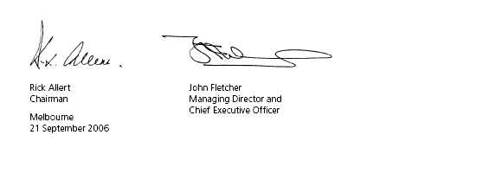

Independent Audit Report
Matters relating to the electronic presentation of the audited financial report
This audit report relates to the Financial Report and remuneration disclosures of Coles Myer Ltd. (the Company) and the Coles Myer Ltd. Group (defined below) for the financial year ended 30 July 2006 included on Coles Myer Ltd. web site. The Company’s Directors are responsible for the integrity of the Coles Myer Ltd. web site. We have not been engaged to report on the integrity of this web site. The audit report refers only to the financial report and remuneration disclosures identified below. It does not provide an opinion on any other information which may have been hyperlinked to/from the Financial Report or the remuneration disclosures identified below. If users of this report are concerned with the inherent risks arising from electronic data communications they are advised to refer to the hard copy of the audited financial report and remuneration disclosures to confirm the information included in the audited financial report and remuneration disclosures presented on this web site.
Audit opinion
In our opinion
1. the Financial Report of Coles Myer Ltd.:
n | gives a true and fair view, as required by the Corporations Act 2001 in Australia, of the financial position of Coles Myer Ltd. and the Coles Myer Ltd. Group (defined below) as at 30 July 2006, and of their performance for the year ended on that date,
n | is presented in accordance with the Corporations Act 2001, Accounting Standards and other mandatory financial reporting requirements in Australia, and the Corporations Regulations 2001; and
2. the remuneration disclosures, excluding Section 2B of the Remuneration Report on which we express no opinion, that are contained on pages 41 to 56 of the Annual Report (separate from this Financial Report) comply with Accounting Standard AASB
124 Related Party Disclosures (AASB 124) and the Corporations Regulations 2001.
This opinion must be read in conjunction with the rest of our audit report.
Scope
The Financial Report, remuneration disclosures and Directors’ responsibility
The Financial Report comprises the Income Statements, Balance Sheets, Statements of Recognised Income and Expenses, Cash Flow Statements, accompanying notes to the financial statements, and the Directors’ Declaration for both Coles Myer Ltd. (the Company) and the Coles Myer Ltd. Group (the consolidated entity), for the year ended 30 July 2006. The consolidated entity comprises both the Company and the entities it controlled during that year.
The Company has disclosed information about the remuneration of Directors and executives (remuneration disclosures) as required by AASB 124, under the heading “Remuneration Report” on pages 41 to 56 of the separate Annual Report, as permitted by the Corporations Regulations 2001.
The Directors of the Company are responsible for the preparation and true and fair presentation of the Financial Report in accordance with the Corporations Act 2001. This includes responsibility for the maintenance of adequate accounting records and internal controls
that are designed to prevent and detect fraud and error, and for the accounting policies and accounting estimates inherent in the Financial Report. The Directors are also responsible for the Remuneration Report contained in the Annual Report.
Audit approach
We conducted an independent audit in order to express an opinion to the members of the Company. Our audit was conducted in accordance with Australian Auditing Standards, in order to provide reasonable assurance as to whether the Financial Report is free of material misstatement and the remuneration disclosures comply with AASB
124 and the Corporations Regulations 2001. The nature of an audit is influenced by factors such as the use of professional judgement, selective testing, the inherent limitations of internal control, and the availability of persuasive rather than conclusive evidence. Therefore, an audit cannot guarantee that all material misstatements have been detected.
We performed procedures to assess whether in all material respects the Financial Report presents fairly, in accordance with the Corporations Act 2001, Accounting Standards and other mandatory financial reporting requirements in Australia, a view which is consistent with our understanding of the Company’s and consolidated entity’s financial position, and of their performance as represented by the results of their operations, changes in equity and cash flows. We also performed procedures to assess whether the remuneration disclosures comply with AASB 124 and the Corporations Regulations 2001.
We formed our audit opinion on the basis of these procedures, which included:
n | examining, on a test basis, information to provide evidence supporting the amounts and disclosures in the Financial Report and remuneration disclosures in the separate Annual Report; and
n | assessing the appropriateness of the accounting policies and disclosures used and the reasonableness of significant accounting estimates made by the Directors.
Our procedures include reading the other information in the Annual Report to determine whether it contains any material inconsistencies with the Financial Report.
While we considered the effectiveness of management’s internal controls over financial reporting when determining the nature and extent of our procedures, our audit was not designed to provide assurance on internal controls.
Our audit did not involve an analysis of the prudence of business decisions made by Directors or management.
Independence
In conducting our audit, we followed applicable independence requirements of Australian professional ethical pronouncements and the Corporations Act 2001.
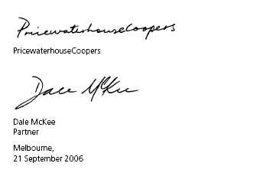
Business directory
Coles Myer Ltd.
Registered Office 800 Toorak Road Tooronga Vic 3146 Telephone: (03) 9829 3111 Facsimile: (03) 9829 6787 www.colesmyer.com Email info@colesmyer.com
Corporate and Retail Support
800 Toorak Road Tooronga Vic 3146 Telephone: (03) 9829 3111 Facsimile: (03) 9829 6787
Food & Liquor Coles Supermarkets
800 Toorak Road Tooronga Vic 3146 Telephone: (03) 9829 5111 Facsimile: (03) 9829 6787
Bi-Lo
800 Toorak Road Tooronga Vic 3146 Telephone: (03) 9829 5111 Facsimile: (03) 9829 5990
Coles Myer Liquor Group
800 Toorak Road Tooronga Vic 3146 Telephone: (03) 9829 3111 Facsimile: (03) 9829 6787
Coles Express
800 Toorak Road Tooronga Vic 3146 Telephone: (03) 9829 3111 Facsimile: (03) 9829 6787
Target
12-14 Thompson Road North Geelong Vic 3215 Telephone: (03) 5246 2000 Facsimile: (03) 5246 2257
Kmart
800 Toorak Road Tooronga Vic 3146 Telephone: (03) 9829 4111 Facsimile: (03) 9829 6787
Officeworks
Virginia Park 1 South Drive 236-262 East Boundary Road Bentleigh East Vic 3165 Telephone: (03) 8575 1900 Facsimile: (03) 8575 1999

