Content:
- Introduction
- The concept
  - Platform, genre, and audience
  - Main features of the game
  - Game Description
  - System requirements
- Functional specification
  - Game objects
    - Coins
    - Catapults
    - Portals
    - Bombs and inventory
    - Finish line
    - Character
  - User Interface
    - Switch game modes
    - Game Settings
    - Level Editor
    - On-screen control buttons
    - Help button
    - Diagram of the layout of user interface elements
  - Sounds
    - General Description
    - Sound Effects
- Contacts

- Introduction
The further content of this document is organized in sections that contain the following information::
- Section 2 (concept). This section contains basic information about the game – general description, genre, features of the game, its target audience and platforms. This section is intended for all interested parties.
- Section 2 (Functional specification). This section describes the game from the user's point of view and the features it offers. It contains information about the game's principles, interface, game objects, and graphics and sound components. This section is intended for all interested parties.
- Section 4 (contacts). Contains contact information.
- The concept
  - Platform, genre, and audience
The game belongs to the time-killer genre in two-dimensional graphics and is developed in the browser version (for any devices based on Windows, Macintosh, Linux, Android, Windows Phone or Tablet OS).
The game is aimed at a wide audience, does not contain restrictive content, and the minimum age of the player is 6 years. The game has an additional appeal for people who regularly want to pass the time, for example, when traveling on public transport. The younger part of the target audience is characterized by the need for simple games, which this game can satisfy.
The Game does not use any trademarks or other proprietary rights that are subject to licensing.
  - Main features of the game
Key features of the Game (USP):
- A large number of game modes that do not let you get bored;
- The ability to customize levels, allowing you to customize the map "for yourself";
- Infinite number of levels – play as much as you want!
The game is suitable for publication in the Western market.
  - Game Description
The player's task is to complete the generated mazes by interacting with various game objects.
Obstacles appear in the player's path:
- Maze as the main difficulty.
- Catapults (see point 3.3.2)
  - System requirements
Requirements | Minimum requirements | Recommended features
Operating System
Processor
RAM | 64 MB | 128 MB
Free disk space | 300 KB
Management | Mouse, keyboard
- Functional specification
  - Game objects
    - Coins
A game object that the character interacts with and gets 10 points to the current score. They are displayed as yellow cells in the maze. The object cannot be generated in the same cell as the walls.
    - Catapults
A game object, when interacting with which the player is thrown in a random direction, but strictly defined for each catapult, to the nearest wall. You can't control the character at this time, but you can interact with others. They are displayed as blue cells in the maze. The object cannot be generated in the same cell as the walls.
    - Portals
Game objects linked in pairs. When interacting with one of them, the player is teleported to the linked portal. When passing through portals, the character exits from the opposite side from which he entered the other portal, which in some situations can complicate the passage of the maze. When generating wall cells that have common faces with the portal, they are removed. The maze displays as purple cells. The object cannot be generated in the same cell as the walls.
    - Bombs and inventory
Bombs – game objects that can be located in the same cell with the character. In this case, a pop-up is displayed, offering to blow it up or take it to inventory in order to use it later. The inventory capacity is unlimited, but when you move to a new level, the inventory is cleared. When a bomb explodes, it destroys walls in a circle (by default, its radius is 5 cells, not including the cell where the bomb is located). In Survival mode, explosions stun the character for 3 seconds. They are displayed as red cells in the maze. The object cannot be generated in the same cell as the walls.
    - Finish line
Part of the setting. When a player steps on it, the latter is transferred to the next level, the inventory is cleared and bonus points are awarded for completing the level (from 10 to 100, depending on the speed of passage).
    - Character
Managed user avatar.
  - User Interface
    - Switch game modes
It is a group of radio buttons located in the upper-right part of the screen. When changing the game mode, a warning is displayed that the game progress will be reset.
    - Game Settings
It is a set of checkboxes located in the upper-left part of the screen. Includes FPS and audio display switches.
    - Level Editor
      - Button to open the level editor
Located on the left side of the screen, it opens the main part of the level editor.
      - Level Editor Fields
They are fields for entering values for level settings.
      - Save button
Applies the current settings and generates a new level.
    - On-screen control buttons
There are 4 buttons located at the bottom of the screen. They can be used to control the character. Each button can change its accessibility depending on the ability to move the character in this direction.
    - Help button
It is located below the on-screen control buttons. When clicked, it displays a brief guide to the game; the game is paused for this time.
    - Diagram of the layout of user interface elements
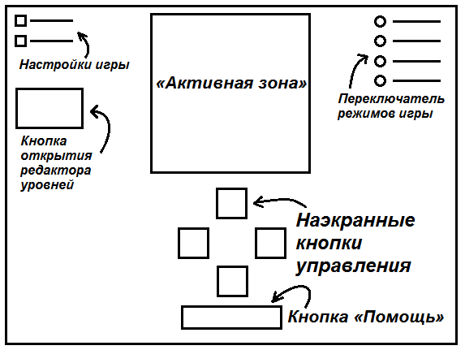
  - Sounds
    - General Description
The approach to the game's sound design is based on the style of eight-bit sound effects.
    - Sound Effects
The following parts of the game are subject to sound effects::
Element | Comments
Coins | Selection process
Catapults | Activation; hitting a character against a wall
Portals | Teleportation
Bombs | Blast; pick-up; pop-up appearance
Finish | Moving to the next level
Player | Trying to go "into the wall"
- Contacts
Contact persons: Pavel Ovchinnikov
Semyon Kleshchev
Phone numbers: +7 (965) 169-28-74
E-mail: skip.py@mail.ru

