INFO90002 S1 2026 Assignment 2 - SQL
Hospital Management System
Student Name: ____________________
Student ID: 1856981
Table suffix used: 6981
Note: SQL statements use the ENG script table names with suffix 6981.

Q1. List all types of rooms each department has. Your list should show department ID and name and room type ordered alphabetically by department name.
SQL statement:
SELECT DISTINCT
'1856981' AS StuID,
d.dept_Id AS DepartmentID,
d.dept_Name AS DepartmentName,
r.room_Type AS RoomType
FROM Department6981 AS d
INNER JOIN Room6981 AS r
ON d.dept_Id = r.dept_Id
ORDER BY d.dept_Name, r.room_Type;
Result screenshot:
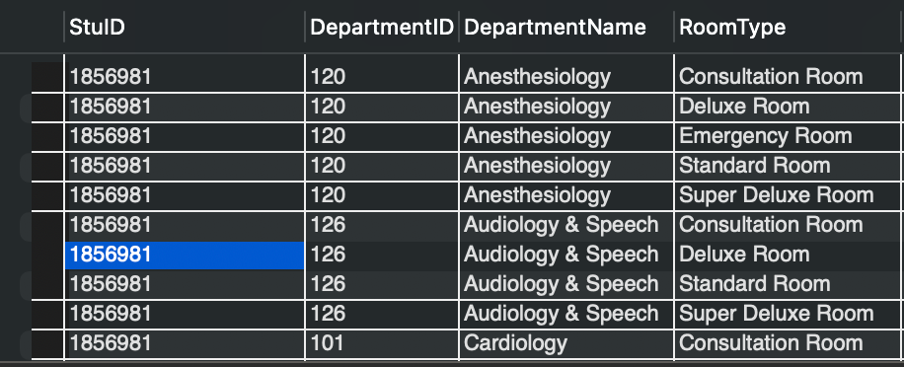
145 rows returned

Q2. List all departments, wards they contain and number of beds in each ward that have at least 10 beds per ward. Your list should display department ID, department name, ward number, ward name and total number of beds per ward in the descending order of number of beds.
SQL statement:
SELECT
'1856981' AS StuID,
d.dept_ID,
d.dept_Name,
w.ward_No,
w.ward_Name,
COUNT(b.bed_No) AS Total_Bed
FROM Department6981 AS d
INNER JOIN Ward6981 AS w
ON d.dept_ID = w.dept_ID
INNER JOIN Bed6981 AS b
ON w.ward_No = b.ward_No
GROUP BY d.dept_ID,
d.dept_Name,
w.ward_No,
w.ward_Name
HAVING COUNT(bed_No) >= 10
ORDER BY Total_Bed DESC;
Result screenshot:
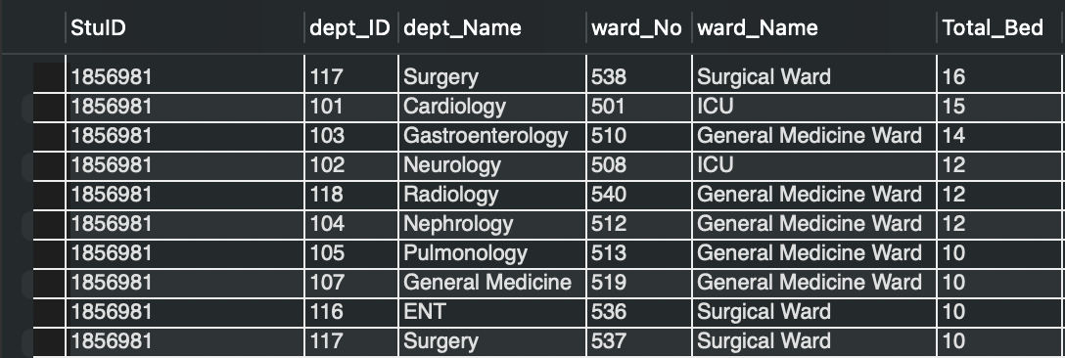
19 rows returned

Q3. List doctors who had appointments in January of the last year. Results should show doctor full name, appointment date, patient's last name and patient ID, ordered by doctor ID and appointment date.
SQL statement:
SELECT
'1856981' AS StuID,
CONCAT(d.FName,' ',d.LName) AS DoctorName,
a.appointment_Date AS AppointmentDate,
p.LName AS Patient_LastName,
p.patient_Id AS PatientID
FROM Appointment6981 AS a
INNER JOIN Patients6981 AS p
ON a.patient_Id = p.patient_Id
INNER JOIN Doctor6981 AS d
ON a.doct_Id = d.doct_Id
WHERE YEAR(CURDATE()) - 1 = YEAR(a.appointment_Date) AND MONTH(a.appointment_Date) = 1
GROUP BY d.doct_Id,
CONCAT(d.FName,' ',d.LName),
p.patient_Id,
p.LName,
a.appointment_Date
ORDER BY d.doct_Id, a.appointment_Date;
Result screenshot:
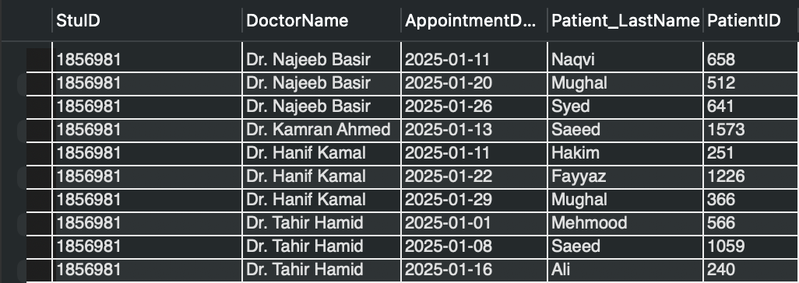
76 rows returned

Q4. List doctors with most expensive appointments. Results should show doctor's name as last name, comma, first name, appointment date, patient name as first name then last name, and payment amount.
SQL statement:
SELECT
'1856981' AS StuID,
CONCAT(d.LName,',',d.FName) AS Doctor_Name,
a.appointment_Date AS Appointment_Date,
CONCAT(p.FName,' ',p.LName) AS Patient_Name,
a.payment_amount AS The_Most_Expensive_Amount
FROM Appointment6981 AS a
INNER JOIN Patients6981 as p
ON a.patient_Id = p.patient_Id
INNER JOIN Doctor6981 AS d
ON d.doct_Id = a.doct_Id
WHERE
a.payment_amount = (
SELECT MAX(a.payment_amount)
FROM Appointment6981 AS a
)
ORDER BY a.payment_amount DESC;
Result screenshot:
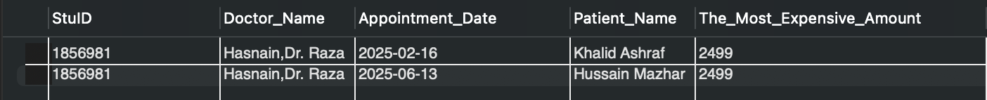
2 rows returned

Q5. List all wards that currently have no beds. Results should show ward number and ward name sorted in alphabetical order of ward names.
SQL statement:
SELECT
'1856981' AS StuID,
w.ward_No AS Ward_No,
w.ward_Name AS Ward_Name
FROM Ward6981 AS w
LEFT JOIN Bed6981 AS b
ON w.ward_No = b.ward_No
GROUP BY
w.ward_No,
w.ward_Name
HAVING COUNT(b.bed_No) = 0
ORDER BY w.ward_Name;
Result screenshot:
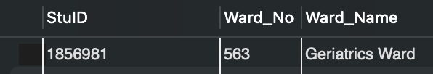
1 row returned

Q6. List how many rooms have never been used within each department, not including consultation rooms. For each department with unused rooms, show department ID, department name and number of unused rooms in descending order of room count.
SQL statement:
SELECT
'1856981' AS StuID,
d.dept_Id AS Department_Id,
d.dept_Name AS Department_Name,
COUNT(r.room_No) AS Unused_Rooms
FROM Department6981 AS d
INNER JOIN Room6981 AS r
ON r.dept_Id = d.dept_Id
LEFT JOIN RoomRecords6981 AS rr
ON r.room_No = rr.room_no
WHERE r.room_Type <> 'Consultation Room'
AND rr.room_no IS NULL
GROUP BY
d.dept_Id,
d.dept_Name
HAVING COUNT(r.room_No) > 0
ORDER BY Unused_Rooms DESC;
Result screenshot:
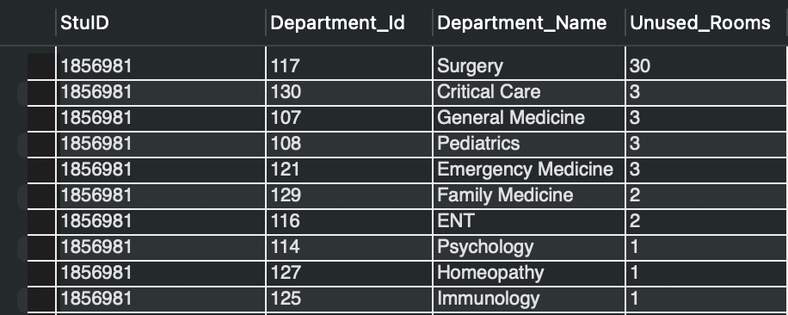
25 rows returned

Q7. What is the average length of a surgical procedure, for surgeries where the patient had already presented with diabetes? Show the time in minutes.
SQL statement:
SELECT
'1856981' AS StuID,
AVG(TIMESTAMPDIFF(
MINUTE,
TIMESTAMP(s.surgery_Date, s.start_Time),
TIMESTAMP(s.surgery_Date, s.end_Time))) AS Average_Surgery_Length_Minutes
FROM Patients6981 AS p
INNER JOIN SurgeryRecord6981 AS s
ON s.patient_Id = p.patient_Id
INNER JOIN MedicalRecord6981 AS m
ON m.patient_Id = p.patient_Id
WHERE LOWER(m.diagnosis) LIKE '%diabetes%'
AND s.surgery_Date > m.visit_Date;
Result screenshot:
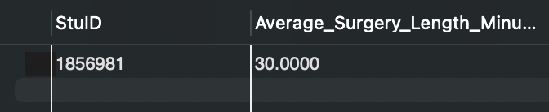
1 row returned

Q8. List surgeries where any two of doctor, nurse or helper had the same last name. Show surgeon ID and the doctor's, nurse's and helper's full names; order by doctor's name.
SQL statement:
SELECT
'1856981' AS StuID,
d.doct_Id AS DoctorID,
CONCAT(d.FName,' ',d.LName) AS DoctorName,
CONCAT(n.FName,' ',n.LName) AS NurseName,
CONCAT(h.FName,' ',h.LName) AS HelperName
FROM SurgeryRecord6981 AS s
INNER JOIN Helpers6981 AS h
ON h.helper_Id = s.helper_Id
INNER JOIN Nurse6981 AS n
ON n.nurse_Id = s.nurse_Id
INNER JOIN Doctor6981 AS d
ON d.doct_Id = s.surgeon_ID
WHERE d.LName = n.LName
OR d.LName = h.LName
OR n.LName = h.LName
ORDER BY CONCAT(d.FName,' ',d.LName);
Result screenshot:
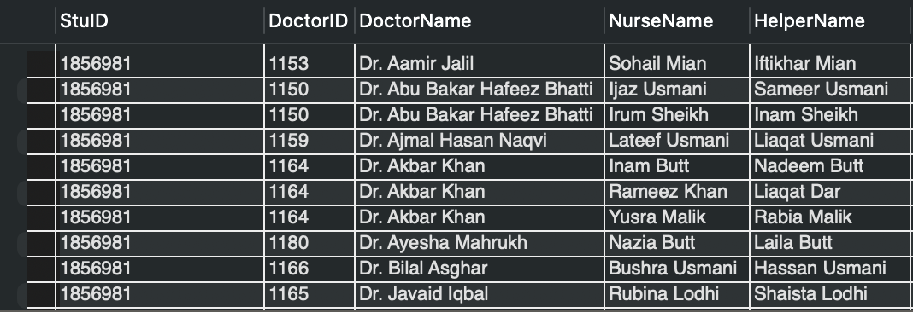
27 rows returned

Q9. List numbers of doctors, nurses and helpers in each department and the total number of medical staff. Show department name, medical staff type, and number of staff; last row should show empty department name, 'Total', and total value.
SQL statement:
SELECT
'1856981' AS StuID,
dp.dept_Name AS DepartmentName,
'Doctor' AS MedStaff,
COUNT(dt.doct_Id) AS Number
FROM Department6981 AS dp
INNER JOIN Doctor6981 AS dt
ON dt.dept_Id = dp.dept_Id
GROUP BY dp.dept_Name
UNION ALL
SELECT
'1856981' AS StuID,
dp.dept_Name AS DepartmentName,
'Nurse' AS MedStaff,
COUNT(n.nurse_Id) AS Number
FROM Department6981 AS dp
INNER JOIN Nurse6981 AS n
ON dp.dept_Id = n.dept_Id
GROUP BY dp.dept_Name
UNION ALL
SELECT
'1856981' AS StuID,
dp.dept_Name AS DepartmentName,
'Helper' AS MedStaff,
COUNT(h.helper_Id) AS Number
FROM Department6981 AS dp
INNER JOIN Helpers6981 AS h
ON dp.dept_Id = h.dept_Id
GROUP BY dp.dept_Name
UNION ALL
SELECT
'1856981' AS StuID,
'' AS DepartmentName,
'Total' AS MedStaff,
(SELECT COUNT(*) FROM Doctor6981)
+ (SELECT COUNT(*) FROM Nurse6981)
+ (SELECT COUNT(*) FROM Helpers6981) AS Number;
Result screenshot:
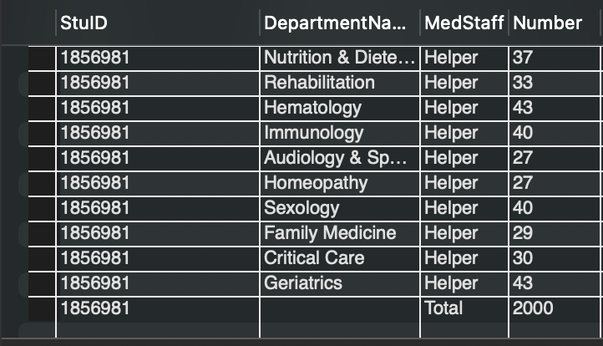
93 rows returned

Q10a. Add a column capacity to Room6981. Show all columns with the respective data types using the relevant SQL statement.
SQL statement:
ALTER TABLE Room6981
ADD COLUMN capacity INT;
DESCRIBE Room6981;
Result screenshot:
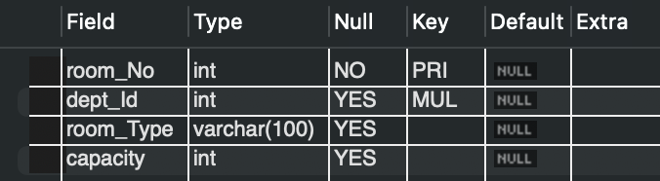
4 rows returned by DESCRIBE Room6981

Q10b. Set capacity of all standard rooms to 4. Check that all standard rooms got updated by running a SELECT statement with student ID.
SQL statement:
UPDATE Room6981
SET capacity = 4
WHERE room_Type = 'Standard Room'
AND room_No > 0;
SELECT
'1856981' AS StuID,
room_No,
dept_Id,
room_Type,
capacity
FROM Room6981
WHERE room_Type = 'Standard Room';
Result screenshot:
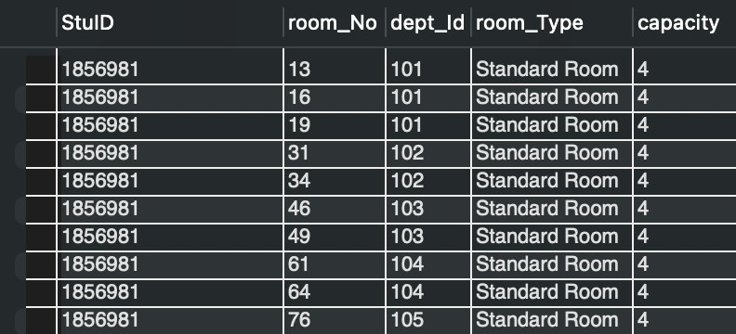
60 rows returned

Q11a. Create a view that counts the number of surgeries performed by each surgeon. Include surgeon ID, full name and number of surgeries. Do not include StuID in this view.
SQL statement:
CREATE VIEW SurgeonSurgeryCount6981 AS
SELECT
d.doct_Id AS Surgeon_Id,
CONCAT(d.FName, ' ', d.LName) AS Surgeon_Name,
COUNT(s.surgery_Id) AS Number_Of_Surgeries
FROM Doctor6981 AS d
INNER JOIN SurgeryRecord6981 AS s
ON d.doct_Id = s.surgeon_Id
GROUP BY
d.doct_Id,
CONCAT(d.FName, ' ', d.LName);
SELECT *
FROM SurgeonSurgeryCount6981;
Workbench left pane showing created view:
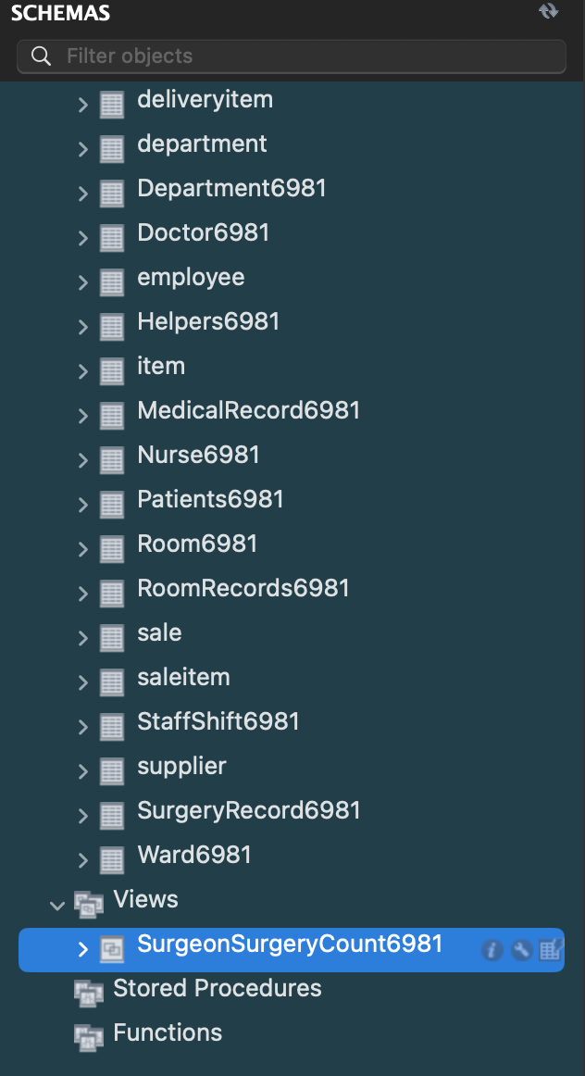
SELECT from view result screenshot:
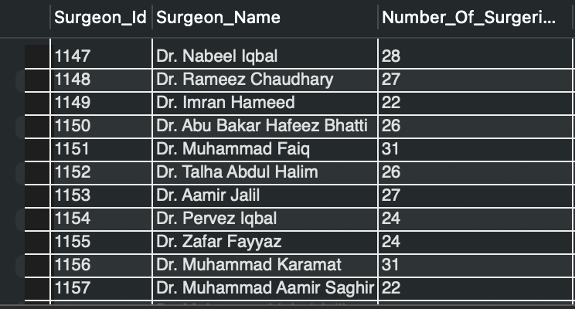
38 rows returned by SELECT from view

Q11b. Using the view created in Q11a, list the surgeons who completed the highest number of surgeries. Display surgeon ID, full name and number of surgeries, with student ID.
SQL statement:
SELECT
'1856981' AS StuID,
Surgeon_Id,
Surgeon_Name,
Number_Of_Surgeries
FROM SurgeonSurgeryCount6981
WHERE Number_Of_Surgeries = (
SELECT MAX(Number_Of_Surgeries)
FROM SurgeonSurgeryCount6981);
Result screenshot:

1 row returned

