Brand X Dealer Platform
Technical Design Document · Company A, Lucknow
GitHub: https://github.com/R2005ishi/isocode
Live app: to be added after deployment
Demo logins: see deployment.md (all demo accounts use the password Demo@1234)
Author: Rishi Agrawal · 9 November 2026

1. Summary
Company A loses about ₹2.11 crore a year because web leads are not called quickly and service calls go unanswered (figures from the brief). The client wants buyers to see real on-road prices and book without calling, and every enquiry to reach a named consultant within five minutes.
I built the core slice end to end — model and used-car pages with the on-road price breakup, test-drive booking in real slots, a lead inbox with auto-assignment and a live response timer, admin for cars and prices, and the AI buyer summary and first-reply draft — and then the rest of the must-have list as extra depth:
- Service booking limited by workshop bay capacity
- Trade-in request form, EMI calculator
- Portal CSV lead import; assignment by showroom and model
- Admin CMS for offers, banners and user roles
- Missed-call escalation: a lead not called in 5 minutes is reassigned and the lead desk is alerted — this acts on the client's main success metric instead of only displaying it
- AI quality page: shows how often drafts pass the checks, get corrected, are replaced by a safe template, and how much consultants edit them
Everything runs on realistic sample data seeded from the brief (NEW-H-02, UC-1182, UC-1190 exactly as given, plus invented models, showrooms, staff, leads and history). Messages, payments and the DMS are mocked, as the brief allows.

2. Architecture

2.1 Stack
Layer | Choice | Why
Web app + API | Next.js 15 (App Router), React 19, TypeScript | Server-rendered car pages for SEO and fast 4G loads; buyer site, staff app and API in one deploy — right-sized for 8 weeks and one team
Database | PostgreSQL + Prisma | Relational data (variants × cities × prices, leads × activities); database-level guarantees such as a unique (demo car, slot) index make double-booking impossible
Sign-in | Auth.js v5, email + password, JWT with role | No external identity provider needed; the role is re-read from the database on every API call
UI | Tailwind CSS 4, Radix primitives, TanStack Query | Consistent design tokens; accessible components; the inbox polls every few seconds
Languages | next-intl, cookie-based en / hi | One indexable URL per car page in both languages
AI | Anthropic API behind an AiProvider interface | Swappable and mockable; the app is fully usable with no key (templates, clearly labelled)
Hosting | Vercel + Neon Postgres | Managed, scales to zero, migrations run on every deploy
Tests | Vitest (unit + API), Playwright (e2e) | Fast tests for the logic that carries money or promises

2.2 Code structure
Requests flow through four layers, each with one job:
Layer | Folder | Responsibility
Routes / pages | src/app | HTTP and rendering only. Every API handler validates input with Zod and checks the role itself
Workflows | src/server/workflows | Use cases (book a test drive, import a CSV, escalate a lead). Enforce ownership: a consultant only touches their own leads
Services | src/server/services | Pure, unit-tested rules: on-road price, EMI, slots, assignment, SLA, escalation, CSV parsing, AI quality
AI | src/server/ai | Prompts, guardrails, fallbacks, price band. Never sends anything itself

The rules that carry money or promises (prices, slots, assignment, escalation) are pure functions with no database access, so they are easy to test and to explain.

3. Data model
21 tables. Money is stored as whole rupees (integers) so price breakups never drift. The main groups:
Group | Tables | Notes
Catalogue | Model, Variant, City, PriceComponent | Variant holds ex-showroom price, specs and colours. PriceComponent (one row per variant × city) holds road-tax %, registration, insurance, accessories, other charges and a validity date — the only source of prices
Used cars | UsedCar, PastSale | Inspection report as structured items; full registration never leaves the server for buyers. PastSale feeds the used-car price band
Places & bookings | Showroom, DemoCar, TestDriveBooking, Workshop, ServiceBooking | Unique (demoCarId, slotStart) for test drives; Workshop.bays caps service bookings per slot
Leads | Lead, LeadActivity, TradeInRequest, LeadImport | Lead has source, status, assignee, consent, opt-out, first-contact time and escalation level. Every change is written to LeadActivity (the timeline)
People | User (roles: BUYER, CONSULTANT, ADMIN, USED_CAR_MANAGER) | Consultants have a showroom and optional model specialties
AI & messages | AiOutput, MessageLog, OptOut | Every AI summary/draft is stored with its inputs, attempts, status and the text actually sent. Mock WhatsApp/SMS are logged, and the opt-out register is checked before every send
CMS | Offer, Banner | Text-only offers next to the price; home-page banners with schedules

4. Main flows

4.1 On-road price by city (the hard part)
The buyer picks a city; the server loads that variant's PriceComponent row and computes the breakup with one shared function (computeOnRoad), used by both the buyer page and the admin price grid preview. Admins therefore see exactly what buyers will see before saving.
Line (NEW-H-02, Model H ZX Automatic, Lucknow) | Amount
Ex-showroom (from the brief) | ₹12,45,000
Road tax — 10% of ex-showroom | ₹1,24,500
Registration (RTO + handling) | ₹2,100
Insurance, first year | ₹39,840
Accessories pack | ₹15,000
On-road total | ₹14,26,440

- Every price shows its validity date and the note that prices may change.
- No row, or an expired row, for that city → "Price not yet published for this city". The site never estimates, and the AI is never allowed to produce a price.

4.2 Test-drive booking
- Buyer picks a showroom, a demo car and a free 45-minute slot (generated in IST from showroom hours, minus booked slots).
- Contact details with a consent checkbox (unticked by default).
- In one transaction: lead + booking are created. The database's unique (car, slot) index rejects a double-booking even when two buyers click at the same moment.
- The lead is auto-assigned, a WhatsApp acknowledgement with a TD- reference is sent (mock), and the consultant's 5-minute timer starts.

4.3 Lead lifecycle: assignment, timer, escalation
Leads arrive from the website, test drives, trade-ins and portal CSV imports. Assignment picks, in order: a consultant at the same showroom who specialises in the model → anyone at that showroom → any specialist → anyone; ties go to fewest open leads, then the person who waited longest for a lead. With nobody available, the lead goes to the lead desk.
The inbox shows a live timer per lead (green, then amber at 3 minutes, red at 5). Escalation then acts on it:
- 5 minutes, still not contacted → reassigned to the next-best consultant (never the same person), who gets an SMS, and the lead desk is alerted.
- 10 minutes → the desk is alerted again. No more reassigning: bouncing a lead between people only delays the call.
- Each lead is claimed with a conditional database update, so two sweeps at the same time can never escalate it twice. The sweep runs on inbox polls (no infrastructure needed) and on a secret-protected cron endpoint.
Consultants can also reassign manually, change status, mark contacted, and send messages; every action lands on the lead's timeline.

4.4 Service booking by bay capacity
A slot can hold as many cars as the workshop has bays, so there is no unique index to rely on. The booking counts confirmed bookings and inserts inside a serializable transaction, retrying with jitter on conflicts. Tested with 9 simultaneous requests on a 6-bay slot: exactly 6 confirmed, 3 cleanly refused.

4.5 Portal CSV import
The admin uploads a portal export, previews it (nothing written), then imports. Headers are matched flexibly ("Mobile", "Customer Name"…), Indian phone numbers are normalised, and each row is imported in its own transaction. Bad rows, duplicates (same portal lead id, or a phone with an open lead) and opted-out numbers are skipped with a row number and reason. Imported leads are auto-assigned and get the same timer.

4.6 Used cars and trade-ins
Listings show year, owners, kilometres, inspection report and price; the registration is masked (e.g. UP32 •• ••82). A trade-in request becomes a normal lead with the car details attached, so it follows the same assignment and timer.

5. How the AI works — and what happens when it is wrong
Feature | What it does | When it is wrong or unsure
Buyer summary | Turns the enquiry and history into needs, budget, timeline and missing info, with a confidence level | Output must match a strict schema. With no buyer text, confidence is forced to "low" and only known facts are listed. On failure, a basic factual summary is shown, labelled as such
First-reply draft | Writes a short WhatsApp reply in English or Hindi, using only verified facts: real free slots and the admin price | Checked in code: any discount wording (English or Hindi) or any rupee figure not in the admin breakup rejects it. One retry with the reason; then a safe template built from verified data. Status BLOCKED or FALLBACK tells the consultant why
Used-car price band | Q1–Q3 of past sales of the same model, ±1 year, ±25,000 km (at least 3 comparables) | Plain statistics, not an LLM, so it is explainable. Only the used-car manager sees it; they set every final price. Too few comparables → no band shown

- Nothing is sent automatically. A consultant edits and sends every draft. On send, the edited text is checked again for discount wording.
- Data minimisation: the AI never receives the buyer's phone or email, and the buyer's text is wrapped and treated as data to resist prompt injection.
- 8-second timeout: a consultant racing the 5-minute timer never waits on the AI.
- No API key → the app works on templates and says so; it never passes off canned text as AI.
- AI quality page (/admin/ai): from data already stored per draft, it shows the share that passed first time, self-corrected after a rejected attempt, were replaced by a template, and how much consultants edited before sending (word-level edit distance).

6. Security and privacy
- Roles: buyer (no login needed), consultant (own leads only), admin / lead desk, used-car manager. Pages are gated by middleware; every API handler re-checks the role, reading it fresh from the database so a deactivated user loses access immediately.
- Validated inputs: every request body and query string goes through Zod schemas; public forms are rate-limited.
- DPDP Act 2023: consent checkbox unticked by default and stored with a timestamp; an opt-out page and register honoured by every send; phones masked in the inbox list; registrations masked for buyers.
- No secrets in the repository: .env is git-ignored; .env.example lists names only. A Content-Security-Policy and security headers are set on every response.

7. UI and design decisions
The brief asks for a premium-showroom feel: white space, a restrained palette, clear type and one accent colour. I used warm neutrals with a single copper accent, the Mukta and Anek Devanagari fonts (good Hindi and English in one family), and large car imagery. Every car page ends with a price and a clear next step.
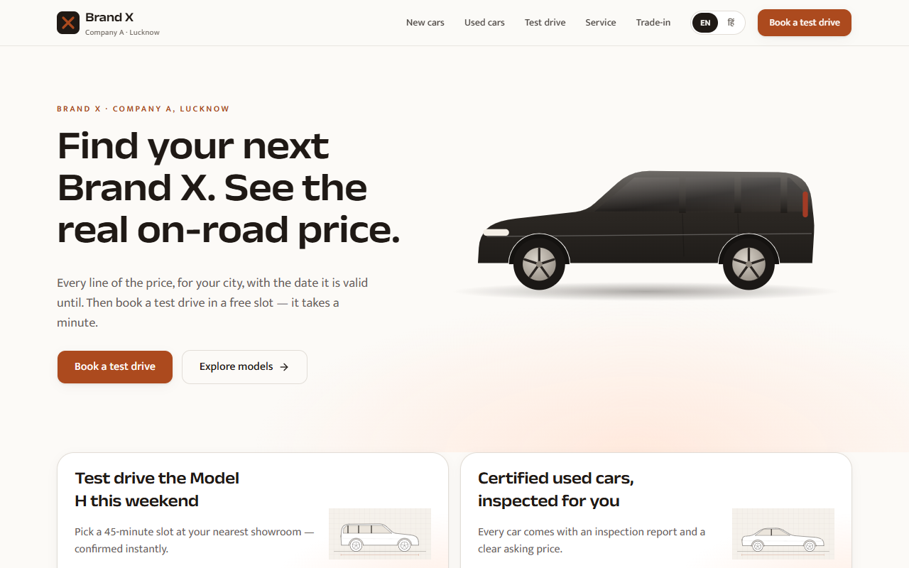
Home: one message, one primary action (book a test drive), live offer banners below.
Car pages lead with the price. The breakup is a plain list a buyer can check line by line, with the validity date and "prices may change" note required by the brief. Offers sit next to the price, never inside it.
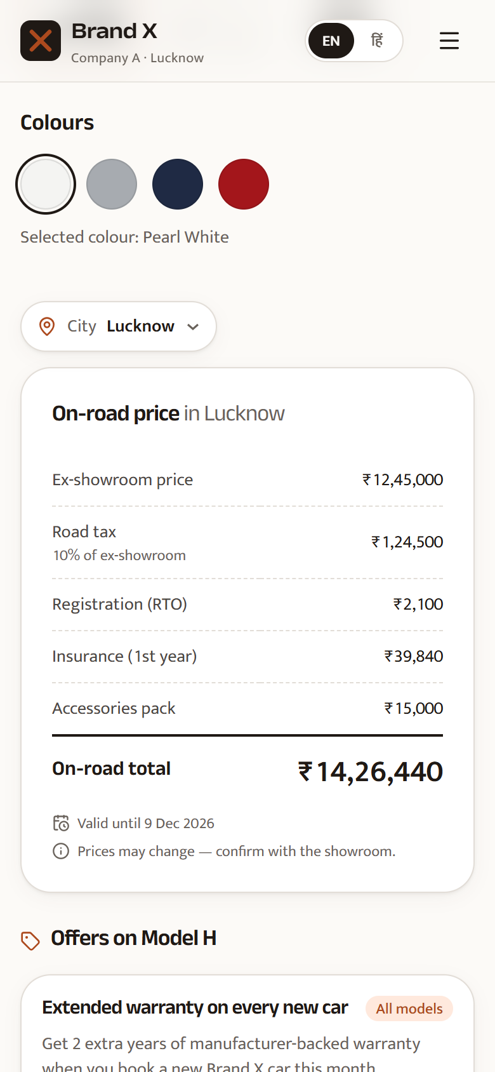
Variant page on a phone: city picker, full breakup, validity and disclaimer.
Mobile first: buyers are mostly on phones, so the booking flows are single-column steps with large tap targets, and every screen has loading, empty and error states.
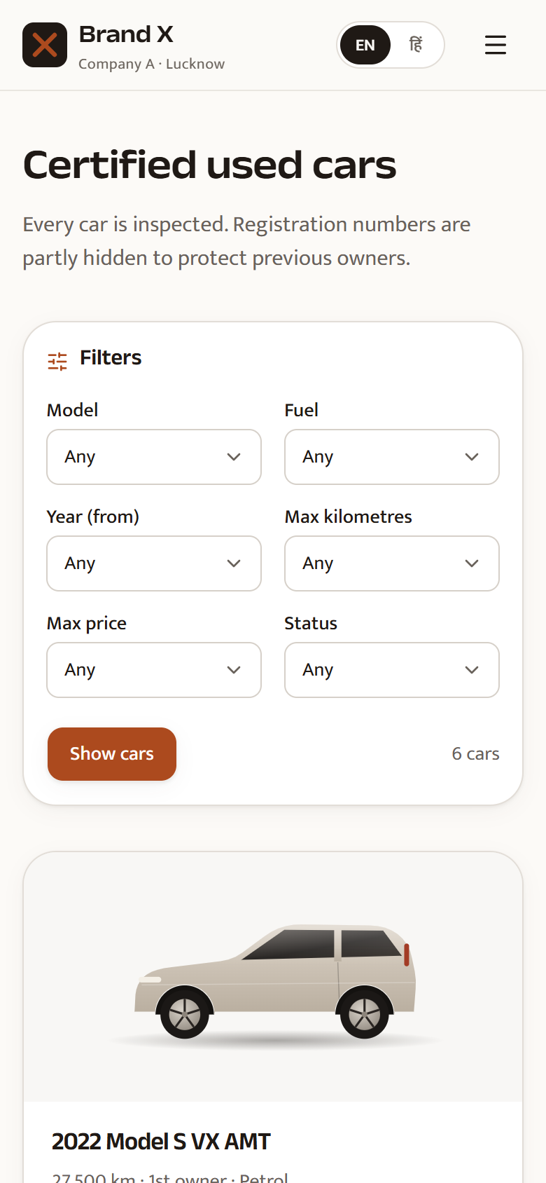
Used cars on a phone: filters, year/owners/km on every card.
Staff screens optimise for speed, not decoration. The inbox puts the response timer in the first column, because that is what decides the client's success metric; escalated leads carry a red badge. Colour is never the only signal — each state also has an icon and text.
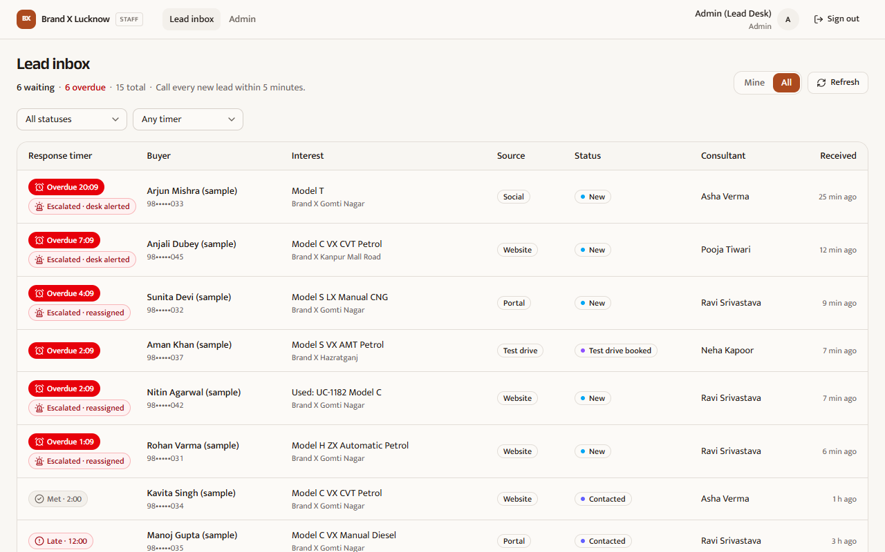
Lead inbox: live timers, escalation badges, source, status and owner at a glance.
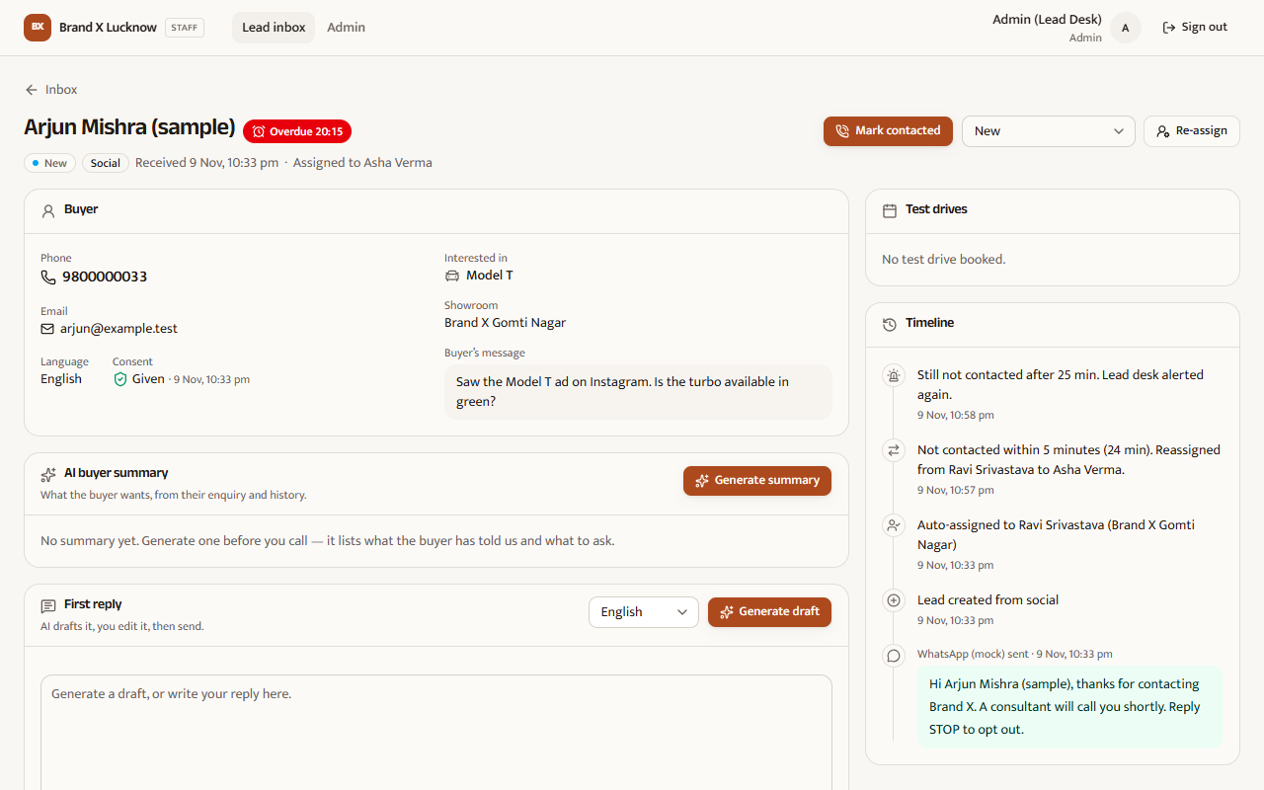
Lead detail: buyer facts, AI summary and draft, and a timeline that explains every reassignment.
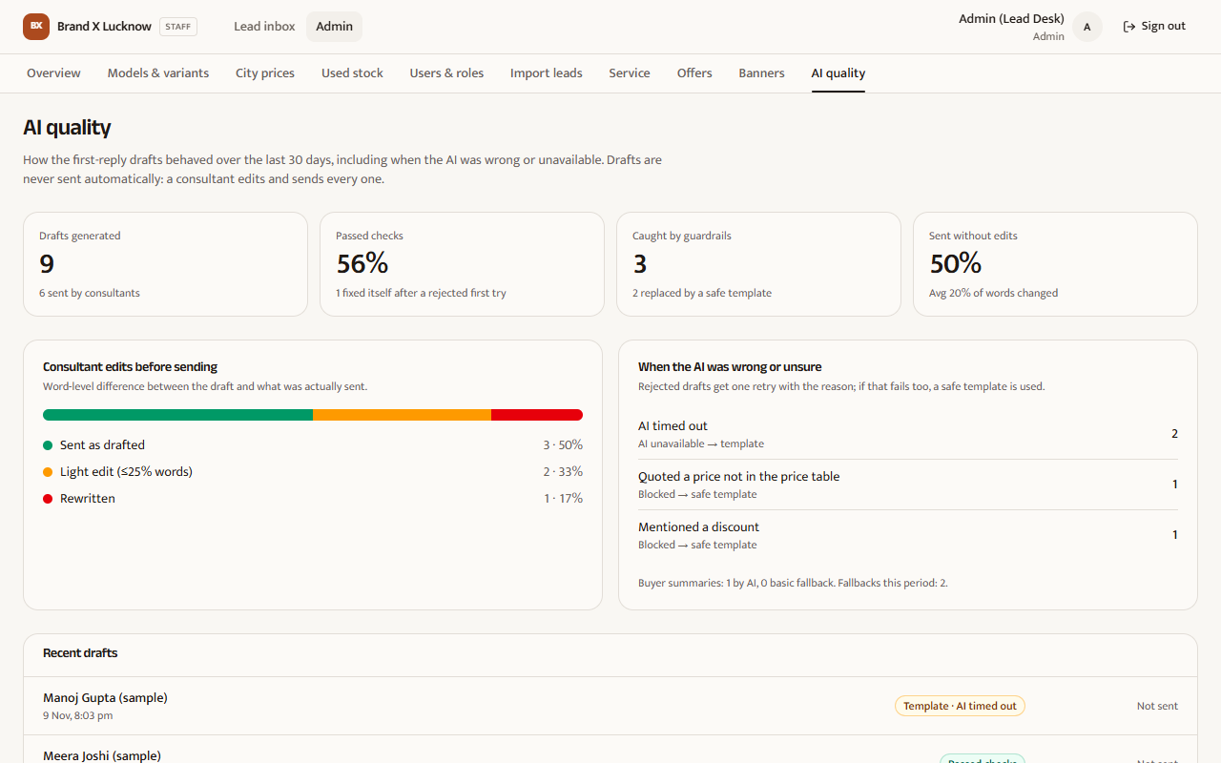
AI quality: how the AI behaved, including when it was wrong.

8. Testing
Kind | Count | What it covers
Unit (Vitest) | 279 | On-road price, EMI, slot generation in IST, assignment pools, SLA states, escalation rules, AI guardrails and fallbacks, CSV parsing, service capacity slots, CMS live rules, AI quality maths
API (Vitest, real Postgres test DB) | 37 | Roles and access control, masking, consent and opt-out, booking conflicts, price publishing, rate limiting, escalation through the cron route
End-to-end (Playwright) | 1 flow × 2 devices | Buyer books a test drive on desktop and a Pixel 7 viewport

Also checked by hand on the running app: the concurrency of service booking (9 requests, 6 bays), CSV import with bad rows and re-import, and escalation at 6 and 11 minutes.

9. Assumptions
Everything not stated in the brief is labelled. The full list (with where each value lives in code) is in docs/ASSUMPTIONS.md; the main ones:
- ASSUMPTION — Cities served: Lucknow, Kanpur, Varanasi. UP road tax 8% below ₹10 lakh ex-showroom, 10% at or above; registration ₹2,100; first-year insurance ≈ 3.2% of ex-showroom; accessories ₹15,000; prices valid 30 days. All editable by the admin.
- ASSUMPTION — Showrooms open 10:00–19:00 IST; test-drive slots are 45 minutes; bookings open for 14 days. Workshops open 09:00–18:00 with 60-minute service slots.
- ASSUMPTION — EMI defaults: 9.5% a year, 60 months, 10% down payment — all editable by the buyer.
- ASSUMPTION — The response timer turns amber at 3 minutes; escalation reassigns at 5 minutes and alerts the desk again at 10.
- ASSUMPTION — Portal leads consented on the portal, so imported leads are marked consented at import time; their timer starts at import.
- ASSUMPTION — Used-car price band uses same model, ±1 year, ±25,000 km and at least 3 past sales.
- ASSUMPTION — All names, phones (98000000xx) and emails (.test) are fictional; car images are illustrative drawings, not real photos or brand marks.

10. What I cut, and what I would do next

Cut or mocked
- Real WhatsApp/SMS sending (mocked to a message log), payments and DMS integration — out of scope or allowed to mock by the brief.
- The daily DMS CSV export suggested in the brief.
- Real car photography — the design is built for large photos, but the sample uses drawings to avoid real brand marks.

Next
- Connect a WhatsApp Business provider with approved templates; keep the same opt-out checks.
- A Dealer Principal dashboard tracking the three success targets (5-minute calls, 400 online test drives a month, unanswered service calls).
- Service callbacks and reminders, aimed at cutting unanswered service calls from 20% to under 5%.
- Measure the 2.5-second-on-4G target with Lighthouse in CI and set a performance budget.
- A shared rate-limit store (Redis) and a scheduled escalation job on paid hosting.
- Playwright coverage for the staff flows (inbox, admin pricing).

11. Honest notes on limits
- Page speed has not been measured with Lighthouse yet. Pages are server-rendered with SVG imagery and small client bundles (about 103 kB shared JavaScript), but the 2.5-second target is unverified.
- Rate limiting and the poll-triggered escalation are per server instance; on serverless hosting a scheduler should call the cron endpoint for guaranteed timing.
- The Playwright suite covers the buyer booking flow only, and was not re-run for the latest commits.
- Staff screens are English-only; the buyer site and AI drafts are bilingual.

12. How I used AI tools
I used Claude Code throughout: to scaffold, to build the four optional features in parallel with separate agents working on separate files, to write tests, and to review. I set the scope and the rules the code had to follow (prices only from the admin table, no automatic sending, consent and masking), checked the results by running them — for example the concurrency test on service bookings, which exposed a retry setting I then changed — and made the final calls on trade-offs. The decisions and their reasons are recorded in docs/DECISIONS.md.

