
Nazarbayev Intellectual School of Science and Mathematics in Kyzylorda

Kyzylorda, 2026
CODEQUEST: Start Coding Today
Author: Danial Shakizada, Grade 7H
Raushan Bakirova, Grade 11E
Superviser: Raziya Baimurzayeva

Оглавление
1. ABSTRACT 3
2. INTRODUCTION 4
3. RESEARCH SECTION 5
3.1. Justification for the Choice of Topic 5
3.2. Research Materials and Methods 6
4. EXPERIMENTAL SECTION 7
4.1. Architecture and interface development 8
4.2. Implementation of functional logic 9
5. TESTING AND EVALUATION 13
6. RESULTS AND CONCLUSIONS 14
6.1. Analysis of the Obtained Results 14
6.2. Conclusions 15
6.3. Practical significance of the project 15
6.4. Prospects for further project development 15
7. REFERENCES 17

1. ABSTRACT
Modern computer science education requires the use of digital approaches, which is reflected in the updated curriculum of the Republic of Kazakhstan [1]. However, traditional teaching methods do not always provide sufficient motivation or practical orientation. At the same time, the use of digital educational resources, including game-based elements, has been shown to positively influence student engagement and learning outcomes [2].
The aim of this project is to develop the mobile educational application CodeQuest, designed to form basic programming skills in school students through the use of gamification elements. To achieve this goal, several tasks were set: analysis of the computer science curriculum, study of the impact of gamification on student motivation [3], development of the application structure and interface, implementation of a level system and progress tracking, and conducting testing among school students.
The relevance of the project is determined by the need to introduce interactive and game-based approaches that increase students’ cognitive interest and develop practical programming skills [3]. The research question is whether the use of game mechanisms increases student engagement in learning computer science and contributes to more effective mastery of educational material.
The object of the research is the process of teaching computer science to school students, while the subject is the use of gamification elements in mobile educational applications. The study employed methods of curriculum analysis, interface design, and software testing.
During the work, key topics of the school curriculum were identified, and the application interface was developed in the Swift programming language using SwiftUI. The CodeQuest application combines learning and gameplay, increasing students’ interest in programming.

2. INTRODUCTION
The development of digital technologies in Kazakhstan requires schools to adopt new teaching methods that correspond to modern educational standards. The updated computer science curriculum emphasizes the importance of forming students’ practical skills in programming, algorithmic thinking, and working with digital tools, as well as developing cognitive activity [1]. However, due to limited classroom time, traditional teaching approaches do not always ensure sufficient practical training and sustained learning motivation.
According to research by national experts in digital education, one of the most effective ways to increase learning motivation is the implementation of game-based and interactive technologies. Methodological recommendations of the Y. Altynsarin National Center for Educational Development emphasize that game mechanics help maintain students’ attention, improve understanding of educational material, and create conditions for developing stable skills [3]. The practice of Kazakhstani schools confirms the effectiveness of these approaches: the educational platform BilimLand, widely used in the educational process, demonstrates a positive impact of game elements such as mini-games, point systems, animations, and step-by-step tasks on the development of students’ algorithmic thinking [2].
International research in the field of gamification also proves that the use of levels, achievements, and visual progress systems significantly increases learner engagement and contributes to more effective knowledge acquisition by activating intrinsic motivation [4]. Thus, analysis of both national and international sources indicates that the application of game technologies is a promising direction in the development of computer science education.
In this regard, the development of a mobile educational application with gamification elements aimed at forming basic programming skills among school students is particularly relevant.
Research objective: to develop and justify the effectiveness of the mobile educational application CodeQuest for forming basic programming skills in 7th-grade students.
Research objectives:
- to analyze the content of the 7th-grade computer science curriculum;
- to study the impact of gamification on students’ learning motivation;
- to develop the structure and user interface of the mobile application;
- to implement a system of levels, game tasks, and progress tracking;
- to test the application among 7th-grade students and analyze the results.
Object of research: the process of teaching computer science to 7th-grade students.
Subject of research: the use of the CodeQuest mobile educational application for learning the basics of programming.
Research hypothesis: the use of a mobile educational application with gamification elements increases students’ learning motivation and improves learning outcomes in computer science.
Research question: does the use of a gamified mobile educational application increase students’ interest and the effectiveness of mastering programming fundamentals?
The study used methods of educational and scientific literature analysis, student surveys, pedagogical experimentation, and modeling.
The practical significance of the research lies in the possibility of using the CodeQuest mobile application in computer science lessons and extracurricular activities to increase student motivation and develop practical programming skills.

3. RESEARCH SECTION

3.1. Justification for the Choice of Topic

Modern computer science education in Kazakhstan requires the introduction of interactive digital tools, as reflected in the updated curriculum of the Ministry of Education of the Republic of Kazakhstan [1]. However, analysis of traditional teaching methods shows that many students experience difficulties in mastering topics such as algorithms, loops, conditions, and programming basics. The main problems of traditional computer science education include low motivation, weak progress tracking, and lack of adaptation to different knowledge levels. This is due to the predominance of theoretical instruction without sufficient practical tasks.
Interactive platforms such as BilimLand [2] and Open School (eschool.kz) [6] demonstrate that the use of game elements significantly increases student motivation. Methodological recommendations of the National Center for Educational Development also note that game mechanics enhance student engagement and contribute to the development of algorithmic thinking [3].
International sources confirm the effectiveness of gamification as well. Studies by Code.org [8] and Khan Academy [7] show that game-based tasks help children better understand programming fundamentals. Researchers in digital education emphasize that game mechanisms stimulate intrinsic motivation and facilitate material comprehension [10].
The study “The Role of Programming Experience in ICT Students’ Learning Motivation and Academic Achievement” reports that the global average pass rate for introductory programming courses is approximately 67.7%, indicating that many students face difficulties and low motivation [11].
Another study, “Exploring Interest in Informatics with a Focus on K-12…”, indicates that the interest of K–12 students in computer science can be significantly increased through targeted software interventions [12].
Considering the need for accessible and modern digital tools in Kazakhstan and students’ interest in mobile applications, the CodeQuest educational application project was chosen. Its goal is to make learning computer science more interactive, understandable, and engaging.

3.2. Research Materials and Methods
The research involved analyzing the updated 7th-grade computer science curriculum to identify topics requiring enhanced visualization and interactive practice, such as algorithms, variables, data types, and loops [1]. A comparative analysis of digital platforms including BilimLand [2], Open School [6], Code.org [8], and Khan Academy [7] was conducted to identify effective game mechanics. Parameters such as level systems, achievements, visual elements, and interactive exercise quality were examined.
Based on the findings, the design of the CodeQuest mobile application interface began. Prototypes of key screens were developed: progress screen, character collection, levels, quizzes, and theoretical content blocks. Technical implementation followed, with programming in Swift using the SwiftUI framework and local storage via UserDefaults to save points, levels, and collected characters.
To evaluate usability and effectiveness, pedagogical testing was conducted with 10 seventh-grade students. Initial data were collected on motivation levels, interest in the subject, and basic understanding. Post-test data were collected after using the application to assess its impact on the learning process (Table 1).

№ | Indicator | Before Use | Comment
1 | Interest in the subject | 40% | based on a Grade 7 survey
2 | Average mini-test score | 50% | by topic
3 | Frequency of independent revision | once per week | low motivation
4 | Confidence in programming | 20% | based on a questionnaire
Table 1. Baseline Statistics (Before Using the Application)

4. EXPERIMENTAL SECTION
The experimental phase focused on developing and practically testing the CodeQuest mobile application for learning programming fundamentals through gameplay.
Project novelty includes:
- Interactive learning through a mobile application rather than purely theoretical lessons;
- Gamification with levels and visual progress indicators;
- Personalized progress tracking with saved results;
- Alignment with the 7th-grade computer science curriculum;
- Integration of theory and practice through mini-tests;
- A flexible administrative system for managing content.
For the software implementation of the project, the Swift programming language was used, which is designed for mobile application development. During the development process, the following functional features of the application were implemented:
- automatic checking of task completion correctness;
- a point-based scoring system with gradual progression between levels;
- storage of individual student progress using the UserDefaults mechanism;
- the ability to repeat tasks in order to improve results and reinforce knowledge.

4.1. Architecture and interface development

Figure 1 shows the structure of the CodeQuest project in the Xcode development environment. The left side of the window displays the application’s file hierarchy, reflecting the modular organization of the project.
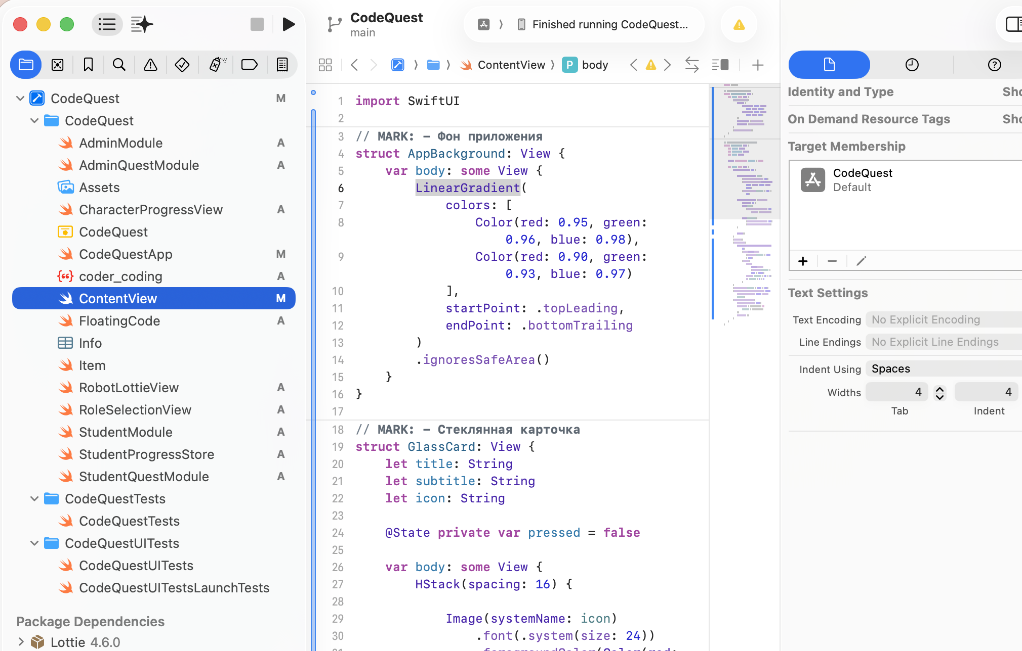
Figure 1. Project Structure

The project includes the following main components:
- AdminModule and AdminQuestModule – modules of the administrative part of the application designed for creating and editing educational topics, test tasks, and quests;
- StudentModule and StudentQuestModule – modules that support the user side of the application, including learning, completing tests, and quests;
- StudentProgressStore – a component responsible for storing and updating the learner’s individual progress;
- CharacterProgressView – a module that visualizes progress in the form of a game character;
- RoleSelectionView – a screen for selecting the user role (administrator or student);
- RobotLottieView and FloatingCode – animation and visual design elements of the interface.
The central part of the window displays the user interface code implemented using the SwiftUI framework. The application is launched through the main file CodeQuestApp.swift, which defines the initial screen and the navigation structure of the application.
This project structure ensures ease of development, scalability of functionality, and a clear separation of the logic between the administrative and user parts of the application.

4.2. Implementation of functional logic
Figure 2 shows the application icon and the main screen of the CodeQuest mobile application, designed for learning the basics of computer science and programming. The application icon is created in a modern style and reflects the idea of learning computer science through gameplay.
The main screen contains the primary navigation elements and allows the user to choose a role - administrator or student - which separates content management functions from the learning process. Students are provided with access to educational materials, tests, and quest-based tasks.
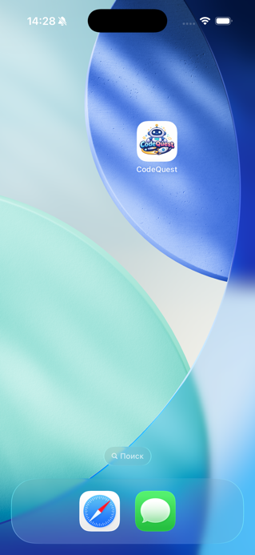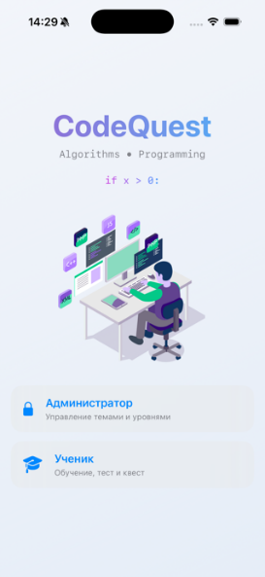
Figure 2. Application Icon and Main Screen of the Mobile Application

Figure 3 shows the administrator access screen and the administrative panel interface of the CodeQuest mobile application. The administrative section is protected by a password and provides functionality for managing educational content, including adding and editing topics by difficulty level, as well as populating them with theoretical materials, tests, and quest-based tasks. All changes become available to students in real time.
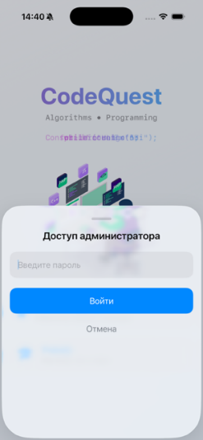
Figure 3. Administrative Panel Screens
Figure 4 shows the interface of the administrative panel of the CodeQuest mobile application, designed for managing educational content. The administrator can manually enter and edit theoretical materials, test tasks, and quest-based assignments, as well as use automatic content generation. Educational topics are structured by levels of difficulty, ensuring a sequential learning process. The application’s functionality is designed for individual use and provides access for only one student. All changes are saved automatically and become available to the user without requiring an application update.
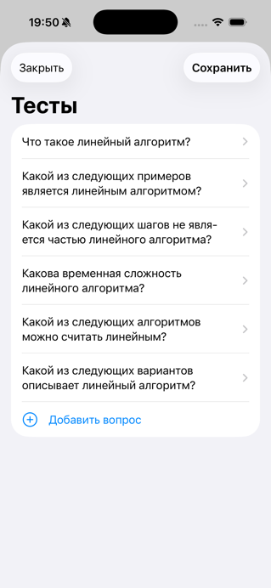
Figure 4. Educational Content Management Interface

Figure 5 shows the student interface of the CodeQuest mobile application, which includes the selection of learning topics, difficulty levels, and the display of individual learning progress.
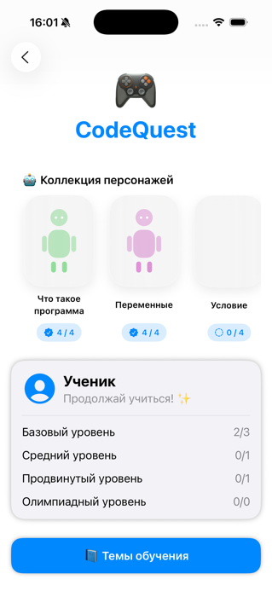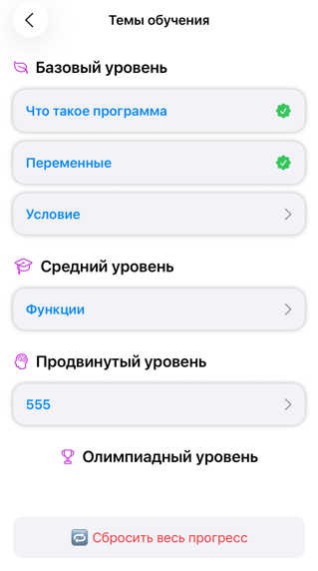
Рисунок 5 - Интерфейс ученика и выбор учебных тем

На рисунке 6 представлен интерфейс изучения учебной темы в мобильном приложении CodeQuest. Пользователь может ознакомиться с теоретическим материалом, пройти тест для проверки знаний и выполнить квестовые задания. Реализованная структура обеспечивает поэтапное освоение темы и способствует закреплению учебного материала.
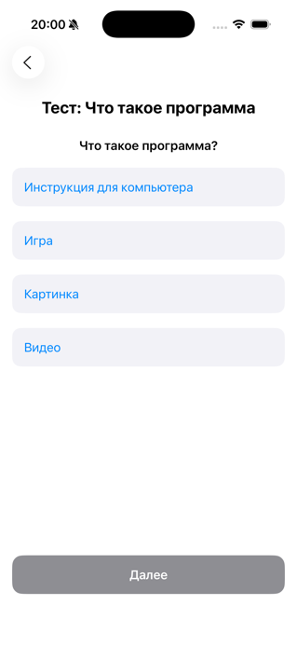
Figure 6. Interface for Studying a Topic and Completing Tasks

5. TESTING AND EVALUATION
The effectiveness of the developed application was evaluated with 7th-grade students. The students were asked to study the topics “What Is a Program” and “Variables” using the CodeQuest mobile application and to complete the tasks provided within the application.
The testing was conducted in two stages. During the first stage, students studied the selected topics using traditional learning materials. After this stage, baseline data were collected, including students’ level of interest in the subject, mini-test results, frequency of independent revision, and confidence in their programming knowledge.
During the second stage, students studied the same topics using the CodeQuest mobile application and completed the built-in test and quest-based tasks. After completing the learning process, final statistics were collected to evaluate the impact of the application on the learning process.
In addition, a student survey was conducted in which participants evaluated the clarity of the tasks, the usability of the interface, and the overall ease of use of the application. The survey results are presented in Figure 7.

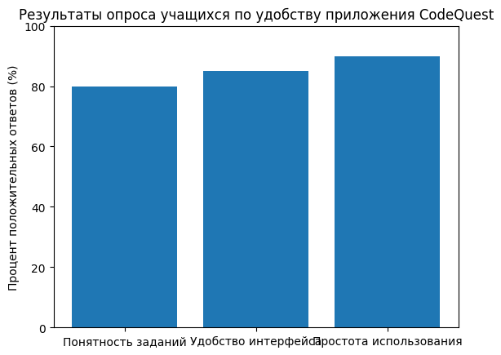
Figure 7. Results of the Student Survey

6. RESULTS AND CONCLUSIONS

6.1. Analysis of the Obtained Results
During the course of the work, the CodeQuest mobile application was developed to support learning the basics of programming through a game-based approach.
A comparison of the baseline and final statistics demonstrated a positive impact of using the CodeQuest application on the computer science learning process. An increase in students’ interest in the subject, improved mini-test results, higher learning activity, and greater confidence in their knowledge were observed.
Students’ interest in computer science increased from 40% to 70%, while the average mini-test score rose from 50% to 70%. Positive changes were also recorded in the frequency of independent revision and students’ confidence in their programming skills. Quantitative results are presented in Table 2.
Students became more actively engaged in completing tasks, were able to solve exercises more quickly, and made fewer mistakes when working on the studied topics. The use of game elements - such as levels, points, and visual progress indicators - contributed significantly to increased engagement and interest in learning.

№ | Indicator | After Use | Change
1 | Interest in the subject | 70% | +30%
2 | Average mini-test score | 70% | +20%
3 | Frequency of independent revision | 2 times per week | ×2 increase
4 | Confidence in programming | 50% | +30%
Table 2. Final Statistics (After Using the Application)

6.2. Conclusions
The conducted study demonstrated that the CodeQuest mobile application effectively supports learning the basics of programming among 7th-grade students. The use of gamification makes the educational process more understandable, engaging, and motivating. Interactive tasks and a quest-based structure help students better master learning material, develop logical and algorithmic thinking, and build confidence in their knowledge.
Thus, the CodeQuest application can be recommended as an additional tool for teaching computer science in classroom lessons, extracurricular activities, and independent home learning.

6.3. Practical significance of the project
The practical significance of the project lies in the possibility of using the CodeQuest mobile application in a real educational environment. The application can be used:
- in Grade 7 computer science lessons to explain and reinforce topics;
- for independent revision of material before formative and summative assessments;
- for home-based learning.
The game-based format of the tasks helps increase student motivation and supports the development of algorithmic thinking.

6.4. Prospects for further project development
In the future, the CodeQuest project can be expanded and further improved. Planned developments include:
- increasing task complexity and expanding test types, such as coding tasks, logic problems, program debugging tasks, and mini-projects;
- introducing ranking and competitive elements, including leaderboards, challenges, and weekly achievements;
- expanding the character collection, including different robots, character progression, and animations;
- ensuring cross-platform support for both iOS and Android;
- creating a teacher dashboard featuring class statistics, individual student progress tracking, and personalized recommendations.
The implementation of these features will make the application more functional and more convenient for use in the school educational environment.

7. REFERENCES
- Abdrakhmanova, G. T., Kusainova, A. A. Computer Science. Grade 7: Textbook for Secondary Schools. Almaty: Mektep, 2022. 176 p.
- Wing, J. M. “Computational Thinking.” Communications of the ACM, vol. 49, no. 3, 2006, pp. 33–35.
- Resnick, M., Maloney, J., Monroy-Hernández, A. “Scratch: Programming for All.” Communications of the ACM, vol. 52, no. 11, 2009.
- Papert, S. Mindstorms: Children, Computers, and Powerful Ideas. New York: Basic Books, 1980.
- Apple Developer. Official Swift Documentation. Available at: https://developer.apple.com/swift/ (accessed November 10, 2025).
- Apple Developer. SwiftUI Tutorials. Available at: https://developer.apple.com/tutorials/swiftui (accessed November 10, 2025).
- Code.org. International Platform for Learning Programming. Available at: https://code.org (accessed November 10, 2025).
- Tynker. Interactive Programming Learning Environment for Children. Available at: https://www.tynker.com (accessed November 10, 2025).
- Khan Academy. Educational Resources on Computer Science and Algorithms. Available at: https://www.khanacademy.org (accessed November 10, 2025).
- Kozlov, D. V. Mobile Application Development in Swift: A Practical Guide. Moscow: BHV-Petersburg, 2023. 240 p.
- Zhumabekova, A. T. Gamification in Education: Methods and Tools. Almaty: Abai KazNPU, 2021. 128 p.
- Prikhodko, V. V. Methods of Interactive Teaching of Computer Science in Schools. Saint Petersburg: Piter, 2020. 176 p.

