Shingirirai Mwarunzika
R229121B
HDSC

OUTPUT
Mounted at /content/drive
✅ GPU DETECTED: Tesla T4

--- Loading Data ---
/tmp/ipython-input-2377531637.py:54: FutureWarning: `torch.cuda.amp.GradScaler(args...)` is deprecated. Please use `torch.amp.GradScaler('cuda', args...)` instead.
scaler = torch.cuda.amp.GradScaler(enabled=USE_AMP)
Data Loaded: 1551 valid samples ready for training.

🚀 STARTING BENCHMARK ON 20 MODELS...
============================================================

>>> Training: AlexNet (2012)
Downloading: "https://download.pytorch.org/models/alexnet-owt-7be5be79.pth" to /root/.cache/torch/hub/checkpoints/alexnet-owt-7be5be79.pth
100%|██████████| 233M/233M [00:01<00:00, 204MB/s]
Ep 1: 100%
20/20 [02:07<00:00, 4.89s/it, loss=26.81]
/tmp/ipython-input-2377531637.py:289: FutureWarning: `torch.cuda.amp.autocast(args...)` is deprecated. Please use `torch.amp.autocast('cuda', args...)` instead.
with torch.cuda.amp.autocast():
Ep 2: 95%
19/20 [00:08<00:00, 2.98it/s, loss=7.35]
Ep 3: 95%
19/20 [00:07<00:00, 2.29it/s, loss=4.22]
✅ R-Squared: -1.4269 | MAE (Log): 1.4473
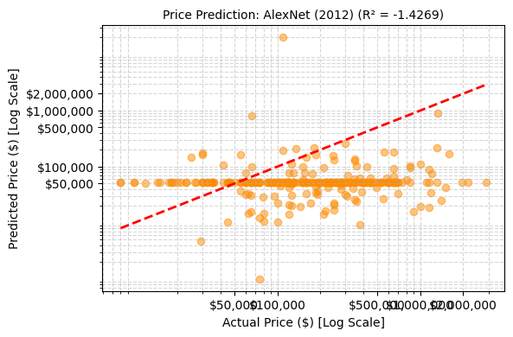
>>> Training: NIN (Network in Network) (2013)
Downloading: "https://download.pytorch.org/models/squeezenet1_0-b66bff10.pth" to /root/.cache/torch/hub/checkpoints/squeezenet1_0-b66bff10.pth
100%|██████████| 4.78M/4.78M [00:00<00:00, 158MB/s]
Ep 1: 100%
20/20 [00:08<00:00, 3.10it/s, loss=18.21]
/tmp/ipython-input-2377531637.py:289: FutureWarning: `torch.cuda.amp.autocast(args...)` is deprecated. Please use `torch.amp.autocast('cuda', args...)` instead.
with torch.cuda.amp.autocast():
Ep 2: 95%
19/20 [00:07<00:00, 2.99it/s, loss=3.92]
Ep 3: 95%
19/20 [00:08<00:00, 3.11it/s, loss=2.17]
✅ R-Squared: -0.9679 | MAE (Log): 1.2602
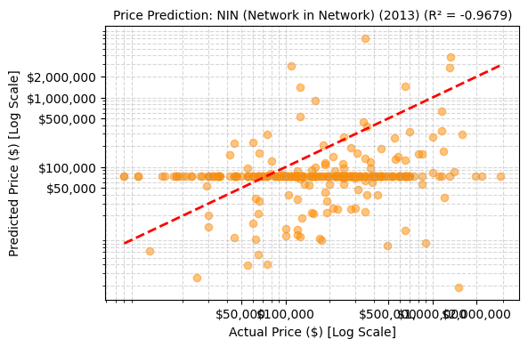
>>> Training: ZfNet (2013)
Ep 1: 95%
19/20 [00:08<00:00, 3.05it/s, loss=16.85]
/tmp/ipython-input-2377531637.py:289: FutureWarning: `torch.cuda.amp.autocast(args...)` is deprecated. Please use `torch.amp.autocast('cuda', args...)` instead.
with torch.cuda.amp.autocast():
Ep 2: 95%
19/20 [00:06<00:00, 3.24it/s, loss=3.21]
Ep 3: 95%
19/20 [00:08<00:00, 3.22it/s, loss=3.83]
✅ R-Squared: -1.1728 | MAE (Log): 1.3002
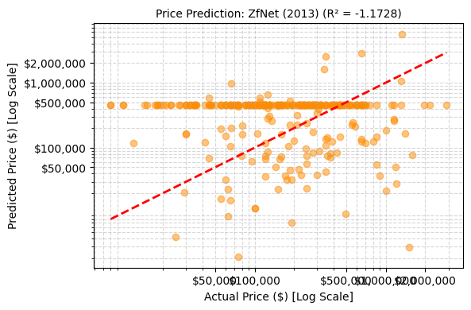
>>> Training: VGG (2014)
Downloading: "https://download.pytorch.org/models/vgg11-8a719046.pth" to /root/.cache/torch/hub/checkpoints/vgg11-8a719046.pth
100%|██████████| 507M/507M [00:02<00:00, 185MB/s]
Ep 1: 100%
20/20 [00:09<00:00, 3.30it/s, loss=64.50]
/tmp/ipython-input-2377531637.py:289: FutureWarning: `torch.cuda.amp.autocast(args...)` is deprecated. Please use `torch.amp.autocast('cuda', args...)` instead.
with torch.cuda.amp.autocast():
Ep 2: 100%
20/20 [00:10<00:00, 3.06it/s, loss=6.48]
Ep 3: 100%
20/20 [00:09<00:00, 2.45it/s, loss=3.64]
✅ R-Squared: -1.9193 | MAE (Log): 1.3883
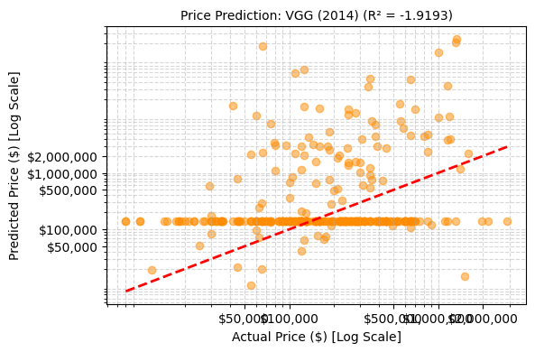
>>> Training: GoogLeNet / Inception-V1 (2014)
Downloading: "https://download.pytorch.org/models/googlenet-1378be20.pth" to /root/.cache/torch/hub/checkpoints/googlenet-1378be20.pth
100%|██████████| 49.7M/49.7M [00:00<00:00, 179MB/s]
Ep 1: 100%
20/20 [00:08<00:00, 2.24it/s, loss=10.06]
/tmp/ipython-input-2377531637.py:289: FutureWarning: `torch.cuda.amp.autocast(args...)` is deprecated. Please use `torch.amp.autocast('cuda', args...)` instead.
with torch.cuda.amp.autocast():
Ep 2: 95%
19/20 [00:08<00:00, 2.97it/s, loss=1.39]
Ep 3: 95%
19/20 [00:09<00:00, 2.92it/s, loss=1.60]
✅ R-Squared: 0.0145 | MAE (Log): 0.8706
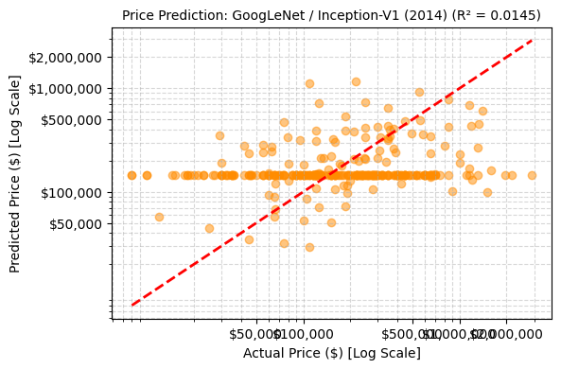
>>> Training: Inception-V3 (2015)
Downloading: "https://download.pytorch.org/models/inception_v3_google-0cc3c7bd.pth" to /root/.cache/torch/hub/checkpoints/inception_v3_google-0cc3c7bd.pth
100%|██████████| 104M/104M [00:00<00:00, 179MB/s]
Ep 1: 100%
20/20 [00:11<00:00, 2.07it/s, loss=1.10]
/tmp/ipython-input-2377531637.py:289: FutureWarning: `torch.cuda.amp.autocast(args...)` is deprecated. Please use `torch.amp.autocast('cuda', args...)` instead.
with torch.cuda.amp.autocast():
Ep 2: 100%
20/20 [00:10<00:00, 2.53it/s, loss=1.53]
Ep 3: 100%
20/20 [00:10<00:00, 2.65it/s, loss=2.00]
✅ R-Squared: -0.7854 | MAE (Log): 1.1941
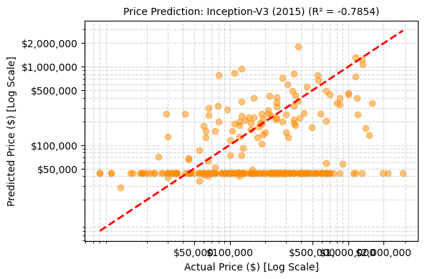
>>> Training: Highway Networks (2015)
Downloading: "https://download.pytorch.org/models/resnet18-f37072fd.pth" to /root/.cache/torch/hub/checkpoints/resnet18-f37072fd.pth
100%|██████████| 44.7M/44.7M [00:00<00:00, 191MB/s]
Ep 1: 100%
20/20 [00:07<00:00, 3.83it/s, loss=1.82]
/tmp/ipython-input-2377531637.py:289: FutureWarning: `torch.cuda.amp.autocast(args...)` is deprecated. Please use `torch.amp.autocast('cuda', args...)` instead.
with torch.cuda.amp.autocast():
Ep 2: 95%
19/20 [00:08<00:00, 2.78it/s, loss=1.52]
Ep 3: 95%
19/20 [00:07<00:00, 2.68it/s, loss=1.48]
✅ R-Squared: -0.5135 | MAE (Log): 1.0596
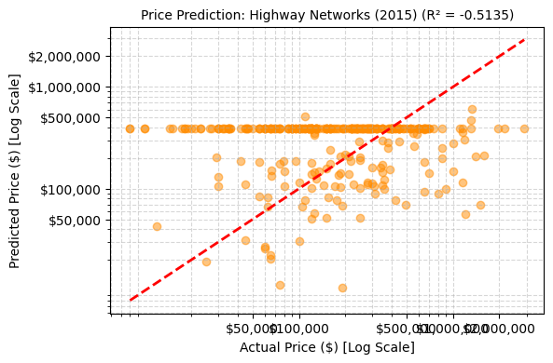
>>> Training: Inception-V4 (2016)
/usr/local/lib/python3.12/dist-packages/huggingface_hub/utils/_auth.py:94: UserWarning:
The secret `HF_TOKEN` does not exist in your Colab secrets.
To authenticate with the Hugging Face Hub, create a token in your settings tab (https://huggingface.co/settings/tokens), set it as secret in your Google Colab and restart your session.
You will be able to reuse this secret in all of your notebooks.
Please note that authentication is recommended but still optional to access public models or datasets.
warnings.warn(
model.safetensors: 100%
171M/171M [00:02<00:00, 66.9MB/s]
Ep 1: 100%
20/20 [00:17<00:00, 1.44it/s, loss=4.18]
/tmp/ipython-input-2377531637.py:289: FutureWarning: `torch.cuda.amp.autocast(args...)` is deprecated. Please use `torch.amp.autocast('cuda', args...)` instead.
with torch.cuda.amp.autocast():
Ep 2: 100%
20/20 [00:16<00:00, 1.51it/s, loss=2.77]
Ep 3: 100%
20/20 [00:17<00:00, 1.50it/s, loss=0.94]
✅ R-Squared: -0.0586 | MAE (Log): 0.9011
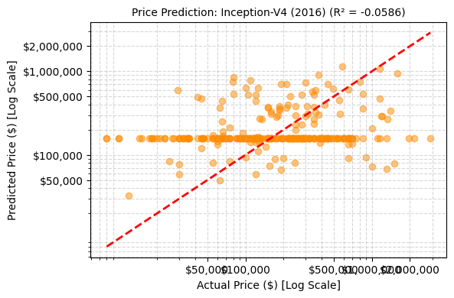
>>> Training: ResNet (2016)
Downloading: "https://download.pytorch.org/models/resnet50-11ad3fa6.pth" to /root/.cache/torch/hub/checkpoints/resnet50-11ad3fa6.pth
100%|██████████| 97.8M/97.8M [00:00<00:00, 154MB/s]
Ep 1: 100%
20/20 [00:10<00:00, 2.56it/s, loss=10.39]
/tmp/ipython-input-2377531637.py:289: FutureWarning: `torch.cuda.amp.autocast(args...)` is deprecated. Please use `torch.amp.autocast('cuda', args...)` instead.
with torch.cuda.amp.autocast():
Ep 2: 100%
20/20 [00:09<00:00, 3.38it/s, loss=2.55]
Ep 3: 100%
20/20 [00:10<00:00, 3.31it/s, loss=1.96]
✅ R-Squared: -0.7293 | MAE (Log): 1.2124
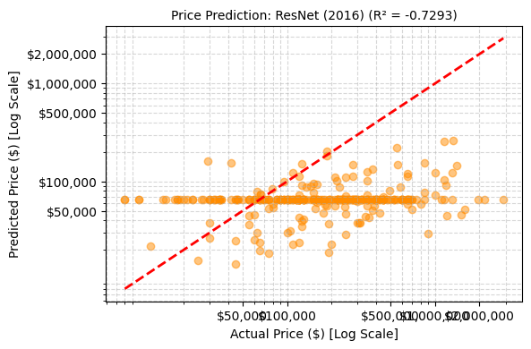
>>> Training: Inception-ResNet-V2 (2016)
model.safetensors: 100%
224M/224M [00:03<00:00, 199MB/s]
Ep 1: 100%
20/20 [00:20<00:00, 1.22it/s, loss=2.58]
/tmp/ipython-input-2377531637.py:289: FutureWarning: `torch.cuda.amp.autocast(args...)` is deprecated. Please use `torch.amp.autocast('cuda', args...)` instead.
with torch.cuda.amp.autocast():
Ep 2: 100%
20/20 [00:20<00:00, 1.25it/s, loss=1.58]
Ep 3: 100%
20/20 [00:19<00:00, 1.28it/s, loss=1.37]
✅ R-Squared: -5.1319 | MAE (Log): 2.4741
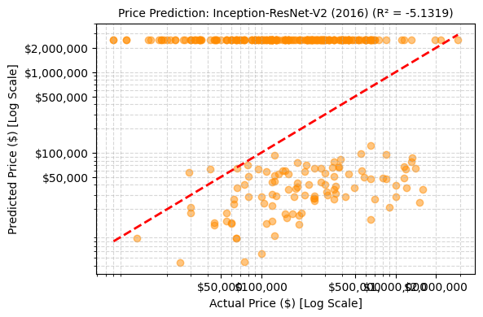
>>> Training: FractalNet (2016)
Downloading: "https://download.pytorch.org/models/densenet121-a639ec97.pth" to /root/.cache/torch/hub/checkpoints/densenet121-a639ec97.pth
100%|██████████| 30.8M/30.8M [00:00<00:00, 115MB/s]
Ep 1: 100%
20/20 [00:11<00:00, 2.22it/s, loss=3.07]
/tmp/ipython-input-2377531637.py:289: FutureWarning: `torch.cuda.amp.autocast(args...)` is deprecated. Please use `torch.amp.autocast('cuda', args...)` instead.
with torch.cuda.amp.autocast():
Ep 2: 100%
20/20 [00:10<00:00, 3.08it/s, loss=2.33]
Ep 3: 100%
20/20 [00:10<00:00, 2.24it/s, loss=2.36]
✅ R-Squared: 0.0834 | MAE (Log): 0.8379
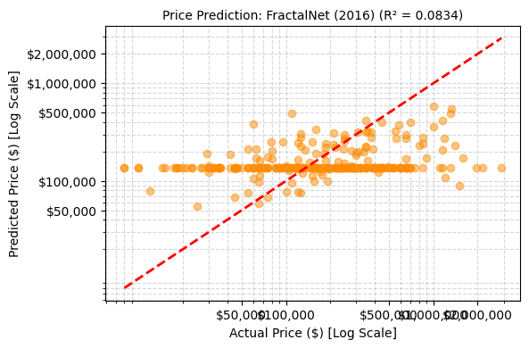
>>> Training: WideResNet (2016)
Downloading: "https://download.pytorch.org/models/wide_resnet50_2-9ba9bcbe.pth" to /root/.cache/torch/hub/checkpoints/wide_resnet50_2-9ba9bcbe.pth
100%|██████████| 263M/263M [00:16<00:00, 16.9MB/s]
Ep 1: 100%
20/20 [00:11<00:00, 2.52it/s, loss=8.05]
/tmp/ipython-input-2377531637.py:289: FutureWarning: `torch.cuda.amp.autocast(args...)` is deprecated. Please use `torch.amp.autocast('cuda', args...)` instead.
with torch.cuda.amp.autocast():
Ep 2: 100%
20/20 [00:11<00:00, 2.51it/s, loss=10.83]
Ep 3: 100%
20/20 [00:11<00:00, 2.04it/s, loss=2.74]
✅ R-Squared: -0.2879 | MAE (Log): 0.9807
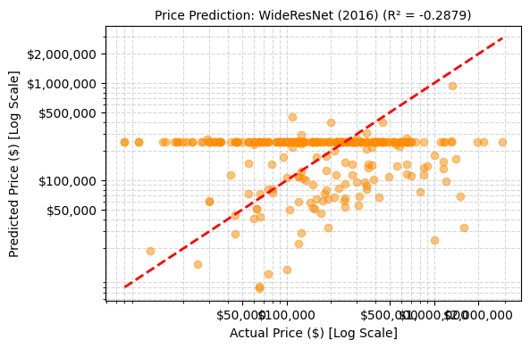
>>> Training: Xception (2017)
/usr/local/lib/python3.12/dist-packages/timm/models/_factory.py:138: UserWarning: Mapping deprecated model name xception to current legacy_xception.
model = create_fn(
Downloading: "https://github.com/rwightman/pytorch-image-models/releases/download/v0.1-cadene/xception-43020ad28.pth" to /root/.cache/torch/hub/checkpoints/xception-43020ad28.pth
Ep 1: 100%
20/20 [00:41<00:00, 4.39s/it, loss=30.11]
/tmp/ipython-input-2377531637.py:289: FutureWarning: `torch.cuda.amp.autocast(args...)` is deprecated. Please use `torch.amp.autocast('cuda', args...)` instead.
with torch.cuda.amp.autocast():
Ep 2: 100%
20/20 [00:17<00:00, 1.51it/s, loss=2.19]
Ep 3: 100%
20/20 [00:17<00:00, 1.51it/s, loss=16.17]
✅ R-Squared: -37.8712 | MAE (Log): 6.5725
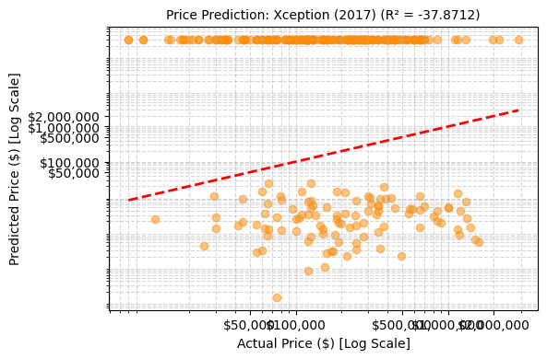
>>> Training: Residual Attention Network (2017)
❌ Skipped Residual Attention Network (2017): Unknown model (se_resnet50)

>>> Training: Squeeze-and-Excitation Networks (SENet) (2017)
model.safetensors: 100%
113M/113M [00:04<00:00, 31.3MB/s]
Ep 1: 100%
20/20 [00:10<00:00, 2.90it/s, loss=1.66]
/tmp/ipython-input-2377531637.py:289: FutureWarning: `torch.cuda.amp.autocast(args...)` is deprecated. Please use `torch.amp.autocast('cuda', args...)` instead.
with torch.cuda.amp.autocast():
Ep 2: 100%
20/20 [00:10<00:00, 2.70it/s, loss=1.68]
Ep 3: 100%
20/20 [00:10<00:00, 2.13it/s, loss=1.40]
✅ R-Squared: -0.0232 | MAE (Log): 0.9006
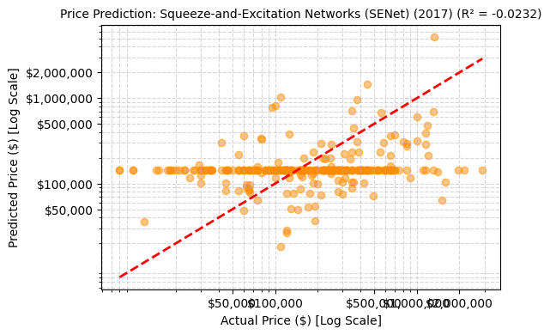
>>> Training: DenseNet (2017)
Ep 1: 100%
20/20 [00:10<00:00, 2.21it/s, loss=9.80]
/tmp/ipython-input-2377531637.py:289: FutureWarning: `torch.cuda.amp.autocast(args...)` is deprecated. Please use `torch.amp.autocast('cuda', args...)` instead.
with torch.cuda.amp.autocast():
Ep 2: 100%
20/20 [00:09<00:00, 3.02it/s, loss=1.54]
Ep 3: 100%
20/20 [00:11<00:00, 3.12it/s, loss=1.44]
✅ R-Squared: -0.2341 | MAE (Log): 0.9799
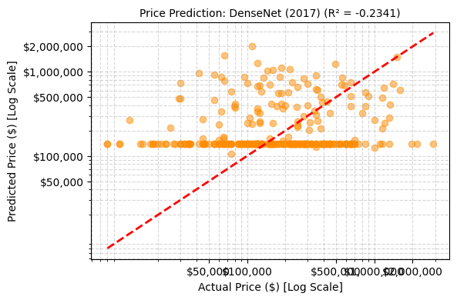
>>> Training: Competitive Squeeze-and-Excitation Network (2018)
model.safetensors: 100%
111M/111M [00:02<00:00, 56.9MB/s]
Ep 1: 100%
20/20 [00:11<00:00, 2.86it/s, loss=2.56]
/tmp/ipython-input-2377531637.py:289: FutureWarning: `torch.cuda.amp.autocast(args...)` is deprecated. Please use `torch.amp.autocast('cuda', args...)` instead.
with torch.cuda.amp.autocast():
Ep 2: 100%
20/20 [00:11<00:00, 2.88it/s, loss=1.08]
Ep 3: 100%
20/20 [00:11<00:00, 2.25it/s, loss=1.38]
✅ R-Squared: -72.3937 | MAE (Log): 7.9213
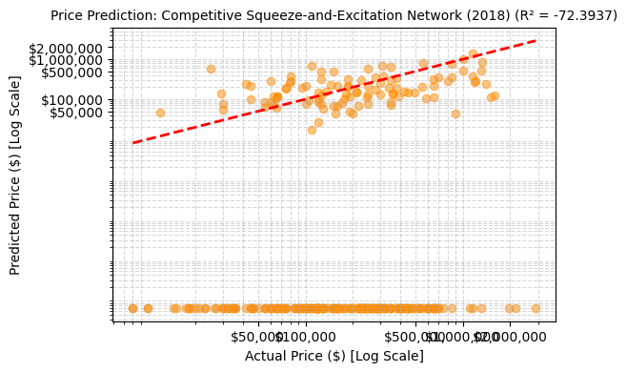
>>> Training: MobileNet-V2 (2018)
Downloading: "https://download.pytorch.org/models/mobilenet_v2-7ebf99e0.pth" to /root/.cache/torch/hub/checkpoints/mobilenet_v2-7ebf99e0.pth
100%|██████████| 13.6M/13.6M [00:00<00:00, 167MB/s]
Ep 1: 100%
20/20 [00:26<00:00, 2.95s/it, loss=27.50]
/tmp/ipython-input-2377531637.py:289: FutureWarning: `torch.cuda.amp.autocast(args...)` is deprecated. Please use `torch.amp.autocast('cuda', args...)` instead.
with torch.cuda.amp.autocast():
Ep 2: 95%
19/20 [00:09<00:00, 1.90it/s, loss=29.96]
Ep 3: 95%
19/20 [00:09<00:00, 2.75it/s, loss=3.16]
✅ R-Squared: -6.7093 | MAE (Log): 2.8057
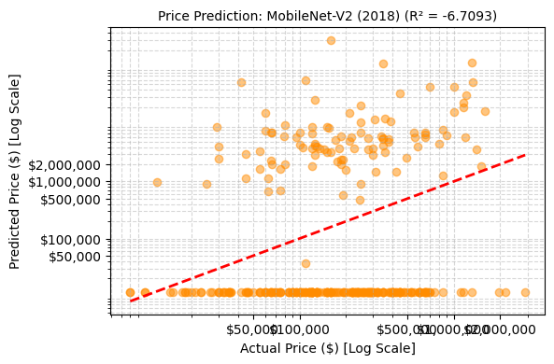
>>> Training: CapsuleNet (2018)
Downloading: "https://download.pytorch.org/models/resnext50_32x4d-1a0047aa.pth" to /root/.cache/torch/hub/checkpoints/resnext50_32x4d-1a0047aa.pth
100%|██████████| 95.8M/95.8M [00:00<00:00, 131MB/s]
Ep 1: 100%
20/20 [00:11<00:00, 3.07it/s, loss=3.24]
/tmp/ipython-input-2377531637.py:289: FutureWarning: `torch.cuda.amp.autocast(args...)` is deprecated. Please use `torch.amp.autocast('cuda', args...)` instead.
with torch.cuda.amp.autocast():
Ep 2: 100%
20/20 [00:11<00:00, 2.72it/s, loss=2.01]
Ep 3: 100%
20/20 [00:11<00:00, 2.18it/s, loss=1.54]
✅ R-Squared: -10.1350 | MAE (Log): 3.1685
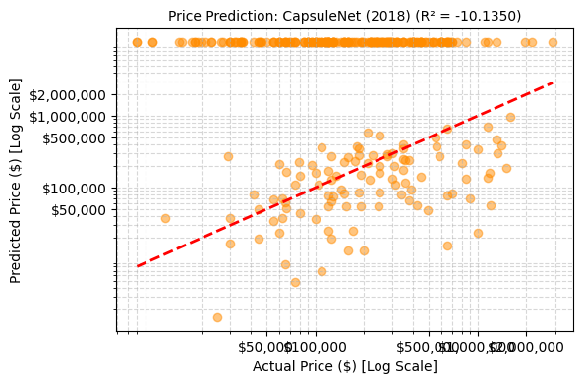
>>> Training: HRNet-V2 (2020)
model.safetensors: 100%
85.6M/85.6M [00:06<00:00, 34.8MB/s]
Ep 1: 100%
20/20 [00:14<00:00, 1.56it/s, loss=2.57]
/tmp/ipython-input-2377531637.py:289: FutureWarning: `torch.cuda.amp.autocast(args...)` is deprecated. Please use `torch.amp.autocast('cuda', args...)` instead.
with torch.cuda.amp.autocast():
Ep 2: 100%
20/20 [00:13<00:00, 1.98it/s, loss=1.23]
Ep 3: 100%
20/20 [00:13<00:00, 1.93it/s, loss=0.93]
✅ R-Squared: -0.0657 | MAE (Log): 0.9132
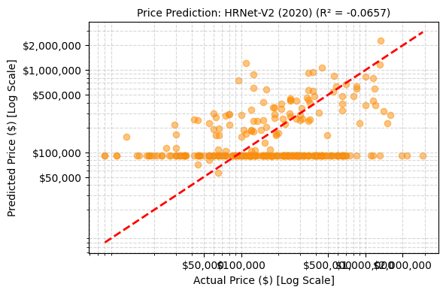

================🏆 FINAL LEADERBOARD 🏆================
Model R-Squared MAE Loss
10 FractalNet (2016) 0.083414 0.837881
4 GoogLeNet / Inception-V1 (2014) 0.014476 0.870578
13 Squeeze-and-Excitation Networks (SENet) (2017) -0.023184 0.900584
7 Inception-V4 (2016) -0.058634 0.901105
18 HRNet-V2 (2020) -0.065740 0.913204
14 DenseNet (2017) -0.234085 0.979904
11 WideResNet (2016) -0.287940 0.980654
6 Highway Networks (2015) -0.513494 1.059555
8 ResNet (2016) -0.729292 1.212373
5 Inception-V3 (2015) -0.785351 1.194105
1 NIN (Network in Network) (2013) -0.967876 1.260168
2 ZfNet (2013) -1.172820 1.300217
0 AlexNet (2012) -1.426853 1.447258
3 VGG (2014) -1.919272 1.388299
9 Inception-ResNet-V2 (2016) -5.131856 2.474127
16 MobileNet-V2 (2018) -6.709264 2.805721
17 CapsuleNet (2018) -10.134991 3.168465
12 Xception (2017) -37.871239 6.572452
15 Competitive Squeeze-and-Excitation Network (2018) -72.393708 7.921291

>>> 💰 SAMPLE PREDICTIONS (FractalNet (2016))
Actual Price | Predicted Price | Diff
--------------------------------------------------
$220,000 | $136,566 | $83,434
$30,000 | $123,282 | $93,282
$350,000 | $136,566 | $213,434
$590,000 | $136,566 | $453,434
$300,000 | $193,129 | $106,871
$100,000 | $136,566 | $36,566
$42,000 | $187,354 | $145,354
$220,000 | $136,566 | $83,434
$400,000 | $136,566 | $263,434
$650,000 | $299,541 | $350,459

