Importing tsv file to postgres table

1. Apply DDL and go to tables -> DataBases , Schema(imdb) , Schemas , Tables , right click on table and select impot export. Show in image below.

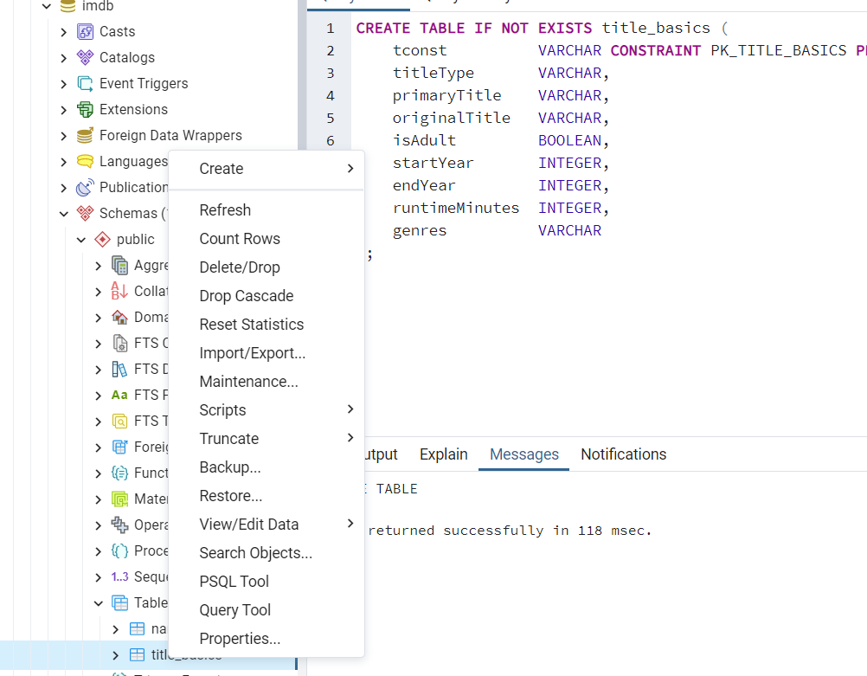

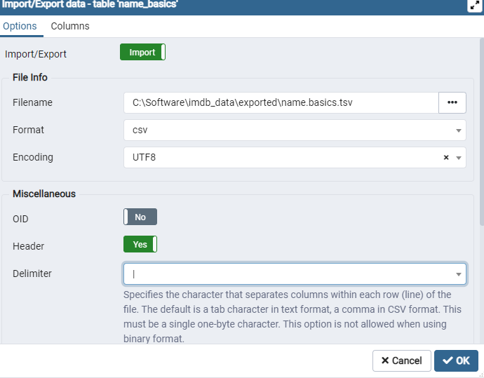

Click on ok to start tsv import to tables. This will take some time and progress can be monitored

