1. Create a maven project

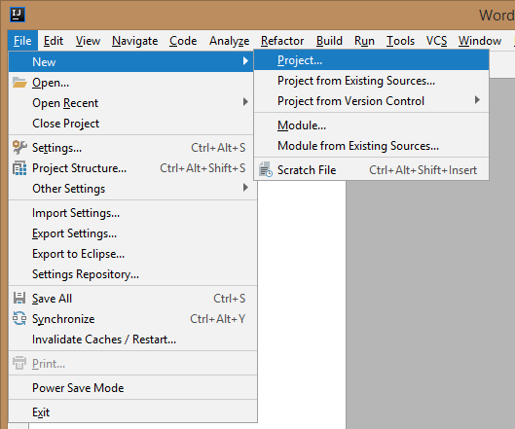

1. Choose maven

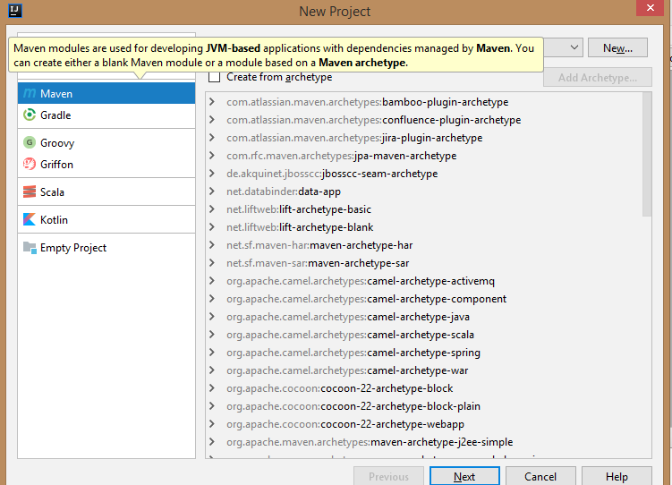

1. Click Next
2. Enter GroupId and Artifact

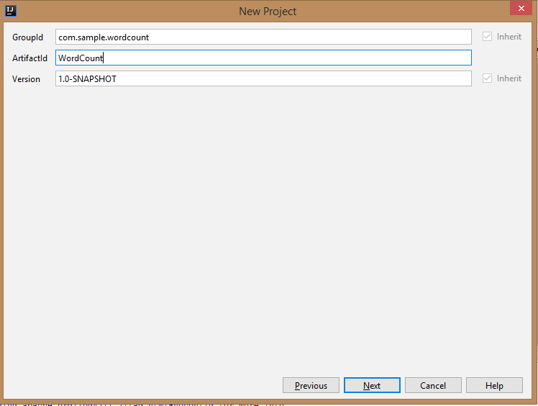

1. Select target directory for project

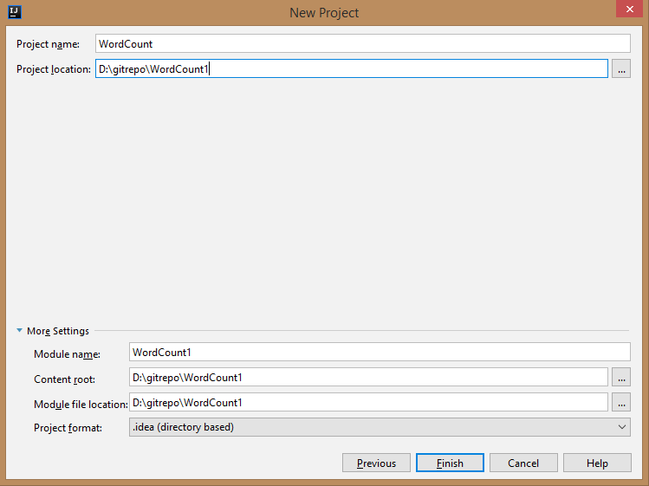

1. Enable auto import on bottom right corner

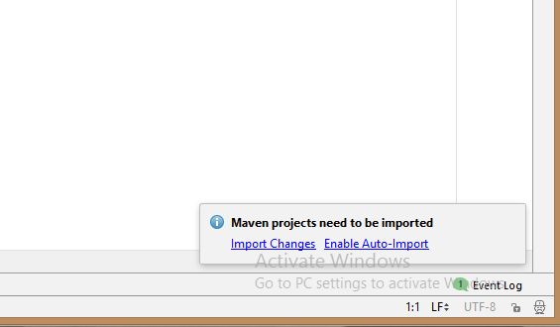

1. Copy following code and paste it in pom.xml file just before </project> tag

*<dependencies>*

*<dependency>*

*<groupId>org.apache.hadoop</groupId>*

*<artifactId>hadoop-common</artifactId>*

*<version>2.6.2</version>*

*</dependency>*

*<dependency>*

*<groupId>org.apache.hadoop</groupId>*

*<artifactId>hadoop-mapreduce-client-common</artifactId>*

*<version>2.6.2</version>*

*</dependency>*

*</dependencies>*

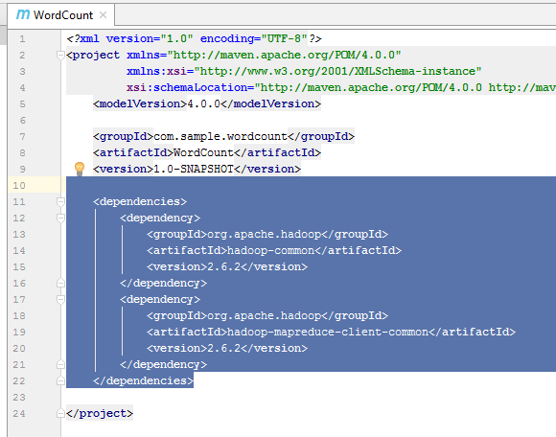

1. Create source code package you have mentioned in GroupId

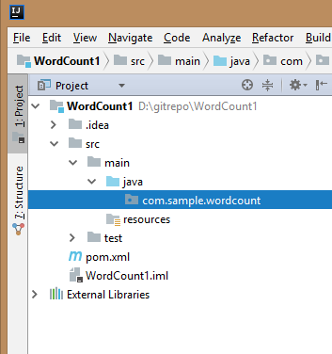

1. Copy WordCount.java file into that folder
2. Modify Hadoop.dir property within your program
3. Create input directory and copy your input text file within that
4. Create new runtime configuration

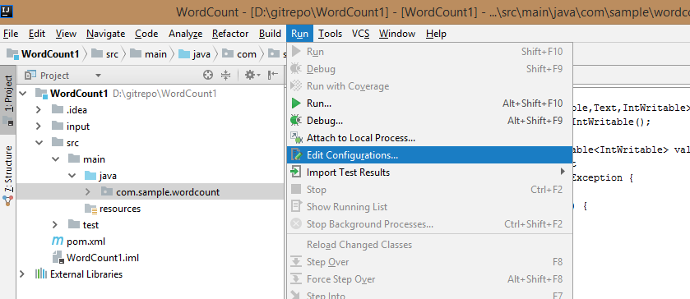

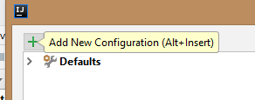

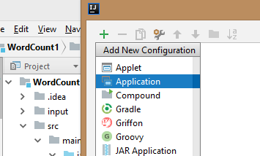

1. Configure main class name, arguments to the program and name of configuration

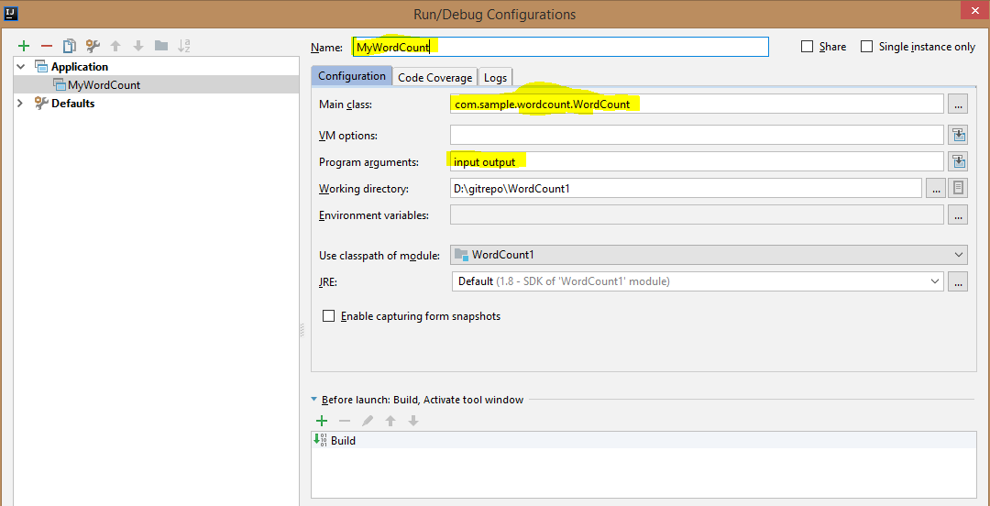

1. Finally run your program

